Crypto Challenge #1

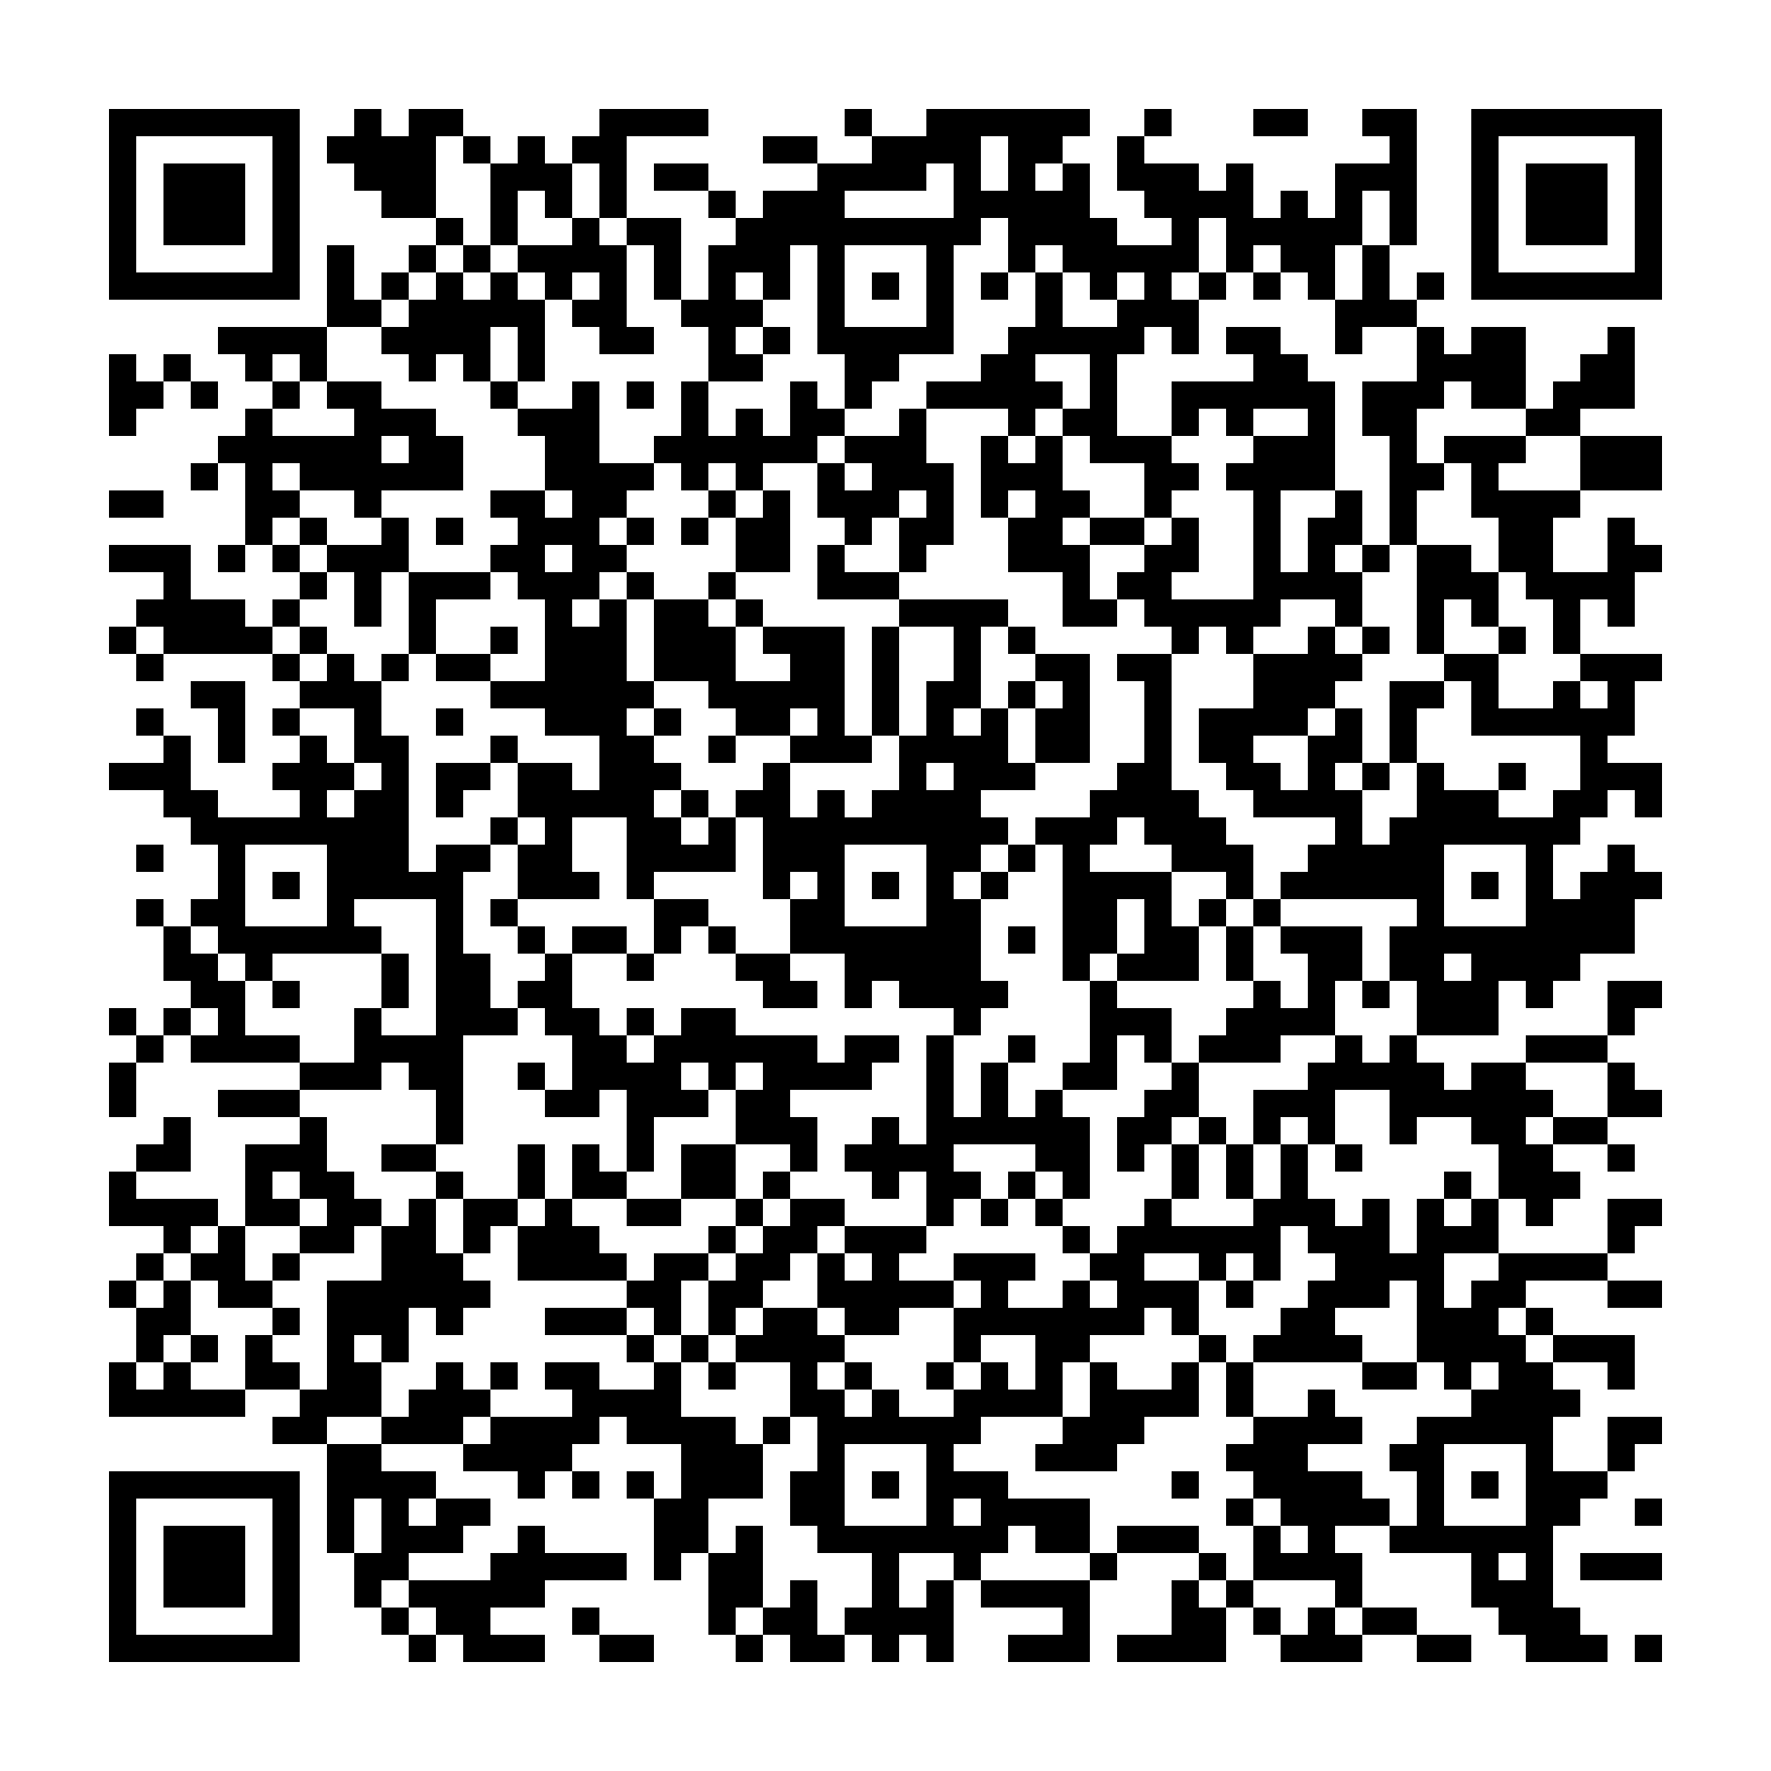

Crypto Challenge #2

l>66 rjx x6z)3

F

ugrj xN[W)>pR

W

gl 6[WpNvzRp

**https://crypto.cyberpdx.org/static/________.jpg**

Crypto Challenge #3



**WWYJ RXGD AODD DGVO QLDC BELC AOTF FLWK UVYD RNJP RRJM SYJE**

Crypto Challenge #4

**BE-SEIS-NA-NEH HANE-AL-NEH BILH DAY-DIL-JAH-HE ACHE BAH-HAS-TKIH**

**Vigenere secret key = ???**

**SAZPRVSFJGUXSMRUEAUBUIVEEZKNBVMEHVGVTEVUIA**

Final Crypto Challenge

**68 74 74 70 73 3a 2f 2f 67 6f 6f 2e 67 6c 2f 69 67 4a 79 6c 30**

Final Crypto Challenge

**68 74 74 70 73 3a 2f 2f 67 6f 6f 2e 67 6c 2f 69 67 4a 79 6c 30**

Final Crypto Challenge

**68 74 74 70 73 3a 2f 2f 67 6f 6f 2e 67 6c 2f 69 67 4a 79 6c 30**