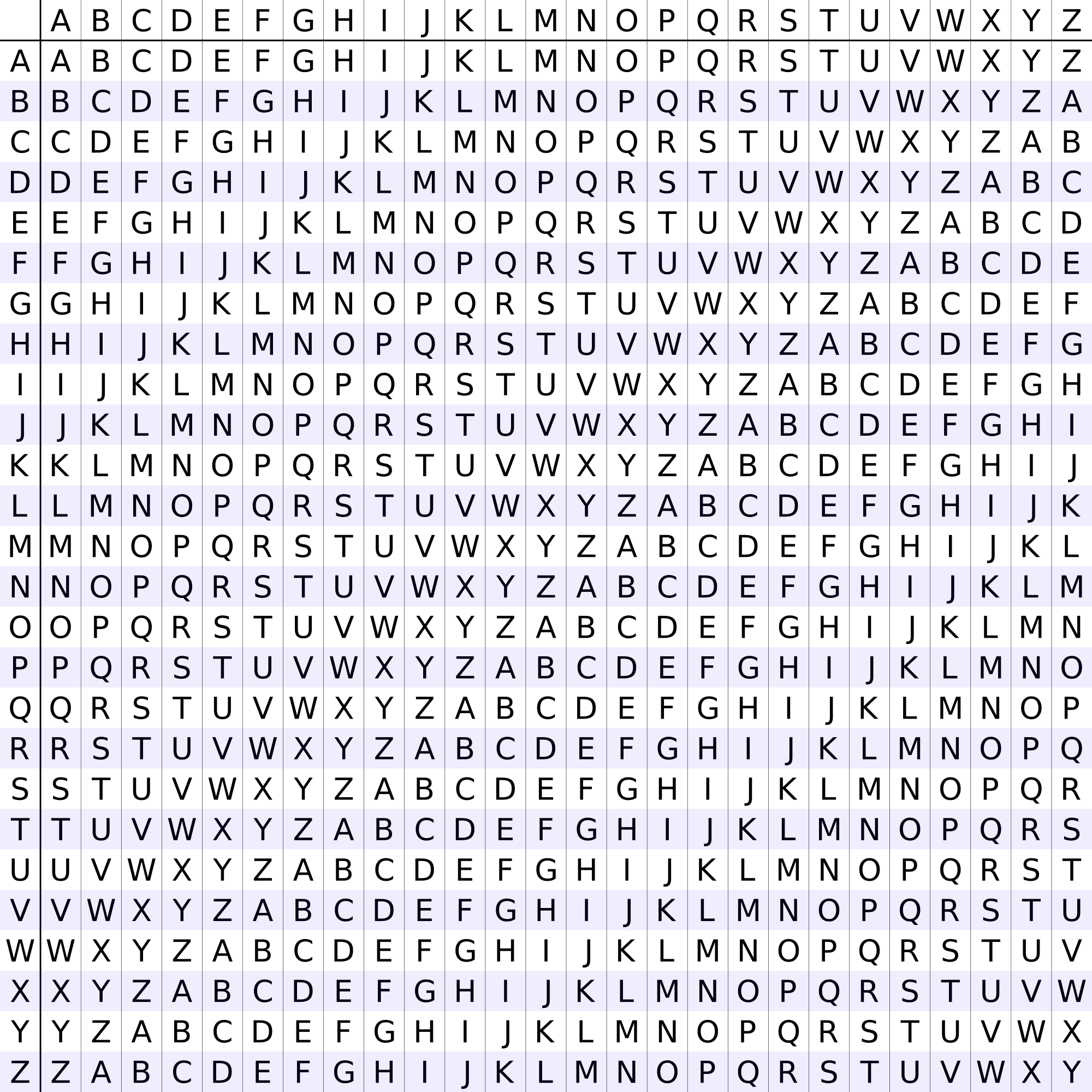
Snippet #1: TITOEHBIFOEEEAPLRSPL

Snippet #2: EERRRNREEWEWNVIVEOEL

Snippet #3: LEENTBCWTREUHHASREEN

Snippet #4: SIOEUAOFILCNTRETSHRR

Snippet #5: SCEDMAOAFTRNLRHECEOE

Snippet #6: MRHY8PIE1XACN7XTKR8X
Vigenere key = CYBERDIS
Ciphertext #1 = CLZWFFQWVWULRW

Vigenere key = CYBERDIS
Ciphertext #2 = YMVPUJQNGSQECLBLNC

Vigenere key = CYBERDIS
Ciphertext #3 = NGCIIWGXQPBPZWBDG

Vigenere key = CYBERDIS
Ciphertext #4 = UCDYILBQYGMPUHAWTTF

Vigenere key = CYBERDIS
Ciphertext #5 = PCJXYHZSPBMSJHJGVF

Vigenere key = CYBERDIS
Ciphertext #6 = DCONRPQFHPBRBOQF

Enigma sez: AADD LLZB DTQN SNAB JWED RXMD CIYC SQQZ GEGA BLFQ LSAP OXHI UCRC UIPP YVXC NYJZ AIMF OHDE KLRM MDKV SKHR LYOK WGMT

Enigma sez: AADD LLZB DTQN SNAB JWED RXMD CIYC SQQZ GEGA BLFQ LSAP OXHI UCRC UIPP YVXC NYJZ AIMF OHDE KLRM MDKV SKHR LYOK WGMT

Enigma sez: AADD LLZB DTQN SNAB JWED RXMD CIYC SQQZ GEGA BLFQ LSAP OXHI UCRC UIPP YVXC NYJZ AIMF OHDE KLRM MDKV SKHR LYOK WGMT

Enigma sez: AADD LLZB DTQN SNAB JWED RXMD CIYC SQQZ GEGA BLFQ LSAP OXHI UCRC UIPP YVXC NYJZ AIMF OHDE KLRM MDKV SKHR LYOK WGMT

Enigma sez: AADD LLZB DTQN SNAB JWED RXMD CIYC SQQZ GEGA BLFQ LSAP OXHI UCRC UIPP YVXC NYJZ AIMF OHDE KLRM MDKV SKHR LYOK WGMT

Enigma sez: AADD LLZB DTQN SNAB JWED RXMD CIYC SQQZ GEGA BLFQ LSAP OXHI UCRC UIPP YVXC NYJZ AIMF OHDE KLRM MDKV SKHR LYOK WGMT

Enigma sez: AADD LLZB DTQN SNAB JWED RXMD CIYC SQQZ GEGA BLFQ LSAP OXHI UCRC UIPP YVXC NYJZ AIMF OHDE KLRM MDKV SKHR LYOK WGMT

