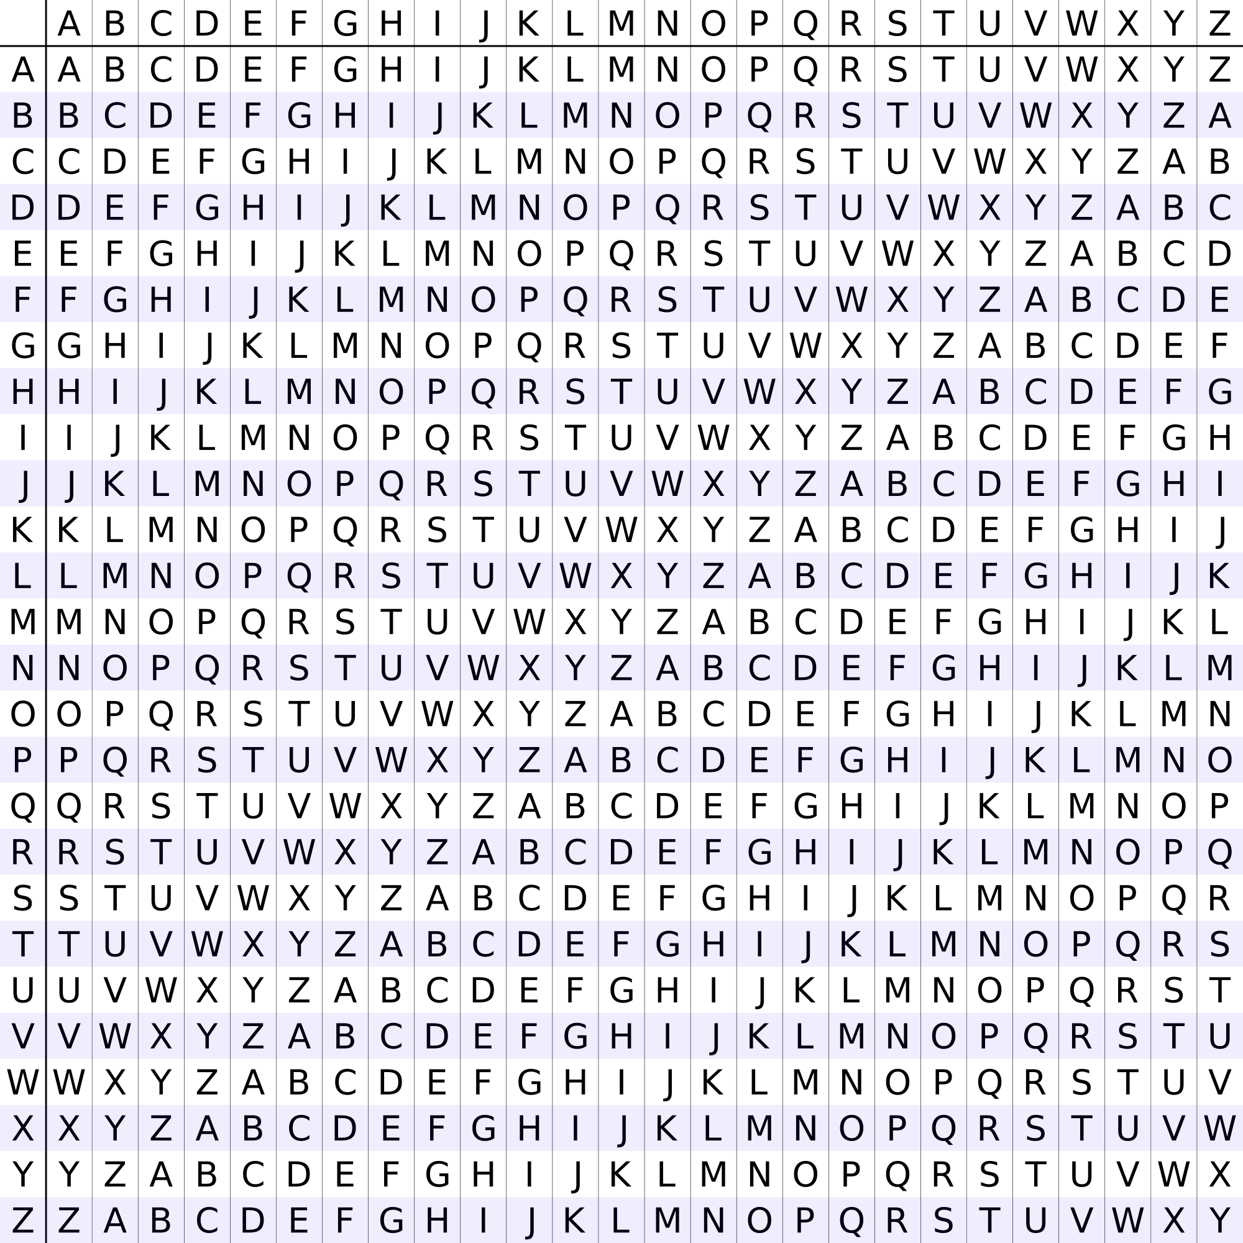
Snippet #1: TITOEHBIFOEEEAPLRSPL

Snippet #2: EERRRNREEWEWNVIVEOEL

Snippet #3: LEENTBCWTREUHHASREEN

Snippet #4: SIOEUAOFILCNTRETSHRR

Snippet #5: SCEDMAOAFTRNLRHECEOE

Snippet #6: MRHY8PIE1XACN7XTKR8X
Vigenere key = CYBERDIS
Ciphertext #1 = CLZWFFQWVWULRW

Vigenere key = CYBERDIS
Ciphertext #2 = YMVPUJQNGSQECLBLNC

Vigenere key = CYBERDIS
Ciphertext #3 = NGCIIWGXQPBPZWBDG

Vigenere key = CYBERDIS
Ciphertext #4 = UCDYILBQYGMPUHAWTTF

Vigenere key = CYBERDIS
Ciphertext #5 = PCJXYHZSPBMSJHJGVF

Vigenere key = CYBERDIS
Ciphertext #6 = DCONRPQFHPBRBOQF

Enigma sez: TPRW EDLX TLGF ZGSN KT

Enigma sez: TPRW EDLX TLGF ZGSN KT

Enigma sez: TPRW EDLX TLGF ZGSN KT

Enigma sez: TPRW EDLX TLGF ZGSN KT

Enigma sez: TPRW EDLX TLGF ZGSN KT

Enigma sez: TPRW EDLX TLGF ZGSN KT

Enigma sez: TPRW EDLX TLGF ZGSN KT

Enigma sez: TPRW EDLX TLGF ZGSN KT

Enigma sez: TPRW EDLX TLGF ZGSN KT

Enigma sez: TPRW EDLX TLGF ZGSN KT

Enigma sez: TPRW EDLX TLGF ZGSN KT

Enigma sez: TPRW EDLX TLGF ZGSN KT

Enigma sez: TPRW EDLX TLGF ZGSN KT

Enigma sez: TPRW EDLX TLGF ZGSN KT

Enigma sez: TPRW EDLX TLGF ZGSN KT

sgf slff dw ibmflsv xjks mf lfwlfkgft wldx sbxf sd

sbxf ubsg sgf middt dw ohslbdsk hyt svlhysk.

sgdxhk nfwwflkdy

Ciphertext
Letter Frequency
S 14
F 13
D 9
L 8
W 6
K 6
G 5
B 5
X 5
H 4

English text
Letter Frequency
E 12.02
T 9.10
A 8.12
O 7.68
I 7.31
N 6.95
S 6.28
R 6.02
H 5.92
D 4.32

