PrintfAttack

1. printf的缺陷

int a=44,b=77;

__asm int 3

printf("a=%d,b=%d\n",a,b);

printf("a=%d,b=%d\n");

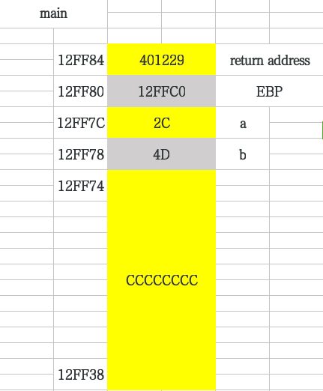

初始化后

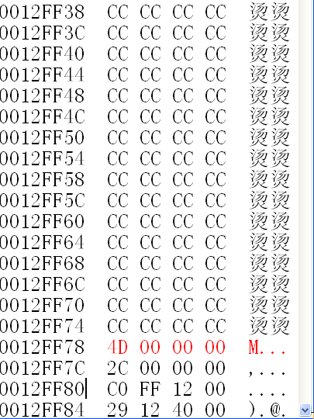

printf("a=%d,b=%d\n",a,b);

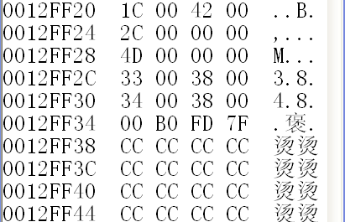

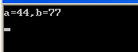

printf("a=%d,b=%d\n");

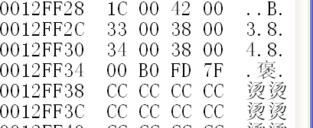

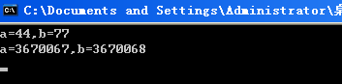

0x380033=3670067

0x380034=3670068

1. 用printf向内存中写数据

int len=0;

__asm int 3

printf("before write:length=%d\n",len);

printf("failwest:%d%n",len,&len);

printf("after write:length=%d\n",len);

return 0;

printf("before write:length=%d\n",len);

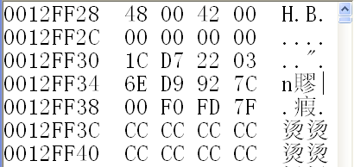

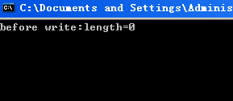

printf("failwest:%d%n",len,&len);

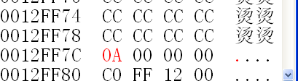

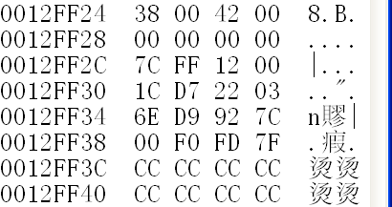

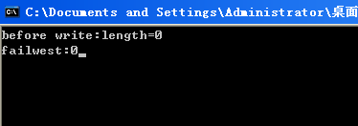

printf("after write:length=%d\n",len);

