3节班课资料

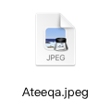
标题：Mathematics: Let’s practice
老师：Ateeqa
关键字：Mathematics, Practice
正文：The class is tailored to international school students aged 8 to 18, who require additional support to improve their math skills. My objective is to help students keep up with their school's teaching progress, improve academic performance, and raise self-confidence. My tutoring includes targeted consolidation and extension of knowledge points learned in school courses, accompanied by in-depth explanations and practice. Join us today and succeed in math!
价格：USD 7.00

2.
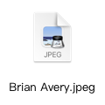
标题：IGCSE Business：Get Over It! (Reviewing & short answers) SUPPORT GROUP [IG/BUS]
老师：Brian Avery
关键字：IGCSE Business, Review, Short Answers
正文：The class provides targeted practice and in-depth explanations to help students consolidate and extend their knowledge of business concepts, including accounting, finance, marketing, and more. I also provide essay writing assistance to help students improve their academic performance and raise self-confidence in school.. Sign up now for a brighter future in business!
价格：USD 11.00

3.
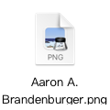
标题：English Group Course
老师：Aaron
关键字：Listening, Speaking, Reading, Writing
正文：Course for those plan to study in international schools in the future, or are entering international schools, want to improve their comprehensive English skills and have the intention to go abroad. I will help you improve your English listening, speaking, reading and writing skills, and lay a solid foundation for adapting to international schools. Allow children to experience international curriculum and culture in-depth and to gain academic success. Enhance students' English adaptability and flexible application ability of the
language in the international curriculum.
价格：USD 10.00

1对1预约老师和即使课时，两者可以有好几个重复的老师，换顺序排列就好；同时也可以用在首页的那8个老师上面，该有的信息都有了，价格在USD 5-10随便写

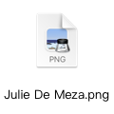
姓名：Julie De Meza
头衔&体系：Associate Prof｜IGCSE | ALevel
教授学科：Mathematics, Physics
自我介绍：Taught for 35 years in the UK (Key stage 3, IGCSE, A level) curriculum system and the US curriculum for grades 6-12, and in recent years also taught in grades 2-5 in primary schools. Over 18 years of teaching experience in China and the Asia Pacific region.

2.
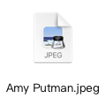
姓名：Amy Putman
头衔&体系：Associate Prof｜IGCSE
教授学科：English
自我介绍：Taught humanities and arts at the University of Edinburgh. With nearly 10 years of rich teaching experience, I have unique insights and effective teaching system methods for the teaching of English literature, social science and other humanities.Taught in many international schools around the world and served as subje ct leaders and principals.

3.
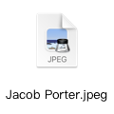
姓名：Jacob Porter
头衔&体系：Lecturer | IGCSE
教授学科：English, Mathematics, Science,
自我介绍：Holder of TEFL certificate with 6+ years of teaching experience. Taught English, Mathematics and science in a number of international schools and educational institutions in Southeast Asia. Rigorous teaching, logical classroom design, good at combining teaching content with daily life, ask questions to assess students' grasp of knowledge points and then conduct targeted teaching

4.
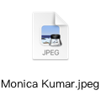
姓名：Monica Kumar
头衔&体系：Lecturer | ALevel | IGCSE
教授学科：Chemistry
自我介绍：Specialist, qualified Science Teacher with a strong background in Chemistry. Tutoring experience of seven years. Builds great rapport with students to allow them to reach their individual goals. Strong understanding of how best to support student learning and development.

5.
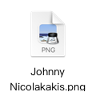
姓名：Johnny Nicolakakis
头衔&体系：Lecturer | ALevel
教授学科：Mathematics, Physics
自我介绍：I have been involved with teaching and tutoring for more than 5 years and have taught in 3 different countries. During this time I have across multiple levels in multiple subjects including Mathematics, Physics, ESL and other proficiency examinations such as TOEIC and IELTS.

6.

姓名：Brent Little
头衔&体系：Professor | IGCSE | ALevel
教授学科：Computer Science
自我介绍：Teaching Online from home my office with fibre Internet 1000/500 Mbps, I am now in Thailand SE Asia. The morning here is early afternoon in Canada and the US.

7.
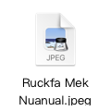
姓名：Ruckfa Mek Nuanual
头衔&体系：Lecturer | ALevel | IB |IGCSE
教授学科：Chemistry, Mathematics
自我介绍：I have been teaching Advanced Placement and A-Level Chemistry, International Baccalaureate (IB) Diploma Chemistry, IB Middle Years Program (MYP) Science, IGCSE Chemistry, Key Stage 3 and 4 Science, Mathematics (from grade 6 math to Calculus), and/or American middle/high school general science at the international school level. In addition to having taught at international schools, I have an undergraduate and master’s degree in Chemical Engineering with three years of Environmental Consulting experience in the United States.

8.
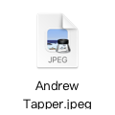
姓名：Andrew Tapper
头衔&体系：TA | ALevel | IB | IGCSE
教授学科：Chemistry
自我介绍：During my studies and before starting my career as a pharmaceutical engineer I have tutored A-Level, IB and GCSE students based in the UK and France. I have always loved tutoring students and helping them achieve the best of their potential. I tailor my lessons to every student using a fluid style of teaching where we focus on the areas you are struggling with most. Most importantly, I provide exciting lessons full of problem solving and fun learning that I make sure all of my students enjoy!

9.
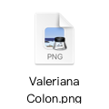
姓名：Valeriana Colon
头衔&体系：Professor | ALevel
教授学科：Business
自我介绍：I can't help but to smile anytime I'm asked: As business leader and certified teacher with over a decade of experience why have you committed to tutoring throughout your career? I have found teaching hones my skills like no other.

10.
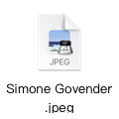
姓名：Simone Govender
头衔&体系：TA| IGCSE
教授学科：Biology
自我介绍：Hello, I am an engaging and encouraging teaching professional who provides a strong educational experience to students of all levels. I have a Bachelor of Science Degree and I am a qualified Microsoft Innovative educator I use technology to help enhance the knowledge and understanding of complex subjects for students. I am easily adaptable to different learning styles based on the students I am teaching.

