Tutorial
This section covers the fundamentals of developing with librosa, including a package overview, basic and advanced usage, and integration with the scikit-learn package. We will assume basic familiarity with Python and NumPy/SciPy.

Overview
The librosa package is structured as collection of submodules:
- librosa
  - librosa.beat
Functions for estimating tempo and detecting beat events.
  - librosa.core
Core functionality includes functions to load audio from disk, compute various spectrogram representations, and a variety of commonly used tools for music analysis. For convenience, all functionality in this submodule is directly accessible from the top-level librosa.* namespace.
  - librosa.decompose
Functions for harmonic-percussive source separation (HPSS) and generic spectrogram decomposition using matrix decomposition methods implemented in scikit-learn.
  - librosa.display
Visualization and display routines using matplotlib.
  - librosa.effects
Time-domain audio processing, such as pitch shifting and time stretching. This submodule also provides time-domain wrappers for the decompose submodule.
  - librosa.feature
Feature extraction and manipulation. This includes low-level feature extraction, such as chromagrams, pseudo-constant-Q (log-frequency) transforms, Mel spectrogram, MFCC, and tuning estimation. Also provided are feature manipulation methods, such as delta features, memory embedding, and event-synchronous feature alignment.
  - librosa.filters
Filter-bank generation (chroma, pseudo-CQT, CQT, etc.). These are primarily internal functions used by other parts of librosa.
  - librosa.onset
Onset detection and onset strength computation.
  - librosa.output
Text- and wav-file output. (Deprecated)
  - librosa.segment
Functions useful for structural segmentation, such as recurrence matrix construction, time-lag representation, and sequentially constrained clustering.
  - librosa.sequence
Functions for sequential modeling. Various forms of Viterbi decoding, and helper functions for constructing transition matrices.
  - librosa.util
Helper utilities (normalization, padding, centering, etc.)

Quickstart
Before diving into the details, we’ll walk through a brief example program

# Beat tracking example
from __future__ import print_function
import librosa

# 1. Get the file path to the included audio example
filename = librosa.util.example_audio_file()

# 2. Load the audio as a waveform `y`
# Store the sampling rate as `sr`
y, sr = librosa.load(filename)

# 3. Run the default beat tracker
tempo, beat_frames = librosa.beat.beat_track(y=y, sr=sr)

print('Estimated tempo: {:.2f} beats per minute'.format(tempo))

# 4. Convert the frame indices of beat events into timestamps
beat_times = librosa.frames_to_time(beat_frames, sr=sr)
The first step of the program:
filename = librosa.util.example_audio_file()
gets the path to the audio example file included with librosa. After this step, filename will be a string variable containing the path to the example audio file. The example is encoded in OGG Vorbis format, so you will need the appropriate codec installed for audioread.
The second step:
y, sr = librosa.load(filename)
loads and decodes the audio as a time series y, represented as a one-dimensional NumPy floating point array. The variable sr contains the sampling rate of y, that is, the number of samples per second of audio. By default, all audio is mixed to mono and resampled to 22050 Hz at load time. This behavior can be overridden by supplying additional arguments to librosa.load().
Next, we run the beat tracker:
tempo, beat_frames = librosa.beat.beat_track(y=y, sr=sr)
The output of the beat tracker is an estimate of the tempo (in beats per minute), and an array of frame numbers corresponding to detected beat events.
Frames here correspond to short windows of the signal (y), each separated by hop_length = 512 samples. Since v0.3, librosa uses centered frames, so that the kth frame is centered around sample k * hop_length.
The next operation converts the frame numbers beat_frames into timings:
beat_times = librosa.frames_to_time(beat_frames, sr=sr)
Now, beat_times will be an array of timestamps (in seconds) corresponding to detected beat events.
The contents of beat_times should look something like this:
7.43
8.29
9.218
10.124
...

Advanced usage
Here we’ll cover a more advanced example, integrating harmonic-percussive separation, multiple spectral features, and beat-synchronous feature aggregation.

# Feature extraction example
import numpy as np
import librosa

# Load the example clip
y, sr = librosa.load(librosa.util.example_audio_file())

# Set the hop length; at 22050 Hz, 512 samples ~= 23ms
hop_length = 512

# Separate harmonics and percussives into two waveforms
y_harmonic, y_percussive = librosa.effects.hpss(y)

# Beat track on the percussive signal
tempo, beat_frames = librosa.beat.beat_track(y=y_percussive,
sr=sr)

# Compute MFCC features from the raw signal
mfcc = librosa.feature.mfcc(y=y, sr=sr, hop_length=hop_length, n_mfcc=13)

# And the first-order differences (delta features)
mfcc_delta = librosa.feature.delta(mfcc)

# Stack and synchronize between beat events
# This time, we'll use the mean value (default) instead of median
beat_mfcc_delta = librosa.util.sync(np.vstack([mfcc, mfcc_delta]),
beat_frames)

# Compute chroma features from the harmonic signal
chromagram = librosa.feature.chroma_cqt(y=y_harmonic,
sr=sr)

# Aggregate chroma features between beat events
# We'll use the median value of each feature between beat frames
beat_chroma = librosa.util.sync(chromagram,
beat_frames,
aggregate=np.median)

# Finally, stack all beat-synchronous features together
beat_features = np.vstack([beat_chroma, beat_mfcc_delta])
This example builds on tools we’ve already covered in the quickstart example, so here we’ll focus just on the new parts.
The first difference is the use of the effects module for time-series harmonic-percussive separation:
y_harmonic, y_percussive = librosa.effects.hpss(y)
The result of this line is that the time series y has been separated into two time series, containing the harmonic (tonal) and percussive (transient) portions of the signal. Each of y_harmonic and y_percussive have the same shape and duration as y.
The motivation for this kind of operation is two-fold: first, percussive elements tend to be stronger indicators of rhythmic content, and can help provide more stable beat tracking results; second, percussive elements can pollute tonal feature representations (such as chroma) by contributing energy across all frequency bands, so we’d be better off without them.
Next, we introduce the feature module and extract the Mel-frequency cepstral coefficients from the raw signal y:
mfcc = librosa.feature.mfcc(y=y, sr=sr, hop_length=hop_length, n_mfcc=13)
The output of this function is the matrix mfcc, which is an numpy.ndarray of size (n_mfcc, T) (where T denotes the track duration in frames). Note that we use the same hop_length here as in the beat tracker, so the detected beat_frames values correspond to columns of mfcc.
The first type of feature manipulation we introduce is delta, which computes (smoothed) first-order differences among columns of its input:
mfcc_delta = librosa.feature.delta(mfcc)
The resulting matrix mfcc_delta has the same shape as the input mfcc.
The second type of feature manipulation is sync, which aggregates columns of its input between sample indices (e.g., beat frames):
beat_mfcc_delta = librosa.util.sync(np.vstack([mfcc, mfcc_delta]),
beat_frames)
Here, we’ve vertically stacked the mfcc and mfcc_delta matrices together. The result of this operation is a matrix beat_mfcc_delta with the same number of rows as its input, but the number of columns depends on beat_frames. Each column beat_mfcc_delta[:, k] will be the average of input columns between beat_frames[k] and beat_frames[k+1]. (beat_frames will be expanded to span the full range [0, T] so that all data is accounted for.)
Next, we compute a chromagram using just the harmonic component:
chromagram = librosa.feature.chroma_cqt(y=y_harmonic,
sr=sr)
After this line, chromagram will be a numpy.ndarray of size (12, T), and each row corresponds to a pitch class (e.g., C, C#, etc.). Each column of chromagram is normalized by its peak value, though this behavior can be overridden by setting the norm parameter.
Once we have the chromagram and list of beat frames, we again synchronize the chroma between beat events:
beat_chroma = librosa.util.sync(chromagram,
beat_frames,
aggregate=np.median)
This time, we’ve replaced the default aggregate operation (average, as used above for MFCCs) with the median. In general, any statistical summarization function can be supplied here, including np.max(), np.min(), np.std(), etc.
Finally, the all features are vertically stacked again:
beat_features = np.vstack([beat_chroma, beat_mfcc_delta])
resulting in a feature matrix beat_features of dimension (12 + 13 + 13, # beat intervals).

More examples
More example scripts are provided in the advanced examples section.

Core IO and DSP

Audio processing
load(path[, sr, mono, offset, duration, …]) | Load an audio file as a floating point time series.
stream(path, block_length, frame_length, …) | Stream audio in fixed-length buffers.
to_mono(y) | Force an audio signal down to mono by averaging samples across channels.
resample(y, orig_sr, target_sr[, res_type, …]) | Resample a time series from orig_sr to target_sr
get_duration([y, sr, S, n_fft, hop_length, …]) | Compute the duration (in seconds) of an audio time series, feature matrix, or filename.
get_samplerate(path) | Get the sampling rate for a given file.
autocorrelate(y[, max_size, axis]) | Bounded auto-correlation
lpc(y, order) | Linear Prediction Coefficients via Burg’s method
zero_crossings(y[, threshold, …]) | Find the zero-crossings of a signal y: indices i such that sign(y[i]) != sign(y[j]).
clicks([times, frames, sr, hop_length, …]) | Returns a signal with the signal click placed at each specified time
tone(frequency[, sr, length, duration, phi]) | Returns a pure tone signal.
chirp(fmin, fmax[, sr, length, duration, …]) | Returns a chirp signal that goes from frequency fmin to frequency fmax

Spectral representations
stft(y[, n_fft, hop_length, win_length, …]) | Short-time Fourier transform (STFT).
istft(stft_matrix[, hop_length, win_length, …]) | Inverse short-time Fourier transform (ISTFT).
reassigned_spectrogram(y[, sr, S, n_fft, …]) | Time-frequency reassigned spectrogram.
cqt(y[, sr, hop_length, fmin, n_bins, …]) | Compute the constant-Q transform of an audio signal.
icqt(C[, sr, hop_length, fmin, …]) | Compute the inverse constant-Q transform.
hybrid_cqt(y[, sr, hop_length, fmin, …]) | Compute the hybrid constant-Q transform of an audio signal.
pseudo_cqt(y[, sr, hop_length, fmin, …]) | Compute the pseudo constant-Q transform of an audio signal.
iirt(y[, sr, win_length, hop_length, …]) | Time-frequency representation using IIR filters [Rd4077732470d-1].
fmt(y[, t_min, n_fmt, kind, beta, …]) | The fast Mellin transform (FMT) [R6343f8d4cac9-1] of a uniformly sampled signal y.
griffinlim(S[, n_iter, hop_length, …]) | Approximate magnitude spectrogram inversion using the “fast” Griffin-Lim algorithm [R047f50301c96-1] [R047f50301c96-2].
griffinlim_cqt(C[, n_iter, sr, hop_length, …]) | Approximate constant-Q magnitude spectrogram inversion using the “fast” Griffin-Lim algorithm [Re33fb425db1f-1] [Re33fb425db1f-2].
interp_harmonics(x, freqs, h_range[, kind, …]) | Compute the energy at harmonics of time-frequency representation.
salience(S, freqs, h_range[, weights, …]) | Harmonic salience function.
phase_vocoder(D, rate[, hop_length]) | Phase vocoder.
magphase(D[, power]) | Separate a complex-valued spectrogram D into its magnitude (S) and phase (P) components, so that D = S * P.
get_fftlib() | Get the FFT library currently used by librosa
set_fftlib([lib]) | Set the FFT library used by librosa.

Magnitude scaling
amplitude_to_db(S[, ref, amin, top_db]) | Convert an amplitude spectrogram to dB-scaled spectrogram.
db_to_amplitude(S_db[, ref]) | Convert a dB-scaled spectrogram to an amplitude spectrogram.
power_to_db(S[, ref, amin, top_db]) | Convert a power spectrogram (amplitude squared) to decibel (dB) units
db_to_power(S_db[, ref]) | Convert a dB-scale spectrogram to a power spectrogram.
perceptual_weighting(S, frequencies, \*\*kwargs) | Perceptual weighting of a power spectrogram:
A_weighting(frequencies[, min_db]) | Compute the A-weighting of a set of frequencies.
pcen(S[, sr, hop_length, gain, bias, power, …]) | Per-channel energy normalization (PCEN) [Rb388d53f6b92-1]

Time and frequency conversion
frames_to_samples(frames[, hop_length, n_fft]) | Converts frame indices to audio sample indices.
frames_to_time(frames[, sr, hop_length, n_fft]) | Converts frame counts to time (seconds).
samples_to_frames(samples[, hop_length, n_fft]) | Converts sample indices into STFT frames.
samples_to_time(samples[, sr]) | Convert sample indices to time (in seconds).
time_to_frames(times[, sr, hop_length, n_fft]) | Converts time stamps into STFT frames.
time_to_samples(times[, sr]) | Convert timestamps (in seconds) to sample indices.
blocks_to_frames(blocks, block_length) | Convert block indices to frame indices
blocks_to_samples(blocks, block_length, …) | Convert block indices to sample indices
blocks_to_time(blocks, block_length, …) | Convert block indices to time (in seconds)
hz_to_note(frequencies, \*\*kwargs) | Convert one or more frequencies (in Hz) to the nearest note names.
hz_to_midi(frequencies) | Get MIDI note number(s) for given frequencies
midi_to_hz(notes) | Get the frequency (Hz) of MIDI note(s)
midi_to_note(midi[, octave, cents]) | Convert one or more MIDI numbers to note strings.
note_to_hz(note, \*\*kwargs) | Convert one or more note names to frequency (Hz)
note_to_midi(note[, round_midi]) | Convert one or more spelled notes to MIDI number(s).
hz_to_mel(frequencies[, htk]) | Convert Hz to Mels
hz_to_octs(frequencies[, tuning, …]) | Convert frequencies (Hz) to (fractional) octave numbers.
mel_to_hz(mels[, htk]) | Convert mel bin numbers to frequencies
octs_to_hz(octs[, tuning, bins_per_octave, A440]) | Convert octaves numbers to frequencies.
fft_frequencies([sr, n_fft]) | Alternative implementation of np.fft.fftfreq
cqt_frequencies(n_bins, fmin[, …]) | Compute the center frequencies of Constant-Q bins.
mel_frequencies([n_mels, fmin, fmax, htk]) | Compute an array of acoustic frequencies tuned to the mel scale.
tempo_frequencies(n_bins[, hop_length, sr]) | Compute the frequencies (in beats per minute) corresponding to an onset auto-correlation or tempogram matrix.
fourier_tempo_frequencies([sr, win_length, …]) | Compute the frequencies (in beats per minute) corresponding to a Fourier tempogram matrix.
samples_like(X[, hop_length, n_fft, axis]) | Return an array of sample indices to match the time axis from a feature matrix.
times_like(X[, sr, hop_length, n_fft, axis]) | Return an array of time values to match the time axis from a feature matrix.

Pitch and tuning
estimate_tuning([y, sr, S, n_fft, …]) | Estimate the tuning of an audio time series or spectrogram input.
pitch_tuning(frequencies[, resolution, …]) | Given a collection of pitches, estimate its tuning offset (in fractions of a bin) relative to A440=440.0Hz.
piptrack([y, sr, S, n_fft, hop_length, …]) | Pitch tracking on thresholded parabolically-interpolated STFT.

Deprecated
ifgram(y[, sr, n_fft, hop_length, …]) | Compute the instantaneous

librosa.core.load
librosa.core.load(path, sr=22050, mono=True, offset=0.0, duration=None, dtype=<class 'numpy.float32'>, res_type='kaiser_best')[source]
Load an audio file as a floating point time series.
Audio will be automatically resampled to the given rate (default sr=22050).
To preserve the native sampling rate of the file, use sr=None.
Parameters: | path : string, int, or file-like object  path to the input file.  Any codec supported by soundfile or audioread will work.  If the codec is supported by soundfile, then path can also be an open file descriptor (int), or any object implementing Python’s file interface.  If the codec is not supported by soundfile (e.g., MP3), then only string file paths are supported.  sr : number > 0 [scalar]  target sampling rate  ‘None’ uses the native sampling rate  mono : bool  convert signal to mono  offset : float  start reading after this time (in seconds)  duration : float  only load up to this much audio (in seconds)  dtype : numeric type  data type of y  res_type : str  resample type (see note)  Note  By default, this uses resampy’s high-quality mode (‘kaiser_best’).  For alternative resampling modes, see resample  Note  audioread may truncate the precision of the audio data to 16 bits.  See https://librosa.github.io/librosa/ioformats.html for alternate loading methods.
Returns: | y : np.ndarray [shape=(n,) or (2, n)]  audio time series  sr : number > 0 [scalar]  sampling rate of y
Examples
>>> # Load an ogg vorbis file
>>> filename = librosa.util.example_audio_file()
>>> y, sr = librosa.load(filename)
>>> y
array([ -4.756e-06, -6.020e-06, ..., -1.040e-06, 0.000e+00], dtype=float32)
>>> sr
22050
>>> # Load a file and resample to 11 KHz
>>> filename = librosa.util.example_audio_file()
>>> y, sr = librosa.load(filename, sr=11025)
>>> y
array([ -2.077e-06, -2.928e-06, ..., -4.395e-06, 0.000e+00], dtype=float32)
>>> sr
11025
>>> # Load 5 seconds of a file, starting 15 seconds in
>>> filename = librosa.util.example_audio_file()
>>> y, sr = librosa.load(filename, offset=15.0, duration=5.0)
>>> y
array([ 0.069, 0.1 , ..., -0.101, 0. ], dtype=float32)
>>> sr
22050

librosa.core.stream
librosa.core.stream(path, block_length, frame_length, hop_length, mono=True, offset=0.0, duration=None, fill_value=None, dtype=<class 'numpy.float32'>)[source]
Stream audio in fixed-length buffers.
This is primarily useful for processing large files that won’t fit entirely in memory at once.
Instead of loading the entire audio signal into memory (as in load(), this function produces blocks of audio spanning a fixed number of frames at a specified frame length and hop length.
While this function strives for similar behavior to load, there are a few caveats that users should be aware of:
- This function does not return audio buffers directly. It returns a generator, which you can iterate over to produce blocks of audio. A block, in this context, refers to a buffer of audio which spans a given number of (potentially overlapping) frames.
- Automatic sample-rate conversion is not supported. Audio will be streamed in its native sample rate, so no default values are provided for frame_length and hop_length. It is recommended that you first get the sampling rate for the file in question, using get_samplerate(), and set these parameters accordingly.
- Many analyses require access to the entire signal to behave correctly, such as resample, cqt, or beat_track, so these methods will not be appropriate for streamed data.
- The block_length parameter specifies how many frames of audio will be produced per block. Larger values will consume more memory, but will be more efficient to process down-stream. The best value will ultimately depend on your application and other system constraints.
- By default, most librosa analyses (e.g., short-time Fourier transform) assume centered frames, which requires padding the signal at the beginning and end. This will not work correctly when the signal is carved into blocks, because it would introduce padding in the middle of the signal. To disable this feature, use center=False in all frame-based analyses.
See the examples below for proper usage of this function.
Parameters: | path : string, int, or file-like object  path to the input file to stream.  Any codec supported by soundfile is permitted here.  block_length : int > 0  The number of frames to include in each block.  Note that at the end of the file, there may not be enough data to fill an entire block, resulting in a shorter block by default. To pad the signal out so that blocks are always full length, set fill_value (see below).  frame_length : int > 0  The number of samples per frame.  hop_length : int > 0  The number of samples to advance between frames.  Note that by when hop_length < frame_length, neighboring frames will overlap. Similarly, the last frame of one block will overlap with the first frame of the next block.  mono : bool  Convert the signal to mono during streaming  offset : float  Start reading after this time (in seconds)  duration : float  Only load up to this much audio (in seconds)  fill_value : float [optional]  If padding the signal to produce constant-length blocks, this value will be used at the end of the signal.  In most cases, fill_value=0 (silence) is expected, but you may specify any value here.  dtype : numeric type  data type of audio buffers to be produced
Yields: | y : np.ndarray  An audio buffer of (at most) block_length * (hop_length-1) + frame_length samples.
See also
load
get_samplerate
soundfile.blocks
Examples
Apply a short-term Fourier transform to blocks of 256 frames at a time. Note that streaming operation requires left-aligned frames, so we must set center=False to avoid padding artifacts.
>>> filename = librosa.util.example_audio_file()
>>> sr = librosa.get_samplerate(filename)
>>> stream = librosa.stream(filename,
... block_length=256,
... frame_length=4096,
... hop_length=1024)
>>> for y_block in stream:
... D_block = librosa.stft(y_block, center=False)
Or compute a mel spectrogram over a stream, using a shorter frame and non-overlapping windows
>>> filename = librosa.util.example_audio_file()
>>> sr = librosa.get_samplerate(filename)
>>> stream = librosa.stream(filename,
... block_length=256,
... frame_length=2048,
... hop_length=2048)
>>> for y_block in stream:
... m_block = librosa.feature.melspectrogram(y_block, sr=sr,
... n_fft=2048,
... hop_length=2048,
... center=False)

librosa.core.to_mono
librosa.core.to_mono(y)[source]
Force an audio signal down to mono by averaging samples across channels.
Parameters: | y : np.ndarray [shape=(2,n) or shape=(n,)]  audio time series, either stereo or mono
Returns: | y_mono : np.ndarray [shape=(n,)]  y as a monophonic time-series
Notes
This function caches at level 20.
Examples
>>> y, sr = librosa.load(librosa.util.example_audio_file(), mono=False)
>>> y.shape
(2, 1355168)
>>> y_mono = librosa.to_mono(y)
>>> y_mono.shape
(1355168,)

librosa.core.resample
librosa.core.resample(y, orig_sr, target_sr, res_type='kaiser_best', fix=True, scale=False, **kwargs)[source]
Resample a time series from orig_sr to target_sr
Parameters: | y : np.ndarray [shape=(n,) or shape=(2, n)]  audio time series. Can be mono or stereo.  orig_sr : number > 0 [scalar]  original sampling rate of y  target_sr : number > 0 [scalar]  target sampling rate  res_type : str  resample type (see note)  Note  By default, this uses resampy’s high-quality mode (‘kaiser_best’).  To use a faster method, set res_type=’kaiser_fast’.  To use scipy.signal.resample, set res_type=’fft’ or res_type=’scipy’.  To use scipy.signal.resample_poly, set res_type=’polyphase’.  Note  When using res_type=’polyphase’, only integer sampling rates are supported.  fix : bool  adjust the length of the resampled signal to be of size exactly ceil(target_sr * len(y) / orig_sr)  scale : bool  Scale the resampled signal so that y and y_hat have approximately equal total energy.  kwargs : additional keyword arguments  If fix==True, additional keyword arguments to pass to librosa.util.fix_length.
Returns: | y_hat : np.ndarray [shape=(n * target_sr / orig_sr,)]  y resampled from orig_sr to target_sr
Raises: | ParameterError  If res_type=’polyphase’ and orig_sr or target_sr are not both integer-valued.
See also
librosa.util.fix_length
scipy.signal.resample
resampy.resample
Notes
This function caches at level 20.
Examples
Downsample from 22 KHz to 8 KHz
>>> y, sr = librosa.load(librosa.util.example_audio_file(), sr=22050)
>>> y_8k = librosa.resample(y, sr, 8000)
>>> y.shape, y_8k.shape
((1355168,), (491671,)

librosa.core.get_duration
librosa.core.get_duration(y=None, sr=22050, S=None, n_fft=2048, hop_length=512, center=True, filename=None)[source]
Compute the duration (in seconds) of an audio time series, feature matrix, or filename.
Parameters: | y : np.ndarray [shape=(n,), (2, n)] or None  audio time series  sr : number > 0 [scalar]  audio sampling rate of y  S : np.ndarray [shape=(d, t)] or None  STFT matrix, or any STFT-derived matrix (e.g., chromagram or mel spectrogram). Durations calculated from spectrogram inputs are only accurate up to the frame resolution. If high precision is required, it is better to use the audio time series directly.  n_fft : int > 0 [scalar]  FFT window size for S  hop_length : int > 0 [ scalar]  number of audio samples between columns of S  center : boolean  - If True, S[:, t] is centered at y[t * hop_length]  - If False, then S[:, t] begins at y[t * hop_length]  filename : str  If provided, all other parameters are ignored, and the duration is calculated directly from the audio file. Note that this avoids loading the contents into memory, and is therefore useful for querying the duration of long files.  As in load(), this can also be an integer or open file-handle that can be processed by soundfile.
Returns: | d : float >= 0  Duration (in seconds) of the input time series or spectrogram.
Raises: | ParameterError  if none of y, S, or filename are provided.
Notes
get_duration can be applied to a file (filename), a spectrogram (S), or audio buffer (y, sr). Only one of these three options should be provided. If you do provide multiple options (e.g., filename and S), then filename takes precedence over S, and S takes precedence over (y, sr).
Examples
>>> # Load the example audio file
>>> y, sr = librosa.load(librosa.util.example_audio_file())
>>> librosa.get_duration(y=y, sr=sr)
61.45886621315193
>>> # Or directly from an audio file
>>> librosa.get_duration(filename=librosa.util.example_audio_file())
61.4
>>> # Or compute duration from an STFT matrix
>>> y, sr = librosa.load(librosa.util.example_audio_file())
>>> S = librosa.stft(y)
>>> librosa.get_duration(S=S, sr=sr)
61.44
>>> # Or a non-centered STFT matrix
>>> S_left = librosa.stft(y, center=False)
>>> librosa.get_duration(S=S_left, sr=sr)
61.3471201814059

librosa.core.get_samplerate
librosa.core.get_samplerate(path)[source]
Get the sampling rate for a given file.
Parameters: | path : string, int, or file-like  The path to the file to be loaded As in load(), this can also be an integer or open file-handle that can be processed by soundfile.
Returns: | sr : number > 0  The sampling rate of the given audio file
Examples
Get the sampling rate for the included audio file
>>> path = librosa.util.example_audio_file()
>>> librosa.get_samplerate(path)
44100

librosa.core.autocorrelate
librosa.core.autocorrelate(y, max_size=None, axis=-1)[source]
Bounded auto-correlation
Parameters: | y : np.ndarray  array to autocorrelate  max_size : int > 0 or None  maximum correlation lag. If unspecified, defaults to y.shape[axis] (unbounded)  axis : int  The axis along which to autocorrelate. By default, the last axis (-1) is taken.
Returns: | z : np.ndarray  truncated autocorrelation y*y along the specified axis. If max_size is specified, then z.shape[axis] is bounded to max_size.
Notes
This function caches at level 20.
Examples
Compute full autocorrelation of y
>>> y, sr = librosa.load(librosa.util.example_audio_file(), offset=20, duration=10)
>>> librosa.autocorrelate(y)
array([ 3.226e+03, 3.217e+03, ..., 8.277e-04, 3.575e-04], dtype=float32)
Compute onset strength auto-correlation up to 4 seconds
>>> import matplotlib.pyplot as plt
>>> odf = librosa.onset.onset_strength(y=y, sr=sr, hop_length=512)
>>> ac = librosa.autocorrelate(odf, max_size=4* sr / 512)
>>> plt.plot(ac)
>>> plt.title('Auto-correlation')
>>> plt.xlabel('Lag (frames)')
>>> plt.show()
(Source code)
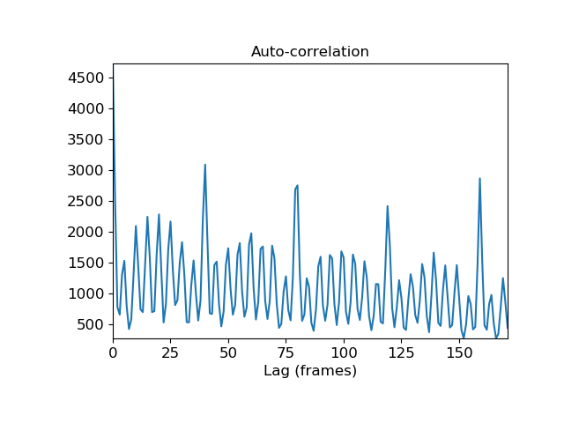

librosa.core.lpc
librosa.core.lpc(y, order)[source]
Linear Prediction Coefficients via Burg’s method
This function applies Burg’s method to estimate coefficients of a linear filter on y of order order. Burg’s method is an extension to the Yule-Walker approach, which are both sometimes referred to as LPC parameter estimation by autocorrelation.
It follows the description and implementation approach described in the introduction in [1]. N.B. This paper describes a different method, which is not implemented here, but has been chosen for its clear explanation of Burg’s technique in its introduction.

[1] | Larry Marple A New Autoregressive Spectrum Analysis Algorithm IEEE Transactions on Accoustics, Speech, and Signal Processing vol 28, no. 4, 1980
Parameters: | y : np.ndarray  Time series to fit  order : int > 0  Order of the linear filter
Returns: | a : np.ndarray of length order + 1  LP prediction error coefficients, i.e. filter denominator polynomial
Raises: | ParameterError  - If y is not valid audio as per util.valid_audio  - If order < 1 or not integer  FloatingPointError  - If y is ill-conditioned
See also
scipy.signal.lfilter
Examples
Compute LP coefficients of y at order 16 on entire series
>>> y, sr = librosa.load(librosa.util.example_audio_file(), offset=30,
... duration=10)
>>> librosa.lpc(y, 16)
Compute LP coefficients, and plot LP estimate of original series
>>> import matplotlib.pyplot as plt
>>> import scipy
>>> y, sr = librosa.load(librosa.util.example_audio_file(), offset=30,
... duration=0.020)
>>> a = librosa.lpc(y, 2)
>>> y_hat = scipy.signal.lfilter([0] + -1*a[1:], [1], y)
>>> plt.figure()
>>> plt.plot(y)
>>> plt.plot(y_hat, linestyle='--')
>>> plt.legend(['y', 'y_hat'])
>>> plt.title('LP Model Forward Prediction')
>>> plt.show()
(Source code)
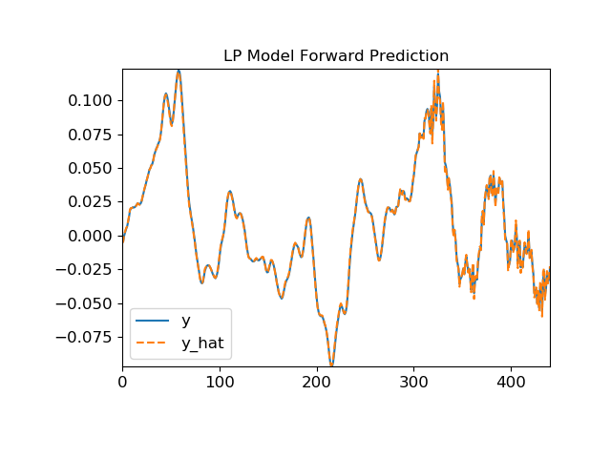

librosa.core.zero_crossings
librosa.core.zero_crossings(y, threshold=1e-10, ref_magnitude=None, pad=True, zero_pos=True, axis=-1)[source]
Find the zero-crossings of a signal y: indices i such that sign(y[i]) != sign(y[j]).
If y is multi-dimensional, then zero-crossings are computed along the specified axis.
Parameters: | y : np.ndarray  The input array  threshold : float > 0 or None  If specified, values where -threshold <= y <= threshold are clipped to 0.  ref_magnitude : float > 0 or callable  If numeric, the threshold is scaled relative to ref_magnitude.  If callable, the threshold is scaled relative to ref_magnitude(np.abs(y)).  pad : boolean  If True, then y[0] is considered a valid zero-crossing.  zero_pos : boolean  If True then the value 0 is interpreted as having positive sign.  If False, then 0, -1, and +1 all have distinct signs.  axis : int  Axis along which to compute zero-crossings.
Returns: | zero_crossings : np.ndarray [shape=y.shape, dtype=boolean]  Indicator array of zero-crossings in y along the selected axis.
Notes
This function caches at level 20.
Examples
>>> # Generate a time-series
>>> y = np.sin(np.linspace(0, 4 * 2 * np.pi, 20))
>>> y
array([ 0.000e+00, 9.694e-01, 4.759e-01, -7.357e-01,
-8.372e-01, 3.247e-01, 9.966e-01, 1.646e-01,
-9.158e-01, -6.142e-01, 6.142e-01, 9.158e-01,
-1.646e-01, -9.966e-01, -3.247e-01, 8.372e-01,
7.357e-01, -4.759e-01, -9.694e-01, -9.797e-16])
>>> # Compute zero-crossings
>>> z = librosa.zero_crossings(y)
>>> z
array([ True, False, False, True, False, True, False, False,
True, False, True, False, True, False, False, True,
False, True, False, True], dtype=bool)
>>> # Stack y against the zero-crossing indicator
>>> librosa.util.stack([y, z], axis=-1)
array([[ 0.000e+00, 1.000e+00],
[ 9.694e-01, 0.000e+00],
[ 4.759e-01, 0.000e+00],
[ -7.357e-01, 1.000e+00],
[ -8.372e-01, 0.000e+00],
[ 3.247e-01, 1.000e+00],
[ 9.966e-01, 0.000e+00],
[ 1.646e-01, 0.000e+00],
[ -9.158e-01, 1.000e+00],
[ -6.142e-01, 0.000e+00],
[ 6.142e-01, 1.000e+00],
[ 9.158e-01, 0.000e+00],
[ -1.646e-01, 1.000e+00],
[ -9.966e-01, 0.000e+00],
[ -3.247e-01, 0.000e+00],
[ 8.372e-01, 1.000e+00],
[ 7.357e-01, 0.000e+00],
[ -4.759e-01, 1.000e+00],
[ -9.694e-01, 0.000e+00],
[ -9.797e-16, 1.000e+00]])
>>> # Find the indices of zero-crossings
>>> np.nonzero(z)
(array([ 0, 3, 5, 8, 10, 12, 15, 17, 19]),)

librosa.core.clicks
librosa.core.clicks(times=None, frames=None, sr=22050, hop_length=512, click_freq=1000.0, click_duration=0.1, click=None, length=None)[source]
Returns a signal with the signal click placed at each specified time
Parameters: | times : np.ndarray or None  times to place clicks, in seconds  frames : np.ndarray or None  frame indices to place clicks  sr : number > 0  desired sampling rate of the output signal  hop_length : int > 0  if positions are specified by frames, the number of samples between frames.  click_freq : float > 0  frequency (in Hz) of the default click signal. Default is 1KHz.  click_duration : float > 0  duration (in seconds) of the default click signal. Default is 100ms.  click : np.ndarray or None  optional click signal sample to use instead of the default blip.  length : int > 0  desired number of samples in the output signal
Returns: | click_signal : np.ndarray  Synthesized click signal
Raises: | ParameterError  - If neither times nor frames are provided.  - If any of click_freq, click_duration, or length are out of range.
Examples
>>> # Sonify detected beat events
>>> y, sr = librosa.load(librosa.util.example_audio_file())
>>> tempo, beats = librosa.beat.beat_track(y=y, sr=sr)
>>> y_beats = librosa.clicks(frames=beats, sr=sr)
>>> # Or generate a signal of the same length as y
>>> y_beats = librosa.clicks(frames=beats, sr=sr, length=len(y))
>>> # Or use timing instead of frame indices
>>> times = librosa.frames_to_time(beats, sr=sr)
>>> y_beat_times = librosa.clicks(times=times, sr=sr)
>>> # Or with a click frequency of 880Hz and a 500ms sample
>>> y_beat_times880 = librosa.clicks(times=times, sr=sr,
... click_freq=880, click_duration=0.5)
Display click waveform next to the spectrogram
>>> import matplotlib.pyplot as plt
>>> plt.figure()
>>> S = librosa.feature.melspectrogram(y=y, sr=sr)
>>> ax = plt.subplot(2,1,2)
>>> librosa.display.specshow(librosa.power_to_db(S, ref=np.max),
... x_axis='time', y_axis='mel')
>>> plt.subplot(2,1,1, sharex=ax)
>>> librosa.display.waveplot(y_beat_times, sr=sr, label='Beat clicks')
>>> plt.legend()
>>> plt.xlim(15, 30)
>>> plt.tight_layout()
>>> plt.show()

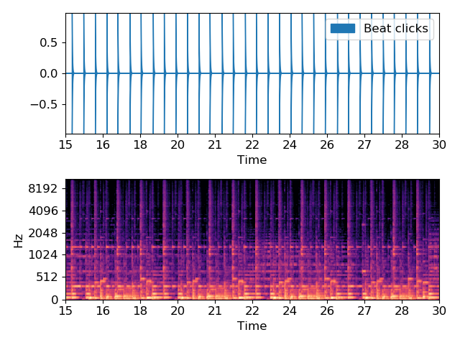

librosa.core.tone
librosa.core.tone(frequency, sr=22050, length=None, duration=None, phi=None)[source]
Returns a pure tone signal. The signal generated is a cosine wave.
Parameters: | frequency : float > 0  frequency  sr : number > 0  desired sampling rate of the output signal  length : int > 0  desired number of samples in the output signal. When both duration and length are defined, length would take priority.  duration : float > 0  desired duration in seconds. When both duration and length are defined, length would take priority.  phi : float or None  phase offset, in radians. If unspecified, defaults to -np.pi * 0.5.
Returns: | tone_signal : np.ndarray [shape=(length,), dtype=float64]  Synthesized pure sine tone signal
Raises: | ParameterError  - If frequency is not provided.  - If neither length nor duration are provided.
Examples
>>> # Generate a pure sine tone A4
>>> tone = librosa.tone(440, duration=1)
>>> # Or generate the same signal using `length`
>>> tone = librosa.tone(440, sr=22050, length=22050)
Display spectrogram
>>> import matplotlib.pyplot as plt
>>> plt.figure()
>>> S = librosa.feature.melspectrogram(y=tone)
>>> librosa.display.specshow(librosa.power_to_db(S, ref=np.max),
... x_axis='time', y_axis='mel')
>>> plt.show()
(Source code)

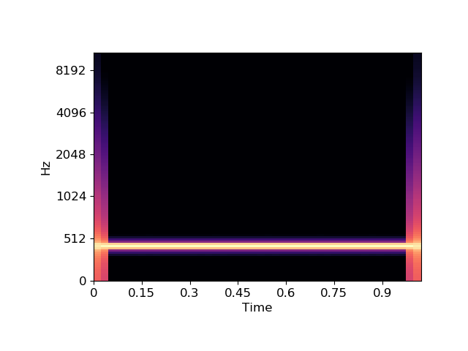

librosa.core.chirp
librosa.core.chirp(fmin, fmax, sr=22050, length=None, duration=None, linear=False, phi=None)[source]
Returns a chirp signal that goes from frequency fmin to frequency fmax
Parameters: | fmin : float > 0  initial frequency  fmax : float > 0  final frequency  sr : number > 0  desired sampling rate of the output signal  length : int > 0  desired number of samples in the output signal. When both duration and length are defined, length would take priority.  duration : float > 0  desired duration in seconds. When both duration and length are defined, length would take priority.  linear : boolean  - If True, use a linear sweep, i.e., frequency changes linearly with time  - If False, use a exponential sweep.  Default is False.  phi : float or None  phase offset, in radians. If unspecified, defaults to -np.pi * 0.5.
Returns: | chirp_signal : np.ndarray [shape=(length,), dtype=float64]  Synthesized chirp signal
Raises: | ParameterError  - If either fmin or fmax are not provided.  - If neither length nor duration are provided.
See also
scipy.signal.chirp
Examples
>>> # Generate a exponential chirp from A4 to A5
>>> exponential_chirp = librosa.chirp(440, 880, duration=1)
>>> # Or generate the same signal using `length`
>>> exponential_chirp = librosa.chirp(440, 880, sr=22050, length=22050)
>>> # Or generate a linear chirp instead
>>> linear_chirp = librosa.chirp(440, 880, duration=1, linear=True)
Display spectrogram for both exponential and linear chirps
>>> import matplotlib.pyplot as plt
>>> plt.figure()
>>> S_exponential = librosa.feature.melspectrogram(y=exponential_chirp)
>>> ax = plt.subplot(2,1,1)
>>> librosa.display.specshow(librosa.power_to_db(S_exponential, ref=np.max),
... x_axis='time', y_axis='mel')
>>> plt.subplot(2,1,2, sharex=ax)
>>> S_linear = librosa.feature.melspectrogram(y=linear_chirp)
>>> librosa.display.specshow(librosa.power_to_db(S_linear, ref=np.max),
... x_axis='time', y_axis='mel')
>>> plt.tight_layout()
>>> plt.show()
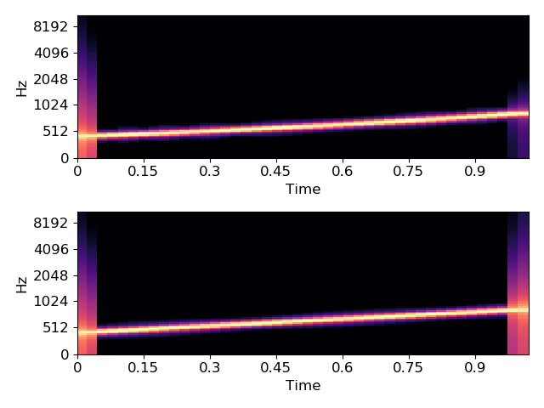

librosa.core.stft
librosa.core.stft(y, n_fft=2048, hop_length=None, win_length=None, window='hann', center=True, dtype=<class 'numpy.complex64'>, pad_mode='reflect')[source]
Short-time Fourier transform (STFT). [1] (chapter 2)
The STFT represents a signal in the time-frequency domain by computing discrete Fourier transforms (DFT) over short overlapping windows.
This function returns a complex-valued matrix D such that
- np.abs(D[f, t]) is the magnitude of frequency bin f at frame t, and
- np.angle(D[f, t]) is the phase of frequency bin f at frame t.
The integers t and f can be converted to physical units by means of the utility functions frames_to_sample and fft_frequencies.

[1] | - Müller. “Fundamentals of Music Processing.” Springer, 2015
Parameters: | y : np.ndarray [shape=(n,)], real-valued  input signal  n_fft : int > 0 [scalar]  length of the windowed signal after padding with zeros. The number of rows in the STFT matrix D is (1 + n_fft/2). The default value, n_fft=2048 samples, corresponds to a physical duration of 93 milliseconds at a sample rate of 22050 Hz, i.e. the default sample rate in librosa. This value is well adapted for music signals. However, in speech processing, the recommended value is 512, corresponding to 23 milliseconds at a sample rate of 22050 Hz. In any case, we recommend setting n_fft to a power of two for optimizing the speed of the fast Fourier transform (FFT) algorithm.  hop_length : int > 0 [scalar]  number of audio samples between adjacent STFT columns.  Smaller values increase the number of columns in D without affecting the frequency resolution of the STFT.  If unspecified, defaults to win_length / 4 (see below).  win_length : int <= n_fft [scalar]  Each frame of audio is windowed by window() of length win_length and then padded with zeros to match n_fft.  Smaller values improve the temporal resolution of the STFT (i.e. the ability to discriminate impulses that are closely spaced in time) at the expense of frequency resolution (i.e. the ability to discriminate pure tones that are closely spaced in frequency). This effect is known as the time-frequency localization tradeoff and needs to be adjusted according to the properties of the input signal y.  If unspecified, defaults to win_length = n_fft.  window : string, tuple, number, function, or np.ndarray [shape=(n_fft,)]  Either:  - a window specification (string, tuple, or number); see scipy.signal.get_window  - a window function, such as scipy.signal.hanning  - a vector or array of length n_fft  Defaults to a raised cosine window (“hann”), which is adequate for most applications in audio signal processing.  center : boolean  If True, the signal y is padded so that frame D[:, t] is centered at y[t * hop_length].  If False, then D[:, t] begins at y[t * hop_length].  Defaults to True, which simplifies the alignment of D onto a time grid by means of librosa.core.frames_to_samples. Note, however, that center must be set to False when analyzing signals with librosa.stream.  dtype : numeric type  Complex numeric type for D. Default is single-precision floating-point complex (np.complex64).  pad_mode : string or function  If center=True, this argument is passed to np.pad for padding the edges of the signal y. By default (pad_mode=”reflect”), y is padded on both sides with its own reflection, mirrored around its first and last sample respectively. If center=False, this argument is ignored.
Returns: | D : np.ndarray [shape=(1 + n_fft/2, n_frames), dtype=dtype]  Complex-valued matrix of short-term Fourier transform coefficients.
See also
istft
Inverse STFT
reassigned_spectrogram
Time-frequency reassigned spectrogram
Notes
This function caches at level 20.
Examples
>>> y, sr = librosa.load(librosa.util.example_audio_file())
>>> D = np.abs(librosa.stft(y))
>>> D
array([[2.58028018e-03, 4.32422794e-02, 6.61255598e-01, ...,
6.82710262e-04, 2.51654536e-04, 7.23036574e-05],
[2.49403086e-03, 5.15930466e-02, 6.00107312e-01, ...,
3.48026224e-04, 2.35853557e-04, 7.54836728e-05],
[7.82410789e-04, 1.05394892e-01, 4.37517226e-01, ...,
6.29352580e-04, 3.38571583e-04, 8.38094638e-05],
...,
[9.48568513e-08, 4.74725084e-07, 1.50052492e-05, ...,
1.85637656e-08, 2.89708542e-08, 5.74304337e-09],
[1.25165826e-07, 8.58259284e-07, 1.11157215e-05, ...,
3.49099771e-08, 3.11740926e-08, 5.29926236e-09],
[1.70630571e-07, 8.92518756e-07, 1.23656537e-05, ...,
5.33256745e-08, 3.33264900e-08, 5.13272980e-09]], dtype=float32)
Use left-aligned frames, instead of centered frames
>>> D_left = np.abs(librosa.stft(y, center=False))
Use a shorter hop length
>>> D_short = np.abs(librosa.stft(y, hop_length=64))
Display a spectrogram
>>> import matplotlib.pyplot as plt
>>> librosa.display.specshow(librosa.amplitude_to_db(D,
... ref=np.max),
... y_axis='log', x_axis='time')
>>> plt.title('Power spectrogram')
>>> plt.colorbar(format='%+2.0f dB')
>>> plt.tight_layout()
>>> plt.show()
(Source code)

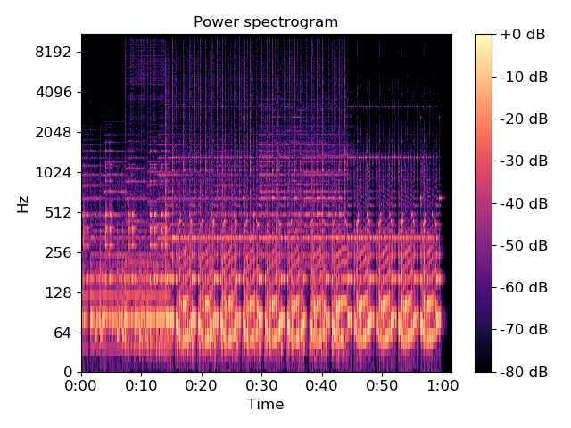
librosa.core.istft
librosa.core.istft(stft_matrix, hop_length=None, win_length=None, window='hann', center=True, dtype=<class 'numpy.float32'>, length=None)[source]
Inverse short-time Fourier transform (ISTFT).
Converts a complex-valued spectrogram stft_matrix to time-series y by minimizing the mean squared error between stft_matrix and STFT of y as described in [1] up to Section 2 (reconstruction from MSTFT).
In general, window function, hop length and other parameters should be same as in stft, which mostly leads to perfect reconstruction of a signal from unmodified stft_matrix.

[1] | D. W. Griffin and J. S. Lim, “Signal estimation from modified short-time Fourier transform,” IEEE Trans. ASSP, vol.32, no.2, pp.236–243, Apr. 1984.
Parameters: | stft_matrix : np.ndarray [shape=(1 + n_fft/2, t)]  STFT matrix from stft  hop_length : int > 0 [scalar]  Number of frames between STFT columns. If unspecified, defaults to win_length / 4.  win_length : int <= n_fft = 2 * (stft_matrix.shape[0] - 1)  When reconstructing the time series, each frame is windowed and each sample is normalized by the sum of squared window according to the window function (see below).  If unspecified, defaults to n_fft.  window : string, tuple, number, function, np.ndarray [shape=(n_fft,)]  - a window specification (string, tuple, or number); see scipy.signal.get_window  - a window function, such as scipy.signal.hanning  - a user-specified window vector of length n_fft  center : boolean  - If True, D is assumed to have centered frames.  - If False, D is assumed to have left-aligned frames.  dtype : numeric type  Real numeric type for y. Default is 32-bit float.  length : int > 0, optional  If provided, the output y is zero-padded or clipped to exactly length samples.
Returns: | y : np.ndarray [shape=(n,)]  time domain signal reconstructed from stft_matrix
See also
stft
Short-time Fourier Transform
Notes
This function caches at level 30.
Examples
>>> y, sr = librosa.load(librosa.util.example_audio_file())
>>> D = librosa.stft(y)
>>> y_hat = librosa.istft(D)
>>> y_hat
array([ -4.812e-06, -4.267e-06, ..., 6.271e-06, 2.827e-07], dtype=float32)
Exactly preserving length of the input signal requires explicit padding. Otherwise, a partial frame at the end of y will not be represented.
>>> n = len(y)
>>> n_fft = 2048
>>> y_pad = librosa.util.fix_length(y, n + n_fft // 2)
>>> D = librosa.stft(y_pad, n_fft=n_fft)
>>> y_out = librosa.istft(D, length=n)
>>> np.max(np.abs(y - y_out))
1.4901161e-07

librosa.core.reassigned_spectrogram
librosa.core.reassigned_spectrogram(y, sr=22050, S=None, n_fft=2048, hop_length=None, win_length=None, window='hann', center=True, reassign_frequencies=True, reassign_times=True, ref_power=1e-06, fill_nan=False, clip=True, dtype=<class 'numpy.complex64'>, pad_mode='reflect')[source]
Time-frequency reassigned spectrogram.
The reassignment vectors are calculated using equations 5.20 and 5.23 in [1]:
ω^=ω−I(SdhSh)t^=t+R(SthSh)
where S_h is the complex STFT calculated using the original window, S_dh is the complex STFT calculated using the derivative of the original window, and S_th is the complex STFT calculated using the original window multiplied by the time offset from the window center. See [2] for additional algorithms, and [3] and [4] for history and discussion of the method.
It is recommended to use center=False with this function rather than the librosa default True. Unlike stft, reassigned times are not aligned to the left or center of each frame, so padding the signal does not affect the meaning of the reassigned times. However, reassignment assumes that the energy in each FFT bin is associated with exactly one signal component and impulse event. The default center=True with reflection padding can thus invalidate the reassigned estimates in the half-reflected frames at the beginning and end of the signal.
If reassign_times is False, the frame times that are returned will be aligned to the left or center of the frame, depending on the value of center. In this case, if center is True, then pad_mode=”wrap” is recommended for valid estimation of the instantaneous frequencies in the boundary frames.

[1] | Flandrin, P., Auger, F., & Chassande-Mottin, E. (2002). Time-Frequency reassignment: From principles to algorithms. In Applications in Time-Frequency Signal Processing (Vol. 10, pp. 179-204). CRC Press.

[2] | Fulop, S. A., & Fitz, K. (2006). Algorithms for computing the time-corrected instantaneous frequency (reassigned) spectrogram, with applications. The Journal of the Acoustical Society of America, 119(1), 360. doi:10.1121/1.2133000

[3] | Auger, F., Flandrin, P., Lin, Y.-T., McLaughlin, S., Meignen, S., Oberlin, T., & Wu, H.-T. (2013). Time-Frequency Reassignment and Synchrosqueezing: An Overview. IEEE Signal Processing Magazine, 30(6), 32-41. doi:10.1109/MSP.2013.2265316

[4] | Hainsworth, S., Macleod, M. (2003). Time-frequency reassignment: a review and analysis. Tech. Rep. CUED/FINFENG/TR.459, Cambridge University Engineering Department
Parameters: | y : np.ndarray [shape=(n,)], real-valued  audio time series  sr : number > 0 [scalar]  sampling rate of y  S : np.ndarray [shape=(d, t)] or None  (optional) complex STFT calculated using the other arguments provided to reassigned_spectrogram  n_fft : int > 0 [scalar]  FFT window size. Defaults to 2048.  hop_length : int > 0 [scalar]  hop length, number samples between subsequent frames. If not supplied, defaults to win_length / 4.  win_length : int > 0, <= n_fft  Window length. Defaults to n_fft. See stft for details.  window : string, tuple, number, function, or np.ndarray [shape=(n_fft,)]  - a window specification (string, tuple, number); see scipy.signal.get_window  - a window function, such as scipy.signal.hanning  - a user-specified window vector of length n_fft  See stft for details.  center : boolean  - If True (default), the signal y is padded so that frame D[:, t] is centered at y[t * hop_length].  - If False, then D[:, t] begins at y[t * hop_length]  reassign_frequencies : boolean  - If True (default), the returned frequencies will be instantaneous frequency estimates.  - If False, the returned frequencies will be a read-only view of the STFT bin frequencies for all frames.  reassign_times : boolean  - If True (default), the returned times will be corrected (reassigned) time estimates for each bin.  - If False, the returned times will be a read-only view of the STFT frame times for all bins.  ref_power : float >= 0 or callable  Minimum power threshold for estimating time-frequency reassignments. Any bin with np.abs(S[f, t])**2 < ref_power will be returned as np.nan in both frequency and time, unless fill_nan is True. If 0 is provided, then only bins with zero power will be returned as np.nan (unless fill_nan=True).  fill_nan : boolean  - If False (default), the frequency and time reassignments for bins below the power threshold provided in ref_power will be returned as np.nan.  - If True, the frequency and time reassignments for these bins will be returned as the bin center frequencies and frame times.  clip : boolean  - If True (default), estimated frequencies outside the range [0, 0.5 * sr] or times outside the range [0, len(y) / sr] will be clipped to those ranges.  - If False, estimated frequencies and times beyond the bounds of the spectrogram may be returned.  dtype : numeric type  Complex numeric type for STFT calculation. Default is 64-bit complex.  pad_mode : string  If center=True, the padding mode to use at the edges of the signal. By default, STFT uses reflection padding.
Returns: | freqs : np.ndarray [shape=(1 + n_fft/2, t), dtype=real]  Instantaneous frequencies: freqs[f, t] is the frequency for bin f, frame t If reassign_frequencies=False, this will instead be a read-only array of the same shape containing the bin center frequencies for all frames.  times : np.ndarray [shape=(1 + n_fft/2, t), dtype=real]  Reassigned times: times[f, t] is the time for bin f, frame t If reassign_times=False, this will instead be a read-only array of the same shape containing the frame times for all bins.  mags : np.ndarray [shape=(1 + n_fft/2, t), dtype=real]  Magnitudes from short-time Fourier transform: mags[f, t] is the magnitude for bin f, frame t
Warns: | RuntimeWarning  Frequency or time estimates with zero support will produce a divide-by-zero warning, and will be returned as np.nan unless fill_nan=True.
See also
stft
Short-time Fourier Transform
Examples
>>> amin = 1e-10
>>> n_fft = 64
>>> sr = 4000
>>> y = 1e-3 * librosa.clicks(times=[0.3], sr=sr, click_duration=1.0,
... click_freq=1200.0, length=8000) +\
... 1e-3 * librosa.clicks(times=[1.5], sr=sr, click_duration=0.5,
... click_freq=400.0, length=8000) +\
... 1e-3 * librosa.chirp(200, 1600, sr=sr, duration=2.0) +\
... 1e-6 * np.random.randn(2*sr)
>>> freqs, times, mags = librosa.reassigned_spectrogram(y=y, sr=sr, n_fft=n_fft)
>>> mags_db = librosa.power_to_db(mags, amin=amin)
>>> ax = plt.subplot(2, 1, 1)
>>> librosa.display.specshow(mags_db, x_axis="s", y_axis="linear", sr=sr,
... hop_length=n_fft//4, cmap="gray_r")
>>> plt.title("Spectrogram")
>>> plt.tick_params(axis='x', labelbottom=False)
>>> plt.xlabel("")
>>> plt.subplot(2, 1, 2, sharex=ax, sharey=ax)
>>> plt.scatter(times, freqs, c=mags_db, alpha=0.05, cmap="gray_r")
>>> plt.clim(10*np.log10(amin), np.max(mags_db))
>>> plt.title("Reassigned spectrogram"))

librosa.core.cqt
librosa.core.cqt(y, sr=22050, hop_length=512, fmin=None, n_bins=84, bins_per_octave=12, tuning=0.0, filter_scale=1, norm=1, sparsity=0.01, window='hann', scale=True, pad_mode='reflect', res_type=None)[source]
Compute the constant-Q transform of an audio signal.
This implementation is based on the recursive sub-sampling method described by [1].

[1] | Schoerkhuber, Christian, and Anssi Klapuri. “Constant-Q transform toolbox for music processing.” 7th Sound and Music Computing Conference, Barcelona, Spain. 2010.
Parameters: | y : np.ndarray [shape=(n,)]  audio time series  sr : number > 0 [scalar]  sampling rate of y  hop_length : int > 0 [scalar]  number of samples between successive CQT columns.  fmin : float > 0 [scalar]  Minimum frequency. Defaults to C1 ~= 32.70 Hz  n_bins : int > 0 [scalar]  Number of frequency bins, starting at fmin  bins_per_octave : int > 0 [scalar]  Number of bins per octave  tuning : None or float  Tuning offset in fractions of a bin.  If None, tuning will be automatically estimated from the signal.  The minimum frequency of the resulting CQT will be modified to fmin * 2**(tuning / bins_per_octave).  filter_scale : float > 0  Filter scale factor. Small values (<1) use shorter windows for improved time resolution.  norm : {inf, -inf, 0, float > 0}  Type of norm to use for basis function normalization. See librosa.util.normalize.  sparsity : float in [0, 1)  Sparsify the CQT basis by discarding up to sparsity fraction of the energy in each basis.  Set sparsity=0 to disable sparsification.  window : str, tuple, number, or function  Window specification for the basis filters. See filters.get_window for details.  scale : bool  If True, scale the CQT response by square-root the length of each channel’s filter. This is analogous to norm=’ortho’ in FFT.  If False, do not scale the CQT. This is analogous to norm=None in FFT.  pad_mode : string  Padding mode for centered frame analysis.  See also: librosa.core.stft and np.pad.  res_type : string [optional]  The resampling mode for recursive downsampling.  By default, cqt will adaptively select a resampling mode which trades off accuracy at high frequencies for efficiency at low frequencies.  You can override this by specifying a resampling mode as supported by librosa.core.resample. For example, res_type=’fft’ will use a high-quality, but potentially slow FFT-based down-sampling, while res_type=’polyphase’ will use a fast, but potentially inaccurate down-sampling.
Returns: | CQT : np.ndarray [shape=(n_bins, t), dtype=np.complex or np.float]  Constant-Q value each frequency at each time.
Raises: | ParameterError  If hop_length is not an integer multiple of 2**(n_bins / bins_per_octave)  Or if y is too short to support the frequency range of the CQT.
See also
librosa.core.resample
librosa.util.normalize
Notes
This function caches at level 20.
Examples
Generate and plot a constant-Q power spectrum
>>> import matplotlib.pyplot as plt
>>> y, sr = librosa.load(librosa.util.example_audio_file())
>>> C = np.abs(librosa.cqt(y, sr=sr))
>>> librosa.display.specshow(librosa.amplitude_to_db(C, ref=np.max),
... sr=sr, x_axis='time', y_axis='cqt_note')
>>> plt.colorbar(format='%+2.0f dB')
>>> plt.title('Constant-Q power spectrum')
>>> plt.tight_layout()
>>> plt.show()
(Source code)
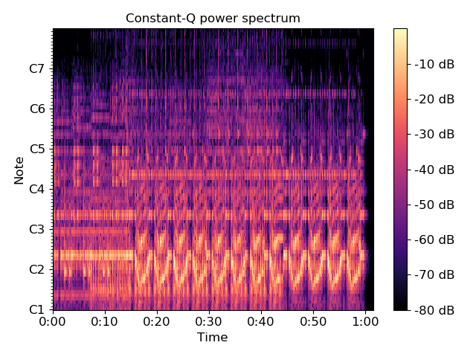
Limit the frequency range
>>> C = np.abs(librosa.cqt(y, sr=sr, fmin=librosa.note_to_hz('C2'),
... n_bins=60))
>>> C
array([[ 8.827e-04, 9.293e-04, ..., 3.133e-07, 2.942e-07],
[ 1.076e-03, 1.068e-03, ..., 1.153e-06, 1.148e-06],
...,
[ 1.042e-07, 4.087e-07, ..., 1.612e-07, 1.928e-07],
[ 2.363e-07, 5.329e-07, ..., 1.294e-07, 1.611e-07]])
Using a higher frequency resolution
>>> C = np.abs(librosa.cqt(y, sr=sr, fmin=librosa.note_to_hz('C2'),
... n_bins=60 * 2, bins_per_octave=12 * 2))
>>> C
array([[ 1.536e-05, 5.848e-05, ..., 3.241e-07, 2.453e-07],
[ 1.856e-03, 1.854e-03, ..., 2.397e-08, 3.549e-08],
...,
[ 2.034e-07, 4.245e-07, ..., 6.213e-08, 1.463e-07],
[ 4.896e-08, 5.407e-07, ..., 9.176e-08, 1.051e-07]])

librosa.core.icqt
librosa.core.icqt(C, sr=22050, hop_length=512, fmin=None, bins_per_octave=12, tuning=0.0, filter_scale=1, norm=1, sparsity=0.01, window='hann', scale=True, length=None, amin=<DEPRECATED parameter>, res_type='fft', dtype=<class 'numpy.float32'>)[source]
Compute the inverse constant-Q transform.
Given a constant-Q transform representation C of an audio signal y, this function produces an approximation y_hat
Parameters: | C : np.ndarray, [shape=(n_bins, n_frames)]  Constant-Q representation as produced by core.cqt  hop_length : int > 0 [scalar]  number of samples between successive frames  fmin : float > 0 [scalar]  Minimum frequency. Defaults to C1 ~= 32.70 Hz  tuning : float [scalar]  Tuning offset in fractions of a bin.  The minimum frequency of the CQT will be modified to fmin * 2**(tuning / bins_per_octave).  filter_scale : float > 0 [scalar]  Filter scale factor. Small values (<1) use shorter windows for improved time resolution.  norm : {inf, -inf, 0, float > 0}  Type of norm to use for basis function normalization. See librosa.util.normalize.  sparsity : float in [0, 1)  Sparsify the CQT basis by discarding up to sparsity fraction of the energy in each basis.  Set sparsity=0 to disable sparsification.  window : str, tuple, number, or function  Window specification for the basis filters. See filters.get_window for details.  scale : bool  If True, scale the CQT response by square-root the length of each channel’s filter. This is analogous to norm=’ortho’ in FFT.  If False, do not scale the CQT. This is analogous to norm=None in FFT.  length : int > 0, optional  If provided, the output y is zero-padded or clipped to exactly length samples.  amin : float or None [DEPRECATED]  Note  This parameter is deprecated in 0.7.0 and will be removed in 0.8.0.  res_type : string  Resampling mode. By default, this uses fft mode for high-quality reconstruction, but this may be slow depending on your signal duration. See librosa.resample for supported modes.  dtype : numeric type  Real numeric type for y. Default is 32-bit float.
Returns: | y : np.ndarray, [shape=(n_samples), dtype=np.float]  Audio time-series reconstructed from the CQT representation.
See also
cqt
core.resample
Notes
This function caches at level 40.
Examples
Using default parameters
>>> y, sr = librosa.load(librosa.util.example_audio_file(), duration=15)
>>> C = librosa.cqt(y=y, sr=sr)
>>> y_hat = librosa.icqt(C=C, sr=sr)
Or with a different hop length and frequency resolution:
>>> hop_length = 256
>>> bins_per_octave = 12 * 3
>>> C = librosa.cqt(y=y, sr=sr, hop_length=256, n_bins=7*bins_per_octave,
... bins_per_octave=bins_per_octave)
>>> y_hat = librosa.icqt(C=C, sr=sr, hop_length=hop_length,
... bins_per_octave=bins_per_octave)

librosa.core.hybrid_cqt
librosa.core.hybrid_cqt(y, sr=22050, hop_length=512, fmin=None, n_bins=84, bins_per_octave=12, tuning=0.0, filter_scale=1, norm=1, sparsity=0.01, window='hann', scale=True, pad_mode='reflect', res_type=None)[source]
Compute the hybrid constant-Q transform of an audio signal.
Here, the hybrid CQT uses the pseudo CQT for higher frequencies where the hop_length is longer than half the filter length and the full CQT for lower frequencies.
Parameters: | y : np.ndarray [shape=(n,)]  audio time series  sr : number > 0 [scalar]  sampling rate of y  hop_length : int > 0 [scalar]  number of samples between successive CQT columns.  fmin : float > 0 [scalar]  Minimum frequency. Defaults to C1 ~= 32.70 Hz  n_bins : int > 0 [scalar]  Number of frequency bins, starting at fmin  bins_per_octave : int > 0 [scalar]  Number of bins per octave  tuning : None or float  Tuning offset in fractions of a bin.  If None, tuning will be automatically estimated from the signal.  The minimum frequency of the resulting CQT will be modified to fmin * 2**(tuning / bins_per_octave).  filter_scale : float > 0  Filter filter_scale factor. Larger values use longer windows.  sparsity : float in [0, 1)  Sparsify the CQT basis by discarding up to sparsity fraction of the energy in each basis.  Set sparsity=0 to disable sparsification.  window : str, tuple, number, or function  Window specification for the basis filters. See filters.get_window for details.  pad_mode : string  Padding mode for centered frame analysis.  See also: librosa.core.stft and np.pad.  res_type : string  Resampling mode. See librosa.core.cqt for details.
Returns: | CQT : np.ndarray [shape=(n_bins, t), dtype=np.float]  Constant-Q energy for each frequency at each time.
Raises: | ParameterError  If hop_length is not an integer multiple of 2**(n_bins / bins_per_octave)  Or if y is too short to support the frequency range of the CQT.
See also
cqt
pseudo_cqt
Notes
This function caches at level 20.

librosa.core.pseudo_cqt
librosa.core.pseudo_cqt(y, sr=22050, hop_length=512, fmin=None, n_bins=84, bins_per_octave=12, tuning=0.0, filter_scale=1, norm=1, sparsity=0.01, window='hann', scale=True, pad_mode='reflect')[source]
Compute the pseudo constant-Q transform of an audio signal.
This uses a single fft size that is the smallest power of 2 that is greater than or equal to the max of:
- The longest CQT filter
- 2x the hop_length
Parameters: | y : np.ndarray [shape=(n,)]  audio time series  sr : number > 0 [scalar]  sampling rate of y  hop_length : int > 0 [scalar]  number of samples between successive CQT columns.  fmin : float > 0 [scalar]  Minimum frequency. Defaults to C1 ~= 32.70 Hz  n_bins : int > 0 [scalar]  Number of frequency bins, starting at fmin  bins_per_octave : int > 0 [scalar]  Number of bins per octave  tuning : None or float  Tuning offset in fractions of a bin.  If None, tuning will be automatically estimated from the signal.  The minimum frequency of the resulting CQT will be modified to fmin * 2**(tuning / bins_per_octave).  filter_scale : float > 0  Filter filter_scale factor. Larger values use longer windows.  sparsity : float in [0, 1)  Sparsify the CQT basis by discarding up to sparsity fraction of the energy in each basis.  Set sparsity=0 to disable sparsification.  window : str, tuple, number, or function  Window specification for the basis filters. See filters.get_window for details.  pad_mode : string  Padding mode for centered frame analysis.  See also: librosa.core.stft and np.pad.
Returns: | CQT : np.ndarray [shape=(n_bins, t), dtype=np.float]  Pseudo Constant-Q energy for each frequency at each time.
Raises: | ParameterError  If hop_length is not an integer multiple of 2**(n_bins / bins_per_octave)  Or if y is too short to support the frequency range of the CQT.
Notes
This function caches at level 20.

librosa.core.iirt
librosa.core.iirt(y, sr=22050, win_length=2048, hop_length=None, center=True, tuning=0.0, pad_mode='reflect', flayout='sos', **kwargs)[source]
Time-frequency representation using IIR filters [1].
This function will return a time-frequency representation using a multirate filter bank consisting of IIR filters. First, y is resampled as needed according to the provided sample_rates. Then, a filterbank with with n band-pass filters is designed. The resampled input signals are processed by the filterbank as a whole. (scipy.signal.filtfilt resp. sosfiltfilt is used to make the phase linear.) The output of the filterbank is cut into frames. For each band, the short-time mean-square power (STMSP) is calculated by summing win_length subsequent filtered time samples.
When called with the default set of parameters, it will generate the TF-representation as described in [1] (pitch filterbank):
- 85 filters with MIDI pitches [24, 108] as center_freqs.
- each filter having a bandwith of one semitone.

[1] | (1, 2) Müller, Meinard. “Information Retrieval for Music and Motion.” Springer Verlag. 2007.
Parameters: | y : np.ndarray [shape=(n,)]  audio time series  sr : number > 0 [scalar]  sampling rate of y  win_length : int > 0, <= n_fft  Window length.  hop_length : int > 0 [scalar]  Hop length, number samples between subsequent frames. If not supplied, defaults to win_length / 4.  center : boolean  - If True, the signal y is padded so that frame D[:, t] is centered at y[t * hop_length].  - If False, then D[:, t] begins at y[t * hop_length]  tuning : float [scalar]  Tuning deviation from A440 in fractions of a bin.  pad_mode : string  If center=True, the padding mode to use at the edges of the signal. By default, this function uses reflection padding.  flayout : string  - If sos (default), a series of second-order filters is used for filtering with scipy.signal.sosfiltfilt. Minimizes numerical precision errors for high-order filters, but is slower.  - If ba, the standard difference equation is used for filtering with scipy.signal.filtfilt. Can be unstable for high-order filters.  kwargs : additional keyword arguments  Additional arguments for librosa.filters.semitone_filterbank() (e.g., could be used to provide another set of center_freqs and sample_rates).
Returns: | bands_power : np.ndarray [shape=(n, t), dtype=dtype]  Short-time mean-square power for the input signal.
Raises: | ParameterError  If flayout is not None, ba, or sos.
See also
librosa.filters.semitone_filterbank
librosa.filters._multirate_fb
librosa.filters.mr_frequencies
librosa.core.cqt
scipy.signal.filtfilt
scipy.signal.sosfiltfilt
Examples
>>> import matplotlib.pyplot as plt
>>> y, sr = librosa.load(librosa.util.example_audio_file())
>>> D = np.abs(librosa.iirt(y))
>>> librosa.display.specshow(librosa.amplitude_to_db(D, ref=np.max),
... y_axis='cqt_hz', x_axis='time')
>>> plt.title('Semitone spectrogram')
>>> plt.colorbar(format='%+2.0f dB')
>>> plt.tight_layout()
>>> plt.show()

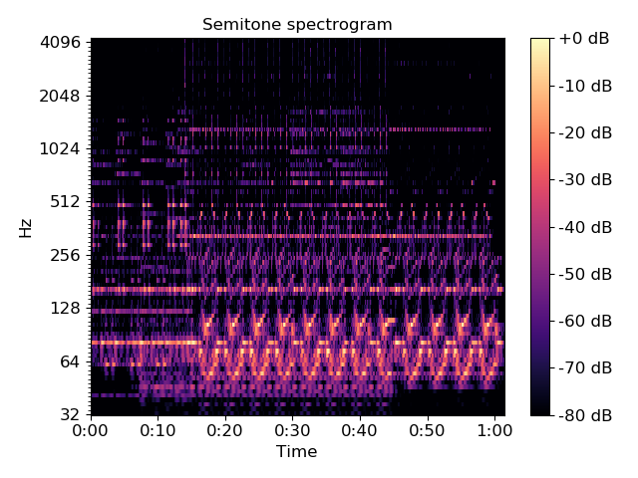
librosa.core.fmt
librosa.core.fmt(y, t_min=0.5, n_fmt=None, kind='cubic', beta=0.5, over_sample=1, axis=-1)[source]
The fast Mellin transform (FMT) [1] of a uniformly sampled signal y.
When the Mellin parameter (beta) is 1/2, it is also known as the scale transform [2]. The scale transform can be useful for audio analysis because its magnitude is invariant to scaling of the domain (e.g., time stretching or compression). This is analogous to the magnitude of the Fourier transform being invariant to shifts in the input domain.

[1] | De Sena, Antonio, and Davide Rocchesso. “A fast Mellin and scale transform.” EURASIP Journal on Applied Signal Processing 2007.1 (2007): 75-75.

[2] | Cohen, L. “The scale representation.” IEEE Transactions on Signal Processing 41, no. 12 (1993): 3275-3292.
Parameters: | y : np.ndarray, real-valued  The input signal(s). Can be multidimensional. The target axis must contain at least 3 samples.  t_min : float > 0  The minimum time spacing (in samples). This value should generally be less than 1 to preserve as much information as possible.  n_fmt : int > 2 or None  The number of scale transform bins to use. If None, then n_bins = over_sample * ceil(n * log((n-1)/t_min)) is taken, where n = y.shape[axis]  kind : str  The type of interpolation to use when re-sampling the input. See scipy.interpolate.interp1d for possible values.  Note that the default is to use high-precision (cubic) interpolation. This can be slow in practice; if speed is preferred over accuracy, then consider using kind=’linear’.  beta : float  The Mellin parameter. beta=0.5 provides the scale transform.  over_sample : float >= 1  Over-sampling factor for exponential resampling.  axis : int  The axis along which to transform y
Returns: | x_scale : np.ndarray [dtype=complex]  The scale transform of y along the axis dimension.
Raises: | ParameterError  if n_fmt < 2 or t_min <= 0 or if y is not finite or if y.shape[axis] < 3.
Notes
This function caches at level 30.
Examples
>>> # Generate a signal and time-stretch it (with energy normalization)
>>> scale = 1.25
>>> freq = 3.0
>>> x1 = np.linspace(0, 1, num=1024, endpoint=False)
>>> x2 = np.linspace(0, 1, num=scale * len(x1), endpoint=False)
>>> y1 = np.sin(2 * np.pi * freq * x1)
>>> y2 = np.sin(2 * np.pi * freq * x2) / np.sqrt(scale)
>>> # Verify that the two signals have the same energy
>>> np.sum(np.abs(y1)**2), np.sum(np.abs(y2)**2)
(255.99999999999997, 255.99999999999969)
>>> scale1 = librosa.fmt(y1, n_fmt=512)
>>> scale2 = librosa.fmt(y2, n_fmt=512)
>>> # And plot the results
>>> import matplotlib.pyplot as plt
>>> plt.figure(figsize=(8, 4))
>>> plt.subplot(1, 2, 1)
>>> plt.plot(y1, label='Original')
>>> plt.plot(y2, linestyle='--', label='Stretched')
>>> plt.xlabel('time (samples)')
>>> plt.title('Input signals')
>>> plt.legend(frameon=True)
>>> plt.axis('tight')
>>> plt.subplot(1, 2, 2)
>>> plt.semilogy(np.abs(scale1), label='Original')
>>> plt.semilogy(np.abs(scale2), linestyle='--', label='Stretched')
>>> plt.xlabel('scale coefficients')
>>> plt.title('Scale transform magnitude')
>>> plt.legend(frameon=True)
>>> plt.axis('tight')
>>> plt.tight_layout()
>>> plt.show()
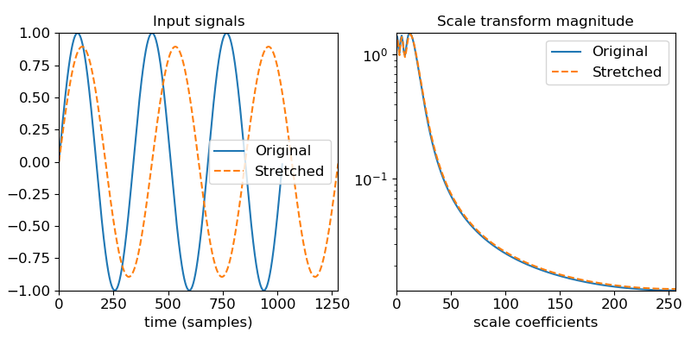
>>> # Plot the scale transform of an onset strength autocorrelation
>>> y, sr = librosa.load(librosa.util.example_audio_file(),
... offset=10.0, duration=30.0)
>>> odf = librosa.onset.onset_strength(y=y, sr=sr)
>>> # Auto-correlate with up to 10 seconds lag
>>> odf_ac = librosa.autocorrelate(odf, max_size=10 * sr // 512)
>>> # Normalize
>>> odf_ac = librosa.util.normalize(odf_ac, norm=np.inf)
>>> # Compute the scale transform
>>> odf_ac_scale = librosa.fmt(librosa.util.normalize(odf_ac), n_fmt=512)
>>> # Plot the results
>>> plt.figure()
>>> plt.subplot(3, 1, 1)
>>> plt.plot(odf, label='Onset strength')
>>> plt.axis('tight')
>>> plt.xlabel('Time (frames)')
>>> plt.xticks([])
>>> plt.legend(frameon=True)
>>> plt.subplot(3, 1, 2)
>>> plt.plot(odf_ac, label='Onset autocorrelation')
>>> plt.axis('tight')
>>> plt.xlabel('Lag (frames)')
>>> plt.xticks([])
>>> plt.legend(frameon=True)
>>> plt.subplot(3, 1, 3)
>>> plt.semilogy(np.abs(odf_ac_scale), label='Scale transform magnitude')
>>> plt.axis('tight')
>>> plt.xlabel('scale coefficients')
>>> plt.legend(frameon=True)
>>> plt.tight_layout()
>>> plt.show()

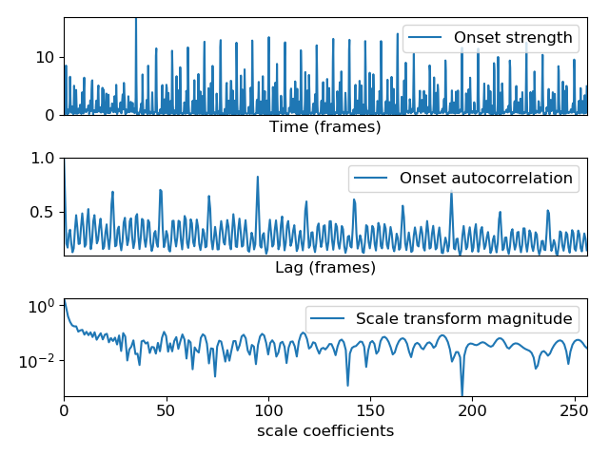
librosa.core.griffinlim
librosa.core.griffinlim(S, n_iter=32, hop_length=None, win_length=None, window='hann', center=True, dtype=<class 'numpy.float32'>, length=None, pad_mode='reflect', momentum=0.99, init='random', random_state=None)[source]
Approximate magnitude spectrogram inversion using the “fast” Griffin-Lim algorithm [1] [2].
Given a short-time Fourier transform magnitude matrix (S), the algorithm randomly initializes phase estimates, and then alternates forward- and inverse-STFT operations. Note that this assumes reconstruction of a real-valued time-domain signal, and that S contains only the non-negative frequencies (as computed by core.stft).

[1] | (1, 2) Perraudin, N., Balazs, P., & Søndergaard, P. L. “A fast Griffin-Lim algorithm,” IEEE Workshop on Applications of Signal Processing to Audio and Acoustics (pp. 1-4), Oct. 2013.

[2] | D. W. Griffin and J. S. Lim, “Signal estimation from modified short-time Fourier transform,” IEEE Trans. ASSP, vol.32, no.2, pp.236–243, Apr. 1984.
Parameters: | S : np.ndarray [shape=(n_fft / 2 + 1, t), non-negative]  An array of short-time Fourier transform magnitudes as produced by core.stft.  n_iter : int > 0  The number of iterations to run  hop_length : None or int > 0  The hop length of the STFT. If not provided, it will default to n_fft // 4  win_length : None or int > 0  The window length of the STFT. By default, it will equal n_fft  window : string, tuple, number, function, or np.ndarray [shape=(n_fft,)]  A window specification as supported by stft or istft  center : boolean  If True, the STFT is assumed to use centered frames. If False, the STFT is assumed to use left-aligned frames.  dtype : np.dtype  Real numeric type for the time-domain signal. Default is 32-bit float.  length : None or int > 0  If provided, the output y is zero-padded or clipped to exactly length samples.  pad_mode : string  If center=True, the padding mode to use at the edges of the signal. By default, STFT uses reflection padding.  momentum : number >= 0  The momentum parameter for fast Griffin-Lim. Setting this to 0 recovers the original Griffin-Lim method [1]. Values near 1 can lead to faster convergence, but above 1 may not converge.  init : None or ‘random’ [default]  If ‘random’ (the default), then phase values are initialized randomly according to random_state. This is recommended when the input S is a magnitude spectrogram with no initial phase estimates.  If None, then the phase is initialized from S. This is useful when an initial guess for phase can be provided, or when you want to resume Griffin-Lim from a previous output.  random_state : None, int, or np.random.RandomState  If int, random_state is the seed used by the random number generator for phase initialization.  If np.random.RandomState instance, the random number generator itself.  If None, defaults to the current np.random object.
Returns: | y : np.ndarray [shape=(n,)]  time-domain signal reconstructed from S
See also
stft
istft
magphase
filters.get_window
Examples
A basic STFT inverse example
>>> y, sr = librosa.load(librosa.util.example_audio_file(), duration=5, offset=30)
>>> # Get the magnitude spectrogram
>>> S = np.abs(librosa.stft(y))
>>> # Invert using Griffin-Lim
>>> y_inv = librosa.griffinlim(S)
>>> # Invert without estimating phase
>>> y_istft = librosa.istft(S)
Wave-plot the results
>>> import matplotlib.pyplot as plt
>>> plt.figure()
>>> ax = plt.subplot(3,1,1)
>>> librosa.display.waveplot(y, sr=sr, color='b')
>>> plt.title('Original')
>>> plt.xlabel('')
>>> plt.subplot(3,1,2, sharex=ax, sharey=ax)
>>> librosa.display.waveplot(y_inv, sr=sr, color='g')
>>> plt.title('Griffin-Lim reconstruction')
>>> plt.xlabel('')
>>> plt.subplot(3,1,3, sharex=ax, sharey=ax)
>>> librosa.display.waveplot(y_istft, sr=sr, color='r')
>>> plt.title('Magnitude-only istft reconstruction')
>>> plt.tight_layout()
>>> plt.show()

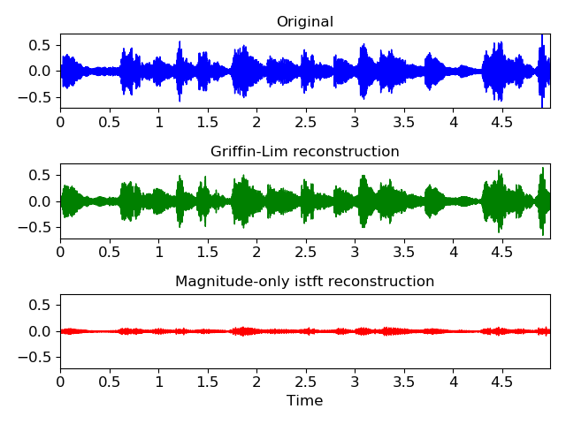
librosa.core.griffinlim_cqt
librosa.core.griffinlim_cqt(C, n_iter=32, sr=22050, hop_length=512, fmin=None, bins_per_octave=12, tuning=0.0, filter_scale=1, norm=1, sparsity=0.01, window='hann', scale=True, pad_mode='reflect', res_type='kaiser_fast', dtype=<class 'numpy.float32'>, length=None, momentum=0.99, init='random', random_state=None)[source]
Approximate constant-Q magnitude spectrogram inversion using the “fast” Griffin-Lim algorithm [1] [2].
Given the magnitude of a constant-Q spectrogram (C), the algorithm randomly initializes phase estimates, and then alternates forward- and inverse-CQT operations.
This implementation is based on the Griffin-Lim method for Short-time Fourier Transforms, but adapted for use with constant-Q spectrograms.

[1] | (1, 2) Perraudin, N., Balazs, P., & Søndergaard, P. L. “A fast Griffin-Lim algorithm,” IEEE Workshop on Applications of Signal Processing to Audio and Acoustics (pp. 1-4), Oct. 2013.

[2] | D. W. Griffin and J. S. Lim, “Signal estimation from modified short-time Fourier transform,” IEEE Trans. ASSP, vol.32, no.2, pp.236–243, Apr. 1984.
Parameters: | C : np.ndarray [shape=(n_bins, n_frames)]  The constant-Q magnitude spectrogram  n_iter : int > 0  The number of iterations to run  sr : number > 0  Audio sampling rate  hop_length : int > 0  The hop length of the CQT  fmin : number > 0  Minimum frequency for the CQT.  If not provided, it defaults to C1.  bins_per_octave : int > 0  Number of bins per octave  tuning : float  Tuning deviation from A440, in fractions of a bin  filter_scale : float > 0  Filter scale factor. Small values (<1) use shorter windows for improved time resolution.  norm : {inf, -inf, 0, float > 0}  Type of norm to use for basis function normalization. See librosa.util.normalize.  sparsity : float in [0, 1)  Sparsify the CQT basis by discarding up to sparsity fraction of the energy in each basis.  Set sparsity=0 to disable sparsification.  window : str, tuple, or function  Window specification for the basis filters. See filters.get_window for details.  scale : bool  If True, scale the CQT response by square-root the length of each channel’s filter. This is analogous to norm=’ortho’ in FFT.  If False, do not scale the CQT. This is analogous to norm=None in FFT.  pad_mode : string  Padding mode for centered frame analysis.  See also: librosa.core.stft and np.pad  res_type : string  The resampling mode for recursive downsampling.  By default, CQT uses an adaptive mode selection to trade accuracy at high frequencies for efficiency at low frequencies.  Griffin-Lim uses the efficient (fast) resampling mode by default.  See librosa.core.resample for a list of available options.  dtype : numeric type  Real numeric type for y. Default is 32-bit float.  length : int > 0, optional  If provided, the output y is zero-padded or clipped to exactly length samples.  momentum : float > 0  The momentum parameter for fast Griffin-Lim. Setting this to 0 recovers the original Griffin-Lim method [1]. Values near 1 can lead to faster convergence, but above 1 may not converge.  init : None or ‘random’ [default]  If ‘random’ (the default), then phase values are initialized randomly according to random_state. This is recommended when the input C is a magnitude spectrogram with no initial phase estimates.  If None, then the phase is initialized from C. This is useful when an initial guess for phase can be provided, or when you want to resume Griffin-Lim from a previous output.  random_state : None, int, or np.random.RandomState  If int, random_state is the seed used by the random number generator for phase initialization.  If np.random.RandomState instance, the random number generator itself.  If None, defaults to the current np.random object.
Returns: | y : np.ndarray [shape=(n,)]  time-domain signal reconstructed from C
See also
cqt
icqt
griffinlim
filters.get_window
resample
Examples
A basis CQT inverse example
>>> y, sr = librosa.load(librosa.util.example_audio_file(), duration=5, offset=30, sr=None)
>>> # Get the CQT magnitude, 7 octaves at 36 bins per octave
>>> C = np.abs(librosa.cqt(y=y, sr=sr, bins_per_octave=36, n_bins=7*36))
>>> # Invert using Griffin-Lim
>>> y_inv = librosa.griffinlim_cqt(C, sr=sr, bins_per_octave=36)
>>> # And invert without estimating phase
>>> y_icqt = librosa.icqt(C, sr=sr, bins_per_octave=36)
Wave-plot the results
>>> import matplotlib.pyplot as plt
>>> plt.figure()
>>> ax = plt.subplot(3,1,1)
>>> librosa.display.waveplot(y, sr=sr, color='b')
>>> plt.title('Original')
>>> plt.xlabel('')
>>> plt.subplot(3,1,2, sharex=ax, sharey=ax)
>>> librosa.display.waveplot(y_inv, sr=sr, color='g')
>>> plt.title('Griffin-Lim reconstruction')
>>> plt.xlabel('')
>>> plt.subplot(3,1,3, sharex=ax, sharey=ax)
>>> librosa.display.waveplot(y_icqt, sr=sr, color='r')
>>> plt.title('Magnitude-only icqt reconstruction')
>>> plt.tight_layout()
>>> plt.show()
(Source code)

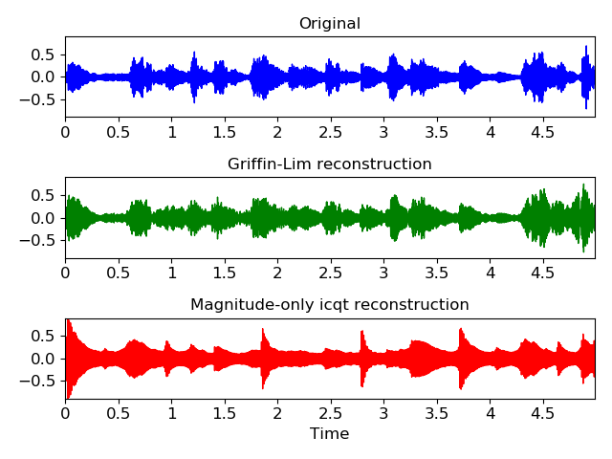
librosa.core.interp_harmonics
librosa.core.interp_harmonics(x, freqs, h_range, kind='linear', fill_value=0, axis=0)[source]
Compute the energy at harmonics of time-frequency representation.
Given a frequency-based energy representation such as a spectrogram or tempogram, this function computes the energy at the chosen harmonics of the frequency axis. (See examples below.) The resulting harmonic array can then be used as input to a salience computation.
Parameters: | x : np.ndarray  The input energy  freqs : np.ndarray, shape=(X.shape[axis])  The frequency values corresponding to X’s elements along the chosen axis.  h_range : list-like, non-negative  Harmonics to compute. The first harmonic (1) corresponds to x itself. Values less than one (e.g., 1/2) correspond to sub-harmonics.  kind : str  Interpolation type. See scipy.interpolate.interp1d.  fill_value : float  The value to fill when extrapolating beyond the observed frequency range.  axis : int  The axis along which to compute harmonics
Returns: | x_harm : np.ndarray, shape=(len(h_range), [x.shape])  x_harm[i] will have the same shape as x, and measure the energy at the h_range[i] harmonic of each frequency.
See also
scipy.interpolate.interp1d
Examples
Estimate the harmonics of a time-averaged tempogram
>>> y, sr = librosa.load(librosa.util.example_audio_file(),
... duration=15, offset=30)
>>> # Compute the time-varying tempogram and average over time
>>> tempi = np.mean(librosa.feature.tempogram(y=y, sr=sr), axis=1)
>>> # We'll measure the first five harmonics
>>> h_range = [1, 2, 3, 4, 5]
>>> f_tempo = librosa.tempo_frequencies(len(tempi), sr=sr)
>>> # Build the harmonic tensor
>>> t_harmonics = librosa.interp_harmonics(tempi, f_tempo, h_range)
>>> print(t_harmonics.shape)
(5, 384)
>>> # And plot the results
>>> import matplotlib.pyplot as plt
>>> plt.figure()
>>> librosa.display.specshow(t_harmonics, x_axis='tempo', sr=sr)
>>> plt.yticks(0.5 + np.arange(len(h_range)),
... ['{:.3g}'.format(_) for _ in h_range])
>>> plt.ylabel('Harmonic')
>>> plt.xlabel('Tempo (BPM)')
>>> plt.tight_layout()
>>> plt.show()
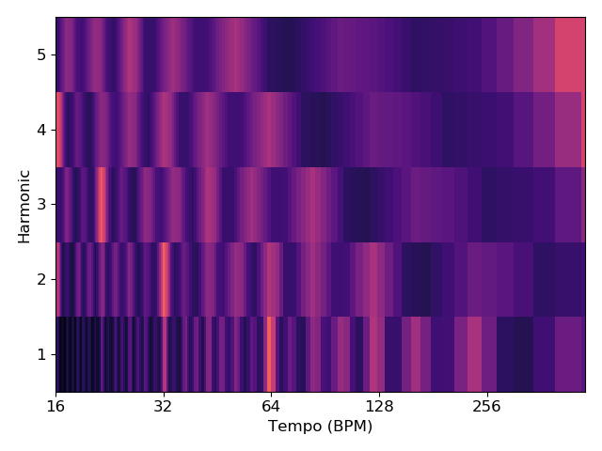
We can also compute frequency harmonics for spectrograms. To calculate sub-harmonic energy, use values < 1.
>>> h_range = [1./3, 1./2, 1, 2, 3, 4]
>>> S = np.abs(librosa.stft(y))
>>> fft_freqs = librosa.fft_frequencies(sr=sr)
>>> S_harm = librosa.interp_harmonics(S, fft_freqs, h_range, axis=0)
>>> print(S_harm.shape)
(6, 1025, 646)
>>> plt.figure()
>>> for i, _sh in enumerate(S_harm, 1):
... plt.subplot(3, 2, i)
... librosa.display.specshow(librosa.amplitude_to_db(_sh,
... ref=S.max()),
... sr=sr, y_axis='log')
... plt.title('h={:.3g}'.format(h_range[i-1]))
... plt.yticks([])
>>> plt.tight_layout()

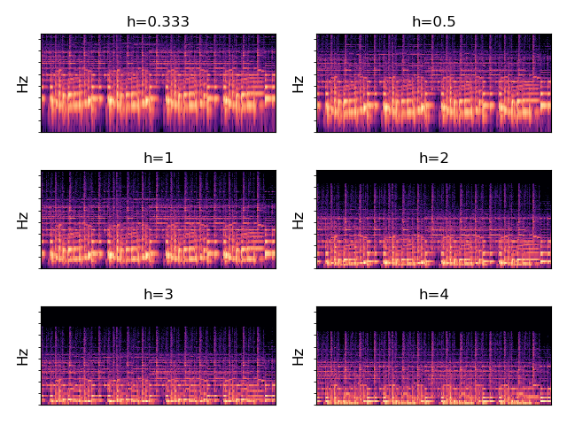
librosa.core.salience
librosa.core.salience(S, freqs, h_range, weights=None, aggregate=None, filter_peaks=True, fill_value=nan, kind='linear', axis=0)[source]
Harmonic salience function.
Parameters: | S : np.ndarray [shape=(d, n)]  input time frequency magnitude representation (e.g. STFT or CQT magnitudes). Must be real-valued and non-negative.  freqs : np.ndarray, shape=(S.shape[axis])  The frequency values corresponding to S’s elements along the chosen axis.  h_range : list-like, non-negative  Harmonics to include in salience computation. The first harmonic (1) corresponds to S itself. Values less than one (e.g., 1/2) correspond to sub-harmonics.  weights : list-like  The weight to apply to each harmonic in the summation. (default: uniform weights). Must be the same length as harmonics.  aggregate : function  aggregation function (default: np.average) If aggregate=np.average, then a weighted average is computed per-harmonic according to the specified weights. For all other aggregation functions, all harmonics are treated equally.  filter_peaks : bool  If true, returns harmonic summation only on frequencies of peak magnitude. Otherwise returns harmonic summation over the full spectrum. Defaults to True.  fill_value : float  The value to fill non-peaks in the output representation. (default: np.nan) Only used if filter_peaks == True.  kind : str  Interpolation type for harmonic estimation. See scipy.interpolate.interp1d.  axis : int  The axis along which to compute harmonics
Returns: | S_sal : np.ndarray, shape=(len(h_range), [x.shape])  S_sal will have the same shape as S, and measure the overal harmonic energy at each frequency.
See also
interp_harmonics
Examples
>>> y, sr = librosa.load(librosa.util.example_audio_file(),
... duration=15, offset=30)
>>> S = np.abs(librosa.stft(y))
>>> freqs = librosa.core.fft_frequencies(sr)
>>> harms = [1, 2, 3, 4]
>>> weights = [1.0, 0.5, 0.33, 0.25]
>>> S_sal = librosa.salience(S, freqs, harms, weights, fill_value=0)
>>> print(S_sal.shape)
(1025, 646)
>>> import matplotlib.pyplot as plt
>>> plt.figure()
>>> librosa.display.specshow(librosa.amplitude_to_db(S_sal,
... ref=np.max),
... sr=sr, y_axis='log', x_axis='time')
>>> plt.colorbar()
>>> plt.title('Salience spectrogram')
>>> plt.tight_layout()
>>> plt.show()

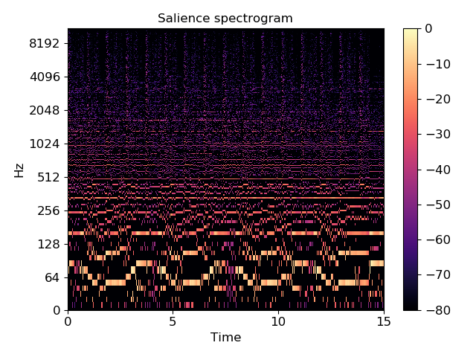
librosa.core.phase_vocoder
librosa.core.phase_vocoder(D, rate, hop_length=None)[source]
Phase vocoder. Given an STFT matrix D, speed up by a factor of rate
Based on the implementation provided by [1].
Note
This is a simplified implementation, intended primarily for reference and pedagogical purposes. It makes no attempt to handle transients, and is likely to produce many audible artifacts. For a higher quality implementation, we recommend the RubberBand library [2] and its Python wrapper pyrubberband.

[1] | Ellis, D. P. W. “A phase vocoder in Matlab.” Columbia University, 2002. http://www.ee.columbia.edu/~dpwe/resources/matlab/pvoc/

[2] | https://breakfastquay.com/rubberband/
Parameters: | D : np.ndarray [shape=(d, t), dtype=complex]  STFT matrix  rate : float > 0 [scalar]  Speed-up factor: rate > 1 is faster, rate < 1 is slower.  hop_length : int > 0 [scalar] or None  The number of samples between successive columns of D.  If None, defaults to n_fft/4 = (D.shape[0]-1)/2
Returns: | D_stretched : np.ndarray [shape=(d, t / rate), dtype=complex]  time-stretched STFT
See also
pyrubberband
Examples
>>> # Play at double speed
>>> y, sr = librosa.load(librosa.util.example_audio_file())
>>> D = librosa.stft(y, n_fft=2048, hop_length=512)
>>> D_fast = librosa.phase_vocoder(D, 2.0, hop_length=512)
>>> y_fast = librosa.istft(D_fast, hop_length=512)
>>> # Or play at 1/3 speed
>>> y, sr = librosa.load(librosa.util.example_audio_file())
>>> D = librosa.stft(y, n_fft=2048, hop_length=512)
>>> D_slow = librosa.phase_vocoder(D, 1./3, hop_length=512)
>>> y_slow = librosa.istft(D_slow, hop_length=512)

librosa.core.magphase
librosa.core.magphase(D, power=1)[source]
Separate a complex-valued spectrogram D into its magnitude (S) and phase (P) components, so that D = S * P.
Parameters: | D : np.ndarray [shape=(d, t), dtype=complex]  complex-valued spectrogram  power : float > 0  Exponent for the magnitude spectrogram, e.g., 1 for energy, 2 for power, etc.
Returns: | D_mag : np.ndarray [shape=(d, t), dtype=real]  magnitude of D, raised to power  D_phase : np.ndarray [shape=(d, t), dtype=complex]  exp(1.j * phi) where phi is the phase of D
Examples
>>> y, sr = librosa.load(librosa.util.example_audio_file())
>>> D = librosa.stft(y)
>>> magnitude, phase = librosa.magphase(D)
>>> magnitude
array([[ 2.524e-03, 4.329e-02, ..., 3.217e-04, 3.520e-05],
[ 2.645e-03, 5.152e-02, ..., 3.283e-04, 3.432e-04],
...,
[ 1.966e-05, 9.828e-06, ..., 3.164e-07, 9.370e-06],
[ 1.966e-05, 9.830e-06, ..., 3.161e-07, 9.366e-06]], dtype=float32)
>>> phase
array([[ 1.000e+00 +0.000e+00j, 1.000e+00 +0.000e+00j, ...,
-1.000e+00 +8.742e-08j, -1.000e+00 +8.742e-08j],
[ 1.000e+00 +1.615e-16j, 9.950e-01 -1.001e-01j, ...,
9.794e-01 +2.017e-01j, 1.492e-02 -9.999e-01j],
...,
[ 1.000e+00 -5.609e-15j, -5.081e-04 +1.000e+00j, ...,
-9.549e-01 -2.970e-01j, 2.938e-01 -9.559e-01j],
[ -1.000e+00 +8.742e-08j, -1.000e+00 +8.742e-08j, ...,
-1.000e+00 +8.742e-08j, -1.000e+00 +8.742e-08j]], dtype=complex64)
Or get the phase angle (in radians)
>>> np.angle(phase)
array([[ 0.000e+00, 0.000e+00, ..., 3.142e+00, 3.142e+00],
[ 1.615e-16, -1.003e-01, ..., 2.031e-01, -1.556e+00],
...,
[ -5.609e-15, 1.571e+00, ..., -2.840e+00, -1.273e+00],
[ 3.142e+00, 3.142e+00, ..., 3.142e+00, 3.142e+00]], dtype=float32)

librosa.core.get_fftlib
librosa.core.get_fftlib()[source]
Get the FFT library currently used by librosa
Returns: | fft : module  The FFT library currently used by librosa. Must API-compatible with numpy.fft.

librosa.core.set_fftlib
librosa.core.set_fftlib(lib=None)[source]
Set the FFT library used by librosa.
Parameters: | lib : None or module  Must implement an interface compatible with numpy.fft. If None, reverts to numpy.fft.
Examples
Use pyfftw:
>>> import pyfftw
>>> librosa.set_fftlib(pyfftw.interfaces.numpy_fft)
Reset to default numpy implementation
>>> librosa.set_fftlib()librosa.core.amplitude_to_db
librosa.core.amplitude_to_db(S, ref=1.0, amin=1e-05, top_db=80.0)[source]
Convert an amplitude spectrogram to dB-scaled spectrogram.
This is equivalent to power_to_db(S**2), but is provided for convenience.
Parameters: | S : np.ndarray  input amplitude  ref : scalar or callable  If scalar, the amplitude abs(S) is scaled relative to ref: 20 * log10(S / ref). Zeros in the output correspond to positions where S == ref.  If callable, the reference value is computed as ref(S).  amin : float > 0 [scalar]  minimum threshold for S and ref  top_db : float >= 0 [scalar]  threshold the output at top_db below the peak: max(20 * log10(S)) - top_db
Returns: | S_db : np.ndarray  S measured in dB
See also
power_to_db, db_to_amplitude
Notes
This function caches at level 30.

librosa.core.db_to_amplitude
librosa.core.db_to_amplitude(S_db, ref=1.0)[source]
Convert a dB-scaled spectrogram to an amplitude spectrogram.
This effectively inverts amplitude_to_db:
db_to_amplitude(S_db) ~= 10.0**(0.5 * (S_db + log10(ref)/10))
Parameters: | S_db : np.ndarray  dB-scaled spectrogram  ref: number > 0  Optional reference power.
Returns: | S : np.ndarray  Linear magnitude spectrogram
Notes
This function caches at level 30.

librosa.core.power_to_db
librosa.core.power_to_db(S, ref=1.0, amin=1e-10, top_db=80.0)[source]
Convert a power spectrogram (amplitude squared) to decibel (dB) units
This computes the scaling 10 * log10(S / ref) in a numerically stable way.
Parameters: | S : np.ndarray  input power  ref : scalar or callable  If scalar, the amplitude abs(S) is scaled relative to ref: 10 * log10(S / ref). Zeros in the output correspond to positions where S == ref.  If callable, the reference value is computed as ref(S).  amin : float > 0 [scalar]  minimum threshold for abs(S) and ref  top_db : float >= 0 [scalar]  threshold the output at top_db below the peak: max(10 * log10(S)) - top_db
Returns: | S_db : np.ndarray  S_db ~= 10 * log10(S) - 10 * log10(ref)
See also
perceptual_weighting
db_to_power
amplitude_to_db
db_to_amplitude
Notes
This function caches at level 30.
Examples
Get a power spectrogram from a waveform y
>>> y, sr = librosa.load(librosa.util.example_audio_file())
>>> S = np.abs(librosa.stft(y))
>>> librosa.power_to_db(S**2)
array([[-33.293, -27.32 , ..., -33.293, -33.293],
[-33.293, -25.723, ..., -33.293, -33.293],
...,
[-33.293, -33.293, ..., -33.293, -33.293],
[-33.293, -33.293, ..., -33.293, -33.293]], dtype=float32)
Compute dB relative to peak power
>>> librosa.power_to_db(S**2, ref=np.max)
array([[-80. , -74.027, ..., -80. , -80. ],
[-80. , -72.431, ..., -80. , -80. ],
...,
[-80. , -80. , ..., -80. , -80. ],
[-80. , -80. , ..., -80. , -80. ]], dtype=float32)
Or compare to median power
>>> librosa.power_to_db(S**2, ref=np.median)
array([[-0.189, 5.784, ..., -0.189, -0.189],
[-0.189, 7.381, ..., -0.189, -0.189],
...,
[-0.189, -0.189, ..., -0.189, -0.189],
[-0.189, -0.189, ..., -0.189, -0.189]], dtype=float32)
And plot the results
>>> import matplotlib.pyplot as plt
>>> plt.figure()
>>> plt.subplot(2, 1, 1)
>>> librosa.display.specshow(S**2, sr=sr, y_axis='log')
>>> plt.colorbar()
>>> plt.title('Power spectrogram')
>>> plt.subplot(2, 1, 2)
>>> librosa.display.specshow(librosa.power_to_db(S**2, ref=np.max),
... sr=sr, y_axis='log', x_axis='time')
>>> plt.colorbar(format='%+2.0f dB')
>>> plt.title('Log-Power spectrogram')
>>> plt.tight_layout()
>>> plt.show()

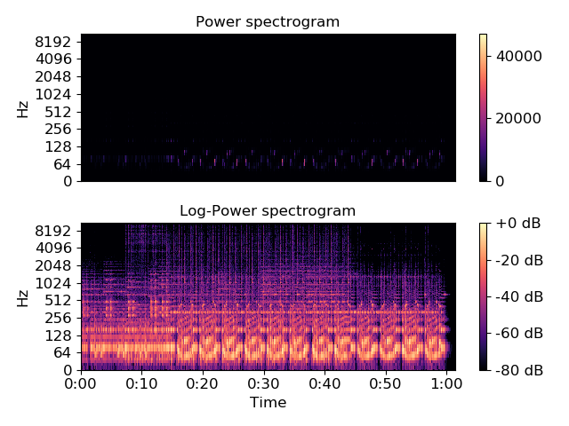
librosa.core.db_to_power
librosa.core.db_to_power(S_db, ref=1.0)[source]
Convert a dB-scale spectrogram to a power spectrogram.
This effectively inverts power_to_db:
db_to_power(S_db) ~= ref * 10.0**(S_db / 10)
Parameters: | S_db : np.ndarray  dB-scaled spectrogram  ref : number > 0  Reference power: output will be scaled by this value
Returns: | S : np.ndarray  Power spectrogram
Notes
This function caches at level 30.

librosa.core.perceptual_weighting
librosa.core.perceptual_weighting(S, frequencies, **kwargs)[source]
Perceptual weighting of a power spectrogram:
S_p[f] = A_weighting(f) + 10*log(S[f] / ref)
Parameters: | S : np.ndarray [shape=(d, t)]  Power spectrogram  frequencies : np.ndarray [shape=(d,)]  Center frequency for each row of S  kwargs : additional keyword arguments  Additional keyword arguments to power_to_db.
Returns: | S_p : np.ndarray [shape=(d, t)]  perceptually weighted version of S
See also
power_to_db
Notes
This function caches at level 30.
Examples
Re-weight a CQT power spectrum, using peak power as reference
>>> y, sr = librosa.load(librosa.util.example_audio_file())
>>> C = np.abs(librosa.cqt(y, sr=sr, fmin=librosa.note_to_hz('A1')))
>>> freqs = librosa.cqt_frequencies(C.shape[0],
... fmin=librosa.note_to_hz('A1'))
>>> perceptual_CQT = librosa.perceptual_weighting(C**2,
... freqs,
... ref=np.max)
>>> perceptual_CQT
array([[ -80.076, -80.049, ..., -104.735, -104.735],
[ -78.344, -78.555, ..., -103.725, -103.725],
...,
[ -76.272, -76.272, ..., -76.272, -76.272],
[ -76.485, -76.485, ..., -76.485, -76.485]])
>>> import matplotlib.pyplot as plt
>>> plt.figure()
>>> plt.subplot(2, 1, 1)
>>> librosa.display.specshow(librosa.amplitude_to_db(C,
... ref=np.max),
... fmin=librosa.note_to_hz('A1'),
... y_axis='cqt_hz')
>>> plt.title('Log CQT power')
>>> plt.colorbar(format='%+2.0f dB')
>>> plt.subplot(2, 1, 2)
>>> librosa.display.specshow(perceptual_CQT, y_axis='cqt_hz',
... fmin=librosa.note_to_hz('A1'),
... x_axis='time')
>>> plt.title('Perceptually weighted log CQT')
>>> plt.colorbar(format='%+2.0f dB')
>>> plt.tight_layout()
>>> plt.show()
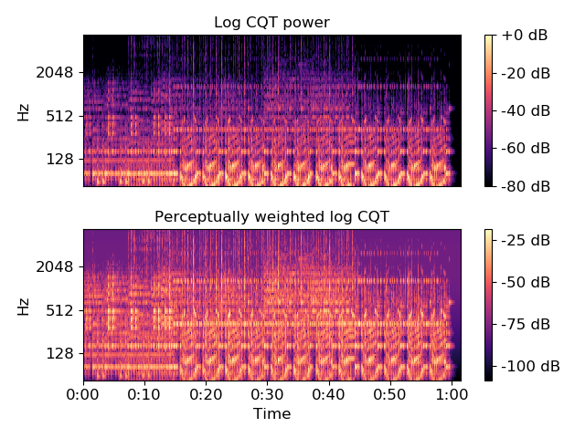

librosa.core.A_weighting
librosa.core.A_weighting(frequencies, min_db=-80.0)[source]
Compute the A-weighting of a set of frequencies.
Parameters: | frequencies : scalar or np.ndarray [shape=(n,)]  One or more frequencies (in Hz)  min_db : float [scalar] or None  Clip weights below this threshold. If None, no clipping is performed.
Returns: | A_weighting : scalar or np.ndarray [shape=(n,)]  A_weighting[i] is the A-weighting of frequencies[i]
See also
perceptual_weighting
Examples
Get the A-weighting for CQT frequencies
>>> import matplotlib.pyplot as plt
>>> freqs = librosa.cqt_frequencies(108, librosa.note_to_hz('C1'))
>>> aw = librosa.A_weighting(freqs)
>>> plt.plot(freqs, aw)
>>> plt.xlabel('Frequency (Hz)')
>>> plt.ylabel('Weighting (log10)')
>>> plt.title('A-Weighting of CQT frequencies')
>>> plt.show()

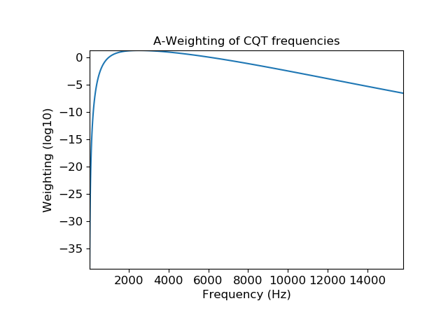
librosa.core.pcen
librosa.core.pcen(S, sr=22050, hop_length=512, gain=0.98, bias=2, power=0.5, time_constant=0.4, eps=1e-06, b=None, max_size=1, ref=None, axis=-1, max_axis=None, zi=None, return_zf=False)[source]
Per-channel energy normalization (PCEN) [1]
This function normalizes a time-frequency representation S by performing automatic gain control, followed by nonlinear compression:
P[f, t] = (S / (eps + M[f, t])**gain + bias)**power - bias**power
IMPORTANT: the default values of eps, gain, bias, and power match the original publication [1], in which M is a 40-band mel-frequency spectrogram with 25 ms windowing, 10 ms frame shift, and raw audio values in the interval [-2**31; 2**31-1[. If you use these default values, we recommend to make sure that the raw audio is properly scaled to this interval, and not to [-1, 1[ as is most often the case.
The matrix M is the result of applying a low-pass, temporal IIR filter to S:
M[f, t] = (1 - b) * M[f, t - 1] + b * S[f, t]
If b is not provided, it is calculated as:
b = (sqrt(1 + 4* T**2) - 1) / (2 * T**2)
where T = time_constant * sr / hop_length, as in [2].
This normalization is designed to suppress background noise and emphasize foreground signals, and can be used as an alternative to decibel scaling (amplitude_to_db).
This implementation also supports smoothing across frequency bins by specifying max_size > 1. If this option is used, the filtered spectrogram M is computed as
M[f, t] = (1 - b) * M[f, t - 1] + b * R[f, t]
where R has been max-filtered along the frequency axis, similar to the SuperFlux algorithm implemented in onset.onset_strength:
R[f, t] = max(S[f - max_size//2: f + max_size//2, t])
This can be used to perform automatic gain control on signals that cross or span multiple frequency bans, which may be desirable for spectrograms with high frequency resolution.

[1] | (1, 2) Wang, Y., Getreuer, P., Hughes, T., Lyon, R. F., & Saurous, R. A. (2017, March). Trainable frontend for robust and far-field keyword spotting. In Acoustics, Speech and Signal Processing (ICASSP), 2017 IEEE International Conference on (pp. 5670-5674). IEEE.

[2] | Lostanlen, V., Salamon, J., McFee, B., Cartwright, M., Farnsworth, A., Kelling, S., and Bello, J. P. Per-Channel Energy Normalization: Why and How. IEEE Signal Processing Letters, 26(1), 39-43.
Parameters: | S : np.ndarray (non-negative)  The input (magnitude) spectrogram  sr : number > 0 [scalar]  The audio sampling rate  hop_length : int > 0 [scalar]  The hop length of S, expressed in samples  gain : number >= 0 [scalar]  The gain factor. Typical values should be slightly less than 1.  bias : number >= 0 [scalar]  The bias point of the nonlinear compression (default: 2)  power : number >= 0 [scalar]  The compression exponent. Typical values should be between 0 and 0.5. Smaller values of power result in stronger compression. At the limit power=0, polynomial compression becomes logarithmic.  time_constant : number > 0 [scalar]  The time constant for IIR filtering, measured in seconds.  eps : number > 0 [scalar]  A small constant used to ensure numerical stability of the filter.  b : number in [0, 1] [scalar]  The filter coefficient for the low-pass filter. If not provided, it will be inferred from time_constant.  max_size : int > 0 [scalar]  The width of the max filter applied to the frequency axis. If left as 1, no filtering is performed.  ref : None or np.ndarray (shape=S.shape)  An optional pre-computed reference spectrum (R in the above). If not provided it will be computed from S.  axis : int [scalar]  The (time) axis of the input spectrogram.  max_axis : None or int [scalar]  The frequency axis of the input spectrogram. If None, and S is two-dimensional, it will be inferred as the opposite from axis. If S is not two-dimensional, and max_size > 1, an error will be raised.  zi : np.ndarray  The initial filter delay values.  This may be the zf (final delay values) of a previous call to pcen, or computed by scipy.signal.lfilter_zi.  return_zf : bool  If True, return the final filter delay values along with the PCEN output P. This is primarily useful in streaming contexts, where the final state of one block of processing should be used to initialize the next block.  If False (default) only the PCEN values P are returned.
Returns: | P : np.ndarray, non-negative [shape=(n, m)]  The per-channel energy normalized version of S.  zf : np.ndarray (optional)  The final filter delay values. Only returned if return_zf=True.
See also
amplitude_to_db
librosa.onset.onset_strength
Examples
Compare PCEN to log amplitude (dB) scaling on Mel spectra
>>> import matplotlib.pyplot as plt
>>> y, sr = librosa.load(librosa.util.example_audio_file(),
... offset=10, duration=10)
>>> # We recommend scaling y to the range [-2**31, 2**31[ before applying
>>> # PCEN's default parameters. Furthermore, we use power=1 to get a
>>> # magnitude spectrum instead of a power spectrum.
>>> S = librosa.feature.melspectrogram(y, sr=sr, power=1)
>>> log_S = librosa.amplitude_to_db(S, ref=np.max)
>>> pcen_S = librosa.pcen(S * (2**31))
>>> plt.figure()
>>> plt.subplot(2,1,1)
>>> librosa.display.specshow(log_S, x_axis='time', y_axis='mel')
>>> plt.title('log amplitude (dB)')
>>> plt.colorbar()
>>> plt.subplot(2,1,2)
>>> librosa.display.specshow(pcen_S, x_axis='time', y_axis='mel')
>>> plt.title('Per-channel energy normalization')
>>> plt.colorbar()
>>> plt.tight_layout()
>>> plt.show()
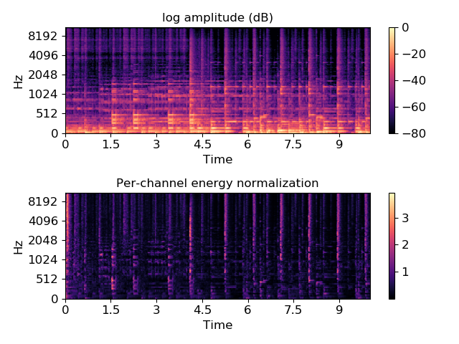
Compare PCEN with and without max-filtering
>>> pcen_max = librosa.pcen(S * (2**31), max_size=3)
>>> plt.figure()
>>> plt.subplot(2,1,1)
>>> librosa.display.specshow(pcen_S, x_axis='time', y_axis='mel')
>>> plt.title('Per-channel energy normalization (no max-filter)')
>>> plt.colorbar()
>>> plt.subplot(2,1,2)
>>> librosa.display.specshow(pcen_max, x_axis='time', y_axis='mel')
>>> plt.title('Per-channel energy normalization (max_size=3)')
>>> plt.colorbar()
>>> plt.tight_layout()
>>> plt.show()

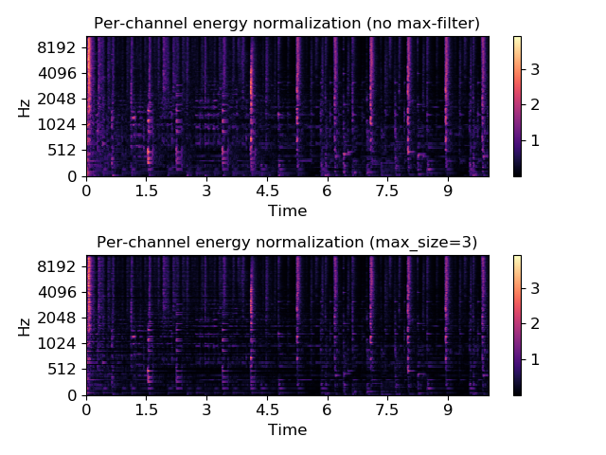
librosa.core.frames_to_samples
librosa.core.frames_to_samples(frames, hop_length=512, n_fft=None)[source]
Converts frame indices to audio sample indices.
Parameters: | frames : number or np.ndarray [shape=(n,)]  frame index or vector of frame indices  hop_length : int > 0 [scalar]  number of samples between successive frames  n_fft : None or int > 0 [scalar]  Optional: length of the FFT window. If given, time conversion will include an offset of n_fft / 2 to counteract windowing effects when using a non-centered STFT.
Returns: | times : number or np.ndarray  time (in samples) of each given frame number: times[i] = frames[i] * hop_length
See also
frames_to_time
convert frame indices to time values
samples_to_frames
convert sample indices to frame indices
Examples
>>> y, sr = librosa.load(librosa.util.example_audio_file())
>>> tempo, beats = librosa.beat.beat_track(y, sr=sr)
>>> beat_samples = librosa.frames_to_samples(beats)

librosa.core.frames_to_time
librosa.core.frames_to_time(frames, sr=22050, hop_length=512, n_fft=None)[source]
Converts frame counts to time (seconds).
Parameters: | frames : np.ndarray [shape=(n,)]  frame index or vector of frame indices  sr : number > 0 [scalar]  audio sampling rate  hop_length : int > 0 [scalar]  number of samples between successive frames  n_fft : None or int > 0 [scalar]  Optional: length of the FFT window. If given, time conversion will include an offset of n_fft / 2 to counteract windowing effects when using a non-centered STFT.
Returns: | times : np.ndarray [shape=(n,)]  time (in seconds) of each given frame number: times[i] = frames[i] * hop_length / sr
See also
time_to_frames
convert time values to frame indices
frames_to_samples
convert frame indices to sample indices
Examples
>>> y, sr = librosa.load(librosa.util.example_audio_file())
>>> tempo, beats = librosa.beat.beat_track(y, sr=sr)
>>> beat_times = librosa.frames_to_time(beats, sr=sr)

librosa.core.samples_to_frames
librosa.core.samples_to_frames(samples, hop_length=512, n_fft=None)[source]
Converts sample indices into STFT frames.
Parameters: | samples : int or np.ndarray [shape=(n,)]  sample index or vector of sample indices  hop_length : int > 0 [scalar]  number of samples between successive frames  n_fft : None or int > 0 [scalar]  Optional: length of the FFT window. If given, time conversion will include an offset of - n_fft / 2 to counteract windowing effects in STFT.  Note  This may result in negative frame indices.
Returns: | frames : int or np.ndarray [shape=(n,), dtype=int]  Frame numbers corresponding to the given times: frames[i] = floor( samples[i] / hop_length )
See also
samples_to_time
convert sample indices to time values
frames_to_samples
convert frame indices to sample indices
Examples
>>> # Get the frame numbers for every 256 samples
>>> librosa.samples_to_frames(np.arange(0, 22050, 256))
array([ 0, 0, 1, 1, 2, 2, 3, 3, 4, 4, 5, 5, 6, 6,
7, 7, 8, 8, 9, 9, 10, 10, 11, 11, 12, 12, 13, 13,
14, 14, 15, 15, 16, 16, 17, 17, 18, 18, 19, 19, 20, 20,
21, 21, 22, 22, 23, 23, 24, 24, 25, 25, 26, 26, 27, 27,
28, 28, 29, 29, 30, 30, 31, 31, 32, 32, 33, 33, 34, 34,
35, 35, 36, 36, 37, 37, 38, 38, 39, 39, 40, 40, 41, 41,
42, 42, 43])

librosa.core.blocks_to_frames
librosa.core.blocks_to_frames(blocks, block_length)[source]
Convert block indices to frame indices
Parameters: | blocks : np.ndarray  Block index or array of block indices  block_length : int > 0  The number of frames per block
Returns: | frames : np.ndarray [shape=samples.shape, dtype=int]  The index or indices of frames corresponding to the beginning of each provided block.
See also
blocks_to_samples
blocks_to_time
Examples
Get frame indices for each block in a stream
>>> filename = librosa.util.example_audio_file()
>>> sr = librosa.get_samplerate(filename)
>>> stream = librosa.stream(filename, block_length=16,
... frame_length=2048, hop_length=512)
>>> for n, y in enumerate(stream):
... n_frame = librosa.blocks_to_frames(n, block_length=16)

librosa.core.blocks_to_samples
librosa.core.blocks_to_samples(blocks, block_length, hop_length)[source]
Convert block indices to sample indices
Parameters: | blocks : np.ndarray  Block index or array of block indices  block_length : int > 0  The number of frames per block  hop_length : int > 0  The number of samples to advance between frames
Returns: | samples : np.ndarray [shape=samples.shape, dtype=int]  The index or indices of samples corresponding to the beginning of each provided block.  Note that these correspond to the first sample index in each block, and are not frame-centered.
See also
blocks_to_frames
blocks_to_time
Examples
Get sample indices for each block in a stream
>>> filename = librosa.util.example_audio_file()
>>> sr = librosa.get_samplerate(filename)
>>> stream = librosa.stream(filename, block_length=16,
... frame_length=2048, hop_length=512)
>>> for n, y in enumerate(stream):
... n_sample = librosa.blocks_to_samples(n, block_length=16,
... hop_length=512)

librosa.core.blocks_to_time
librosa.core.blocks_to_time(blocks, block_length, hop_length, sr)[source]
Convert block indices to time (in seconds)
Parameters: | blocks : np.ndarray  Block index or array of block indices  block_length : int > 0  The number of frames per block  hop_length : int > 0  The number of samples to advance between frames  sr : int > 0  The sampling rate (samples per second)
Returns: | times : np.ndarray [shape=samples.shape]  The time index or indices (in seconds) corresponding to the beginning of each provided block.  Note that these correspond to the time of the first sample in each block, and are not frame-centered.
See also
blocks_to_frames
blocks_to_samples
Examples
Get time indices for each block in a stream
>>> filename = librosa.util.example_audio_file()
>>> sr = librosa.get_samplerate(filename)
>>> stream = librosa.stream(filename, block_length=16,
... frame_length=2048, hop_length=512)
>>> for n, y in enumerate(stream):
... n_time = librosa.blocks_to_time(n, block_length=16,
... hop_length=512, sr=sr)librosa.core.hz_to_note
librosa.core.hz_to_note(frequencies, **kwargs)[source]
Convert one or more frequencies (in Hz) to the nearest note names.
Parameters: | frequencies : float or iterable of float  Input frequencies, specified in Hz  kwargs : additional keyword arguments  Arguments passed through to midi_to_note
Returns: | notes : list of str  notes[i] is the closest note name to frequency[i] (or frequency if the input is scalar)
See also
hz_to_midi
midi_to_note
note_to_hz
Examples
Get a single note name for a frequency
>>> librosa.hz_to_note(440.0)
['A5']
Get multiple notes with cent deviation
>>> librosa.hz_to_note([32, 64], cents=True)
['C1-38', 'C2-38']
Get multiple notes, but suppress octave labels
>>> librosa.hz_to_note(440.0 * (2.0 ** np.linspace(0, 1, 12)),
... octave=False)
['A', 'A#', 'B', 'C', 'C#', 'D', 'E', 'F', 'F#', 'G', 'G#', 'A']

librosa.core.hz_to_midi
librosa.core.hz_to_midi(frequencies)[source]
Get MIDI note number(s) for given frequencies
Parameters: | frequencies : float or np.ndarray [shape=(n,), dtype=float]  frequencies to convert
Returns: | note_nums : number or np.ndarray [shape=(n,), dtype=float]  MIDI notes to frequencies
See also
midi_to_hz
note_to_midi
hz_to_note
Examples
>>> librosa.hz_to_midi(60)
34.506
>>> librosa.hz_to_midi([110, 220, 440])
array([ 45., 57., 69.])

librosa.core.midi_to_hz
librosa.core.midi_to_hz(notes)[source]
Get the frequency (Hz) of MIDI note(s)
Parameters: | notes : int or np.ndarray [shape=(n,), dtype=int]  midi number(s) of the note(s)
Returns: | frequency : number or np.ndarray [shape=(n,), dtype=float]  frequency (frequencies) of notes in Hz
See also
hz_to_midi
note_to_hz
Examples
>>> librosa.midi_to_hz(36)
65.406
>>> librosa.midi_to_hz(np.arange(36, 48))
array([ 65.406, 69.296, 73.416, 77.782, 82.407,
87.307, 92.499, 97.999, 103.826, 110. ,
116.541, 123.471])

librosa.core.midi_to_note
librosa.core.midi_to_note(midi, octave=True, cents=False)[source]
Convert one or more MIDI numbers to note strings.
MIDI numbers will be rounded to the nearest integer.
Notes will be of the format ‘C0’, ‘C#0’, ‘D0’, …
Parameters: | midi : int or iterable of int  Midi numbers to convert.  octave: bool  If True, include the octave number  cents: bool  If true, cent markers will be appended for fractional notes. Eg, midi_to_note(69.3, cents=True) == A4+03
Returns: | notes : str or iterable of str  Strings describing each midi note.
Raises: | ParameterError  if cents is True and octave is False
See also
midi_to_hz
note_to_midi
hz_to_note
Examples
>>> librosa.midi_to_note(0)
'C-1'
>>> librosa.midi_to_note(37)
'C#2'
>>> librosa.midi_to_note(-2)
'A#-2'
>>> librosa.midi_to_note(104.7)
'A7'
>>> librosa.midi_to_note(104.7, cents=True)
'A7-30'
>>> librosa.midi_to_note(list(range(12, 24)))
['C0', 'C#0', 'D0', 'D#0', 'E0', 'F0', 'F#0', 'G0', 'G#0', 'A0', 'A#0', 'B0']

librosa.core.note_to_hz
librosa.core.note_to_hz(note, **kwargs)[source]
Convert one or more note names to frequency (Hz)
Parameters: | note : str or iterable of str  One or more note names to convert  kwargs : additional keyword arguments  Additional parameters to note_to_midi
Returns: | frequencies : number or np.ndarray [shape=(len(note),)]  Array of frequencies (in Hz) corresponding to note
See also
midi_to_hz
note_to_midi
hz_to_note
Examples
>>> # Get the frequency of a note
>>> librosa.note_to_hz('C')
array([ 16.352])
>>> # Or multiple notes
>>> librosa.note_to_hz(['A3', 'A4', 'A5'])
array([ 220., 440., 880.])
>>> # Or notes with tuning deviations
>>> librosa.note_to_hz('C2-32', round_midi=False)
array([ 64.209])

librosa.core.note_to_midi
librosa.core.note_to_midi(note, round_midi=True)[source]
Convert one or more spelled notes to MIDI number(s).
Notes may be spelled out with optional accidentals or octave numbers.
The leading note name is case-insensitive.
Sharps are indicated with #, flats may be indicated with ! or b.
Parameters: | note : str or iterable of str  One or more note names.  round_midi : bool  - If True, allow for fractional midi notes  - Otherwise, round cent deviations to the nearest note
Returns: | midi : float or np.array  Midi note numbers corresponding to inputs.
Raises: | ParameterError  If the input is not in valid note format
See also
midi_to_note
note_to_hz
Examples
>>> librosa.note_to_midi('C')
12
>>> librosa.note_to_midi('C#3')
49
>>> librosa.note_to_midi('f4')
65
>>> librosa.note_to_midi('Bb-1')
10
>>> librosa.note_to_midi('A!8')
116
>>> # Lists of notes also work
>>> librosa.note_to_midi(['C', 'E', 'G'])
array([12, 16, 19])

librosa.core.hz_to_mel
librosa.core.hz_to_mel(frequencies, htk=False)[source]
Convert Hz to Mels
Parameters: | frequencies : number or np.ndarray [shape=(n,)] , float  scalar or array of frequencies  htk : bool  use HTK formula instead of Slaney
Returns: | mels : number or np.ndarray [shape=(n,)]  input frequencies in Mels
See also
mel_to_hz
Examples
>>> librosa.hz_to_mel(60)
0.9
>>> librosa.hz_to_mel([110, 220, 440])
array([ 1.65, 3.3 , 6.6 ])

librosa.core.hz_to_octs
librosa.core.hz_to_octs(frequencies, tuning=0.0, bins_per_octave=12, A440=<DEPRECATED parameter>)[source]
Convert frequencies (Hz) to (fractional) octave numbers.
Parameters: | frequencies : number >0 or np.ndarray [shape=(n,)] or float  scalar or vector of frequencies  tuning : float  Tuning deviation from A440 in (fractional) bins per octave.  bins_per_octave : int > 0  Number of bins per octave.  A440 : float <DEPRECATED>  frequency of A440 (in Hz)  Note  This parameter is deprecated in 0.7.1 and will be removed in version 0.8.0. Use tuning= instead.
Returns: | octaves : number or np.ndarray [shape=(n,)]  octave number for each frequency
See also
octs_to_hz
Examples
>>> librosa.hz_to_octs(440.0)
4.
>>> librosa.hz_to_octs([32, 64, 128, 256])
array([ 0.219, 1.219, 2.219, 3.219])

librosa.core.mel_to_hz
librosa.core.mel_to_hz(mels, htk=False)[source]
Convert mel bin numbers to frequencies
Parameters: | mels : np.ndarray [shape=(n,)], float  mel bins to convert  htk : bool  use HTK formula instead of Slaney
Returns: | frequencies : np.ndarray [shape=(n,)]  input mels in Hz
See also
hz_to_mel
Examples
>>> librosa.mel_to_hz(3)
200.
>>> librosa.mel_to_hz([1,2,3,4,5])
array([ 66.667, 133.333, 200. , 266.667, 333.333])

librosa.core.octs_to_hz
librosa.core.octs_to_hz(octs, tuning=0.0, bins_per_octave=12, A440=<DEPRECATED parameter>)[source]
Convert octaves numbers to frequencies.
Octaves are counted relative to A.
Parameters: | octaves : np.ndarray [shape=(n,)] or float  octave number for each frequency  tuning : float  Tuning deviation from A440 in (fractional) bins per octave.  bins_per_octave : int > 0  Number of bins per octave.  A440 : float <DEPRECATED>  frequency of A440
Returns: | frequencies : number or np.ndarray [shape=(n,)]  scalar or vector of frequencies
See also
hz_to_octs
Examples
>>> librosa.octs_to_hz(1)
55.
>>> librosa.octs_to_hz([-2, -1, 0, 1, 2])
array([ 6.875, 13.75 , 27.5 , 55. , 110. ])

librosa.core.fft_frequencies
librosa.core.fft_frequencies(sr=22050, n_fft=2048)[source]
Alternative implementation of np.fft.fftfreq
Parameters: | sr : number > 0 [scalar]  Audio sampling rate  n_fft : int > 0 [scalar]  FFT window size
Returns: | freqs : np.ndarray [shape=(1 + n_fft/2,)]  Frequencies (0, sr/n_fft, 2*sr/n_fft, …, sr/2)
Examples
>>> librosa.fft_frequencies(sr=22050, n_fft=16)
array([ 0. , 1378.125, 2756.25 , 4134.375,
5512.5 , 6890.625, 8268.75 , 9646.875, 11025. ])

librosa.core.cqt_frequencies
librosa.core.cqt_frequencies(n_bins, fmin, bins_per_octave=12, tuning=0.0)[source]
Compute the center frequencies of Constant-Q bins.
Parameters: | n_bins : int > 0 [scalar]  Number of constant-Q bins  fmin : float > 0 [scalar]  Minimum frequency  bins_per_octave : int > 0 [scalar]  Number of bins per octave  tuning : float  Deviation from A440 tuning in fractional bins
Returns: | frequencies : np.ndarray [shape=(n_bins,)]  Center frequency for each CQT bin
Examples
>>> # Get the CQT frequencies for 24 notes, starting at C2
>>> librosa.cqt_frequencies(24, fmin=librosa.note_to_hz('C2'))
array([ 65.406, 69.296, 73.416, 77.782, 82.407, 87.307,
92.499, 97.999, 103.826, 110. , 116.541, 123.471,
130.813, 138.591, 146.832, 155.563, 164.814, 174.614,
184.997, 195.998, 207.652, 220. , 233.082, 246.942])

librosa.core.mel_frequencies
librosa.core.mel_frequencies(n_mels=128, fmin=0.0, fmax=11025.0, htk=False)[source]
Compute an array of acoustic frequencies tuned to the mel scale.
The mel scale is a quasi-logarithmic function of acoustic frequency designed such that perceptually similar pitch intervals (e.g. octaves) appear equal in width over the full hearing range.
Because the definition of the mel scale is conditioned by a finite number of subjective psychoaoustical experiments, several implementations coexist in the audio signal processing literature [1]. By default, librosa replicates the behavior of the well-established MATLAB Auditory Toolbox of Slaney [2]. According to this default implementation, the conversion from Hertz to mel is linear below 1 kHz and logarithmic above 1 kHz. Another available implementation replicates the Hidden Markov Toolkit [3] (HTK) according to the following formula:
mel = 2595.0 * np.log10(1.0 + f / 700.0).
The choice of implementation is determined by the htk keyword argument: setting htk=False leads to the Auditory toolbox implementation, whereas setting it htk=True leads to the HTK implementation.

[1] | Umesh, S., Cohen, L., & Nelson, D. Fitting the mel scale. In Proc. International Conference on Acoustics, Speech, and Signal Processing (ICASSP), vol. 1, pp. 217-220, 1998.

[2] | Slaney, M. Auditory Toolbox: A MATLAB Toolbox for Auditory Modeling Work. Technical Report, version 2, Interval Research Corporation, 1998.

[3] | Young, S., Evermann, G., Gales, M., Hain, T., Kershaw, D., Liu, X., Moore, G., Odell, J., Ollason, D., Povey, D., Valtchev, V., & Woodland, P. The HTK book, version 3.4. Cambridge University, March 2009.
Parameters: | n_mels : int > 0 [scalar]  Number of mel bins.  fmin : float >= 0 [scalar]  Minimum frequency (Hz).  fmax : float >= 0 [scalar]  Maximum frequency (Hz).  htk : bool  If True, use HTK formula to convert Hz to mel. Otherwise (False), use Slaney’s Auditory Toolbox.
Returns: | bin_frequencies : ndarray [shape=(n_mels,)]  Vector of n_mels frequencies in Hz which are uniformly spaced on the Mel axis.
See also
hz_to_mel
mel_to_hz
librosa.feature.melspectrogram
librosa.feature.mfcc
Examples
>>> librosa.mel_frequencies(n_mels=40)
array([ 0. , 85.317, 170.635, 255.952,
341.269, 426.586, 511.904, 597.221,
682.538, 767.855, 853.173, 938.49 ,
1024.856, 1119.114, 1222.042, 1334.436,
1457.167, 1591.187, 1737.532, 1897.337,
2071.84 , 2262.393, 2470.47 , 2697.686,
2945.799, 3216.731, 3512.582, 3835.643,
4188.417, 4573.636, 4994.285, 5453.621,
5955.205, 6502.92 , 7101.009, 7754.107,
8467.272, 9246.028, 10096.408, 11025. ])

librosa.core.tempo_frequencies
librosa.core.tempo_frequencies(n_bins, hop_length=512, sr=22050)[source]
Compute the frequencies (in beats per minute) corresponding to an onset auto-correlation or tempogram matrix.
Parameters: | n_bins : int > 0  The number of lag bins  hop_length : int > 0  The number of samples between each bin  sr : number > 0  The audio sampling rate
Returns: | bin_frequencies : ndarray [shape=(n_bins,)]  vector of bin frequencies measured in BPM.  Note  bin_frequencies[0] = +np.inf corresponds to 0-lag
Examples
Get the tempo frequencies corresponding to a 384-bin (8-second) tempogram
>>> librosa.tempo_frequencies(384)
array([ inf, 2583.984, 1291.992, ..., 6.782,
6.764, 6.747])

librosa.core.fourier_tempo_frequencies
librosa.core.fourier_tempo_frequencies(sr=22050, win_length=384, hop_length=512)[source]
Compute the frequencies (in beats per minute) corresponding to a Fourier tempogram matrix.
Parameters: | sr : number > 0  The audio sampling rate  win_length : int > 0  The number of frames per analysis window  hop_length : int > 0  The number of samples between each bin
Returns: | bin_frequencies : ndarray [shape=(win_length // 2 + 1 ,)]  vector of bin frequencies measured in BPM.
Examples
Get the tempo frequencies corresponding to a 384-bin (8-second) tempogram
>>> librosa.fourier_tempo_frequencies(384)
array([ 0. , 0.117, 0.234, ..., 22.266, 22.383, 22.5 ])

librosa.core.samples_like
librosa.core.samples_like(X, hop_length=512, n_fft=None, axis=-1)[source]
Return an array of sample indices to match the time axis from a feature matrix.
Parameters: | X : np.ndarray or scalar  - If ndarray, X is a feature matrix, e.g. STFT, chromagram, or mel spectrogram.  - If scalar, X represents the number of frames.  hop_length : int > 0 [scalar]  number of samples between successive frames  n_fft : None or int > 0 [scalar]  Optional: length of the FFT window. If given, time conversion will include an offset of n_fft / 2 to counteract windowing effects when using a non-centered STFT.  axis : int [scalar]  The axis representing the time axis of X. By default, the last axis (-1) is taken.
Returns: | samples : np.ndarray [shape=(n,)]  ndarray of sample indices corresponding to each frame of X.
See also
times_like
Return an array of time values to match the time axis from a feature matrix.
Examples
Provide a feature matrix input:
>>> y, sr = librosa.load(librosa.util.example_audio_file())
>>> X = librosa.stft(y)
>>> samples = librosa.samples_like(X)
>>> samples
array([ 0, 512, 1024, ..., 1353728, 1354240, 1354752])
Provide a scalar input:
>>> n_frames = 2647
>>> samples = librosa.samples_like(n_frames)
>>> samples
array([ 0, 512, 1024, ..., 1353728, 1354240, 1354752])

librosa.core.times_like
librosa.core.times_like(X, sr=22050, hop_length=512, n_fft=None, axis=-1)[source]
Return an array of time values to match the time axis from a feature matrix.
Parameters: | X : np.ndarray or scalar  - If ndarray, X is a feature matrix, e.g. STFT, chromagram, or mel spectrogram.  - If scalar, X represents the number of frames.  sr : number > 0 [scalar]  audio sampling rate  hop_length : int > 0 [scalar]  number of samples between successive frames  n_fft : None or int > 0 [scalar]  Optional: length of the FFT window. If given, time conversion will include an offset of n_fft / 2 to counteract windowing effects when using a non-centered STFT.  axis : int [scalar]  The axis representing the time axis of X. By default, the last axis (-1) is taken.
Returns: | times : np.ndarray [shape=(n,)]  ndarray of times (in seconds) corresponding to each frame of X.
See also
samples_like
Return an array of sample indices to match the time axis from a feature matrix.
Examples
Provide a feature matrix input:
>>> y, sr = librosa.load(librosa.util.example_audio_file())
>>> X = librosa.stft(y)
>>> times = librosa.times_like(X)
>>> times
array([ 0.00000000e+00, 2.32199546e-02, 4.64399093e-02, ...,
6.13935601e+01, 6.14167800e+01, 6.14400000e+01])
Provide a scalar input:
>>> n_frames = 2647
>>> times = librosa.times_like(n_frames)
>>> times
array([ 0.00000000e+00, 2.32199546e-02, 4.64399093e-02, ...,
6.13935601e+01, 6.14167800e+01, 6.14400000e+01])

librosa.core.estimate_tuning
librosa.core.estimate_tuning(y=None, sr=22050, S=None, n_fft=2048, resolution=0.01, bins_per_octave=12, **kwargs)[source]
Estimate the tuning of an audio time series or spectrogram input.
Parameters: | y: np.ndarray [shape=(n,)] or None  audio signal  sr : number > 0 [scalar]  audio sampling rate of y  S: np.ndarray [shape=(d, t)] or None  magnitude or power spectrogram  n_fft : int > 0 [scalar] or None  number of FFT bins to use, if y is provided.  resolution : float in (0, 1)  Resolution of the tuning as a fraction of a bin. 0.01 corresponds to measurements in cents.  bins_per_octave : int > 0 [scalar]  How many frequency bins per octave  kwargs : additional keyword arguments  Additional arguments passed to piptrack
Returns: | tuning: float in [-0.5, 0.5)  estimated tuning deviation (fractions of a bin)
See also
piptrack
Pitch tracking by parabolic interpolation
Examples
>>> # With time-series input
>>> y, sr = librosa.load(librosa.util.example_audio_file())
>>> librosa.estimate_tuning(y=y, sr=sr)
0.089999999999999969
>>> # In tenths of a cent
>>> y, sr = librosa.load(librosa.util.example_audio_file())
>>> librosa.estimate_tuning(y=y, sr=sr, resolution=1e-3)
0.093999999999999972
>>> # Using spectrogram input
>>> y, sr = librosa.load(librosa.util.example_audio_file())
>>> S = np.abs(librosa.stft(y))
>>> librosa.estimate_tuning(S=S, sr=sr)
0.089999999999999969
>>> # Using pass-through arguments to `librosa.piptrack`
>>> y, sr = librosa.load(librosa.util.example_audio_file())
>>> librosa.estimate_tuning(y=y, sr=sr, n_fft=8192,
... fmax=librosa.note_to_hz('G#9'))
0.070000000000000062

librosa.core.pitch_tuning
librosa.core.pitch_tuning(frequencies, resolution=0.01, bins_per_octave=12)[source]
Given a collection of pitches, estimate its tuning offset (in fractions of a bin) relative to A440=440.0Hz.
Parameters: | frequencies : array-like, float  A collection of frequencies detected in the signal. See piptrack  resolution : float in (0, 1)  Resolution of the tuning as a fraction of a bin. 0.01 corresponds to cents.  bins_per_octave : int > 0 [scalar]  How many frequency bins per octave
Returns: | tuning: float in [-0.5, 0.5)  estimated tuning deviation (fractions of a bin)
See also
estimate_tuning
Estimating tuning from time-series or spectrogram input
Examples
>>> # Generate notes at +25 cents
>>> freqs = librosa.cqt_frequencies(24, 55, tuning=0.25)
>>> librosa.pitch_tuning(freqs)
0.25
>>> # Track frequencies from a real spectrogram
>>> y, sr = librosa.load(librosa.util.example_audio_file())
>>> pitches, magnitudes, stft = librosa.ifptrack(y, sr)
>>> # Select out pitches with high energy
>>> pitches = pitches[magnitudes > np.median(magnitudes)]
>>> librosa.pitch_tuning(pitches)
0.089999999999999969

librosa.core.piptrack
librosa.core.piptrack(y=None, sr=22050, S=None, n_fft=2048, hop_length=None, fmin=150.0, fmax=4000.0, threshold=0.1, win_length=None, window='hann', center=True, pad_mode='reflect', ref=None)[source]
Pitch tracking on thresholded parabolically-interpolated STFT.
This implementation uses the parabolic interpolation method described by [1].

[1] | https://ccrma.stanford.edu/~jos/sasp/Sinusoidal_Peak_Interpolation.html
Parameters: | y: np.ndarray [shape=(n,)] or None  audio signal  sr : number > 0 [scalar]  audio sampling rate of y  S: np.ndarray [shape=(d, t)] or None  magnitude or power spectrogram  n_fft : int > 0 [scalar] or None  number of FFT bins to use, if y is provided.  hop_length : int > 0 [scalar] or None  number of samples to hop  threshold : float in (0, 1)  A bin in spectrum S is considered a pitch when it is greater than threshold*ref(S).  By default, ref(S) is taken to be max(S, axis=0) (the maximum value in each column).  fmin : float > 0 [scalar]  lower frequency cutoff.  fmax : float > 0 [scalar]  upper frequency cutoff.  win_length : int <= n_fft [scalar]  Each frame of audio is windowed by window(). The window will be of length win_length and then padded with zeros to match n_fft.  If unspecified, defaults to win_length = n_fft.  window : string, tuple, number, function, or np.ndarray [shape=(n_fft,)]  - a window specification (string, tuple, or number); see scipy.signal.get_window  - a window function, such as scipy.signal.hanning  - a vector or array of length n_fft  center : boolean  - If True, the signal y is padded so that frame t is centered at y[t * hop_length].  - If False, then frame t begins at y[t * hop_length]  pad_mode : string  If center=True, the padding mode to use at the edges of the signal. By default, STFT uses reflection padding.  ref : scalar or callable [default=np.max]  If scalar, the reference value against which S is compared for determining pitches.  If callable, the reference value is computed as ref(S, axis=0).  .. note::  One of S or y must be provided.  If S is not given, it is computed from y using the default parameters of librosa.core.stft.
Returns: | pitches : np.ndarray [shape=(d, t)]  magnitudes : np.ndarray [shape=(d,t)]  Where d is the subset of FFT bins within fmin and fmax.  pitches[f, t] contains instantaneous frequency at bin f, time t  magnitudes[f, t] contains the corresponding magnitudes.  Both pitches and magnitudes take value 0 at bins of non-maximal magnitude.
Notes
This function caches at level 30.
Examples
Computing pitches from a waveform input
>>> y, sr = librosa.load(librosa.util.example_audio_file())
>>> pitches, magnitudes = librosa.piptrack(y=y, sr=sr)
Or from a spectrogram input
>>> S = np.abs(librosa.stft(y))
>>> pitches, magnitudes = librosa.piptrack(S=S, sr=sr)
Or with an alternate reference value for pitch detection, where values above the mean spectral energy in each frame are counted as pitches
>>> pitches, magnitudes = librosa.piptrack(S=S, sr=sr, threshold=1,
... ref=np.mean)

librosa.core.ifgram
librosa.core.ifgram(y, sr=22050, n_fft=2048, hop_length=None, win_length=None, window='hann', norm=False, center=True, ref_power=1e-06, clip=True, dtype=<class 'numpy.complex64'>, pad_mode='reflect')[source]
Compute the instantaneous frequency (as a proportion of the sampling rate) obtained as the time-derivative of the phase of the complex spectrum as described by [1].
Calculates regular STFT as a side effect.

[1] | Abe, Toshihiko, Takao Kobayashi, and Satoshi Imai. “Harmonics tracking and pitch extraction based on instantaneous frequency.” International Conference on Acoustics, Speech, and Signal Processing, ICASSP-95., Vol. 1. IEEE, 1995.
Warning
This function is deprecated in version 0.7.1, and will be removed in version 0.8.0. The function reassigned_spectrogram provides comparable functionality, and should be used instead of ifgram.
Parameters: | y : np.ndarray [shape=(n,)]  audio time series  sr : number > 0 [scalar]  sampling rate of y  n_fft : int > 0 [scalar]  FFT window size  hop_length : int > 0 [scalar]  hop length, number samples between subsequent frames. If not supplied, defaults to win_length / 4.  win_length : int > 0, <= n_fft  Window length. Defaults to n_fft. See stft for details.  window : string, tuple, number, function, or np.ndarray [shape=(n_fft,)]  - a window specification (string, tuple, number); see scipy.signal.get_window  - a window function, such as scipy.signal.hanning  - a user-specified window vector of length n_fft  See stft for details.  norm : bool  Normalize the STFT.  center : boolean  - If True, the signal y is padded so that frame  D[:, t] (and if_gram) is centered at y[t * hop_length].  - If False, then D[:, t] at y[t * hop_length]  ref_power : float >= 0 or callable  Minimum power threshold for estimating instantaneous frequency. Any bin with np.abs(D[f, t])**2 < ref_power will receive the default frequency estimate.  If callable, the threshold is set to ref_power(np.abs(D)**2).  clip : boolean  - If True, clip estimated frequencies to the range [0, 0.5 * sr].  - If False, estimated frequencies can be negative or exceed 0.5 * sr.  dtype : numeric type  Complex numeric type for D. Default is 64-bit complex.  pad_mode : string  If center=True, the padding mode to use at the edges of the signal. By default, STFT uses reflection padding.
Returns: | if_gram : np.ndarray [shape=(1 + n_fft/2, t), dtype=real]  Instantaneous frequency spectrogram: if_gram[f, t] is the frequency at bin f, time t  D : np.ndarray [shape=(1 + n_fft/2, t), dtype=complex]  Short-time Fourier transform
See also
stft
Short-time Fourier Transform
reassigned_spectrogram
Time-frequency reassigned spectrogram
Examples
>>> y, sr = librosa.load(librosa.util.example_audio_file())
>>> frequencies, D = librosa.ifgram(y, sr=sr)
>>> frequencies
array([[ 0.000e+00, 0.000e+00, ..., 0.000e+00, 0.000e+00],
[ 3.150e+01, 3.070e+01, ..., 1.077e+01, 1.077e+01],
...,
[ 1.101e+04, 1.101e+04, ..., 1.101e+04, 1.101e+04],
[ 1.102e+04, 1.102e+04, ..., 1.102e+04, 1.102e+04]])

Display
specshow(data[, x_coords, y_coords, x_axis, …]) | Display a spectrogram/chromagram/cqt/etc.
waveplot(y[, sr, max_points, x_axis, …]) | Plot the amplitude envelope of a waveform.
cmap(data[, robust, cmap_seq, cmap_bool, …]) | Get a default colormap from the given data.
TimeFormatter([lag, unit]) | A tick formatter for time axes.
NoteFormatter([octave, major]) | Ticker formatter for Notes
LogHzFormatter([major]) | Ticker formatter for logarithmic frequency
ChromaFormatter | A formatter for chroma axes
TonnetzFormatter | A formatter for tonnetz axes

librosa.display.specshow
librosa.display.specshow(data, x_coords=None, y_coords=None, x_axis=None, y_axis=None, sr=22050, hop_length=512, fmin=None, fmax=None, tuning=0.0, bins_per_octave=12, ax=None, **kwargs)[source]
Display a spectrogram/chromagram/cqt/etc.
Parameters: | data : np.ndarray [shape=(d, n)]  Matrix to display (e.g., spectrogram)  sr : number > 0 [scalar]  Sample rate used to determine time scale in x-axis.  hop_length : int > 0 [scalar]  Hop length, also used to determine time scale in x-axis  x_axis : None or str  y_axis : None or str  Range for the x- and y-axes.  Valid types are:  - None, ‘none’, or ‘off’ : no axis decoration is displayed.  Frequency types:  - ‘linear’, ‘fft’, ‘hz’ : frequency range is determined by the FFT window and sampling rate.  - ‘log’ : the spectrum is displayed on a log scale.  - ‘mel’ : frequencies are determined by the mel scale.  - ‘cqt_hz’ : frequencies are determined by the CQT scale.  - ‘cqt_note’ : pitches are determined by the CQT scale.  All frequency types are plotted in units of Hz.  Categorical types:  - ‘chroma’ : pitches are determined by the chroma filters. Pitch classes are arranged at integer locations (0-11).  - ‘tonnetz’ : axes are labeled by Tonnetz dimensions (0-5)  - ‘frames’ : markers are shown as frame counts.  Time types:  - ‘time’ : markers are shown as milliseconds, seconds, minutes, or hours.  Values are plotted in units of seconds.  - ‘s’ : markers are shown as seconds.  - ‘ms’ : markers are shown as milliseconds.  - ‘lag’ : like time, but past the halfway point counts as negative values.  - ‘lag_s’ : same as lag, but in seconds.  - ‘lag_ms’ : same as lag, but in milliseconds.  Rhythm:  - ‘tempo’ : markers are shown as beats-per-minute (BPM)  using a logarithmic scale. This is useful for visualizing the outputs of feature.tempogram.  - ‘fourier_tempo’ : same as ‘tempo’, but used when  tempograms are calculated in the Frequency domain using feature.fourier_tempogram.  x_coords : np.ndarray [shape=data.shape[1]+1]  y_coords : np.ndarray [shape=data.shape[0]+1]  Optional positioning coordinates of the input data. These can be use to explicitly set the location of each element data[i, j], e.g., for displaying beat-synchronous features in natural time coordinates.  If not provided, they are inferred from x_axis and y_axis.  fmin : float > 0 [scalar] or None  Frequency of the lowest spectrogram bin. Used for Mel and CQT scales.  If y_axis is cqt_hz or cqt_note and fmin is not given, it is set by default to note_to_hz(‘C1’).  fmax : float > 0 [scalar] or None  Used for setting the Mel frequency scales  tuning : float  Tuning deviation from A440, in fractions of a bin.  This is used for CQT frequency scales, so that fmin is adjusted to fmin * 2**(tuning / bins_per_octave).  bins_per_octave : int > 0 [scalar]  Number of bins per octave. Used for CQT frequency scale.  ax : matplotlib.axes.Axes or None  Axes to plot on instead of the default plt.gca().  kwargs : additional keyword arguments  Arguments passed through to matplotlib.pyplot.pcolormesh.  By default, the following options are set:  - rasterized=True  - shading=’flat’  - edgecolors=’None’
Returns: | axes  The axis handle for the figure.
See also
cmap
Automatic colormap detection
matplotlib.pyplot.pcolormesh
Examples
Visualize an STFT power spectrum
>>> import matplotlib.pyplot as plt
>>> y, sr = librosa.load(librosa.util.example_audio_file())
>>> plt.figure(figsize=(12, 8))
>>> D = librosa.amplitude_to_db(np.abs(librosa.stft(y)), ref=np.max)
>>> plt.subplot(4, 2, 1)
>>> librosa.display.specshow(D, y_axis='linear')
>>> plt.colorbar(format='%+2.0f dB')
>>> plt.title('Linear-frequency power spectrogram')
Or on a logarithmic scale
>>> plt.subplot(4, 2, 2)
>>> librosa.display.specshow(D, y_axis='log')
>>> plt.colorbar(format='%+2.0f dB')
>>> plt.title('Log-frequency power spectrogram')
Or use a CQT scale
>>> CQT = librosa.amplitude_to_db(np.abs(librosa.cqt(y, sr=sr)), ref=np.max)
>>> plt.subplot(4, 2, 3)
>>> librosa.display.specshow(CQT, y_axis='cqt_note')
>>> plt.colorbar(format='%+2.0f dB')
>>> plt.title('Constant-Q power spectrogram (note)')
>>> plt.subplot(4, 2, 4)
>>> librosa.display.specshow(CQT, y_axis='cqt_hz')
>>> plt.colorbar(format='%+2.0f dB')
>>> plt.title('Constant-Q power spectrogram (Hz)')
Draw a chromagram with pitch classes
>>> C = librosa.feature.chroma_cqt(y=y, sr=sr)
>>> plt.subplot(4, 2, 5)
>>> librosa.display.specshow(C, y_axis='chroma')
>>> plt.colorbar()
>>> plt.title('Chromagram')
Force a grayscale colormap (white -> black)
>>> plt.subplot(4, 2, 6)
>>> librosa.display.specshow(D, cmap='gray_r', y_axis='linear')
>>> plt.colorbar(format='%+2.0f dB')
>>> plt.title('Linear power spectrogram (grayscale)')
Draw time markers automatically
>>> plt.subplot(4, 2, 7)
>>> librosa.display.specshow(D, x_axis='time', y_axis='log')
>>> plt.colorbar(format='%+2.0f dB')
>>> plt.title('Log power spectrogram')
Draw a tempogram with BPM markers
>>> plt.subplot(4, 2, 8)
>>> Tgram = librosa.feature.tempogram(y=y, sr=sr)
>>> librosa.display.specshow(Tgram, x_axis='time', y_axis='tempo')
>>> plt.colorbar()
>>> plt.title('Tempogram')
>>> plt.tight_layout()
>>> plt.show()
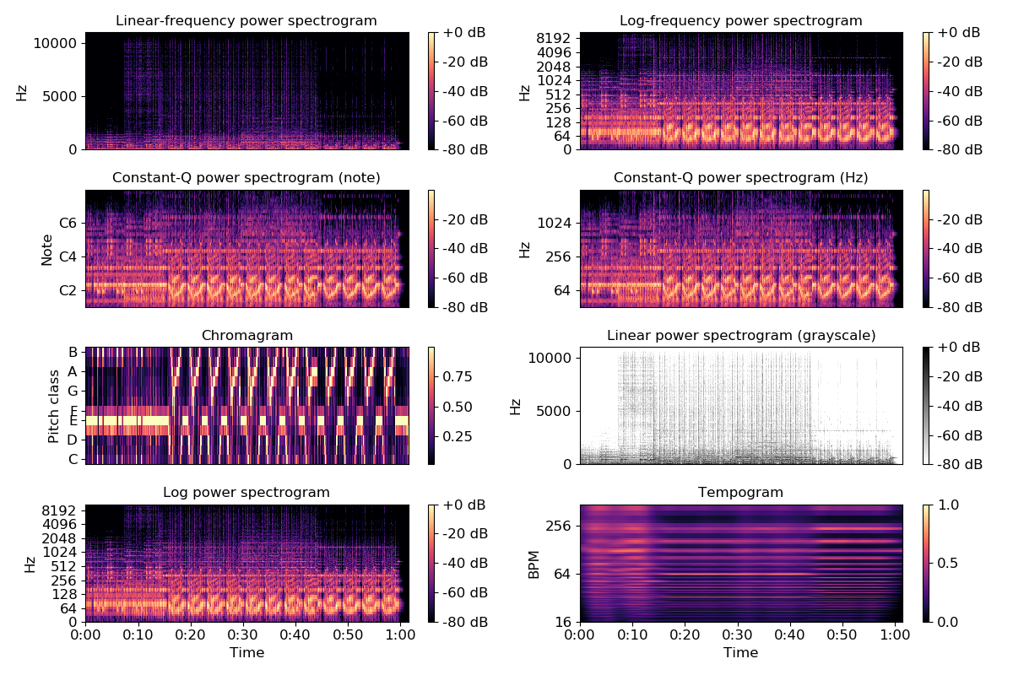
Draw beat-synchronous chroma in natural time
>>> plt.figure()
>>> tempo, beat_f = librosa.beat.beat_track(y=y, sr=sr, trim=False)
>>> beat_f = librosa.util.fix_frames(beat_f, x_max=C.shape[1])
>>> Csync = librosa.util.sync(C, beat_f, aggregate=np.median)
>>> beat_t = librosa.frames_to_time(beat_f, sr=sr)
>>> ax1 = plt.subplot(2,1,1)
>>> librosa.display.specshow(C, y_axis='chroma', x_axis='time')
>>> plt.title('Chroma (linear time)')
>>> ax2 = plt.subplot(2,1,2, sharex=ax1)
>>> librosa.display.specshow(Csync, y_axis='chroma', x_axis='time',
... x_coords=beat_t)
>>> plt.title('Chroma (beat time)')
>>> plt.tight_layout()
>>> plt.show()

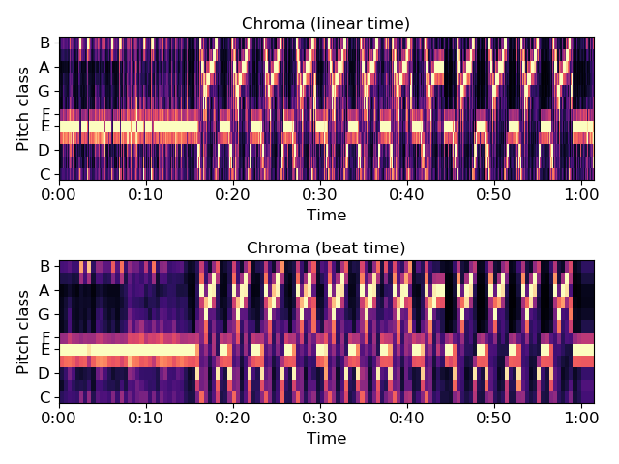
librosa.display.waveplot
librosa.display.waveplot(y, sr=22050, max_points=50000.0, x_axis='time', offset=0.0, max_sr=1000, ax=None, **kwargs)[source]
Plot the amplitude envelope of a waveform.
If y is monophonic, a filled curve is drawn between [-abs(y), abs(y)].
If y is stereo, the curve is drawn between [-abs(y[1]), abs(y[0])], so that the left and right channels are drawn above and below the axis, respectively.
Long signals (duration >= max_points) are down-sampled to at most max_sr before plotting.
Parameters: | y : np.ndarray [shape=(n,) or (2,n)]  audio time series (mono or stereo)  sr : number > 0 [scalar]  sampling rate of y  max_points : postive number or None  Maximum number of time-points to plot: if max_points exceeds the duration of y, then y is downsampled.  If None, no downsampling is performed.  x_axis : str or None  Display of the x-axis ticks and tick markers. Accepted values are:  - ‘time’ : markers are shown as milliseconds, seconds, minutes, or hours.  Values are plotted in units of seconds.  - ‘s’ : markers are shown as seconds.  - ‘ms’ : markers are shown as milliseconds.  - ‘lag’ : like time, but past the halfway point counts as negative values.  - ‘lag_s’ : same as lag, but in seconds.  - ‘lag_ms’ : same as lag, but in milliseconds.  - None, ‘none’, or ‘off’: ticks and tick markers are hidden.  ax : matplotlib.axes.Axes or None  Axes to plot on instead of the default plt.gca().  offset : float  Horizontal offset (in seconds) to start the waveform plot  max_sr : number > 0 [scalar]  Maximum sampling rate for the visualization  kwargs  Additional keyword arguments to matplotlib.pyplot.fill_between
Returns: | pc : matplotlib.collections.PolyCollection  The PolyCollection created by fill_between.
See also
librosa.core.resample
matplotlib.pyplot.fill_between
Examples
Plot a monophonic waveform
>>> import matplotlib.pyplot as plt
>>> y, sr = librosa.load(librosa.util.example_audio_file(), duration=10)
>>> plt.figure()
>>> plt.subplot(3, 1, 1)
>>> librosa.display.waveplot(y, sr=sr)
>>> plt.title('Monophonic')
Or a stereo waveform
>>> y, sr = librosa.load(librosa.util.example_audio_file(),
... mono=False, duration=10)
>>> plt.subplot(3, 1, 2)
>>> librosa.display.waveplot(y, sr=sr)
>>> plt.title('Stereo')
Or harmonic and percussive components with transparency
>>> y, sr = librosa.load(librosa.util.example_audio_file(), duration=10)
>>> y_harm, y_perc = librosa.effects.hpss(y)
>>> plt.subplot(3, 1, 3)
>>> librosa.display.waveplot(y_harm, sr=sr, alpha=0.25)
>>> librosa.display.waveplot(y_perc, sr=sr, color='r', alpha=0.5)
>>> plt.title('Harmonic + Percussive')
>>> plt.tight_layout()
>>> plt.show()

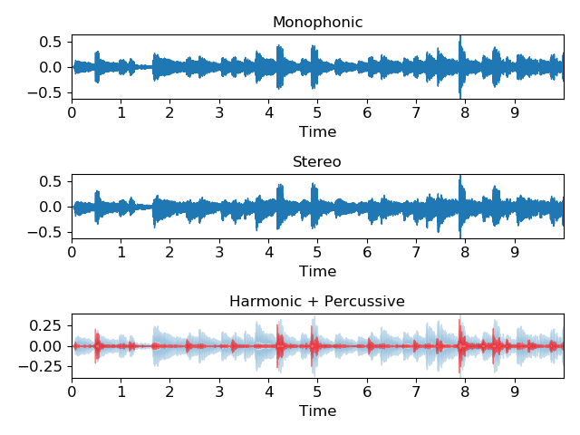
librosa.display.cmap
librosa.display.cmap(data, robust=True, cmap_seq='magma', cmap_bool='gray_r', cmap_div='coolwarm')[source]
Get a default colormap from the given data.
If the data is boolean, use a black and white colormap.
If the data has both positive and negative values, use a diverging colormap.
Otherwise, use a sequential colormap.
Parameters: | data : np.ndarray  Input data  robust : bool  If True, discard the top and bottom 2% of data when calculating range.  cmap_seq : str  The sequential colormap name  cmap_bool : str  The boolean colormap name  cmap_div : str  The diverging colormap name
Returns: | cmap : matplotlib.colors.Colormap  The colormap to use for data
See also
matplotlib.pyplot.colormaps

librosa.display.TimeFormatter
class librosa.display.TimeFormatter(lag=False, unit=None)[source]
A tick formatter for time axes.
Automatically switches between seconds, minutes:seconds, or hours:minutes:seconds.
Parameters: | lag : bool  If True, then the time axis is interpreted in lag coordinates. Anything past the midpoint will be converted to negative time.  unit : str or None  Abbreviation of the physical unit for axis labels and ticks. Either equal to s (seconds) or ms (milliseconds) or None (default). If set to None, the resulting TimeFormatter object adapts its string representation to the duration of the underlying time range: hh:mm:ss above 3600 seconds; mm:ss between 60 and 3600 seconds; and ss below 60 seconds.
See also
matplotlib.ticker.Formatter
Examples
For normal time
>>> import matplotlib.pyplot as plt
>>> times = np.arange(30)
>>> values = np.random.randn(len(times))
>>> plt.figure()
>>> ax = plt.gca()
>>> ax.plot(times, values)
>>> ax.xaxis.set_major_formatter(librosa.display.TimeFormatter())
>>> ax.set_xlabel('Time')
>>> plt.show()
(Source code)
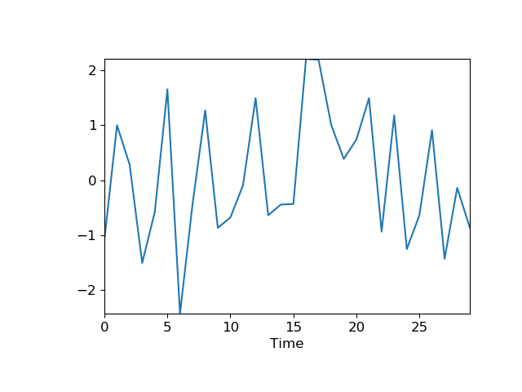
Manually set the physical time unit of the x-axis to milliseconds
>>> times = np.arange(100)
>>> values = np.random.randn(len(times))
>>> plt.figure()
>>> ax = plt.gca()
>>> ax.plot(times, values)
>>> ax.xaxis.set_major_formatter(librosa.display.TimeFormatter(unit='ms'))
>>> ax.set_xlabel('Time (ms)')
For lag plots
>>> times = np.arange(60)
>>> values = np.random.randn(len(times))
>>> plt.figure()
>>> ax = plt.gca()
>>> ax.plot(times, values)
>>> ax.xaxis.set_major_formatter(librosa.display.TimeFormatter(lag=True))
>>> ax.set_xlabel('Lag')

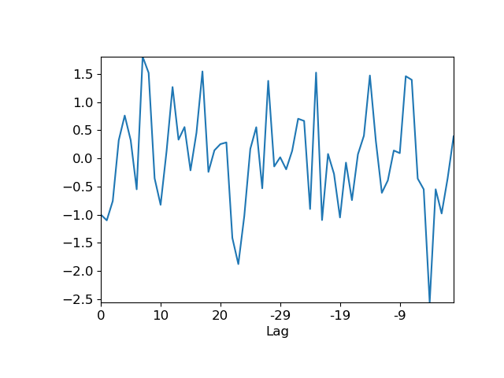
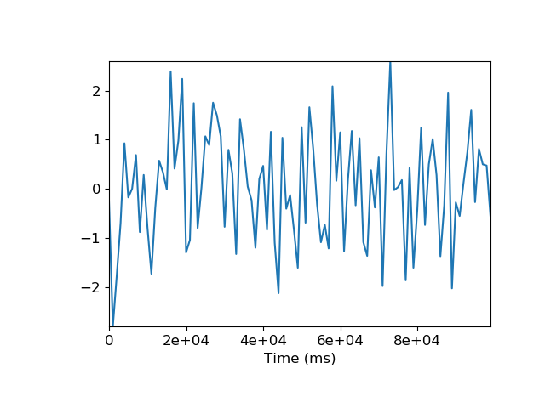
__init__(self, lag=False, unit=None)[source]
Initialize self. See help(type(self)) for accurate signature.
Methods
__init__(self[, lag, unit]) | Initialize self.
create_dummy_axis(self, \*\*kwargs)
fix_minus(self, s) | Some classes may want to replace a hyphen for minus with the proper unicode symbol (U+2212) for typographical correctness.
format_data(self, value) | Returns the full string representation of the value with the position unspecified.
format_data_short(self, value) | Return a short string version of the tick value.
format_ticks(self, values) | Return the tick labels for all the ticks at once.
get_offset(self)
set_axis(self, axis)
set_bounds(self, vmin, vmax)
set_data_interval(self, vmin, vmax)
set_locs(self, locs)
set_view_interval(self, vmin, vmax)
Attributes
axis
locs

librosa.display.NoteFormatter
class librosa.display.NoteFormatter(octave=True, major=True)[source]
Ticker formatter for Notes
Parameters: | octave : bool  If True, display the octave number along with the note name.  Otherwise, only show the note name (and cent deviation)  major : bool  If True, ticks are always labeled.  If False, ticks are only labeled if the span is less than 2 octaves
See also
LogHzFormatter
matplotlib.ticker.Formatter
Examples
>>> import matplotlib.pyplot as plt
>>> values = librosa.midi_to_hz(np.arange(48, 72))
>>> plt.figure()
>>> ax1 = plt.subplot(2,1,1)
>>> ax1.bar(np.arange(len(values)), values)
>>> ax1.set_ylabel('Hz')
>>> ax2 = plt.subplot(2,1,2)
>>> ax2.bar(np.arange(len(values)), values)
>>> ax2.yaxis.set_major_formatter(librosa.display.NoteFormatter())
>>> ax2.set_ylabel('Note')
>>> plt.show()
(Source code)
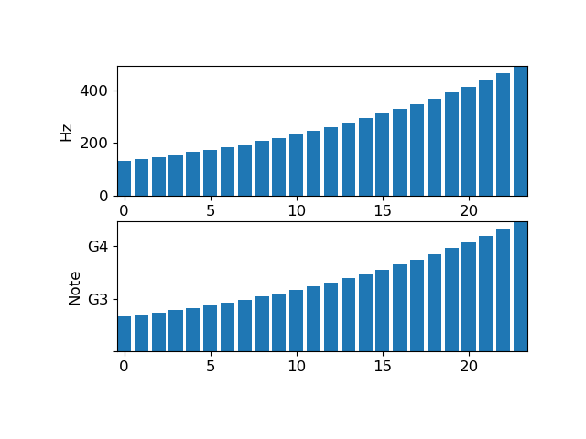
__init__(self, octave=True, major=True)[source]
Initialize self. See help(type(self)) for accurate signature.
Methods
__init__(self[, octave, major]) | Initialize self.
create_dummy_axis(self, \*\*kwargs)
fix_minus(self, s) | Some classes may want to replace a hyphen for minus with the proper unicode symbol (U+2212) for typographical correctness.
format_data(self, value) | Returns the full string representation of the value with the position unspecified.
format_data_short(self, value) | Return a short string version of the tick value.
format_ticks(self, values) | Return the tick labels for all the ticks at once.
get_offset(self)
set_axis(self, axis)
set_bounds(self, vmin, vmax)
set_data_interval(self, .
vmin, vmax)
set_locs(self, locs)
set_view_interval(self, vmin, vmax)
Attributes
axis
locs

librosa.display.LogHzFormatter
class librosa.display.LogHzFormatter(major=True)[source]
Ticker formatter for logarithmic frequency
Parameters: | major : bool  If True, ticks are always labeled.  If False, ticks are only labeled if the span is less than 2 octaves
See also
NoteFormatter
matplotlib.ticker.Formatter
Examples
>>> import matplotlib.pyplot as plt
>>> values = librosa.midi_to_hz(np.arange(48, 72))
>>> plt.figure()
>>> ax1 = plt.subplot(2,1,1)
>>> ax1.bar(np.arange(len(values)), values)
>>> ax1.yaxis.set_major_formatter(librosa.display.LogHzFormatter())
>>> ax1.set_ylabel('Hz')
>>> ax2 = plt.subplot(2,1,2)
>>> ax2.bar(np.arange(len(values)), values)
>>> ax2.yaxis.set_major_formatter(librosa.display.NoteFormatter())
>>> ax2.set_ylabel('Note')
>>> plt.show()
(Source code)
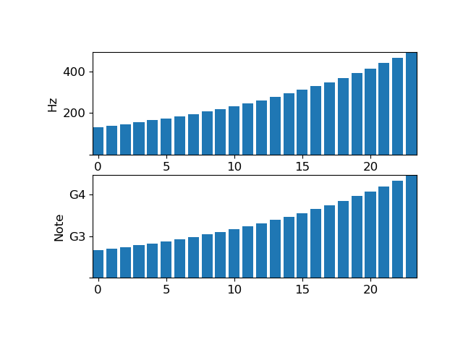
__init__(self, major=True)[source]
Initialize self. See help(type(self)) for accurate signature.
Methods
__init__(self[, major]) | Initialize self.
create_dummy_axis(self, \*\*kwargs)
fix_minus(self, s) | Some classes may want to replace a hyphen for minus with the proper unicode symbol (U+2212) for typographical correctness.
format_data(self, value) | Returns the full string representation of the value with the position unspecified.
format_data_short(self, value) | Return a short string version of the tick value.
format_ticks(self, values) | Return the tick labels for all the ticks at once.
get_offset(self)
set_axis(self, axis)
set_bounds(self, vmin, vmax)
set_data_interval(self, vmin, vmax)
set_locs(self, locs)
set_view_interval(self, vmin, vmax)
Attributes
axis
locs

librosa.display.ChromaFormatter
class librosa.display.ChromaFormatter[source]
A formatter for chroma axes
See also
matplotlib.ticker.Formatter
Examples
>>> import matplotlib.pyplot as plt
>>> values = np.arange(12)
>>> plt.figure()
>>> ax = plt.gca()
>>> ax.plot(values)
>>> ax.yaxis.set_major_formatter(librosa.display.ChromaFormatter())
>>> ax.set_ylabel('Pitch class')
>>> plt.show()
(Source code)
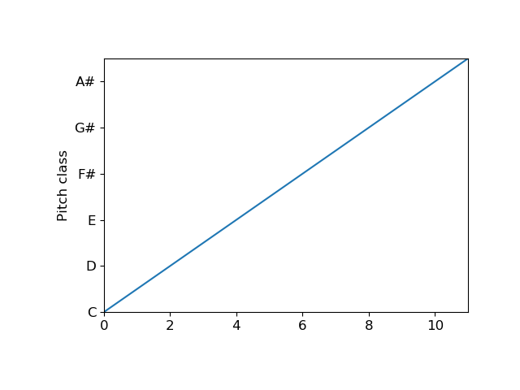

__init__(self, /, *args, **kwargs)
Initialize self. See help(type(self)) for accurate signature.
Methods
create_dummy_axis(self, \*\*kwargs)
fix_minus(self, s) | Some classes may want to replace a hyphen for minus with the proper unicode symbol (U+2212) for typographical correctness.
format_data(self, value) | Returns the full string representation of the value with the position unspecified.
format_data_short(self, value) | Return a short string version of the tick value.
format_ticks(self, values) | Return the tick labels for all the ticks at once.
get_offset(self)
set_axis(self, axis)
set_bounds(self, vmin, vmax)
set_data_interval(self, vmin, vmax)
set_locs(self, locs)
set_view_interval(self, vmin, vmax)
Attributes
axis
locs

librosa.display.TonnetzFormatter
class librosa.display.TonnetzFormatter[source]
A formatter for tonnetz axes
See also
matplotlib.ticker.Formatter
Examples
>>> import matplotlib.pyplot as plt
>>> values = np.arange(6)
>>> plt.figure()
>>> ax = plt.gca()
>>> ax.plot(values)
>>> ax.yaxis.set_major_formatter(librosa.display.TonnetzFormatter())
>>> ax.set_ylabel('Tonnetz')
>>> plt.show()
(Source code)
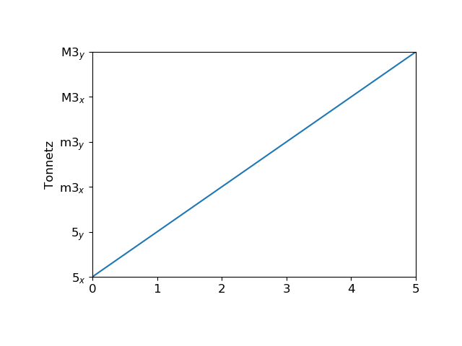

__init__(self, /, *args, **kwargs)
Initialize self. See help(type(self)) for accurate signature.
Methods
create_dummy_axis(self, \*\*kwargs)
fix_minus(self, s) | Some classes may want to replace a hyphen for minus with the proper unicode symbol (U+2212) for typographical correctness.
format_data(self, value) | Returns the full string representation of the value with the position unspecified.
format_data_short(self, value) | Return a short string version of the tick value.
format_ticks(self, values) | Return the tick labels for all the ticks at once.
get_offset(self)
set_axis(self, axis)
set_bounds(self, vmin, vmax)
set_data_interval(self, vmin, vmax)
set_locs(self, locs)
set_view_interval(self, vmin, vmax)
Attributes
axis
locs

Feature extraction

Spectral features
chroma_stft([y, sr, S, norm, n_fft, …]) | Compute a chromagram from a waveform or power spectrogram.
chroma_cqt([y, sr, C, hop_length, fmin, …]) | Constant-Q chromagram
chroma_cens([y, sr, C, hop_length, fmin, …]) | Computes the chroma variant “Chroma Energy Normalized” (CENS), following [R674badebce0d-1].
melspectrogram([y, sr, S, n_fft, …]) | Compute a mel-scaled spectrogram.
mfcc([y, sr, S, n_mfcc, dct_type, norm, lifter]) | Mel-frequency cepstral coefficients (MFCCs)
rms([y, S, frame_length, hop_length, …]) | Compute root-mean-square (RMS) value for each frame, either from the audio samples y or from a spectrogram S.
spectral_centroid([y, sr, S, n_fft, …]) | Compute the spectral centroid.
spectral_bandwidth([y, sr, S, n_fft, …]) | Compute p’th-order spectral bandwidth.
spectral_contrast([y, sr, S, n_fft, …]) | Compute spectral contrast [R6ffcc01153df-1]
spectral_flatness([y, S, n_fft, hop_length, …]) | Compute spectral flatness
spectral_rolloff([y, sr, S, n_fft, …]) | Compute roll-off frequency.
poly_features([y, sr, S, n_fft, hop_length, …]) | Get coefficients of fitting an nth-order polynomial to the columns of a spectrogram.
tonnetz([y, sr, chroma]) | Computes the tonal centroid features (tonnetz), following the method of [Recf246e5a035-1].
zero_crossing_rate(y[, frame_length, …]) | Compute the zero-crossing rate of an audio time series.

Rhythm features
tempogram([y, sr, onset_envelope, …]) | Compute the tempogram: local autocorrelation of the onset strength envelope.
fourier_tempogram([y, sr, onset_envelope, …]) | Compute the Fourier tempogram: the short-time Fourier transform of the onset strength envelope.

Feature manipulation
delta(data[, width, order, axis, mode]) | Compute delta features: local estimate of the derivative of the input data along the selected axis.
stack_memory(data[, n_steps, delay]) | Short-term history embedding: vertically concatenate a data vector or matrix with delayed copies of itself.

Feature inversion
inverse.mel_to_stft(M[, sr, n_fft, power]) | Approximate STFT magnitude from a Mel power spectrogram.
inverse.mel_to_audio(M[, sr, n_fft, …]) | Invert a mel power spectrogram to audio using Griffin-Lim.
inverse.mfcc_to_mel(mfcc[, n_mels, …]) | Invert Mel-frequency cepstral coefficients to approximate a Mel power spectrogram.
inverse.mfcc_to_audio(mfcc[, n_mels, …]) | Convert Mel-frequency cepstral coefficients to a time-domain audio signal

librosa.feature.chroma_stft
librosa.feature.chroma_stft(y=None, sr=22050, S=None, norm=inf, n_fft=2048, hop_length=512, win_length=None, window='hann', center=True, pad_mode='reflect', tuning=None, n_chroma=12, **kwargs)[source]
Compute a chromagram from a waveform or power spectrogram.
This implementation is derived from chromagram_E [1]

[1] | Ellis, Daniel P.W. “Chroma feature analysis and synthesis” 2007/04/21 http://labrosa.ee.columbia.edu/matlab/chroma-ansyn/
Parameters: | y : np.ndarray [shape=(n,)] or None  audio time series  sr : number > 0 [scalar]  sampling rate of y  S : np.ndarray [shape=(d, t)] or None  power spectrogram  norm : float or None  Column-wise normalization. See librosa.util.normalize for details.  If None, no normalization is performed.  n_fft : int > 0 [scalar]  FFT window size if provided y, sr instead of S  hop_length : int > 0 [scalar]  hop length if provided y, sr instead of S  win_length : int <= n_fft [scalar]  Each frame of audio is windowed by window(). The window will be of length win_length and then padded with zeros to match n_fft.  If unspecified, defaults to win_length = n_fft.  window : string, tuple, number, function, or np.ndarray [shape=(n_fft,)]  - a window specification (string, tuple, or number); see scipy.signal.get_window  - a window function, such as scipy.signal.hanning  - a vector or array of length n_fft  center : boolean  - If True, the signal y is padded so that frame t is centered at y[t * hop_length].  - If False, then frame t begins at y[t * hop_length]  pad_mode : string  If center=True, the padding mode to use at the edges of the signal. By default, STFT uses reflection padding.  tuning : float [scalar] or None.  Deviation from A440 tuning in fractional chroma bins. If None, it is automatically estimated.  n_chroma : int > 0 [scalar]  Number of chroma bins to produce (12 by default).  kwargs : additional keyword arguments  Arguments to parameterize chroma filters. See librosa.filters.chroma for details.
Returns: | chromagram : np.ndarray [shape=(n_chroma, t)]  Normalized energy for each chroma bin at each frame.
See also
librosa.filters.chroma
Chroma filter bank construction
librosa.util.normalize
Vector normalization
Examples
>>> y, sr = librosa.load(librosa.util.example_audio_file())
>>> librosa.feature.chroma_stft(y=y, sr=sr)
array([[ 0.974, 0.881, ..., 0.925, 1. ],
[ 1. , 0.841, ..., 0.882, 0.878],
...,
[ 0.658, 0.985, ..., 0.878, 0.764],
[ 0.969, 0.92 , ..., 0.974, 0.915]])
Use an energy (magnitude) spectrum instead of power spectrogram
>>> S = np.abs(librosa.stft(y))
>>> chroma = librosa.feature.chroma_stft(S=S, sr=sr)
>>> chroma
array([[ 0.884, 0.91 , ..., 0.861, 0.858],
[ 0.963, 0.785, ..., 0.968, 0.896],
...,
[ 0.871, 1. , ..., 0.928, 0.829],
[ 1. , 0.982, ..., 0.93 , 0.878]])
Use a pre-computed power spectrogram with a larger frame
>>> S = np.abs(librosa.stft(y, n_fft=4096))**2
>>> chroma = librosa.feature.chroma_stft(S=S, sr=sr)
>>> chroma
array([[ 0.685, 0.477, ..., 0.961, 0.986],
[ 0.674, 0.452, ..., 0.952, 0.926],
...,
[ 0.844, 0.575, ..., 0.934, 0.869],
[ 0.793, 0.663, ..., 0.964, 0.972]])
>>> import matplotlib.pyplot as plt
>>> plt.figure(figsize=(10, 4))
>>> librosa.display.specshow(chroma, y_axis='chroma', x_axis='time')
>>> plt.colorbar()
>>> plt.title('Chromagram')
>>> plt.tight_layout()
>>> plt.show()
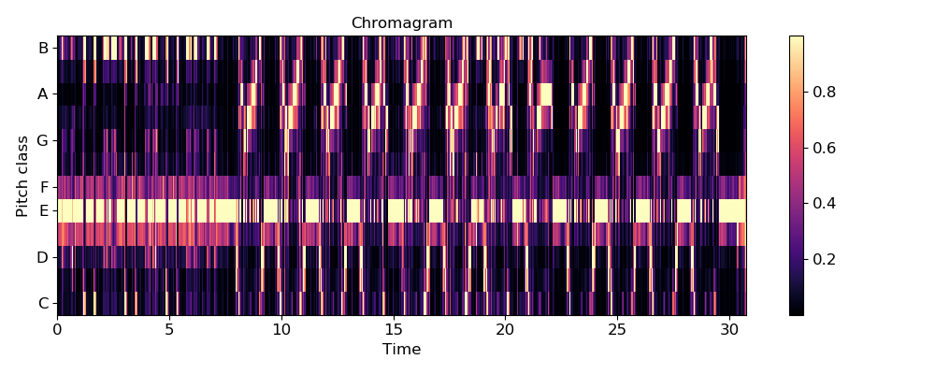

librosa.feature.chroma_cqt
librosa.feature.chroma_cqt(y=None, sr=22050, C=None, hop_length=512, fmin=None, norm=inf, threshold=0.0, tuning=None, n_chroma=12, n_octaves=7, window=None, bins_per_octave=None, cqt_mode='full')[source]
Constant-Q chromagram
Parameters: | y : np.ndarray [shape=(n,)]  audio time series  sr : number > 0  sampling rate of y  C : np.ndarray [shape=(d, t)] [Optional]  a pre-computed constant-Q spectrogram  hop_length : int > 0  number of samples between successive chroma frames  fmin : float > 0  minimum frequency to analyze in the CQT. Default: ‘C1’ ~= 32.7 Hz  norm : int > 0, +-np.inf, or None  Column-wise normalization of the chromagram.  threshold : float  Pre-normalization energy threshold. Values below the threshold are discarded, resulting in a sparse chromagram.  tuning : float  Deviation (in fractions of a CQT bin) from A440 tuning  n_chroma : int > 0  Number of chroma bins to produce  n_octaves : int > 0  Number of octaves to analyze above fmin  window : None or np.ndarray  Optional window parameter to filters.cq_to_chroma  bins_per_octave : int > 0  Number of bins per octave in the CQT. Default: matches n_chroma  cqt_mode : [‘full’, ‘hybrid’]  Constant-Q transform mode
Returns: | chromagram : np.ndarray [shape=(n_chroma, t)]  The output chromagram
See also
librosa.util.normalize
librosa.core.cqt
librosa.core.hybrid_cqt
chroma_stft
Examples
Compare a long-window STFT chromagram to the CQT chromagram
>>> y, sr = librosa.load(librosa.util.example_audio_file(),
... offset=10, duration=15)
>>> chroma_stft = librosa.feature.chroma_stft(y=y, sr=sr,
... n_chroma=12, n_fft=4096)
>>> chroma_cq = librosa.feature.chroma_cqt(y=y, sr=sr)
>>> import matplotlib.pyplot as plt
>>> plt.figure()
>>> plt.subplot(2,1,1)
>>> librosa.display.specshow(chroma_stft, y_axis='chroma')
>>> plt.title('chroma_stft')
>>> plt.colorbar()
>>> plt.subplot(2,1,2)
>>> librosa.display.specshow(chroma_cq, y_axis='chroma', x_axis='time')
>>> plt.title('chroma_cqt')
>>> plt.colorbar()
>>> plt.tight_layout()
>>> plt.show()

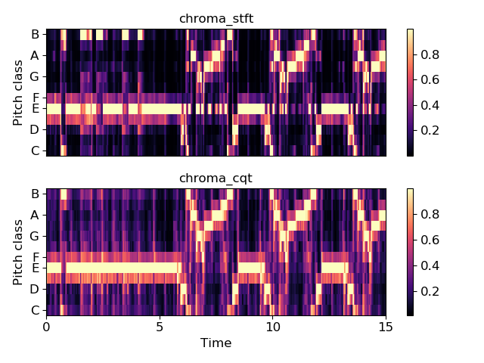
librosa.feature.chroma_cens
librosa.feature.chroma_cens(y=None, sr=22050, C=None, hop_length=512, fmin=None, tuning=None, n_chroma=12, n_octaves=7, bins_per_octave=None, cqt_mode='full', window=None, norm=2, win_len_smooth=41, smoothing_window='hann')[source]
Computes the chroma variant “Chroma Energy Normalized” (CENS), following [1].
To compute CENS features, following steps are taken after obtaining chroma vectors using chroma_cqt: 1. L-1 normalization of each chroma vector 2. Quantization of amplitude based on “log-like” amplitude thresholds 3. (optional) Smoothing with sliding window. Default window length = 41 frames 4. (not implemented) Downsampling
CENS features are robust to dynamics, timbre and articulation, thus these are commonly used in audio matching and retrieval applications.

[1] | Meinard Müller and Sebastian Ewert “Chroma Toolbox: MATLAB implementations for extracting variants of chroma-based audio features” In Proceedings of the International Conference on Music Information Retrieval (ISMIR), 2011.
Parameters: | y : np.ndarray [shape=(n,)]  audio time series  sr : number > 0  sampling rate of y  C : np.ndarray [shape=(d, t)] [Optional]  a pre-computed constant-Q spectrogram  hop_length : int > 0  number of samples between successive chroma frames  fmin : float > 0  minimum frequency to analyze in the CQT. Default: ‘C1’ ~= 32.7 Hz  norm : int > 0, +-np.inf, or None  Column-wise normalization of the chromagram.  tuning : float  Deviation (in fractions of a CQT bin) from A440 tuning  n_chroma : int > 0  Number of chroma bins to produce  n_octaves : int > 0  Number of octaves to analyze above fmin  window : None or np.ndarray  Optional window parameter to filters.cq_to_chroma  bins_per_octave : int > 0  Number of bins per octave in the CQT. Default: matches n_chroma  cqt_mode : [‘full’, ‘hybrid’]  Constant-Q transform mode  win_len_smooth : int > 0 or None  Length of temporal smoothing window. None disables temporal smoothing. Default: 41  smoothing_window : str, float or tuple  Type of window function for temporal smoothing. See filters.get_window for possible inputs. Default: ‘hann’
Returns: | chroma_cens : np.ndarray [shape=(n_chroma, t)]  The output cens-chromagram
See also
chroma_cqt
Compute a chromagram from a constant-Q transform.
chroma_stft
Compute a chromagram from an STFT spectrogram or waveform.
filters.get_window
Compute a window function.
Examples
Compare standard cqt chroma to CENS.
>>> y, sr = librosa.load(librosa.util.example_audio_file(),
... offset=10, duration=15)
>>> chroma_cens = librosa.feature.chroma_cens(y=y, sr=sr)
>>> chroma_cq = librosa.feature.chroma_cqt(y=y, sr=sr)
>>> import matplotlib.pyplot as plt
>>> plt.figure()
>>> plt.subplot(2,1,1)
>>> librosa.display.specshow(chroma_cq, y_axis='chroma')
>>> plt.title('chroma_cq')
>>> plt.colorbar()
>>> plt.subplot(2,1,2)
>>> librosa.display.specshow(chroma_cens, y_axis='chroma', x_axis='time')
>>> plt.title('chroma_cens')
>>> plt.colorbar()
>>> plt.tight_layout()
>>> plt.show()

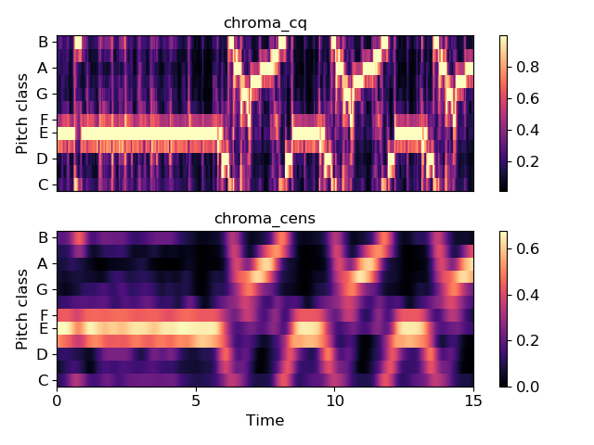
librosa.feature.melspectrogram
librosa.feature.melspectrogram(y=None, sr=22050, S=None, n_fft=2048, hop_length=512, win_length=None, window='hann', center=True, pad_mode='reflect', power=2.0, **kwargs)[source]
Compute a mel-scaled spectrogram.
If a spectrogram input S is provided, then it is mapped directly onto the mel basis mel_f by mel_f.dot(S).
If a time-series input y, sr is provided, then its magnitude spectrogram S is first computed, and then mapped onto the mel scale by mel_f.dot(S**power). By default, power=2 operates on a power spectrum.
Parameters: | y : np.ndarray [shape=(n,)] or None  audio time-series  sr : number > 0 [scalar]  sampling rate of y  S : np.ndarray [shape=(d, t)]  spectrogram  n_fft : int > 0 [scalar]  length of the FFT window  hop_length : int > 0 [scalar]  number of samples between successive frames. See librosa.core.stft  win_length : int <= n_fft [scalar]  Each frame of audio is windowed by window(). The window will be of length win_length and then padded with zeros to match n_fft.  If unspecified, defaults to win_length = n_fft.  window : string, tuple, number, function, or np.ndarray [shape=(n_fft,)]  - a window specification (string, tuple, or number); see scipy.signal.get_window  - a window function, such as scipy.signal.hanning  - a vector or array of length n_fft  center : boolean  - If True, the signal y is padded so that frame t is centered at y[t * hop_length].  - If False, then frame t begins at y[t * hop_length]  pad_mode : string  If center=True, the padding mode to use at the edges of the signal. By default, STFT uses reflection padding.  power : float > 0 [scalar]  Exponent for the magnitude melspectrogram. e.g., 1 for energy, 2 for power, etc.  kwargs : additional keyword arguments  Mel filter bank parameters. See librosa.filters.mel for details.
Returns: | S : np.ndarray [shape=(n_mels, t)]  Mel spectrogram
See also
librosa.filters.mel
Mel filter bank construction
librosa.core.stft
Short-time Fourier Transform
Examples
>>> y, sr = librosa.load(librosa.util.example_audio_file())
>>> librosa.feature.melspectrogram(y=y, sr=sr)
array([[ 2.891e-07, 2.548e-03, ..., 8.116e-09, 5.633e-09],
[ 1.986e-07, 1.162e-02, ..., 9.332e-08, 6.716e-09],
...,
[ 3.668e-09, 2.029e-08, ..., 3.208e-09, 2.864e-09],
[ 2.561e-10, 2.096e-09, ..., 7.543e-10, 6.101e-10]])
Using a pre-computed power spectrogram would give the same result:
>>> D = np.abs(librosa.stft(y))**2
>>> S = librosa.feature.melspectrogram(S=D, sr=sr)
Display of mel-frequency spectrogram coefficients, with custom arguments for mel filterbank construction (default is fmax=sr/2):
>>> # Passing through arguments to the Mel filters
>>> S = librosa.feature.melspectrogram(y=y, sr=sr, n_mels=128,
... fmax=8000)
>>> import matplotlib.pyplot as plt
>>> plt.figure(figsize=(10, 4))
>>> S_dB = librosa.power_to_db(S, ref=np.max)
>>> librosa.display.specshow(S_dB, x_axis='time',
... y_axis='mel', sr=sr,
... fmax=8000)
>>> plt.colorbar(format='%+2.0f dB')
>>> plt.title('Mel-frequency spectrogram')
>>> plt.tight_layout()
>>> plt.show()

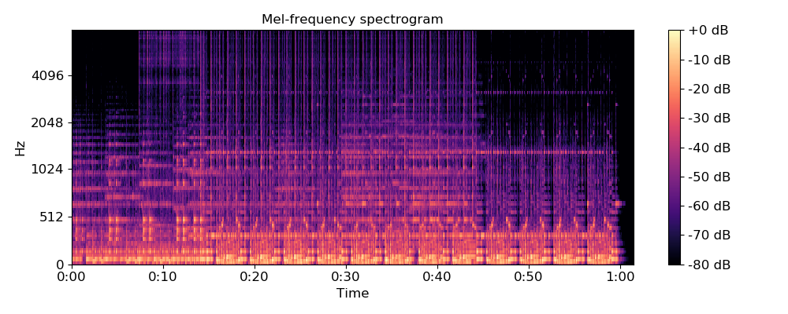
librosa.feature.mfcc
librosa.feature.mfcc(y=None, sr=22050, S=None, n_mfcc=20, dct_type=2, norm='ortho', lifter=0, **kwargs)[source]
Mel-frequency cepstral coefficients (MFCCs)
Parameters: | y : np.ndarray [shape=(n,)] or None  audio time series  sr : number > 0 [scalar]  sampling rate of y  S : np.ndarray [shape=(d, t)] or None  log-power Mel spectrogram  n_mfcc: int > 0 [scalar]  number of MFCCs to return  dct_type : None, or {1, 2, 3}  Discrete cosine transform (DCT) type. By default, DCT type-2 is used.  norm : None or ‘ortho’  If dct_type is 2 or 3, setting norm=’ortho’ uses an ortho-normal DCT basis.  Normalization is not supported for dct_type=1.  lifter : number >= 0  If lifter>0, apply liftering (cepstral filtering) to the MFCCs:  M[n, :] <- M[n, :] * (1 + sin(pi * (n + 1) / lifter)) * lifter / 2  Setting lifter >= 2 * n_mfcc emphasizes the higher-order coefficients. As lifter increases, the coefficient weighting becomes approximately linear.  kwargs : additional keyword arguments  Arguments to melspectrogram, if operating on time series input
Returns: | M : np.ndarray [shape=(n_mfcc, t)]  MFCC sequence
See also
melspectrogram
scipy.fftpack.dct
Examples
Generate mfccs from a time series
>>> y, sr = librosa.load(librosa.util.example_audio_file(), offset=30, duration=5)
>>> librosa.feature.mfcc(y=y, sr=sr)
array([[ -5.229e+02, -4.944e+02, ..., -5.229e+02, -5.229e+02],
[ 7.105e-15, 3.787e+01, ..., -7.105e-15, -7.105e-15],
...,
[ 1.066e-14, -7.500e+00, ..., 1.421e-14, 1.421e-14],
[ 3.109e-14, -5.058e+00, ..., 2.931e-14, 2.931e-14]])
Using a different hop length and HTK-style Mel frequencies
>>> librosa.feature.mfcc(y=y, sr=sr, hop_length=1024, htk=True)
array([[-1.628e+02, -8.903e+01, -1.409e+02, ..., -1.078e+02,
-2.504e+02, -2.393e+02],
[ 1.275e+02, 9.532e+01, 1.019e+02, ..., 1.152e+02,
2.224e+02, 1.750e+02],
[ 1.139e+01, 6.155e+00, 1.266e+01, ..., 4.557e+01,
4.585e+01, 3.985e+01],
...,
[ 3.462e+00, 4.032e+00, -5.694e-01, ..., -6.677e+00,
-1.183e-01, 1.485e+00],
[ 9.569e-01, 1.069e+00, -6.865e+00, ..., -9.598e+00,
-1.611e+00, -6.716e+00],
[ 8.457e+00, 3.582e+00, -1.156e-01, ..., -3.018e+00,
-1.456e+01, -6.991e+00]], dtype=float32)
Use a pre-computed log-power Mel spectrogram
>>> S = librosa.feature.melspectrogram(y=y, sr=sr, n_mels=128,
... fmax=8000)
>>> librosa.feature.mfcc(S=librosa.power_to_db(S))
array([[ -5.207e+02, -4.898e+02, ..., -5.207e+02, -5.207e+02],
[ -2.576e-14, 4.054e+01, ..., -3.997e-14, -3.997e-14],
...,
[ 7.105e-15, -3.534e+00, ..., 0.000e+00, 0.000e+00],
[ 3.020e-14, -2.613e+00, ..., 3.553e-14, 3.553e-14]])
Get more components
>>> mfccs = librosa.feature.mfcc(y=y, sr=sr, n_mfcc=40)
Visualize the MFCC series
>>> import matplotlib.pyplot as plt
>>> plt.figure(figsize=(10, 4))
>>> librosa.display.specshow(mfccs, x_axis='time')
>>> plt.colorbar()
>>> plt.title('MFCC')
>>> plt.tight_layout()
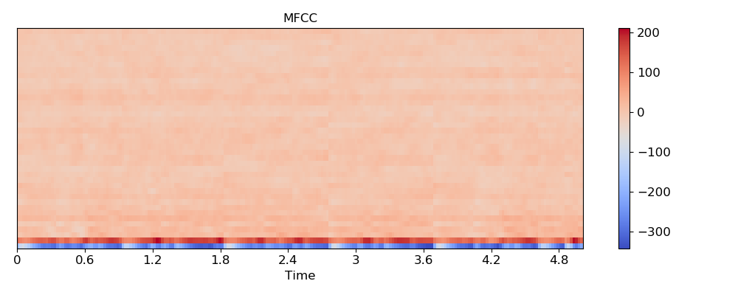
>>> plt.show()
Compare different DCT bases
>>> m_slaney = librosa.feature.mfcc(y=y, sr=sr, dct_type=2)
>>> m_htk = librosa.feature.mfcc(y=y, sr=sr, dct_type=3)
>>> plt.figure(figsize=(10, 6))
>>> plt.subplot(2, 1, 1)
>>> librosa.display.specshow(m_slaney, x_axis='time')
>>> plt.title('RASTAMAT / Auditory toolbox (dct_type=2)')
>>> plt.colorbar()
>>> plt.subplot(2, 1, 2)
>>> librosa.display.specshow(m_htk, x_axis='time')
>>> plt.title('HTK-style (dct_type=3)')
>>> plt.colorbar()
>>> plt.tight_layout()
>>> plt.show()

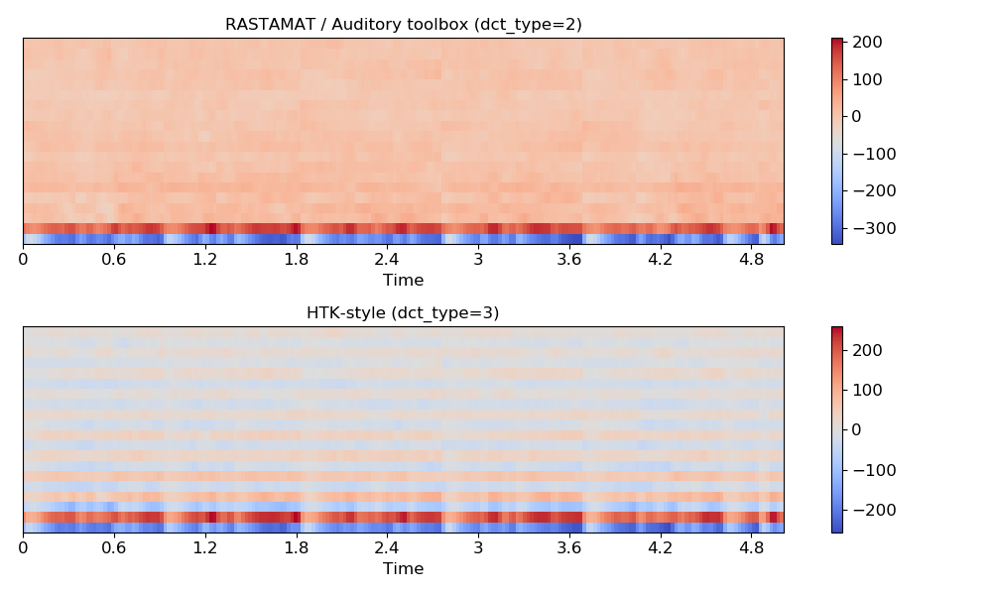
librosa.feature.rms
librosa.feature.rms(y=None, S=None, frame_length=2048, hop_length=512, center=True, pad_mode='reflect')[source]
Compute root-mean-square (RMS) value for each frame, either from the audio samples y or from a spectrogram S.
Computing the RMS value from audio samples is faster as it doesn’t require a STFT calculation. However, using a spectrogram will give a more accurate representation of energy over time because its frames can be windowed, thus prefer using S if it’s already available.
Parameters: | y : np.ndarray [shape=(n,)] or None  (optional) audio time series. Required if S is not input.  S : np.ndarray [shape=(d, t)] or None  (optional) spectrogram magnitude. Required if y is not input.  frame_length : int > 0 [scalar]  length of analysis frame (in samples) for energy calculation  hop_length : int > 0 [scalar]  hop length for STFT. See librosa.core.stft for details.  center : bool  If True and operating on time-domain input (y), pad the signal by frame_length//2 on either side.  If operating on spectrogram input, this has no effect.  pad_mode : str  Padding mode for centered analysis. See np.pad for valid values.
Returns: | rms : np.ndarray [shape=(1, t)]  RMS value for each frame
Examples
>>> y, sr = librosa.load(librosa.util.example_audio_file())
>>> librosa.feature.rms(y=y)
array([[ 0. , 0.056, ..., 0. , 0. ]], dtype=float32)
Or from spectrogram input
>>> S, phase = librosa.magphase(librosa.stft(y))
>>> rms = librosa.feature.rms(S=S)
>>> import matplotlib.pyplot as plt
>>> plt.figure()
>>> plt.subplot(2, 1, 1)
>>> plt.semilogy(rms.T, label='RMS Energy')
>>> plt.xticks([])
>>> plt.xlim([0, rms.shape[-1]])
>>> plt.legend()
>>> plt.subplot(2, 1, 2)
>>> librosa.display.specshow(librosa.amplitude_to_db(S, ref=np.max),
... y_axis='log', x_axis='time')
>>> plt.title('log Power spectrogram')
>>> plt.tight_layout()
Use a STFT window of constant ones and no frame centering to get consistent results with the RMS computed from the audio samples y
>>> S = librosa.magphase(librosa.stft(y, window=np.ones, center=False))[0]
>>> librosa.feature.rms(S=S)
>>> plt.show()

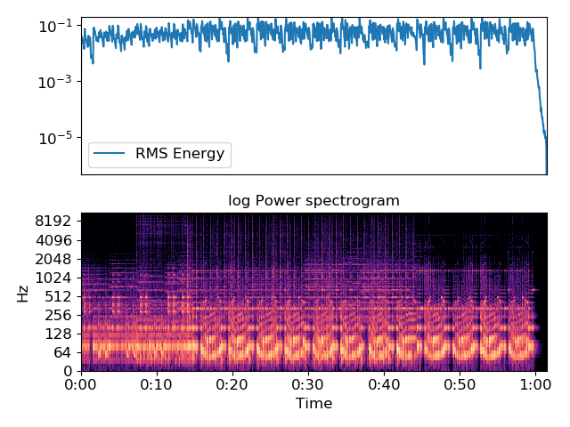
librosa.feature.spectral_centroid
librosa.feature.spectral_centroid(y=None, sr=22050, S=None, n_fft=2048, hop_length=512, freq=None, win_length=None, window='hann', center=True, pad_mode='reflect')[source]
Compute the spectral centroid.
Each frame of a magnitude spectrogram is normalized and treated as a distribution over frequency bins, from which the mean (centroid) is extracted per frame.
More precisely, the centroid at frame t is defined as [1]:
centroid[t] = sum_k S[k, t] * freq[k] / (sum_j S[j, t])
where S is a magnitude spectrogram, and freq is the array of frequencies (e.g., FFT frequencies in Hz) of the rows of S.

[1] | Klapuri, A., & Davy, M. (Eds.). (2007). Signal processing methods for music transcription, chapter 5. Springer Science & Business Media.
Parameters: | y : np.ndarray [shape=(n,)] or None  audio time series  sr : number > 0 [scalar]  audio sampling rate of y  S : np.ndarray [shape=(d, t)] or None  (optional) spectrogram magnitude  n_fft : int > 0 [scalar]  FFT window size  hop_length : int > 0 [scalar]  hop length for STFT. See librosa.core.stft for details.  freq : None or np.ndarray [shape=(d,) or shape=(d, t)]  Center frequencies for spectrogram bins. If None, then FFT bin center frequencies are used. Otherwise, it can be a single array of d center frequencies, or a matrix of center frequencies as constructed by librosa.core.ifgram  win_length : int <= n_fft [scalar]  Each frame of audio is windowed by window(). The window will be of length win_length and then padded with zeros to match n_fft.  If unspecified, defaults to win_length = n_fft.  window : string, tuple, number, function, or np.ndarray [shape=(n_fft,)]  - a window specification (string, tuple, or number); see scipy.signal.get_window  - a window function, such as scipy.signal.hanning  - a vector or array of length n_fft  center : boolean  - If True, the signal y is padded so that frame t is centered at y[t * hop_length].  - If False, then frame t begins at y[t * hop_length]  pad_mode : string  If center=True, the padding mode to use at the edges of the signal. By default, STFT uses reflection padding.
Returns: | centroid : np.ndarray [shape=(1, t)]  centroid frequencies
See also
librosa.core.stft
Short-time Fourier Transform
librosa.core.ifgram
Instantaneous-frequency spectrogram
Examples
From time-series input:
>>> y, sr = librosa.load(librosa.util.example_audio_file())
>>> cent = librosa.feature.spectral_centroid(y=y, sr=sr)
>>> cent
array([[ 4382.894, 626.588, ..., 5037.07 , 5413.398]])
From spectrogram input:
>>> S, phase = librosa.magphase(librosa.stft(y=y))
>>> librosa.feature.spectral_centroid(S=S)
array([[ 4382.894, 626.588, ..., 5037.07 , 5413.398]])
Using variable bin center frequencies:
>>> y, sr = librosa.load(librosa.util.example_audio_file())
>>> if_gram, D = librosa.ifgram(y)
>>> librosa.feature.spectral_centroid(S=np.abs(D), freq=if_gram)
array([[ 4420.719, 625.769, ..., 5011.86 , 5221.492]])
Plot the result
>>> import matplotlib.pyplot as plt
>>> plt.figure()
>>> plt.subplot(2, 1, 1)
>>> plt.semilogy(cent.T, label='Spectral centroid')
>>> plt.ylabel('Hz')
>>> plt.xticks([])
>>> plt.xlim([0, cent.shape[-1]])
>>> plt.legend()
>>> plt.subplot(2, 1, 2)
>>> librosa.display.specshow(librosa.amplitude_to_db(S, ref=np.max),
... y_axis='log', x_axis='time')
>>> plt.title('log Power spectrogram')
>>> plt.tight_layout()
>>> plt.show()

librosa.feature.spectral_centroid
librosa.feature.spectral_centroid(y=None, sr=22050, S=None, n_fft=2048, hop_length=512, freq=None, win_length=None, window='hann', center=True, pad_mode='reflect')[source]
Compute the spectral centroid.
Each frame of a magnitude spectrogram is normalized and treated as a distribution over frequency bins, from which the mean (centroid) is extracted per frame.
More precisely, the centroid at frame t is defined as [1]:
centroid[t] = sum_k S[k, t] * freq[k] / (sum_j S[j, t])
where S is a magnitude spectrogram, and freq is the array of frequencies (e.g., FFT frequencies in Hz) of the rows of S.

[1] | Klapuri, A., & Davy, M. (Eds.). (2007). Signal processing methods for music transcription, chapter 5. Springer Science & Business Media.
Parameters: | y : np.ndarray [shape=(n,)] or None  audio time series  sr : number > 0 [scalar]  audio sampling rate of y  S : np.ndarray [shape=(d, t)] or None  (optional) spectrogram magnitude  n_fft : int > 0 [scalar]  FFT window size  hop_length : int > 0 [scalar]  hop length for STFT. See librosa.core.stft for details.  freq : None or np.ndarray [shape=(d,) or shape=(d, t)]  Center frequencies for spectrogram bins. If None, then FFT bin center frequencies are used. Otherwise, it can be a single array of d center frequencies, or a matrix of center frequencies as constructed by librosa.core.ifgram  win_length : int <= n_fft [scalar]  Each frame of audio is windowed by window(). The window will be of length win_length and then padded with zeros to match n_fft.  If unspecified, defaults to win_length = n_fft.  window : string, tuple, number, function, or np.ndarray [shape=(n_fft,)]  - a window specification (string, tuple, or number); see scipy.signal.get_window  - a window function, such as scipy.signal.hanning  - a vector or array of length n_fft  center : boolean  - If True, the signal y is padded so that frame t is centered at y[t * hop_length].  - If False, then frame t begins at y[t * hop_length]  pad_mode : string  If center=True, the padding mode to use at the edges of the signal. By default, STFT uses reflection padding.
Returns: | centroid : np.ndarray [shape=(1, t)]  centroid frequencies
See also
librosa.core.stft
Short-time Fourier Transform
librosa.core.ifgram
Instantaneous-frequency spectrogram
Examples
From time-series input:
>>> y, sr = librosa.load(librosa.util.example_audio_file())
>>> cent = librosa.feature.spectral_centroid(y=y, sr=sr)
>>> cent
array([[ 4382.894, 626.588, ..., 5037.07 , 5413.398]])
From spectrogram input:
>>> S, phase = librosa.magphase(librosa.stft(y=y))
>>> librosa.feature.spectral_centroid(S=S)
array([[ 4382.894, 626.588, ..., 5037.07 , 5413.398]])
Using variable bin center frequencies:
>>> y, sr = librosa.load(librosa.util.example_audio_file())
>>> if_gram, D = librosa.ifgram(y)
>>> librosa.feature.spectral_centroid(S=np.abs(D), freq=if_gram)
array([[ 4420.719, 625.769, ..., 5011.86 , 5221.492]])
Plot the result
>>> import matplotlib.pyplot as plt
>>> plt.figure()
>>> plt.subplot(2, 1, 1)
>>> plt.semilogy(cent.T, label='Spectral centroid')
>>> plt.ylabel('Hz')
>>> plt.xticks([])
>>> plt.xlim([0, cent.shape[-1]])
>>> plt.legend()
>>> plt.subplot(2, 1, 2)
>>> librosa.display.specshow(librosa.amplitude_to_db(S, ref=np.max),
... y_axis='log', x_axis='time')
>>> plt.title('log Power spectrogram')
>>> plt.tight_layout()
>>> plt.show()

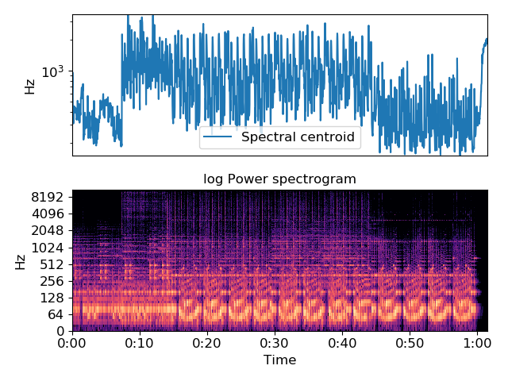
librosa.feature.spectral_bandwidth
librosa.feature.spectral_bandwidth(y=None, sr=22050, S=None, n_fft=2048, hop_length=512, win_length=None, window='hann', center=True, pad_mode='reflect', freq=None, centroid=None, norm=True, p=2)[source]
Compute p’th-order spectral bandwidth.
The spectral bandwidth [1] at frame t is computed by
(sum_k S[k, t] * (freq[k, t] - centroid[t])**p)**(1/p)

[1] | Klapuri, A., & Davy, M. (Eds.). (2007). Signal processing methods for music transcription, chapter 5. Springer Science & Business Media.
Parameters: | y : np.ndarray [shape=(n,)] or None  audio time series  sr : number > 0 [scalar]  audio sampling rate of y  S : np.ndarray [shape=(d, t)] or None  (optional) spectrogram magnitude  n_fft : int > 0 [scalar]  FFT window size  hop_length : int > 0 [scalar]  hop length for STFT. See librosa.core.stft for details.  win_length : int <= n_fft [scalar]  Each frame of audio is windowed by window(). The window will be of length win_length and then padded with zeros to match n_fft.  If unspecified, defaults to win_length = n_fft.  window : string, tuple, number, function, or np.ndarray [shape=(n_fft,)]  - a window specification (string, tuple, or number); see scipy.signal.get_window  - a window function, such as scipy.signal.hanning  - a vector or array of length n_fft  center : boolean  - If True, the signal y is padded so that frame t is centered at y[t * hop_length].  - If False, then frame t begins at y[t * hop_length]  pad_mode : string  If center=True, the padding mode to use at the edges of the signal. By default, STFT uses reflection padding.  freq : None or np.ndarray [shape=(d,) or shape=(d, t)]  Center frequencies for spectrogram bins. If None, then FFT bin center frequencies are used. Otherwise, it can be a single array of d center frequencies, or a matrix of center frequencies as constructed by librosa.core.ifgram  centroid : None or np.ndarray [shape=(1, t)]  pre-computed centroid frequencies  norm : bool  Normalize per-frame spectral energy (sum to one)  p : float > 0  Power to raise deviation from spectral centroid.
Returns: | bandwidth : np.ndarray [shape=(1, t)]  frequency bandwidth for each frame
Examples
From time-series input
>>> y, sr = librosa.load(librosa.util.example_audio_file())
>>> spec_bw = librosa.feature.spectral_bandwidth(y=y, sr=sr)
>>> spec_bw
array([[ 3379.878, 1429.486, ..., 3235.214, 3080.148]])
From spectrogram input
>>> S, phase = librosa.magphase(librosa.stft(y=y))
>>> librosa.feature.spectral_bandwidth(S=S)
array([[ 3379.878, 1429.486, ..., 3235.214, 3080.148]])
Using variable bin center frequencies
>>> if_gram, D = librosa.ifgram(y)
>>> librosa.feature.spectral_bandwidth(S=np.abs(D), freq=if_gram)
array([[ 3380.011, 1429.11 , ..., 3235.22 , 3080.148]])
Plot the result
>>> import matplotlib.pyplot as plt
>>> plt.figure()
>>> plt.subplot(2, 1, 1)
>>> plt.semilogy(spec_bw.T, label='Spectral bandwidth')
>>> plt.ylabel('Hz')
>>> plt.xticks([])
>>> plt.xlim([0, spec_bw.shape[-1]])
>>> plt.legend()
>>> plt.subplot(2, 1, 2)
>>> librosa.display.specshow(librosa.amplitude_to_db(S, ref=np.max),
... y_axis='log', x_axis='time')
>>> plt.title('log Power spectrogram')
>>> plt.tight_layout()
>>> plt.show()

librosa.feature.spectral_bandwidth
librosa.feature.spectral_bandwidth(y=None, sr=22050, S=None, n_fft=2048, hop_length=512, win_length=None, window='hann', center=True, pad_mode='reflect', freq=None, centroid=None, norm=True, p=2)[source]
Compute p’th-order spectral bandwidth.
The spectral bandwidth [1] at frame t is computed by
(sum_k S[k, t] * (freq[k, t] - centroid[t])**p)**(1/p)

[1] | Klapuri, A., & Davy, M. (Eds.). (2007). Signal processing methods for music transcription, chapter 5. Springer Science & Business Media.
Parameters: | y : np.ndarray [shape=(n,)] or None  audio time series  sr : number > 0 [scalar]  audio sampling rate of y  S : np.ndarray [shape=(d, t)] or None  (optional) spectrogram magnitude  n_fft : int > 0 [scalar]  FFT window size  hop_length : int > 0 [scalar]  hop length for STFT. See librosa.core.stft for details.  win_length : int <= n_fft [scalar]  Each frame of audio is windowed by window(). The window will be of length win_length and then padded with zeros to match n_fft.  If unspecified, defaults to win_length = n_fft.  window : string, tuple, number, function, or np.ndarray [shape=(n_fft,)]  - a window specification (string, tuple, or number); see scipy.signal.get_window  - a window function, such as scipy.signal.hanning  - a vector or array of length n_fft  center : boolean  - If True, the signal y is padded so that frame t is centered at y[t * hop_length].  - If False, then frame t begins at y[t * hop_length]  pad_mode : string  If center=True, the padding mode to use at the edges of the signal. By default, STFT uses reflection padding.  freq : None or np.ndarray [shape=(d,) or shape=(d, t)]  Center frequencies for spectrogram bins. If None, then FFT bin center frequencies are used. Otherwise, it can be a single array of d center frequencies, or a matrix of center frequencies as constructed by librosa.core.ifgram  centroid : None or np.ndarray [shape=(1, t)]  pre-computed centroid frequencies  norm : bool  Normalize per-frame spectral energy (sum to one)  p : float > 0  Power to raise deviation from spectral centroid.
Returns: | bandwidth : np.ndarray [shape=(1, t)]  frequency bandwidth for each frame
Examples
From time-series input
>>> y, sr = librosa.load(librosa.util.example_audio_file())
>>> spec_bw = librosa.feature.spectral_bandwidth(y=y, sr=sr)
>>> spec_bw
array([[ 3379.878, 1429.486, ..., 3235.214, 3080.148]])
From spectrogram input
>>> S, phase = librosa.magphase(librosa.stft(y=y))
>>> librosa.feature.spectral_bandwidth(S=S)
array([[ 3379.878, 1429.486, ..., 3235.214, 3080.148]])
Using variable bin center frequencies
>>> if_gram, D = librosa.ifgram(y)
>>> librosa.feature.spectral_bandwidth(S=np.abs(D), freq=if_gram)
array([[ 3380.011, 1429.11 , ..., 3235.22 , 3080.148]])
Plot the result
>>> import matplotlib.pyplot as plt
>>> plt.figure()
>>> plt.subplot(2, 1, 1)
>>> plt.semilogy(spec_bw.T, label='Spectral bandwidth')
>>> plt.ylabel('Hz')
>>> plt.xticks([])
>>> plt.xlim([0, spec_bw.shape[-1]])
>>> plt.legend()
>>> plt.subplot(2, 1, 2)
>>> librosa.display.specshow(librosa.amplitude_to_db(S, ref=np.max),
... y_axis='log', x_axis='time')
>>> plt.title('log Power spectrogram')
>>> plt.tight_layout()
>>> plt.show()

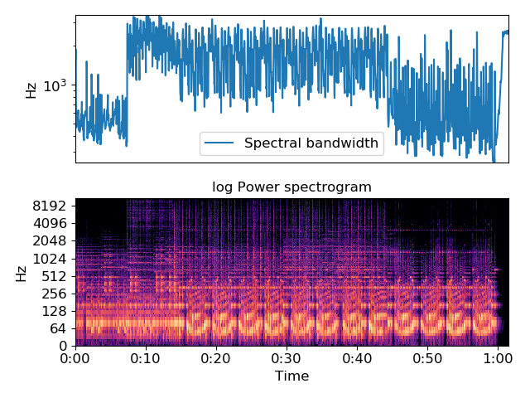
librosa.feature.spectral_contrast
librosa.feature.spectral_contrast(y=None, sr=22050, S=None, n_fft=2048, hop_length=512, win_length=None, window='hann', center=True, pad_mode='reflect', freq=None, fmin=200.0, n_bands=6, quantile=0.02, linear=False)[source]
Compute spectral contrast [1]
Each frame of a spectrogram S is divided into sub-bands. For each sub-band, the energy contrast is estimated by comparing the mean energy in the top quantile (peak energy) to that of the bottom quantile (valley energy). High contrast values generally correspond to clear, narrow-band signals, while low contrast values correspond to broad-band noise.

[1] | Jiang, Dan-Ning, Lie Lu, Hong-Jiang Zhang, Jian-Hua Tao, and Lian-Hong Cai. “Music type classification by spectral contrast feature.” In Multimedia and Expo, 2002. ICME‘02. Proceedings. 2002 IEEE International Conference on, vol. 1, pp. 113-116. IEEE, 2002.
Parameters: | y : np.ndarray [shape=(n,)] or None  audio time series  sr : number > 0 [scalar]  audio sampling rate of y  S : np.ndarray [shape=(d, t)] or None  (optional) spectrogram magnitude  n_fft : int > 0 [scalar]  FFT window size  hop_length : int > 0 [scalar]  hop length for STFT. See librosa.core.stft for details.  win_length : int <= n_fft [scalar]  Each frame of audio is windowed by window(). The window will be of length win_length and then padded with zeros to match n_fft.  If unspecified, defaults to win_length = n_fft.  window : string, tuple, number, function, or np.ndarray [shape=(n_fft,)]  - a window specification (string, tuple, or number); see scipy.signal.get_window  - a window function, such as scipy.signal.hanning  - a vector or array of length n_fft  center : boolean  - If True, the signal y is padded so that frame t is centered at y[t * hop_length].  - If False, then frame t begins at y[t * hop_length]  pad_mode : string  If center=True, the padding mode to use at the edges of the signal. By default, STFT uses reflection padding.  freq : None or np.ndarray [shape=(d,)]  Center frequencies for spectrogram bins. If None, then FFT bin center frequencies are used. Otherwise, it can be a single array of d center frequencies.  fmin : float > 0  Frequency cutoff for the first bin [0, fmin] Subsequent bins will cover [fmin, 2*fmin], [2*fmin, 4*fmin], etc.  n_bands : int > 1  number of frequency bands  quantile : float in (0, 1)  quantile for determining peaks and valleys  linear : bool  If True, return the linear difference of magnitudes: peaks - valleys.  If False, return the logarithmic difference: log(peaks) - log(valleys).
Returns: | contrast : np.ndarray [shape=(n_bands + 1, t)]  each row of spectral contrast values corresponds to a given octave-based frequency
Examples
>>> y, sr = librosa.load(librosa.util.example_audio_file())
>>> S = np.abs(librosa.stft(y))
>>> contrast = librosa.feature.spectral_contrast(S=S, sr=sr)
>>> import matplotlib.pyplot as plt
>>> plt.figure()
>>> plt.subplot(2, 1, 1)
>>> librosa.display.specshow(librosa.amplitude_to_db(S,
... ref=np.max),
... y_axis='log')
>>> plt.colorbar(format='%+2.0f dB')
>>> plt.title('Power spectrogram')
>>> plt.subplot(2, 1, 2)
>>> librosa.display.specshow(contrast, x_axis='time')
>>> plt.colorbar()
>>> plt.ylabel('Frequency bands')
>>> plt.title('Spectral contrast')
>>> plt.tight_layout()
>>> plt.show()

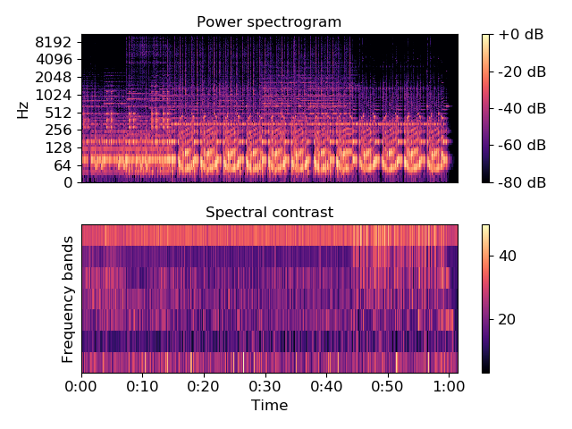
librosa.feature.spectral_flatness
librosa.feature.spectral_flatness(y=None, S=None, n_fft=2048, hop_length=512, win_length=None, window='hann', center=True, pad_mode='reflect', amin=1e-10, power=2.0)[source]
Compute spectral flatness
Spectral flatness (or tonality coefficient) is a measure to quantify how much noise-like a sound is, as opposed to being tone-like [1]. A high spectral flatness (closer to 1.0) indicates the spectrum is similar to white noise. It is often converted to decibel.

[1] | Dubnov, Shlomo “Generalization of spectral flatness measure for non-gaussian linear processes” IEEE Signal Processing Letters, 2004, Vol. 11.
Parameters: | y : np.ndarray [shape=(n,)] or None  audio time series  S : np.ndarray [shape=(d, t)] or None  (optional) pre-computed spectrogram magnitude  n_fft : int > 0 [scalar]  FFT window size  hop_length : int > 0 [scalar]  hop length for STFT. See librosa.core.stft for details.  win_length : int <= n_fft [scalar]  Each frame of audio is windowed by window(). The window will be of length win_length and then padded with zeros to match n_fft.  If unspecified, defaults to win_length = n_fft.  window : string, tuple, number, function, or np.ndarray [shape=(n_fft,)]  - a window specification (string, tuple, or number); see scipy.signal.get_window  - a window function, such as scipy.signal.hanning  - a vector or array of length n_fft  center : boolean  - If True, the signal y is padded so that frame t is centered at y[t * hop_length].  - If False, then frame t begins at y[t * hop_length]  pad_mode : string  If center=True, the padding mode to use at the edges of the signal. By default, STFT uses reflection padding.  amin : float > 0 [scalar]  minimum threshold for S (=added noise floor for numerical stability)  power : float > 0 [scalar]  Exponent for the magnitude spectrogram. e.g., 1 for energy, 2 for power, etc. Power spectrogram is usually used for computing spectral flatness.
Returns: | flatness : np.ndarray [shape=(1, t)]  spectral flatness for each frame. The returned value is in [0, 1] and often converted to dB scale.
Examples
From time-series input
>>> y, sr = librosa.load(librosa.util.example_audio_file())
>>> flatness = librosa.feature.spectral_flatness(y=y)
>>> flatness
array([[ 1.00000e+00, 5.82299e-03, 5.64624e-04, ..., 9.99063e-01,
1.00000e+00, 1.00000e+00]], dtype=float32)
From spectrogram input
>>> S, phase = librosa.magphase(librosa.stft(y))
>>> librosa.feature.spectral_flatness(S=S)
array([[ 1.00000e+00, 5.82299e-03, 5.64624e-04, ..., 9.99063e-01,
1.00000e+00, 1.00000e+00]], dtype=float32)
From power spectrogram input
>>> S, phase = librosa.magphase(librosa.stft(y))
>>> S_power = S ** 2
>>> librosa.feature.spectral_flatness(S=S_power, power=1.0)
array([[ 1.00000e+00, 5.82299e-03, 5.64624e-04, ..., 9.99063e-01,
1.00000e+00, 1.00000e+00]], dtype=float32)

librosa.feature.spectral_rolloff
librosa.feature.spectral_rolloff(y=None, sr=22050, S=None, n_fft=2048, hop_length=512, win_length=None, window='hann', center=True, pad_mode='reflect', freq=None, roll_percent=0.85)[source]
Compute roll-off frequency.
The roll-off frequency is defined for each frame as the center frequency for a spectrogram bin such that at least roll_percent (0.85 by default) of the energy of the spectrum in this frame is contained in this bin and the bins below. This can be used to, e.g., approximate the maximum (or minimum) frequency by setting roll_percent to a value close to 1 (or 0).
Parameters: | y : np.ndarray [shape=(n,)] or None  audio time series  sr : number > 0 [scalar]  audio sampling rate of y  S : np.ndarray [shape=(d, t)] or None  (optional) spectrogram magnitude  n_fft : int > 0 [scalar]  FFT window size  hop_length : int > 0 [scalar]  hop length for STFT. See librosa.core.stft for details.  win_length : int <= n_fft [scalar]  Each frame of audio is windowed by window(). The window will be of length win_length and then padded with zeros to match n_fft.  If unspecified, defaults to win_length = n_fft.  window : string, tuple, number, function, or np.ndarray [shape=(n_fft,)]  - a window specification (string, tuple, or number); see scipy.signal.get_window  - a window function, such as scipy.signal.hanning  - a vector or array of length n_fft  center : boolean  - If True, the signal y is padded so that frame t is centered at y[t * hop_length].  - If False, then frame t begins at y[t * hop_length]  pad_mode : string  If center=True, the padding mode to use at the edges of the signal. By default, STFT uses reflection padding.  freq : None or np.ndarray [shape=(d,) or shape=(d, t)]  Center frequencies for spectrogram bins. If None, then FFT bin center frequencies are used. Otherwise, it can be a single array of d center frequencies,  Note  freq is assumed to be sorted in increasing order  roll_percent : float [0 < roll_percent < 1]  Roll-off percentage.
Returns: | rolloff : np.ndarray [shape=(1, t)]  roll-off frequency for each frame
Examples
From time-series input
>>> y, sr = librosa.load(librosa.util.example_audio_file())
>>> # Approximate maximum frequencies with roll_percent=0.85 (default)
>>> rolloff = librosa.feature.spectral_rolloff(y=y, sr=sr)
>>> rolloff
array([[ 8376.416, 968.994, ..., 8925.513, 9108.545]])
>>> # Approximate minimum frequencies with roll_percent=0.1
>>> rolloff = librosa.feature.spectral_rolloff(y=y, sr=sr, roll_percent=0.1)
>>> rolloff
array([[ 75.36621094, 64.59960938, 64.59960938, ..., 75.36621094,
75.36621094, 64.59960938]])
From spectrogram input
>>> S, phase = librosa.magphase(librosa.stft(y))
>>> librosa.feature.spectral_rolloff(S=S, sr=sr)
array([[ 8376.416, 968.994, ..., 8925.513, 9108.545]])
>>> # With a higher roll percentage:
>>> y, sr = librosa.load(librosa.util.example_audio_file())
>>> librosa.feature.spectral_rolloff(y=y, sr=sr, roll_percent=0.95)
array([[ 10012.939, 3003.882, ..., 10034.473, 10077.539]])
>>> import matplotlib.pyplot as plt
>>> plt.figure()
>>> plt.subplot(2, 1, 1)
>>> plt.semilogy(rolloff.T, label='Roll-off frequency')
>>> plt.ylabel('Hz')
>>> plt.xticks([])
>>> plt.xlim([0, rolloff.shape[-1]])
>>> plt.legend()
>>> plt.subplot(2, 1, 2)
>>> librosa.display.specshow(librosa.amplitude_to_db(S, ref=np.max),
... y_axis='log', x_axis='time')
>>> plt.title('log Power spectrogram')
>>> plt.tight_layout()
>>> plt.show()

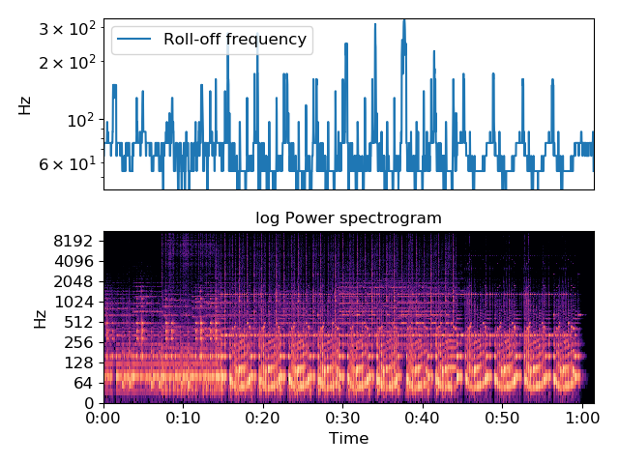
librosa.feature.poly_features
librosa.feature.poly_features(y=None, sr=22050, S=None, n_fft=2048, hop_length=512, win_length=None, window='hann', center=True, pad_mode='reflect', order=1, freq=None)[source]
Get coefficients of fitting an nth-order polynomial to the columns of a spectrogram.
Parameters: | y : np.ndarray [shape=(n,)] or None  audio time series  sr : number > 0 [scalar]  audio sampling rate of y  S : np.ndarray [shape=(d, t)] or None  (optional) spectrogram magnitude  n_fft : int > 0 [scalar]  FFT window size  hop_length : int > 0 [scalar]  hop length for STFT. See librosa.core.stft for details.  win_length : int <= n_fft [scalar]  Each frame of audio is windowed by window(). The window will be of length win_length and then padded with zeros to match n_fft.  If unspecified, defaults to win_length = n_fft.  window : string, tuple, number, function, or np.ndarray [shape=(n_fft,)]  - a window specification (string, tuple, or number); see scipy.signal.get_window  - a window function, such as scipy.signal.hanning  - a vector or array of length n_fft  center : boolean  - If True, the signal y is padded so that frame t is centered at y[t * hop_length].  - If False, then frame t begins at y[t * hop_length]  pad_mode : string  If center=True, the padding mode to use at the edges of the signal. By default, STFT uses reflection padding.  order : int > 0  order of the polynomial to fit  freq : None or np.ndarray [shape=(d,) or shape=(d, t)]  Center frequencies for spectrogram bins. If None, then FFT bin center frequencies are used. Otherwise, it can be a single array of d center frequencies, or a matrix of center frequencies as constructed by librosa.core.ifgram
Returns: | coefficients : np.ndarray [shape=(order+1, t)]  polynomial coefficients for each frame.  coeffecients[0] corresponds to the highest degree (order),  coefficients[1] corresponds to the next highest degree (order-1),  down to the constant term coefficients[order].
Examples
>>> y, sr = librosa.load(librosa.util.example_audio_file())
>>> S = np.abs(librosa.stft(y))
Fit a degree-0 polynomial (constant) to each frame
>>> p0 = librosa.feature.poly_features(S=S, order=0)
Fit a linear polynomial to each frame
>>> p1 = librosa.feature.poly_features(S=S, order=1)
Fit a quadratic to each frame
>>> p2 = librosa.feature.poly_features(S=S, order=2)
Plot the results for comparison
>>> import matplotlib.pyplot as plt
>>> plt.figure(figsize=(8, 8))
>>> ax = plt.subplot(4,1,1)
>>> plt.plot(p2[2], label='order=2', alpha=0.8)
>>> plt.plot(p1[1], label='order=1', alpha=0.8)
>>> plt.plot(p0[0], label='order=0', alpha=0.8)
>>> plt.xticks([])
>>> plt.ylabel('Constant')
>>> plt.legend()
>>> plt.subplot(4,1,2, sharex=ax)
>>> plt.plot(p2[1], label='order=2', alpha=0.8)
>>> plt.plot(p1[0], label='order=1', alpha=0.8)
>>> plt.xticks([])
>>> plt.ylabel('Linear')
>>> plt.subplot(4,1,3, sharex=ax)
>>> plt.plot(p2[0], label='order=2', alpha=0.8)
>>> plt.xticks([])
>>> plt.ylabel('Quadratic')
>>> plt.subplot(4,1,4, sharex=ax)
>>> librosa.display.specshow(librosa.amplitude_to_db(S, ref=np.max),
... y_axis='log')
>>> plt.tight_layout()
>>> plt.show()

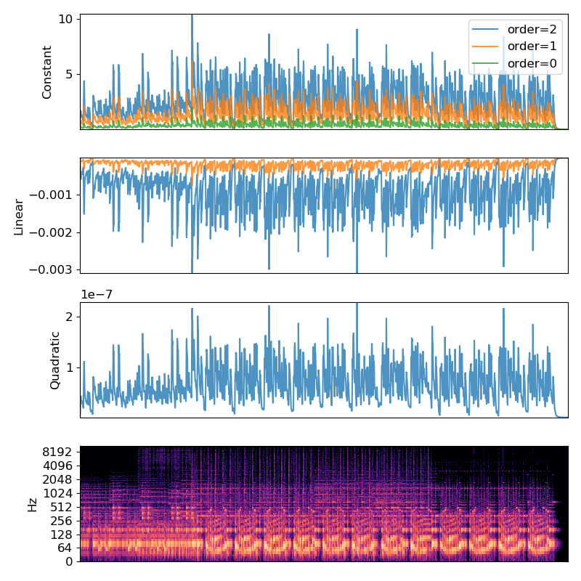
librosa.feature.tonnetz
librosa.feature.tonnetz(y=None, sr=22050, chroma=None)[source]
Computes the tonal centroid features (tonnetz), following the method of [1].

[1] | Harte, C., Sandler, M., & Gasser, M. (2006). “Detecting Harmonic Change in Musical Audio.” In Proceedings of the 1st ACM Workshop on Audio and Music Computing Multimedia (pp. 21-26). Santa Barbara, CA, USA: ACM Press. doi:10.1145/1178723.1178727.
Parameters: | y : np.ndarray [shape=(n,)] or None  Audio time series.  sr : number > 0 [scalar]  sampling rate of y  chroma : np.ndarray [shape=(n_chroma, t)] or None  Normalized energy for each chroma bin at each frame.  If None, a cqt chromagram is performed.
Returns: | tonnetz : np.ndarray [shape(6, t)]  Tonal centroid features for each frame.  Tonnetz dimensions:  - 0: Fifth x-axis  - 1: Fifth y-axis  - 2: Minor x-axis  - 3: Minor y-axis  - 4: Major x-axis  - 5: Major y-axis
See also
chroma_cqt
Compute a chromagram from a constant-Q transform.
chroma_stft
Compute a chromagram from an STFT spectrogram or waveform.
Examples
Compute tonnetz features from the harmonic component of a song
>>> y, sr = librosa.load(librosa.util.example_audio_file())
>>> y = librosa.effects.harmonic(y)
>>> tonnetz = librosa.feature.tonnetz(y=y, sr=sr)
>>> tonnetz
array([[-0.073, -0.053, ..., -0.054, -0.073],
[ 0.001, 0.001, ..., -0.054, -0.062],
...,
[ 0.039, 0.034, ..., 0.044, 0.064],
[ 0.005, 0.002, ..., 0.011, 0.017]])
Compare the tonnetz features to chroma_cqt
>>> import matplotlib.pyplot as plt
>>> plt.subplot(2, 1, 1)
>>> librosa.display.specshow(tonnetz, y_axis='tonnetz')
>>> plt.colorbar()
>>> plt.title('Tonal Centroids (Tonnetz)')
>>> plt.subplot(2, 1, 2)
>>> librosa.display.specshow(librosa.feature.chroma_cqt(y, sr=sr),
... y_axis='chroma', x_axis='time')
>>> plt.colorbar()
>>> plt.title('Chroma')
>>> plt.tight_layout()
>>> plt.show()

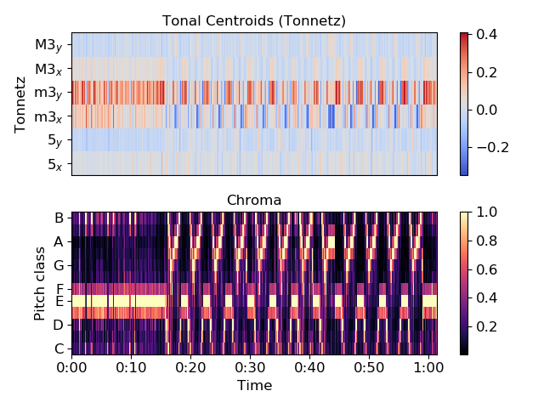
librosa.feature.zero_crossing_rate
librosa.feature.zero_crossing_rate(y, frame_length=2048, hop_length=512, center=True, **kwargs)[source]
Compute the zero-crossing rate of an audio time series.
Parameters: | y : np.ndarray [shape=(n,)]  Audio time series  frame_length : int > 0  Length of the frame over which to compute zero crossing rates  hop_length : int > 0  Number of samples to advance for each frame  center : bool  If True, frames are centered by padding the edges of y. This is similar to the padding in librosa.core.stft, but uses edge-value copies instead of reflection.  kwargs : additional keyword arguments  See librosa.core.zero_crossings  Note  By default, the pad parameter is set to False, which differs from the default specified by librosa.core.zero_crossings.
Returns: | zcr : np.ndarray [shape=(1, t)]  zcr[0, i] is the fraction of zero crossings in the i th frame
See also
librosa.core.zero_crossings
Compute zero-crossings in a time-series
Examples
>>> y, sr = librosa.load(librosa.util.example_audio_file())
>>> librosa.feature.zero_crossing_rate(y)
array([[ 0.134, 0.139, ..., 0.387, 0.322]])

librosa.feature.tempogram
librosa.feature.tempogram(y=None, sr=22050, onset_envelope=None, hop_length=512, win_length=384, center=True, window='hann', norm=inf)[source]
Compute the tempogram: local autocorrelation of the onset strength envelope. [1]

[1] | Grosche, Peter, Meinard Müller, and Frank Kurth. “Cyclic tempogram - A mid-level tempo representation for music signals.” ICASSP, 2010.
Parameters: | y : np.ndarray [shape=(n,)] or None  Audio time series.  sr : number > 0 [scalar]  sampling rate of y  onset_envelope : np.ndarray [shape=(n,) or (m, n)] or None  Optional pre-computed onset strength envelope as provided by onset.onset_strength.  If multi-dimensional, tempograms are computed independently for each band (first dimension).  hop_length : int > 0  number of audio samples between successive onset measurements  win_length : int > 0  length of the onset autocorrelation window (in frames/onset measurements) The default settings (384) corresponds to 384 * hop_length / sr ~= 8.9s.  center : bool  If True, onset autocorrelation windows are centered. If False, windows are left-aligned.  window : string, function, number, tuple, or np.ndarray [shape=(win_length,)]  A window specification as in core.stft.  norm : {np.inf, -np.inf, 0, float > 0, None}  Normalization mode. Set to None to disable normalization.
Returns: | tempogram : np.ndarray [shape=(win_length, n) or (m, win_length, n)]  Localized autocorrelation of the onset strength envelope.  If given multi-band input (onset_envelope.shape==(m,n)) then tempogram[i] is the tempogram of onset_envelope[i].
Raises: | ParameterError  if neither y nor onset_envelope are provided  if win_length < 1
See also
fourier_tempogram
librosa.onset.onset_strength
librosa.util.normalize
librosa.core.stft
Examples
>>> # Compute local onset autocorrelation
>>> y, sr = librosa.load(librosa.util.example_audio_file())
>>> hop_length = 512
>>> oenv = librosa.onset.onset_strength(y=y, sr=sr, hop_length=hop_length)
>>> tempogram = librosa.feature.tempogram(onset_envelope=oenv, sr=sr,
... hop_length=hop_length)
>>> # Compute global onset autocorrelation
>>> ac_global = librosa.autocorrelate(oenv, max_size=tempogram.shape[0])
>>> ac_global = librosa.util.normalize(ac_global)
>>> # Estimate the global tempo for display purposes
>>> tempo = librosa.beat.tempo(onset_envelope=oenv, sr=sr,
... hop_length=hop_length)[0]
>>> import matplotlib.pyplot as plt
>>> plt.figure(figsize=(8, 8))
>>> plt.subplot(4, 1, 1)
>>> plt.plot(oenv, label='Onset strength')
>>> plt.xticks([])
>>> plt.legend(frameon=True)
>>> plt.axis('tight')
>>> plt.subplot(4, 1, 2)
>>> # We'll truncate the display to a narrower range of tempi
>>> librosa.display.specshow(tempogram, sr=sr, hop_length=hop_length,
>>> x_axis='time', y_axis='tempo')
>>> plt.axhline(tempo, color='w', linestyle='--', alpha=1,
... label='Estimated tempo={:g}'.format(tempo))
>>> plt.legend(frameon=True, framealpha=0.75)
>>> plt.subplot(4, 1, 3)
>>> x = np.linspace(0, tempogram.shape[0] * float(hop_length) / sr,
... num=tempogram.shape[0])
>>> plt.plot(x, np.mean(tempogram, axis=1), label='Mean local autocorrelation')
>>> plt.plot(x, ac_global, '--', alpha=0.75, label='Global autocorrelation')
>>> plt.xlabel('Lag (seconds)')
>>> plt.axis('tight')
>>> plt.legend(frameon=True)
>>> plt.subplot(4,1,4)
>>> # We can also plot on a BPM axis
>>> freqs = librosa.tempo_frequencies(tempogram.shape[0], hop_length=hop_length, sr=sr)
>>> plt.semilogx(freqs[1:], np.mean(tempogram[1:], axis=1),
... label='Mean local autocorrelation', basex=2)
>>> plt.semilogx(freqs[1:], ac_global[1:], '--', alpha=0.75,
... label='Global autocorrelation', basex=2)
>>> plt.axvline(tempo, color='black', linestyle='--', alpha=.8,
... label='Estimated tempo={:g}'.format(tempo))
>>> plt.legend(frameon=True)
>>> plt.xlabel('BPM')
>>> plt.axis('tight')
>>> plt.grid()
>>> plt.tight_layout()
>>> plt.show()

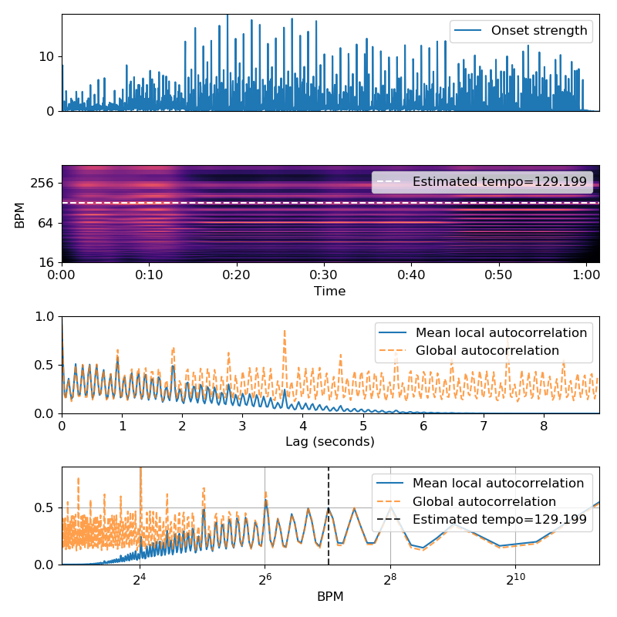
librosa.feature.fourier_tempogram
librosa.feature.fourier_tempogram(y=None, sr=22050, onset_envelope=None, hop_length=512, win_length=384, center=True, window='hann')[source]
Compute the Fourier tempogram: the short-time Fourier transform of the onset strength envelope. [1]

[1] | Grosche, Peter, Meinard Müller, and Frank Kurth. “Cyclic tempogram - A mid-level tempo representation for music signals.” ICASSP, 2010.
Parameters: | y : np.ndarray [shape=(n,)] or None  Audio time series.  sr : number > 0 [scalar]  sampling rate of y  onset_envelope : np.ndarray [shape=(n,)] or None  Optional pre-computed onset strength envelope as provided by onset.onset_strength.  hop_length : int > 0  number of audio samples between successive onset measurements  win_length : int > 0  length of the onset window (in frames/onset measurements) The default settings (384) corresponds to 384 * hop_length / sr ~= 8.9s.  center : bool  If True, onset windows are centered. If False, windows are left-aligned.  window : string, function, number, tuple, or np.ndarray [shape=(win_length,)]  A window specification as in core.stft.
Returns: | tempogram : np.ndarray [shape=(win_length // 2 + 1, n)]  Complex short-time Fourier transform of the onset envelope.
Raises: | ParameterError  if neither y nor onset_envelope are provided  if win_length < 1
See also
tempogram
librosa.onset.onset_strength
librosa.util.normalize
librosa.core.stft
Examples
>>> # Compute local onset autocorrelation
>>> y, sr = librosa.load(librosa.util.example_audio_file())
>>> hop_length = 512
>>> oenv = librosa.onset.onset_strength(y=y, sr=sr, hop_length=hop_length)
>>> tempogram = librosa.feature.fourier_tempogram(onset_envelope=oenv, sr=sr,
... hop_length=hop_length)
>>> # Compute the auto-correlation tempogram, unnormalized to make comparison easier
>>> ac_tempogram = librosa.feature.tempogram(onset_envelope=oenv, sr=sr,
... hop_length=hop_length, norm=None)
>>> import matplotlib.pyplot as plt
>>> plt.figure(figsize=(8, 8))
>>> plt.subplot(3, 1, 1)
>>> plt.plot(oenv, label='Onset strength')
>>> plt.xticks([])
>>> plt.legend(frameon=True)
>>> plt.axis('tight')
>>> plt.subplot(3, 1, 2)
>>> librosa.display.specshow(np.abs(tempogram), sr=sr, hop_length=hop_length,
>>> x_axis='time', y_axis='fourier_tempo', cmap='magma')
>>> plt.title('Fourier tempogram')
>>> plt.subplot(3, 1, 3)
>>> librosa.display.specshow(ac_tempogram, sr=sr, hop_length=hop_length,
>>> x_axis='time', y_axis='tempo', cmap='magma')
>>> plt.title('Autocorrelation tempogram')
>>> plt.tight_layout()
>>> plt.show()
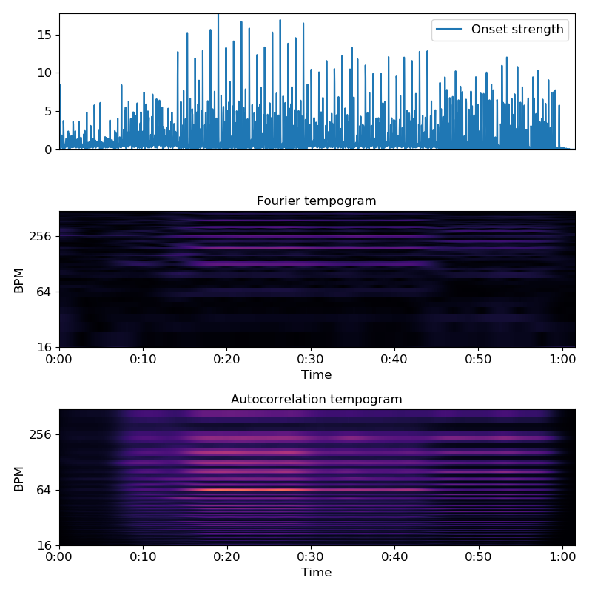

librosa.feature.delta
librosa.feature.delta(data, width=9, order=1, axis=-1, mode='interp', **kwargs)[source]
Compute delta features: local estimate of the derivative of the input data along the selected axis.
Delta features are computed Savitsky-Golay filtering.
Parameters: | data : np.ndarray  the input data matrix (eg, spectrogram)  width : int, positive, odd [scalar]  Number of frames over which to compute the delta features. Cannot exceed the length of data along the specified axis. If mode=’interp’, then width must be at least data.shape[axis].  order : int > 0 [scalar]  the order of the difference operator. 1 for first derivative, 2 for second, etc.  axis : int [scalar]  the axis along which to compute deltas. Default is -1 (columns).  mode : str, {‘interp’, ‘nearest’, ‘mirror’, ‘constant’, ‘wrap’}  Padding mode for estimating differences at the boundaries.  kwargs : additional keyword arguments  See scipy.signal.savgol_filter
Returns: | delta_data : np.ndarray [shape=(d, t)]  delta matrix of data at specified order
See also
scipy.signal.savgol_filter
Notes
This function caches at level 40.
Examples
Compute MFCC deltas, delta-deltas
>>> y, sr = librosa.load(librosa.util.example_audio_file())
>>> mfcc = librosa.feature.mfcc(y=y, sr=sr)
>>> mfcc_delta = librosa.feature.delta(mfcc)
>>> mfcc_delta
array([[ 1.666e+01, 1.666e+01, ..., 1.869e-15, 1.869e-15],
[ 1.784e+01, 1.784e+01, ..., 6.085e-31, 6.085e-31],
...,
[ 7.262e-01, 7.262e-01, ..., 9.259e-31, 9.259e-31],
[ 6.578e-01, 6.578e-01, ..., 7.597e-31, 7.597e-31]])
>>> mfcc_delta2 = librosa.feature.delta(mfcc, order=2)
>>> mfcc_delta2
array([[ -1.703e+01, -1.703e+01, ..., 3.834e-14, 3.834e-14],
[ -1.108e+01, -1.108e+01, ..., -1.068e-30, -1.068e-30],
...,
[ 4.075e-01, 4.075e-01, ..., -1.565e-30, -1.565e-30],
[ 1.676e-01, 1.676e-01, ..., -2.104e-30, -2.104e-30]])
>>> import matplotlib.pyplot as plt
>>> plt.subplot(3, 1, 1)
>>> librosa.display.specshow(mfcc)
>>> plt.title('MFCC')
>>> plt.colorbar()
>>> plt.subplot(3, 1, 2)
>>> librosa.display.specshow(mfcc_delta)
>>> plt.title(r'MFCC-$\Delta$')
>>> plt.colorbar()
>>> plt.subplot(3, 1, 3)
>>> librosa.display.specshow(mfcc_delta2, x_axis='time')
>>> plt.title(r'MFCC-$\Delta^2$')
>>> plt.colorbar()
>>> plt.tight_layout()
>>> plt.show()

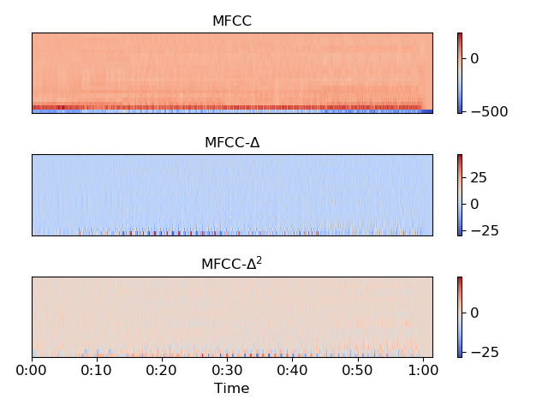
librosa.feature.stack_memory
librosa.feature.stack_memory(data, n_steps=2, delay=1, **kwargs)[source]
Short-term history embedding: vertically concatenate a data vector or matrix with delayed copies of itself.
Each column data[:, i] is mapped to:
data[:, i] -> [data[:, i],
data[:, i - delay],
...
data[:, i - (n_steps-1)*delay]]
For columns i < (n_steps - 1) * delay , the data will be padded. By default, the data is padded with zeros, but this behavior can be overridden by supplying additional keyword arguments which are passed to np.pad().
Parameters: | data : np.ndarray [shape=(t,) or (d, t)]  Input data matrix. If data is a vector (data.ndim == 1), it will be interpreted as a row matrix and reshaped to (1, t).  n_steps : int > 0 [scalar]  embedding dimension, the number of steps back in time to stack  delay : int != 0 [scalar]  the number of columns to step.  Positive values embed from the past (previous columns).  Negative values embed from the future (subsequent columns).  kwargs : additional keyword arguments  Additional arguments to pass to np.pad.
Returns: | data_history : np.ndarray [shape=(m * d, t)]  data augmented with lagged copies of itself, where m == n_steps - 1.
Notes
This function caches at level 40.
Examples
Keep two steps (current and previous)
>>> data = np.arange(-3, 3)
>>> librosa.feature.stack_memory(data)
array([[-3, -2, -1, 0, 1, 2],
[ 0, -3, -2, -1, 0, 1]])
Or three steps
>>> librosa.feature.stack_memory(data, n_steps=3)
array([[-3, -2, -1, 0, 1, 2],
[ 0, -3, -2, -1, 0, 1],
[ 0, 0, -3, -2, -1, 0]])
Use reflection padding instead of zero-padding
>>> librosa.feature.stack_memory(data, n_steps=3, mode='reflect')
array([[-3, -2, -1, 0, 1, 2],
[-2, -3, -2, -1, 0, 1],
[-1, -2, -3, -2, -1, 0]])
Or pad with edge-values, and delay by 2
>>> librosa.feature.stack_memory(data, n_steps=3, delay=2, mode='edge')
array([[-3, -2, -1, 0, 1, 2],
[-3, -3, -3, -2, -1, 0],
[-3, -3, -3, -3, -3, -2]])
Stack time-lagged beat-synchronous chroma edge padding
>>> y, sr = librosa.load(librosa.util.example_audio_file())
>>> chroma = librosa.feature.chroma_stft(y=y, sr=sr)
>>> tempo, beats = librosa.beat.beat_track(y=y, sr=sr, hop_length=512)
>>> beats = librosa.util.fix_frames(beats, x_min=0, x_max=chroma.shape[1])
>>> chroma_sync = librosa.util.sync(chroma, beats)
>>> chroma_lag = librosa.feature.stack_memory(chroma_sync, n_steps=3,
... mode='edge')
Plot the result
>>> import matplotlib.pyplot as plt
>>> beat_times = librosa.frames_to_time(beats, sr=sr, hop_length=512)
>>> librosa.display.specshow(chroma_lag, y_axis='chroma', x_axis='time',
... x_coords=beat_times)
>>> plt.yticks([0, 12, 24], ['Lag=0', 'Lag=1', 'Lag=2'])
>>> plt.title('Time-lagged chroma')
>>> plt.colorbar()
>>> plt.tight_layout()
>>> plt.show()

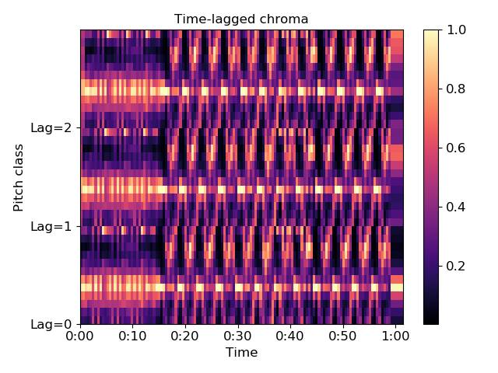
librosa.feature.inverse.mel_to_stft
librosa.feature.inverse.mel_to_stft(M, sr=22050, n_fft=2048, power=2.0, **kwargs)[source]
Approximate STFT magnitude from a Mel power spectrogram.
Parameters: | M : np.ndarray [shape=(n_mels, n), non-negative]  The spectrogram as produced by feature.melspectrogram  sr : number > 0 [scalar]  sampling rate of the underlying signal  n_fft : int > 0 [scalar]  number of FFT components in the resulting STFT  power : float > 0 [scalar]  Exponent for the magnitude melspectrogram  kwargs : additional keyword arguments  Mel filter bank parameters. See librosa.filters.mel for details
Returns: | S : np.ndarray [shape=(n_fft, t), non-negative]  An approximate linear magnitude spectrogram
See also
feature.melspectrogram
core.stft
filters.mel
util.nnls
Examples
>>> y, sr = librosa.load(librosa.util.example_audio_file(), duration=5, offset=10)
>>> S = np.abs(librosa.stft(y))
>>> mel_spec = librosa.feature.melspectrogram(S=S, sr=sr)
>>> S_inv = librosa.feature.inverse.mel_to_stft(mel_spec, sr=sr)
Compare the results visually
>>> import matplotlib.pyplot as plt
>>> plt.figure()
>>> plt.subplot(2,1,1)
>>> librosa.display.specshow(librosa.amplitude_to_db(S, ref=np.max, top_db=None),
... y_axis='log', x_axis='time')
>>> plt.colorbar()
>>> plt.title('Original STFT')
>>> plt.subplot(2,1,2)
>>> librosa.display.specshow(librosa.amplitude_to_db(np.abs(S_inv - S),
... ref=S.max(), top_db=None),
... vmax=0, y_axis='log', x_axis='time', cmap='magma')
>>> plt.title('Residual error (dB)')
>>> plt.colorbar()
>>> plt.tight_layout()
>>> plt.show()

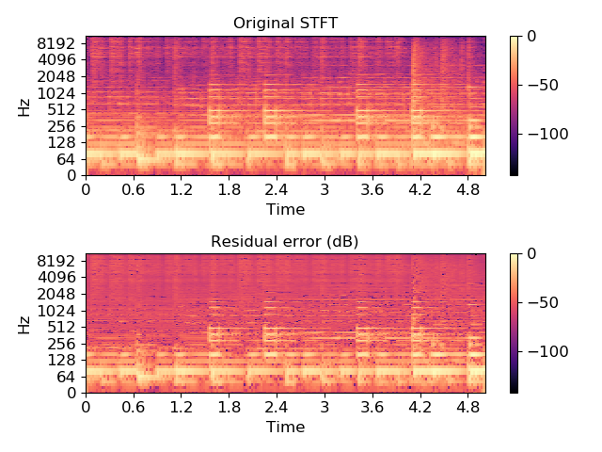
librosa.feature.inverse.mel_to_audio
librosa.feature.inverse.mel_to_audio(M, sr=22050, n_fft=2048, hop_length=512, win_length=None, window='hann', center=True, pad_mode='reflect', power=2.0, n_iter=32, length=None, dtype=<class 'numpy.float32'>, **kwargs)[source]
Invert a mel power spectrogram to audio using Griffin-Lim.
This is primarily a convenience wrapper for:
>>> S = librosa.feature.inverse.mel_to_stft(M)
>>> y = librosa.griffinlim(S)
Parameters: | M : np.ndarray [shape=(n_mels, n), non-negative]  The spectrogram as produced by feature.melspectrogram  sr : number > 0 [scalar]  sampling rate of the underlying signal  n_fft : int > 0 [scalar]  number of FFT components in the resulting STFT  hop_length : None or int > 0  The hop length of the STFT. If not provided, it will default to n_fft // 4  win_length : None or int > 0  The window length of the STFT. By default, it will equal n_fft  window : string, tuple, number, function, or np.ndarray [shape=(n_fft,)]  A window specification as supported by stft or istft  center : boolean  If True, the STFT is assumed to use centered frames. If False, the STFT is assumed to use left-aligned frames.  pad_mode : string  If center=True, the padding mode to use at the edges of the signal. By default, STFT uses reflection padding.  power : float > 0 [scalar]  Exponent for the magnitude melspectrogram  n_iter : int > 0  The number of iterations for Griffin-Lim  length : None or int > 0  If provided, the output y is zero-padded or clipped to exactly length samples.  dtype : np.dtype  Real numeric type for the time-domain signal. Default is 32-bit float.  kwargs : additional keyword arguments  Mel filter bank parameters
Returns: | y : np.ndarray [shape(n,)]  time-domain signal reconstructed from M
See also
core.griffinlim
feature.melspectrogram
filters.mel
feature.inverse.mel_to_stft

librosa.feature.inverse.mfcc_to_mel
librosa.feature.inverse.mfcc_to_mel(mfcc, n_mels=128, dct_type=2, norm='ortho', ref=1.0)[source]
Invert Mel-frequency cepstral coefficients to approximate a Mel power spectrogram.
This inversion proceeds in two steps:
- The inverse DCT is applied to the MFCCs
- core.db_to_power is applied to map the dB-scaled result to a power spectrogram
Parameters: | mfcc : np.ndarray [shape=(n_mfcc, n)]  The Mel-frequency cepstral coefficients  n_mels : int > 0  The number of Mel frequencies  dct_type : None or {1, 2, 3}  Discrete cosine transform (DCT) type By default, DCT type-2 is used.  norm : None or ‘ortho’  If dct_type is 2 or 3, setting norm=’ortho’ uses an orthonormal DCT basis.  Normalization is not supported for dct_type=1.  ref : number or callable  Reference power for (inverse) decibel calculation
Returns: | M : np.ndarray [shape=(n_mels, n)]  An approximate Mel power spectrum recovered from mfcc
See also
mfcc
melspectrogram
scipy.fftpack.dct

librosa.feature.inverse.mfcc_to_audio
librosa.feature.inverse.mfcc_to_audio(mfcc, n_mels=128, dct_type=2, norm='ortho', ref=1.0, **kwargs)[source]
Convert Mel-frequency cepstral coefficients to a time-domain audio signal
This function is primarily a convenience wrapper for the following steps:
- Convert mfcc to Mel power spectrum (mfcc_to_mel)
- Convert Mel power spectrum to time-domain audio (mel_to_audio)
Parameters: | mfcc : np.ndarray [shape=(n_mfcc, n)]  The Mel-frequency cepstral coefficients  n_mels : int > 0  The number of Mel frequencies  dct_type : None or {1, 2, 3}  Discrete cosine transform (DCT) type By default, DCT type-2 is used.  norm : None or ‘ortho’  If dct_type is 2 or 3, setting norm=’ortho’ uses an orthonormal DCT basis.  Normalization is not supported for dct_type=1.  ref : number or callable  Reference power for (inverse) decibel calculation  kwargs : additional keyword arguments  Parameters to pass through to mel_to_audio
Returns: | y : np.ndarray [shape=(n)]  A time-domain signal reconstructed from mfcc
See also
mfcc_to_mel
mel_to_audio
feature.mfcc
core.griffinlim
scipy.fftpack.dct

Onset detection
onset_detect([y, sr, onset_envelope, …]) | Basic onset detector.
onset_backtrack(events, energy) | Backtrack detected onset events to the nearest preceding local minimum of an energy function.
onset_strength([y, sr, S, lag, max_size, …]) | Compute a spectral flux onset strength envelope.
onset_strength_multi([y, sr, S, n_fft, …]) | Compute a spectral flux onset strength envelope across multiple channels.

librosa.onset.onset_detect
librosa.onset.onset_detect(y=None, sr=22050, onset_envelope=None, hop_length=512, backtrack=False, energy=None, units='frames', **kwargs)[source]
Basic onset detector. Locate note onset events by picking peaks in an onset strength envelope.
The peak_pick parameters were chosen by large-scale hyper-parameter optimization over the dataset provided by [1].

[1] | https://github.com/CPJKU/onset_db
Parameters: | y : np.ndarray [shape=(n,)]  audio time series  sr : number > 0 [scalar]  sampling rate of y  onset_envelope : np.ndarray [shape=(m,)]  (optional) pre-computed onset strength envelope  hop_length : int > 0 [scalar]  hop length (in samples)  units : {‘frames’, ‘samples’, ‘time’}  The units to encode detected onset events in. By default, ‘frames’ are used.  backtrack : bool  If True, detected onset events are backtracked to the nearest preceding minimum of energy.  This is primarily useful when using onsets as slice points for segmentation.  energy : np.ndarray [shape=(m,)] (optional)  An energy function to use for backtracking detected onset events. If none is provided, then onset_envelope is used.  kwargs : additional keyword arguments  Additional parameters for peak picking.  See librosa.util.peak_pick for details.
Returns: | onsets : np.ndarray [shape=(n_onsets,)]  estimated positions of detected onsets, in whichever units are specified. By default, frame indices.  Note  If no onset strength could be detected, onset_detect returns an empty list.
Raises: | ParameterError  if neither y nor onsets are provided  or if units is not one of ‘frames’, ‘samples’, or ‘time’
See also
onset_strength
compute onset strength per-frame
onset_backtrack
backtracking onset events
librosa.util.peak_pick
pick peaks from a time series
Examples
Get onset times from a signal
>>> y, sr = librosa.load(librosa.util.example_audio_file(),
... offset=30, duration=2.0)
>>> onset_frames = librosa.onset.onset_detect(y=y, sr=sr)
>>> librosa.frames_to_time(onset_frames, sr=sr)
array([ 0.07 , 0.395, 0.511, 0.627, 0.766, 0.975,
1.207, 1.324, 1.44 , 1.788, 1.881])
Or use a pre-computed onset envelope
>>> o_env = librosa.onset.onset_strength(y, sr=sr)
>>> times = librosa.times_like(o_env, sr=sr)
>>> onset_frames = librosa.onset.onset_detect(onset_envelope=o_env, sr=sr)
>>> import matplotlib.pyplot as plt
>>> D = np.abs(librosa.stft(y))
>>> plt.figure()
>>> ax1 = plt.subplot(2, 1, 1)
>>> librosa.display.specshow(librosa.amplitude_to_db(D, ref=np.max),
... x_axis='time', y_axis='log')
>>> plt.title('Power spectrogram')
>>> plt.subplot(2, 1, 2, sharex=ax1)
>>> plt.plot(times, o_env, label='Onset strength')
>>> plt.vlines(times[onset_frames], 0, o_env.max(), color='r', alpha=0.9,
... linestyle='--', label='Onsets')
>>> plt.axis('tight')
>>> plt.legend(frameon=True, framealpha=0.75)
>>> plt.show()

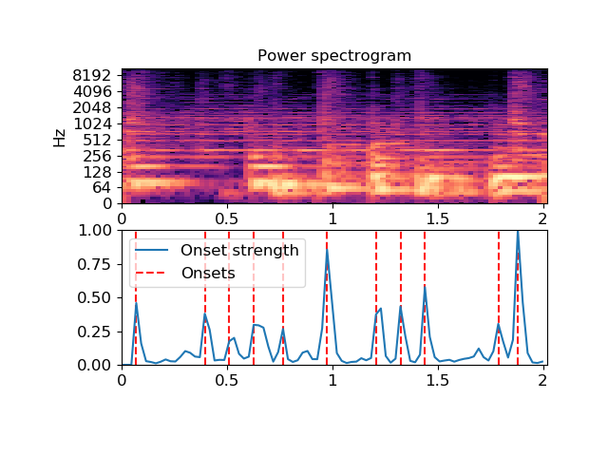
librosa.onset.onset_backtrack
librosa.onset.onset_backtrack(events, energy)[source]
Backtrack detected onset events to the nearest preceding local minimum of an energy function.
This function can be used to roll back the timing of detected onsets from a detected peak amplitude to the preceding minimum.
This is most useful when using onsets to determine slice points for segmentation, as described by [1].

[1] | Jehan, Tristan. “Creating music by listening” Doctoral dissertation Massachusetts Institute of Technology, 2005.
Parameters: | events : np.ndarray, dtype=int  List of onset event frame indices, as computed by onset_detect  energy : np.ndarray, shape=(m,)  An energy function
Returns: | events_backtracked : np.ndarray, shape=events.shape  The input events matched to nearest preceding minima of energy.
Examples
>>> y, sr = librosa.load(librosa.util.example_audio_file(),
... offset=30, duration=2.0)
>>> oenv = librosa.onset.onset_strength(y=y, sr=sr)
>>> # Detect events without backtracking
>>> onset_raw = librosa.onset.onset_detect(onset_envelope=oenv,
... backtrack=False)
>>> # Backtrack the events using the onset envelope
>>> onset_bt = librosa.onset.onset_backtrack(onset_raw, oenv)
>>> # Backtrack the events using the RMS values
>>> rms = librosa.feature.rms(S=np.abs(librosa.stft(y=y)))
>>> onset_bt_rms = librosa.onset.onset_backtrack(onset_raw, rms[0])
>>> # Plot the results
>>> import matplotlib.pyplot as plt
>>> plt.figure()
>>> plt.subplot(2,1,1)
>>> plt.plot(oenv, label='Onset strength')
>>> plt.vlines(onset_raw, 0, oenv.max(), label='Raw onsets')
>>> plt.vlines(onset_bt, 0, oenv.max(), label='Backtracked', color='r')
>>> plt.legend(frameon=True, framealpha=0.75)
>>> plt.subplot(2,1,2)
>>> plt.plot(rms[0], label='RMS')
>>> plt.vlines(onset_bt_rms, 0, rms.max(), label='Backtracked (RMS)', color='r')
>>> plt.legend(frameon=True, framealpha=0.75)
>>> plt.show()
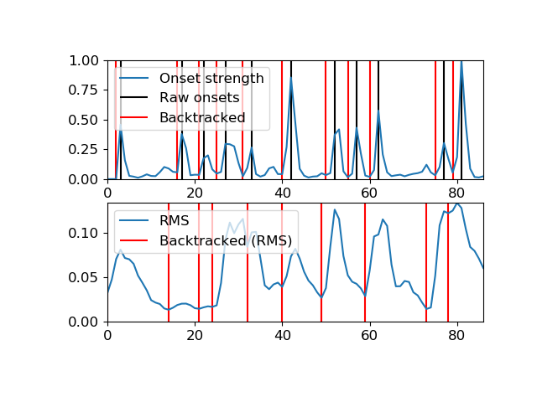

librosa.onset.onset_strength
librosa.onset.onset_strength(y=None, sr=22050, S=None, lag=1, max_size=1, ref=None, detrend=False, center=True, feature=None, aggregate=None, centering=None, **kwargs)[source]
Compute a spectral flux onset strength envelope.
Onset strength at time t is determined by:
mean_f max(0, S[f, t] - ref[f, t - lag])
where ref is S after local max filtering along the frequency axis [1].
By default, if a time series y is provided, S will be the log-power Mel spectrogram.

[1] | Böck, Sebastian, and Gerhard Widmer. “Maximum filter vibrato suppression for onset detection.” 16th International Conference on Digital Audio Effects, Maynooth, Ireland. 2013.
Parameters: | y : np.ndarray [shape=(n,)]  audio time-series  sr : number > 0 [scalar]  sampling rate of y  S : np.ndarray [shape=(d, m)]  pre-computed (log-power) spectrogram  lag : int > 0  time lag for computing differences  max_size : int > 0  size (in frequency bins) of the local max filter. set to 1 to disable filtering.  ref : None or np.ndarray [shape=(d, m)]  An optional pre-computed reference spectrum, of the same shape as S. If not provided, it will be computed from S. If provided, it will override any local max filtering governed by max_size.  detrend : bool [scalar]  Filter the onset strength to remove the DC component  center : bool [scalar]  Shift the onset function by n_fft / (2 * hop_length) frames  feature : function  Function for computing time-series features, eg, scaled spectrograms. By default, uses librosa.feature.melspectrogram with fmax=11025.0  aggregate : function  Aggregation function to use when combining onsets at different frequency bins.  Default: np.mean  kwargs : additional keyword arguments  Additional parameters to feature(), if S is not provided.
Returns: | onset_envelope : np.ndarray [shape=(m,)]  vector containing the onset strength envelope
Raises: | ParameterError  if neither (y, sr) nor S are provided  or if lag or max_size are not positive integers
See also
onset_detect
onset_strength_multi
Examples
First, load some audio and plot the spectrogram
>>> import matplotlib.pyplot as plt
>>> y, sr = librosa.load(librosa.util.example_audio_file(),
... duration=10.0)
>>> D = np.abs(librosa.stft(y))
>>> times = librosa.times_like(D)
>>> plt.figure()
>>> ax1 = plt.subplot(2, 1, 1)
>>> librosa.display.specshow(librosa.amplitude_to_db(D, ref=np.max),
... y_axis='log', x_axis='time')
>>> plt.title('Power spectrogram')
Construct a standard onset function
>>> onset_env = librosa.onset.onset_strength(y=y, sr=sr)
>>> plt.subplot(2, 1, 2, sharex=ax1)
>>> plt.plot(times, 2 + onset_env / onset_env.max(), alpha=0.8,
... label='Mean (mel)')
Median aggregation, and custom mel options
>>> onset_env = librosa.onset.onset_strength(y=y, sr=sr,
... aggregate=np.median,
... fmax=8000, n_mels=256)
>>> plt.plot(times, 1 + onset_env / onset_env.max(), alpha=0.8,
... label='Median (custom mel)')
Constant-Q spectrogram instead of Mel
>>> C = np.abs(librosa.cqt(y=y, sr=sr))
>>> onset_env = librosa.onset.onset_strength(sr=sr, S=librosa.amplitude_to_db(C, ref=np.max))
>>> plt.plot(times, onset_env / onset_env.max(), alpha=0.8,
... label='Mean (CQT)')
>>> plt.legend(frameon=True, framealpha=0.75)
>>> plt.ylabel('Normalized strength')
>>> plt.yticks([])
>>> plt.axis('tight')
>>> plt.tight_layout()
>>> plt.show()

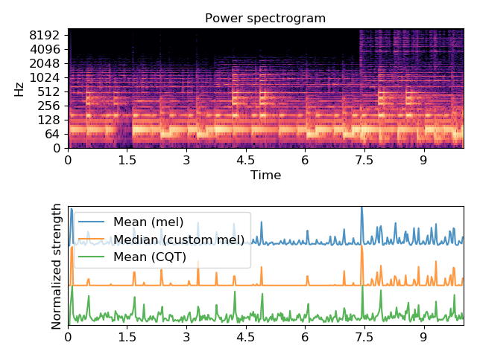
librosa.onset.onset_strength_multi
librosa.onset.onset_strength_multi(y=None, sr=22050, S=None, n_fft=2048, hop_length=512, lag=1, max_size=1, ref=None, detrend=False, center=True, feature=None, aggregate=None, channels=None, **kwargs)[source]
Compute a spectral flux onset strength envelope across multiple channels.
Onset strength for channel i at time t is determined by:
mean_{f in channels[i]} max(0, S[f, t+1] - S[f, t])
Parameters: | y : np.ndarray [shape=(n,)]  audio time-series  sr : number > 0 [scalar]  sampling rate of y  S : np.ndarray [shape=(d, m)]  pre-computed (log-power) spectrogram  n_fft : int > 0 [scalar]  FFT window size for use in feature() if S is not provided.  hop_length : int > 0 [scalar]  hop length for use in feature() if S is not provided.  lag : int > 0  time lag for computing differences  max_size : int > 0  size (in frequency bins) of the local max filter. set to 1 to disable filtering.  ref : None or np.ndarray [shape=(d, m)]  An optional pre-computed reference spectrum, of the same shape as S. If not provided, it will be computed from S. If provided, it will override any local max filtering governed by max_size.  detrend : bool [scalar]  Filter the onset strength to remove the DC component  center : bool [scalar]  Shift the onset function by n_fft / (2 * hop_length) frames  feature : function  Function for computing time-series features, eg, scaled spectrograms. By default, uses librosa.feature.melspectrogram with fmax=11025.0  Must support arguments: y, sr, n_fft, hop_length  aggregate : function or False  Aggregation function to use when combining onsets at different frequency bins.  If False, then no aggregation is performed.  Default: np.mean  channels : list or None  Array of channel boundaries or slice objects. If None, then a single channel is generated to span all bands.  kwargs : additional keyword arguments  Additional parameters to feature(), if S is not provided.
Returns: | onset_envelope : np.ndarray [shape=(n_channels, m)]  array containing the onset strength envelope for each specified channel
Raises: | ParameterError  if neither (y, sr) nor S are provided
See also
onset_strength
Notes
This function caches at level 30.
Examples
First, load some audio and plot the spectrogram
>>> import matplotlib.pyplot as plt
>>> y, sr = librosa.load(librosa.util.example_audio_file(),
... duration=10.0)
>>> D = np.abs(librosa.stft(y))
>>> plt.figure()
>>> plt.subplot(2, 1, 1)
>>> librosa.display.specshow(librosa.amplitude_to_db(D, ref=np.max),
... y_axis='log')
>>> plt.title('Power spectrogram')
Construct a standard onset function over four sub-bands
>>> onset_subbands = librosa.onset.onset_strength_multi(y=y, sr=sr,
... channels=[0, 32, 64, 96, 128])
>>> plt.subplot(2, 1, 2)
>>> librosa.display.specshow(onset_subbands, x_axis='time')
>>> plt.ylabel('Sub-bands')
>>> plt.title('Sub-band onset strength')
>>> plt.show()
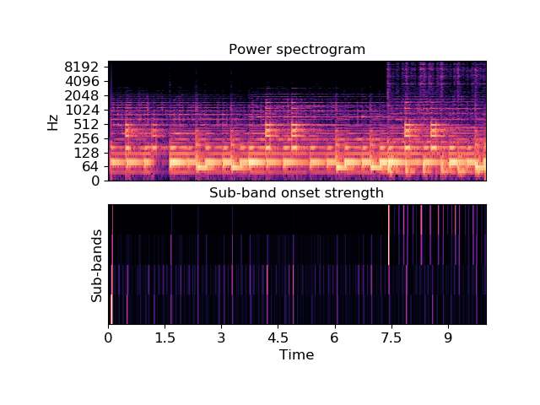

Beat and tempo
beat_track([y, sr, onset_envelope, …]) | Dynamic programming beat tracker.
plp([y, sr, onset_envelope, hop_length, …]) | Predominant local pulse (PLP) estimation.
tempo([y, sr, onset_envelope, hop_length, …]) | Estimate the tempo (beats per minute)

librosa.beat.beat_track
librosa.beat.beat_track(y=None, sr=22050, onset_envelope=None, hop_length=512, start_bpm=120.0, tightness=100, trim=True, bpm=None, prior=None, units='frames')[source]
Dynamic programming beat tracker.
Beats are detected in three stages, following the method of [1]:
- Measure onset strength
- Estimate tempo from onset correlation
- Pick peaks in onset strength approximately consistent with estimated tempo

[1] | Ellis, Daniel PW. “Beat tracking by dynamic programming.” Journal of New Music Research 36.1 (2007): 51-60. http://labrosa.ee.columbia.edu/projects/beattrack/
Parameters: | y : np.ndarray [shape=(n,)] or None  audio time series  sr : number > 0 [scalar]  sampling rate of y  onset_envelope : np.ndarray [shape=(n,)] or None  (optional) pre-computed onset strength envelope.  hop_length : int > 0 [scalar]  number of audio samples between successive onset_envelope values  start_bpm : float > 0 [scalar]  initial guess for the tempo estimator (in beats per minute)  tightness : float [scalar]  tightness of beat distribution around tempo  trim : bool [scalar]  trim leading/trailing beats with weak onsets  bpm : float [scalar]  (optional) If provided, use bpm as the tempo instead of estimating it from onsets.  prior : scipy.stats.rv_continuous [optional]  An optional prior distribution over tempo. If provided, start_bpm will be ignored.  units : {‘frames’, ‘samples’, ‘time’}  The units to encode detected beat events in. By default, ‘frames’ are used.
Returns: | tempo : float [scalar, non-negative]  estimated global tempo (in beats per minute)  beats : np.ndarray [shape=(m,)]  estimated beat event locations in the specified units (default is frame indices)  Note  If no onset strength could be detected, beat_tracker estimates 0 BPM and returns an empty list.
Raises: | ParameterError  if neither y nor onset_envelope are provided, or if units is not one of ‘frames’, ‘samples’, or ‘time’
See also
librosa.onset.onset_strength
Examples
Track beats using time series input
>>> y, sr = librosa.load(librosa.util.example_audio_file())
>>> tempo, beats = librosa.beat.beat_track(y=y, sr=sr)
>>> tempo
64.599609375
Print the first 20 beat frames
>>> beats[:20]
array([ 320, 357, 397, 436, 480, 525, 569, 609, 658,
698, 737, 777, 817, 857, 896, 936, 976, 1016,
1055, 1095])
Or print them as timestamps
>>> librosa.frames_to_time(beats[:20], sr=sr)
array([ 7.43 , 8.29 , 9.218, 10.124, 11.146, 12.19 ,
13.212, 14.141, 15.279, 16.208, 17.113, 18.042,
18.971, 19.9 , 20.805, 21.734, 22.663, 23.591,
24.497, 25.426])
Track beats using a pre-computed onset envelope
>>> onset_env = librosa.onset.onset_strength(y, sr=sr,
... aggregate=np.median)
>>> tempo, beats = librosa.beat.beat_track(onset_envelope=onset_env,
... sr=sr)
>>> tempo
64.599609375
>>> beats[:20]
array([ 320, 357, 397, 436, 480, 525, 569, 609, 658,
698, 737, 777, 817, 857, 896, 936, 976, 1016,
1055, 1095])
Plot the beat events against the onset strength envelope
>>> import matplotlib.pyplot as plt
>>> hop_length = 512
>>> plt.figure(figsize=(8, 4))
>>> times = librosa.times_like(onset_env, sr=sr, hop_length=hop_length)
>>> plt.plot(times, librosa.util.normalize(onset_env),
... label='Onset strength')
>>> plt.vlines(times[beats], 0, 1, alpha=0.5, color='r',
... linestyle='--', label='Beats')
>>> plt.legend(frameon=True, framealpha=0.75)
>>> # Limit the plot to a 15-second window
>>> plt.xlim(15, 30)
>>> plt.gca().xaxis.set_major_formatter(librosa.display.TimeFormatter())
>>> plt.tight_layout()
>>> plt.show()

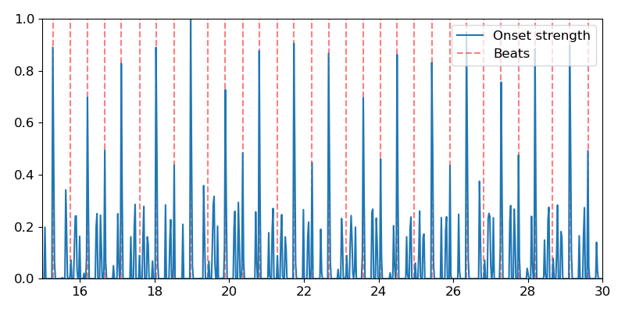
librosa.beat.plp
librosa.beat.plp(y=None, sr=22050, onset_envelope=None, hop_length=512, win_length=384, tempo_min=30, tempo_max=300, prior=None)[source]
Predominant local pulse (PLP) estimation. [1]
The PLP method analyzes the onset strength envelope in the frequency domain to find a locally stable tempo for each frame. These local periodicities are used to synthesize local half-waves, which are combined such that peaks coincide with rhythmically salient frames (e.g. onset events on a musical time grid). The local maxima of the pulse curve can be taken as estimated beat positions.
This method may be preferred over the dynamic programming method of beat_track when either the tempo is expected to vary significantly over time. Additionally, since plp does not require the entire signal to make predictions, it may be preferable when beat-tracking long recordings in a streaming setting.

[1] | Grosche, P., & Muller, M. (2011). “Extracting predominant local pulse information from music recordings.” IEEE Transactions on Audio, Speech, and Language Processing, 19(6), 1688-1701.
Parameters: | y : np.ndarray [shape=(n,)] or None  audio time series  sr : number > 0 [scalar]  sampling rate of y  onset_envelope : np.ndarray [shape=(n,)] or None  (optional) pre-computed onset strength envelope  hop_length : int > 0 [scalar]  number of audio samples between successive onset_envelope values  win_length : int > 0 [scalar]  number of frames to use for tempogram analysis. By default, 384 frames (at sr=22050 and hop_length=512) corresponds to about 8.9 seconds.  tempo_min, tempo_max : numbers > 0 [scalar], optional  Minimum and maximum permissible tempo values. tempo_max must be at least tempo_min.  Set either (or both) to None to disable this constraint.  prior : scipy.stats.rv_continuous [optional]  A prior distribution over tempo (in beats per minute). By default, a uniform prior over [tempo_min, tempo_max] is used.
Returns: | pulse : np.ndarray, shape=[(n,)]  The estimated pulse curve. Maxima correspond to rhythmically salient points of time.
See also
beat_track
librosa.onset.onset_strength
librosa.feature.fourier_tempogram
Examples
Visualize the PLP compared to an onset strength envelope. Both are normalized here to make comparison easier.
>>> y, sr = librosa.load(librosa.util.example_audio_file())
>>> onset_env = librosa.onset.onset_strength(y=y, sr=sr)
>>> pulse = librosa.beat.plp(onset_envelope=onset_env, sr=sr)
>>> # Or compute pulse with an alternate prior, like log-normal
>>> import scipy.stats
>>> prior = scipy.stats.lognorm(loc=np.log(120), scale=120, s=1)
>>> pulse_lognorm = librosa.beat.plp(onset_envelope=onset_env, sr=sr,
... prior=prior)
>>> melspec = librosa.feature.melspectrogram(y=y, sr=sr)
>>> import matplotlib.pyplot as plt
>>> ax = plt.subplot(3,1,1)
>>> librosa.display.specshow(librosa.power_to_db(melspec,
... ref=np.max),
... x_axis='time', y_axis='mel')
>>> plt.title('Mel spectrogram')
>>> plt.subplot(3,1,2, sharex=ax)
>>> plt.plot(librosa.times_like(onset_env),
... librosa.util.normalize(onset_env),
... label='Onset strength')
>>> plt.plot(librosa.times_like(pulse),
... librosa.util.normalize(pulse),
... label='Predominant local pulse (PLP)')
>>> plt.title('Uniform tempo prior [30, 300]')
>>> plt.subplot(3,1,3, sharex=ax)
>>> plt.plot(librosa.times_like(onset_env),
... librosa.util.normalize(onset_env),
... label='Onset strength')
>>> plt.plot(librosa.times_like(pulse_lognorm),
... librosa.util.normalize(pulse_lognorm),
... label='Predominant local pulse (PLP)')
>>> plt.title('Log-normal tempo prior, mean=120')
>>> plt.legend()
>>> plt.xlim([30, 35])
>>> plt.tight_layout()
>>> plt.show()
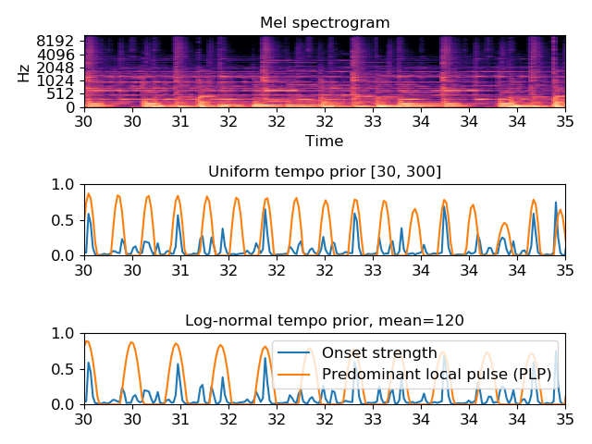
PLP local maxima can be used as estimates of beat positions.
>>> tempo, beats = librosa.beat.beat_track(onset_envelope=onset_env)
>>> beats_plp = np.flatnonzero(librosa.util.localmax(pulse))
>>> import matplotlib.pyplot as plt
>>> ax = plt.subplot(2,1,1)
>>> times = librosa.times_like(onset_env, sr=sr)
>>> plt.plot(times, librosa.util.normalize(onset_env),
... label='Onset strength')
>>> plt.vlines(times[beats], 0, 1, alpha=0.5, color='r',
... linestyle='--', label='Beats')
>>> plt.legend(frameon=True, framealpha=0.75)
>>> plt.title('librosa.beat.beat_track')
>>> # Limit the plot to a 15-second window
>>> plt.subplot(2,1,2, sharex=ax)
>>> times = librosa.times_like(pulse, sr=sr)
>>> plt.plot(times, librosa.util.normalize(pulse),
... label='PLP')
>>> plt.vlines(times[beats_plp], 0, 1, alpha=0.5, color='r',
... linestyle='--', label='PLP Beats')
>>> plt.legend(frameon=True, framealpha=0.75)
>>> plt.title('librosa.beat.plp')
>>> plt.xlim(30, 35)
>>> ax.xaxis.set_major_formatter(librosa.display.TimeFormatter())
>>> plt.tight_layout()
>>> plt.show()

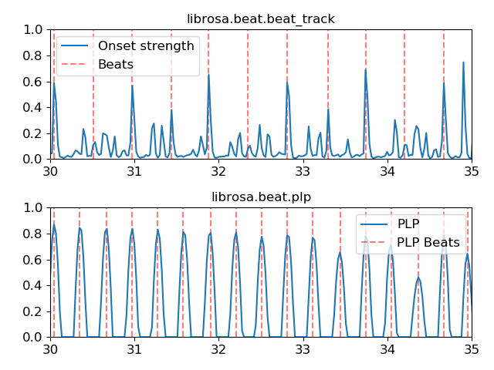
librosa.beat.tempo
librosa.beat.tempo(y=None, sr=22050, onset_envelope=None, hop_length=512, start_bpm=120, std_bpm=1.0, ac_size=8.0, max_tempo=320.0, aggregate=<function mean at 0x7fcba2eb26a8>, prior=None)[source]
Estimate the tempo (beats per minute)
Parameters: | y : np.ndarray [shape=(n,)] or None  audio time series  sr : number > 0 [scalar]  sampling rate of the time series  onset_envelope : np.ndarray [shape=(n,)]  pre-computed onset strength envelope  hop_length : int > 0 [scalar]  hop length of the time series  start_bpm : float [scalar]  initial guess of the BPM  std_bpm : float > 0 [scalar]  standard deviation of tempo distribution  ac_size : float > 0 [scalar]  length (in seconds) of the auto-correlation window  max_tempo : float > 0 [scalar, optional]  If provided, only estimate tempo below this threshold  aggregate : callable [optional]  Aggregation function for estimating global tempo. If None, then tempo is estimated independently for each frame.  prior : scipy.stats.rv_continuous [optional]  A prior distribution over tempo (in beats per minute). By default, a pseudo-log-normal prior is used. If given, start_bpm and std_bpm will be ignored.
Returns: | tempo : np.ndarray [scalar]  estimated tempo (beats per minute)
See also
librosa.onset.onset_strength
librosa.feature.tempogram
Notes
This function caches at level 30.
Examples
>>> # Estimate a static tempo
>>> y, sr = librosa.load(librosa.util.example_audio_file())
>>> onset_env = librosa.onset.onset_strength(y, sr=sr)
>>> tempo = librosa.beat.tempo(onset_envelope=onset_env, sr=sr)
>>> tempo
array([129.199])
>>> # Or a static tempo with a uniform prior instead
>>> import scipy.stats
>>> prior = scipy.stats.uniform(30, 300) # uniform over 30-300 BPM
>>> utempo = librosa.beat.tempo(onset_envelope=onset_env, sr=sr, prior=prior)
>>> utempo
array([64.6])
>>> # Or a dynamic tempo
>>> dtempo = librosa.beat.tempo(onset_envelope=onset_env, sr=sr,
... aggregate=None)
>>> dtempo
array([ 143.555, 143.555, 143.555, ..., 161.499, 161.499,
172.266])
>>> # Dynamic tempo with a proper log-normal prior
>>> prior_lognorm = scipy.stats.lognorm(loc=np.log(120), scale=120, s=1)
>>> dtempo_lognorm = librosa.beat.tempo(onset_envelope=onset_env, sr=sr,
... aggregate=None,
... prior=prior_lognorm)
>>> dtempo_lognorm
array([ 86.133, 86.133, ..., 129.199, 129.199])
Plot the estimated tempo against the onset autocorrelation
>>> import matplotlib.pyplot as plt
>>> # Convert to scalar
>>> tempo = tempo.item()
>>> utempo = utempo.item()
>>> # Compute 2-second windowed autocorrelation
>>> hop_length = 512
>>> ac = librosa.autocorrelate(onset_env, 2 * sr // hop_length)
>>> freqs = librosa.tempo_frequencies(len(ac), sr=sr,
... hop_length=hop_length)
>>> # Plot on a BPM axis. We skip the first (0-lag) bin.
>>> plt.figure(figsize=(8,4))
>>> plt.semilogx(freqs[1:], librosa.util.normalize(ac)[1:],
... label='Onset autocorrelation', basex=2)
>>> plt.axvline(tempo, 0, 1, color='r', alpha=0.75, linestyle='--',
... label='Tempo (default prior): {:.2f} BPM'.format(tempo))
>>> plt.axvline(utempo, 0, 1, color='y', alpha=0.75, linestyle=':',
... label='Tempo (uniform prior): {:.2f} BPM'.format(utempo))
>>> plt.xlabel('Tempo (BPM)')
>>> plt.grid()
>>> plt.title('Static tempo estimation')
>>> plt.legend(frameon=True)
>>> plt.axis('tight')
>>> plt.show()
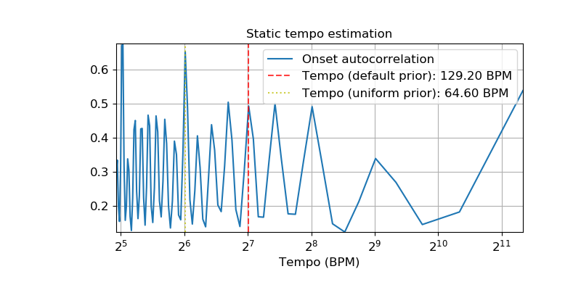
Plot dynamic tempo estimates over a tempogram
>>> plt.figure()
>>> tg = librosa.feature.tempogram(onset_envelope=onset_env, sr=sr,
... hop_length=hop_length)
>>> librosa.display.specshow(tg, x_axis='time', y_axis='tempo')
>>> plt.plot(librosa.times_like(dtempo), dtempo,
... color='w', linewidth=1.5, label='Tempo estimate (default prior)')
>>> plt.plot(librosa.times_like(dtempo_lognorm), dtempo_lognorm,
... color='c', linewidth=1.5, linestyle='--',
... label='Tempo estimate (lognorm prior)')
>>> plt.title('Dynamic tempo estimation')
>>> plt.legend(frameon=True, framealpha=0.75)
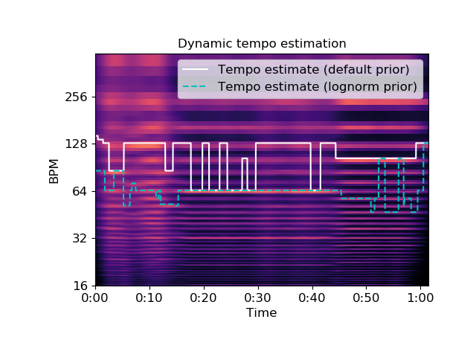

Spectrogram decomposition
decompose(S[, n_components, transformer, …]) | Decompose a feature matrix.
hpss(S[, kernel_size, power, mask, margin]) | Median-filtering harmonic percussive source separation (HPSS).
nn_filter(S[, rec, aggregate, axis]) | Filtering by nearest-neighbors.

librosa.decompose.decompose
librosa.decompose.decompose(S, n_components=None, transformer=None, sort=False, fit=True, **kwargs)[source]
Decompose a feature matrix.
Given a spectrogram S, produce a decomposition into components and activations such that S ~= components.dot(activations).
By default, this is done with with non-negative matrix factorization (NMF), but any sklearn.decomposition-type object will work.
Parameters: | S : np.ndarray [shape=(n_features, n_samples), dtype=float]  The input feature matrix (e.g., magnitude spectrogram)  n_components : int > 0 [scalar] or None  number of desired components  if None, then n_features components are used  transformer : None or object  If None, use sklearn.decomposition.NMF  Otherwise, any object with a similar interface to NMF should work. transformer must follow the scikit-learn convention, where input data is (n_samples, n_features).  transformer.fit_transform() will be run on S.T (not S), the return value of which is stored (transposed) as activations  The components will be retrieved as transformer.components_.T  S ~= np.dot(activations, transformer.components_).T  or equivalently: S ~= np.dot(transformer.components_.T, activations.T)  sort : bool  If True, components are sorted by ascending peak frequency.  Note  If used with transformer, sorting is applied to copies of the decomposition parameters, and not to transformer’s internal parameters.  fit : bool  If True, components are estimated from the input S.  If False, components are assumed to be pre-computed and stored in transformer, and are not changed.  kwargs : Additional keyword arguments to the default transformer  sklearn.decomposition.NMF
Returns: | components: np.ndarray [shape=(n_features, n_components)]  matrix of components (basis elements).  activations: np.ndarray [shape=(n_components, n_samples)]  transformed matrix/activation matrix
Raises: | ParameterError  if fit is False and no transformer object is provided.
See also
sklearn.decomposition
SciKit-Learn matrix decomposition modules
Examples
Decompose a magnitude spectrogram into 32 components with NMF
>>> y, sr = librosa.load(librosa.util.example_audio_file())
>>> S = np.abs(librosa.stft(y))
>>> comps, acts = librosa.decompose.decompose(S, n_components=8)
>>> comps
array([[ 1.876e-01, 5.559e-02, ..., 1.687e-01, 4.907e-02],
[ 3.148e-01, 1.719e-01, ..., 2.314e-01, 9.493e-02],
...,
[ 1.561e-07, 8.564e-08, ..., 7.167e-08, 4.997e-08],
[ 1.531e-07, 7.880e-08, ..., 5.632e-08, 4.028e-08]])
>>> acts
array([[ 4.197e-05, 8.512e-03, ..., 3.056e-05, 9.159e-06],
[ 9.568e-06, 1.718e-02, ..., 3.322e-05, 7.869e-06],
...,
[ 5.982e-05, 1.311e-02, ..., -0.000e+00, 6.323e-06],
[ 3.782e-05, 7.056e-03, ..., 3.290e-05, -0.000e+00]])
Sort components by ascending peak frequency
>>> comps, acts = librosa.decompose.decompose(S, n_components=16,
... sort=True)
Or with sparse dictionary learning
>>> import sklearn.decomposition
>>> T = sklearn.decomposition.MiniBatchDictionaryLearning(n_components=16)
>>> scomps, sacts = librosa.decompose.decompose(S, transformer=T, sort=True)
>>> import matplotlib.pyplot as plt
>>> plt.figure(figsize=(10,8))
>>> plt.subplot(3, 1, 1)
>>> librosa.display.specshow(librosa.amplitude_to_db(S,
... ref=np.max),
... y_axis='log', x_axis='time')
>>> plt.title('Input spectrogram')
>>> plt.colorbar(format='%+2.0f dB')
>>> plt.subplot(3, 2, 3)
>>> librosa.display.specshow(librosa.amplitude_to_db(comps,
... ref=np.max),
... y_axis='log')
>>> plt.colorbar(format='%+2.0f dB')
>>> plt.title('Components')
>>> plt.subplot(3, 2, 4)
>>> librosa.display.specshow(acts, x_axis='time')
>>> plt.ylabel('Components')
>>> plt.title('Activations')
>>> plt.colorbar()
>>> plt.subplot(3, 1, 3)
>>> S_approx = comps.dot(acts)
>>> librosa.display.specshow(librosa.amplitude_to_db(S_approx,
... ref=np.max),
... y_axis='log', x_axis='time')
>>> plt.colorbar(format='%+2.0f dB')
>>> plt.title('Reconstructed spectrogram')
>>> plt.tight_layout()
>>> plt.show()
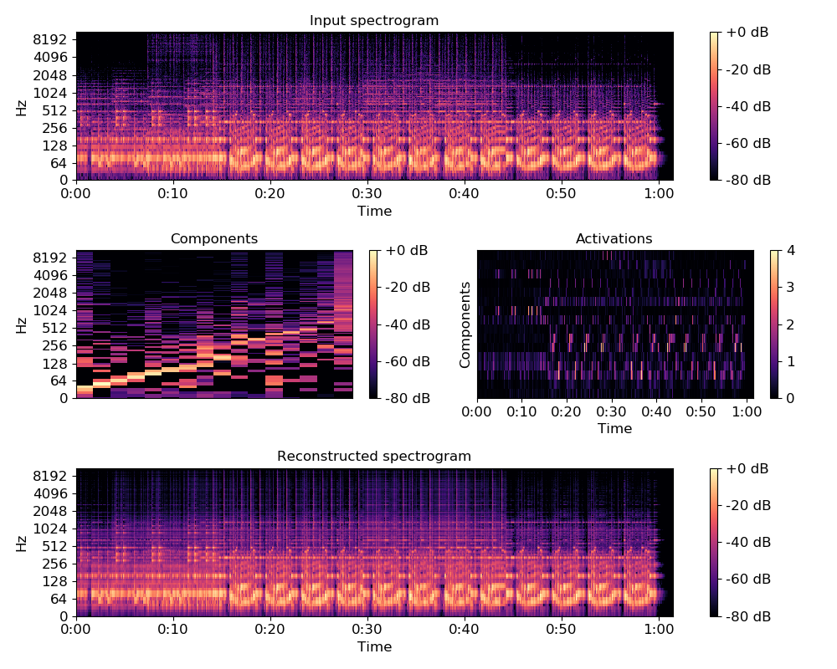

librosa.decompose.hpss
librosa.decompose.hpss(S, kernel_size=31, power=2.0, mask=False, margin=1.0)[source]
Median-filtering harmonic percussive source separation (HPSS).
If margin = 1.0, decomposes an input spectrogram S = H + P where H contains the harmonic components, and P contains the percussive components.
If margin > 1.0, decomposes an input spectrogram S = H + P + R where R contains residual components not included in H or P.
This implementation is based upon the algorithm described by [1] and [2].

[1] | Fitzgerald, Derry. “Harmonic/percussive separation using median filtering.” 13th International Conference on Digital Audio Effects (DAFX10), Graz, Austria, 2010.

[2] | (1, 2) Driedger, Müller, Disch. “Extending harmonic-percussive separation of audio.” 15th International Society for Music Information Retrieval Conference (ISMIR 2014), Taipei, Taiwan, 2014.
Parameters: | S : np.ndarray [shape=(d, n)]  input spectrogram. May be real (magnitude) or complex.  kernel_size : int or tuple (kernel_harmonic, kernel_percussive)  kernel size(s) for the median filters.  - If scalar, the same size is used for both harmonic and percussive.  - If tuple, the first value specifies the width of the harmonic filter, and the second value specifies the width of the percussive filter.  power : float > 0 [scalar]  Exponent for the Wiener filter when constructing soft mask matrices.  mask : bool  Return the masking matrices instead of components.  Masking matrices contain non-negative real values that can be used to measure the assignment of energy from S into harmonic or percussive components.  Components can be recovered by multiplying S * mask_H or S * mask_P.  margin : float or tuple (margin_harmonic, margin_percussive)  margin size(s) for the masks (as described in [2])  - If scalar, the same size is used for both harmonic and percussive.  - If tuple, the first value specifies the margin of the harmonic mask, and the second value specifies the margin of the percussive mask.
Returns: | harmonic : np.ndarray [shape=(d, n)]  harmonic component (or mask)  percussive : np.ndarray [shape=(d, n)]  percussive component (or mask)
See also
util.softmask
Notes
This function caches at level 30.
Examples
Separate into harmonic and percussive
>>> y, sr = librosa.load(librosa.util.example_audio_file(), duration=15)
>>> D = librosa.stft(y)
>>> H, P = librosa.decompose.hpss(D)
>>> import matplotlib.pyplot as plt
>>> plt.figure()
>>> plt.subplot(3, 1, 1)
>>> librosa.display.specshow(librosa.amplitude_to_db(np.abs(D),
... ref=np.max),
... y_axis='log')
>>> plt.colorbar(format='%+2.0f dB')
>>> plt.title('Full power spectrogram')
>>> plt.subplot(3, 1, 2)
>>> librosa.display.specshow(librosa.amplitude_to_db(np.abs(H),
... ref=np.max),
... y_axis='log')
>>> plt.colorbar(format='%+2.0f dB')
>>> plt.title('Harmonic power spectrogram')
>>> plt.subplot(3, 1, 3)
>>> librosa.display.specshow(librosa.amplitude_to_db(np.abs(P),
... ref=np.max),
... y_axis='log')
>>> plt.colorbar(format='%+2.0f dB')
>>> plt.title('Percussive power spectrogram')
>>> plt.tight_layout()
>>> plt.show()
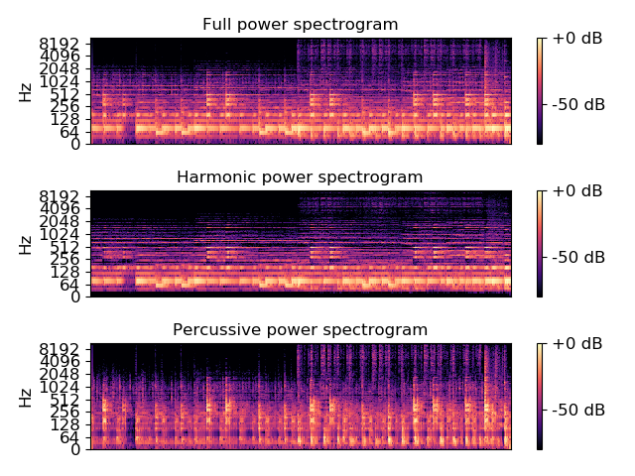
Or with a narrower horizontal filter
>>> H, P = librosa.decompose.hpss(D, kernel_size=(13, 31))
Just get harmonic/percussive masks, not the spectra
>>> mask_H, mask_P = librosa.decompose.hpss(D, mask=True)
>>> mask_H
array([[ 1.000e+00, 1.469e-01, ..., 2.648e-03, 2.164e-03],
[ 1.000e+00, 2.368e-01, ..., 9.413e-03, 7.703e-03],
...,
[ 8.869e-01, 5.673e-02, ..., 4.603e-02, 1.247e-05],
[ 7.068e-01, 2.194e-02, ..., 4.453e-02, 1.205e-05]], dtype=float32)
>>> mask_P
array([[ 2.858e-05, 8.531e-01, ..., 9.974e-01, 9.978e-01],
[ 1.586e-05, 7.632e-01, ..., 9.906e-01, 9.923e-01],
...,
[ 1.131e-01, 9.433e-01, ..., 9.540e-01, 1.000e+00],
[ 2.932e-01, 9.781e-01, ..., 9.555e-01, 1.000e+00]], dtype=float32)
Separate into harmonic/percussive/residual components by using a margin > 1.0
>>> H, P = librosa.decompose.hpss(D, margin=3.0)
>>> R = D - (H+P)
>>> y_harm = librosa.core.istft(H)
>>> y_perc = librosa.core.istft(P)
>>> y_resi = librosa.core.istft(R)
Get a more isolated percussive component by widening its margin
>>> H, P = librosa.decompose.hpss(D, margin=(1.0,5.0))

librosa.decompose.nn_filter
librosa.decompose.nn_filter(S, rec=None, aggregate=None, axis=-1, **kwargs)[source]
Filtering by nearest-neighbors.
Each data point (e.g, spectrogram column) is replaced by aggregating its nearest neighbors in feature space.
This can be useful for de-noising a spectrogram or feature matrix.
The non-local means method [1] can be recovered by providing a weighted recurrence matrix as input and specifying aggregate=np.average.
Similarly, setting aggregate=np.median produces sparse de-noising as in REPET-SIM [2].

[1] | Buades, A., Coll, B., & Morel, J. M. (2005, June). A non-local algorithm for image denoising. In Computer Vision and Pattern Recognition, 2005. CVPR 2005. IEEE Computer Society Conference on (Vol. 2, pp. 60-65). IEEE.

[2] | Rafii, Z., & Pardo, B. (2012, October). “Music/Voice Separation Using the Similarity Matrix.” International Society for Music Information Retrieval Conference, 2012.
Parameters: | S : np.ndarray  The input data (spectrogram) to filter  rec : (optional) scipy.sparse.spmatrix or np.ndarray  Optionally, a pre-computed nearest-neighbor matrix as provided by librosa.segment.recurrence_matrix  aggregate : function  aggregation function (default: np.mean)  If aggregate=np.average, then a weighted average is computed according to the (per-row) weights in rec.  For all other aggregation functions, all neighbors are treated equally.  axis : int  The axis along which to filter (by default, columns)  kwargs  Additional keyword arguments provided to librosa.segment.recurrence_matrix if rec is not provided
Returns: | S_filtered : np.ndarray  The filtered data
Raises: | ParameterError  if rec is provided and its shape is incompatible with S.
See also
decompose
hpss
librosa.segment.recurrence_matrix
Notes
This function caches at level 30.
Examples
De-noise a chromagram by non-local median filtering. By default this would use euclidean distance to select neighbors, but this can be overridden directly by setting the metric parameter.
>>> y, sr = librosa.load(librosa.util.example_audio_file(),
... offset=30, duration=10)
>>> chroma = librosa.feature.chroma_cqt(y=y, sr=sr)
>>> chroma_med = librosa.decompose.nn_filter(chroma,
... aggregate=np.median,
... metric='cosine')
To use non-local means, provide an affinity matrix and aggregate=np.average.
>>> rec = librosa.segment.recurrence_matrix(chroma, mode='affinity',
... metric='cosine', sparse=True)
>>> chroma_nlm = librosa.decompose.nn_filter(chroma, rec=rec,
... aggregate=np.average)
>>> import matplotlib.pyplot as plt
>>> plt.figure(figsize=(10, 8))
>>> plt.subplot(5, 1, 1)
>>> librosa.display.specshow(chroma, y_axis='chroma')
>>> plt.colorbar()
>>> plt.title('Unfiltered')
>>> plt.subplot(5, 1, 2)
>>> librosa.display.specshow(chroma_med, y_axis='chroma')
>>> plt.colorbar()
>>> plt.title('Median-filtered')
>>> plt.subplot(5, 1, 3)
>>> librosa.display.specshow(chroma_nlm, y_axis='chroma')
>>> plt.colorbar()
>>> plt.title('Non-local means')
>>> plt.subplot(5, 1, 4)
>>> librosa.display.specshow(chroma - chroma_med,
... y_axis='chroma')
>>> plt.colorbar()
>>> plt.title('Original - median')
>>> plt.subplot(5, 1, 5)
>>> librosa.display.specshow(chroma - chroma_nlm,
... y_axis='chroma', x_axis='time')
>>> plt.colorbar()
>>> plt.title('Original - NLM')
>>> plt.tight_layout()
>>> plt.show()
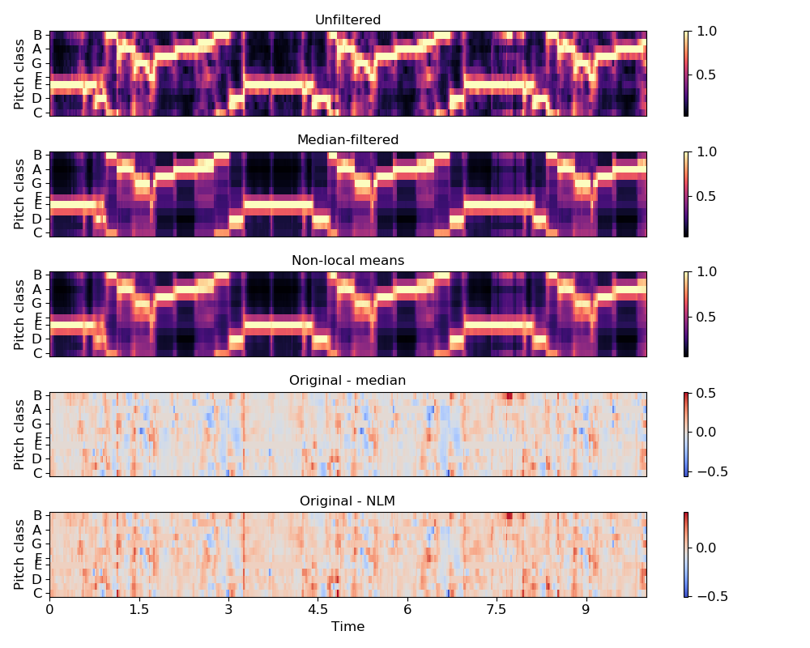

Effects

Harmonic-percussive source separation
hpss(y, \*\*kwargs) | Decompose an audio time series into harmonic and percussive components.
harmonic(y, \*\*kwargs) | Extract harmonic elements from an audio time-series.
percussive(y, \*\*kwargs) | Extract percussive elements from an audio time-series.

Time and frequency
time_stretch(y, rate, \*\*kwargs) | Time-stretch an audio series by a fixed rate.
pitch_shift(y, sr, n_steps[, …]) | Shift the pitch of a waveform by n_steps semitones.

Miscellaneous
remix(y, intervals[, align_zeros]) | Remix an audio signal by re-ordering time intervals.
trim(y[, top_db, ref, frame_length, hop_length]) | Trim leading and trailing silence from an audio signal.
split(y[, top_db, ref, frame_length, hop_length]) | Split an audio signal into non-silent intervals.
preemphasis(y[, coef, zi, return_zf]) | Pre-emphasize an audio signal with a first-order auto-regressive filter:

librosa.effects.hpss
librosa.effects.hpss(y, **kwargs)[source]
Decompose an audio time series into harmonic and percussive components.
This function automates the STFT->HPSS->ISTFT pipeline, and ensures that the output waveforms have equal length to the input waveform y.
Parameters: | y : np.ndarray [shape=(n,)]  audio time series  kwargs : additional keyword arguments.  See librosa.decompose.hpss for details.
Returns: | y_harmonic : np.ndarray [shape=(n,)]  audio time series of the harmonic elements  y_percussive : np.ndarray [shape=(n,)]  audio time series of the percussive elements
See also
harmonic
Extract only the harmonic component
percussive
Extract only the percussive component
librosa.decompose.hpss
HPSS on spectrograms
Examples
>>> # Extract harmonic and percussive components
>>> y, sr = librosa.load(librosa.util.example_audio_file())
>>> y_harmonic, y_percussive = librosa.effects.hpss(y)
>>> # Get a more isolated percussive component by widening its margin
>>> y_harmonic, y_percussive = librosa.effects.hpss(y, margin=(1.0,5.0))

librosa.effects.harmonic
librosa.effects.harmonic(y, **kwargs)[source]
Extract harmonic elements from an audio time-series.
Parameters: | y : np.ndarray [shape=(n,)]  audio time series  kwargs : additional keyword arguments.  See librosa.decompose.hpss for details.
Returns: | y_harmonic : np.ndarray [shape=(n,)]  audio time series of just the harmonic portion
See also
hpss
Separate harmonic and percussive components
percussive
Extract only the percussive component
librosa.decompose.hpss
HPSS for spectrograms
Examples
>>> # Extract harmonic component
>>> y, sr = librosa.load(librosa.util.example_audio_file())
>>> y_harmonic = librosa.effects.harmonic(y)
>>> # Use a margin > 1.0 for greater harmonic separation
>>> y_harmonic = librosa.effects.harmonic(y, margin=3.0)

librosa.effects.percussive
librosa.effects.percussive(y, **kwargs)[source]
Extract percussive elements from an audio time-series.
Parameters: | y : np.ndarray [shape=(n,)]  audio time series  kwargs : additional keyword arguments.  See librosa.decompose.hpss for details.
Returns: | y_percussive : np.ndarray [shape=(n,)]  audio time series of just the percussive portion
See also
hpss
Separate harmonic and percussive components
harmonic
Extract only the harmonic component
librosa.decompose.hpss
HPSS for spectrograms
Examples
>>> # Extract percussive component
>>> y, sr = librosa.load(librosa.util.example_audio_file())
>>> y_percussive = librosa.effects.percussive(y)
>>> # Use a margin > 1.0 for greater percussive separation
>>> y_percussive = librosa.effects.percussive(y, margin=3.0)

librosa.effects.time_stretch
librosa.effects.time_stretch(y, rate, **kwargs)[source]
Time-stretch an audio series by a fixed rate.
Parameters: | y : np.ndarray [shape=(n,)]  audio time series  rate : float > 0 [scalar]  Stretch factor. If rate > 1, then the signal is sped up. If rate < 1, then the signal is slowed down.  kwargs : additional keyword arguments.  See librosa.decompose.stft for details.
Returns: | y_stretch : np.ndarray [shape=(round(n/rate),)]  audio time series stretched by the specified rate
See also
pitch_shift
pitch shifting
librosa.core.phase_vocoder
spectrogram phase vocoder
pyrubberband.pyrb.time_stretch
high-quality time stretching using RubberBand
Examples
Compress to be twice as fast
>>> y, sr = librosa.load(librosa.util.example_audio_file())
>>> y_fast = librosa.effects.time_stretch(y, 2.0)
Or half the original speed
>>> y_slow = librosa.effects.time_stretch(y, 0.5)

librosa.effects.pitch_shift
librosa.effects.pitch_shift(y, sr, n_steps, bins_per_octave=12, res_type='kaiser_best', **kwargs)[source]
Shift the pitch of a waveform by n_steps semitones.
Parameters: | y : np.ndarray [shape=(n,)]  audio time series  sr : number > 0 [scalar]  audio sampling rate of y  n_steps : float [scalar]  how many (fractional) half-steps to shift y  bins_per_octave : float > 0 [scalar]  how many steps per octave  res_type : string  Resample type. Possible options: ‘kaiser_best’, ‘kaiser_fast’, and ‘scipy’, ‘polyphase’, ‘fft’. By default, ‘kaiser_best’ is used.  See core.resample for more information.  kwargs: additional keyword arguments.  See librosa.decompose.stft for details.
Returns: | y_shift : np.ndarray [shape=(n,)]  The pitch-shifted audio time-series
See also
time_stretch
time stretching
librosa.core.phase_vocoder
spectrogram phase vocoder
pyrubberband.pyrb.pitch_shift
high-quality pitch shifting using RubberBand
Examples
Shift up by a major third (four half-steps)
>>> y, sr = librosa.load(librosa.util.example_audio_file())
>>> y_third = librosa.effects.pitch_shift(y, sr, n_steps=4)
Shift down by a tritone (six half-steps)
>>> y_tritone = librosa.effects.pitch_shift(y, sr, n_steps=-6)
Shift up by 3 quarter-tones
>>> y_three_qt = librosa.effects.pitch_shift(y, sr, n_steps=3,
... bins_per_octave=24)

librosa.effects.remix
librosa.effects.remix(y, intervals, align_zeros=True)[source]
Remix an audio signal by re-ordering time intervals.
Parameters: | y : np.ndarray [shape=(t,) or (2, t)]  Audio time series  intervals : iterable of tuples (start, end)  An iterable (list-like or generator) where the i`th item `intervals[i] indicates the start and end (in samples) of a slice of y.  align_zeros : boolean  If True, interval boundaries are mapped to the closest zero-crossing in y. If y is stereo, zero-crossings are computed after converting to mono.
Returns: | y_remix : np.ndarray [shape=(d,) or (2, d)]  y remixed in the order specified by intervals
Examples
Load in the example track and reverse the beats
>>> y, sr = librosa.load(librosa.util.example_audio_file())
Compute beats
>>> _, beat_frames = librosa.beat.beat_track(y=y, sr=sr,
... hop_length=512)
Convert from frames to sample indices
>>> beat_samples = librosa.frames_to_samples(beat_frames)
Generate intervals from consecutive events
>>> intervals = librosa.util.frame(beat_samples, frame_length=2,
... hop_length=1).T
Reverse the beat intervals
>>> y_out = librosa.effects.remix(y, intervals[::-1])

librosa.effects.trim
librosa.effects.trim(y, top_db=60, ref=<function amax at 0x7fcba2eb3d90>, frame_length=2048, hop_length=512)[source]
Trim leading and trailing silence from an audio signal.
Parameters: | y : np.ndarray, shape=(n,) or (2,n)  Audio signal, can be mono or stereo  top_db : number > 0  The threshold (in decibels) below reference to consider as silence  ref : number or callable  The reference power. By default, it uses np.max and compares to the peak power in the signal.  frame_length : int > 0  The number of samples per analysis frame  hop_length : int > 0  The number of samples between analysis frames
Returns: | y_trimmed : np.ndarray, shape=(m,) or (2, m)  The trimmed signal  index : np.ndarray, shape=(2,)  the interval of y corresponding to the non-silent region: y_trimmed = y[index[0]:index[1]] (for mono) or y_trimmed = y[:, index[0]:index[1]] (for stereo).
Examples
>>> # Load some audio
>>> y, sr = librosa.load(librosa.util.example_audio_file())
>>> # Trim the beginning and ending silence
>>> yt, index = librosa.effects.trim(y)
>>> # Print the durations
>>> print(librosa.get_duration(y), librosa.get_duration(yt))
61.45886621315193 60.58086167800454

librosa.effects.split
librosa.effects.split(y, top_db=60, ref=<function amax at 0x7fcba2eb3d90>, frame_length=2048, hop_length=512)[source]
Split an audio signal into non-silent intervals.
Parameters: | y : np.ndarray, shape=(n,) or (2, n)  An audio signal  top_db : number > 0  The threshold (in decibels) below reference to consider as silence  ref : number or callable  The reference power. By default, it uses np.max and compares to the peak power in the signal.  frame_length : int > 0  The number of samples per analysis frame  hop_length : int > 0  The number of samples between analysis frames
Returns: | intervals : np.ndarray, shape=(m, 2)  intervals[i] == (start_i, end_i) are the start and end time (in samples) of non-silent interval i.

librosa.effects.preemphasis
librosa.effects.preemphasis(y, coef=0.97, zi=None, return_zf=False)[source]
Pre-emphasize an audio signal with a first-order auto-regressive filter:
y[n] -> y[n] - coef * y[n-1]
Parameters: | y : np.ndarray  Audio signal  coef : positive number  Pre-emphasis coefficient. Typical values of coef are between 0 and 1.  At the limit coef=0, the signal is unchanged.  At coef=1, the result is the first-order difference of the signal.  zi : number  Initial filter state  return_zf : boolean  If True, return the final filter state. If False, only return the pre-emphasized signal.
Returns: | `y_out` : np.ndarray  pre-emphasized signal  zf : number  if return_zf=True, the final filter state is also returned
Examples
Apply a standard pre-emphasis filter
>>> import matplotlib.pyplot as plt
>>> y, sr = librosa.load(librosa.util.example_audio_file(), offset=30, duration=10)
>>> y_filt = librosa.effects.preemphasis(y)
>>> # and plot the results for comparison
>>> S_orig = librosa.amplitude_to_db(np.abs(librosa.stft(y)), ref=np.max)
>>> S_preemph = librosa.amplitude_to_db(np.abs(librosa.stft(y_filt)), ref=np.max)
>>> plt.subplot(2,1,1)
>>> librosa.display.specshow(S_orig, y_axis='log', x_axis='time')
>>> plt.title('Original signal')
>>> plt.colorbar()
>>> plt.subplot(2,1,2)
>>> librosa.display.specshow(S_preemph, y_axis='log', x_axis='time')
>>> plt.title('Pre-emphasized signal')
>>> plt.colorbar()
>>> plt.tight_layout();
Apply pre-emphasis in pieces for block streaming. Note that the second block initializes zi with the final state zf returned by the first call.
>>> y_filt_1, zf = librosa.effects.preemphasis(y[:1000], return_zf=True)
>>> y_filt_2, zf = librosa.effects.preemphasis(y[1000:], zi=zf, return_zf=True)
>>> np.allclose(y_filt, np.concatenate([y_filt_1, y_filt_2]))
True

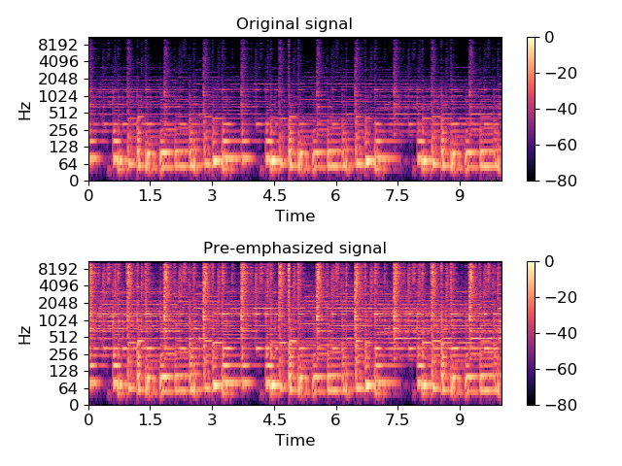
Output
Note: the librosa.output module is deprecated as of version 0.7.0, and it will be removed entirely in version 0.8.

Text output
annotation(path, intervals[, annotations, …]) | Save annotations in a 3-column format.
times_csv(path, times[, annotations, …]) | Save time steps as in CSV format.

Audio output
write_wav(path, y, sr[, norm]) | Output a time series as a .wav file

librosa.output.annotation
librosa.output.annotation(path, intervals, annotations=None, delimiter=', ', fmt='%0.3f')[source]
Save annotations in a 3-column format:
intervals[0, 0],intervals[0, 1],annotations[0]\n
intervals[1, 0],intervals[1, 1],annotations[1]\n
intervals[2, 0],intervals[2, 1],annotations[2]\n
...
This can be used for segment or chord annotations.
Warning
This function is deprecated in librosa 0.7.0. It will be removed in 0.8.
Parameters: | path : str  path to save the output CSV file  intervals : np.ndarray [shape=(n, 2)]  array of interval start and end-times.  intervals[i, 0] marks the start time of interval i  intervals[i, 1] marks the end time of interval i  annotations : None or list-like [shape=(n,)]  optional list of annotation strings. annotations[i] applies to the time range intervals[i, 0] to intervals[i, 1]  delimiter : str  character to separate fields  fmt : str  format-string for rendering time data
Raises: | ParameterError  if annotations is not None and length does not match intervals
Examples
>>> y, sr = librosa.load(librosa.util.example_audio_file())
>>> data = librosa.feature.mfcc(y=y, sr=sr, hop_length=512)
Detect segment boundaries
>>> boundaries = librosa.segment.agglomerative(data, k=10)
Convert to time
>>> boundary_times = librosa.frames_to_time(boundaries, sr=sr,
... hop_length=512)
Convert events boundaries to intervals
>>> intervals = np.hstack([boundary_times[:-1, np.newaxis],
... boundary_times[1:, np.newaxis]])
Make some fake annotations
>>> labels = ['Seg #{:03d}'.format(i) for i in range(len(intervals))]
Save the output
>>> librosa.output.annotation('segments.csv', intervals,
... annotations=labels)

librosa.output.times_csv
librosa.output.times_csv(path, times, annotations=None, delimiter=', ', fmt='%0.3f')[source]
Save time steps as in CSV format. This can be used to store the output of a beat-tracker or segmentation algorithm.
If only times are provided, the file will contain each value of times on a row:
times[0]\n
times[1]\n
times[2]\n
...
If annotations are also provided, the file will contain delimiter-separated values:
times[0],annotations[0]\n
times[1],annotations[1]\n
times[2],annotations[2]\n
...
Warning
This function is deprecated in librosa 0.7.0. It will be removed in 0.8.
Parameters: | path : string  path to save the output CSV file  times : list-like of floats  list of frame numbers for beat events  annotations : None or list-like  optional annotations for each time step  delimiter : str  character to separate fields  fmt : str  format-string for rendering time
Raises: | ParameterError  if annotations is not None and length does not match times
Examples
Write beat-tracker time to CSV
>>> y, sr = librosa.load(librosa.util.example_audio_file())
>>> tempo, beats = librosa.beat.beat_track(y, sr=sr, units='time')
>>> librosa.output.times_csv('beat_times.csv', beats)

librosa.output.write_wav
librosa.output.write_wav(path, y, sr, norm=False)[source]
Output a time series as a .wav file
Note: only mono or stereo, floating-point data is supported.
Warning
This function is deprecated in librosa 0.7.0. It will be removed in 0.8. Usage of write_wav should be replaced by soundfile.write.
Parameters: | path : str  path to save the output wav file  y : np.ndarray [shape=(n,) or (2,n), dtype=np.float]  audio time series (mono or stereo).  Note that only floating-point values are supported.  sr : int > 0 [scalar]  sampling rate of y  norm : boolean [scalar]  enable amplitude normalization. For floating point y, scale the data to the range [-1, +1].
See also
soundfile.write
Examples
Trim a signal to 5 seconds and save it back
>>> y, sr = librosa.load(librosa.util.example_audio_file(),
... duration=5.0)
>>> librosa.output.write_wav('file_trim_5s.wav', y, sr)

Temporal segmentation

Recurrence and self-similarity
cross_similarity(data, data_ref[, k, …]) | Compute cross-similarity from one data sequence to a reference sequence.
recurrence_matrix(data[, k, width, metric, …]) | Compute a recurrence matrix from a data matrix.
recurrence_to_lag(rec[, pad, axis]) | Convert a recurrence matrix into a lag matrix.
lag_to_recurrence(lag[, axis]) | Convert a lag matrix into a recurrence matrix.
timelag_filter(function[, pad, index]) | Filtering in the time-lag domain.
path_enhance(R, n[, window, max_ratio, …]) | Multi-angle path enhancement for self- and cross-similarity matrices.

Temporal clustering
agglomerative(data, k[, clusterer, axis]) | Bottom-up temporal segmentation.
subsegment(data, frames[, n_segments, axis]) | Sub-divide a segmentation by feature clustering.

librosa.segment.cross_similarity
librosa.segment.cross_similarity(data, data_ref, k=None, metric='euclidean', sparse=False, mode='connectivity', bandwidth=None)[source]
Compute cross-similarity from one data sequence to a reference sequence.
The output is a matrix xsim:
xsim[i, j] is non-zero if data_ref[:, i] is a k-nearest neighbor of data[:, j].
Parameters: | data : np.ndarray [shape=(d, n)]  A feature matrix for the comparison sequence  data_ref : np.ndarray [shape=(d, n_ref)]  A feature matrix for the reference sequence  k : int > 0 [scalar] or None  the number of nearest-neighbors for each sample  Default: k = 2 * ceil(sqrt(n_ref)), or k = 2 if n_ref <= 3  metric : str  Distance metric to use for nearest-neighbor calculation.  See sklearn.neighbors.NearestNeighbors for details.  sparse : bool [scalar]  if False, returns a dense type (ndarray) if True, returns a sparse type (scipy.sparse.csc_matrix)  mode : str, {‘connectivity’, ‘distance’, ‘affinity’}  If ‘connectivity’, a binary connectivity matrix is produced.  If ‘distance’, then a non-zero entry contains the distance between points.  If ‘affinity’, then non-zero entries are mapped to exp( - distance(i, j) / bandwidth) where bandwidth is as specified below.  bandwidth : None or float > 0  If using mode='affinity', this can be used to set the bandwidth on the affinity kernel.  If no value is provided, it is set automatically to the median distance to the k’th nearest neighbor of each data[:, i].
Returns: | xsim : np.ndarray or scipy.sparse.csc_matrix, [shape=(n_ref, n)]  Cross-similarity matrix
See also
recurrence_matrix
recurrence_to_lag
feature.stack_memory
sklearn.neighbors.NearestNeighbors
scipy.spatial.distance.cdist
Notes
This function caches at level 30.
Examples
Find nearest neighbors in MFCC space between two sequences
>>> hop_length = 1024
>>> y_ref, sr = librosa.load(librosa.util.example_audio_file())
>>> y_comp, sr = librosa.load(librosa.util.example_audio_file(), offset=10)
>>> mfcc_ref = librosa.feature.mfcc(y=y_ref, sr=sr, hop_length=hop_length)
>>> mfcc_comp = librosa.feature.mfcc(y=y_comp, sr=sr, hop_length=hop_length)
>>> xsim = librosa.segment.cross_similarity(mfcc_comp, mfcc_ref)
Or fix the number of nearest neighbors to 5
>>> xsim = librosa.segment.cross_similarity(mfcc_comp, mfcc_ref, k=5)
Use cosine similarity instead of Euclidean distance
>>> xsim = librosa.segment.cross_similarity(mfcc_comp, mfcc_ref, metric='cosine')
Use an affinity matrix instead of binary connectivity
>>> xsim_aff = librosa.segment.cross_similarity(mfcc_comp, mfcc_ref, mode='affinity')
Plot the feature and recurrence matrices
>>> import matplotlib.pyplot as plt
>>> plt.figure(figsize=(8, 4))
>>> plt.subplot(1, 2, 1)
>>> librosa.display.specshow(xsim, x_axis='time', y_axis='time', hop_length=hop_length)
>>> plt.title('Binary recurrence (symmetric)')
>>> plt.subplot(1, 2, 2)
>>> librosa.display.specshow(xsim_aff, x_axis='time', y_axis='time',
... cmap='magma_r', hop_length=hop_length)
>>> plt.title('Affinity recurrence')
>>> plt.tight_layout()
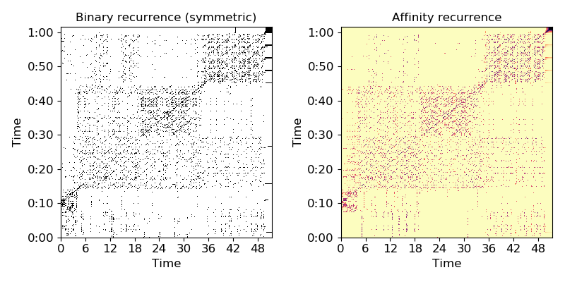

librosa.segment.recurrence_matrix
librosa.segment.recurrence_matrix(data, k=None, width=1, metric='euclidean', sym=False, sparse=False, mode='connectivity', bandwidth=None, self=False, axis=-1)[source]
Compute a recurrence matrix from a data matrix.
rec[i, j] is non-zero if data[:, i] is one of data[:, j]’s k-nearest-neighbors and |i - j| >= width
The specific value of rec[i, j] can have several forms, governed by the mode parameter below:
- Connectivity: rec[i, j] = 1 or 0 indicates that frames i and j are repetitions
- Affinity: rec[i, j] > 0 measures how similar frames i and j are. This is also known as a (sparse) self-similarity matrix.
- Distance: rec[i, j] > 0 measures how distant frames i and j are. This is also known as a (sparse) self-distance matrix.
The general term recurrence matrix can refer to any of the three forms above.
Parameters: | data : np.ndarray  A feature matrix  k : int > 0 [scalar] or None  the number of nearest-neighbors for each sample  Default: k = 2 * ceil(sqrt(t - 2 * width + 1)), or k = 2 if t <= 2 * width + 1  width : int >= 1 [scalar]  only link neighbors (data[:, i], data[:, j]) if |i - j| >= width  width cannot exceed the length of the data.  metric : str  Distance metric to use for nearest-neighbor calculation.  See sklearn.neighbors.NearestNeighbors for details.  sym : bool [scalar]  set sym=True to only link mutual nearest-neighbors  sparse : bool [scalar]  if False, returns a dense type (ndarray) if True, returns a sparse type (scipy.sparse.csc_matrix)  mode : str, {‘connectivity’, ‘distance’, ‘affinity’}  If ‘connectivity’, a binary connectivity matrix is produced.  If ‘distance’, then a non-zero entry contains the distance between points.  If ‘affinity’, then non-zero entries are mapped to exp( - distance(i, j) / bandwidth) where bandwidth is as specified below.  bandwidth : None or float > 0  If using mode='affinity', this can be used to set the bandwidth on the affinity kernel.  If no value is provided, it is set automatically to the median distance between furthest nearest neighbors.  self : bool  If True, then the main diagonal is populated with self-links: 0 if mode='distance', and 1 otherwise.  If False, the main diagonal is left empty.  axis : int  The axis along which to compute recurrence. By default, the last index (-1) is taken.
Returns: | rec : np.ndarray or scipy.sparse.csc_matrix, [shape=(t, t)]  Recurrence matrix
See also
sklearn.neighbors.NearestNeighbors
scipy.spatial.distance.cdist
librosa.feature.stack_memory
recurrence_to_lag
Notes
This function caches at level 30.
Examples
Find nearest neighbors in MFCC space
>>> y, sr = librosa.load(librosa.util.example_audio_file())
>>> hop_length = 1024
>>> mfcc = librosa.feature.mfcc(y=y, sr=sr, hop_length=hop_length)
>>> R = librosa.segment.recurrence_matrix(mfcc)
Or fix the number of nearest neighbors to 5
>>> R = librosa.segment.recurrence_matrix(mfcc, k=5)
Suppress neighbors within +- 7 frames
>>> R = librosa.segment.recurrence_matrix(mfcc, width=7)
Use cosine similarity instead of Euclidean distance
>>> R = librosa.segment.recurrence_matrix(mfcc, metric='cosine')
Require mutual nearest neighbors
>>> R = librosa.segment.recurrence_matrix(mfcc, sym=True)
Use an affinity matrix instead of binary connectivity
>>> R_aff = librosa.segment.recurrence_matrix(mfcc, mode='affinity')
Plot the feature and recurrence matrices
>>> import matplotlib.pyplot as plt
>>> plt.figure(figsize=(8, 4))
>>> plt.subplot(1, 2, 1)
>>> librosa.display.specshow(R, x_axis='time', y_axis='time', hop_length=hop_length)
>>> plt.title('Binary recurrence (symmetric)')
>>> plt.subplot(1, 2, 2)
>>> librosa.display.specshow(R_aff, x_axis='time', y_axis='time',
... hop_length=hop_length, cmap='magma_r')
>>> plt.title('Affinity recurrence')
>>> plt.tight_layout()
>>> plt.show()

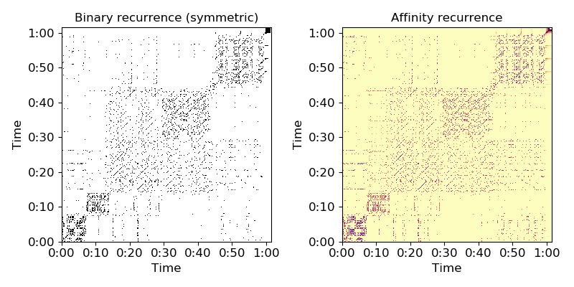
librosa.segment.recurrence_to_lag
librosa.segment.recurrence_to_lag(rec, pad=True, axis=-1)[source]
Convert a recurrence matrix into a lag matrix.
lag[i, j] == rec[i+j, j]
Parameters: | rec : np.ndarray, or scipy.sparse.spmatrix [shape=(n, n)]  A (binary) recurrence matrix, as returned by recurrence_matrix  pad : bool  If False, lag matrix is square, which is equivalent to assuming that the signal repeats itself indefinitely.  If True, lag is padded with n zeros, which eliminates the assumption of repetition.  axis : int  The axis to keep as the time axis. The alternate axis will be converted to lag coordinates.
Returns: | lag : np.ndarray  The recurrence matrix in (lag, time) (if axis=1) or (time, lag) (if axis=0) coordinates
Raises: | ParameterError : if rec is non-square
See also
recurrence_matrix
lag_to_recurrence
util.shear
Examples
>>> y, sr = librosa.load(librosa.util.example_audio_file())
>>> hop_length = 1024
>>> mfccs = librosa.feature.mfcc(y=y, sr=sr, hop_length=hop_length)
>>> recurrence = librosa.segment.recurrence_matrix(mfccs)
>>> lag_pad = librosa.segment.recurrence_to_lag(recurrence, pad=True)
>>> lag_nopad = librosa.segment.recurrence_to_lag(recurrence, pad=False)
>>> import matplotlib.pyplot as plt
>>> plt.figure(figsize=(8, 4))
>>> plt.subplot(1, 2, 1)
>>> librosa.display.specshow(lag_pad, x_axis='time', y_axis='lag',
... hop_length=hop_length)
>>> plt.title('Lag (zero-padded)')
>>> plt.subplot(1, 2, 2)
>>> librosa.display.specshow(lag_nopad, x_axis='time', hop_length=hop_length)
>>> plt.title('Lag (no padding)')
>>> plt.tight_layout()
>>> plt.show()
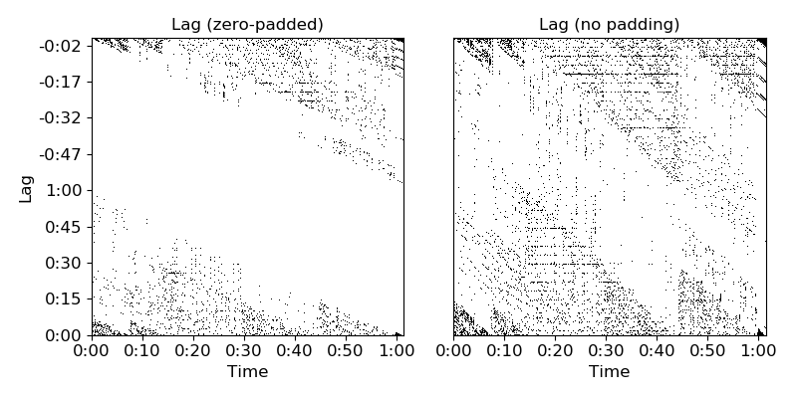

librosa.segment.lag_to_recurrence
librosa.segment.lag_to_recurrence(lag, axis=-1)[source]
Convert a lag matrix into a recurrence matrix.
Parameters: | lag : np.ndarray or scipy.sparse.spmatrix  A lag matrix, as produced by recurrence_to_lag  axis : int  The axis corresponding to the time dimension. The alternate axis will be interpreted in lag coordinates.
Returns: | rec : np.ndarray or scipy.sparse.spmatrix [shape=(n, n)]  A recurrence matrix in (time, time) coordinates For sparse matrices, format will match that of lag.
Raises: | ParameterError : if lag does not have the correct shape
See also
recurrence_to_lag
Examples
>>> y, sr = librosa.load(librosa.util.example_audio_file())
>>> hop_length = 1024
>>> mfccs = librosa.feature.mfcc(y=y, sr=sr, hop_length=hop_length)
>>> recurrence = librosa.segment.recurrence_matrix(mfccs)
>>> lag_pad = librosa.segment.recurrence_to_lag(recurrence, pad=True)
>>> lag_nopad = librosa.segment.recurrence_to_lag(recurrence, pad=False)
>>> rec_pad = librosa.segment.lag_to_recurrence(lag_pad)
>>> rec_nopad = librosa.segment.lag_to_recurrence(lag_nopad)
>>> import matplotlib.pyplot as plt
>>> plt.figure(figsize=(8, 4))
>>> plt.subplot(2, 2, 1)
>>> librosa.display.specshow(lag_pad, x_axis='time', y_axis='lag',
... hop_length=hop_length)
>>> plt.title('Lag (zero-padded)')
>>> plt.subplot(2, 2, 2)
>>> librosa.display.specshow(lag_nopad, x_axis='time', y_axis='time',
... hop_length=hop_length)
>>> plt.title('Lag (no padding)')
>>> plt.subplot(2, 2, 3)
>>> librosa.display.specshow(rec_pad, x_axis='time', y_axis='time',
... hop_length=hop_length)
>>> plt.title('Recurrence (with padding)')
>>> plt.subplot(2, 2, 4)
>>> librosa.display.specshow(rec_nopad, x_axis='time', y_axis='time',
... hop_length=hop_length)
>>> plt.title('Recurrence (without padding)')
>>> plt.tight_layout()
>>> plt.show()

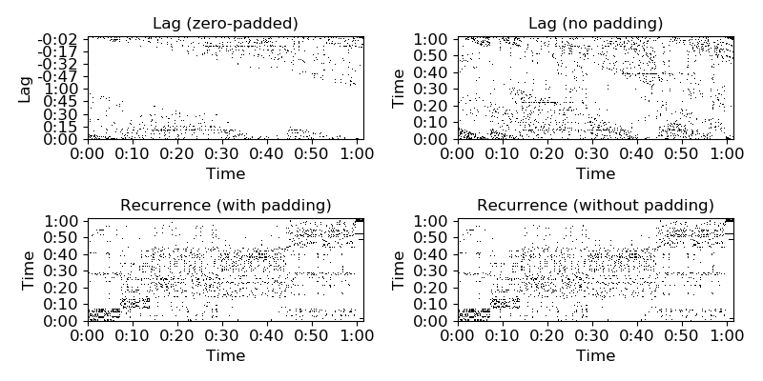
librosa.segment.timelag_filter
librosa.segment.timelag_filter(function, pad=True, index=0)[source]
Filtering in the time-lag domain.
This is primarily useful for adapting image filters to operate on recurrence_to_lag output.
Using timelag_filter is equivalent to the following sequence of operations:
>>> data_tl = librosa.segment.recurrence_to_lag(data)
>>> data_filtered_tl = function(data_tl)
>>> data_filtered = librosa.segment.lag_to_recurrence(data_filtered_tl)
Parameters: | function : callable  The filtering function to wrap, e.g., scipy.ndimage.median_filter  pad : bool  Whether to zero-pad the structure feature matrix  index : int >= 0  If function accepts input data as a positional argument, it should be indexed by index
Returns: | wrapped_function : callable  A new filter function which applies in time-lag space rather than time-time space.
Examples
Apply a 5-bin median filter to the diagonal of a recurrence matrix
>>> y, sr = librosa.load(librosa.util.example_audio_file())
>>> chroma = librosa.feature.chroma_cqt(y=y, sr=sr)
>>> rec = librosa.segment.recurrence_matrix(chroma)
>>> from scipy.ndimage import median_filter
>>> diagonal_median = librosa.segment.timelag_filter(median_filter)
>>> rec_filtered = diagonal_median(rec, size=(1, 3), mode='mirror')
Or with affinity weights
>>> rec_aff = librosa.segment.recurrence_matrix(chroma, mode='affinity')
>>> rec_aff_fil = diagonal_median(rec_aff, size=(1, 3), mode='mirror')
>>> import matplotlib.pyplot as plt
>>> plt.figure(figsize=(8,8))
>>> plt.subplot(2, 2, 1)
>>> librosa.display.specshow(rec, y_axis='time')
>>> plt.title('Raw recurrence matrix')
>>> plt.subplot(2, 2, 2)
>>> librosa.display.specshow(rec_filtered)
>>> plt.title('Filtered recurrence matrix')
>>> plt.subplot(2, 2, 3)
>>> librosa.display.specshow(rec_aff, x_axis='time', y_axis='time',
... cmap='magma_r')
>>> plt.title('Raw affinity matrix')
>>> plt.subplot(2, 2, 4)
>>> librosa.display.specshow(rec_aff_fil, x_axis='time',
... cmap='magma_r')
>>> plt.title('Filtered affinity matrix')
>>> plt.tight_layout()
>>> plt.show()

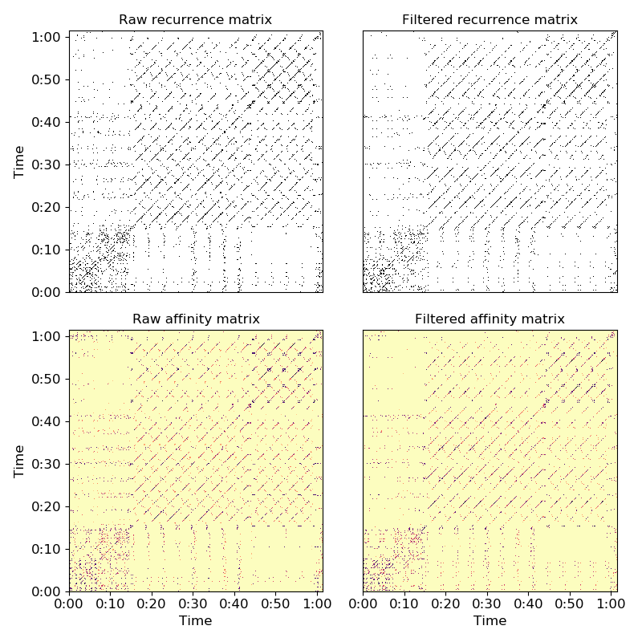
librosa.segment.path_enhance
librosa.segment.path_enhance(R, n, window='hann', max_ratio=2.0, min_ratio=None, n_filters=7, zero_mean=False, clip=True, **kwargs)[source]
Multi-angle path enhancement for self- and cross-similarity matrices.
This function convolves multiple diagonal smoothing filters with a self-similarity (or recurrence) matrix R, and aggregates the result by an element-wise maximum.
Technically, the output is a matrix R_smooth such that
R_smooth[i, j] = max_theta (R * filter_theta)[i, j]
where * denotes 2-dimensional convolution, and filter_theta is a smoothing filter at orientation theta.
This is intended to provide coherent temporal smoothing of self-similarity matrices when there are changes in tempo.
Smoothing filters are generated at evenly spaced orientations between min_ratio and max_ratio.
This function is inspired by the multi-angle path enhancement of [1], but differs by modeling tempo differences in the space of similarity matrices rather than re-sampling the underlying features prior to generating the self-similarity matrix.

[1] | Müller, Meinard and Frank Kurth. “Enhancing similarity matrices for music audio analysis.” 2006 IEEE International Conference on Acoustics Speech and Signal Processing Proceedings. Vol. 5. IEEE, 2006.
Note
if using recurrence_matrix to construct the input similarity matrix, be sure to include the main diagonal by setting self=True. Otherwise, the diagonal will be suppressed, and this is likely to produce discontinuities which will pollute the smoothing filter response.
Parameters: | R : np.ndarray  The self- or cross-similarity matrix to be smoothed. Note: sparse inputs are not supported.  n : int > 0  The length of the smoothing filter  window : window specification  The type of smoothing filter to use. See filters.get_window for more information on window specification formats.  max_ratio : float > 0  The maximum tempo ratio to support  min_ratio : float > 0  The minimum tempo ratio to support. If not provided, it will default to 1/max_ratio  n_filters : int >= 1  The number of different smoothing filters to use, evenly spaced between min_ratio and max_ratio.  If min_ratio = 1/max_ratio (the default), using an odd number of filters will ensure that the main diagonal (ratio=1) is included.  zero_mean : bool  By default, the smoothing filters are non-negative and sum to one (i.e. are averaging filters).  If zero_mean=True, then the smoothing filters are made to sum to zero by subtracting a constant value from the non-diagonal coordinates of the filter. This is primarily useful for suppressing blocks while enhancing diagonals.  clip : bool  If True, the smoothed similarity matrix will be thresholded at 0, and will not contain negative entries.  kwargs : additional keyword arguments  Additional arguments to pass to scipy.ndimage.convolve
Returns: | R_smooth : np.ndarray, shape=R.shape  The smoothed self- or cross-similarity matrix
See also
filters.diagonal_filter
recurrence_matrix
Examples
Use a 51-frame diagonal smoothing filter to enhance paths in a recurrence matrix
>>> y, sr = librosa.load(librosa.util.example_audio_file(), duration=30)
>>> hop_length = 1024
>>> chroma = librosa.feature.chroma_cqt(y=y, sr=sr, hop_length=hop_length)
>>> rec = librosa.segment.recurrence_matrix(chroma, mode='affinity', self=True)
>>> rec_smooth = librosa.segment.path_enhance(rec, 51, window='hann', n_filters=7)
Plot the recurrence matrix before and after smoothing
>>> import matplotlib.pyplot as plt
>>> plt.figure(figsize=(8, 4))
>>> plt.subplot(1,2,1)
>>> librosa.display.specshow(rec, x_axis='time', y_axis='time',
... hop_length=hop_length)
>>> plt.title('Unfiltered recurrence')
>>> plt.subplot(1,2,2)
>>> librosa.display.specshow(rec_smooth, x_axis='time', y_axis='time',
... hop_length=hop_length)
>>> plt.title('Multi-angle enhanced recurrence')
>>> plt.tight_layout()
>>> plt.show()

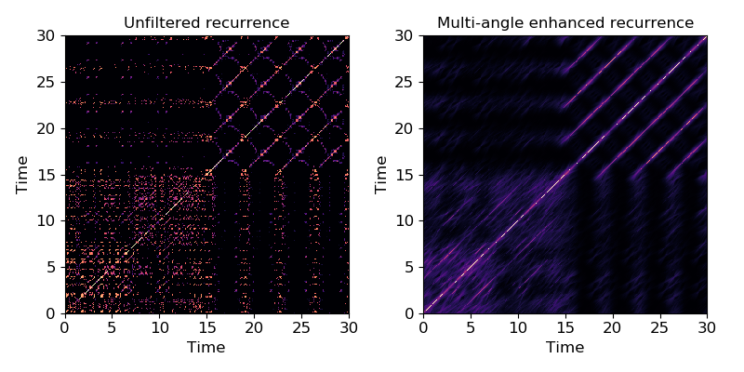
librosa.segment.agglomerative
librosa.segment.agglomerative(data, k, clusterer=None, axis=-1)[source]
Bottom-up temporal segmentation.
Use a temporally-constrained agglomerative clustering routine to partition data into k contiguous segments.
Parameters: | data : np.ndarray  data to cluster  k : int > 0 [scalar]  number of segments to produce  clusterer : sklearn.cluster.AgglomerativeClustering, optional  An optional AgglomerativeClustering object. If None, a constrained Ward object is instantiated.  axis : int  axis along which to cluster. By default, the last axis (-1) is chosen.
Returns: | boundaries : np.ndarray [shape=(k,)]  left-boundaries (frame numbers) of detected segments. This will always include 0 as the first left-boundary.
See also
sklearn.cluster.AgglomerativeClustering
Examples
Cluster by chroma similarity, break into 20 segments
>>> y, sr = librosa.load(librosa.util.example_audio_file(), duration=15)
>>> chroma = librosa.feature.chroma_cqt(y=y, sr=sr)
>>> bounds = librosa.segment.agglomerative(chroma, 20)
>>> bound_times = librosa.frames_to_time(bounds, sr=sr)
>>> bound_times
array([ 0. , 1.672, 2.322, 2.624, 3.251, 3.506,
4.18 , 5.387, 6.014, 6.293, 6.943, 7.198,
7.848, 9.033, 9.706, 9.961, 10.635, 10.89 ,
11.54 , 12.539])
Plot the segmentation over the chromagram
>>> import matplotlib.pyplot as plt
>>> plt.figure()
>>> librosa.display.specshow(chroma, y_axis='chroma', x_axis='time')
>>> plt.vlines(bound_times, 0, chroma.shape[0], color='linen', linestyle='--',
... linewidth=2, alpha=0.9, label='Segment boundaries')
>>> plt.axis('tight')
>>> plt.legend(frameon=True, shadow=True)
>>> plt.title('Power spectrogram')
>>> plt.tight_layout()
>>> plt.show()

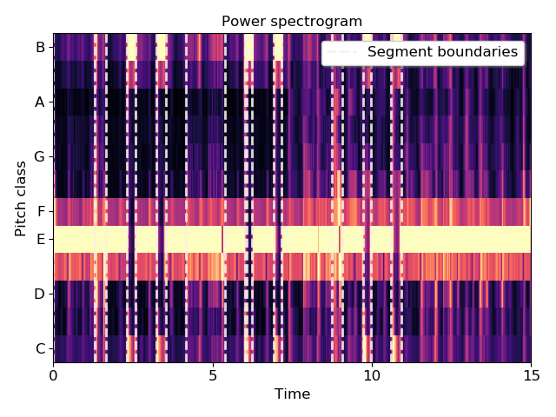
librosa.segment.subsegment
librosa.segment.subsegment(data, frames, n_segments=4, axis=-1)[source]
Sub-divide a segmentation by feature clustering.
Given a set of frame boundaries (frames), and a data matrix (data), each successive interval defined by frames is partitioned into n_segments by constrained agglomerative clustering.
Note
If an interval spans fewer than n_segments frames, then each frame becomes a sub-segment.
Parameters: | data : np.ndarray  Data matrix to use in clustering  frames : np.ndarray [shape=(n_boundaries,)], dtype=int, non-negative]  Array of beat or segment boundaries, as provided by librosa.beat.beat_track, librosa.onset.onset_detect, or agglomerative.  n_segments : int > 0  Maximum number of frames to sub-divide each interval.  axis : int  Axis along which to apply the segmentation. By default, the last index (-1) is taken.
Returns: | boundaries : np.ndarray [shape=(n_subboundaries,)]  List of sub-divided segment boundaries
See also
agglomerative
Temporal segmentation
librosa.onset.onset_detect
Onset detection
librosa.beat.beat_track
Beat tracking
Notes
This function caches at level 30.
Examples
Load audio, detect beat frames, and subdivide in twos by CQT
>>> y, sr = librosa.load(librosa.util.example_audio_file(), duration=8)
>>> tempo, beats = librosa.beat.beat_track(y=y, sr=sr, hop_length=512)
>>> beat_times = librosa.frames_to_time(beats, sr=sr, hop_length=512)
>>> cqt = np.abs(librosa.cqt(y, sr=sr, hop_length=512))
>>> subseg = librosa.segment.subsegment(cqt, beats, n_segments=2)
>>> subseg_t = librosa.frames_to_time(subseg, sr=sr, hop_length=512)
>>> subseg
array([ 0, 2, 4, 21, 23, 26, 43, 55, 63, 72, 83,
97, 102, 111, 122, 137, 142, 153, 162, 180, 182, 185,
202, 210, 221, 231, 241, 256, 261, 271, 281, 296, 301,
310, 320, 339, 341, 344, 361, 368, 382, 389, 401, 416,
420, 430, 436, 451, 456, 465, 476, 489, 496, 503, 515,
527, 535, 544, 553, 558, 571, 578, 590, 607, 609, 638])
>>> import matplotlib.pyplot as plt
>>> plt.figure()
>>> librosa.display.specshow(librosa.amplitude_to_db(cqt,
... ref=np.max),
... y_axis='cqt_hz', x_axis='time')
>>> lims = plt.gca().get_ylim()
>>> plt.vlines(beat_times, lims[0], lims[1], color='lime', alpha=0.9,
... linewidth=2, label='Beats')
>>> plt.vlines(subseg_t, lims[0], lims[1], color='linen', linestyle='--',
... linewidth=1.5, alpha=0.5, label='Sub-beats')
>>> plt.legend(frameon=True, shadow=True)
>>> plt.title('CQT + Beat and sub-beat markers')
>>> plt.tight_layout()
>>> plt.show()

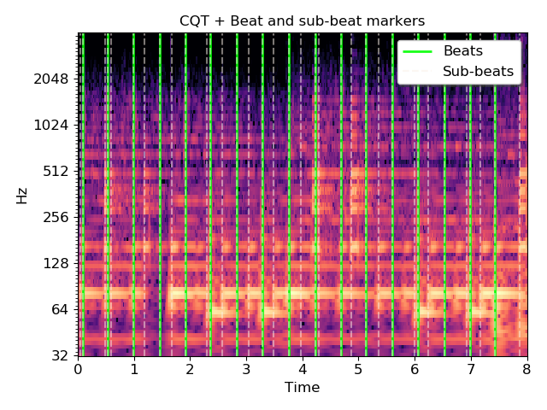
Sequential modeling

Sequence alignment
dtw([X, Y, C, metric, step_sizes_sigma, …])
rqa(sim[, gap_onset, gap_extend, …])

Viterbi decoding
viterbi(prob, transition[, p_init, return_logp]) | Viterbi decoding from observation likelihoods.
viterbi_discriminative(prob, transition[, …]) | Viterbi decoding from discriminative state predictions.
viterbi_binary(prob, transition[, p_state, …]) | Viterbi decoding from binary (multi-label), discriminative state predictions.

Transition matrices
transition_uniform(n_states) | Construct a uniform transition matrix over n_states.
transition_loop(n_states, prob) | Construct a self-loop transition matrix over n_states.
transition_cycle(n_states, prob) | Construct a cyclic transition matrix over n_states.
transition_local(n_states, width[, window, wrap]) | Construct a localized transition matrix.

librosa.sequence.dtw
librosa.sequence.dtw(X=None, Y=None, C=None, metric='euclidean', step_sizes_sigma=None, weights_add=None, weights_mul=None, subseq=False, backtrack=True, global_constraints=False, band_rad=0.25)[source]
Dynamic time warping (DTW).
This function performs a DTW and path backtracking on two sequences. We follow the nomenclature and algorithmic approach as described in [1].

[1] | Meinard Mueller Fundamentals of Music Processing — Audio, Analysis, Algorithms, Applications Springer Verlag, ISBN: 978-3-319-21944-8, 2015.
Parameters: | X : np.ndarray [shape=(K, N)]  audio feature matrix (e.g., chroma features)  Y : np.ndarray [shape=(K, M)]  audio feature matrix (e.g., chroma features)  C : np.ndarray [shape=(N, M)]  Precomputed distance matrix. If supplied, X and Y must not be supplied and metric will be ignored.  metric : str  Identifier for the cost-function as documented in scipy.spatial.cdist()  step_sizes_sigma : np.ndarray [shape=[n, 2]]  Specifies allowed step sizes as used by the dtw.  weights_add : np.ndarray [shape=[n, ]]  Additive weights to penalize certain step sizes.  weights_mul : np.ndarray [shape=[n, ]]  Multiplicative weights to penalize certain step sizes.  subseq : binary  Enable subsequence DTW, e.g., for retrieval tasks.  backtrack : binary  Enable backtracking in accumulated cost matrix.  global_constraints : binary  Applies global constraints to the cost matrix C (Sakoe-Chiba band).  band_rad : float  The Sakoe-Chiba band radius (1/2 of the width) will be int(radius*min(C.shape)).
Returns: | D : np.ndarray [shape=(N,M)]  accumulated cost matrix. D[N,M] is the total alignment cost. When doing subsequence DTW, D[N,:] indicates a matching function.  wp : np.ndarray [shape=(N,2)]  Warping path with index pairs. Each row of the array contains an index pair n,m). Only returned when backtrack is True.
Raises: | ParameterError  If you are doing diagonal matching and Y is shorter than X or if an incompatible combination of X, Y, and C are supplied. If your input dimensions are incompatible.
Examples
>>> import numpy as np
>>> import matplotlib.pyplot as plt
>>> y, sr = librosa.load(librosa.util.example_audio_file(), offset=10, duration=15)
>>> X = librosa.feature.chroma_cens(y=y, sr=sr)
>>> noise = np.random.rand(X.shape[0], 200)
>>> Y = np.concatenate((noise, noise, X, noise), axis=1)
>>> D, wp = librosa.sequence.dtw(X, Y, subseq=True)
>>> plt.subplot(2, 1, 1)
>>> librosa.display.specshow(D, x_axis='frames', y_axis='frames')
>>> plt.title('Database excerpt')
>>> plt.plot(wp[:, 1], wp[:, 0], label='Optimal path', color='y')
>>> plt.legend()
>>> plt.subplot(2, 1, 2)
>>> plt.plot(D[-1, :] / wp.shape[0])
>>> plt.xlim([0, Y.shape[1]])
>>> plt.ylim([0, 2])
>>> plt.title('Matching cost function')
>>> plt.tight_layout()
>>> plt.show()
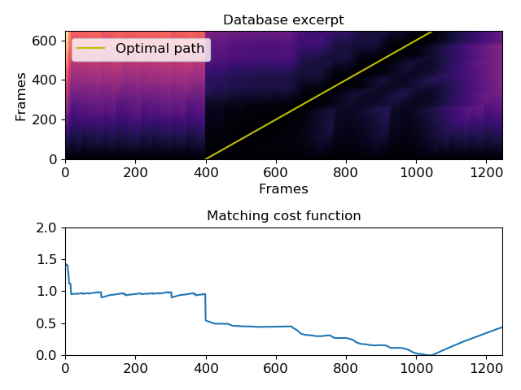

librosa.sequence.rqa
librosa.sequence.rqa(sim, gap_onset=1, gap_extend=1, knight_moves=True, backtrack=True)[source]
Recurrence quantification analysis (RQA)
This function implements different forms of RQA as described by Serra, Serra, and Andrzejak [1]. These methods take as input a self- or cross-similarity matrix sim, and calculate the value of path alignments by dynamic programming.
Note that unlike dynamic time warping (dtw), alignment paths here are maximized, not minimized, so the input should measure similarity rather than distance.
The simplest RQA method, denoted as L [1] (equation 3) and equivalent to the method described by Eckman, Kamphorst, and Ruelle [2], accumulates the length of diagonal paths with positive values in the input:
- score[i, j] = score[i-1, j-1] + 1 if sim[i, j] > 0
- score[i, j] = 0 otherwise.
The second method, denoted as S [1] (equation 4), is similar to the first, but allows for “knight moves” (as in the chess piece) in addition to strict diagonal moves:
- score[i, j] = max(score[i-1, j-1], score[i-2, j-1], score[i-1, j-2]) + 1 if sim[i, j] > 0
- score[i, j] = 0 otherwise.
The third method, denoted as Q [1] (equations 5 and 6) extends this by allowing gaps in the alignment that incur some cost, rather than a hard reset to 0 whenever sim[i, j] == 0. Gaps are penalized by two additional parameters, gap_onset and gap_extend, which are subtracted from the value of the alignment path every time a gap is introduced or extended (respectively).
Note that setting gap_onset and gap_extend to np.inf recovers the second method, and disabling knight moves recovers the first.

[1] | (1, 2, 3, 4) Serrà, Joan, Xavier Serra, and Ralph G. Andrzejak. “Cross recurrence quantification for cover song identification.” New Journal of Physics 11, no. 9 (2009): 093017.

[2] | Eckmann, J. P., S. Oliffson Kamphorst, and D. Ruelle. “Recurrence plots of dynamical systems.” World Scientific Series on Nonlinear Science Series A 16 (1995): 441-446.
Parameters: | sim : np.ndarray [shape=(N, M), non-negative]  The similarity matrix to use as input.  This can either be a recurrence matrix (self-similarity) or a cross-similarity matrix between two sequences.  gap_onset : float > 0  Penalty for introducing a gap to an alignment sequence  gap_extend : float > 0  Penalty for extending a gap in an alignment sequence  knight_moves : bool  If True (default), allow for “knight moves” in the alignment, e.g., (n, m) => (n + 1, m + 2) or (n + 2, m + 1).  If False, only allow for diagonal moves (n, m) => (n + 1, m + 1).  backtrack : bool  If True, return the alignment path.  If False, only return the score matrix.
Returns: | score : np.ndarray [shape=(N, M)]  The alignment score matrix. score[n, m] is the cumulative value of the best alignment sequence ending in frames n and m.  path : np.ndarray [shape=(k, 2)] (optional)  If backtrack=True, path contains a list of pairs of aligned frames in the best alignment sequence.  path[i] = [n, m] indicates that row n aligns to column m.
See also
segment.recurrence_matrix
segment.cross_similarity
dtw
Examples
Simple diagonal path enhancement (L-mode)
>>> import numpy as np
>>> import matplotlib.pyplot as plt
>>> y, sr = librosa.load(librosa.util.example_audio_file(),
... offset=10, duration=30)
>>> chroma = librosa.feature.chroma_cqt(y=y, sr=sr)
>>> # Use time-delay embedding to reduce noise
>>> chroma_stack = librosa.feature.stack_memory(chroma, n_steps=3)
>>> # Build recurrence, suppress self-loops within 1 second
>>> rec = librosa.segment.recurrence_matrix(chroma_stack, width=43,
... mode='affinity',
... metric='cosine')
>>> # using infinite cost for gaps enforces strict path continuation
>>> L_score, L_path = librosa.sequence.rqa(rec, np.inf, np.inf,
... knight_moves=False)
>>> plt.figure(figsize=(10, 4))
>>> plt.subplot(1,2,1)
>>> librosa.display.specshow(rec, x_axis='frames', y_axis='frames')
>>> plt.title('Recurrence matrix')
>>> plt.colorbar()
>>> plt.subplot(1,2,2)
>>> librosa.display.specshow(L_score, x_axis='frames', y_axis='frames')
>>> plt.title('Alignment score matrix')
>>> plt.colorbar()
>>> plt.plot(L_path[:, 1], L_path[:, 0], label='Optimal path', color='c')
>>> plt.legend()
>>> plt.show()

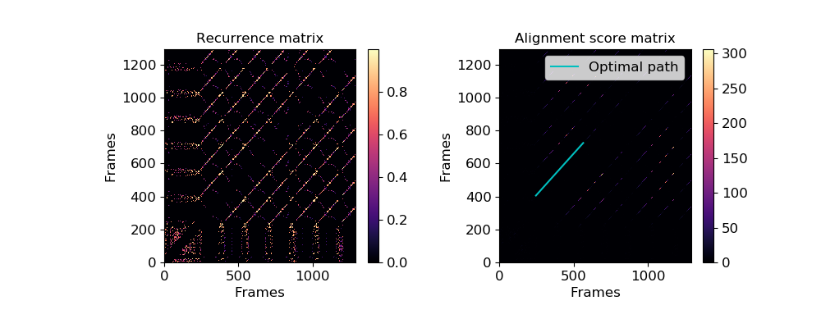
Full alignment using gaps and knight moves
>>> # New gaps cost 5, extending old gaps cost 10 for each step
>>> score, path = librosa.sequence.rqa(rec, 5, 10)
>>> plt.figure(figsize=(10, 4))
>>> plt.subplot(1,2,1)
>>> librosa.display.specshow(rec, x_axis='frames', y_axis='frames')
>>> plt.title('Recurrence matrix')
>>> plt.colorbar()
>>> plt.subplot(1,2,2)
>>> librosa.display.specshow(score, x_axis='frames', y_axis='frames')
>>> plt.title('Alignment score matrix')
>>> plt.plot(path[:, 1], path[:, 0], label='Optimal path', color='c')
>>> plt.colorbar()
>>> plt.legend()
>>> plt.show()

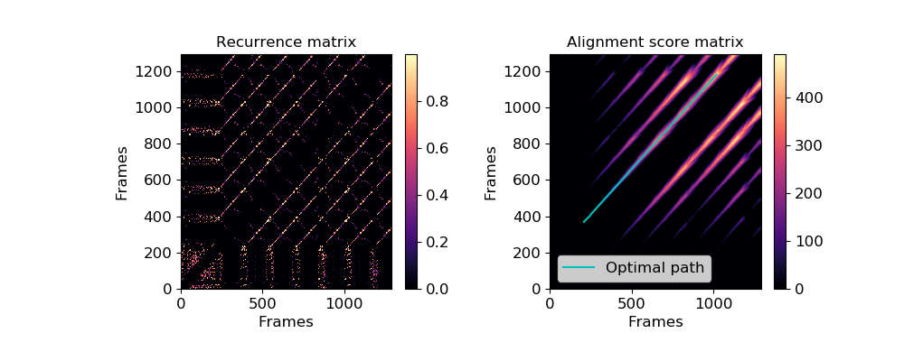
librosa.sequence.viterbi
librosa.sequence.viterbi(prob, transition, p_init=None, return_logp=False)[source]
Viterbi decoding from observation likelihoods.
Given a sequence of observation likelihoods prob[s, t], indicating the conditional likelihood of seeing the observation at time t from state s, and a transition matrix transition[i, j] which encodes the conditional probability of moving from state i to state j, the Viterbi algorithm [1] computes the most likely sequence of states from the observations.

[1] | Viterbi, Andrew. “Error bounds for convolutional codes and an asymptotically optimum decoding algorithm.” IEEE transactions on Information Theory 13.2 (1967): 260-269.
Parameters: | prob : np.ndarray [shape=(n_states, n_steps), non-negative]  prob[s, t] is the probability of observation at time t being generated by state s.  transition : np.ndarray [shape=(n_states, n_states), non-negative]  transition[i, j] is the probability of a transition from i->j. Each row must sum to 1.  p_init : np.ndarray [shape=(n_states,)]  Optional: initial state distribution. If not provided, a uniform distribution is assumed.  return_logp : bool  If True, return the log-likelihood of the state sequence.
Returns: | Either states or (states, logp):  states : np.ndarray [shape=(n_steps,)]  The most likely state sequence.  logp : scalar [float]  If return_logp=True, the log probability of states given the observations.
See also
viterbi_discriminative
Viterbi decoding from state likelihoods
Examples
Example from https://en.wikipedia.org/wiki/Viterbi_algorithm#Example
In this example, we have two states healthy and fever, with initial probabilities 60% and 40%.
We have three observation possibilities: normal, cold, and dizzy, whose probabilities given each state are:
healthy => {normal: 50%, cold: 40%, dizzy: 10%} and fever => {normal: 10%, cold: 30%, dizzy: 60%}
Finally, we have transition probabilities:
healthy => healthy (70%) and fever => fever (60%).
Over three days, we observe the sequence [normal, cold, dizzy], and wish to know the maximum likelihood assignment of states for the corresponding days, which we compute with the Viterbi algorithm below.
>>> p_init = np.array([0.6, 0.4])
>>> p_emit = np.array([[0.5, 0.4, 0.1],
... [0.1, 0.3, 0.6]])
>>> p_trans = np.array([[0.7, 0.3], [0.4, 0.6]])
>>> path, logp = librosa.sequence.viterbi(p_emit, p_trans, p_init,
... return_logp=True)
>>> print(logp, path)
-4.19173690823075 [0 0 1]

librosa.sequence.viterbi_discriminative
librosa.sequence.viterbi_discriminative(prob, transition, p_state=None, p_init=None, return_logp=False)[source]
Viterbi decoding from discriminative state predictions.
Given a sequence of conditional state predictions prob[s, t], indicating the conditional likelihood of state s given the observation at time t, and a transition matrix transition[i, j] which encodes the conditional probability of moving from state i to state j, the Viterbi algorithm computes the most likely sequence of states from the observations.
This implementation uses the standard Viterbi decoding algorithm for observation likelihood sequences, under the assumption that P[Obs(t) | State(t) = s] is proportional to P[State(t) = s | Obs(t)] / P[State(t) = s], where the denominator is the marginal probability of state s occurring as given by p_state.
Parameters: | prob : np.ndarray [shape=(n_states, n_steps), non-negative]  prob[s, t] is the probability of state s conditional on the observation at time t. Must be non-negative and sum to 1 along each column.  transition : np.ndarray [shape=(n_states, n_states), non-negative]  transition[i, j] is the probability of a transition from i->j. Each row must sum to 1.  p_state : np.ndarray [shape=(n_states,)]  Optional: marginal probability distribution over states, must be non-negative and sum to 1. If not provided, a uniform distribution is assumed.  p_init : np.ndarray [shape=(n_states,)]  Optional: initial state distribution. If not provided, it is assumed to be uniform.  return_logp : bool  If True, return the log-likelihood of the state sequence.
Returns: | Either states or (states, logp):  states : np.ndarray [shape=(n_steps,)]  The most likely state sequence.  logp : scalar [float]  If return_logp=True, the log probability of states given the observations.
See also
viterbi
Viterbi decoding from observation likelihoods
viterbi_binary
Viterbi decoding for multi-label, conditional state likelihoods
Examples
This example constructs a simple, template-based discriminative chord estimator, using CENS chroma as input features.
Note
this chord model is not accurate enough to use in practice. It is only intended to demonstrate how to use discriminative Viterbi decoding.
>>> # Create templates for major, minor, and no-chord qualities
>>> maj_template = np.array([1,0,0, 0,1,0, 0,1,0, 0,0,0])
>>> min_template = np.array([1,0,0, 1,0,0, 0,1,0, 0,0,0])
>>> N_template = np.array([1,1,1, 1,1,1, 1,1,1, 1,1,1.]) / 4.
>>> # Generate the weighting matrix that maps chroma to labels
>>> weights = np.zeros((25, 12), dtype=float)
>>> labels = ['C:maj', 'C#:maj', 'D:maj', 'D#:maj', 'E:maj', 'F:maj',
... 'F#:maj', 'G:maj', 'G#:maj', 'A:maj', 'A#:maj', 'B:maj',
... 'C:min', 'C#:min', 'D:min', 'D#:min', 'E:min', 'F:min',
... 'F#:min', 'G:min', 'G#:min', 'A:min', 'A#:min', 'B:min',
... 'N']
>>> for c in range(12):
... weights[c, :] = np.roll(maj_template, c) # c:maj
... weights[c + 12, :] = np.roll(min_template, c) # c:min
>>> weights[-1] = N_template # the last row is the no-chord class
>>> # Make a self-loop transition matrix over 25 states
>>> trans = librosa.sequence.transition_loop(25, 0.9)
>>> # Load in audio and make features
>>> y, sr = librosa.load(librosa.util.example_audio_file())
>>> # Suppress percussive elements
>>> y = librosa.effects.harmonic(y, margin=4)
>>> chroma = librosa.feature.chroma_cens(y=y, sr=sr, bins_per_octave=36)
>>> # Map chroma (observations) to class (state) likelihoods
>>> probs = np.exp(weights.dot(chroma)) # P[class | chroma] ~= exp(template' chroma)
>>> probs /= probs.sum(axis=0, keepdims=True) # probabilities must sum to 1 in each column
>>> # Compute independent frame-wise estimates
>>> chords_ind = np.argmax(probs, axis=0)
>>> # And viterbi estimates
>>> chords_vit = librosa.sequence.viterbi_discriminative(probs, trans)
>>> # Plot the features and prediction map
>>> import matplotlib.pyplot as plt
>>> plt.figure(figsize=(10, 6))
>>> plt.subplot(2,1,1)
>>> librosa.display.specshow(chroma, x_axis='time', y_axis='chroma')
>>> plt.colorbar()
>>> plt.subplot(2,1,2)
>>> librosa.display.specshow(weights, x_axis='chroma')
>>> plt.yticks(np.arange(25) + 0.5, labels)
>>> plt.ylabel('Chord')
>>> plt.colorbar()
>>> plt.tight_layout()
>>> plt.show()
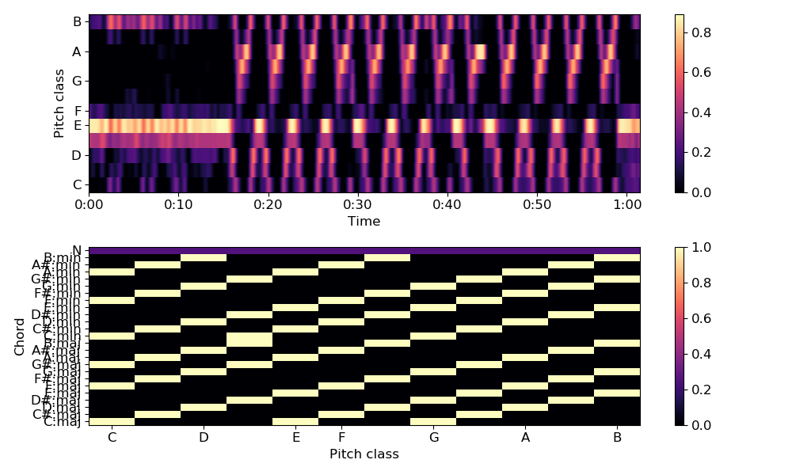
>>> # And plot the results
>>> plt.figure(figsize=(10, 4))
>>> librosa.display.specshow(probs, x_axis='time', cmap='gray')
>>> plt.colorbar()
>>> times = librosa.times_like(chords_vit)
>>> plt.scatter(times, chords_ind + 0.75, color='lime', alpha=0.5, marker='+',
... s=15, label='Independent')
>>> plt.scatter(times, chords_vit + 0.25, color='deeppink', alpha=0.5, marker='o',
... s=15, label='Viterbi')
>>> plt.yticks(0.5 + np.unique(chords_vit),
... [labels[i] for i in np.unique(chords_vit)], va='center')
>>> plt.legend()
>>> plt.tight_layout()
>>> plt.show()

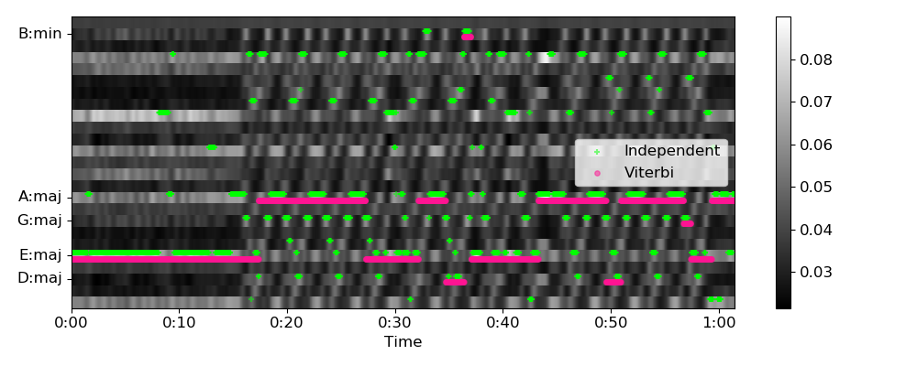
librosa.sequence.viterbi_binary
librosa.sequence.viterbi_binary(prob, transition, p_state=None, p_init=None, return_logp=False)[source]
Viterbi decoding from binary (multi-label), discriminative state predictions.
Given a sequence of conditional state predictions prob[s, t], indicating the conditional likelihood of state s being active conditional on observation at time t, and a 2*2 transition matrix transition which encodes the conditional probability of moving from state s to state s (not-s), the Viterbi algorithm computes the most likely sequence of states from the observations.
This function differs from viterbi_discriminative in that it does not assume the states to be mutually exclusive. viterbi_binary is implemented by transforming the multi-label decoding problem to a collection of binary Viterbi problems (one for each state or label).
The output is a binary matrix states[s, t] indicating whether each state s is active at time t.
Parameters: | prob : np.ndarray [shape=(n_steps,) or (n_states, n_steps)], non-negative  prob[s, t] is the probability of state s being active conditional on the observation at time t. Must be non-negative and less than 1.  If prob is 1-dimensional, it is expanded to shape (1, n_steps).  transition : np.ndarray [shape=(2, 2) or (n_states, 2, 2)], non-negative  If 2-dimensional, the same transition matrix is applied to each sub-problem. transition[0, i] is the probability of the state going from inactive to i, transition[1, i] is the probability of the state going from active to i. Each row must sum to 1.  If 3-dimensional, transition[s] is interpreted as the 2x2 transition matrix for state label s.  p_state : np.ndarray [shape=(n_states,)]  Optional: marginal probability for each state (between [0,1]). If not provided, a uniform distribution (0.5 for each state) is assumed.  p_init : np.ndarray [shape=(n_states,)]  Optional: initial state distribution. If not provided, it is assumed to be uniform.  return_logp : bool  If True, return the log-likelihood of the state sequence.
Returns: | Either states or (states, logp):  states : np.ndarray [shape=(n_states, n_steps)]  The most likely state sequence.  logp : np.ndarray [shape=(n_states,)]  If return_logp=True, the log probability of each state activation sequence states
See also
viterbi
Viterbi decoding from observation likelihoods
viterbi_discriminative
Viterbi decoding for discriminative (mutually exclusive) state predictions
Examples
In this example, we have a sequence of binary state likelihoods that we want to de-noise under the assumption that state changes are relatively uncommon. Positive predictions should only be retained if they persist for multiple steps, and any transient predictions should be considered as errors. This use case arises frequently in problems such as instrument recognition, where state activations tend to be stable over time, but subject to abrupt changes (e.g., when an instrument joins the mix).
We assume that the 0 state has a self-transition probability of 90%, and the 1 state has a self-transition probability of 70%. We assume the marginal and initial probability of either state is 50%.
>>> trans = np.array([[0.9, 0.1], [0.3, 0.7]])
>>> prob = np.array([0.1, 0.7, 0.4, 0.3, 0.8, 0.9, 0.8, 0.2, 0.6, 0.3])
>>> librosa.sequence.viterbi_binary(prob, trans, p_state=0.5, p_init=0.5)
array([[0, 0, 0, 0, 1, 1, 1, 0, 0, 0]])

librosa.sequence.transition_uniform
librosa.sequence.transition_uniform(n_states)[source]
Construct a uniform transition matrix over n_states.
Parameters: | n_states : int > 0  The number of states
Returns: | transition : np.ndarray [shape=(n_states, n_states)]  transition[i, j] = 1./n_states
Examples
>>> librosa.sequence.transition_uniform(3)
array([[0.333, 0.333, 0.333],
[0.333, 0.333, 0.333],
[0.333, 0.333, 0.333]])

librosa.sequence.transition_loop
librosa.sequence.transition_loop(n_states, prob)[source]
Construct a self-loop transition matrix over n_states.
The transition matrix will have the following properties:
- transition[i, i] = p for all i
- transition[i, j] = (1 - p) / (n_states - 1) for all j != i
This type of transition matrix is appropriate when states tend to be locally stable, and there is no additional structure between different states. This is primarily useful for de-noising frame-wise predictions.
Parameters: | n_states : int > 1  The number of states  prob : float in [0, 1] or iterable, length=n_states  If a scalar, this is the probability of a self-transition.  If a vector of length n_states, p[i] is the probability of state i’s self-transition.
Returns: | transition : np.ndarray [shape=(n_states, n_states)]  The transition matrix
Examples
>>> librosa.sequence.transition_loop(3, 0.5)
array([[0.5 , 0.25, 0.25],
[0.25, 0.5 , 0.25],
[0.25, 0.25, 0.5 ]])
>>> librosa.sequence.transition_loop(3, [0.8, 0.5, 0.25])
array([[0.8 , 0.1 , 0.1 ],
[0.25 , 0.5 , 0.25 ],
[0.375, 0.375, 0.25 ]])

librosa.sequence.transition_cycle
librosa.sequence.transition_cycle(n_states, prob)[source]
Construct a cyclic transition matrix over n_states.
The transition matrix will have the following properties:
- transition[i, i] = p
- transition[i, i + 1] = (1 - p)
This type of transition matrix is appropriate for state spaces with cyclical structure, such as metrical position within a bar. For example, a song in 4/4 time has state transitions of the form
1->{1, 2}, 2->{2, 3}, 3->{3, 4}, 4->{4, 1}.
Parameters: | n_states : int > 1  The number of states  prob : float in [0, 1] or iterable, length=n_states  If a scalar, this is the probability of a self-transition.  If a vector of length n_states, p[i] is the probability of state i’s self-transition.
Returns: | transition : np.ndarray [shape=(n_states, n_states)]  The transition matrix
Examples
>>> librosa.sequence.transition_cycle(4, 0.9)
array([[0.9, 0.1, 0. , 0. ],
[0. , 0.9, 0.1, 0. ],
[0. , 0. , 0.9, 0.1],
[0.1, 0. , 0. , 0.9]])

librosa.sequence.transition_local
librosa.sequence.transition_local(n_states, width, window='triangle', wrap=False)[source]
Construct a localized transition matrix.
The transition matrix will have the following properties:
- transition[i, j] = 0 if |i - j| > width
- transition[i, i] is maximal
- transition[i, i - width//2 : i + width//2] has shape window
This type of transition matrix is appropriate for state spaces that discretely approximate continuous variables, such as in fundamental frequency estimation.
Parameters: | n_states : int > 1  The number of states  width : int >= 1 or iterable  The maximum number of states to treat as “local”. If iterable, it should have length equal to n_states, and specify the width independently for each state.  window : str, callable, or window specification  The window function to determine the shape of the “local” distribution.  Any window specification supported by filters.get_window will work here.  Note  Certain windows (e.g., ‘hann’) are identically 0 at the boundaries, so and effectively have width-2 non-zero values. You may have to expand width to get the desired behavior.  wrap : bool  If True, then state locality |i - j| is computed modulo n_states. If False (default), then locality is absolute.
Returns: | transition : np.ndarray [shape=(n_states, n_states)]  The transition matrix
See also
filters.get_window
Examples
Triangular distributions with and without wrapping
>>> librosa.sequence.transition_local(5, 3, window='triangle', wrap=False)
array([[0.667, 0.333, 0. , 0. , 0. ],
[0.25 , 0.5 , 0.25 , 0. , 0. ],
[0. , 0.25 , 0.5 , 0.25 , 0. ],
[0. , 0. , 0.25 , 0.5 , 0.25 ],
[0. , 0. , 0. , 0.333, 0.667]])
>>> librosa.sequence.transition_local(5, 3, window='triangle', wrap=True)
array([[0.5 , 0.25, 0. , 0. , 0.25],
[0.25, 0.5 , 0.25, 0. , 0. ],
[0. , 0.25, 0.5 , 0.25, 0. ],
[0. , 0. , 0.25, 0.5 , 0.25],
[0.25, 0. , 0. , 0.25, 0.5 ]])
Uniform local distributions with variable widths and no wrapping
>>> librosa.sequence.transition_local(5, [1, 2, 3, 3, 1], window='ones', wrap=False)
array([[1. , 0. , 0. , 0. , 0. ],
[0.5 , 0.5 , 0. , 0. , 0. ],
[0. , 0.333, 0.333, 0.333, 0. ],
[0. , 0. , 0.333, 0.333, 0.333],
[0. , 0. , 0. , 0. , 1. ]])

Utilities

Array operations

frame(x[, frame_length, hop_length, axis]) | Slice a data array into (overlapping) frames.
pad_center(data, size[, axis]) | Wrapper for np.pad to automatically center an array prior to padding.
fix_length(data, size[, axis]) | Fix the length an array data to exactly size.
fix_frames(frames[, x_min, x_max, pad]) | Fix a list of frames to lie within [x_min, x_max]
index_to_slice(idx[, idx_min, idx_max, …]) | Generate a slice array from an index array.
softmask(X, X_ref[, power, split_zeros]) | Robustly compute a softmask operation.
stack(arrays[, axis]) | Stack one or more arrays along a target axis.
sync(data, idx[, aggregate, pad, axis]) | Synchronous aggregation of a multi-dimensional array between boundaries
axis_sort(S[, axis, index, value]) | Sort an array along its rows or columns.
normalize(S[, norm, axis, threshold, fill]) | Normalize an array along a chosen axis.
shear(X[, factor, axis]) | Shear a matrix by a given factor.
sparsify_rows(x[, quantile]) | Return a row-sparse matrix approximating the input x.
buf_to_float(x[, n_bytes, dtype]) | Convert an integer buffer to floating point values.
tiny(x) | Compute the tiny-value corresponding to an input’s data type.

Matching

match_intervals(intervals_from, intervals_to) | Match one set of time intervals to another.
match_events(events_from, events_to[, left, …]) | Match one set of events to another.

Miscellaneous

localmax(x[, axis]) | Find local maxima in an array x.
peak_pick(x, pre_max, post_max, pre_avg, …) | Uses a flexible heuristic to pick peaks in a signal.
nnls(A, B, \*\*kwargs) | Non-negative least squares.
cyclic_gradient(data[, edge_order, axis]) | Estimate the gradient of a function over a uniformly sampled, periodic domain.

validation

valid_audio(y[, mono]) | Validate whether a variable contains valid, mono audio data.
valid_int(x[, cast]) | Ensure that an input value is integer-typed.
valid_intervals(intervals) | Ensure that an array is a valid representation of time intervals:

File operations

example_audio_file() | Get the path to an included audio example file.
find_files(directory[, ext, recurse, …]) | Get a sorted list of (audio) files in a directory or directory sub-tree.

Deprecated

roll_sparse(x, shift[, axis]) | Sparse matrix roll

librosa.util.frame
librosa.util.frame(x, frame_length=2048, hop_length=512, axis=-1)[source]
Slice a data array into (overlapping) frames.
This implementation uses low-level stride manipulation to avoid making a copy of the data. The resulting frame representation is a new view of the input data.
For example, a one-dimensional input x = [0, 1, 2, 3, 4, 5, 6] can be framed with frame length 3 and hop length 2 in two ways. The first (axis=-1), results in the array x_frames:
[[0, 2, 4],
[1, 3, 5], [2, 4, 6]]
where each column x_frames[:, i] contains a contiguous slice of the input x[i * hop_length : i * hop_length + frame_length].
The second way (axis=0) results in the array x_frames:
[[0, 1, 2],
[2, 3, 4], [4, 5, 6]]
where each row x_frames[i] contains a contiguous slice of the input.
This generalizes to higher dimensional inputs, as shown in the examples below. In general, the framing operation increments by 1 the number of dimensions, adding a new “frame axis” either to the end of the array (axis=-1) or the beginning of the array (axis=0).
Parameters: | x : np.ndarray  Time series to frame. Must be contiguous in memory, see the “Raises” section below for more information.  frame_length : int > 0 [scalar]  Length of the frame  hop_length : int > 0 [scalar]  Number of steps to advance between frames  axis : 0 or -1  The axis along which to frame.  If axis=-1 (the default), then x is framed along its last dimension. x must be “F-contiguous” in this case.  If axis=0, then x is framed along its first dimension. x must be “C-contiguous” in this case.
Returns: | x_frames : np.ndarray [shape=(…, frame_length, N_FRAMES) or (N_FRAMES, frame_length, …)]  A framed view of x, for example with axis=-1 (framing on the last dimension): x_frames[…, j] == x[…, j * hop_length : j * hop_length + frame_length]  If axis=0 (framing on the first dimension), then: x_frames[j] = x[j * hop_length : j * hop_length + frame_length]
Raises: | ParameterError  If x is not contiguous in memory or not an np.ndarray.  If x.shape[axis] < frame_length, there is not enough data to fill one frame.  If hop_length < 1, frames cannot advance.  If axis is not 0 or -1. Framing is only supported along the first or last axis.  If axis=-1 (the default), then x must be “F-contiguous”. If axis=0, then x must be “C-contiguous”.  If the contiguity of x is incompatible with the framing axis.
See also
np.asfortranarray
Convert data to F-contiguous representation
np.ascontiguousarray
Convert data to C-contiguous representation
np.ndarray.flags
information about the memory layout of a numpy ndarray.
Examples
Extract 2048-sample frames from monophonic y with a hop of 64 samples per frame
>>> y, sr = librosa.load(librosa.util.example_audio_file())
>>> frames = librosa.util.frame(y, frame_length=2048, hop_length=64)
>>> frames
array([[ 0.000e+00, 0.000e+00, ..., -2.448e-06, -6.789e-07],
[ 0.000e+00, 0.000e+00, ..., -1.399e-05, 1.004e-06],
...,
[-7.352e-04, 5.162e-03, ..., 0.000e+00, 0.000e+00],
[ 2.168e-03, 4.870e-03, ..., 0.000e+00, 0.000e+00]],
dtype=float32)
>>> y.shape
(1355168,)
>>> frames.shape
(2048, 21143)
Or frame along the first axis instead of the last:
>>> frames = librosa.util.frame(y, frame_length=2048, hop_length=64, axis=0)
>>> frames.shape
(21143, 2048)
Frame a stereo signal:
>>> y, sr = librosa.load(librosa.util.example_audio_file(), mono=False)
>>> y.shape
(2, 1355168)
>>> frames = librosa.util.frame(y, frame_length=2048, hop_length=64)
(2, 2048, 21143)
Carve an STFT into fixed-length patches of 32 frames with 50% overlap
>>> y, sr = librosa.load(librosa.util.example_audio_file())
>>> S = np.abs(librosa.stft(y))
>>> S.shape
(1025, 2647)
>>> S_patch = librosa.util.frame(S, frame_length=32, hop_length=16)
>>> S_patch.shape
(1025, 32, 82)
>>> # The first patch contains the first 32 frames of S
>>> np.allclose(S_patch[:, :, 0], S[:, :32])
True
>>> # The second patch contains frames 16 to 16+32=48, and so on
>>> np.allclose(S_patch[:, :, 1], S[:, 16:48])
True
librosa.util.pad_center
librosa.util.pad_center(data, size, axis=-1, **kwargs)[source]
Wrapper for np.pad to automatically center an array prior to padding. This is analogous to str.center()
Parameters: | data : np.ndarray  Vector to be padded and centered  size : int >= len(data) [scalar]  Length to pad data  axis : int  Axis along which to pad and center the data  kwargs : additional keyword arguments  arguments passed to np.pad()
Returns: | data_padded : np.ndarray  data centered and padded to length size along the specified axis
Raises: | ParameterError  If size < data.shape[axis]
See also
numpy.pad
Examples
>>> # Generate a vector
>>> data = np.ones(5)
>>> librosa.util.pad_center(data, 10, mode='constant')
array([ 0., 0., 1., 1., 1., 1., 1., 0., 0., 0.])
>>> # Pad a matrix along its first dimension
>>> data = np.ones((3, 5))
>>> librosa.util.pad_center(data, 7, axis=0)
array([[ 0., 0., 0., 0., 0.],
[ 0., 0., 0., 0., 0.],
[ 1., 1., 1., 1., 1.],
[ 1., 1., 1., 1., 1.],
[ 1., 1., 1., 1., 1.],
[ 0., 0., 0., 0., 0.],
[ 0., 0., 0., 0., 0.]])
>>> # Or its second dimension
>>> librosa.util.pad_center(data, 7, axis=1)
array([[ 0., 1., 1., 1., 1., 1., 0.],
[ 0., 1., 1., 1., 1., 1., 0.],
[ 0., 1., 1., 1., 1., 1., 0.]])

librosa.util.fix_length
librosa.util.fix_length(data, size, axis=-1, **kwargs)[source]
Fix the length an array data to exactly size.
If data.shape[axis] < n, pad according to the provided kwargs. By default, data is padded with trailing zeros.
Parameters: | data : np.ndarray  array to be length-adjusted  size : int >= 0 [scalar]  desired length of the array  axis : int, <= data.ndim  axis along which to fix length  kwargs : additional keyword arguments  Parameters to np.pad()
Returns: | data_fixed : np.ndarray [shape=data.shape]  data either trimmed or padded to length size along the specified axis.
See also
numpy.pad
Examples
>>> y = np.arange(7)
>>> # Default: pad with zeros
>>> librosa.util.fix_length(y, 10)
array([0, 1, 2, 3, 4, 5, 6, 0, 0, 0])
>>> # Trim to a desired length
>>> librosa.util.fix_length(y, 5)
array([0, 1, 2, 3, 4])
>>> # Use edge-padding instead of zeros
>>> librosa.util.fix_length(y, 10, mode='edge')
array([0, 1, 2, 3, 4, 5, 6, 6, 6, 6])

librosa.util.fix_frames
librosa.util.fix_frames(frames, x_min=0, x_max=None, pad=True)[source]
Fix a list of frames to lie within [x_min, x_max]
Parameters: | frames : np.ndarray [shape=(n_frames,)]  List of non-negative frame indices  x_min : int >= 0 or None  Minimum allowed frame index  x_max : int >= 0 or None  Maximum allowed frame index  pad : boolean  If True, then frames is expanded to span the full range [x_min, x_max]
Returns: | fixed_frames : np.ndarray [shape=(n_fixed_frames,), dtype=int]  Fixed frame indices, flattened and sorted
Raises: | ParameterError  If frames contains negative values
Examples
>>> # Generate a list of frame indices
>>> frames = np.arange(0, 1000.0, 50)
>>> frames
array([ 0., 50., 100., 150., 200., 250., 300., 350.,
400., 450., 500., 550., 600., 650., 700., 750.,
800., 850., 900., 950.])
>>> # Clip to span at most 250
>>> librosa.util.fix_frames(frames, x_max=250)
array([ 0, 50, 100, 150, 200, 250])
>>> # Or pad to span up to 2500
>>> librosa.util.fix_frames(frames, x_max=2500)
array([ 0, 50, 100, 150, 200, 250, 300, 350, 400,
450, 500, 550, 600, 650, 700, 750, 800, 850,
900, 950, 2500])
>>> librosa.util.fix_frames(frames, x_max=2500, pad=False)
array([ 0, 50, 100, 150, 200, 250, 300, 350, 400, 450, 500,
550, 600, 650, 700, 750, 800, 850, 900, 950])
>>> # Or starting away from zero
>>> frames = np.arange(200, 500, 33)
>>> frames
array([200, 233, 266, 299, 332, 365, 398, 431, 464, 497])
>>> librosa.util.fix_frames(frames)
array([ 0, 200, 233, 266, 299, 332, 365, 398, 431, 464, 497])
>>> librosa.util.fix_frames(frames, x_max=500)
array([ 0, 200, 233, 266, 299, 332, 365, 398, 431, 464, 497,
500])

librosa.util.index_to_slice
librosa.util.index_to_slice(idx, idx_min=None, idx_max=None, step=None, pad=True)[source]
Generate a slice array from an index array.
Parameters: | idx : list-like  Array of index boundaries  idx_min : None or int  idx_max : None or int  Minimum and maximum allowed indices  step : None or int  Step size for each slice. If None, then the default step of 1 is used.  pad : boolean  If True, pad idx to span the range idx_min:idx_max.
Returns: | slices : list of slice  slices[i] = slice(idx[i], idx[i+1], step) Additional slice objects may be added at the beginning or end, depending on whether pad==True and the supplied values for idx_min and idx_max.
See also
fix_frames
Examples
>>> # Generate slices from spaced indices
>>> librosa.util.index_to_slice(np.arange(20, 100, 15))
[slice(20, 35, None), slice(35, 50, None), slice(50, 65, None), slice(65, 80, None),
slice(80, 95, None)]
>>> # Pad to span the range (0, 100)
>>> librosa.util.index_to_slice(np.arange(20, 100, 15),
... idx_min=0, idx_max=100)
[slice(0, 20, None), slice(20, 35, None), slice(35, 50, None), slice(50, 65, None),
slice(65, 80, None), slice(80, 95, None), slice(95, 100, None)]
>>> # Use a step of 5 for each slice
>>> librosa.util.index_to_slice(np.arange(20, 100, 15),
... idx_min=0, idx_max=100, step=5)
[slice(0, 20, 5), slice(20, 35, 5), slice(35, 50, 5), slice(50, 65, 5), slice(65, 80, 5),
slice(80, 95, 5), slice(95, 100, 5)]

librosa.util.softmask
librosa.util.softmask(X, X_ref, power=1, split_zeros=False)[source]
Robustly compute a softmask operation.
M = X**power / (X**power + X_ref**power)
Parameters: | X : np.ndarray  The (non-negative) input array corresponding to the positive mask elements  X_ref : np.ndarray  The (non-negative) array of reference or background elements. Must have the same shape as X.  power : number > 0 or np.inf  If finite, returns the soft mask computed in a numerically stable way  If infinite, returns a hard (binary) mask equivalent to X > X_ref. Note: for hard masks, ties are always broken in favor of X_ref (mask=0).  split_zeros : bool  If True, entries where X and X`_ref` are both small (close to 0) will receive mask values of 0.5.  Otherwise, the mask is set to 0 for these entries.
Returns: | mask : np.ndarray, shape=`X.shape`  The output mask array
Raises: | ParameterError  If X and X_ref have different shapes.  If X or X_ref are negative anywhere  If power <= 0
Examples
>>> X = 2 * np.ones((3, 3))
>>> X_ref = np.vander(np.arange(3.0))
>>> X
array([[ 2., 2., 2.],
[ 2., 2., 2.],
[ 2., 2., 2.]])
>>> X_ref
array([[ 0., 0., 1.],
[ 1., 1., 1.],
[ 4., 2., 1.]])
>>> librosa.util.softmask(X, X_ref, power=1)
array([[ 1. , 1. , 0.667],
[ 0.667, 0.667, 0.667],
[ 0.333, 0.5 , 0.667]])
>>> librosa.util.softmask(X_ref, X, power=1)
array([[ 0. , 0. , 0.333],
[ 0.333, 0.333, 0.333],
[ 0.667, 0.5 , 0.333]])
>>> librosa.util.softmask(X, X_ref, power=2)
array([[ 1. , 1. , 0.8],
[ 0.8, 0.8, 0.8],
[ 0.2, 0.5, 0.8]])
>>> librosa.util.softmask(X, X_ref, power=4)
array([[ 1. , 1. , 0.941],
[ 0.941, 0.941, 0.941],
[ 0.059, 0.5 , 0.941]])
>>> librosa.util.softmask(X, X_ref, power=100)
array([[ 1.000e+00, 1.000e+00, 1.000e+00],
[ 1.000e+00, 1.000e+00, 1.000e+00],
[ 7.889e-31, 5.000e-01, 1.000e+00]])
>>> librosa.util.softmask(X, X_ref, power=np.inf)
array([[ True, True, True],
[ True, True, True],
[False, False, True]], dtype=bool)

librosa.util.stack
librosa.util.stack(arrays, axis=0)[source]
Stack one or more arrays along a target axis.
This function is similar to np.stack, except that memory contiguity is retained when stacking along the first dimension.
This is useful when combining multiple monophonic audio signals into a multi-channel signal, or when stacking multiple feature representations to form a multi-dimensional array.
Parameters: | arrays : list  one or more np.ndarray  axis : integer  The target axis along which to stack. axis=0 creates a new first axis, and axis=-1 creates a new last axis.
Returns: | arr_stack : np.ndarray [shape=(len(arrays), array_shape) or shape=(array_shape, len(arrays))]  The input arrays, stacked along the target dimension.  If axis=0, then arr_stack will be F-contiguous. Otherwise, arr_stack will be C-contiguous by default, as computed by np.stack.
Raises: | ParameterError  - If arrays do not all have the same shape  - If no arrays are given
See also
np.stack
np.ndarray.flags
frame
Examples
Combine two buffers into a contiguous arrays
>>> y_left = np.ones(5)
>>> y_right = -np.ones(5)
>>> y_stereo = librosa.util.stack([y_left, y_right], axis=0)
>>> y_stereo
array([[ 1., 1., 1., 1., 1.],
[-1., -1., -1., -1., -1.]])
>>> y_stereo.flags
C_CONTIGUOUS : False
F_CONTIGUOUS : True
OWNDATA : True
WRITEABLE : True
ALIGNED : True
WRITEBACKIFCOPY : False
UPDATEIFCOPY : False
Or along the trailing axis
>>> y_stereo = librosa.util.stack([y_left, y_right], axis=-1)
>>> y_stereo
array([[ 1., -1.],
[ 1., -1.],
[ 1., -1.],
[ 1., -1.],
[ 1., -1.]])
>>> y_stereo.flags
C_CONTIGUOUS : True
F_CONTIGUOUS : False
OWNDATA : True
WRITEABLE : True
ALIGNED : True
WRITEBACKIFCOPY : False
UPDATEIFCOPY : False

