librosa.util.sync
librosa.util.sync(data, idx, aggregate=None, pad=True, axis=-1)[source]
Synchronous aggregation of a multi-dimensional array between boundaries
Note
In order to ensure total coverage, boundary points may be added to idx.
If synchronizing a feature matrix against beat tracker output, ensure that frame index numbers are properly aligned and use the same hop length.
Parameters: | data : np.ndarray  multi-dimensional array of features  idx : iterable of ints or slices  Either an ordered array of boundary indices, or an iterable collection of slice objects.  aggregate : function  aggregation function (default: np.mean)  pad : boolean  If True, idx is padded to span the full range [0, data.shape[axis]]  axis : int  The axis along which to aggregate data
Returns: | data_sync : ndarray  data_sync will have the same dimension as data, except that the axis coordinate will be reduced according to idx.  For example, a 2-dimensional data with axis=-1 should satisfy  data_sync[:, i] = aggregate(data[:, idx[i-1]:idx[i]], axis=-1)
Raises: | ParameterError  If the index set is not of consistent type (all slices or all integers)
Notes
This function caches at level 40.
Examples
Beat-synchronous CQT spectra
>>> y, sr = librosa.load(librosa.util.example_audio_file())
>>> tempo, beats = librosa.beat.beat_track(y=y, sr=sr, trim=False)
>>> C = np.abs(librosa.cqt(y=y, sr=sr))
>>> beats = librosa.util.fix_frames(beats, x_max=C.shape[1])
By default, use mean aggregation
>>> C_avg = librosa.util.sync(C, beats)
Use median-aggregation instead of mean
>>> C_med = librosa.util.sync(C, beats,
... aggregate=np.median)
Or sub-beat synchronization
>>> sub_beats = librosa.segment.subsegment(C, beats)
>>> sub_beats = librosa.util.fix_frames(sub_beats, x_max=C.shape[1])
>>> C_med_sub = librosa.util.sync(C, sub_beats, aggregate=np.median)
Plot the results
>>> import matplotlib.pyplot as plt
>>> beat_t = librosa.frames_to_time(beats, sr=sr)
>>> subbeat_t = librosa.frames_to_time(sub_beats, sr=sr)
>>> plt.figure()
>>> plt.subplot(3, 1, 1)
>>> librosa.display.specshow(librosa.amplitude_to_db(C,
... ref=np.max),
... x_axis='time')
>>> plt.title('CQT power, shape={}'.format(C.shape))
>>> plt.subplot(3, 1, 2)
>>> librosa.display.specshow(librosa.amplitude_to_db(C_med,
... ref=np.max),
... x_coords=beat_t, x_axis='time')
>>> plt.title('Beat synchronous CQT power, '
... 'shape={}'.format(C_med.shape))
>>> plt.subplot(3, 1, 3)
>>> librosa.display.specshow(librosa.amplitude_to_db(C_med_sub,
... ref=np.max),
... x_coords=subbeat_t, x_axis='time')
>>> plt.title('Sub-beat synchronous CQT power, '
... 'shape={}'.format(C_med_sub.shape))
>>> plt.tight_layout()
>>> plt.show()

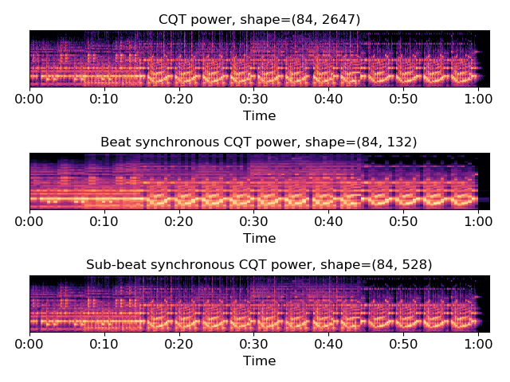
librosa.util.axis_sort
librosa.util.axis_sort(S, axis=-1, index=False, value=None)[source]
Sort an array along its rows or columns.
Parameters: | S : np.ndarray [shape=(d, n)]  Array to be sorted  axis : int [scalar]  The axis along which to compute the sorting values  - axis=0 to sort rows by peak column index  - axis=1 to sort columns by peak row index  index : boolean [scalar]  If true, returns the index array as well as the permuted data.  value : function  function to return the index corresponding to the sort order. Default: np.argmax.
Returns: | S_sort : np.ndarray [shape=(d, n)]  S with the columns or rows permuted in sorting order  idx : np.ndarray (optional) [shape=(d,) or (n,)]  If index == True, the sorting index used to permute S. Length of idx corresponds to the selected axis.
Raises: | ParameterError  If S does not have exactly 2 dimensions (S.ndim != 2)
Examples
Visualize NMF output for a spectrogram S
>>> # Sort the columns of W by peak frequency bin
>>> y, sr = librosa.load(librosa.util.example_audio_file())
>>> S = np.abs(librosa.stft(y))
>>> W, H = librosa.decompose.decompose(S, n_components=32)
>>> W_sort = librosa.util.axis_sort(W)
Or sort by the lowest frequency bin
>>> W_sort = librosa.util.axis_sort(W, value=np.argmin)
Or sort the rows instead of the columns
>>> W_sort_rows = librosa.util.axis_sort(W, axis=0)
Get the sorting index also, and use it to permute the rows of H
>>> W_sort, idx = librosa.util.axis_sort(W, index=True)
>>> H_sort = H[idx, :]
>>> import matplotlib.pyplot as plt
>>> plt.figure()
>>> plt.subplot(2, 2, 1)
>>> librosa.display.specshow(librosa.amplitude_to_db(W, ref=np.max),
... y_axis='log')
>>> plt.title('W')
>>> plt.subplot(2, 2, 2)
>>> librosa.display.specshow(H, x_axis='time')
>>> plt.title('H')
>>> plt.subplot(2, 2, 3)
>>> librosa.display.specshow(librosa.amplitude_to_db(W_sort,
... ref=np.max),
... y_axis='log')
>>> plt.title('W sorted')
>>> plt.subplot(2, 2, 4)
>>> librosa.display.specshow(H_sort, x_axis='time')
>>> plt.title('H sorted')
>>> plt.tight_layout()
>>> plt.show()

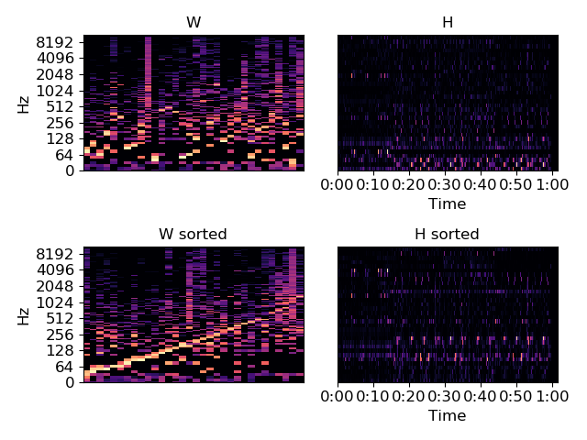
librosa.util.normalize
librosa.util.normalize(S, norm=inf, axis=0, threshold=None, fill=None)[source]
Normalize an array along a chosen axis.
Given a norm (described below) and a target axis, the input array is scaled so that
norm(S, axis=axis) == 1
For example, axis=0 normalizes each column of a 2-d array by aggregating over the rows (0-axis). Similarly, axis=1 normalizes each row of a 2-d array.
This function also supports thresholding small-norm slices: any slice (i.e., row or column) with norm below a specified threshold can be left un-normalized, set to all-zeros, or filled with uniform non-zero values that normalize to 1.
Note: the semantics of this function differ from scipy.linalg.norm in two ways: multi-dimensional arrays are supported, but matrix-norms are not.
Parameters: | S : np.ndarray  The matrix to normalize  norm : {np.inf, -np.inf, 0, float > 0, None}  - np.inf : maximum absolute value  - -np.inf : mininum absolute value  - 0 : number of non-zeros (the support)  - float : corresponding l_p norm  See scipy.linalg.norm for details.  - None : no normalization is performed  axis : int [scalar]  Axis along which to compute the norm.  threshold : number > 0 [optional]  Only the columns (or rows) with norm at least threshold are normalized.  By default, the threshold is determined from the numerical precision of S.dtype.  fill : None or bool  If None, then columns (or rows) with norm below threshold are left as is.  If False, then columns (rows) with norm below threshold are set to 0.  If True, then columns (rows) with norm below threshold are filled uniformly such that the corresponding norm is 1.  Note  fill=True is incompatible with norm=0 because no uniform vector exists with l0 “norm” equal to 1.
Returns: | S_norm : np.ndarray [shape=S.shape]  Normalized array
Raises: | ParameterError  If norm is not among the valid types defined above  If S is not finite  If fill=True and norm=0
See also
scipy.linalg.norm
Notes
This function caches at level 40.
Examples
>>> # Construct an example matrix
>>> S = np.vander(np.arange(-2.0, 2.0))
>>> S
array([[-8., 4., -2., 1.],
[-1., 1., -1., 1.],
[ 0., 0., 0., 1.],
[ 1., 1., 1., 1.]])
>>> # Max (l-infinity)-normalize the columns
>>> librosa.util.normalize(S)
array([[-1. , 1. , -1. , 1. ],
[-0.125, 0.25 , -0.5 , 1. ],
[ 0. , 0. , 0. , 1. ],
[ 0.125, 0.25 , 0.5 , 1. ]])
>>> # Max (l-infinity)-normalize the rows
>>> librosa.util.normalize(S, axis=1)
array([[-1. , 0.5 , -0.25 , 0.125],
[-1. , 1. , -1. , 1. ],
[ 0. , 0. , 0. , 1. ],
[ 1. , 1. , 1. , 1. ]])
>>> # l1-normalize the columns
>>> librosa.util.normalize(S, norm=1)
array([[-0.8 , 0.667, -0.5 , 0.25 ],
[-0.1 , 0.167, -0.25 , 0.25 ],
[ 0. , 0. , 0. , 0.25 ],
[ 0.1 , 0.167, 0.25 , 0.25 ]])
>>> # l2-normalize the columns
>>> librosa.util.normalize(S, norm=2)
array([[-0.985, 0.943, -0.816, 0.5 ],
[-0.123, 0.236, -0.408, 0.5 ],
[ 0. , 0. , 0. , 0.5 ],
[ 0.123, 0.236, 0.408, 0.5 ]])
>>> # Thresholding and filling
>>> S[:, -1] = 1e-308
>>> S
array([[ -8.000e+000, 4.000e+000, -2.000e+000,
1.000e-308],
[ -1.000e+000, 1.000e+000, -1.000e+000,
1.000e-308],
[ 0.000e+000, 0.000e+000, 0.000e+000,
1.000e-308],
[ 1.000e+000, 1.000e+000, 1.000e+000,
1.000e-308]])
>>> # By default, small-norm columns are left untouched
>>> librosa.util.normalize(S)
array([[ -1.000e+000, 1.000e+000, -1.000e+000,
1.000e-308],
[ -1.250e-001, 2.500e-001, -5.000e-001,
1.000e-308],
[ 0.000e+000, 0.000e+000, 0.000e+000,
1.000e-308],
[ 1.250e-001, 2.500e-001, 5.000e-001,
1.000e-308]])
>>> # Small-norm columns can be zeroed out
>>> librosa.util.normalize(S, fill=False)
array([[-1. , 1. , -1. , 0. ],
[-0.125, 0.25 , -0.5 , 0. ],
[ 0. , 0. , 0. , 0. ],
[ 0.125, 0.25 , 0.5 , 0. ]])
>>> # Or set to constant with unit-norm
>>> librosa.util.normalize(S, fill=True)
array([[-1. , 1. , -1. , 1. ],
[-0.125, 0.25 , -0.5 , 1. ],
[ 0. , 0. , 0. , 1. ],
[ 0.125, 0.25 , 0.5 , 1. ]])
>>> # With an l1 norm instead of max-norm
>>> librosa.util.normalize(S, norm=1, fill=True)
array([[-0.8 , 0.667, -0.5 , 0.25 ],
[-0.1 , 0.167, -0.25 , 0.25 ],
[ 0. , 0. , 0. , 0.25 ],
[ 0.1 , 0.167, 0.25 , 0.25 ]])

librosa.util.shear
librosa.util.shear(X, factor=1, axis=-1)[source]
Shear a matrix by a given factor.
The n`th column `X[:, n] will be displaced (rolled) by factor * n.
This is primarily useful for converting between lag and recurrence representations: shearing with factor=-1 converts the main diagonal to a horizontal. Shearing with factor=1 converts a horizontal to a diagonal.
Parameters: | X : np.ndarray [ndim=2] or scipy.sparse matrix  The array to be sheared  factor : integer  The shear factor: X[:, n] -> np.roll(X[:, n], factor * n)  axis : integer  The axis along which to shear
Returns: | X_shear : same type as X  The sheared matrix
Examples
>>> E = np.eye(3)
>>> librosa.util.shear(E, factor=-1, axis=-1)
array([[1., 1., 1.],
[0., 0., 0.],
[0., 0., 0.]])
>>> librosa.util.shear(E, factor=-1, axis=0)
array([[1., 0., 0.],
[1., 0., 0.],
[1., 0., 0.]])
>>> librosa.util.shear(E, factor=1, axis=-1)
array([[1., 0., 0.],
[0., 0., 1.],
[0., 1., 0.]])

librosa.util.sparsify_rows
librosa.util.sparsify_rows(x, quantile=0.01)[source]
Return a row-sparse matrix approximating the input x.
Parameters: | x : np.ndarray [ndim <= 2]  The input matrix to sparsify.  quantile : float in [0, 1.0)  Percentage of magnitude to discard in each row of x
Returns: | x_sparse : scipy.sparse.csr_matrix [shape=x.shape]  Row-sparsified approximation of x  If x.ndim == 1, then x is interpreted as a row vector, and x_sparse.shape == (1, len(x)).
Raises: | ParameterError  If x.ndim > 2  If quantile lies outside [0, 1.0)
Notes
This function caches at level 40.
Examples
>>> # Construct a Hann window to sparsify
>>> x = scipy.signal.hann(32)
>>> x
array([ 0. , 0.01 , 0.041, 0.09 , 0.156, 0.236, 0.326,
0.424, 0.525, 0.625, 0.72 , 0.806, 0.879, 0.937,
0.977, 0.997, 0.997, 0.977, 0.937, 0.879, 0.806,
0.72 , 0.625, 0.525, 0.424, 0.326, 0.236, 0.156,
0.09 , 0.041, 0.01 , 0. ])
>>> # Discard the bottom percentile
>>> x_sparse = librosa.util.sparsify_rows(x, quantile=0.01)
>>> x_sparse
<1x32 sparse matrix of type '<type 'numpy.float64'>'
with 26 stored elements in Compressed Sparse Row format>
>>> x_sparse.todense()
matrix([[ 0. , 0. , 0. , 0.09 , 0.156, 0.236, 0.326,
0.424, 0.525, 0.625, 0.72 , 0.806, 0.879, 0.937,
0.977, 0.997, 0.997, 0.977, 0.937, 0.879, 0.806,
0.72 , 0.625, 0.525, 0.424, 0.326, 0.236, 0.156,
0.09 , 0. , 0. , 0. ]])
>>> # Discard up to the bottom 10th percentile
>>> x_sparse = librosa.util.sparsify_rows(x, quantile=0.1)
>>> x_sparse
<1x32 sparse matrix of type '<type 'numpy.float64'>'
with 20 stored elements in Compressed Sparse Row format>
>>> x_sparse.todense()
matrix([[ 0. , 0. , 0. , 0. , 0. , 0. , 0.326,
0.424, 0.525, 0.625, 0.72 , 0.806, 0.879, 0.937,
0.977, 0.997, 0.997, 0.977, 0.937, 0.879, 0.806,
0.72 , 0.625, 0.525, 0.424, 0.326, 0. , 0. ,
0. , 0. , 0. , 0. ]])

librosa.util.buf_to_float
librosa.util.buf_to_float(x, n_bytes=2, dtype=<class 'numpy.float32'>)[source]
Convert an integer buffer to floating point values. This is primarily useful when loading integer-valued wav data into numpy arrays.
Parameters: | x : np.ndarray [dtype=int]  The integer-valued data buffer  n_bytes : int [1, 2, 4]  The number of bytes per sample in x  dtype : numeric type  The target output type (default: 32-bit float)
Returns: | x_float : np.ndarray [dtype=float]  The input data buffer cast to floating point
See also
buf_to_float

librosa.util.tiny
librosa.util.tiny(x)[source]
Compute the tiny-value corresponding to an input’s data type.
This is the smallest “usable” number representable in x’s data type (e.g., float32).
This is primarily useful for determining a threshold for numerical underflow in division or multiplication operations.
Parameters: | x : number or np.ndarray  The array to compute the tiny-value for. All that matters here is x.dtype.
Returns: | tiny_value : float  The smallest positive usable number for the type of x. If x is integer-typed, then the tiny value for np.float32 is returned instead.
See also
numpy.finfo
Examples
For a standard double-precision floating point number:
>>> librosa.util.tiny(1.0)
2.2250738585072014e-308
Or explicitly as double-precision
>>> librosa.util.tiny(np.asarray(1e-5, dtype=np.float64))
2.2250738585072014e-308
Or complex numbers
>>> librosa.util.tiny(1j)
2.2250738585072014e-308
Single-precision floating point:
>>> librosa.util.tiny(np.asarray(1e-5, dtype=np.float32))
1.1754944e-38
Integer
>>> librosa.util.tiny(5)
1.1754944e-38

librosa.util.match_intervals
librosa.util.match_intervals(intervals_from, intervals_to, strict=True)[source]
Match one set of time intervals to another.
This can be useful for tasks such as mapping beat timings to segments.
Each element [a, b] of intervals_from is matched to the element [c, d] of intervals_to which maximizes the Jaccard similarity between the intervals:
max(0, |min(b, d) - max(a, c)|) / |max(d, b) - min(a, c)|
In strict=True mode, if there is no interval with positive intersection with [a,b], an exception is thrown.
In strict=False mode, any interval [a, b] that has no intersection with any element of intervals_to is instead matched to the interval [c, d] which minimizes
min(|b - c|, |a - d|)
that is, the disjoint interval [c, d] with a boundary closest to [a, b].
Note
An element of intervals_to may be matched to multiple entries of intervals_from.
Parameters: | intervals_from : np.ndarray [shape=(n, 2)]  The time range for source intervals. The i th interval spans time intervals_from[i, 0] to intervals_from[i, 1]. intervals_from[0, 0] should be 0, intervals_from[-1, 1] should be the track duration.  intervals_to : np.ndarray [shape=(m, 2)]  Analogous to intervals_from.  strict : bool  If True, intervals can only match if they intersect. If False, disjoint intervals can match.
Returns: | interval_mapping : np.ndarray [shape=(n,)]  For each interval in intervals_from, the corresponding interval in intervals_to.
Raises: | ParameterError  If either array of input intervals is not the correct shape  If strict=True and some element of intervals_from is disjoint from every element of intervals_to.
See also
match_events
Examples
>>> ints_from = np.array([[3, 5], [1, 4], [4, 5]])
>>> ints_to = np.array([[0, 2], [1, 3], [4, 5], [6, 7]])
>>> librosa.util.match_intervals(ints_from, ints_to)
array([2, 1, 2], dtype=uint32)
>>> # [3, 5] => [4, 5] (ints_to[2])
>>> # [1, 4] => [1, 3] (ints_to[1])
>>> # [4, 5] => [4, 5] (ints_to[2])
The reverse matching of the above is not possible in strict mode because [6, 7] is disjoint from all intervals in ints_from. With strict=False, we get the following:
>>> librosa.util.match_intervals(ints_to, ints_from, strict=False)
array([1, 1, 2, 2], dtype=uint32)
>>> # [0, 2] => [1, 4] (ints_from[1])
>>> # [1, 3] => [1, 4] (ints_from[1])
>>> # [4, 5] => [4, 5] (ints_from[2])
>>> # [6, 7] => [4, 5] (ints_from[2])

librosa.util.match_events
librosa.util.match_events(events_from, events_to, left=True, right=True)[source]
Match one set of events to another.
This is useful for tasks such as matching beats to the nearest detected onsets, or frame-aligned events to the nearest zero-crossing.
Note
A target event may be matched to multiple source events.
Parameters: | events_from : ndarray [shape=(n,)]  Array of events (eg, times, sample or frame indices) to match from.  events_to : ndarray [shape=(m,)]  Array of events (eg, times, sample or frame indices) to match against.  left : bool  right : bool  If False, then matched events cannot be to the left (or right) of source events.
Returns: | event_mapping : np.ndarray [shape=(n,)]  For each event in events_from, the corresponding event index in events_to.  event_mapping[i] == arg min |events_from[i] - events_to[:]|
Raises: | ParameterError  If either array of input events is not the correct shape
See also
match_intervals
Examples
>>> # Sources are multiples of 7
>>> s_from = np.arange(0, 100, 7)
>>> s_from
array([ 0, 7, 14, 21, 28, 35, 42, 49, 56, 63, 70, 77, 84, 91,
98])
>>> # Targets are multiples of 10
>>> s_to = np.arange(0, 100, 10)
>>> s_to
array([ 0, 10, 20, 30, 40, 50, 60, 70, 80, 90])
>>> # Find the matching
>>> idx = librosa.util.match_events(s_from, s_to)
>>> idx
array([0, 1, 1, 2, 3, 3, 4, 5, 6, 6, 7, 8, 8, 9, 9])
>>> # Print each source value to its matching target
>>> zip(s_from, s_to[idx])
[(0, 0), (7, 10), (14, 10), (21, 20), (28, 30), (35, 30),
(42, 40), (49, 50), (56, 60), (63, 60), (70, 70), (77, 80),
(84, 80), (91, 90), (98, 90)]

librosa.util.localmax
librosa.util.localmax(x, axis=0)[source]
Find local maxima in an array x.
An element x[i] is considered a local maximum if the following conditions are met:
- x[i] > x[i-1]
- x[i] >= x[i+1]
Note that the first condition is strict, and that the first element x[0] will never be considered as a local maximum.
Parameters: | x : np.ndarray [shape=(d1,d2,…)]  input vector or array  axis : int  axis along which to compute local maximality
Returns: | m : np.ndarray [shape=x.shape, dtype=bool]  indicator array of local maximality along axis
Examples
>>> x = np.array([1, 0, 1, 2, -1, 0, -2, 1])
>>> librosa.util.localmax(x)
array([False, False, False, True, False, True, False, True], dtype=bool)
>>> # Two-dimensional example
>>> x = np.array([[1,0,1], [2, -1, 0], [2, 1, 3]])
>>> librosa.util.localmax(x, axis=0)
array([[False, False, False],
[ True, False, False],
[False, True, True]], dtype=bool)
>>> librosa.util.localmax(x, axis=1)
array([[False, False, True],
[False, False, True],
[False, False, True]], dtype=bool)

librosa.util.peak_pick
librosa.util.peak_pick(x, pre_max, post_max, pre_avg, post_avg, delta, wait)[source]
Uses a flexible heuristic to pick peaks in a signal.
A sample n is selected as an peak if the corresponding x[n] fulfills the following three conditions:
- x[n] == max(x[n - pre_max:n + post_max])
- x[n] >= mean(x[n - pre_avg:n + post_avg]) + delta
- n - previous_n > wait
where previous_n is the last sample picked as a peak (greedily).
This implementation is based on [1] and [2].

[1] | Boeck, Sebastian, Florian Krebs, and Markus Schedl. “Evaluating the Online Capabilities of Onset Detection Methods.” ISMIR. 2012.

[2] | https://github.com/CPJKU/onset_detection/blob/master/onset_program.py
Parameters: | x : np.ndarray [shape=(n,)]  input signal to peak picks from  pre_max : int >= 0 [scalar]  number of samples before n over which max is computed  post_max : int >= 1 [scalar]  number of samples after n over which max is computed  pre_avg : int >= 0 [scalar]  number of samples before n over which mean is computed  post_avg : int >= 1 [scalar]  number of samples after n over which mean is computed  delta : float >= 0 [scalar]  threshold offset for mean  wait : int >= 0 [scalar]  number of samples to wait after picking a peak
Returns: | peaks : np.ndarray [shape=(n_peaks,), dtype=int]  indices of peaks in x
Raises: | ParameterError  If any input lies outside its defined range
Examples
>>> y, sr = librosa.load(librosa.util.example_audio_file(), duration=15)
>>> onset_env = librosa.onset.onset_strength(y=y, sr=sr,
... hop_length=512,
... aggregate=np.median)
>>> peaks = librosa.util.peak_pick(onset_env, 3, 3, 3, 5, 0.5, 10)
>>> peaks
array([ 4, 23, 73, 102, 142, 162, 182, 211, 261, 301, 320,
331, 348, 368, 382, 396, 411, 431, 446, 461, 476, 491,
510, 525, 536, 555, 570, 590, 609, 625, 639])
>>> import matplotlib.pyplot as plt
>>> times = librosa.times_like(onset_env, sr=sr, hop_length=512)
>>> plt.figure()
>>> ax = plt.subplot(2, 1, 2)
>>> D = librosa.stft(y)
>>> librosa.display.specshow(librosa.amplitude_to_db(D, ref=np.max),
... y_axis='log', x_axis='time')
>>> plt.subplot(2, 1, 1, sharex=ax)
>>> plt.plot(times, onset_env, alpha=0.8, label='Onset strength')
>>> plt.vlines(times[peaks], 0,
... onset_env.max(), color='r', alpha=0.8,
... label='Selected peaks')
>>> plt.legend(frameon=True, framealpha=0.8)
>>> plt.axis('tight')
>>> plt.tight_layout()
>>> plt.show()

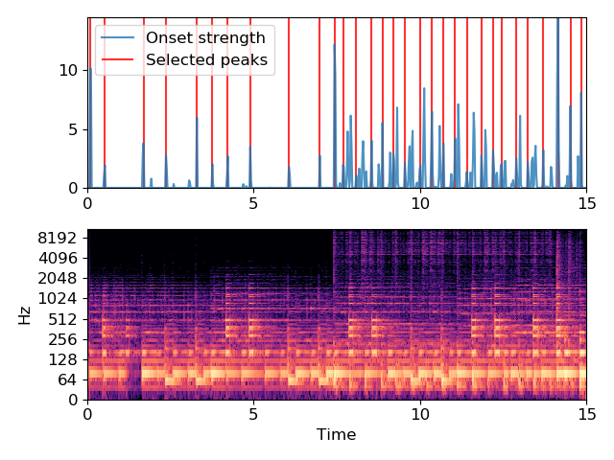
librosa.util.nnls
librosa.util.nnls(A, B, **kwargs)[source]
Non-negative least squares.
Given two matrices A and B, find a non-negative matrix X that minimizes the sum squared error:
err(X) = sum_i,j ((AX)[i,j] - B[i, j])^2
Parameters: | A : np.ndarray [shape=(m, n)]  The basis matrix  B : np.ndarray [shape=(m, N)]  The target matrix.  kwargs  Additional keyword arguments to scipy.optimize.fmin_l_bfgs_b
Returns: | X : np.ndarray [shape=(n, N), non-negative]  A minimizing solution to |AX - B|^2
See also
scipy.optimize.nnls
scipy.optimize.fmin_l_bfgs_b
Examples
Approximate a magnitude spectrum from its mel spectrogram
>>> y, sr = librosa.load(librosa.util.example_audio_file(), offset=30, duration=10)
>>> S = np.abs(librosa.stft(y, n_fft=2048))
>>> M = librosa.feature.melspectrogram(S=S, sr=sr, power=1)
>>> mel_basis = librosa.filters.mel(sr, n_fft=2048, n_mels=M.shape[0])
>>> S_recover = librosa.util.nnls(mel_basis, M)
Plot the results
>>> import matplotlib.pyplot as plt
>>> plt.figure()
>>> plt.subplot(3,1,1)
>>> librosa.display.specshow(librosa.amplitude_to_db(S, ref=np.max), y_axis='log')
>>> plt.colorbar()
>>> plt.title('Original spectrogram (1025 bins)')
>>> plt.subplot(3,1,2)
>>> librosa.display.specshow(librosa.amplitude_to_db(M, ref=np.max),
... y_axis='mel')
>>> plt.title('Mel spectrogram (128 bins)')
>>> plt.colorbar()
>>> plt.subplot(3,1,3)
>>> librosa.display.specshow(librosa.amplitude_to_db(S_recover, ref=np.max),
... y_axis='log')
>>> plt.colorbar()
>>> plt.title('Reconstructed spectrogram (1025 bins)')
>>> plt.tight_layout()
>>> plt.show()

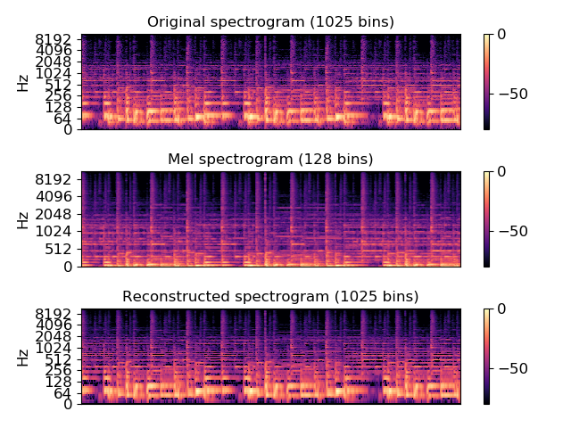

librosa.util.cyclic_gradient
librosa.util.cyclic_gradient(data, edge_order=1, axis=-1)[source]
Estimate the gradient of a function over a uniformly sampled, periodic domain.
This is essentially the same as np.gradient, except that edge effects are handled by wrapping the observations (i.e. assuming periodicity) rather than extrapolation.
Parameters: | data : np.ndarray  The function values observed at uniformly spaced positions on a periodic domain  edge_order: {1, 2}  The order of the difference approximation used for estimating the gradient  axis : int  The axis along which gradients are calculated.
Returns: | grad : np.ndarray like data  The gradient of data taken along the specified axis.
See also
np.gradient
Examples
This example estimates the gradient of cosine (-sine) from 64 samples using direct (aperiodic) and periodic gradient calculation.
>>> import matplotlib.pyplot as plt
>>> x = 2 * np.pi * np.linspace(0, 1, num=64, endpoint=False)
>>> y = np.cos(x)
>>> grad = np.gradient(y)
>>> cyclic_grad = librosa.util.cyclic_gradient(y)
>>> true_grad = -np.sin(x) * 2 * np.pi / len(x)
>>> plt.plot(x, true_grad, label='True gradient', linewidth=5,
... alpha=0.35)
>>> plt.plot(x, cyclic_grad, label='cyclic_gradient')
>>> plt.plot(x, grad, label='np.gradient', linestyle=':')
>>> plt.legend()
>>> # Zoom into the first part of the sequence
>>> plt.xlim([0, np.pi/16])
>>> plt.ylim([-0.025, 0.025])
>>> plt.show()
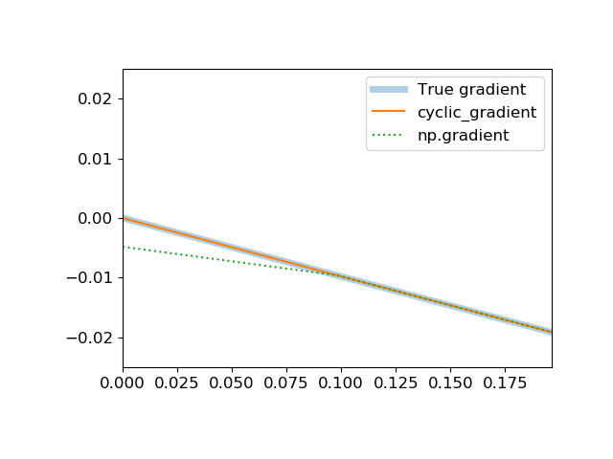

librosa.util.valid_audio
librosa.util.valid_audio(y, mono=True)[source]
Validate whether a variable contains valid, mono audio data.
Parameters: | y : np.ndarray  The input data to validate  mono : bool  Whether or not to force monophonic audio
Returns: | valid : bool  True if all tests pass
Raises: | ParameterError  In any of these cases:  - type(y) is not np.ndarray  - y.dtype is not floating-point  - mono == True and y.ndim is not 1  - mono == False and y.ndim is not 1 or 2  - np.isfinite(y).all() is False  - y.flags[“F_CONTIGUOUS”] is False
See also
stack
numpy.asfortranarray
numpy.float32
Notes
This function caches at level 20.
Examples
>>> # By default, valid_audio allows only mono signals
>>> filepath = librosa.util.example_audio_file()
>>> y_mono, sr = librosa.load(filepath, mono=True)
>>> y_stereo, _ = librosa.load(filepath, mono=False)
>>> librosa.util.valid_audio(y_mono), librosa.util.valid_audio(y_stereo)
True, False
>>> # To allow stereo signals, set mono=False
>>> librosa.util.valid_audio(y_stereo, mono=False)
True

librosa.util.valid_int
librosa.util.valid_int(x, cast=None)[source]
Ensure that an input value is integer-typed. This is primarily useful for ensuring integrable-valued array indices.
Parameters: | x : number  A scalar value to be cast to int  cast : function [optional]  A function to modify x before casting. Default: np.floor
Returns: | x_int : int  x_int = int(cast(x))
Raises: | ParameterError  If cast is provided and is not callable.

librosa.util.valid_intervals
librosa.util.valid_intervals(intervals)[source]
Ensure that an array is a valid representation of time intervals:
- intervals.ndim == 2
- intervals.shape[1] == 2
- intervals[i, 0] <= intervals[i, 1] for all i
Parameters: | intervals : np.ndarray [shape=(n, 2)]  set of time intervals
Returns: | valid : bool  True if intervals passes validation.

librosa.util.example_audio_file
librosa.util.example_audio_file()[source]
Get the path to an included audio example file.
Vibe Ace (Kevin MacLeod) / CC BY 3.0
Returns: | filename : str  Path to the audio example file included with librosa
Examples
>>> # Load the waveform from the example track
>>> y, sr = librosa.load(librosa.util.example_audio_file())

librosa.util.find_files
librosa.util.find_files(directory, ext=None, recurse=True, case_sensitive=False, limit=None, offset=0)[source]
Get a sorted list of (audio) files in a directory or directory sub-tree.
Parameters: | directory : str  Path to look for files  ext : str or list of str  A file extension or list of file extensions to include in the search.  Default: [‘aac’, ‘au’, ‘flac’, ‘m4a’, ‘mp3’, ‘ogg’, ‘wav’]  recurse : boolean  If True, then all subfolders of directory will be searched.  Otherwise, only directory will be searched.  case_sensitive : boolean  If False, files matching upper-case version of extensions will be included.  limit : int > 0 or None  Return at most limit files. If None, all files are returned.  offset : int  Return files starting at offset within the list.  Use negative values to offset from the end of the list.
Returns: | files : list of str  The list of audio files.
Examples
>>> # Get all audio files in a directory sub-tree
>>> files = librosa.util.find_files('~/Music')
>>> # Look only within a specific directory, not the sub-tree
>>> files = librosa.util.find_files('~/Music', recurse=False)
>>> # Only look for mp3 files
>>> files = librosa.util.find_files('~/Music', ext='mp3')
>>> # Or just mp3 and ogg
>>> files = librosa.util.find_files('~/Music', ext=['mp3', 'ogg'])
>>> # Only get the first 10 files
>>> files = librosa.util.find_files('~/Music', limit=10)
>>> # Or last 10 files
>>> files = librosa.util.find_files('~/Music', offset=-10)

librosa.util.roll_sparse
librosa.util.roll_sparse(x, shift, axis=0)[source]
Sparse matrix roll
This operation is equivalent to numpy.roll, but operates on sparse matrices.
Warning
This function is deprecated in version 0.7.1. It will be removed in version 0.8.0.
Parameters: | x : scipy.sparse.spmatrix or np.ndarray  The sparse matrix input  shift : int  The number of positions to roll the specified axis  axis : (0, 1, -1)  The axis along which to roll.
Returns: | x_rolled : same type as x  The rolled matrix, with the same format as x
See also
numpy.roll
Examples
>>> # Generate a random sparse binary matrix
>>> X = scipy.sparse.lil_matrix(np.random.randint(0, 2, size=(5,5)))
>>> X_roll = roll_sparse(X, 2, axis=0) # Roll by 2 on the first axis
>>> X_dense_r = roll_sparse(X.toarray(), 2, axis=0) # Equivalent dense roll
>>> np.allclose(X_roll, X_dense_r.toarray())
True

Filters

Filter bank construction
mel(sr, n_fft[, n_mels, fmin, fmax, htk, …]) | Create a Filterbank matrix to combine FFT bins into Mel-frequency bins
chroma(sr, n_fft[, n_chroma, tuning, A440, …]) | Create a Filterbank matrix to convert STFT to chroma
constant_q(sr[, fmin, n_bins, …]) | Construct a constant-Q basis.
_multirate_fb([center_freqs, sample_rates, …]) | Helper function to construct a multirate filterbank.
semitone_filterbank([center_freqs, tuning, …]) | Constructs a multirate filterbank of infinite-impulse response (IIR) band-pass filters at user-defined center frequencies and sample rates.

Window functions
window_bandwidth(window[, n]) | Get the equivalent noise bandwidth of a window function.
get_window(window, Nx[, fftbins]) | Compute a window function.

Miscellaneous
constant_q_lengths(sr, fmin[, n_bins, …]) | Return length of each filter in a constant-Q basis.
cq_to_chroma(n_input[, bins_per_octave, …]) | Convert a Constant-Q basis to Chroma.
mr_frequencies(tuning) | Helper function for generating center frequency and sample rate pairs.
window_sumsquare(window, n_frames[, …]) | Compute the sum-square envelope of a window function at a given hop length.
diagonal_filter(window, n[, slope, angle, …]) | Build a two-dimensional diagonal filter.

librosa.filters.mel
librosa.filters.mel(sr, n_fft, n_mels=128, fmin=0.0, fmax=None, htk=False, norm=1, dtype=<class 'numpy.float32'>)[source]
Create a Filterbank matrix to combine FFT bins into Mel-frequency bins
Parameters: | sr : number > 0 [scalar]  sampling rate of the incoming signal  n_fft : int > 0 [scalar]  number of FFT components  n_mels : int > 0 [scalar]  number of Mel bands to generate  fmin : float >= 0 [scalar]  lowest frequency (in Hz)  fmax : float >= 0 [scalar]  highest frequency (in Hz). If None, use fmax = sr / 2.0  htk : bool [scalar]  use HTK formula instead of Slaney  norm : {None, 1, np.inf} [scalar]  if 1, divide the triangular mel weights by the width of the mel band (area normalization). Otherwise, leave all the triangles aiming for a peak value of 1.0  dtype : np.dtype  The data type of the output basis. By default, uses 32-bit (single-precision) floating point.
Returns: | M : np.ndarray [shape=(n_mels, 1 + n_fft/2)]  Mel transform matrix
Notes
This function caches at level 10.
Examples
>>> melfb = librosa.filters.mel(22050, 2048)
>>> melfb
array([[ 0. , 0.016, ..., 0. , 0. ],
[ 0. , 0. , ..., 0. , 0. ],
...,
[ 0. , 0. , ..., 0. , 0. ],
[ 0. , 0. , ..., 0. , 0. ]])
Clip the maximum frequency to 8KHz
>>> librosa.filters.mel(22050, 2048, fmax=8000)
array([[ 0. , 0.02, ..., 0. , 0. ],
[ 0. , 0. , ..., 0. , 0. ],
...,
[ 0. , 0. , ..., 0. , 0. ],
[ 0. , 0. , ..., 0. , 0. ]])
>>> import matplotlib.pyplot as plt
>>> plt.figure()
>>> librosa.display.specshow(melfb, x_axis='linear')
>>> plt.ylabel('Mel filter')
>>> plt.title('Mel filter bank')
>>> plt.colorbar()
>>> plt.tight_layout()
>>> plt.show()
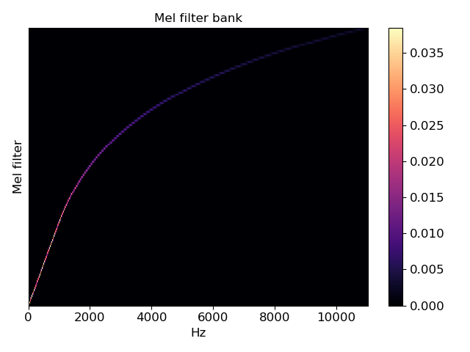

librosa.filters.chroma
librosa.filters.chroma(sr, n_fft, n_chroma=12, tuning=0.0, A440=<DEPRECATED parameter>, ctroct=5.0, octwidth=2, norm=2, base_c=True, dtype=<class 'numpy.float32'>)[source]
Create a Filterbank matrix to convert STFT to chroma
Parameters: | sr : number > 0 [scalar]  audio sampling rate  n_fft : int > 0 [scalar]  number of FFT bins  n_chroma : int > 0 [scalar]  number of chroma bins  tuning : float  Tuning deviation from A440 in fractions of a chroma bin.  A440 : float > 0 [scalar] <Deprecated>  Reference frequency for A440  Note  This parameter is deprecated in version 0.7.1. It will be removed in 0.8.0. Use tuning= instead.  ctroct : float > 0 [scalar]  octwidth : float > 0 or None [scalar]  ctroct and octwidth specify a dominance window - a Gaussian weighting centered on ctroct (in octs, A0 = 27.5Hz) and with a gaussian half-width of octwidth. Set octwidth to None to use a flat weighting.  norm : float > 0 or np.inf  Normalization factor for each filter  base_c : bool  If True, the filter bank will start at ‘C’. If False, the filter bank will start at ‘A’.  dtype : np.dtype  The data type of the output basis. By default, uses 32-bit (single-precision) floating point.
Returns: | wts : ndarray [shape=(n_chroma, 1 + n_fft / 2)]  Chroma filter matrix
See also
util.normalize
feature.chroma_stft
Notes
This function caches at level 10.
Examples
Build a simple chroma filter bank
>>> chromafb = librosa.filters.chroma(22050, 4096)
array([[ 1.689e-05, 3.024e-04, ..., 4.639e-17, 5.327e-17],
[ 1.716e-05, 2.652e-04, ..., 2.674e-25, 3.176e-25],
...,
[ 1.578e-05, 3.619e-04, ..., 8.577e-06, 9.205e-06],
[ 1.643e-05, 3.355e-04, ..., 1.474e-10, 1.636e-10]])
Use quarter-tones instead of semitones
>>> librosa.filters.chroma(22050, 4096, n_chroma=24)
array([[ 1.194e-05, 2.138e-04, ..., 6.297e-64, 1.115e-63],
[ 1.206e-05, 2.009e-04, ..., 1.546e-79, 2.929e-79],
...,
[ 1.162e-05, 2.372e-04, ..., 6.417e-38, 9.923e-38],
[ 1.180e-05, 2.260e-04, ..., 4.697e-50, 7.772e-50]])
Equally weight all octaves
>>> librosa.filters.chroma(22050, 4096, octwidth=None)
array([[ 3.036e-01, 2.604e-01, ..., 2.445e-16, 2.809e-16],
[ 3.084e-01, 2.283e-01, ..., 1.409e-24, 1.675e-24],
...,
[ 2.836e-01, 3.116e-01, ..., 4.520e-05, 4.854e-05],
[ 2.953e-01, 2.888e-01, ..., 7.768e-10, 8.629e-10]])
>>> import matplotlib.pyplot as plt
>>> plt.figure()
>>> librosa.display.specshow(chromafb, x_axis='linear')
>>> plt.ylabel('Chroma filter')
>>> plt.title('Chroma filter bank')
>>> plt.colorbar()
>>> plt.tight_layout()
>>> plt.show()

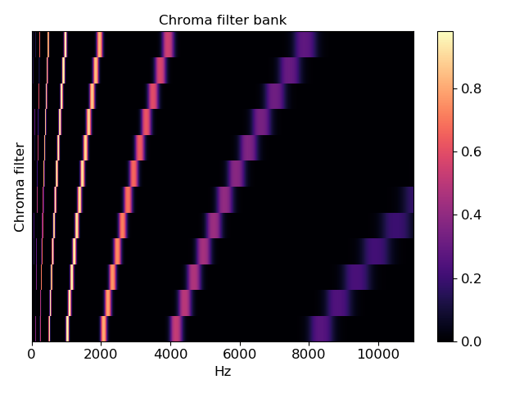
librosa.filters.constant_q
librosa.filters.constant_q(sr, fmin=None, n_bins=84, bins_per_octave=12, tuning=<DEPRECATED parameter>, window='hann', filter_scale=1, pad_fft=True, norm=1, dtype=<class 'numpy.complex64'>, **kwargs)[source]
Construct a constant-Q basis.
This uses the filter bank described by [1].

[1] | McVicar, Matthew. “A machine learning approach to automatic chord extraction.” Dissertation, University of Bristol. 2013.
Parameters: | sr : number > 0 [scalar]  Audio sampling rate  fmin : float > 0 [scalar]  Minimum frequency bin. Defaults to C1 ~= 32.70  n_bins : int > 0 [scalar]  Number of frequencies. Defaults to 7 octaves (84 bins).  bins_per_octave : int > 0 [scalar]  Number of bins per octave  tuning : float [scalar] <DEPRECATED>  Tuning deviation from A440 in fractions of a bin  Note  This parameter is deprecated in 0.7.1. It will be removed in version 0.8.  window : string, tuple, number, or function  Windowing function to apply to filters.  filter_scale : float > 0 [scalar]  Scale of filter windows. Small values (<1) use shorter windows for higher temporal resolution.  pad_fft : boolean  Center-pad all filters up to the nearest integral power of 2.  By default, padding is done with zeros, but this can be overridden by setting the mode= field in kwargs.  norm : {inf, -inf, 0, float > 0}  Type of norm to use for basis function normalization. See librosa.util.normalize  dtype : np.dtype  The data type of the output basis. By default, uses 64-bit (single precision) complex floating point.  kwargs : additional keyword arguments  Arguments to np.pad() when pad==True.
Returns: | filters : np.ndarray, len(filters) == n_bins  filters[i] is ith time-domain CQT basis filter  lengths : np.ndarray, len(lengths) == n_bins  The (fractional) length of each filter
See also
constant_q_lengths
librosa.core.cqt
librosa.util.normalize
Notes
This function caches at level 10.
Examples
Use a shorter window for each filter
>>> basis, lengths = librosa.filters.constant_q(22050, filter_scale=0.5)
Plot one octave of filters in time and frequency
>>> import matplotlib.pyplot as plt
>>> basis, lengths = librosa.filters.constant_q(22050)
>>> plt.figure(figsize=(10, 6))
>>> plt.subplot(2, 1, 1)
>>> notes = librosa.midi_to_note(np.arange(24, 24 + len(basis)))
>>> for i, (f, n) in enumerate(zip(basis, notes[:12])):
... f_scale = librosa.util.normalize(f) / 2
... plt.plot(i + f_scale.real)
... plt.plot(i + f_scale.imag, linestyle=':')
>>> plt.axis('tight')
>>> plt.yticks(np.arange(len(notes[:12])), notes[:12])
>>> plt.ylabel('CQ filters')
>>> plt.title('CQ filters (one octave, time domain)')
>>> plt.xlabel('Time (samples at 22050 Hz)')
>>> plt.legend(['Real', 'Imaginary'], frameon=True, framealpha=0.8)
>>> plt.subplot(2, 1, 2)
>>> F = np.abs(np.fft.fftn(basis, axes=[-1]))
>>> # Keep only the positive frequencies
>>> F = F[:, :(1 + F.shape[1] // 2)]
>>> librosa.display.specshow(F, x_axis='linear')
>>> plt.yticks(np.arange(len(notes))[::12], notes[::12])
>>> plt.ylabel('CQ filters')
>>> plt.title('CQ filter magnitudes (frequency domain)')
>>> plt.tight_layout()
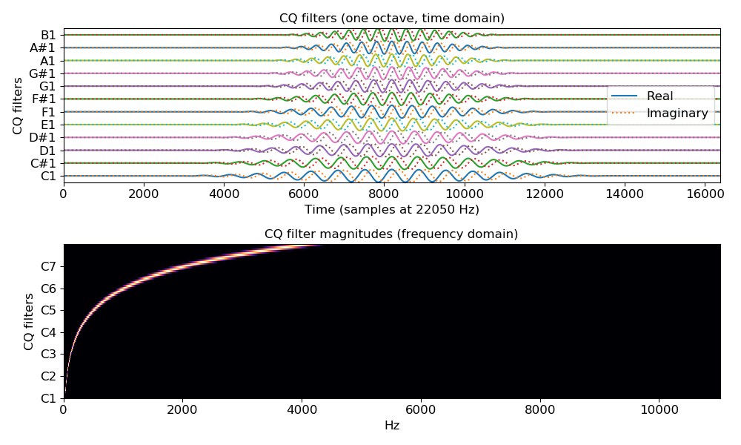
>>> plt.show()

librosa.filters._multirate_fb
librosa.filters._multirate_fb(center_freqs=None, sample_rates=None, Q=25.0, passband_ripple=1, stopband_attenuation=50, ftype='ellip', flayout='sos')[source]
Helper function to construct a multirate filterbank.
A filter bank consists of multiple band-pass filters which divide the input signal into subbands. In the case of a multirate filter bank, the band-pass filters operate with resampled versions of the input signal, e.g. to keep the length of a filter constant while shifting its center frequency.
This implementation uses scipy.signal.iirdesign to design the filters.
Parameters: | center_freqs : np.ndarray [shape=(n,), dtype=float]  Center frequencies of the filter kernels. Also defines the number of filters in the filterbank.  sample_rates : np.ndarray [shape=(n,), dtype=float]  Samplerate for each filter (used for multirate filterbank).  Q : float  Q factor (influences the filter bandwith).  passband_ripple : float  The maximum loss in the passband (dB) See scipy.signal.iirdesign for details.  stopband_attenuation : float  The minimum attenuation in the stopband (dB) See scipy.signal.iirdesign for details.  ftype : str  The type of IIR filter to design See scipy.signal.iirdesign for details.  flayout : string  Valid output argument for scipy.signal.iirdesign.  - If ba, returns numerators/denominators of the transfer functions, used for filtering with scipy.signal.filtfilt. Can be unstable for high-order filters.  - If sos, returns a series of second-order filters, used for filtering with scipy.signal.sosfiltfilt. Minimizes numerical precision errors for high-order filters, but is slower.  - If zpk, returns zeros, poles, and system gains of the transfer functions.
Returns: | filterbank : list [shape=(n,), dtype=float]  Each list entry comprises the filter coefficients for a single filter.  sample_rates : np.ndarray [shape=(n,), dtype=float]  Samplerate for each filter.
Raises: | ParameterError  If center_freqs is None. If sample_rates is None. If center_freqs.shape does not match sample_rates.shape.
See also
scipy.signal.iirdesign
Notes
This function caches at level 10.

librosa.filters.semitone_filterbank
librosa.filters.semitone_filterbank(center_freqs=None, tuning=0.0, sample_rates=None, flayout='ba', **kwargs)[source]
Constructs a multirate filterbank of infinite-impulse response (IIR) band-pass filters at user-defined center frequencies and sample rates.
By default, these center frequencies are set equal to the 88 fundamental frequencies of the grand piano keyboard, according to a pitch tuning standard of A440, that is, note A above middle C set to 440 Hz. The center frequencies are tuned to the twelve-tone equal temperament, which means that they grow exponentially at a rate of 2**(1/12), that is, twelve notes per octave.
The A440 tuning can be changed by the user while keeping twelve-tone equal temperament. While A440 is currently the international standard in the music industry (ISO 16), some orchestras tune to A441-A445, whereas baroque musicians tune to A415.
See [1] for details.

[1] | Müller, Meinard. “Information Retrieval for Music and Motion.” Springer Verlag. 2007.
Parameters: | center_freqs : np.ndarray [shape=(n,), dtype=float]  Center frequencies of the filter kernels. Also defines the number of filters in the filterbank.  tuning : float [scalar]  Tuning deviation from A440 as a fraction of a semitone (1/12 of an octave in equal temperament).  sample_rates : np.ndarray [shape=(n,), dtype=float]  Sample rates of each filter in the multirate filterbank.  flayout : string  - If ba, the standard difference equation is used for filtering with scipy.signal.filtfilt. Can be unstable for high-order filters.  - If sos, a series of second-order filters is used for filtering with scipy.signal.sosfiltfilt. Minimizes numerical precision errors for high-order filters, but is slower.  kwargs : additional keyword arguments  Additional arguments to the private function _multirate_fb().
Returns: | filterbank : list [shape=(n,), dtype=float]  Each list entry contains the filter coefficients for a single filter.  fb_sample_rates : np.ndarray [shape=(n,), dtype=float]  Sample rate for each filter.
See also
librosa.core.cqt
librosa.core.iirt
librosa.filters._multirate_fb
librosa.filters.mr_frequencies
scipy.signal.iirdesign
Examples
>>> import matplotlib.pyplot as plt
>>> import numpy as np
>>> import scipy.signal
>>> semitone_filterbank, sample_rates = librosa.filters.semitone_filterbank()
>>> plt.figure(figsize=(10, 6))
>>> for cur_sr, cur_filter in zip(sample_rates, semitone_filterbank):
... w, h = scipy.signal.freqz(cur_filter[0], cur_filter[1], worN=2000)
... plt.plot((cur_sr / (2 * np.pi)) * w, 20 * np.log10(abs(h)))
>>> plt.semilogx()
>>> plt.xlim([20, 10e3])
>>> plt.ylim([-60, 3])
>>> plt.title('Magnitude Responses of the Pitch Filterbank')
>>> plt.xlabel('Log-Frequency (Hz)')
>>> plt.ylabel('Magnitude (dB)')
>>> plt.tight_layout()
>>> plt.show()
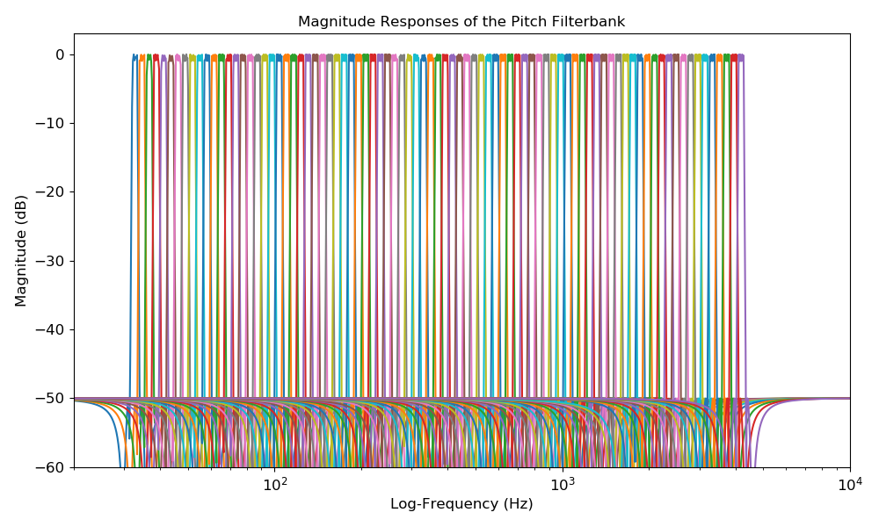

librosa.filters.window_bandwidth
librosa.filters.window_bandwidth(window, n=1000)[source]
Get the equivalent noise bandwidth of a window function.
Parameters: | window : callable or string  A window function, or the name of a window function. Examples: - scipy.signal.hann - ‘boxcar’  n : int > 0  The number of coefficients to use in estimating the window bandwidth
Returns: | bandwidth : float  The equivalent noise bandwidth (in FFT bins) of the given window function
See also
get_window
Notes
This function caches at level 10.

librosa.filters.get_window
librosa.filters.get_window(window, Nx, fftbins=True)[source]
Compute a window function.
This is a wrapper for scipy.signal.get_window that additionally supports callable or pre-computed windows.
Parameters: | window : string, tuple, number, callable, or list-like  The window specification:  - If string, it’s the name of the window function (e.g., ‘hann’)  - If tuple, it’s the name of the window function and any parameters (e.g., (‘kaiser’, 4.0))  - If numeric, it is treated as the beta parameter of the ‘kaiser’ window, as in scipy.signal.get_window.  - If callable, it’s a function that accepts one integer argument (the window length)  - If list-like, it’s a pre-computed window of the correct length Nx  Nx : int > 0  The length of the window  fftbins : bool, optional  If True (default), create a periodic window for use with FFT If False, create a symmetric window for filter design applications.
Returns: | get_window : np.ndarray  A window of length Nx and type window
Raises: | ParameterError  If window is supplied as a vector of length != n_fft, or is otherwise mis-specified.
See also
scipy.signal.get_window
Notes
This function caches at level 10.

librosa.filters.constant_q_lengths
librosa.filters.constant_q_lengths(sr, fmin, n_bins=84, bins_per_octave=12, tuning=<DEPRECATED parameter>, window='hann', filter_scale=1)[source]
Return length of each filter in a constant-Q basis.
Parameters: | sr : number > 0 [scalar]  Audio sampling rate  fmin : float > 0 [scalar]  Minimum frequency bin.  n_bins : int > 0 [scalar]  Number of frequencies. Defaults to 7 octaves (84 bins).  bins_per_octave : int > 0 [scalar]  Number of bins per octave  tuning : float [scalar] <DEPRECATED>  Tuning deviation from A440 in fractions of a bin  Note  This parameter is deprecated in 0.7.1. It will be removed in version 0.8.  window : str or callable  Window function to use on filters  filter_scale : float > 0 [scalar]  Resolution of filter windows. Larger values use longer windows.
Returns: | lengths : np.ndarray  The length of each filter.
See also
constant_q
librosa.core.cqt
Notes
This function caches at level 10.

librosa.filters.cq_to_chroma
librosa.filters.cq_to_chroma(n_input, bins_per_octave=12, n_chroma=12, fmin=None, window=None, base_c=True, dtype=<class 'numpy.float32'>)[source]
Convert a Constant-Q basis to Chroma.
Parameters: | n_input : int > 0 [scalar]  Number of input components (CQT bins)  bins_per_octave : int > 0 [scalar]  How many bins per octave in the CQT  n_chroma : int > 0 [scalar]  Number of output bins (per octave) in the chroma  fmin : None or float > 0  Center frequency of the first constant-Q channel. Default: ‘C1’ ~= 32.7 Hz  window : None or np.ndarray  If provided, the cq_to_chroma filter bank will be convolved with window.  base_c : bool  If True, the first chroma bin will start at ‘C’ If False, the first chroma bin will start at ‘A’  dtype : np.dtype  The data type of the output basis. By default, uses 32-bit (single-precision) floating point.
Returns: | cq_to_chroma : np.ndarray [shape=(n_chroma, n_input)]  Transformation matrix: Chroma = np.dot(cq_to_chroma, CQT)
Raises: | ParameterError  If n_input is not an integer multiple of n_chroma
Notes
This function caches at level 10.
Examples
Get a CQT, and wrap bins to chroma
>>> y, sr = librosa.load(librosa.util.example_audio_file())
>>> CQT = np.abs(librosa.cqt(y, sr=sr))
>>> chroma_map = librosa.filters.cq_to_chroma(CQT.shape[0])
>>> chromagram = chroma_map.dot(CQT)
>>> # Max-normalize each time step
>>> chromagram = librosa.util.normalize(chromagram, axis=0)
>>> import matplotlib.pyplot as plt
>>> plt.subplot(3, 1, 1)
>>> librosa.display.specshow(librosa.amplitude_to_db(CQT,
... ref=np.max),
... y_axis='cqt_note')
>>> plt.title('CQT Power')
>>> plt.colorbar()
>>> plt.subplot(3, 1, 2)
>>> librosa.display.specshow(chromagram, y_axis='chroma')
>>> plt.title('Chroma (wrapped CQT)')
>>> plt.colorbar()
>>> plt.subplot(3, 1, 3)
>>> chroma = librosa.feature.chroma_stft(y=y, sr=sr)
>>> librosa.display.specshow(chroma, y_axis='chroma', x_axis='time')
>>> plt.title('librosa.feature.chroma_stft')
>>> plt.colorbar()
>>> plt.tight_layout()
>>> plt.show()

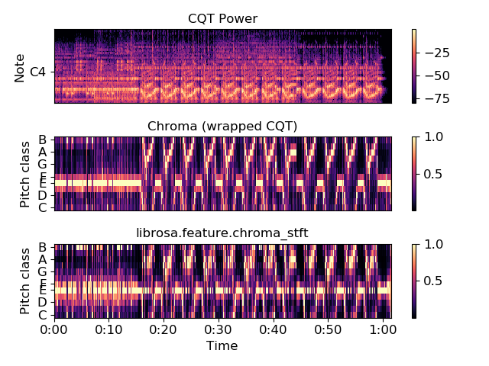
librosa.filters.mr_frequencies
librosa.filters.mr_frequencies(tuning)[source]
Helper function for generating center frequency and sample rate pairs.
This function will return center frequency and corresponding sample rates to obtain similar pitch filterbank settings as described in [1]. Instead of starting with MIDI pitch A0, we start with C0.

[1] | Müller, Meinard. “Information Retrieval for Music and Motion.” Springer Verlag. 2007.
Parameters: | tuning : float [scalar]  Tuning deviation from A440, measure as a fraction of the equally tempered semitone (1/12 of an octave).
Returns: | center_freqs : np.ndarray [shape=(n,), dtype=float]  Center frequencies of the filter kernels. Also defines the number of filters in the filterbank.  sample_rates : np.ndarray [shape=(n,), dtype=float]  Sample rate for each filter, used for multirate filterbank.
See also
librosa.filters.semitone_filterbank
librosa.filters._multirate_fb

librosa.filters.window_sumsquare
librosa.filters.window_sumsquare(window, n_frames, hop_length=512, win_length=None, n_fft=2048, dtype=<class 'numpy.float32'>, norm=None)[source]
Compute the sum-square envelope of a window function at a given hop length.
This is used to estimate modulation effects induced by windowing observations in short-time fourier transforms.
Parameters: | window : string, tuple, number, callable, or list-like  Window specification, as in get_window  n_frames : int > 0  The number of analysis frames  hop_length : int > 0  The number of samples to advance between frames  win_length : [optional]  The length of the window function. By default, this matches n_fft.  n_fft : int > 0  The length of each analysis frame.  dtype : np.dtype  The data type of the output
Returns: | wss : np.ndarray, shape=`(n_fft + hop_length * (n_frames - 1))`  The sum-squared envelope of the window function
Examples
For a fixed frame length (2048), compare modulation effects for a Hann window at different hop lengths:
>>> n_frames = 50
>>> wss_256 = librosa.filters.window_sumsquare('hann', n_frames, hop_length=256)
>>> wss_512 = librosa.filters.window_sumsquare('hann', n_frames, hop_length=512)
>>> wss_1024 = librosa.filters.window_sumsquare('hann', n_frames, hop_length=1024)
>>> import matplotlib.pyplot as plt
>>> plt.figure()
>>> plt.subplot(3,1,1)
>>> plt.plot(wss_256)
>>> plt.title('hop_length=256')
>>> plt.subplot(3,1,2)
>>> plt.plot(wss_512)
>>> plt.title('hop_length=512')
>>> plt.subplot(3,1,3)
>>> plt.plot(wss_1024)
>>> plt.title('hop_length=1024')
>>> plt.tight_layout()
>>> plt.show()

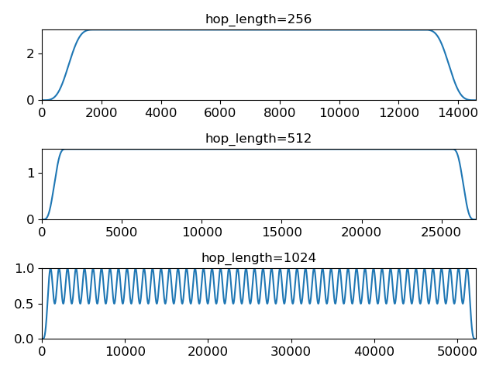
librosa.filters.diagonal_filter
librosa.filters.diagonal_filter(window, n, slope=1.0, angle=None, zero_mean=False)[source]
Build a two-dimensional diagonal filter.
This is primarily used for smoothing recurrence or self-similarity matrices.
Parameters: | window : string, tuple, number, callable, or list-like  The window function to use for the filter.  See get_window for details.  Note that the window used here should be non-negative.  n : int > 0  the length of the filter  slope : float  The slope of the diagonal filter to produce  angle : float or None  If given, the slope parameter is ignored, and angle directly sets the orientation of the filter (in radians). Otherwise, angle is inferred as arctan(slope).  zero_mean : bool  If True, a zero-mean filter is used. Otherwise, a non-negative averaging filter is used.  This should be enabled if you want to enhance paths and suppress blocks.
Returns: | kernel : np.ndarray, shape=[(m, m)]  The 2-dimensional filter kernel

Caching
This section covers the librosa function cache. This allows you to store and re-use intermediate computations across sessions.

Enabling the cache
By default, caching is disabled. To enable caching, the environment variable LIBROSA_CACHE_DIR must be set prior to loading librosa. This can be done on the command line prior to instantiating a python interpreter:
$ export LIBROSA_CACHE_DIR=/tmp/librosa_cache
$ ipython
or from within python, prior to importing librosa:
>>> import os
>>> os.environ['LIBROSA_CACHE_DIR'] = '/tmp/librosa_cache'
>>> import librosa
Warning
The cache does not implement any eviction policy. As such, it can grow without bound on disk if not purged. To purge the cache directly, call:
>>> librosa.cache.clear()

Cache configuration
The cache is implemented on top of joblib.Memory. The default configuration can be overridden by setting the following environment variables
- LIBROSA_CACHE_DIR : path (on disk) to the cache directory
- LIBROSA_CACHE_MMAP : optional memory mapping mode {None, ‘r+’, ‘r’, ‘w+’, ‘c’}
- LIBROSA_CACHE_COMPRESS : flag to enable compression of data on disk {0, 1}
- LIBROSA_CACHE_VERBOSE : controls how much debug info is displayed. {int, non-negative}
- LIBROSA_CACHE_LEVEL : controls the caching level: the larger this value, the more data is cached. {int}
Please refer to the joblib.Memory documentation for a detailed explanation of these parameters.
As of 0.7, librosa’s cache wraps (rather than extends) the joblib.Memory object. The memory object can be directly accessed by librosa.cache.memory.

Cache levels
Cache levels operate in a fashion similar to logging levels. For small values of LIBROSA_CACHE_LEVEL, only the most important (frequently used) data are cached. As the cache level increases, broader classes of functions are cached. As a result, application code may run faster at the expense of larger disk usage.
The caching levels are described as follows:
- 10: filter bases, independent of audio data (mel, chroma, constant-q)
- 20: low-level features (cqt, stft, zero-crossings, etc)
- 30: high-level features (tempo, beats, decomposition, recurrence, etc)
- 40: post-processing (delta, stack_memory, normalize, sync)
The default cache level is 10.

Example
To demonstrate how to use the cache, we’ll first call an example script twice without caching:
$ time -p ./estimate_tuning.py ../librosa/util/example_data/Kevin_MacLeod_-_Vibe_Ace.ogg
Loading ../librosa/util/example_data/Kevin_MacLeod_-_Vibe_Ace.ogg
Separating harmonic component ...
Estimating tuning ...
+9.00 cents
real 6.74
user 6.03
sys 1.09

$ time -p ./estimate_tuning.py ../librosa/util/example_data/Kevin_MacLeod_-_Vibe_Ace.ogg
Loading ../librosa/util/example_data/Kevin_MacLeod_-_Vibe_Ace.ogg
Separating harmonic component ...
Estimating tuning ...
+9.00 cents
real 6.68
user 6.04
sys 1.05
Next, we’ll enable caching to /tmp/librosa:
$ export LIBROSA_CACHE_DIR=/tmp/librosa
and set the cache level to 50:
$ export LIBROSA_CACHE_LEVEL=50
And now we’ll re-run the example script twice. The first time, there will be no cached values, so the time should be similar to running without cache. The second time, we’ll be able to reuse intermediate values, so it should be significantly faster.:
$ time -p ./estimate_tuning.py ../librosa/util/example_data/Kevin_MacLeod_-_Vibe_Ace.ogg
Loading ../librosa/util/example_data/Kevin_MacLeod_-_Vibe_Ace.ogg
Separating harmonic component ...
Estimating tuning ...
+9.00 cents
real 7.60
user 6.79
sys 1.15

$ time -p ./estimate_tuning.py ../librosa/util/example_data/Kevin_MacLeod_-_Vibe_Ace.ogg
Loading ../librosa/util/example_data/Kevin_MacLeod_-_Vibe_Ace.ogg
Separating harmonic component ...
Estimating tuning ...
+9.00 cents
real 1.64
user 1.30
sys 0.74
Reducing the cache level to 20 yields an intermediate acceleration:
$ export LIBROSA_CACHE_LEVEL=20

$ time -p ./estimate_tuning.py ../librosa/util/example_data/Kevin_MacLeod_-_Vibe_Ace.ogg
Loading ../librosa/util/example_data/Kevin_MacLeod_-_Vibe_Ace.ogg
Separating harmonic component ...
Estimating tuning ...
+9.00 cents
real 4.98
user 4.17
sys 1.22

Advanced I/O Use Cases
This section covers advanced use cases for input and output which go beyond the I/O functionality currently provided by librosa.

Read specific formats
librosa uses soundfile and audioread for reading audio. As of v0.7, librosa uses soundfile by default, and falls back on audioread only when dealing with codecs unsupported by soundfile (notably, MP3, and some variants of WAV). For a list of codecs supported by soundfile, see the libsndfile documentation.
Note
See installation instruction for PySoundFile here.
Librosa’s load function is meant for the common case where you want to load an entire (fragment of a) recording into memory, but some applications require more flexibility. In these cases, we recommend using soundfile directly. Reading audio files using soundfile is similar to the method in librosa. One important difference is that the read data is of shape (nb_samples, nb_channels) compared to (nb_channels, nb_samples) in librosa.core.load. Also the signal is not resampled to 22050 Hz by default, hence it would need be transposed and resampled for further processing in librosa. The following example is equivalent to librosa.load(librosa.util.example_audio_file()):

import librosa
import soundfile as sf

# Get example audio file
filename = librosa.util.example_audio_file()

data, samplerate = sf.read(filename, dtype='float32')
data = data.T
data_22k = librosa.resample(data, samplerate, 22050)

Blockwise Reading
For large audio signals it could be beneficial to not load the whole audio file into memory. Librosa 0.7 introduces a streaming interface, which can be used to work on short fragments of audio sequentially. librosa.core.stream cuts an input file into blocks of audio, which correspond to a given number of frames, which can be iterated over as in the following example:

import librosa

sr = librosa.get_samplerate('/path/to/file.wav')

# Set the frame parameters to be equivalent to the librosa defaults
# in the file's native sampling rate
frame_length = (2048 * sr) // 22050
hop_length = (512 * sr) // 22050

# Stream the data, working on 128 frames at a time
stream = librosa.stream('path/to/file.wav',
block_length=128,
frame_length=frame_length,
hop_length=hop_length)

chromas = []
for y in stream:
chroma_block = librosa.feature.chroma_stft(y=y, sr=sr,
n_fft=frame_length,
hop_length=hop_length,
center=False)
chromas.append(chromas)
In this example, each audio fragment y will consist of 128 frames worth of samples, or more specifically, len(y) == frame_length + (block_length - 1) * hop_length. Each fragment y will overlap with the subsequent fragment by frame_length - hop_length samples, which ensures that stream processing will provide equivalent results to if the entire sequence was processed in one step (assuming padding / centering is disabled).
For more details about the streaming interface, refer to librosa.core.stream.

Read file-like objects
If you want to read audio from file-like objects (also called virtual files) you can use soundfile as well. (This will also work with librosa.core.load and librosa.core.stream, provided that the underlying codec is supported by soundfile.)
E.g.: read files from zip compressed archives:
import zipfile as zf
import soundfile as sf
import io

with zf.ZipFile('test.zip') as myzip:
with myzip.open('stereo_file.wav') as myfile:
tmp = io.BytesIO(myfile.read())
data, samplerate = sf.read(tmp)
Warning
This is a example does only work in python 3. For python 2 please use from urllib2 import urlopen.
Download and read from URL:

import soundfile as sf
import io

from six.moves.urllib.request import urlopen

url = "https://raw.githubusercontent.com/librosa/librosa/master/tests/data/test1_44100.wav"

data, samplerate = sf.read(io.BytesIO(urlopen(url).read()))

Write out audio files
PySoundFile provides output functionality that can be used directly with numpy array audio buffers:
import numpy as np
import soundfile as sf

rate = 44100
data = np.random.uniform(-1, 1, size=(rate * 10, 2))

# Write out audio as 24bit PCM WAV
sf.write('stereo_file.wav', data, samplerate, subtype='PCM_24')

# Write out audio as 24bit Flac
sf.write('stereo_file.flac', data, samplerate, format='flac', subtype='PCM_24')

# Write out audio as 16bit OGG
sf.write('stereo_file.ogg', data, samplerate, format='ogg', subtype='vorbis')

Changelog

v0.7.1
2019-10-09
New Features
- #966 util.frame now supports multidimensional data. Includes a new helper function util.stack for contiguous concatenation. Brian McFee
- #934 core.griffinlim_cqt: Phase retrieval from constant-Q magnitude spectra. Brian McFee
- #940 Enhanced compatibility with HTK’s MFCC implementation: effects.preemphasis and lifter= parameter in MFCC. Brian McFee
- #949 util.shear utility for shear-transforming 2D arrays. Brian McFee
- #926 core.reassigned_spectrogram: time-frequency reassigned spectrogram. Scott Seyfarth
Bug fixes
- #983 Added a missing parameter to griffinlim_cqt. Voodoohop
- #978 Correct FFT normalization discrepancy in rms calculation. Brian McFee
- #930 Corrected an error in automatic tuning correction for CQT. Brian McFee
- #942 Fixed seeking behavior in librosa.stream when operating on file-handle inputs. Carl Thome
- #920 Fixed a boundary condition check in full-sequence DTW. Frank Zalkow
Documentation
- #976 Fixed a typo in stream documentation. Alastair Porter
- #958 Visualization of reassigned spectrograms. Vincent Lostanlen
- #943 Improved documentation for core.stft. Vincent Lostanlen
- #939 Expanded documentation of feature.melspectrogram. Vincent Lostanlen
Other changes
- #1004 Expose frame parameters in onset and chroma_stft functions. Brian McFee
- #1003 Removed warning filter reset, and changed the Python2 deprecation warning to class FutureWarning. Brian McFee, Fabian Keller
- #1000 Fixed an upstream deprecation warning from np.asscalar(). Vincent Lostanlen
- #971 Beat and tempo estimation now support prior distributions. Brian McFee
- #968 util.valid_audio now enforces memory contiguity. Vincent Lostanlen
- #963 Improved x-axis decoration types in display.waveplot. Vincent Lostanlen
- #960 Ensure memory contiguity of audio buffers after resampling. Brian McFee
- #957 Code-base audit for proper usage of times_like. Brian McFee
- #953 Deprecated core.ifgram in favor of reassigned_spectrogram. Brian McFee
- #950 Allow initial phase estimates for griffinlim methods. Brian McFee
- #949 Accelerated segment.lag_to_recurrence and segment.recurrence_to_lag. Deprecated util.roll_sparse. Brian McFee
- #930 A440= parameter has been deprecated across the library in favor of a standardized tuning= parameter. Brian McFee

v0.7.0
2019-07-07
Note: the 0.7 series will be the last to officially support Python 2.7.
New features
- #772 librosa.core.stream: Stream generator to process long audio files into smaller pieces. Brian McFee
- #845 librosa.core.load: Replaced the default audio decoder with pysoundfile, and only use audioread as backup. Brian McFee
- #843 librosa.core.griffinlim: Phase retrieval from magnitude spectrograms using the (accelerated) Griffin-Lim method. Brian McFee
- #843 librosa.feature.inverse: New module for feature inversion, based on the Griffin-Lim phase retrieval algorithm. Includes mel_to_audio and mfcc_to_audio. Brian McFee
- #725 librosa.core.lpc: Linear prediction coefficients (LPC). Adam Weiss
- #907 librosa.sequence.rqa: Recurrence Quantification Analysis (RQA) for sequence alignment. Brian McFee
- #739 librosa.beat.plp: Predominant local pulse (PLP) for variable-tempo beat tracking. Brian McFee
- #894 librosa.feature.fourier_tempogram: Fourier Tempogram for representing rhythm in the frequency domain. Brian McFee
- #891 librosa.core.pcen Per-channel energy normalization (PCEN) now allows logarithmic range compression at the limit power->0. Vincent Lostanlen
- #863 librosa.effects.pitch_shift supports custom resampling modes. Taewoon Kim
- #857 librosa.core.cqt and librosa.core.icqt Forward and inverse constant-Q transform now support custom resampling modes. Brian McFee
- #842 librosa.segment.path_enhance: Near-diagonal path enhancement for recurrence, self- or cross-similarity matrices. Brian McFee
- #840 librosa.segment.recurrence_matrix now supports a keyword argument, self=False. If set to True, the recurrence matrix includes self-loops. Brian McFee
- #776 librosa.core.piptrack now supports a keyword argument, ref=None, allowing users to override the reference thresholding behavior for determining which bins correspond to pitches. Brian McFee
- #770 librosa.segment.cross_similarity: Cross-similarity function for comparing two feature sequences. Rachel Bittner, Brian McFee
- #709 librosa.onset.onset_strength_multi now supports a user-specified reference spectrum via the ref keyword argument. Brian McFee
- #576 librosa.core.resample now supports mode=’polyphase’. Brian McFee
- #519 librosa.onset.onset_strength_multi: Setting aggregate=False disables the aggregation of onset strengths across frequency bins. Brian McFee
Bug fixes
- #900 librosa.effects.pitch_shift now preserves length. Vincent Lostanlen
- #891 librosa.core.pcen Dynamic range compression in PCEN is more numerically stable for small values of the exponent. Vincent Lostanlen
- #888 librosa.core.ifgram Instantaneous frequency spectrogram now correctly estimates center frequencies when using windows other than hann. Brian McFee
- #869 librosa.sequence.dtw Fixed a bug in dynamic time warping when subseq=True. Viktor Andreevitch Morozov
- #851 librosa.core.pcen now initializes its autoregressive filtering in the steady state, not with silence. Jan Schlüter, Brian McFee
- #833 librosa.segment.recurrence_matrix: width parameter now cannot exceed data length. Brian McFee
- #825 Filter bank constructors mel, chroma, constant_q, and cq_to_chroma are now type-stable. Vincent Lostanlen, Brian McFee
- #802 librosa.core.icqt Inverse constant-Q transform has been completely rewritten and is more numerically stable. Brian McFee
Removed features (deprecated in v0.6)
- Discrete cosine transform. We recommend using scipy.fftpack.dct
- The delta function no longer support the trim keyword argument.
- Root mean square error (rmse) has been renamed to rms.
- iirt now uses sos mode by default.
Documentation
- #891 Improved the documentation of PCEN. Vincent Lostanlen
- #884 Improved installation documentation. Darío Hereñú
- #882 Improved code style for plot generation. Alex Metsai
- #874 Improved the documentation of spectral features. Brian McFee
- #804 Improved the documentation of MFCC. Brian McFee
- #849 Removed a redundant link in the util documentation. Keunwoo Choi
- #827 Improved the docstring of recurrence_matrix. Brian McFee
- #813 Improved the docstring of load. Andy Sarroff
Other changes
- #917 The output module is now deprecated, and will be removed in version 0.8.
- #878 More informative exception handling. Jack Mason
- #857 librosa.core.resample() now supports mode=’fft’, equivalent to the previous scipy mode. Brian McFee
- #854 More efficient length-aware ISTFT and ICQT. Vincent Lostanlen
- #846 Nine librosa functions now store jit-compiled, numba-accelerated caches across sessions. Brian McFee
- #841 librosa.core.load no longer relies on realpath(). Brian McFee
- #834 All spectral feature extractors now expose all STFT parameters. Brian McFee
- #829 Refactored librosa.cache. Brian McFee
- #818 Thanks to np.fft.rfft, functions stft, istft, ifgram, and fmt are faster and have a reduced memory footprint. Brian McFee

v0.6.3
2019-02-13
Bug fixes
- #806 Fixed a bug in estimate_tuning. @robrib, Monsij Biswal, Brian McFee
- #799 Enhanced stability of elliptical filter implementation in iirt. Frank Zalkow
New features
- #766 made smoothing optional in feature.chroma_cens. Kyungyun Lee
- #760 allow explicit units for time axis decoration in display. Kyungyun Lee
Other changes
- #813 updated core.load documentation to cover bit depth truncation. Andy Sarroff
- #805 updated documentation for core.localmax. Brian McFee
- #801 renamed feature.rmse to feature.rms. @nullmightybofo
- #793 updated comments in stft. Dan Ellis
- #791 updated documentation for write_wav. Brian McFee
- #790 removed dependency on deprecated imp module. Brian McFee
- #787 fixed typos in CONTRIBUTING documentation. Vincent Lostanlen
- #785 removed all run-time assertions in favor of proper exceptions. Brian McFee
- #783 migrated test infrastructure from nose to pytest. Brian McFee
- #777 include LICENSE file in source distribution. toddrme2178
- #769 updated documentation in core.istft. Shayenne Moura

v0.6.2
2018-08-09
Bug fixes
- #730 Fixed cache support for joblib>=0.12. Matt Vollrath
New features
- #735 Added core.times_like and core.samples_like to generate time and sample indices corresponding to an existing feature matrix or shape specification. Steve Tjoa
- #750, #753 Added core.tone and core.chirp signal generators. Ziyao Wei
Other changes
- #727 updated documentation for core.get_duration. Zhen Wang
- #731 fixed a typo in documentation for core.fft_frequencies. Ziyao Wei
- #734 expanded documentation for feature.spectrall_rolloff. Ziyao Wei
- #751 fixed example documentation for proper handling of phase in dB-scaling. Vincent Lostanlen
- #755 forward support and future-proofing for fancy indexing with numpy>1.15. Brian McFee

v0.6.1
2018-05-24
Bug fixes
- #677 util.find_files now correctly de-duplicates files on case-insensitive platforms. Brian McFee
- #713 util.valid_intervals now checks for non-negative durations. Brian McFee, Dana Lee
- #714 util.match_intervals can now explicitly fail when no matches are possible. Brian McFee, Dana Lee
New features
- #679, #708 core.pcen, per-channel energy normalization. Vincent Lostanlen, Brian McFee
- #682 added different DCT modes to feature.mfcc. Brian McFee
- #687 display functions now accept target axes. Pius Friesch
- #688 numba-accelerated util.match_events. Dana Lee
- #710 sequence module and Viterbi decoding for generative, discriminative, and multi-label hidden Markov models. Brian McFee
- #714 util.match_intervals now supports tie-breaking for disjoint query intervals. Brian McFee
Other changes
- #677, #705 added continuous integration testing for Windows. Brian McFee, Ryuichi Yamamoto
- #680 updated display module tests to support matplotlib 2.1. Brian McFee
- #684 corrected documentation for core.stft and core.ifgram. Keunwoo Choi
- #699, #701 corrected documentation for filters.semitone_filterbank and filters.mel_frequencies. Vincent Lostanlen
- #704 eliminated unnecessary side-effects when importing display. Brian McFee
- #707 improved test coverage for dynamic time warping. Brian McFee
- #714 util.match_intervals matching logic has changed from raw intersection to Jaccard similarity. Brian McFee
API Changes and compatibility
- #716 core.dtw has moved to sequence.dtw, and core.fill_off_diagonal has moved to util.fill_off_diagonal. Brian McFee

v0.6.0
2018-02-17
Bug fixes
- #663 fixed alignment errors in feature.delta. Brian McFee
- #646 effects.trim now correctly handles all-zeros signals. Rimvydas Naktinis
- #634 stft now conjugates the correct half of the spectrum. Brian McFee
- #630 fixed display decoration errors with cqt_note mode. Brian McFee
- #619 effects.split no longer returns out-of-bound sample indices. Brian McFee
- #616 Improved util.valid_audio to avoid integer type errors. Brian McFee
- #600 CQT basis functions are now correctly centered. Brian McFee
- #597 fixed frequency bin centering in display.specshow. Brian McFee
- #594 dtw fixed a bug which ignored weights when step_sizes_sigma did not match length. Jackie Wu
- #593 stft properly checks for valid input signals. Erik Peterson
- #587 show_versions now shows correct module names. Ryuichi Yamamoto
New features
- #648 feature.spectral_flatness. Keunwoo Choi
- #633 feature.tempogram now supports multi-band analysis. Brian McFee
- #439 core.iirt implements the multi-rate filterbank from Chroma Toolbox. Stefan Balke
- #435 core.icqt inverse constant-Q transform (unstable). Brian McFee
Other changes
- #674 Improved write_wav documentation with cross-references to soundfile. Brian McFee
- #671 Warn users when phase information is lost in dB conversion. Carl Thome
- #666 Expanded documentation for load’s resampling behavior. Brian McFee
- #656 Future-proofing numpy data type checks. Carl Thome
- #642 Updated unit tests for compatibility with matplotlib 2.1. Brian McFee
- #637 Improved documentation for advanced I/O. Siddhartha Kumar
- #636 util.normalize now preserves data type. Brian McFee
- #632 refined the validation requirements for util.frame. Brian McFee
- #628 all time/frequency conversion functions preserve input shape. Brian McFee
- #625 Numba is now a hard dependency. Brian McFee
- #622 hz_to_midi documentation corrections. Carl Thome
- #621 dtw is now symmetric with respect to input arguments. Stefan Balke
- #620 Updated requirements to prevent installation with (incompatible) sklearn 0.19.0. Brian McFee
- #609 Improved documentation for segment.recurrence_matrix. Julia Wilkins
- #598 Improved efficiency of decompose.nn_filter. Brian McFee
- #574 dtw now supports pre-computed distance matrices. Curtis Hawthorne
API changes and compatibility
- #627 The following functions and features have been removed:
  - real= parameter in cqt
  - core.logamplitude (replaced by amplitude_to_db)
  - beat.estimate_tempo (replaced by beat.tempo)
  - n_fft= parameter to feature.rmse
  - ref_power= parameter to power_to_db
- The following features have been deprecated, and will be removed in 0.7.0:
  - trim= parameter to feature.delta
- #616 write_wav no longer supports integer-typed waveforms. This is due to enforcing consistency with util.valid_audio checks elsewhere in the codebase. If you have existing code that requires integer-valued output, consider using soundfile.write instead.

v0.5.1
2017-05-08
Bug fixes
- #555 added safety check for frequency bands in spectral_contrast. Brian McFee
- #554 fix interactive display for tonnetz visualization. Brian McFee
- #553 fix bug in feature.spectral_bandwidth. Brian McFee
- #539 fix chroma_cens to support scipy >=0.19. Brian McFee
New features
- #565 feature.stack_memory now supports negative delay. Brian McFee
- #563 expose padding mode in stft/ifgram/cqt. Brian McFee
- #559 explicit length option for istft. Brian McFee
- #557 added show_versions. Brian McFee
- #551 add norm= option to filters.mel. Dan Ellis
Other changes
- #569 feature.rmse now centers frames in the time-domain by default. Brian McFee
- #564 display.specshow now rasterizes images by default. Brian McFee
- #558 updated contributing documentation and issue templates. Brian McFee
- #556 updated tutorial for 0.5 API compatibility. Brian McFee
- #544 efficiency improvement in CQT. Carl Thome
- #523 support reading files with more than two channels. Paul Brossier

v0.5.0
2017-02-17
Bug fixes
- #371 preserve integer hop lengths in constant-Q transforms. Brian McFee
- #386 fixed a length check in librosa.util.frame. Brian McFee
- #416 librosa.output.write_wav only normalizes floating point, and normalization is disabled by default. Brian McFee
- #417 librosa.cqt output is now scaled continuously across octave boundaries. Brian McFee, Eric Humphrey
- #450 enhanced numerical stability for librosa.util.softmask. Brian McFee
- #467 correction to chroma documentation. Seth Kranzler
- #501 fixed a numpy 1.12 compatibility error in pitch_tuning. Hojin Lee
New features
- #323 librosa.dtw dynamic time warping. Stefan Balke
- #404 librosa.cache now supports priority levels, analogous to logging levels. Brian McFee
- #405 librosa.interp_harmonics for estimating harmonics of time-frequency representations. Brian McFee
- #410 librosa.beat.beat_track and librosa.onset.onset_detect can return output in frames, samples, or time units. Brian McFee
- #413 full support for scipy-style window specifications. Brian McFee
- #427 librosa.salience for computing spectrogram salience using harmonic peaks. Rachel Bittner
- #428 librosa.effects.trim and librosa.effects.split for trimming and splitting waveforms. Brian McFee
- #464 librosa.amplitude_to_db, db_to_amplitude, power_to_db, and db_to_power for amplitude conversions. This deprecates logamplitude. Brian McFee
- #471 librosa.util.normalize now supports threshold and fill_value arguments. Brian McFee
- #472 librosa.feature.melspectrogram now supports power argument. Keunwoo Choi
- #473 librosa.onset.onset_backtrack for backtracking onset events to previous local minima of energy. Brian McFee
- #479 librosa.beat.tempo replaces librosa.beat.estimate_tempo, supports time-varying estimation. Brian McFee
Other changes
- #352 removed seaborn integration. Brian McFee
- #368 rewrite of the librosa.display submodule. All plots are now in natural coordinates. Brian McFee
- #402 librosa.display submodule is not automatically imported. Brian McFee
- #403 librosa.decompose.hpss now returns soft masks. Brian McFee
- #407 librosa.feature.rmse can now compute directly in the time domain. Carl Thome
- #432 librosa.feature.rmse renames n_fft to frame_length. Brian McFee
- #446 librosa.cqt now disables tuning estimation by default. Brian McFee
- #452 librosa.filters.__float_window now always uses integer length windows. Brian McFee
- #459 librosa.load now supports res_type argument for resampling. CJ Carr
- #482 librosa.filters.mel now warns if parameters will generate empty filter channels. Brian McFee
- #480 expanded documentation for advanced IO use-cases. Fabian Robert-Stoeter
API changes and compatibility
- The following functions have permanently moved:
  - core.peak_peak to util.peak_pick
  - core.localmax to util.localmax
  - feature.sync to util.sync
- The following functions, classes, and constants have been removed:
  - core.ifptrack
  - feature.chromagram
  - feature.logfsgram
  - filters.logfrequency
  - output.frames_csv
  - segment.structure_Feature
  - display.time_ticks
  - util.FeatureExtractor
  - util.buf_to_int
  - util.SMALL_FLOAT
- The following parameters have been removed:
  - librosa.cqt: resolution
  - librosa.cqt: aggregate
  - feature.chroma_cqt: mode
  - onset_strength: centering
- Seaborn integration has been removed, and the display submodule now requires matplotlib >= 1.5.
  - The use_sns argument has been removed from display.cmap
  - magma is now the default sequential colormap.
- The librosa.display module has been rewritten.
  - librosa.display.specshow now plots using pcolormesh, and supports non-uniform time and frequency axes.
  - All plots can be rendered in natural coordinates (e.g., time or Hz)
  - Interactive plotting is now supported via ticker and formatter objects
- librosa.decompose.hpss with mask=True now returns soft masks, rather than binary masks.
- librosa.filters.get_window wraps scipy.signal.get_window, and handles generic callables as well pre-registered window functions. All windowed analyses (e.g., stft, cqt, or tempogram) now support the full range of window functions and parameteric windows via tuple parameters, e.g., window=('kaiser', 4.0).
- stft windows are now explicitly asymmetric by default, which breaks backwards compatibility with the 0.4 series.
- cqt now returns properly scaled outputs that are continuous across octave boundaries. This breaks backwards compatibility with the 0.4 series.
- cqt now uses tuning=0.0 by default, rather than estimating the tuning from the signal. Tuning estimation is still supported, and enabled by default for chroma analysis (librosa.feature.chroma_cqt).
- logamplitude is deprecated in favor of amplitude_to_db or power_to_db. The ref_power parameter has been renamed to ref.

v0.4.3
2016-05-17
Bug fixes
- #315 fixed a positioning error in display.specshow with logarithmic axes. Brian McFee
- #332 librosa.cqt now throws an exception if the signal is too short for analysis. Brian McFee
- #341 librosa.hybrid_cqt properly matches the scale of librosa.cqt. Brian McFee
- #348 librosa.cqt fixed a bug introduced in v0.4.2. Brian McFee
- #354 Fixed a minor off-by-one error in librosa.beat.estimate_tempo. Brian McFee
- #357 improved numerical stability of librosa.decompose.hpss. Brian McFee
New features
- #312 librosa.segment.recurrence_matrix can now construct sparse self-similarity matrices. Brian McFee
- #337 librosa.segment.recurrence_matrix can now produce weighted affinities and distances. Brian McFee
- #311 librosa.decompose.nl_filter implements several self-similarity based filtering operations including non-local means. Brian McFee
- #320 librosa.feature.chroma_cens implements chroma energy normalized statistics (CENS) features. Stefan Balke
- #354 librosa.core.tempo_frequencies computes tempo (BPM) frequencies for autocorrelation and tempogram features. Brian McFee
- #355 librosa.decompose.hpss now supports harmonic-percussive-residual separation. CJ Carr, Brian McFee
- #357 librosa.util.softmask computes numerically stable soft masks. Brian McFee
Other changes
- librosa.cqt, librosa.hybrid_cqt parameter aggregate is now deprecated.
- Resampling is now handled by the resampy library
- librosa.get_duration can now operate directly on filenames as well as audio buffers and feature matrices.
- librosa.decompose.hpss no longer supports power=0.

v0.4.2
2016-02-20
Bug fixes
- Support for matplotlib 1.5 color properties in the display module
- #308 Fixed a per-octave scaling error in librosa.cqt. Brian McFee
New features
- #279 librosa.cqt now provides complex-valued output with argument real=False. This will become the default behavior in subsequent releases.
- #288 core.resample now supports multi-channel inputs. Brian McFee
- #295 librosa.display.frequency_ticks: like time_ticks. Ticks can now dynamically adapt to scale (mHz, Hz, KHz, MHz, GHz) and use automatic precision formatting (%g). Brian McFee
Other changes
- #277 improved documentation for OSX. Stefan Balke
- #294 deprecated the FeatureExtractor object. Brian McFee
- #300 added dependency version requirements to install script. Brian McFee
- #302, #279 renamed the following parameters
  - librosa.display.time_ticks: fmt is now time_fmt
  - librosa.feature.chroma_cqt: mode is now cqt_mode
  - librosa.cqt, hybrid_cqt, pseudo_cqt, librosa.filters.constant_q: resolution is now filter_scale
- #308 librosa.cqt default filter_scale parameter is now 1 instead of 2.

v0.4.1
2015-10-17
Bug fixes
- Improved safety check in CQT for invalid hop lengths
- Fixed division by zero bug in core.pitch.pip_track
- Fixed integer-type error in util.pad_center on numpy v1.10
- Fixed a context scoping error in librosa.load with some audioread backends
- librosa.autocorrelate now persists type for complex input
New features
- librosa.clicks sonifies timed events such as beats or onsets
- librosa.onset.onset_strength_multi computes onset strength within multiple sub-bands
- librosa.feature.tempogram computes localized onset strength autocorrelation
- librosa.display.specshow now supports *_axis='tempo' for annotating tempo-scaled data
- librosa.fmt implements the Fast Mellin Transform
Other changes
- Rewrote display.waveplot for improved efficiency
- decompose.deompose() now supports pre-trained transformation objects
- Nullified side-effects of optional seaborn dependency
- Moved feature.sync to util.sync and expanded its functionality
- librosa.onset.onset_strength and onset_strength_multi support superflux-style lag and max-filtering
- librosa.core.autocorrelate can now operate along any axis of multi-dimensional input
- the segment module functions now support arbitrary target axis
- Added proper window normalization to librosa.core.istft for better reconstruction (PR #235).
- Standardized n_fft=2048 for piptrack, ifptrack (deprecated), and logfsgram (deprecated)
- onset_strength parameter 'centering' has been deprecated and renamed to 'center'
- onset_strength always trims to match the input spectrogram duration
- added tests for piptrack
- added test support for Python 3.5

v0.4.0
2015-07-08
Bug fixes
- Fixed alignment errors with offset and duration in load()
- Fixed an edge-padding issue with decompose.hpss() which resulted in percussive noise leaking into the harmonic component.
- Fixed stability issues with ifgram(), added options to suppress negative frequencies.
- Fixed scaling and padding errors in feature.delta()
- Fixed some errors in note_to_hz() string parsing
- Added robust range detection for display.cmap
- Fixed tick placement in display.specshow
- Fixed a low-frequency filter alignment error in cqt
- Added aliasing checks for cqt filterbanks
- Fixed corner cases in peak_pick
- Fixed bugs in find_files() with negative slicing
- Fixed tuning estimation errors
- Fixed octave numbering in to conform to scientific pitch notation
New features
- python 3 compatibility
- Deprecation and moved-function warnings
- added norm=None option to util.normalize()
- segment.recurrence_to_lag, lag_to_recurrence
- core.hybrid_cqt() and core.pseudo_cqt()
- segment.timelag_filter
- Efficiency enhancements for cqt
- Major rewrite and reformatting of documentation
- Improvements to display.specshow: - added the lag axis format - added the tonnetz axis format - allow any combination of axis formats
- effects.remix()
- Added new time and frequency converters: - note_to_hz(), hz_to_note() - frames_to_samples(), samples_to_frames() - time_to_samples(), samples_to_time()
- core.zero_crossings
- util.match_events()
- segment.subsegment() for segmentation refinement
- Functional examples in almost all docstrings
- improved numerical stability in normalize()
- audio validation checks
- to_mono()
- librosa.cache for storing pre-computed features
- Stereo output support in write_wav
- Added new feature extraction functions: - feature.spectral_contrast - feature.spectral_bandwidth - feature.spectral_centroid - feature.spectral_rolloff - feature.poly_features - feature.rmse - feature.zero_crossing_rate - feature.tonnetz
- Added display.waveplot
Other changes
- Internal refactoring and restructuring of submodules
- Removed the chord module
- input validation and better exception reporting for most functions
- Changed the default colormaps in display
- Changed default parameters in onset detection, beat tracking
- Changed default parameters in cqt
- filters.constant_q now returns filter lengths
- Chroma now starts at C by default, instead of A
- pad_center supports multi-dimensional input and axis parameter
- switched from np.fft to scipy.fftpack for FFT operations
- changed all librosa-generated exception to a new class librosa.ParameterError
Deprecated functions
- util.buf_to_int
- output.frames_csv
- segment.structure_feature
- filters.logfrequency
- feature.logfsgram

v0.3.1
2015-02-18
Bug fixes
- Fixed bug #117: librosa.segment.agglomerative now returns a numpy.ndarray instead of a list
- Fixed bug #115: off-by-one error in librosa.core.load with fixed duration
- Fixed numerical underflow errors in librosa.decompose.hpss
- Fixed bug #104: librosa.decompose.hpss failed with silent, complex-valued input
- Fixed bug #103: librosa.feature.estimate_tuning fails when no bins exceed the threshold
Features
- New function librosa.core.get_duration() computes the duration of an audio signal or spectrogram-like input matrix
- librosa.util.pad_center now accepts multi-dimensional input
Other changes
- Adopted the ISC license
- Python 3 compatibility via futurize
- Fixed issue #102: segment.agglomerative no longer depends on the deprecated Ward module of sklearn; it now depends on the newer Agglomerative module.
- Issue #108: set character encoding on all source files
- Added dtype persistence for resample, stft, istft, and effects functions

v0.3.0
2014-06-30
Bug fixes
- Fixed numpy array indices to force integer values
- librosa.util.frame now warns if the input data is non-contiguous
- Fixed a formatting error in librosa.display.time_ticks()
- Added a warning if scikits.samplerate is not detected
Features
- New module librosa.chord for training chord recognition models
- Parabolic interpolation piptracking librosa.feature.piptrack()
- librosa.localmax() now supports multi-dimensional slicing
- New example scripts
- Improved documentation
- Added the librosa.util.FeatureExtractor class, which allows librosa functions to act as feature extraction stages in sklearn
- New module librosa.effects for time-domain audio processing
- Added demo notebooks for the librosa.effects and librosa.util.FeatureExtractor
- Added a full-track audio example, librosa.util.example_audio_file()
- Added peak-frequency sorting of basis elements in librosa.decompose.decompose()
Other changes
- Spectrogram frames are now centered, rather than left-aligned. This removes the need for window correction in librosa.frames_to_time()
- Accelerated constant-Q transform librosa.cqt()
- PEP8 compliance
- Removed normalization from librosa.feature.logfsgram()
- Efficiency improvements by ensuring memory contiguity
- librosa.logamplitude() now supports functional reference power, in addition to scalar values
- Improved librosa.feature.delta()
- Additional padding options to librosa.feature.stack_memory()
- librosa.cqt and librosa.feature.logfsgram now use the same parameter formats (fmin, n_bins, bins_per_octave).
- Updated demo notebook(s) to IPython 2.0
- Moved perceptual_weighting() from librosa.feature into librosa.core
- Moved stack_memory() from librosa.segment into librosa.feature
- Standardized librosa.output.annotation input format to match mir_eval
- Standardized variable names (e.g., onset_envelope).

v0.2.1
2014-01-21
Bug fixes
- fixed an off-by-one error in librosa.onset.onset_strength()
- fixed a sign-flip error in librosa.output.write_wav()
- removed all mutable object default parameters
Features
- added option centering to librosa.onset.onset_strength() to resolve frame-centering issues with sliding window STFT
- added frame-center correction to librosa.core.frames_to_time() and librosa.core.time_to_frames()
- added librosa.util.pad_center()
- added librosa.output.annotation()
- added librosa.output.times_csv()
- accelerated librosa.core.stft() and ifgram()
- added librosa.util.frame for in-place signal framing
- librosa.beat.beat_track now supports user-supplied tempo
- added librosa.util.normalize()
- added librosa.util.find_files()
- added librosa.util.axis_sort()
- new module: librosa.util()
- librosa.filters.constant_q now support padding
- added boolean input support for librosa.display.cmap()
- speedup in librosa.core.cqt()
Other changes
- optimized default parameters for librosa.onset.onset_detect
- set librosa.filters.mel parameter n_mels=128 by default
- librosa.feature.chromagram() and logfsgram() now use power instead of energy
- librosa.display.specshow() with y_axis='chroma' now labels as pitch class
- set librosa.core.cqt parameter resolution=2 by default
- set librosa.feature.chromagram parameter octwidth=2 by default

v0.2.0
2013-12-14
Bug fixes
- fixed default librosa.core.stft, istft, ifgram to match specification
- fixed a float->int bug in peak_pick
- better memory efficiency
- librosa.segment.recurrence_matrix corrects for width suppression
- fixed a divide-by-0 error in the beat tracker
- fixed a bug in tempo estimation with short windows
- librosa.feature.sync now supports 1d arrays
- fixed a bug in beat trimming
- fixed a bug in librosa.core.stft when calculating window size
- fixed librosa.core.resample to support stereo signals
Features
- added filters option to cqt
- added window function support to istft
- added an IPython notebook demo
- added librosa.features.delta for computing temporal difference features
- new examples scripts: tuning, hpss
- added optional trimming to librosa.segment.stack_memory
- librosa.onset.onset_strength now takes generic spectrogram function feature
- compute reference power directly in librosa.core.logamplitude
- color-blind-friendly default color maps in librosa.display.cmap
- librosa.core.onset_strength now accepts an aggregator
- added librosa.feature.perceptual_weighting
- added tuning estimation to librosa.feature.chromagram
- added librosa.core.A_weighting
- vectorized frequency converters
- added librosa.core.cqt_frequencies to get CQT frequencies
- librosa.core.cqt basic constant-Q transform implementation
- librosa.filters.cq_to_chroma to convert log-frequency to chroma
- added librosa.core.fft_frequencies
- librosa.decompose.hpss can now return masking matrices
- added reversal for librosa.segment.structure_feature
- added librosa.core.time_to_frames
- added cent notation to librosa.core.midi_to_note
- added time-series or spectrogram input options to chromagram, logfsgram, melspectrogram, and mfcc
- new module: librosa.display
- librosa.output.segment_csv => librosa.output.frames_csv
- migrated frequency converters to librosa.core
- new module: librosa.filters
- librosa.decompose.hpss now supports complex-valued STFT matrices
- librosa.decompose.decompose() supports sklearn decomposition objects
- added librosa.core.phase_vocoder
- new module: librosa.onset; migrated onset strength from librosa.beat
- added librosa.core.pick_peaks
- librosa.core.load() supports offset and duration parameters
- librosa.core.magphase() to separate magnitude and phase from a complex matrix
- new module: librosa.segment
Other changes
- onset_estimate_bpm => estimate_tempo
- removed n_fft from librosa.core.istft()
- librosa.core.mel_frequencies returns n_mels values by default
- changed default librosa.decompose.hpss window to 31
- disabled onset de-trending by default in librosa.onset.onset_strength
- added complex-value warning to librosa.display.specshow
- broke compatibilty with ifgram.m; librosa.core.ifgram now matches stft
- changed default beat tracker settings
- migrated hpss into librosa.decompose
- changed default librosa.decompose.hpss power parameter to 2.0
- librosa.core.load() now returns single-precision by default
- standardized n_fft=2048, hop_length=512 for most functions
- refactored tempo estimator

v0.1.0
Initial public release.

Glossary
time series
Typically an audio signal, denoted by y, and represented as a one-dimensional numpy.ndarray of floating-point values. y[t] corresponds to amplitude of the waveform at sample t.
sampling rate
The (positive integer) number of samples per second of a time series. This is denoted by an integer variable sr.
frame
A short slice of a time series used for analysis purposes. This usually corresponds to a single column of a spectrogram matrix.
window
A vector or function used to weight samples within a frame when computing a spectrogram.
frame length
The (positive integer) number of samples in an analysis window (or frame). This is denoted by an integer variable n_fft.
hop length
The number of samples between successive frames, e.g., the columns of a spectrogram. This is denoted as a positive integer hop_length.
window length
The length (width) of the window function (e.g., Hann window). Note that this can be smaller than the frame length used in a short-time Fourier transform. Typically denoted as a positive integer variable win_length.
spectrogram
A matrix S where the rows index frequency bins, and the columns index frames (time). Spectrograms can be either real-valued or complex-valued. By convention, real-valued spectrograms are denoted as numpy.ndarrays S, while complex-valued STFT matrices are denoted as D.
onset (strength) envelope
An onset envelope onset_env[t] measures the strength of note onsets at frame t. Typically stored as a one-dimensional numpy.ndarray of floating-point values onset_envelope.
chroma
Also known as pitch class profile (PCP). Chroma representations measure the amount of relative energy in each pitch class (e.g., the 12 notes in the chromatic scale) at a given frame/time.

