Top 5 Audio Analysis Library for Python : Must for Data Scientist
Reading Time: 3 minutes
As a Data Scientist you never know the upcoming stuffs . Right ? The amazing thing of this profession is that you may have to deal with different kind of data formats . Some time it could be text , images or Audio . Yes It could be an audio as well . As a Data Scientist I did not found so many articles on Audio analysis and process library in python . I have documented all my findings this article . This article ” Top 5 Audio Analysis Library for Python : Must for Data Scientist ” will brief you on this topic . Lets start –

Audio Analysis Library for Python-

1.PyAudioAnalysis –
This Python module is really good in Audio Processing stuffs like classification . It supports feature engineering operations for supervised and unsupervised learning stuffs .

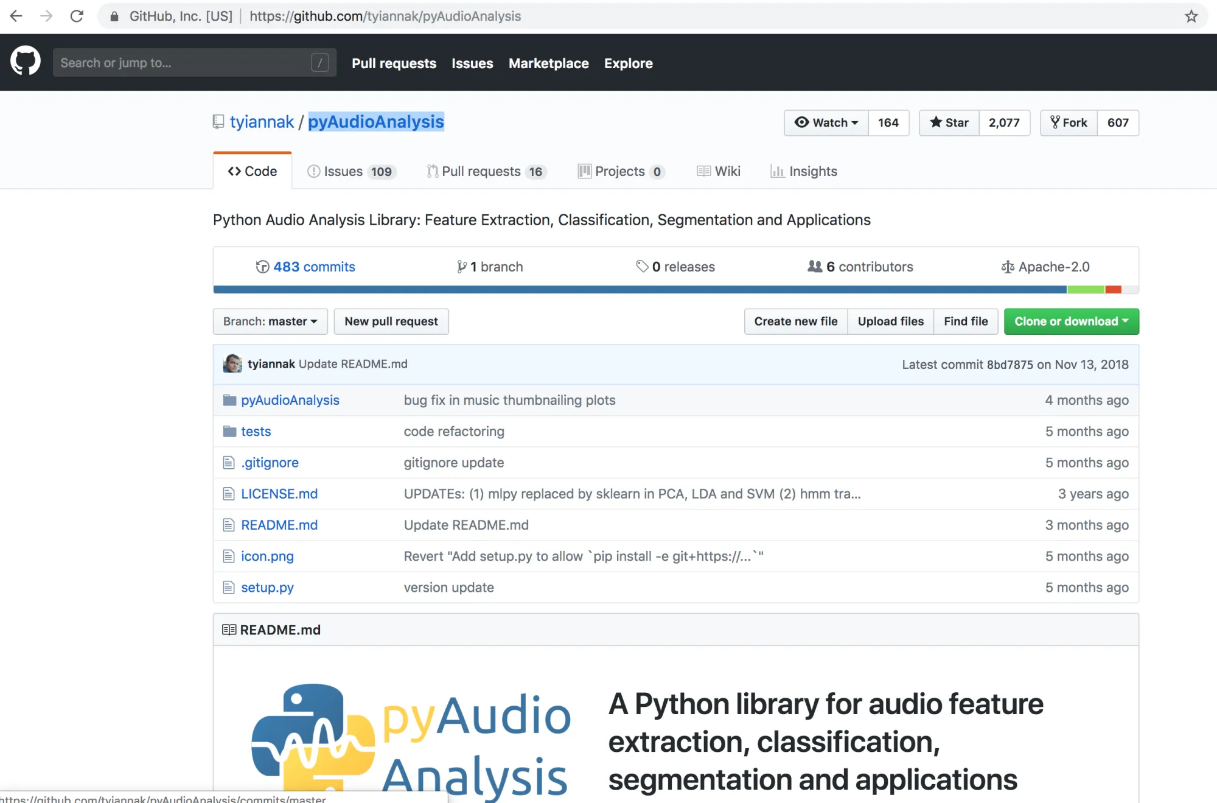
2. Pydub –
It helps to perform various common task in sound processing with python . For example -slicing the sound , concatenating the sound etc .I think you should check it out .
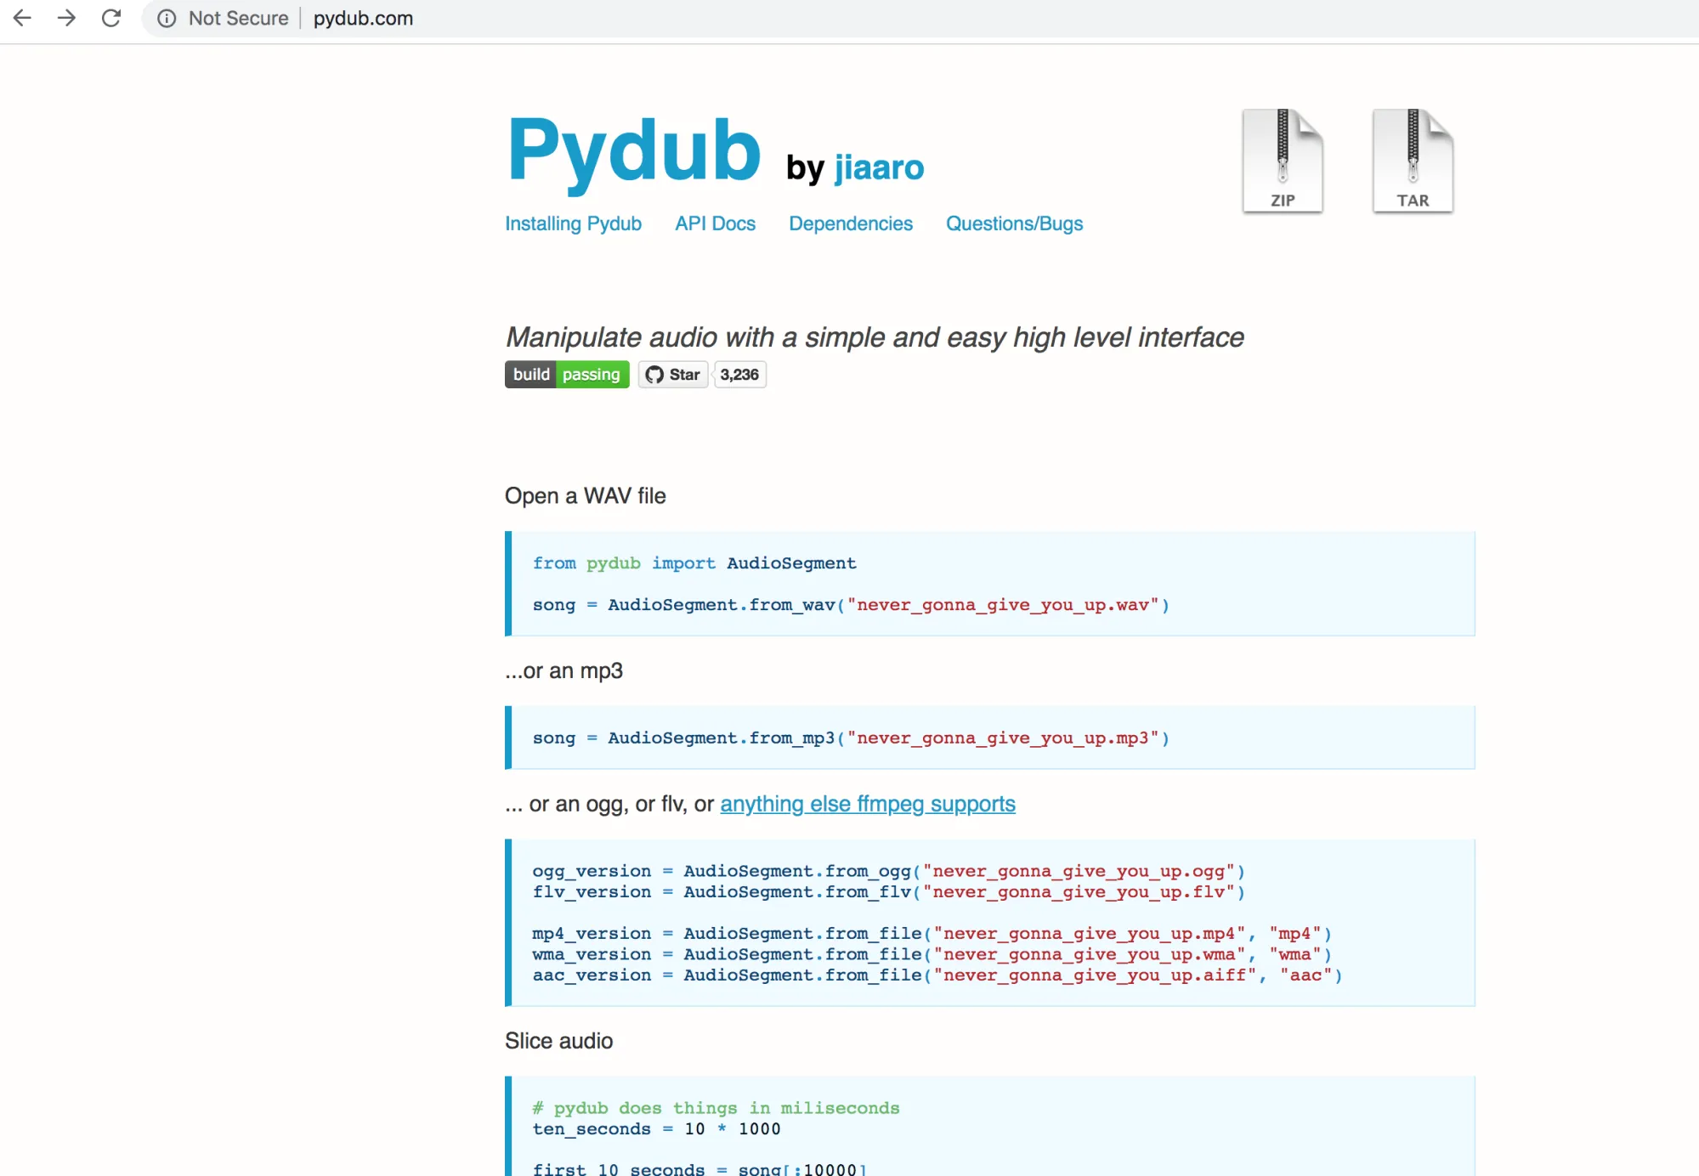
3. TimeSide –
It is a well design python framework for Audio Analysis . Specially for labelling , transcoding, streaming etc .It is more popular for audio processing in python with web .

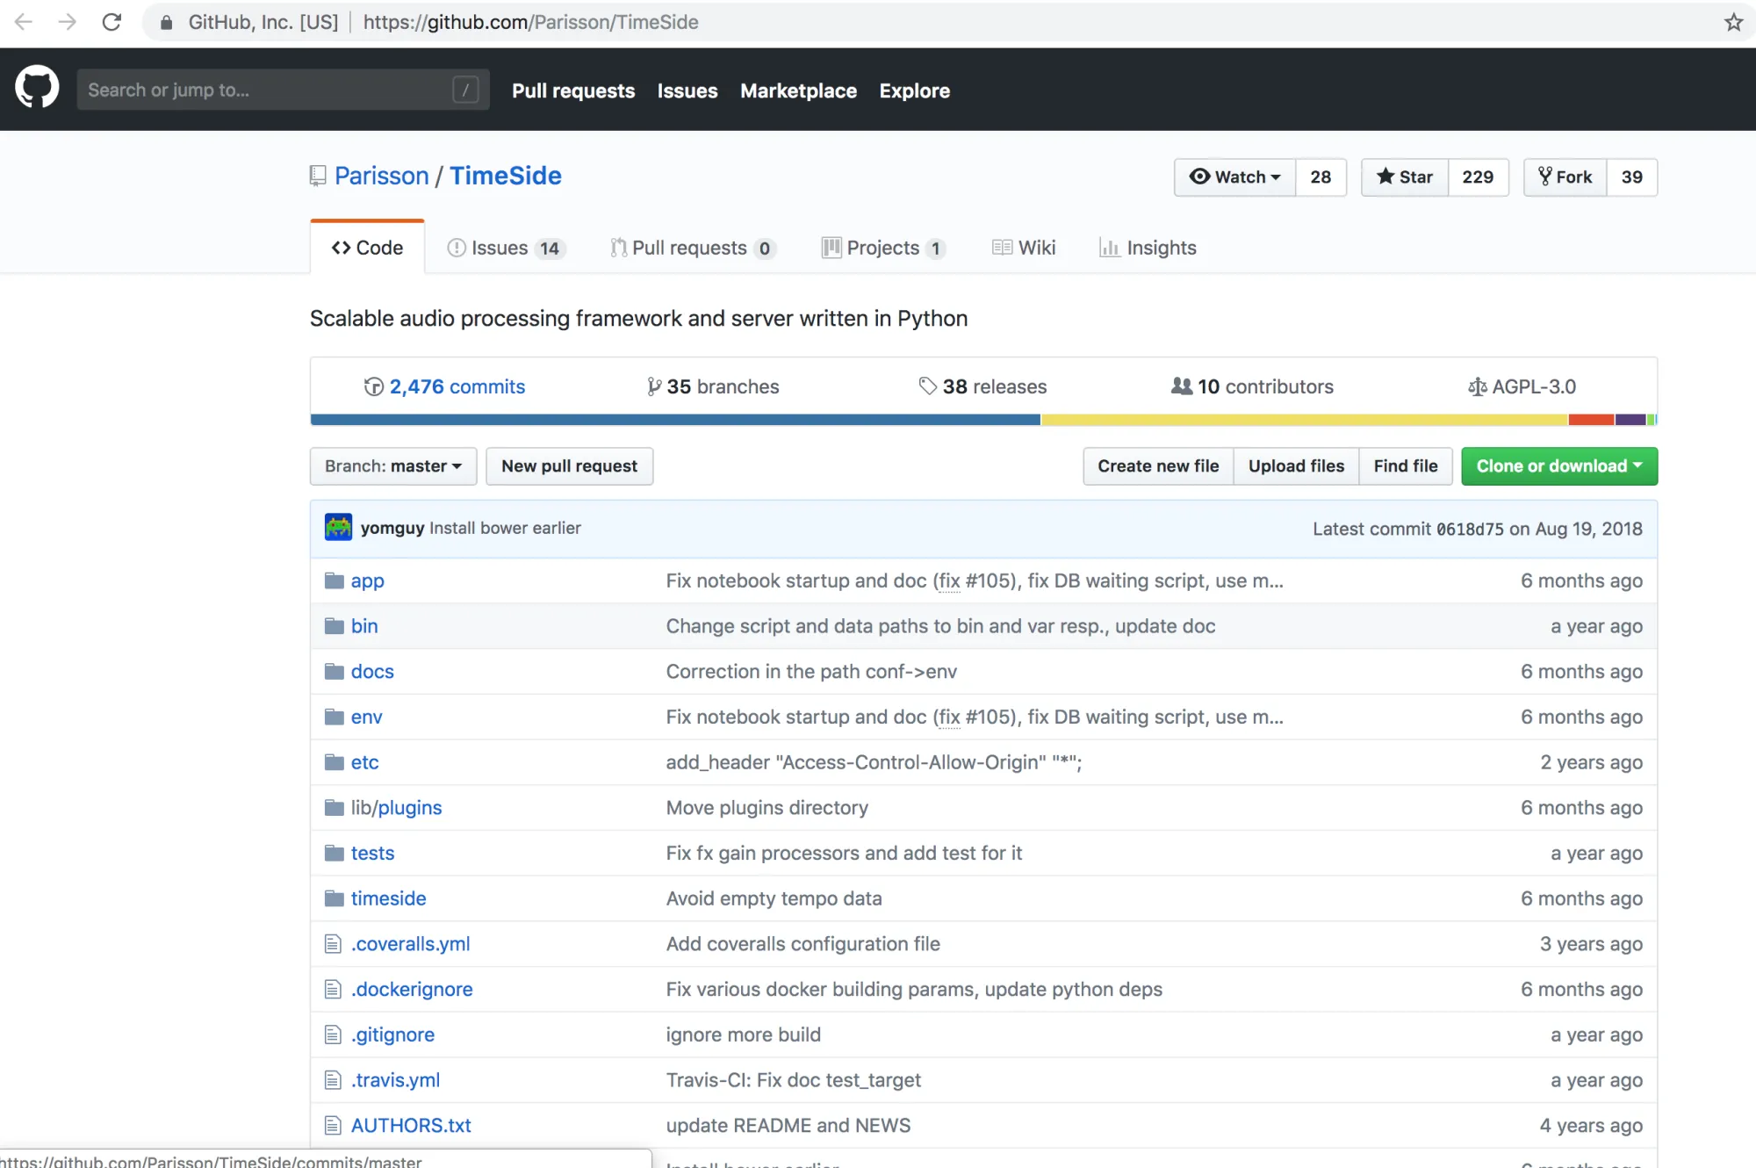
Mutagen –
This is really one of the great python module for audio processing specially tagging ,and meta data extraction . Mutagen also provide command line interface .
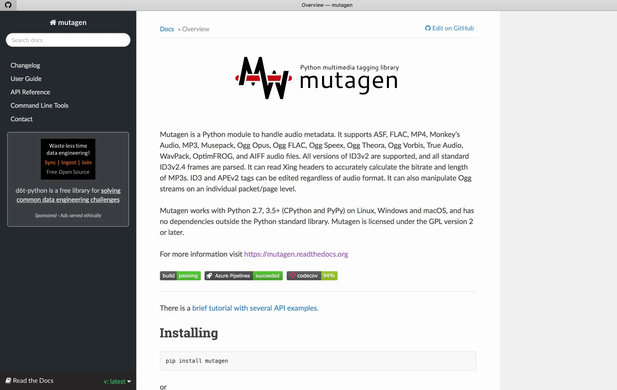

Others –
Truely speaking ! To provide a particular name at this place will be injustice to others Python Audio Processing and Analysis Library . Hence I have decide to create a bucket for this . Here are a list of some more interesting Python Libraries for Audio Processing –
1.audiolazy
2. audioread
3.beats

Audio Processing and Machine Learning –
Audio processing is harder with Machine Learning .Actually before sending directly to Machine Learning Platform so many hidden tasks. Which are quite time taking but seems small . Like we have to load the sound . The imported or loaded audio sample may be of some different format . We have to first convert them into the required one. Now the above mention Library comes to the role . Few of them are coming with such features of format conversion .
Now once it is converted into the required format , we have to perform the preprocessing like noise removal and all . After it the last and the most important step comes where we have to extract the feature from the audio sample . Finally it becomes c a typical machine learning stuff after the feature engineering .

Conclusion –
In this article we tried to cover the Audio Processing stuffs with Python Library . You may solve most of Audio processing stuffs using this libraries . So friends I hope this article ” Top 5 Audio Analysis Library for Python : Must for Data Scientist ” , must clear your doubt .Anyways if you want to discuss some more on it , Please write back to us . Audio Processing and Analysis is little different then text and image processing . If you think you may contribute some more on this topic , Data Science Learner’s Team always appreciate such efforts as guest posting .

