小作文

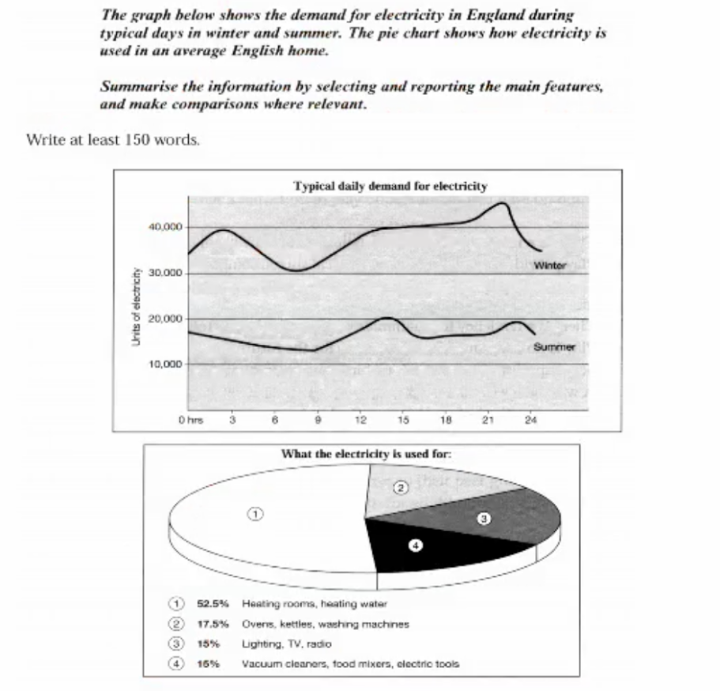

The line graph illustrates the electricity consumption in England in a typically whole day in winter and summer respectively, while the pie chart focuses on the proportion analysis of average electricity consumption for different usage in an English home.

Overall, according to the two figures above, the electricity consumption in winter is nearly twice that in summer for a whole day, and an average English home spends the highest percentage on heating rooms and heating water, which is more than half of the electricity consumption.

To be more specific, the electricity consumption in winter increases gradually from 32,000 at 0 AM to 40,000 at 3 AM and then bottoms out the whole day at 7 o'clock. From then on, it experiences a slow increase in the following hours, reaching a maximum at 11 PM, after which it drops sharply in the later hour. Interestingly, the figure of summer shows a different tendency comparing with that of winter. It declines slightly during the first nine hours and then surges to the peak of the whole day at 2 PM, and fluctuation was found clearly since then.

When it comes to the proportion, heating rooms and water, is second to none, which use 52.5% alone, closely followed by Ovens, kettles, and washing machines, which is only less than one in third of the former. After that, the rest of the percentage(about 30%) is shared evenly by the two other items.