Technical Exercise

# Design

The purpose of the Talent Marketing software is to help companies increase employee engagement and retention.

We accomplish this by figuring out the skills that a user has and the skills they are interested in growing. Additionally, we gather information about the projects that require work and figure out the skills needed to work on them.

We match the users to projects based on their skills and interests. A user can apply to join projects that the system recommends.

The project owner sees all the join requests from interested users and they can accept or deny them. The application provides a match analysis based on user and project skills to help project owners make the right choice.

Once a project is completed, the project owner is required to endorse project members on the skills that they have learned during the project as well as give them a rating and feedback based on how they did on the project.

This experiential learning model allows users to learn skills on the job, thereby helping them transition into roles/jobs that they want in their career. Thus, users are happier and stay longer with their companies rather than move onto other roles.

* **Based on the above description, design a UML class diagram capturing all the necessary objects required for the Talent Marketing software. Figure out the necessary attributes for each class based on your discretion. Make assumptions where necessary and clearly state them.**

# Implementation

* **Implement the UML class diagram as a set of classes using one of the following languages: Java, C#, C++, Python or JavaScript.**

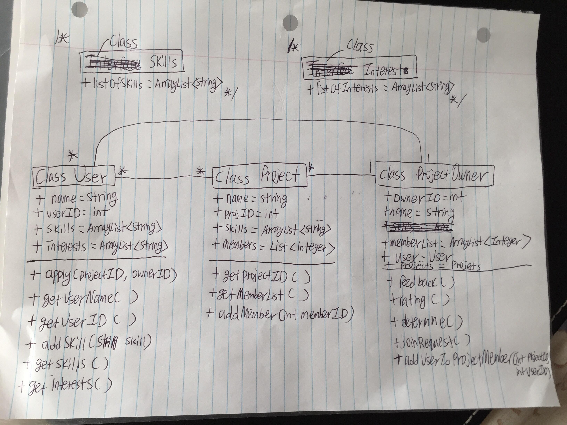

GitHub URL:

# Analysis

The core concept of the Talent Marketing system is the Opportunity Market. This is where users login to look for potential opportunities (Projects) to work on and/or post opportunities asking for help. For some of our pilots, user engagement is starting to drop - users log in, browse some opportunities and don’t come back.

**How would you address this problem?**

To address this problem, I would want to start with getting the data/information on:

* What types of opportunities (Projects) get the most views from users
* What types of opportunities(Projects) get the most applicants
* How are those opportunities(Projects) matching up with users’ skillsets
* How many opportunities(Projects) are posted and allow users to view/choose
* Try to find a UX expert to come in and analyze how friendly the system is to use

**What are some solutions you would propose to encourage users to post and join opportunities?**

* Improve user and project match making. Rather than just allowing users to create a profile, also include personality tests and skills test to help create a more accurate user profile that will allow more accurate matching. Greater accuracy can be beneficial to posting and joining opportunities as their projects will be more catered to their skills and have a lower chance of being rejected or finding an opportunity that they are unhappy with.
* Provide incentives for posting and joining opportunities. Users who engage with the system actively, such as posting, performing and writing reviews can be given more incentives such as awards or bonuses that highlights their achievement over the year.
* The platform needs to expand beyond just posting and joining opportunities. The stickiness of on-demand platforms is also dependent on the ecosystem of the entire application where the functions of the system should not just be posting and joining opportunities. Users should be able to find more information pertaining to their jobs, roles and industries on the system as well. This can provide more encouragements for them to be actively engaged in the system.
* More collaboration on a per-company basis to ensure that projects that can be posted as diverse and wide-ranging, catering to the needs to the company, the system and the user. Users may naturally feel more inclined to use the system if it directly related to their advancement and/or interests and one of the reason for its lack thereof may be that the jobs are not curtailed to their needs and friction between the system and the needs to the company. The system can be made to be more customized for these purposes.