**Chapter 4: Testing**

We have tested the three modules separately.

**Section 1: Wi-Fi Detection Testing**

For verification, the Wi-Fi detection module result was compared with the result from Wi-Fi Analyzer developed by farproc. It has been used by 3 hundred thousand google play users. The detection location was the library of HKUST. Both the applications were run on the LG Nexus 5.

As shown in Figure () and Figure (), difference between the detection from our application and Wi-Fi Analyzer were within a reasonable range. Our application’s Wi-Fi detection module runs correctly.

|  |  |
| --- | --- |
|  |  |
| Figure () Wi-Fi Detections Results from Our Application | Figure () Wi-Fi Detections Results from Wi-Fi  Analyzer |

**Section 2: LTE Detection Testing**

The LTE detection from our application was compared with the LTE Discovery mobile application developed by Danial Goodwin. It has gained six thousand downloads from Google Plat Store. The detection location was the library of HKUST. Both the applications were run on the LG Nexus 5.

LTE Discovery does not keep the record of the last detection. By comparing the LTE channels detected by our application and LTE Discovery, as shown in Figure () and Figure (), the results were exactly the same. Our application’s LTE detection module runs correctly.

|  |  |
| --- | --- |
|  |  |
| Figure () LTE Detection from Our Application | Figure () LTE Detection from LTE Discovery |

**Section 3: Localization Testing**

The localization module is compared with the Google Map within most of the smartphones nowadays. The test location is the piazza in HKUST. Both applications are run on the LG Nexus 5.

Comparing the location reported by these two applications, the results are almost the same. The localization module is running correctly.

|  |  |
| --- | --- |
|  |  |
| Figure () Location Reported By Our Application | Figure () Location Reported by Google Map |

**Section 4: Integrated Testing**

The whole application was testes in the following procedures.

The application first ran the LTE detection. And one of the signal towers was selected. Then we walked around the environment to generated the whole heat map. The result is shown in Figure (). The changes of signal strength were captured. The tested location was the Fok Ying Tung sports center in HKUST. The task was completed successfully.

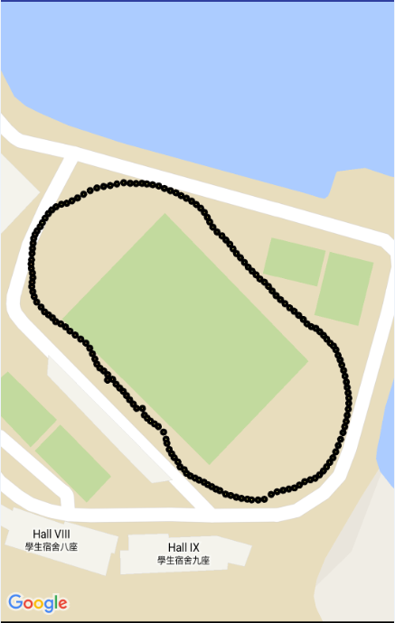

Figure () LTE Detection Map

|  |  |
| --- | --- |
|  |  |
| Figure () LTE Signal Strength Change 1 | Figure () LTE Signal Strength Change 2 |

The application then ran the Wi-Fi detection. And one of the APs was selected. Then we walked around the environment to generated the whole heat map. The result is shown in Figure (). The changes of signal strength were captured. The tested location was the Fok Ying Tung sports center in HKUST. The task was completed successfully.

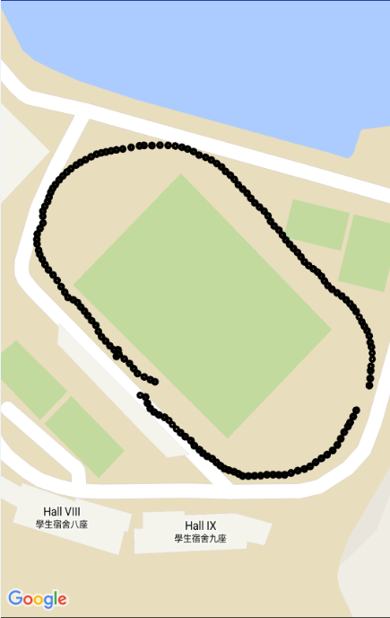

Figure () Wi-FI Detection Map

|  |  |
| --- | --- |
|  |  |
| Figure () Wi-Fi Signal Strength Change 1 | Figure () Wi-Fi Signal Strength Change 2 |

**Section 5: Testing on Different Device**

The application was tested on LG Nexus 4, LG Nexus 5 and Samsung Galaxy S4 separately.

As for LG Nexus 4, Wi-Fi detection module and localization module were run successfully. However, as LG Nexus 4 does not have the LTE function, the LTE List is always empty.

As for LG Nexus 5, all the modules were run successfully.

As for Samsung Galaxy S4, Wi-Fi detection module and localization module were run successfully.

However, when enter the LTE detection module, the application crushed. This error was reported by so developers. It is proposed that Samsung did not provide the accessibility to the LTE cell information.