Polyphyllin VI Regulates Aging in Caenorhabditis elegans via Redox Homeostasis Remodeling and Reproductive-Somatic Trade-Off Optimization
Dan Wu^{1,2}, Yutong Li¹, Yiwen Gong¹, Zhiru Li¹,Hexiang Qiu¹, Yan Pan^{1,2,*}, Bo Xian^{1,2,*}
1, Laboratory of Aging Research, School of Medicine, University of Electronic Science and Technology of China, Chengdu, China, 610054
2, TeloAetas DIgital Biology Center, Beijing, China, 100086
Corresponding author: Yan Pan (yanpan@zohomail.com), Bo Xian(xianbo@uestc.edu.cn)

Abstract
Aging is a complex biological process characterized by progressive functional decline and increased susceptibility to age-related diseases. It is a systemic biological process accompanied by oxidative stress imbalance, mitochondrial dysfunction, and disrupted resource allocation between reproduction and somatic maintenance. Natural products derived from traditional Chinese medicine exhibit great potential in anti-aging interventions and healthspan improvement due to their unique structural diversity and multi-target synergistic regulatory properties. Polyphyllin VI (PV) is a steroidal saponin isolated from the precious traditional Chinese medicinal herb Paris polyphylla. Previous pharmacological studies have fully demonstrated that PV possesses potent anti-tumor, anti-inflammatory, and immunomodulatory activities, with mechanisms involving cell cycle regulation, tumor cell apoptosis induction, invasion and metastasis inhibition, and inflammatory signaling pathway modulation . However, its potential biological effects and systematic regulatory mechanisms during physiological aging remain unclear. Notably, PV was previously identified as a highly promising longevity-active compound via high-throughput screening and prediction using the ElixirSeeker artificial intelligence machine learning model. Using Caenorhabditis elegans as the model, this study systematically evaluated the anti-aging effects of PV and elucidated the underlying mechanisms. The results showed that PV triggered a unique redox homeostasis remodeling by moderately inducing reactive oxygen species (ROS) accumulation to activate adaptive defense responses. In terms of reproductive regulation, 25 μM PV delayed the reproductive peak without affecting the total fecundity or reducing the total number of eggs laid. This strategic adjustment of reproductive timing effectively optimized life-history resource allocation and reduced competitive consumption of somatic maintenance resources. Further transcriptome high-throughput sequencing identified hlh-14, pals-37, dot-1.4, ref-2, and npr-13 as key target genes, constituting the molecular network underlying PV-mediated regulation of reproductive-somatic trade-off.

Keywords: Polyphyllin VI; Caenorhabditis elegans; reactive oxygen species; reproductive-somatic trade-off; redox homeostasis; aging

1. Introduction
The global population aging process is accelerating continuously, posing a major public health and socioeconomic challenge for human society in the 21st century. Aging is an evolutionarily conserved biological process characterized by progressive physiological function decline and tissue homeostasis disruption, with a core feature of significantly increased susceptibility to a series of age-related diseases such as neurodegenerative diseases, metabolic syndrome, cardiovascular diseases, and malignant tumors[1-3]. Aging is driven by multiple conserved mechanisms, including oxidative stress imbalance, mitochondrial dysfunction, proteostasis disruption, dysregulated insulin signaling, and resource trade-off between reproduction and somatic maintenance[4,5]. Among anti-aging intervention strategies, natural products from traditional Chinese medicine stand out from natural compound libraries as an important source for discovering novel anti-aging lead compounds due to their structural diversity, multi-target synergistic properties, and high biosafety[6]. Unlike single-target synthetic drugs, natural products (e.g., flavonoids, polyphenols, saponins, polysaccharides) can modulate multiple conserved longevity pathways (e.g., insulin/IGF-1, mTOR, Sirtuin, NRF2), systematically ameliorate oxidative stress, enhance mitochondrial function, suppress chronic inflammation, and maintain proteostasis, thereby achieving comprehensive effects of delaying aging and extending healthspan[7]. In recent years, the anti-aging mechanisms of natural ingredients such as resveratrol, curcumin, and ganoderic acid A have been extensively validated, further confirming the great potential of traditional Chinese medicine natural products in the field of aging translational medicine[8,9].
Traditional anti-aging drug screening is limited by high cost, low throughput, and long cycles. In contrast, artificial intelligence (AI) and machine learning-driven virtual screening technologies are revolutionizing the drug discovery model with their efficient and precise advantages[10,11]. By constructing predictive models based on known longevity compounds (e.g., ElixirSeeker), candidate molecules with potential longevity-promoting activities can be rapidly and cost-effectively screened from massive natural product libraries, greatly improving the efficiency and success rate of anti-aging drug development[12].
Paris polyphylla Sm. is a perennial herb of the Liliaceae family Paris genus, first recorded in Shennong Bencaojing, a long-history precious traditional Chinese medicinal herb. It is slightly cold in nature, bitter in taste, and acts on the liver meridian, with effects of clearing heat and detoxifying, relieving swelling and pain, and calming the liver to arrest convulsions. Modern phytochemical studies have shown that steroidal saponins are the main pharmacodynamic components of Paris plants, among which Polyphyllin VI (PV) is one of the core active monomers[13,14]. At present, the pharmacological research on PV mainly focuses on anti-tumor and anti-inflammatory fields: in terms of anti-tumor activity, PV has been confirmed to specifically induce intracellular ROS elevation in tumor cells by activating the ROS/NF-κB/NLRP3/GSDMD signaling axis, thereby triggering caspase-1-mediated pyroptosis; it also exerts broad-spectrum anti-cancer effects by inhibiting tumor cell proliferation, migration, invasion, and inducing apoptosis and autophagy[15,16]. In terms of anti-inflammatory activity, PV can effectively inhibit inflammatory pathways such as TLR4/NF-κB, reduce the release of pro-inflammatory factors such as IL-6 and TNF-α, and improve the inflammatory microenvironment[17]. In a recent study, researchers used the constructed ElixirSeeker model to screen and validate PV as a small molecule that can significantly extend the lifespan of Caenorhabditis elegans (C. elegans), making it a highly promising longevity compound[12].
C. elegans is an ideal model organism for anti-aging compound screening due to its short life cycle (about 2–3 weeks), stable phenotypes, and highly conserved aging-regulatory pathways with humans (including insulin/IGF-1 signaling pathway, mitochondrial function pathway, and oxidative stress response pathway)[18]. Its simple biological characteristics also facilitate high-throughput screening and mechanistic exploration of anti-aging compounds.
Based on the regulatory effects of PV on ROS, inflammation, and cellular homeostasis, combined with the advanced theory of mitohormesis, that moderate, low-level mitochondrial stress or ROS signals can activate the body's adaptive defense responses and ultimately improve health and lifespan, this study proposed a scientific hypothesis: Polyphyllin VI can delay aging and improve healthspan in C. elegans by inducing moderate oxidative stress, triggering redox homeostasis remodeling, optimizing reproductive-somatic resource allocation, and coordinately regulating core aging pathways[19,20].
Based on the ElixirSeeker screening results, this study used C. elegans as a model, combined with transcriptomics (RNA-seq) and bioinformatics analysis, to deeply dissect the molecular mechanisms by which PV regulates redox homeostasis and reproductive-somatic trade-off. The aim is to provide a scientific basis for the development of PV as a novel anti-aging agent, and to offer new targets and strategies for anti-aging research of Chinese medicine saponins.
2. Materials and Methods
2.1 Experimental Strains
Wild-type C. elegans N2 strain used in this study was purchased from the Caenorhabditis Genetics Center (CGC), University of Minnesota, USA. This strain is the most commonly used wild-type strain in aging research of C. elegans, with a clear genetic background and highly conserved aging-regulatory pathways with humans, and is widely used in anti-aging compound screening and mechanistic studies. During the experiment, Escherichia coli (E. coli) OP50 strain was used as the standard food source for nematodes. This uracil auxotrophic strain can colonize normally in the intestine of C. elegans without overproliferating to deteriorate the living environment of nematodes. It is a standardized food strain for routine culture of nematodes, purchased from CGC, and used with N2 strain to ensure normal growth, development, and reproduction of nematodes.
2.2 Experimental Reagents
All reagents used in this study were screened and verified to ensure compliance with experimental requirements for purity and activity. The specific reagent information is as follows: Polyphyllin VI (PV, purity ≥ 98%, powder) was provided by Chengdu Puruifa Technology Development Co., Ltd.; analytical grade dimethyl sulfoxide (DMSO) was provided by Chengdu Jinshan Chemical Reagent Co., Ltd.; 10% analytical grade sodium hypochlorite (NaClO) was provided by KESHI; analytical grade sodium hydroxide (NaOH) was provided by Chengdu Jinshan Chemical Reagent Co., Ltd.; analytical grade cholesterol was provided by Solarbio; biological reagent grade agar was provided by BioFroxx; anhydrous analytical grade calcium chloride (CaCl₂) and anhydrous analytical grade magnesium sulfate (MgSO₄) were both provided by Solarbio; biological reagent grade tryptone and biological reagent grade yeast extract were both provided by OXOID; analytical grade sodium chloride (NaCl), dipotassium hydrogen phosphate (K₂HPO₄), potassium dihydrogen phosphate (KH₂PO₄), disodium hydrogen phosphate (Na₂HPO₄), and potassium chloride (KCl) were all provided by Chengdu Jinshan Chemical Reagent Co., Ltd.; biological reagent grade Trizol reagent and 200-reaction SYBR Green fluorescent quantitative kit were both provided by Thermo Fisher Scientific; RNase-free DEPC water was provided by Biosharp; analytical grade anhydrous ethanol and isopropanol were both provided by Chengdu Jinshan Chemical Reagent Co., Ltd.; biological reagent grade 2',7'-dichlorodihydrofluorescein diacetate (DCFH-DA) was provided by Beyotime; floxuridine (Fudr, purity ≥ 98%) was provided by Shanghai Yuanye Bio-Technology Co., Ltd. All reagents were used within their validity periods; biological reagents were stored according to the manufacturer's instructions to avoid activity loss; analytical reagents were sterilized (by filtration or autoclaving) to ensure no bacterial contamination.
2.3 Experimental Instruments
All instruments used in this study were calibrated and qualified with stable performance, complying with experimental operating specifications. They were mainly used for nematode culture, sample processing, gene detection, and phenotypic observation. The main instruments include stereomicroscope, high-speed refrigerated centrifuge, constant temperature incubator, microplate reader, fluorescence microscope, autoclave, and clean bench. All instruments were operated in strict accordance with the instructions to ensure accurate and reliable experimental data.
2.4 Preparation of Experimental Solutions and Media
All solutions and media were prepared using RNase-free and bacteria-free reagents and consumables in strict accordance with aseptic operating specifications. After preparation, they were stored as required to ensure stable performance. All formulations were optimized based on standard experimental methods for C. elegans combined with the needs of this study.
2.5 Culture and Synchronization of C. elegans
C. elegans were cultivated on standard Nematode Growth Medium (NGM) plates at 20 ℃. The NGM contained 25 mM NaCl, 1.7% agar, 2.5 mg/mL peptone, 5 μg/mL cholesterol, 1 mM CaCl₂ , 1 mM MgSO₄ and 50 mM KH₂PO₄ (pH 6.0). UV-inactivated E. coli OP50 was used as the food source to eliminate metabolic interference from viable bacteria.
Synchronization was performed using the sodium hypochlorite lysis method: mature nematodes were treated with freshly prepared Bleach solution (10% NaClO + 5 M NaOH + ddH₂O) for 8–10 min to lyse the nematodes and release eggs; eggs were washed 2–3 times with S-Basal buffer, then incubated overnight at 15 ℃ to obtain synchronized L1 larvae, which were used for subsequent lifespan, phenotypic, and molecular experiments. L1 nematodes under this condition can survive stably for 6–7 days.
2.6 Drug Preparation and Administration
PV was dissolved in DMSO to prepare a 10 mM stock solution, stored at -20 ℃ in the dark. Before the experiment, it was diluted with NGM medium to final concentrations of 25, 50, and 100 μM.
The control group was set as 1% DMSO (consistent with the final solvent concentration of the drug group). Pre-experiments confirmed that this concentration of DMSO had no significant effect on the lifespan, heat stress, and motility of nematodes. The administration method was to directly incorporate into NGM medium, spread inactivated OP50 after the plate solidified, and use for nematode exposure treatment.
2.7 Heat Stress Resistance Assay
Synchronized young adults were treated with PV for 5 days, then transferred to a 37 ℃ constant temperature incubator for heat shock treatment, recorded as 0 h. The number of survivors was recorded every 2 h; nematodes without response to platinum wire stimulation were judged as dead. The survival rate and average survival time of each group were calculated to evaluate stress resistance.
2.8 Biochemical Index Detection
2.8.1 Reactive Oxygen Species (ROS) Level Detection
The intracellular ROS level of nematodes was detected by DCFH-DA fluorescent probe method[21]. Nematodes on days 5 and 7 of treatment were collected, incubated with 10 μM DCFH-DA probe at 20 ℃ for 120 min in the dark, washed 3 times with M9 buffer, and images were collected with a fluorescence microscope. The average fluorescence intensity was quantified by ImageJ.
2.8.2 Lipofuscin Content Detection
The intracellular lipofuscin content of nematodes was measured on days 7, 9, and 11 after administration. Nematodes were mildly anesthetized with 16 mM levamisole and placed on a 2% agar pad. Intestinal lipofuscin autofluorescence was captured using a Zeiss ZEN 3.10.103 imaging system. The relative accumulation of lipofuscin was represented by fluorescence intensity per unit area as a biomarker of aging-related damage accumulation.
2.8.3 Reproductive Capacity Assay
Synchronized L4 nematodes were placed on drug-containing plates and transferred to new plates daily until nematodes completely stopped laying eggs. The number of eggs was counted after all progeny developed into adults. The daily and total number of eggs laid were counted, with n ≥ 20 nematodes per treatment group, to evaluate the effect of PV on the reproductive cycle and capacity.
2.9 Molecular Biology Assays
2.9.1 Library Construction and Transcriptome Sequencing
Samples of nematodes treated with 25 μM PV for 4 days (reproductive peak stage of nematodes) were used for transcriptome sequencing (RNA-seq), with an untreated group (NT) and a solvent control group (CK) set simultaneously. Each group had 3 biological replicates to ensure the reliability and repeatability of sequencing results. Total RNA of nematodes in each group was extracted using Trizol reagent. The purity, concentration, and integrity of RNA were detected by Nanodrop micro-spectrophotometer and agarose gel electrophoresis, respectively. Qualified samples were used for subsequent library construction. Paired-end sequencing was performed on an Illumina NovaSeq 6000 sequencing platform to obtain raw sequencing data.
2.9.2 Sequencing Data Quality Control and Bioinformatics Analysis
Strict quality control was performed on raw data to remove low-quality reads, adapter sequences, and contaminated sequences to obtain high-quality clean reads. Clean reads were aligned to the reference genome of C. elegans (WS285) to complete sequence mapping and expression quantification. DESeq2 software was used for differential expression gene analysis, with FDR < 0.01 and |log₂FC| ≥ 1 as thresholds to screen significantly differentially expressed genes. GO functional enrichment analysis was performed on differential genes for functional annotation from three dimensions: biological process, cellular component, and molecular function; the STRING database was used to construct the protein-protein interaction (PPI) network of differential gene-encoded proteins, and Cytoscape software was used for visual analysis and key module mining to finally identify core genes and key pathways mediating the regulatory effects of PV.
2.10 Statistical Analysis
All data were statistically analyzed and plotted using GraphPad Prism 10.1.0. Lifespan and reproductive indicators were expressed as mean ± standard deviation (Mean ± SD), and molecular and biochemical indicators were expressed as mean ± standard error of the mean (Mean ± SEM). The t-test was used for comparison between two groups, and one-way analysis of variance (ANOVA) was used for comparison among multiple groups. P < 0.05 was considered statistically significant.
3. Results

3.1 Polyphyllin VI Bidirectionally Regulates Lipofuscin Accumulation and Exhibits Specific Regulation of Aging Biomarkers
Lipofuscin is a type of oxidative stress-derived aging pigment that gradually accumulates during cellular senescence, belonging to a heterogeneous polymer complex. It is mainly formed by the incomplete lysosomal degradation and polymerization of lipid peroxides, denatured proteins, and redox-active metal ions (e.g., iron, copper ions). It widely accumulates in the cytoplasm, especially around mitochondria and lysosomes—these two organelles are the core sites of cellular energy metabolism and waste removal, respectively, and their dysfunction and lipofuscin accumulation form a vicious cycle that further accelerates the cellular aging process. As a landmark product of cellular senescence and oxidative damage accumulation, lipofuscin has stable autofluorescence properties, and its fluorescence intensity is highly positively correlated with the biological age of cells and organisms[22]. It can objectively and quantitatively reflect the level of oxidative stress, the degree of proteostasis imbalance, and the decline of autophagic clearance capacity of the body, making it one of the most representative biomarkers for evaluating the aging process[23]. In the model organism C. elegans, lipofuscin mainly presents as intestinal autofluorescence, and its accumulation increases significantly with age, with high stability and repeatability. It has been widely recognized as a classic biological biomarker for evaluating aging degree, anti-aging intervention effects, and cellular damage repair capacity.
Based on the C. elegans model, this study systematically explored the regulatory effect of PV on lipofuscin accumulation using laser confocal microscopy combined with image quantitative analysis. As shown in Figure 1, PV exhibited a concentration- and time-dependent bidirectional regulatory effect on lipofuscin accumulation, a cellular aging biomarker: on day 7 of treatment, the intestinal lipofuscin fluorescence intensity of nematodes in the 25 μM and 50 μM PV treatment groups was significantly lower than that in the control group (P < 0.05), indicating that PV at these concentrations can effectively enhance cellular autophagic clearance capacity, promote the degradation of aging-related wastes such as lipofuscin, and delay the accumulation of aging-related damage; however, on day 11, the intestinal lipofuscin level of nematodes in the 100 μM high-concentration PV treatment group was significantly higher than that in the control group (P < 0.05), suggesting that long-term high-concentration PV exposure may disrupt intracellular redox homeostasis and induce excessive oxidative stress.
These results indicate that the regulatory effect of PV on lipofuscin accumulation in C. elegans presents a concentration- and time-dependent bidirectional effect, and its core mechanism may be related to the regulation of autophagic activity and maintenance of redox homeostasis: appropriate concentrations of PV can enhance the clearance capacity of cells for aging wastes such as lipofuscin by activating the autophagic pathway, delaying the accumulation of aging-related damage; while high concentrations of PV may inhibit autophagic function, induce excessive oxidative stress, disrupt intracellular homeostasis, and lead to abnormal lipofuscin accumulation. Only by selecting the appropriate administration concentration and treatment duration can the accumulation of aging-related damage be effectively delayed to achieve the optimal longevity benefit.
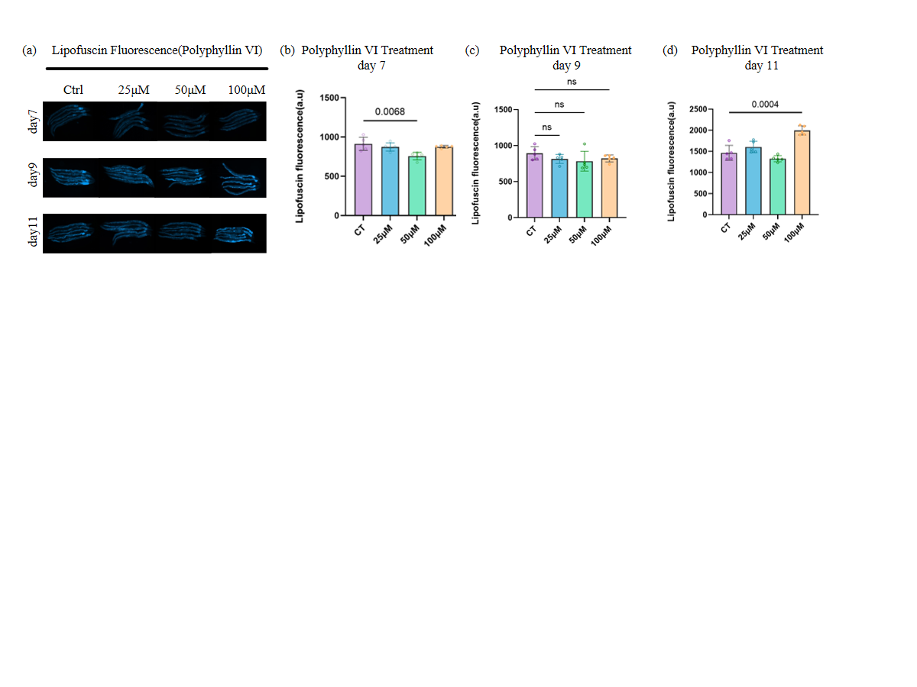

Figure 1 Effects of PV on lipofuscin accumulation in C. elegans.(a) Fluorescence imaging of lipofuscin; (b-d) Quantitative analysis of lipofuscin fluorescence intensity. Data are presented as Mean ± SEM. *P < 0.05 vs. control group.

3.2 Polyphyllin VI Induces Moderate ROS Accumulation and Activates the Body's Adaptive Defense Response
Reactive oxygen species (ROS) are a class of oxygen-containing free radicals and their derivatives continuously produced during mitochondrial respiratory chain and cellular oxidative metabolism, mainly including superoxide anion (O₂⁻·), hydrogen peroxide (H₂O₂), and hydroxyl radical (·OH). Among them, H₂O₂ is the core ROS molecule involved in cell signal transduction due to its high stability and transmembrane transport ability. ROS play dual roles of signal transduction and oxidative damage in the body. In aging biology, ROS play a dual role in physiological activities[24]. Low and physiological concentrations of ROS function as essential signaling molecules. These molecules activate the adaptive stress defense pathways and trigger mitohormesis in organisms. Moderate mitochondrial stimulation leads to the production of appropriate levels of ROS. Such levels further induce the activation of cellular antioxidant systems and autophagic pathways. This process enhances cellular stress resistance, improves mitochondrial function, delays aging, and extends healthspan. Excessively high levels of ROS break intracellular redox homeostasis and cause severe oxidative stress. This condition results in a series of impairments including protein oxidative denaturation, lipid peroxidation, and DNA strand breaks. It also accelerates lipofuscin accumulation, mitochondrial dysfunction, and cellular function decline, which eventually speed up the aging process. Earlier research has established the concept of redox stress signaling threshold (RST). This concept indicates a critical concentration point of ROS. Levels below this threshold generate favorable signaling effects for cells. Levels exceeding this threshold lead to oxidative damage and related injuries. The elevation of RST through mild external interventions effectively enhances stress resistance and supports healthy aging in living organisms[25].
To elucidate the oxidative stress mechanism of PV's anti-aging effect and clarify its specific characteristics of ROS regulation, this study used DCFH-DA probe to detect the intracellular ROS level of C. elegans—this cell-permeable indicator can remove the acetate group under the action of intracellular esterases to generate non-fluorescent H₂DCF. When ROS exist in the cell, H₂DCF is oxidized to fluorescent DCF, and its fluorescence intensity is positively correlated with the ROS level. Laser confocal microscopy combined with image quantitative analysis can achieve accurate detection of ROS levels. The experiment strictly followed standardized operating procedures: nematodes were incubated with 10 μM DCFH-DA probe in serum-free medium for 30 minutes to avoid interference of serum components on the detection results, and then the fluorescence intensity of different treatment groups was detected respectively to ensure the reliability and repeatability of experimental data.
As shown in Figure 2, PV exhibited a significant moderate activation effect on the intracellular ROS level of C. elegans, and this effect was more obvious under stress conditions: the intracellular ROS level of nematodes in the 25 μM and 100 μM PV treatment groups was significantly higher than that in the control group (P < 0.05) after normal culture to day 7 (old age) and heat shock at 37 ℃ for 2 hours on day 5, but no excessive ROS accumulation occurred, indicating that the ROS accumulation induced by PV was within the physiological appropriate range and did not cause oxidative damage.
Further analysis showed that in this study, PV exerted an anti-aging effect not through the traditional direct ROS scavenging mode, but by inducing moderate and controllable ROS accumulation to activate the body's adaptive defense response, thereby achieving longevity and healthspan improvement. This mode is also known as controlled oxidative priming. Compared with the direct ROS scavenging strategy, PV's controlled oxidative priming mode has more advantages: it can activate the body's own antioxidant system and autophagic pathway through moderate ROS signals, enhance long-term stress resistance, and achieve a radical and symptomatic anti-aging effect, rather than simply alleviating oxidative damage symptoms. In addition, combined with the results of Section 3.1, the moderate ROS accumulation induced by PV may be one of the important mechanisms for enhancing cellular autophagy and reducing lipofuscin accumulation at appropriate concentrations, and the two work synergistically to jointly achieve the anti-aging effect of PV.
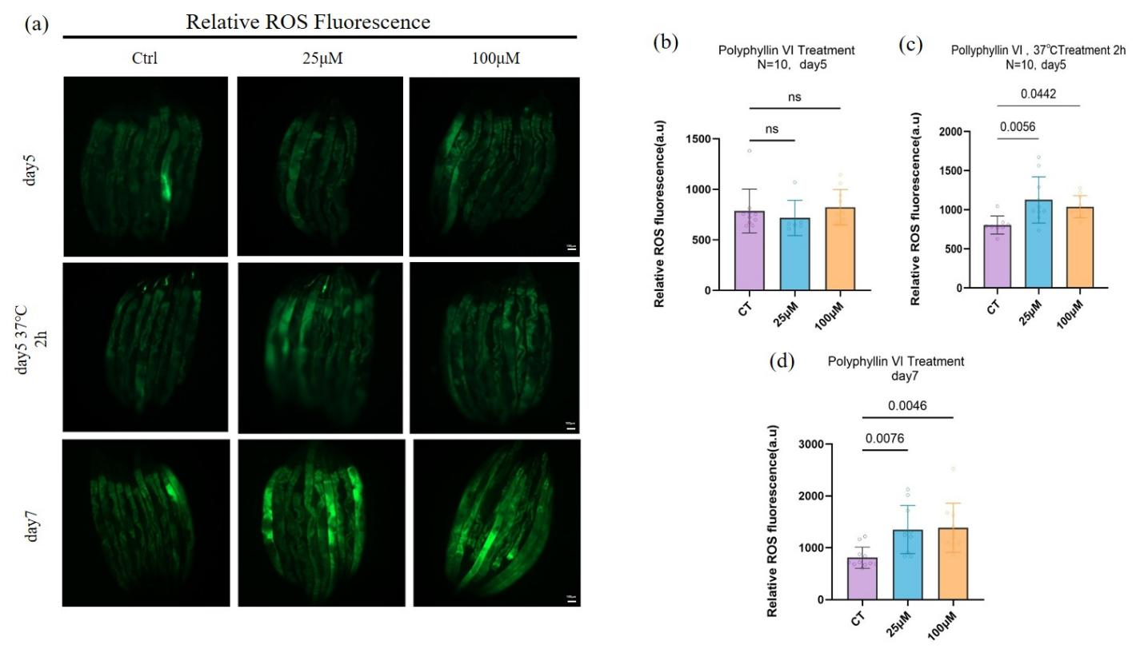

Figure 2 Effects of PV on intracellular ROS levels in C. elegans.(a) Fluorescence imaging of ROS; (b-d) Quantitative analysis of fluorescence intensity. Data are presented as Mean ± SEM. *P < 0.05 vs. control group.

3.3 Polyphyllin VI Optimizes Reproductive-Somatic Trade-Off and Delays Reproductive Peak Without Reducing Fecundity
In evolutionary biology, there is an inherent trade-off between reproduction and lifespan, which stems from the limited energy and resource allocation of the body: organisms need to dynamically balance reproductive investment (for gametogenesis and offspring reproduction) and somatic maintenance (for cell repair, antioxidant defense, autophagic clearance, etc., to ensure individual survival)[26,27]. Excessive investment in reproduction will lead to insufficient somatic resources, accelerate aging and shorten lifespan; while moderate regulation of reproductive timing and optimized resource allocation can extend individual healthspan without affecting reproduction. This core logic has been clearly explained by the disposable soma theory[28]. As a model organism with a short reproductive cycle and easily quantifiable reproductive phenotypes, C. elegans has been widely studied for the trade-off between reproduction and lifespan, making it an ideal model for analyzing the evolutionary regulatory mechanism of aging. Previous studies have confirmed that delaying the reproductive peak and optimizing reproductive-somatic resource allocation through genetic regulation or drug intervention is an important strategy to achieve longevity.
To clarify the relationship between PV's anti-aging effect and reproductive-somatic trade-off, this study systematically analyzed the regulatory effects of different concentrations of PV on the reproductive phenotypes of nematodes, including daily egg production, reproductive peak timing, and total egg production. The experiment strictly followed standardized operations: synchronized L4-stage nematodes were selected, 20 nematodes per group (N=20), cultured individually on NGM medium containing different concentrations of PV (25 μM, 100 μM), and transferred to fresh medium daily to count the number of eggs laid. Continuous recording was performed until nematodes stopped laying eggs to ensure the accuracy and repeatability of experimental data; total egg production was the sum of daily egg production during the entire reproductive cycle of nematodes, used to evaluate the overall effect of PV on reproductive capacity, and changes in daily egg production were used to analyze the remodeling effect of reproductive rhythm.
As shown in Figure 3, PV exhibited a significant concentration-dependent difference in regulating the reproductive phenotype of nematodes, with low-concentration PV showing a clear reproductive timing optimization effect and high-concentration PV showing a reproductive inhibition trend: the 25 μM PV treatment group significantly remodeled the egg-laying rhythm of nematodes. Compared with the control group, the egg production in the early egg-laying stage (day 2) was significantly reduced (p < 0.05), and the egg production at the reproductive peak (day 4) was significantly increased (p < 0.05), but the total egg production during the entire reproductive cycle was not significantly different from that in the control group (P = 0.9726), indicating that PV at this concentration only regulated reproductive timing without inhibiting the overall reproductive capacity of nematodes, achieving synergistic optimization of reproduction and lifespan; in contrast, the 100 μM high-concentration PV treatment group not only changed the egg-laying rhythm, but also significantly reduced the total egg production (P < 0.05), suggesting that PV has a clear reproductive safety concentration window, and excessively high concentrations will disrupt the resource balance between reproduction and soma, causing reproductive toxicity.
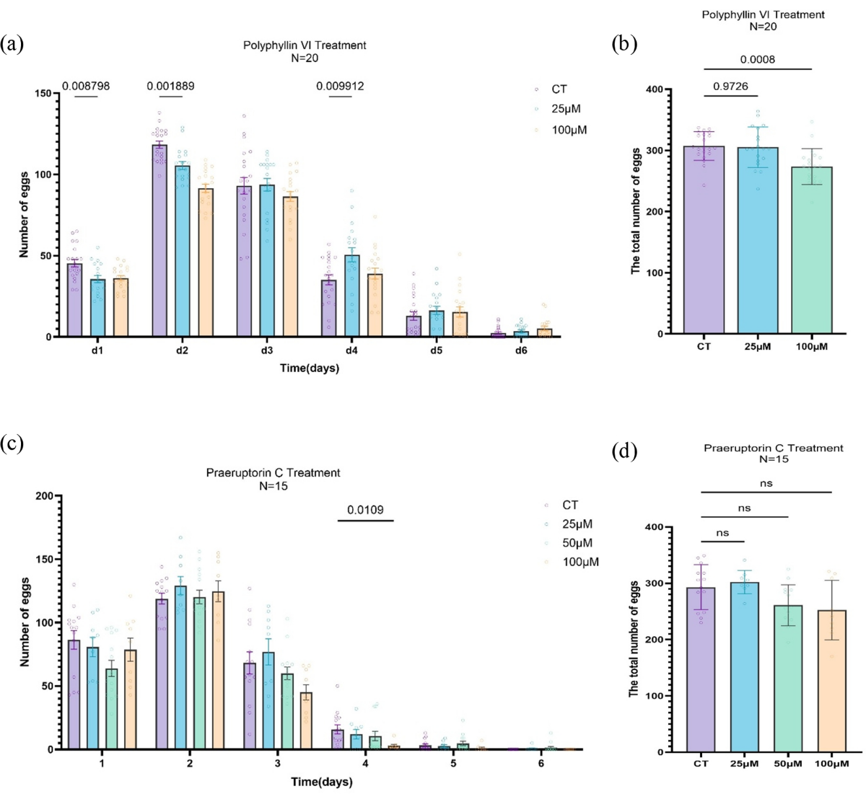

Figure 3 Effects of PV on reproductive rhythm and total egg production in C. elegans.(a) Effects of PV on egg laying of nematodes, N=20; (b) Total egg production of PV. Data are presented as Mean ± SD. *P < 0.05 vs. control group, ns indicates no significant difference.

These results further reveal the important mechanism of PV's anti-aging effect: low-concentration PV can transfer the energy and resources saved in the early reproductive stage to somatic maintenance by delaying the reproductive peak and optimizing the energy allocation strategy, including enhancing cellular autophagy and activating the antioxidant defense system (such as the stress defense pathway induced by moderate ROS in Section 3.2), thereby reducing the accumulation of aging-related damage and achieving longevity and healthspan improvement. This regulatory mode fully conforms to the evolutionary regulatory logic of the disposable soma theory—that organisms maximize somatic survival time on the basis of ensuring offspring reproduction by adjusting the timing of reproductive investment. Previous studies have confirmed that the anti-aging effects of natural products are often related to the optimization of reproductive-somatic trade-off. For example, ginsenosides and lycium barbarum polysaccharides can both delay the reproductive peak and optimize resource allocation to achieve longevity in nematodes without affecting total reproductive capacity. The results of this study are consistent with these findings, further confirming the common mechanism of anti-aging of natural products and providing evolutionary theoretical support for the anti-aging application of PV.
Notably, the characteristic of 25 μM PV achieving reproductive timing optimization rather than reproductive inhibition has important application value: for anti-aging drug research and development, avoiding reproductive inhibition is a key prerequisite. PV at an appropriate concentration can exert a longevity effect by optimizing reproductive-somatic trade-off while retaining the normal reproductive capacity of nematodes, suggesting that it has low reproductive toxicity and provides important experimental evidence for subsequent expansion to higher animal and human research. Combined with the previous results, the anti-aging effect of low-concentration PV is the result of multi-mechanism synergy: moderate ROS induction triggers mitohormesis, enhanced autophagy reduces lipofuscin accumulation, and optimized reproductive-somatic resource allocation provides sufficient energy for somatic maintenance. The three synergistically regulate to jointly achieve the longevity and healthspan improvement effect of PV.

3.4 Polyphyllin VI Regulates Reproductive-Related Transcriptome and Identifies Core Regulatory Genes
Transcriptome sequencing (RNA-seq) is a core technology for analyzing the molecular mechanism of drug-regulated biological phenotypes, which can comprehensively and accurately screen differentially expressed genes (DEGs) and provide important support for identifying core regulatory genes and clarifying signaling pathway regulatory networks[29]. Combined with the results of Section 3.3, 25 μM PV can significantly optimize the reproductive rhythm of nematodes, delay the reproductive peak without reducing the total egg production. To further reveal the molecular mechanism of PV regulating reproductive rhythm and clarify the core molecular targets involved in reproductive-somatic trade-off regulation, this study selected C. elegans treated with 25 μM PV for 4 days (at this time, nematodes were in the early reproductive peak, consistent with the key node of reproductive rhythm regulation), with untreated nematodes as the control group (NT) and solvent-treated nematodes as the blank control group (CK), for whole-transcriptome sequencing analysis. The experiment set 3 biological replicates to ensure the reliability and repeatability of sequencing data.
The sequencing experiment strictly followed standardized procedures: total RNA of nematodes was extracted using Trizol reagent, RNA purity (A260/A280 ratio 1.8–2.0) was detected by Nanodrop, RNA integrity was verified by agarose gel electrophoresis, then cDNA library was constructed, and sequencing was performed on the Illumina NovaSeq 6000 sequencing platform. After quality control of raw data (filtering low-quality reads, removing adapter sequences and contaminated sequences), they were aligned to the C. elegans reference genome (WS285). DESeq2 software was used for differential expression analysis, with the screening criteria of false discovery rate (FDR) < 0.01 and absolute log-fold change (|log₂FC|) ≥ 1 to ensure the statistical significance and biological significance of differential genes.
As shown in Figure 4, compared with the control group, the PV treatment group exhibited a clear specific regulatory characteristic of gene expression: a total of 66 differentially expressed genes (33 PV-specific up-regulated genes and 33 specific down-regulated genes, FDR < 0.01, |log₂FC| ≥ 1) were screened, and no significant differential expression was found between the blank control group (CK) and the untreated group (NT), suggesting that the expression changes of these genes were the result of PV-specific regulation rather than solvent interference or environmental factors.
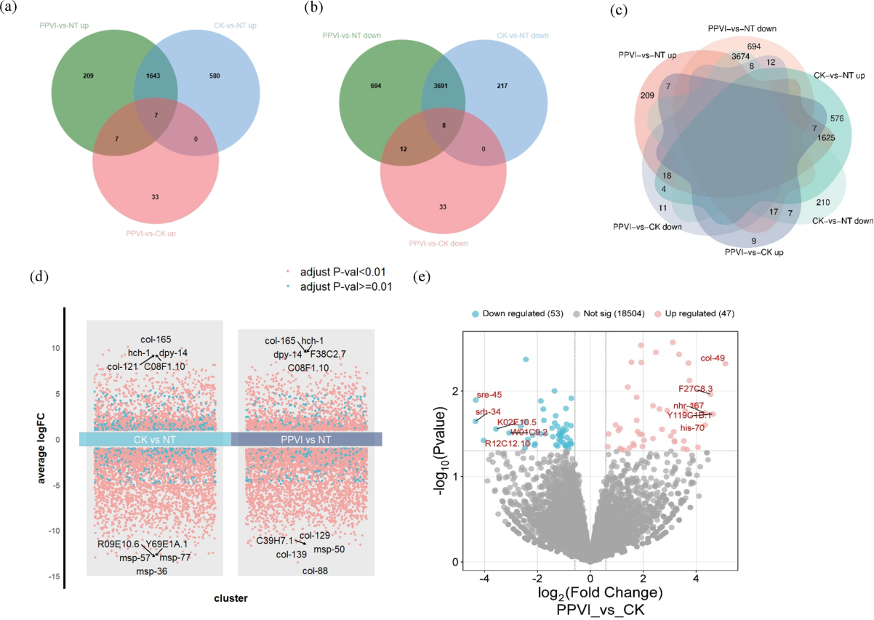

Figure 4 Gene expression changes in nematodes after 4 days of PV treatment.(a) Venn diagram showing the sharing and specificity of differentially expressed genes in PV treatment group (PPVI), control group (CK), and untreated group (NT); (b) Scatter plot showing the average log2 fold change of gene expression in control group (CK) vs. untreated group (NT) and PV treatment group (PPVI) vs. untreated group (NT). Each point represents a gene, pink (p < 0.01) and blue (p ≥ 0.01) points represent differentially significant genes; (c) Volcano plot showing the average log2 fold change of up-regulated and down-regulated genes in PV treatment group (PPVI) vs. control group (NT). Pink: up-regulated genes, blue: down-regulated genes, gray: no significant difference.
To clarify the biological function and regulatory pathways of differential genes, 66 PV-specific differential genes were subjected to Gene Ontology (GO) enrichment analysis, covering three dimensions: biological process (BP), cellular component (CC), and molecular function (MF)[30]. Fisher's exact test was used for statistical analysis, and significantly enriched GO terms were screened with FDR < 0.05 as the standard. As shown in Figure 5, the differential genes regulated by PV exhibited clear functional enrichment characteristics: up-regulated genes were mainly enriched in biological terms such as collagen system development, tissue homeostasis, and wound response, all of which are closely related to somatic maintenance and tissue repair, suggesting that PV up-regulating these genes may enhance somatic repair ability and maintain tissue homeostasis to support resource allocation in reproductive-somatic trade-off; while down-regulated genes were mainly involved in sperm protein function and chemical sensory perception-related terms, which are closely related to germ cell development and reproductive signal transduction, suggesting that PV may inhibit excessive activation in the early reproductive stage by down-regulating these genes, thereby delaying the reproductive peak and optimizing reproductive timing, which is highly consistent with the phenotype of PV delaying reproductive peak in Section 3.3.
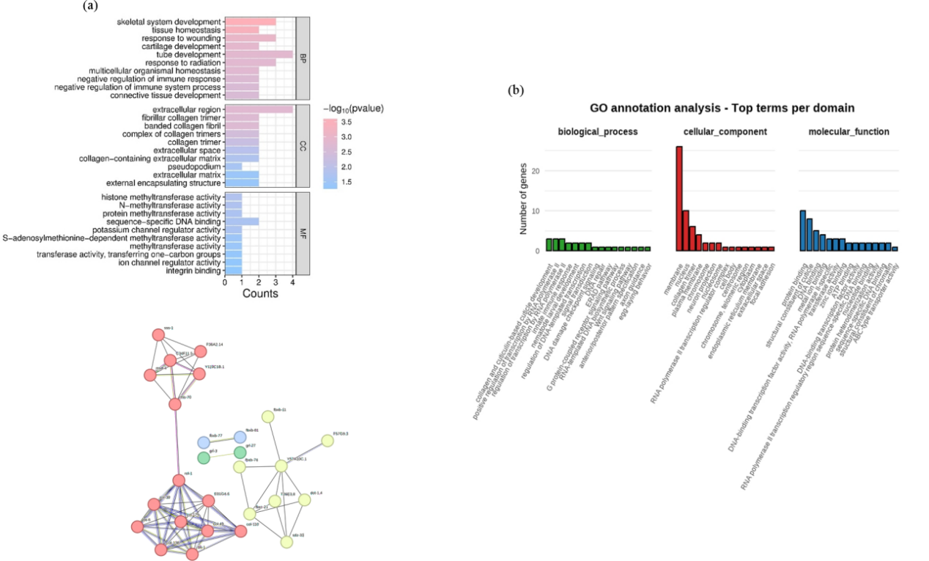

Figure 5 GO enrichment annotation and gene regulation in nematodes after PV treatment.(a) GO enrichment analysis (BP/CC/MF distribution); (b) GO annotation; (c) Gene interaction network diagram, lines represent the interaction relationship between genes.
Combined with the GO enrichment analysis results, as well as the expression characteristics and functional annotations of differential genes, core regulatory genes for PV regulating reproductive rhythm and reproductive-somatic trade-off were further screened. These genes work synergistically from multiple dimensions such as neural development, cell division, epigenetic modification, and signal transduction. The specific information is shown in Table 1:
Table 1 Core Genes Regulated by Polyphyllin VI
Gene Name | Expression | Gene Description
hlh-14 | Down-regulated | Encodes a basic helix-loop-helix (bHLH) transcription factor, widely involved in neural development regulation, especially regulating asymmetric cell division of PVQ/HSN/PHB neuroblasts and normal differentiation of their progeny, and also participates in multiple physiological processes such as egg laying, movement, body shape formation, and larval development.
pals-37 | Up-regulated | Belongs to the centrosomal spindle pole-associated protein family, plays a key role in cell division, regulates spindle assembly and chromosome segregation, and ensures the accuracy of cell division.
dot-1.4 | Down-regulated | Encodes histone H3K79 methyltransferase, participates in epigenetic regulation, and affects gene transcription activity by modifying chromatin status.
ref-2 | Down-regulated | Encodes a zinc-finger transcription factor, cooperates with ref-1 and nxf-1 to regulate female fate determination, and positively regulates larval development.
npr-13 | Down-regulated | Encodes a G protein-coupled receptor (GPCR), mainly involved in physiological processes such as neuropeptide signal transduction, feeding behavior, and nociception regulation.

The above core regulatory genes synergistically mediate the remodeling of the reproductive cycle by PV from multiple dimensions, forming a complete molecular regulatory network: hlh-14 and npr-13 inhibit excessive activation in the early reproductive stage and delay the reproductive peak from the aspects of neural development and signal transduction; dot-1.4 and ref-2 balance the expression of reproductive and somatic-related genes and optimize reproductive timing from the aspects of epigenetic modification and transcriptional regulation; pals-37 enhances somatic repair and maintenance ability from the aspect of cell division to support resource allocation. The synergistic effect of these genes clearly explains the molecular mechanism of PV regulating reproductive rhythm and optimizing reproductive-somatic trade-off, provides a clear molecular explanation for the phenotype of PV delaying reproductive peak without reducing egg production in Section 3.3, and further improves the multi-mechanism synergistic regulatory network of PV's anti-aging effect.
Previous studies have confirmed that the regulation of reproductive-related transcriptome is an important molecular pathway for natural products to optimize reproductive-somatic trade-off and achieve longevity. For example, ginsenoside Rg1 can regulate the expression of reproductive-related transcription factors to optimize the reproductive rhythm of nematodes and extend lifespan. The results of this study are consistent with these findings, further confirming the common molecular mechanism of anti-aging of natural products. In addition, the core regulatory genes screened in this study, such as hlh-14 and dot-1.4, are key genes for the regulation of reproduction and aging in nematodes, and their expression changes can directly affect reproductive-somatic trade-off, providing an important experimental basis for further exploring the molecular mechanism of PV's anti-aging effect and screening specific molecular targets, and also providing new molecular targets and ideas for the research and development of natural product anti-aging drugs.
4. Discussion
Based on the ElixirSeeker machine learning screening system, this study systematically demonstrates the anti-aging activity and mechanism of PV at the phenotypic, physiological, molecular, and transcriptomic levels for the first time, filling the research gap of PV's biological effects and regulatory mechanisms during physiological aging of the body[12]. The results show that PV exerts an effect through a unique pathway of redox homeostasis remodeling and reproductive timing remodeling, breaking the inherent model of traditional anti-aging research, and providing a new paradigm and experimental basis for anti-aging research of traditional Chinese medicine steroidal saponins.

4.1 Redox Homeostasis Remodeling Is the Core Mechanism of PV-Mediated Longevity
Different from traditional antioxidant compounds that exert anti-aging effects simply by scavenging ROS and reducing oxidative stress levels, the core anti-aging mechanism of PV lies in remodeling the body's redox homeostasis. By moderately increasing ROS production (without excessive accumulation), it avoids oxidative damage, exerts the positive signal transduction effect of ROS, and at the same time, appropriate concentrations of PV can significantly reduce lipofuscin accumulation, confirming that PV can reduce aging-related damage and achieve longevity by regulating redox homeostasis.
Different from traditional antioxidant compounds that directly scavenge ROS and reduce the body's oxidative stress level, PV exhibits a unique controlled oxidative priming mode: moderately increasing ROS levels instead of reducing ROS. This study shows that ROS in nematodes increased significantly after PV treatment, while lipofuscin decreased at appropriate concentrations, indicating that low-level oxidative stress can activate the body's defense and damage clearance system.

4.2 Polyphyllin VI Delays Reproductive Aging by Optimizing Reproductive-Somatic Trade-Off
The disposable soma theory holds that organisms have an inherent energy allocation trade-off between reproduction and somatic maintenance. Excessive investment in reproduction will accelerate aging, while moderate regulation of reproductive timing can achieve synergistic optimization of longevity and reproductive capacity. This study found for the first time that 25 μM PV can delay the reproductive peak without reducing the total egg production, only remodeling the egg-laying timing without inhibiting reproductive capacity, which is an extremely rare ideal anti-aging phenotype. Most longevity interventions (such as calorie restriction, daf-2 mutation) reduce reproductive capacity, while PV achieves the ideal effect of longevity without impairing reproduction.
Transcriptomic results show that PV specifically regulates core genes such as hlh-14, ref-2, dot-1.4, pals-37, and npr-13, which are involved in neural development, cell division, epigenetic modification, and vulval structure formation, respectively, and jointly remodel reproductive rhythm at the developmental level. This delayed reproductive peak mode can effectively reduce energy consumption in the early reproductive stage, redirect more resources to somatic maintenance and damage repair, such as enhancing cellular autophagy and activating the antioxidant defense system, thereby delaying the aging process. This finding provides new intervention ideas and potential directions for delaying reproductive aging and optimizing life-history resource allocation.

4.3 Biphasic Effects of Polyphyllin VI and Their Significance
PV exhibits a clear concentration- and time-dependent biphasic effect on lipofuscin accumulation: low-concentration PV reduces lipofuscin accumulation in middle age (day 7 of treatment), enhances cellular autophagic clearance capacity, and delays aging; while high-concentration PV increases lipofuscin accumulation in old age (day 11 of treatment) and aggravates oxidative damage. The occurrence of this biphasic effect may be closely related to the dual role of ROS: moderate ROS induced by low-concentration PV can activate the cellular waste clearance pathway and promote lipofuscin degradation; while excessive ROS induced by high-concentration PV can lead to oxidative damage and lipofuscin accumulation. This biphasic effect highlights the importance of concentration optimization for PV as an anti-aging agent, and also provides key enlightenment for the subsequent translational application of PV: only by selecting the appropriate administration concentration and treatment duration can the anti-aging effect of PV be fully exerted and potential toxicity caused by high concentrations be avoided.

4.4 Research Limitations and Future Directions
Although this study systematically analyzed the anti-aging mechanism of PV and provided sufficient experimental evidence for its translational application, there are still certain limitations: first, the anti-aging effect of PV was only verified in the C. elegans model, and further confirmation in mammalian models is needed to clarify its translational potential; second, the direct molecular target of PV has not yet been identified, and only the core downstream genes regulated by PV have been identified. In the future, techniques such as pull-down assay and mass spectrometry are needed to identify the direct binding protein of PV and clarify the upstream molecular mechanism of its regulation of aging pathways; finally, the mechanism of PV regulating reproductive-somatic trade-off needs to be further verified by gene knockout and RNA interference experiments to clarify the causal relationship of core genes such as hlh-14 and pals-37 in PV regulating reproductive rhythm.
Based on the above limitations, future research can be carried out in the following directions to further improve the anti-aging mechanism research and translational application of PV: first, systematically evaluate the effects of PV on metabolism, movement, reproduction, and lifespan in mammalian aging models such as mice to clarify its anti-aging effect in higher animals; second, carry out structural optimization of PV to improve its anti-aging selectivity, reduce potential toxicity, and enhance its clinical translational feasibility; third, further explore the molecular details of PV regulating reproductive-somatic trade-off, clarify the regulatory relationship between core genes, and improve the multi-target synergistic regulatory network.
5. Conclusions
In conclusion, guided by ElixirSeeker artificial intelligence screening, this study systematically validated the anti‑aging activity of Polyphyllin VI (PV) in C. elegans and clarified its underlying molecular mechanisms. PV exerts its anti‑aging effects through controlled oxidative priming by moderately elevating ROS levels and activating adaptive stress responses, which is distinct from conventional antioxidant strategies. PV optimizes the reproductive‑somatic trade‑off and delays reproductive aging without compromising total fecundity. Specifically, 25 μM PV postpones the reproductive peak and reshapes the egg‑laying rhythm, redirecting energy resources from early reproduction toward somatic maintenance and thereby achieving longevity without reproductive impairment. Mechanistically, PV remodels reproductive timing via the core regulatory genes hlh‑14, pals‑37, dot‑1.4, ref‑2, and npr‑13, which coordinately construct the molecular network underlying the reproductive‑somatic trade‑off regulation. Collectively, these findings establish robust experimental support for PV as a promising anti‑aging candidate compound and offer novel strategies and molecular targets for anti‑aging research of steroidal saponins derived from traditional Chinese medicine[17]. Further investigations including mammalian validation, direct target identification, and structural optimization are warranted to advance the clinical translational potential of PV.
6.References
- López-Otín C, Blasco MA, Partridge L, Serrano M, Kroemer G. The hallmarks of aging. Cell. 2013;153(6):1194-1217. doi:10.1016/j.cell.2013.05.039
- Kulkarni AS, Gubbi S, Barzilai N. Benefits of Metformin in Attenuating the Hallmarks of Aging. Cell Metab. 2020;32(1):15-30. doi:10.1016/j.cmet.2020.04.001
- Hernandez-Segura A, Nehme J, Demaria M. Hallmarks of Cellular Senescence. Trends Cell Biol. 2018;28(6):436-453. doi:10.1016/j.tcb.2018.02.001
- la Torre A, Lo Vecchio F, Greco A. Epigenetic Mechanisms of Aging and Aging-Associated Diseases. Cells. 2023;12(8):1163. Published 2023 Apr 14. doi:10.3390/cells12081163
- de Magalhães JP. An overview of contemporary theories of ageing. Nat Cell Biol. 2025;27(7):1074-1082. doi:10.1038/s41556-025-01698-7
- Campisi J, Kapahi P, Lithgow GJ, Melov S, Newman JC, Verdin E. From discoveries in ageing research to therapeutics for healthy ageing. Nature. 2019;571(7764):183-192. doi:10.1038/s41586-019-1365-2
- Long YC, Tan TM, Takao I, Tang BL. The biochemistry and cell biology of aging: metabolic regulation through mitochondrial signaling. Am J Physiol Endocrinol Metab. 2014;306(6):E581-E591. doi:10.1152/ajpendo.00665.2013
- Baur JA, Sinclair DA. Therapeutic potential of resveratrol: the in vivo evidence. Nat Rev Drug Discov. 2006;5(6):493-506. doi:10.1038/nrd2060
- Zia A, Farkhondeh T, Pourbagher-Shahri AM, Samarghandian S. The role of curcumin in aging and senescence: Molecular mechanisms. Biomed Pharmacother. 2021;134:111119. doi:10.1016/j.biopha.2020.111119
- Hernández-Silva D, Alcaraz-Pérez F, Pérez-Sánchez H, Cayuela ML. Virtual screening and zebrafish models in tandem, for drug discovery and development. Expert Opin Drug Discov. 2023;18(8):903-915. doi:10.1080/17460441.2022.2147503
- Du A, Jia W. Virtual screening, identification, and potential antioxidant mechanism of novel bioactive peptides during aging by a short-chain peptidomics, quantitative structure-activity relationship analysis, and molecular docking. Food Res Int. 2023;172:113129. doi:10.1016/j.foodres.2023.113129
- Pan Y, Cai H, Ye F, et al. ElixirSeeker: A Machine Learning Framework Utilizing Fusion Molecular Fingerprints for the Discovery of Lifespan-Extending Compounds. Aging Cell. 2025;24(8):e70116. doi:10.1111/acel.70116
- Guo L, Su J, Deng BW, et al. Active pharmaceutical ingredients and mechanisms underlying phasic myometrial contractions stimulated with the saponin extract from Paris polyphylla Sm. var. yunnanensis used for abnormal uterine bleeding. Hum Reprod. 2008;23(4):964-971. doi:10.1093/humrep/den001
- Teng JF, Qin DL, Mei QB, et al. Polyphyllin VI, a saponin from Trillium tschonoskii Maxim. induces apoptotic and autophagic cell death via the ROS triggered mTOR signaling pathway in non-small cell lung cancer. Pharmacol Res. 2019;147:104396. doi:10.1016/j.phrs.2019.104396
- Yuan YL, Jiang N, Li ZY, et al. Polyphyllin VI induces apoptosis and autophagy in human osteosarcoma cells by modulation of ROS/JNK activation. Drug Des Devel Ther. 2019;13:3091-3103. Published 2019 Aug 28. doi:10.2147/DDDT.S194961
- Teng JF, Mei QB, Zhou XG, et al. Polyphyllin VI Induces Caspase-1-Mediated Pyroptosis via the Induction of ROS/NF-κB/NLRP3/GSDMD Signal Axis in Non-Small Cell Lung Cancer. Cancers (Basel). 2020;12(1):193. Published 2020 Jan 13. doi:10.3390/cancers12010193
- Kong X, Zhao Y, Wang X, et al. Loganin reduces diabetic kidney injury by inhibiting the activation of NLRP3 inflammasome-mediated pyroptosis. Chem Biol Interact. 2023;382:110640. doi:10.1016/j.cbi.2023.110640
- Park HH, Jung Y, Lee SV. Survival assays using Caenorhabditis elegans. Mol Cells. 2017;40(2):90-99. doi:10.14348/molcells.2017.0017
- Cheng YW, Liu J, Finkel T. Mitohormesis. Cell Metab. 2023;35(11):1872-1886. doi:10.1016/j.cmet.2023.10.011
- Gunawan AL, Liparulo I, Stahl A. Mammalian mitohormesis: from mitochondrial stressors to organismal benefits. EMBO J. 2025;44(20):5640-5661. doi:10.1038/s44318-025-00549-3
- Yong Y, Yan L, Wei J, et al. A novel ferroptosis inhibitor, Thonningianin A, improves Alzheimer's disease by activating GPX4. Theranostics. 2024;14(16):6161-6184. Published 2024 Sep 23. doi:10.7150/thno.98172
- Brunk UT, Terman A. Lipofuscin: mechanisms of age-related accumulation and influence on cell function. Free Radic Biol Med. 2002;33(5):611-619. doi:10.1016/s0891-5849(02)00959-0
- Höhn A, Grune T. Lipofuscin: formation, effects and role of macroautophagy. Redox Biol. 2013;1(1):140-144. Published 2013 Jan 19. doi:10.1016/j.redox.2013.01.006
- Zorov DB, Juhaszova M, Sollott SJ. Mitochondrial reactive oxygen species (ROS) and ROS-induced ROS release. Physiol Rev. 2014;94(3):909-950. doi:10.1152/physrev.00026.2013
- Meng J, Lv Z, Wang Y, Chen C. Identification of the redox-stress signaling threshold (RST): Increased RST helps to delay aging in C. elegans. Free Radic Biol Med. 2022;178:54-58. doi:10.1016/j.freeradbiomed.2021.11.018
- Shi Y, Meng X, Zhang J. Multi- and trans-generational effects of N-butylpyridium chloride on reproduction, lifespan, and pro/antioxidant status in Caenorhabditis elegans. Sci Total Environ. 2021;778:146371. doi:10.1016/j.scitotenv.2021.146371
- Bartke A, Sun LY, Longo V. Somatotropic signaling: trade-offs between growth, reproductive development, and longevity. Physiol Rev. 2013;93(2):571-598. doi:10.1152/physrev.00006.2012
- Douglas PM, Dillin A. The disposable soma theory of aging in reverse. Cell Res. 2014;24(1):7-8. doi:10.1038/cr.2013.148
- Westermann AJ, Vogel J. Cross-species RNA-seq for deciphering host-microbe interactions. Nat Rev Genet. 2021;22(6):361-378. doi:10.1038/s41576-021-00326-y
- Bochalis E, Papageorgiou A, Lagoumintzis G, Chartoumpekis DV, Georgakopoulos-Soares I. TaxaGO: a novel, phylogenetically informed gene ontology enrichment analysis tool. Brief Bioinform. 2025;26(6):bbaf572. doi:10.1093/bib/bbaf572

Data Availability
The data supporting the findings of this study is available within the article and its supplementary materials. Raw data are available from the corresponding author upon reasonable request.
Conflict of Interest
The authors declare that the research was conducted in the absence of any commercial or financial relationships that could be construed as a potential conflict of interest.
Author’s Contributions
Dan Wu and Yutong Li contributed to experimental design and conception. Zhiru Li and Dan Wu performed the experiments and collected the data. Yiwen Gong and Hexiang Qiu analyzed the data and assisted in the experiments. Dan Wu drafted the manuscript. Yan Pan revised the manuscript.All authors read and approved the paper. All authors read and approved the final manuscript.

