BANK OF CANADA

Pensioner Replication
Technical Specification
Phase 2 | BIB Extension Library
Document status
For technical review
Version
1.6
Date
22 September 2026

Contents
Part I Solution Context 3
1 Purpose and design basis 4
2 Business scenarios and employment model 4
3 Architecture and phase scope 5
Part II BIB Extension Design 6
4 Transformation Template Group 7
5 Infotype and BAdI 14
Part III Verification and Delivery 16
6 Verification and acceptance 17
7 Operations and data transition 17
8 Open decisions 18

Document Overview
This specification defines Phase 2 Pensioner replication at the BIB processing boundary. It covers employment selection, in-scope infotype transformation, configuration, acceptance testing and operations. The employment model is one person with multiple PERNRs, with SAP Concurrent Employment disabled. Existing Active Employee replication is the baseline: keep its Template Group, mappings, processing results and job controls unchanged wherever possible. Any necessary shared change must preserve its observable behavior. Pensioner IT0169 and custom IT9000 are outside this phase.
PART I
Solution Context

1 Purpose and design basis
Phase 2 extends the existing Active Employee replication solution to Pensioners. It reuses the established EC → CPI → SOA Manager web service → BIB staging path and monitoring framework. Pensioner-specific payload selection and transformations sit at the BIB processing boundary. Limit changes to shared processing to what Pensioner replication requires, and preserve existing Active Employee results.
Production FTSD, conversion dates and cutover timing require approval before deployment.

2 Business scenarios and employment model
Scenario | Business treatment | Technical consequence
Existing Pensioner | Conversion record at cutover, then EC-driven replication. | Preserve the continuing S/4HANA HRM Pensioner record; conversion keys and dates remain open.
Active Employee retires | Transition the existing PERNR to Pensioner; payroll area A3. | Do not create a new PERNR solely for retirement.
Survivor | New Pensioner PERNR and Template Group; link through IT0032. | Use the new WS_9 / ERP_WS_9 mapping to IT0032-PNALT; validate the link and relationship selection.
Pensioner rehire | Pensioner A3 and active/project A1 may coexist. | Select the correct employment and infotype data for each PERNR; prove isolation in FUT.

2.1 One person with multiple PERNRs
A rehired Pensioner may have a Pensioner PERNR in payroll area A3 and an Active Employee or project PERNR in payroll area A1 under one person. SAP Concurrent Employment remains disabled. Employee Class 9 selects the Pensioner Template Group; classes 1, 2 and 3 select the Active Employee group. Validate that both groups select the intended employment and do not cross-populate infotypes.

3 Architecture and phase scope
END-TO-END PATH Employee Central → existing CPI integration → existing SOA Manager service → BIB staging → Template Group and BAdI processing → S/4HANA HRM infotypes.

Scope item | Technical disposition
Existing Active Employee replication | Retain current Template Group, mappings, infotype results and job controls wherever possible. Prove non-regression for any necessary shared change.
IT0008 Basic Pay | Transform incoming BIB records while preserving dates; validate wage types, currency and payroll amount.
IT0009 and IT0105 | Validate bank-data selection and primary-email behavior for the correct employment.
Pensioner IT0169 and custom IT9000 | Out of scope. No mapping, processing or acceptance tests are included.
IT0006 home address mapping | The attached template lists 19 home-address countries; each country and its required fields await live configuration review and test.
Multi-PERNR employment selection | In scope. Validate PERNR isolation and payload identity mapping for Pensioner rehire.
IT0032 Job Relationship link | WS_9 / ERP_WS_9 field ID 24 is shown mapped to IT0032-PNALT; screenshots label it Name and relUserId. Validate the active mapping and generated record.
PART II
BIB Extension Design

4 Transformation Template Group

4.1 Template Group Routing
Transformation Template Groups select the BIB mapping set for an employment. Phase 2 adds the Pensioner group while retaining the existing Active Employee group and mappings wherever possible.
Area | Design position and verification
Employee Class routing | Employee Class 9 selects BOC_PENSIONER_GROUP; classes 1, 2 and 3 retain the existing Active Employee Template Group. Verify per-PERNR assignment and preserve the current Active Employee route.
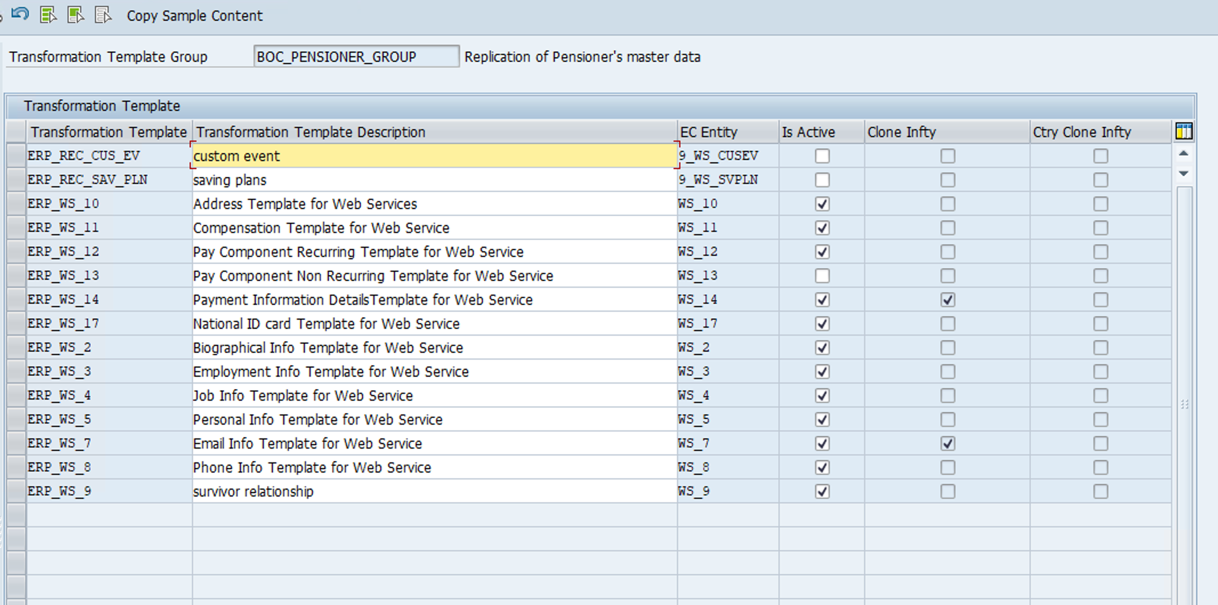
Figure 1. BOC_PENSIONER_GROUP Transformation Template Group overview.
At capture, 12 templates are checked Active: ERP_WS_10, ERP_WS_11, ERP_WS_12, ERP_WS_14, ERP_WS_17, ERP_WS_2, ERP_WS_3, ERP_WS_4, ERP_WS_5, ERP_WS_7, ERP_WS_8 and ERP_WS_9. ERP_WS_13 and ERP_REC_CUS_EV / ERP_REC_SAV_PL are unchecked. The screenshot records configuration state only.

4.2 Template Mapping Screenshots
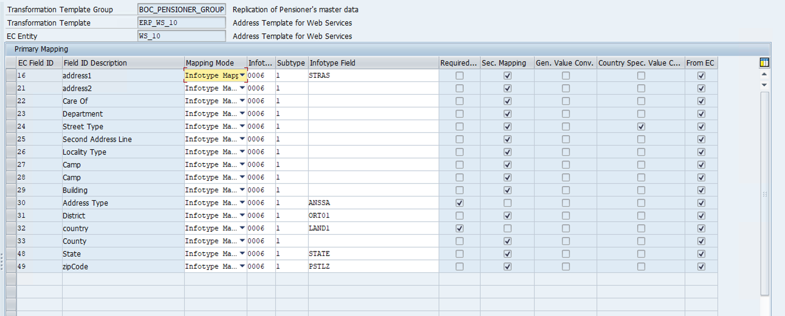
Figure 2. ERP_WS_10 Primary Mapping screen for IT0006 home address, subtype 1.
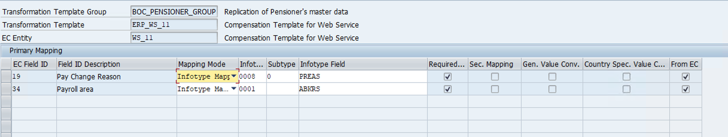
Figure 3. ERP_WS_11 Primary Mapping screen in BOC_PENSIONER_GROUP.
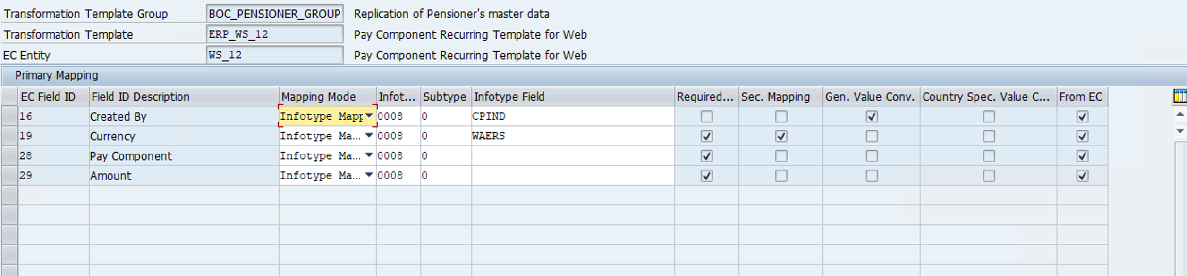
Figure 4. ERP_WS_12 Primary Mapping screen in BOC_PENSIONER_GROUP.
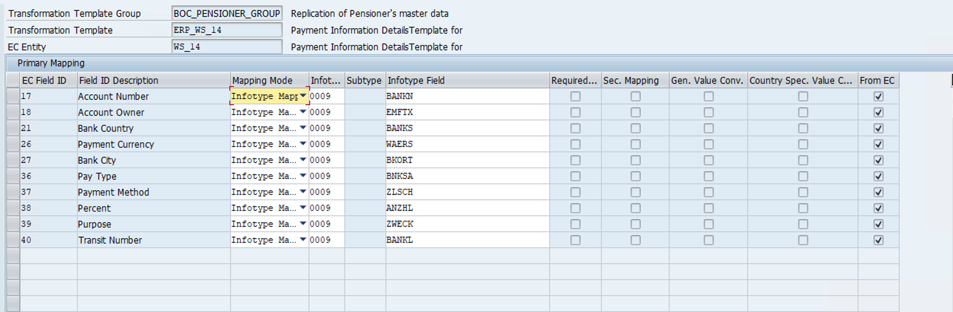
Figure 5. ERP_WS_14 Primary Mapping screen in BOC_PENSIONER_GROUP.
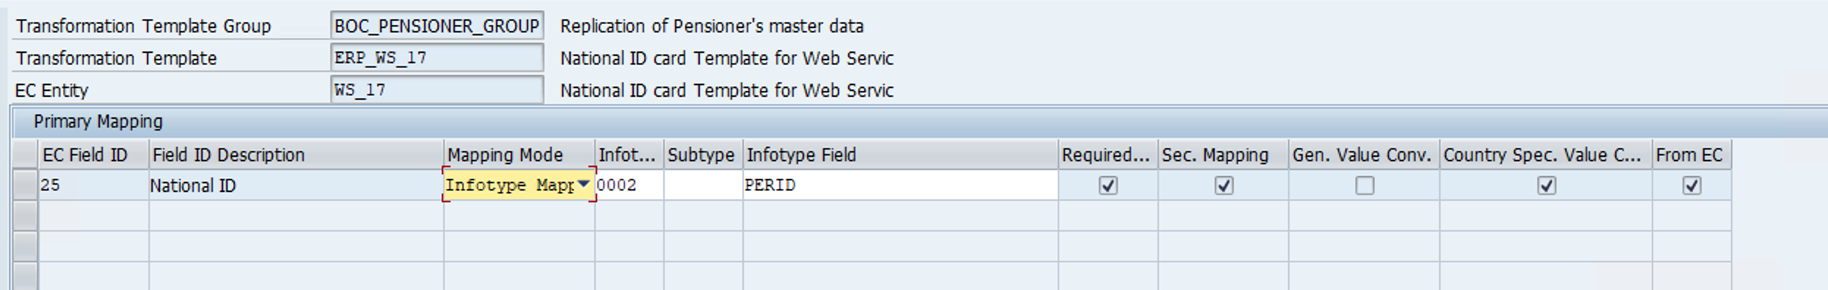
Figure 6. ERP_WS_17 Primary Mapping screen in BOC_PENSIONER_GROUP.
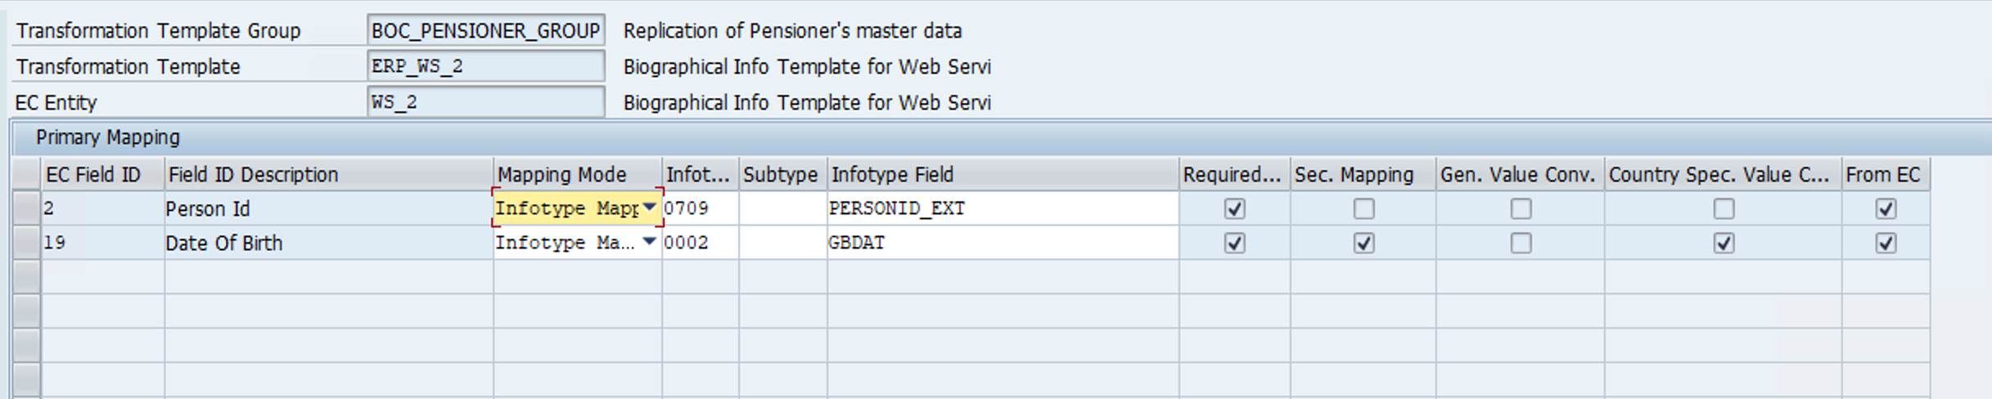
Figure 7. ERP_WS_2 Primary Mapping screen in BOC_PENSIONER_GROUP.
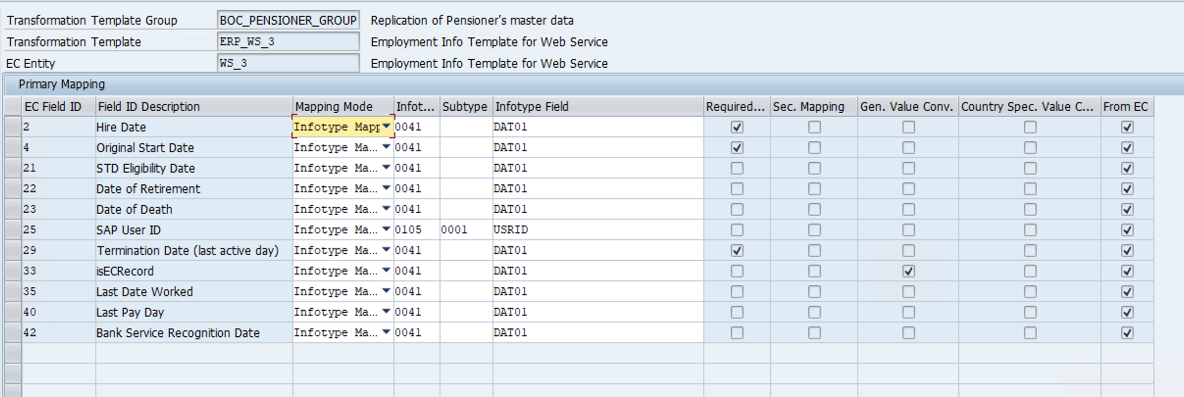
Figure 8. ERP_WS_3 Primary Mapping screen in BOC_PENSIONER_GROUP.
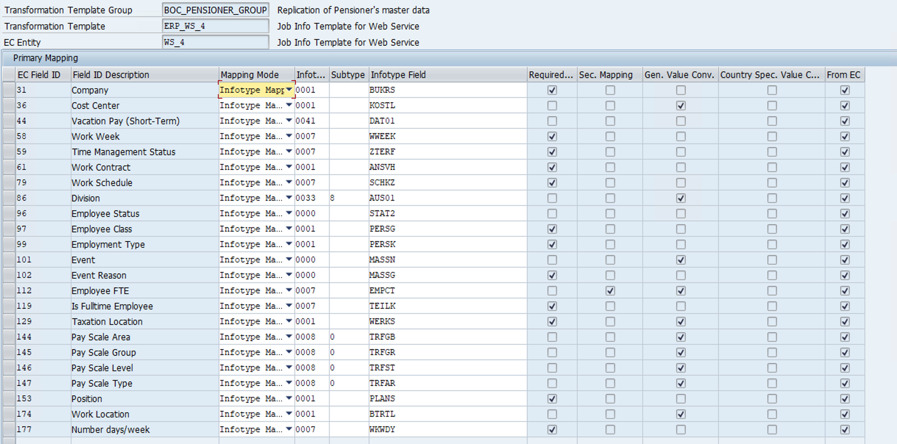
Figure 9. ERP_WS_4 Primary Mapping screen in BOC_PENSIONER_GROUP.
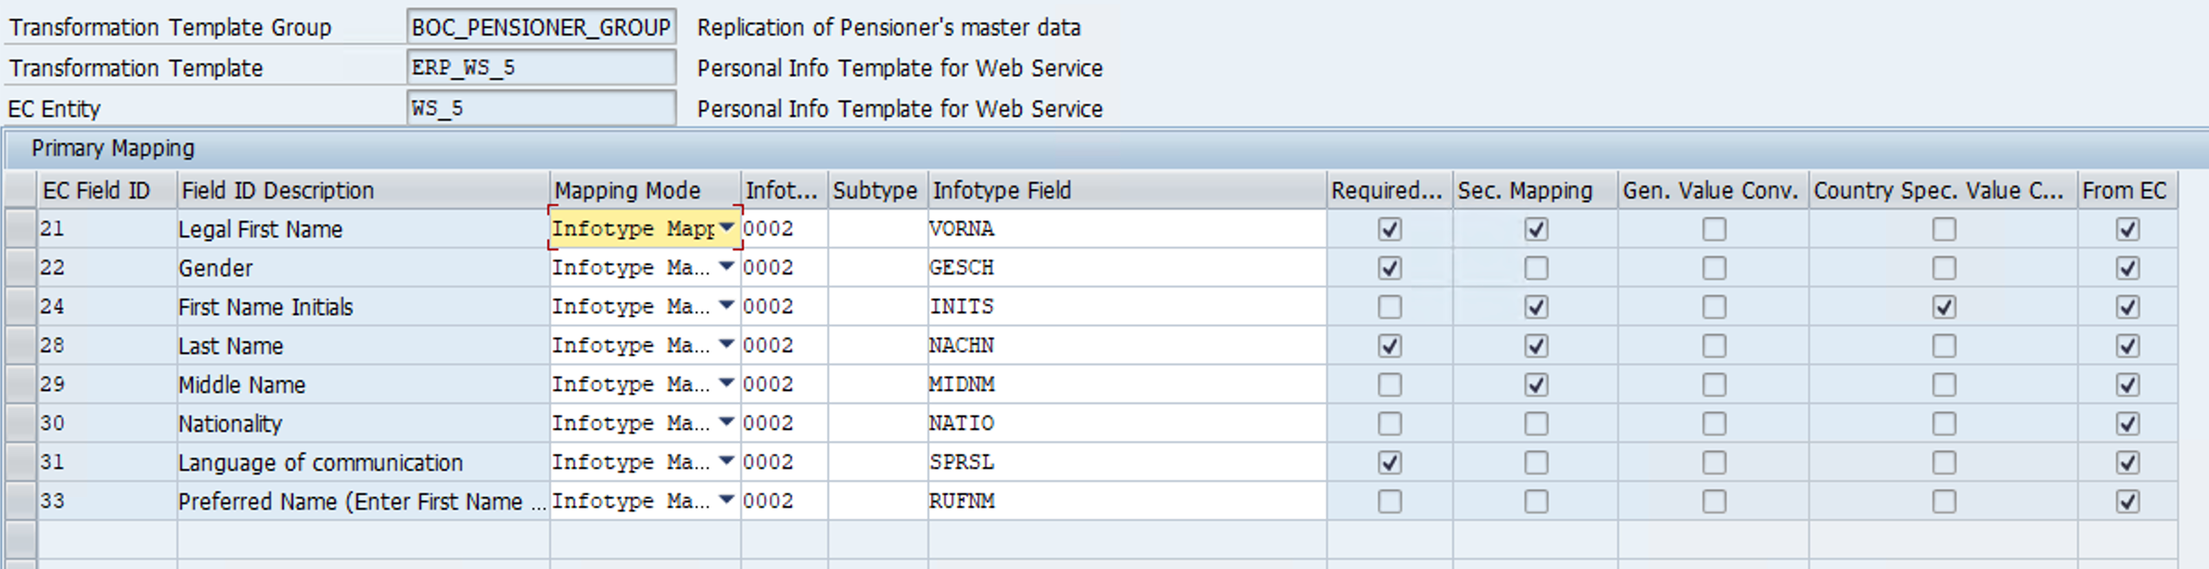
Figure 10. ERP_WS_5 Primary Mapping screen in BOC_PENSIONER_GROUP.
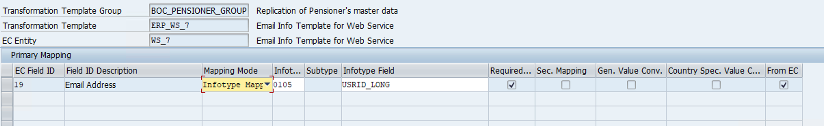
Figure 11. ERP_WS_7 Primary Mapping screen in BOC_PENSIONER_GROUP.
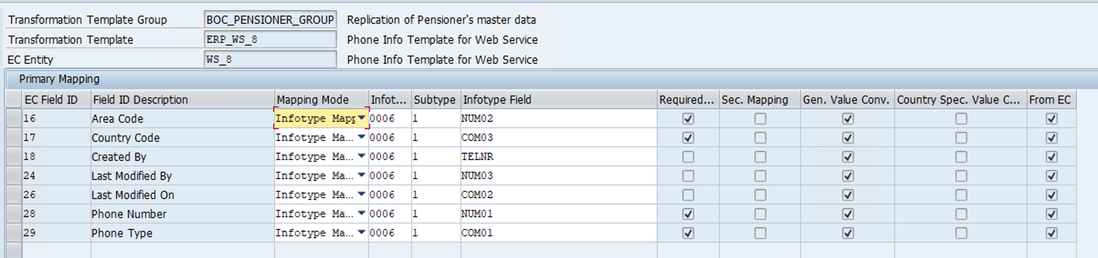
Figure 12. ERP_WS_8 Primary Mapping screen for IT0006 subtype 1 in BOC_PENSIONER_GROUP.
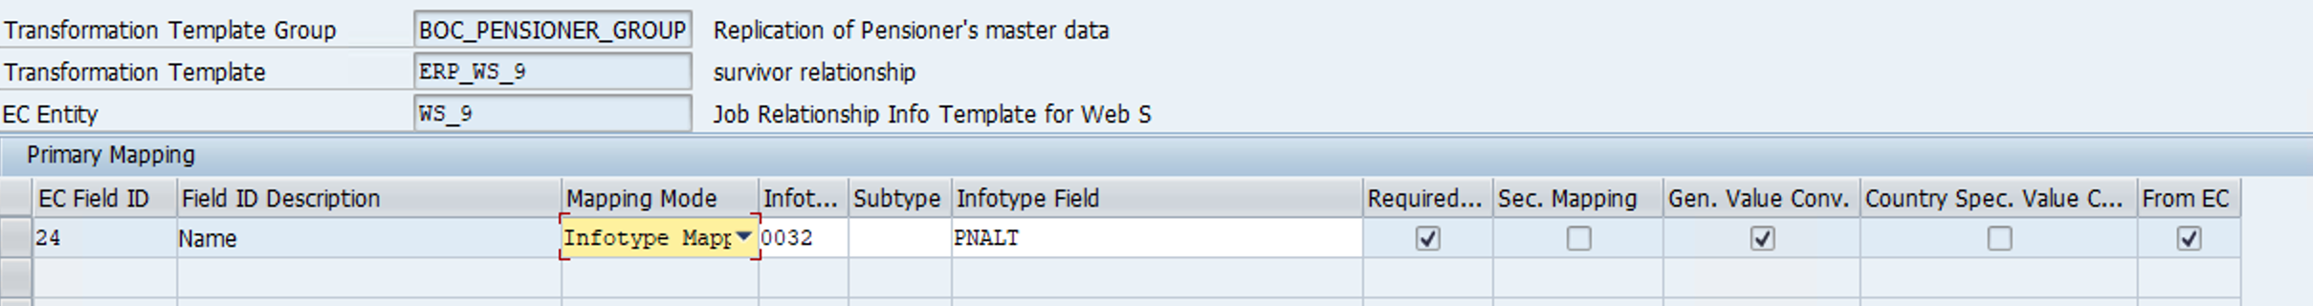
Figure 13. ERP_WS_9 Primary Mapping screen in BOC_PENSIONER_GROUP.

4.3 IT0006 Home Address Mapping
The EC → S/4HANA home-address mapping uses a common Default Mapping and records country-specific exceptions in Secondary Mapping. This is the standard IT0006 address route; the BAdI phone enrichment described in §5.3 remains a separate Canada-only behavior.
The attached mapping template covers 19 countries for address type home. Country review and S/4 required-field checks are pending for every row; production support is subject to approved configuration and end-to-end tests.
Canada (CAN) | Australia (AUS) | Austria (AUT)
Belgium (BEL) | Bermuda (BMU) | China (CHN)
Colombia (COL) | France (FRA) | Hong Kong (HKG)
India (IND) | Ireland (IRL) | Israel (ISR)
Japan (JPN) | Netherlands (NLD) | Spain (ESP)
Switzerland (CHE) | United Kingdom (GBR) | United States (USA)
Germany (DEU)
Attachment A EC_to_S4_IT0006_Home_Address_Mapping_Template.xlsx — embedded workbook snapshot; use its Default Mapping, Secondary Mapping and Countries tabs together.

4.4 IT0032 Job Relationship Template and Mapping
A new WS_9 EC entity has been added for EmpJobRelationships. It uses the Compound Employee job_relation segment, HRIS element jobRelationsInfo, and the startDate/endDate validity fields; Multiple Use and Effective Dated are selected in the shown configuration.
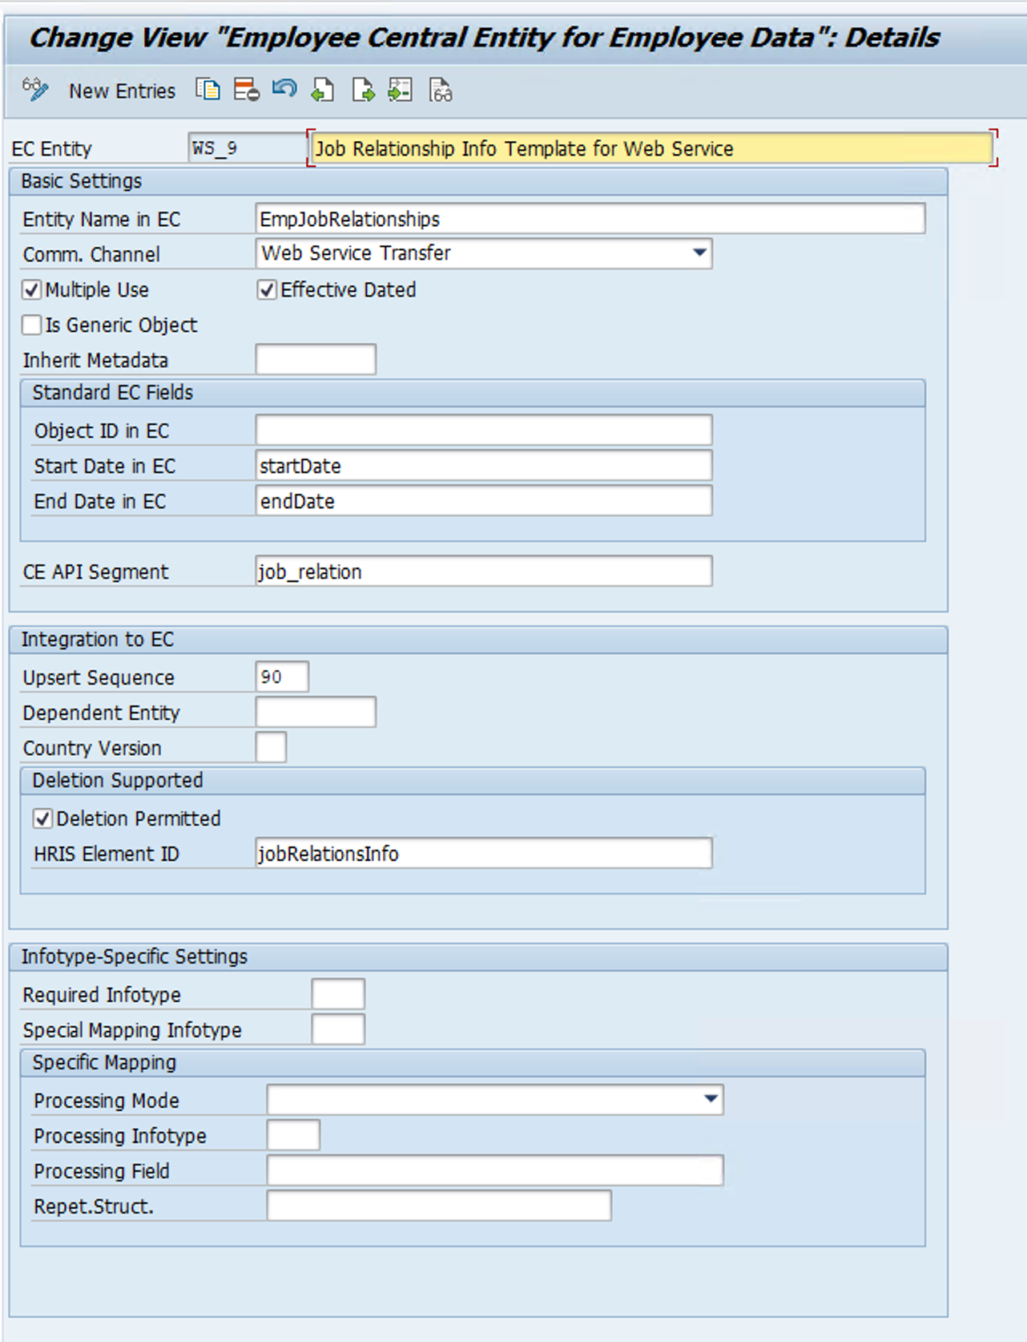
Figure 14. WS_9 EC entity configuration screen for EmpJobRelationships.
The new ERP_WS_9 template is shown in BOC_PENSIONER_GROUP. Screens show EC field ID 24 mapped to IT0032-PNALT, but label it Name in the overview and relUserId in the detailed view. Confirm the active mapping label and representative payload before treating it as the survivor link. Relationship-type selection and target-record behavior still require SAP validation.
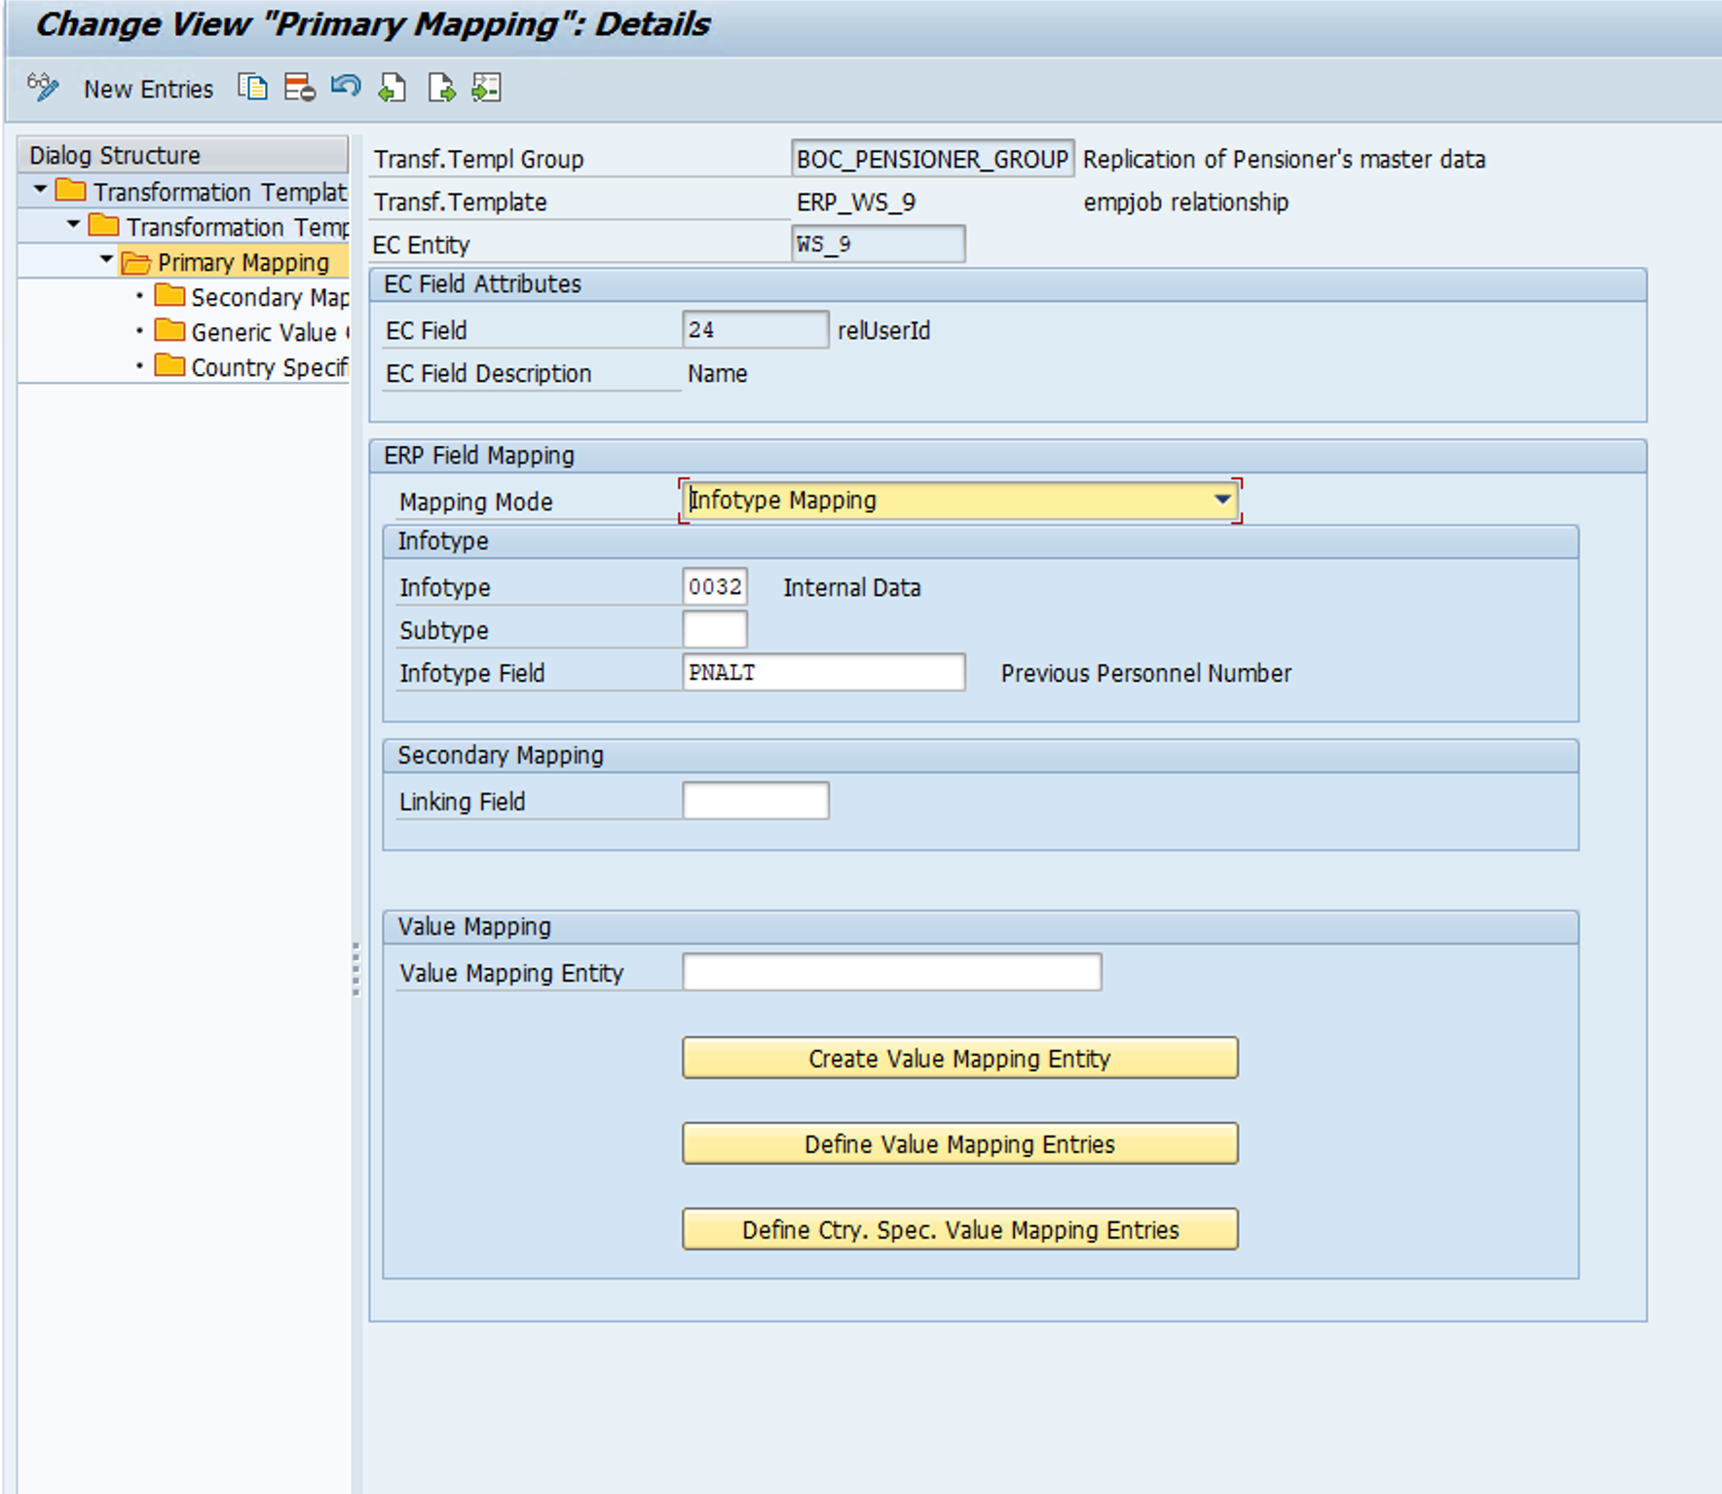
Figure 15. ERP_WS_9 detailed Primary Mapping screen for IT0032-PNALT.

5 Infotype and BAdI

5.1 BAdI Runtime Entry Point
IF_ECPAO_IN_PROCESS_INFOTYPE~PROCESS_INFOTYPE receives INFOTYPE, PERNR, EC_PAYLOAD and PNNNN_PRIMARY_TAB. The extension routes supported infotypes to their processors and passes PNNNN_PRIMARY_TAB as CHANGING PNNNN_TAB. Select Pensioner-specific behavior by the intended employment while preserving existing Active Employee dispatch and output.
Processing route | Infotypes | Design role
BAdI extension | 0000, 0001, 0002, 0006, 0007, 0008, 0009, 0017, 0019, 0033, 0041, 0105, 0171 | Retain existing handlers; add only required Pensioner behavior and verify unchanged Active Employee output.
Separate integration mapping | 0032 | New WS_9 / ERP_WS_9 mapping to IT0032-PNALT; verify filtering and runtime result.
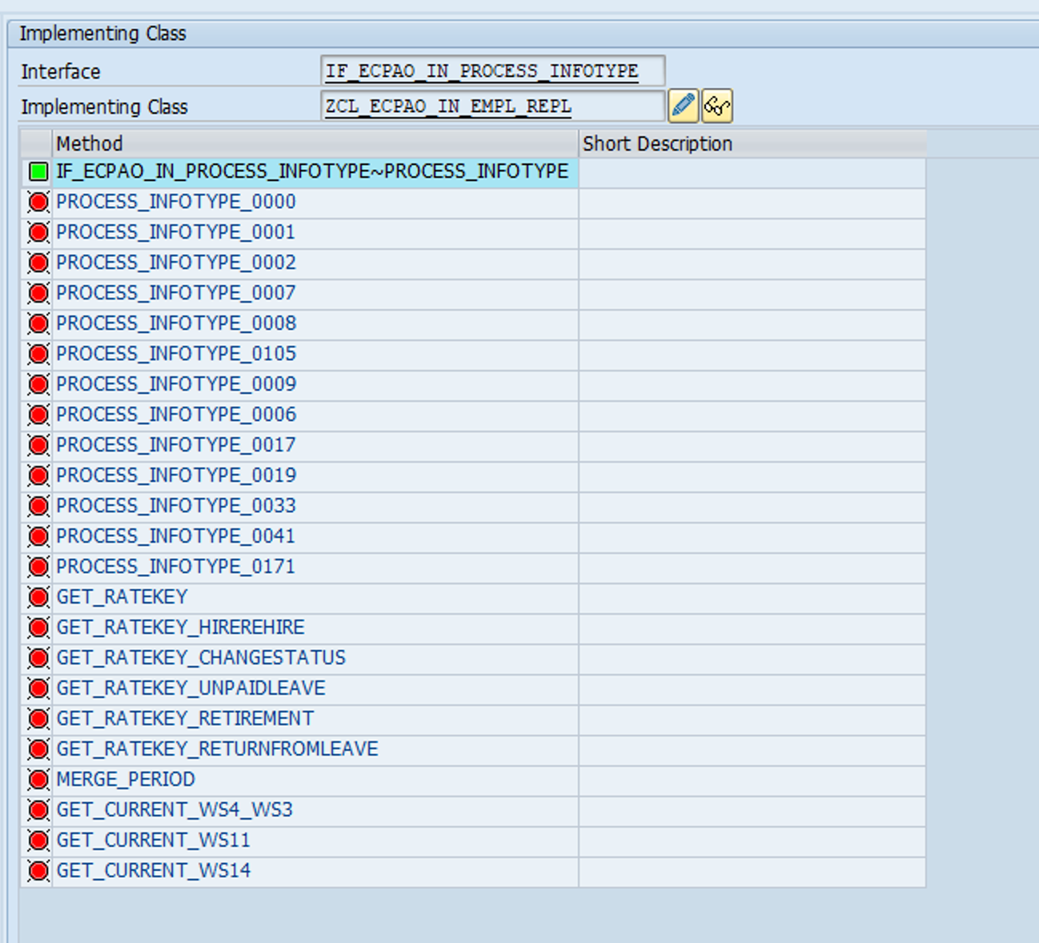
Figure 16. BIB extension class method inventory. The screenshot shows the implementing class and its infotype and selector methods; activation and runtime remain unverified.

5.2 Employee Payload Selection
GET_CURRENT_* selects employee-scoped payload nodes; it does not choose the latest effective-dated row. Direct selectors match WS3 userId to PERNR and link child nodes by parent_node_number. Validate identity mapping and date handling for each PERNR.
Selector | Hierarchy | Selection use
GET_CURRENT_WS4_WS3 | WS3 → WS4 | May resolve PERNR through ECPAO_EE_KMAP. Used by 0000, 0001, 0007, 0008, 0017, 0019, 0033, 0105 and 0171.
GET_CURRENT_WS11 | WS3 → WS11 | Direct WS3 userId = PERNR; used by IT0008.
GET_CURRENT_WS14 | WS3 → WS14 | Direct WS3 userId = PERNR; used by IT0009. Validate parent topology in the target payload.
For a person with Pensioner and Active Employee PERNRs, an EC userId that differs from the target PERNR may work through the WS4/WS3 key map but fail in direct selectors. Validate both identity paths and the runtime node hierarchy for each employment.

5.3 Infotype Processing Contracts
Infotype | Processing rule | Validation boundary
IT0008 | Uses employee-scoped WS11 and WS4 data to adjust Basic Pay fields and wage types while preserving each incoming record and its effective dates. | Confirm PERNR isolation, wage-type and currency results, and payroll amounts. Correct overlapping source periods in EC.
IT0009 | Uses the last date-overlapping WS14 node; routingNumber looks up BNKA-ORT01 by BANKL, then fills BKORT. | Confirm WS14 parent topology and multi-bank selection in SAP.
IT0105 | Uses WS3 customString2 for USRTY 0001. For email, an incoming 0010 base row triggers WS7 processing; only nonblank isPrimary = TRUE email is written to subtype/USRTY 0010. Incoming 0030 is dropped. | WS7 is read directly, without employee filtering. No 0010 base row means no email output. Verify invocation scope and missing-primary behavior.
IT0006 | The BAdI reads WS8 and processes phone nodes only when countryCode = CAN; PHONE_TYPE is mapped through ECPAO_VALUE_MAP. Standard home-address fields use the mapping in §4.3. | Validate the Canada phone path and PHONE_TYPE value mapping. Home-address mapping is specified separately in §4.3.

5.4 Other Infotypes
The extension uses the WS4/WS3 employee selector for 0000, 0001, 0007, 0017, 0019, 0033 and 0171. IT0002 and IT0006 read direct payload nodes. Confirm IT0041 processing in SAP against the approved mapping.

5.5 SAP Configuration Dependencies
Area | Design position and verification
IT0009 bank data | Validate WS14 parent topology, date overlap and bank-key lookup for Pensioner records.
IT0006 phone BAdI | Validate Canada-only phone handling and PHONE_TYPE mapping through ECPAO_VALUE_MAP. Home-address country mapping is specified in §4.3.
Employee identity | Validate PERNR and EC userId linkage for each Pensioner and Active Employee employment.
PART III
Verification and Delivery

6 Verification and acceptance
Capture the existing Active Employee baseline before Phase 2 changes. SAP-side verification must compare that baseline with post-change results and cover each selected Pensioner scenario. Retain syntax and activation logs, BIB staging evidence, debugger node numbers, infotype viewer results and payroll validation as applicable.
Test area | Minimum case | Acceptance evidence
Activation and routing | Activate in-scope Pensioner processing and trace both Template Group and BAdI routes. | No syntax error; existing Active Employee routing and enhancement behavior remain unchanged.
Employee isolation | Two employees and a dual-PERNR person; exercise each in-scope WS3/child selector. | Each infotype receives only its intended employment; direct-ID and key-map paths tested separately.
IT0008 | Representative Basic Pay records covering employee selection, wage types, currency and effective dates. | All incoming rows and dates are preserved; amounts and wage types match approved payroll examples.
Survivor IT0032 | WS_9 / ERP_WS_9, field ID 24 → PNALT; reconcile the Name / relUserId labels. Include an intended relationship and a non-target relationship. | Correct IT0032 predecessor link; approved relationship selection; source payload and SAP record agree.
IT0009 / IT0105 / IT0006 | Multi-bank; primary/non-primary email with and without 0010 base; Canada phone mapping. | WS14 and WS7 scope proven; only primary 0010 email; Canada phone result matches approved value mapping.
IT0006 home address | Representative home-address records from the 19-country template, including a country with Secondary Mapping and one using the default. | Each tested country writes the approved IT0006 fields and required values; country review and SAP output are recorded.
Active Employee non-regression | Replay representative existing Active Employee payloads before and after Phase 2; check infotype and job paths. | Business fields, subtypes, dates, errors and operating controls match the approved baseline.
Pensioner end to end | Existing Pensioner, retirement transition, Survivor and rehire. | EC/CPI/BIB/SAP records and logs agree; BOC business and payroll validation complete.

7 Operations and data transition

7.1 Scheduling and monitoring
Use the same CPI integration, SOA Manager service and monitoring framework for both populations, with separate Active Employee and Pensioner background jobs. Keep the existing Active Employee job schedule and operating controls unchanged. Confirm the five-minute Pensioner processing frequency and the ability to pause its job independently.

7.2 FTSD, conversion and rollback
Approve Production FTSD, the existing-Pensioner conversion Action Type, Action Reason and effective date against the selected multi-PERNR employment model and payroll cutover period. For a critical Pensioner issue, pause the Pensioner job, correct and reprocess affected records, validate, then resume without stopping Active Employee replication.

8 Open decisions
ID | Decision
D01 | Pensioner and Active Employee isolation for a person with multiple PERNRs
D02 | IT0006 home-address country approval
D03 | Employee identity and payload topology
D04 | Production FTSD and SAP component support
D05 | Conversion Action Type, Action Reason and effective date
D06 | Pensioner deployment and operating state
D07 | Active Employee baseline to retain
D08 | IT0032 source field and relationship selection

