

Title Title Title Title

**Thesis / Bachelor Project / Structured Literature Review**

Submitted in partial fulfillment of the degree of

**Bachelor of Science**

**in International Business Information Systems**

at the Faculty Business Information Systems

of the Furtwangen University of Applied Sciences

submitted by the author

**First Name Family Name**

First supervisor: Prof. Dr. …….

Second supervisor: Prof. Dr. ........

Summer semester 2020

Submitted on: 26. Dezember 2023

Affirmation in lieu of an oath

I assure that I have written the above work independently and have not used any other aids for this purpose than those indicated. All passages of the work that have been taken literally or analogously from external sources are marked as such.

The paper has not been submitted in the same or similar form as an examination paper in any other course of study or published elsewhere.

I am aware that a false declaration can have legal consequences.

Place, Date Signature

Furtwangen, den 26. Dezember 2023 Name of the author

# Abstract

The abstract of a thesis is an overview of the essential content or a kind of management summary – usually presented on one page.

The abstract introduces briefly the problem statement, the task definition, the goal of the thesis, method of research or solution development, key findings, the usefulness of the findings or solution and the feasibility of the results.

*Guideline to formatting:*

***To update the directories such as the table of contents, the table of figures or the table of tables, right-click in the directories and select "Update field".***

*By inserting the title and the name of the author on the cover page, the remaining fields will be filled in automatically as these are document properties.*

***To start a new chapter, insert a section break on an odd page. This also adjusts the headers accordingly.***

*Never format using the Enter key. There are format templates for everything.*

***The bibliography is maintained in the ribbon "References" under "Manage sources". The format template for the output corresponds to "ISO 690 - First element and date". With "Insert Citation" you can insert the corresponding source reference into the document, if necessary also as a footnote.***

***Pictures and tables are provided with the corresponding caption below. Never build by hand, but always using the Word mechanisms: Right click on the element - "Insert caption". Otherwise, errors can easily occur.***

*The basic rule is: Do not format, but write! Concentrate on what you want to write. You can format at the end if you still have time. Most of it should work by itself with this template.*

*This template is designed for double-sided printing. But you can change it to single-sided printing by changing the headers to "Odd pages" via "Page setup".*

*It is usually very useful to have the help characters for spaces, tab stop and line break activated. As long as you are still writing, it is advisable to switch off justification in order to get a better orientation (Source: Gabriele Hecker (2010) – Formatvorlage zur Thesis).*

# Table of contents

Abstract 4

Table of contents V

List of figures VII

List of tables IX

1 Problem statement and task definition 1

2 Goals of the thesis 2

3 Problem analysis und requirements 3

4 Scope of Solution 4

5 Usefulness and feasibility of the results 5

6 Solution, approach and methods 7

7 Instruments 9

8 Work plan and timetable 10

8.1 Workplan 10

8.2 Timetable 11

9 Risk analysis 13

10 Structure of the thesis 15

11 Results and discussion 16

12 Conclusion and outlook 17

13 Bibliography and references 18

14 Glossary 19

15 Annex 20

# List of figures

Figure 1: Requirements from problem analysis 3

Figure 2: Research plan for the thesis 7

Figure 3: Work plan in form of a Scrum Board 10

Figure 4: Timetable of the thesis 11

Figure 6: Risk matrix to assess project risks 13

# List of tables

Table 1: Overview of potential project risks 13

# Problem statement and task definition

The problem statement features your cognitive interest – can be in form of an introduction of a given problem or task at a company the author might cooperate with or in form of a hypothesis. In both cases the problem statement should be structured and described in detail.

*Example:*

*In many studies the optimization potential of the real-time bidding process is being investigated. Consumer acceptance and relevance are playing an increasingly important role, especially with regard to personalised and targeted advertising. A study on personalised advertising finds that the perceived relevance of personalised advertising is clearly negatively related to the perception of the user's privacy. However, the authors also find that awareness has a positive effect on the consumer's further intentions of use.[1]*

*But how does the consumer reaction express itself when the consumer is fully aware and specifically advertised for a preferred product? This results in a gap that forms the basis for the problem - and question of this thesis. How does reality look like in relation to the programmatic advertising circuit and how does real-time bidding and retargeting contribute to the success of advertising in terms of frequency, conversion and other metrics? How effective are real-time bidding and retargeting and what impression is made on the consumer?*

# Goals of the thesis

Which goal should the thesis achieve? The targeted goals should be clearly and bindingly defined with one ore two sentences. What is the goal of the company you are working with on the topic? Why does the company want to tackle this problem? How/for what purpose does the company want to use and process the results of the thesis?

*Example:*

*The goal of this thesis is to explain the versatile systematics of Programmatic Advertising to interested parties, including the procedure of real-time bidding and to create clarity between the involved technologies, platforms and their actors.*

*Furthermore, an additional core motif is to explore the consumer reaction to targeted advertising for an individually preferred product. The investigation is to be carried out in two parts. In the first part, the respondent will conduct an experiment to find out how effective the targeted advertising placement works by retargeting in real-time bidding. In a second part, a questionnaire will be filled out parallel to the experiment, in which the advertising campaign will be evaluated for acceptance and relevance based on the observation of the respondent.*

# Problem analysis und requirements

What requirements result from the analysis of the problem? What must be delivered? What does the company need, when, for what and why?

*Example:*

*A detailed analysis of the problem results in the following requirements, which symbolize the core achievement of the thesis. The requirements are expressed in the creation of a carefully and extensively documented experiment as well as a meaningful and insightful empirical study, which is to be carried out by collecting primary data in the form of a survey. For this purpose a test survey has to be created and tested on test persons for usability, feasibility and time expenditure. Based on the feedback of the test persons on the experiment of the test questions and the scope of the survey, the final survey is created, which is to form the core of the thesis. For this purpose, a cluster analysis is used to check the connection between the concrete questions and the results. Thus the concrete requirements result from a literature research, the preparation of the experiment and the questionnaire,* *the test and examination phase …*

Figure 1: Requirements from problem analysis

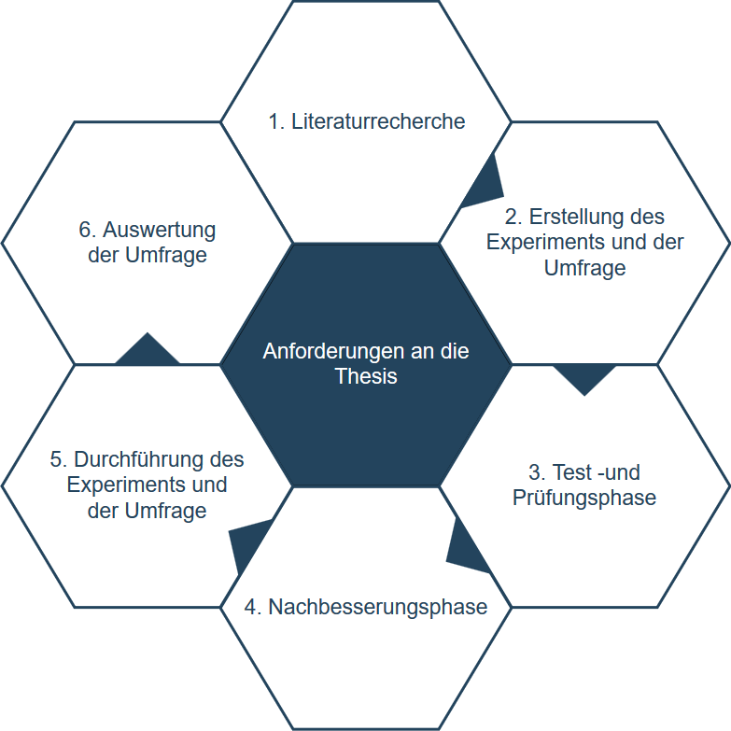

Source: Pavel Schastov (author) – own illustration

# Scope of Solution

Does the thesis pursue the goal of providing new insights, for example through a market analysis? Or do you intend, beyond that, e.g. recommendations, concepts, strategies, or to provide concrete instructions or to implement or test certain measures? Which minimum and maximum/ideal goals do you intend to achieve with the thesis (depending on how well the project progresses and if resources are still available)?

*Example:*

*The thesis pursues the goal of delivering concrete results on targeted advertising by means of an experiment with parallel questioning. Accordingly, the results are based on the collection of primary data.*

*As a minimum goal, at least one tendency should arise from the evaluation of less relevant data sets than expected for targeted advertising.*

*The maximum goal is that the experiment reaches more respondents than initially expected and thus provides a more accurate result.*

*In addition, more important characteristics of display advertising in connection with conversion should be found out. These include the frequency, tolerance and acceptance and benefit of the advertising.*

# Usefulness and feasibility of the results

What decisions or actions can or will the company take on the basis of the knowledge and findings you gain? What is the corporate relevance of the results? What do you need to consider to ensure that your thesis has the highest possible value? How do you check whether your findings and recommendations are valid and feasible? What do you need to consider for the optimal utilization of your recommendations and solutions?

*Example:*

*Since the thesis is not written in cooperation with a company, but is written within the university and in the student's own interest, there is no relevance to the company's results. The implementation of the thesis is done purely out of self-interest in the programmatic advertising and the preparation for a potential job.*

*In order to maximize the personal benefit, it is assumed that the ecosystem of programmatic advertising is understood and correctly understood. Furthermore, the experiment and the survey should prove and validate the efficiency of the real-time bidding and retargeting process. A further aspect is the determination of the acceptance and relevance of the display advertising.*

# Solution, approach and methods

Present your solution in a graphic as well as in an explanatory text. Describe your procedure or research model in its individual phases. Describe the methods used. Why is one method used for the problem definition and not another? In the case of your own empirical primary surveys, define in particular

* **Research plan** (data source, survey method, survey instruments etc.)
* **Sampling plan** (population, sample size and selection procedure)

*Example:*

*Students of the HFU are intended as a data source or research unit through an experiment with parallel survey.*

*The survey aims at a population of 200 subjects of which 150 completed responses are expected as sample size.*

*In the following figure the individual phases of the research plan of the thesis are defined. It contains three phases, which describe the procedure of the research project and its main points ...*

Figure 2: Research plan for the thesis

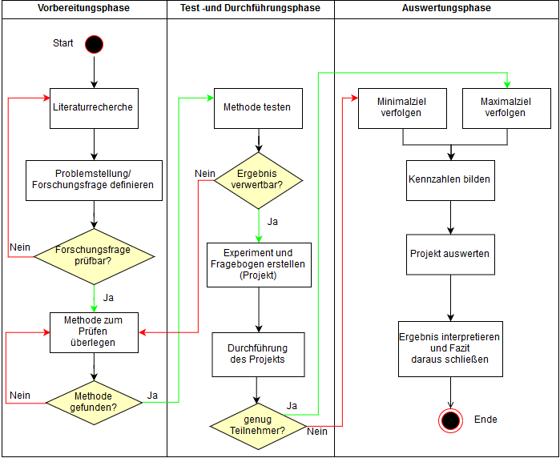 Source: Pavel Schastov (author) – own illustration

# Instruments

If necessary, briefly introduce the tools used for data collection/evaluation:

* Analysis tools (e.g. SPSS and the analyses and tests used therein),
* Online survey tools (e.g. Limesurvey.org).

*Example:*

*The preparation of the questionnaire for the fulfilment of the empirical study is carried out with the online tool of the Swiss enuvo GmbH from their website https://www.umfrageonline.com/. This company offers students a free, individual question catalogue with a large number of freely selectable functions by providing a university e-mail address. The collection of primary data can be exported in various file formats such as pdf, png, csv or as xlsx file. For this purpose, the manufacturers offer an additional integrated evaluation function of the specially created surveys, which are also displayed graphically. In addition, integrated interfaces allow the results to be exported and analyzed in other statistical software such as IBM SPSS Statistics. The analysis of the entire answers takes place without delay in real time and thus guarantees an optimal evaluation down to the participant level.*

# Work plan and timetable

Introduce individual work items – such as a To Do list, sequences in chronological order, scheduling with deadlines and buffers!

*Example:*

*In the following subchapters the work and time schedule is presented and explained in more detail. These are strongly oriented on methods of software development, but can be used effectively in a specially adapted version for planning, controlling and writing theses.*

## Workplan

Figure 3: Work plan in form of a Scrum Board

*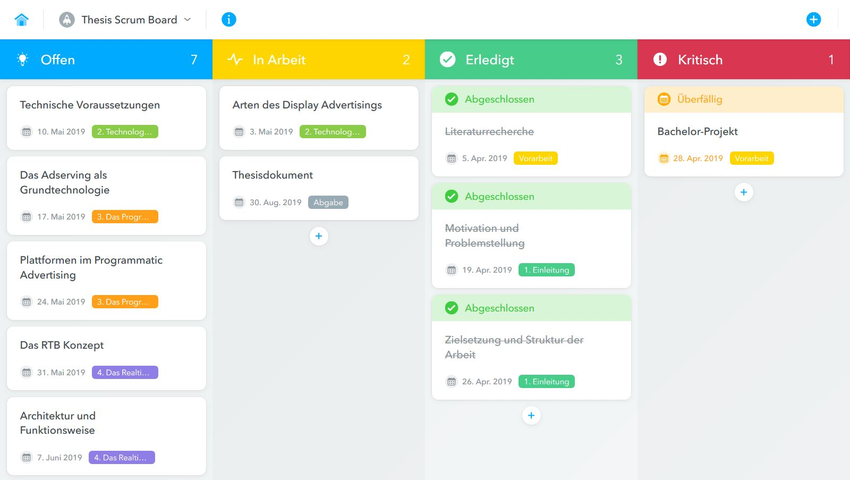The listed work plan is divided into individual work packages, which are processed under specification of a deadline. The work packages can be moved into a total of four possible columns according to their progress. As soon as a work package has not been moved to the "Completed" area under the previously defined deadline, it is automatically marked "Overdue" and processed with priority under the "Critical" column. This procedure guarantees that the entire schedule is not jeopardized.*

Source: Pavel Schastov (author) – own display of a Scrum Board

## Timetable

Source: Pavel Schastov (author) – own table

Figure 4: Timetable of the thesis

*The work plan is derived directly from the time schedule, where it is clearly shown when what has to be done in which time period. The milestones result from the respective main chapter headings of the thesis. The subchapters represent the work packages and are processed step by step according to the principle of a Scrum Taskboard. In this presentation, the presentation of the thesis and the oral exam were specifically disregarded, as there are no deadlines for this yet.*

# Risk analysis

The risk analysis deals with the probability of occurrence of obstacles, complications and damages as well as the extent of possible damage, the measures to prevent damage and complications.

Example:

Table 1: Overview of potential project risks

|  |  |  |  |  |  |  |
| --- | --- | --- | --- | --- | --- | --- |
| **Risikoliste** | | | | | | |
| **Number** | **Affected person** | **Description oft he risk** | **Probability of occurence (1-5)** | **Level of damage** | **Treatment** | **Avoidance** |
| 1 | Author of thesis | Writer’s block | 3 | High | Conversation with supervisor | Not avoidable |
| 2 |  |  |  |  |  |  |

Source: Pavel Schastov (author) - own display

Figure 6: Risk matrix to assess project risks

|  |  |  |  |  |
| --- | --- | --- | --- | --- |
|  | **Risikomatrix** | | |  |
| Probability of occurrence |  |  |  |  |
| 5 |  |  |  |  |
| 4 |  |  | 2 |  |
| 3 |  | 6 | 1 |  |
| 2 |  | 3 | 5 |  |
| 1 | 7 | 4 |  |  |
|  | Low | Medium | High | Extent of damage |

|  |  |
| --- | --- |
|  | Acceptable risk area |
|  |  |
|  | Increased risk area |
|  |  |
|  | Inacceptable risk area |

Source: Pavel Schastov (author) - own display

*Example:*

*The list of risks at the beginning provides an insight into the risks that could delay or even prevent the completion of the thesis. These are shown in the risk matrix in varying degrees of damage and probability of occurrence in order to be prepared for possible risks at an early stage. The probability of occurrence is represented in numerical numbers from one to five and the extent of damage can be estimated in three increasing damage levels from low to high.*

# Structure of the thesis

The structure of a thesis can vary according to the specific topic of the given thesis. A thesis can be structured for example according to the phases of empirical research.

*Example:*

Phase 1: The conceptual phase

* Problem definition statement
* Review of related literature
* Conducting empirical fieldwork
* Definition of the conceptual framework
* Formulation of hypothesis

Phase 2: The design and planning phase

* Selection of appropriate research design
* Development of intervention protocols
* Identification of the population (or main research object)
* Design of the sampling plan
* Specification of methods to measure research variables
* Final, detailed definition of the research plan

Phase 3: The empirical phase

* Collection of data
* Preparation of data for analysis

Phase 4: The analytical phase

* Analysis of data
* Interpretation of the results
* Conclusions for the solution of the problem

Phase 5: The dissemination phase

* Communication of the findings
* Application of the findings in practice

Example:

Figure 5: Phasen im Rahmen einer empirischen Forschung



Source: Bortz, Jürgen (1999): Statistik für Sozialwissenschaftler, p. 3

# Results and discussion

The key findings are introduced and explained. The results are interpreted and discussed. Discussion means the author compares his results with results of similar research works of other authors.

# Conclusion and outlook

Based in his/her findings the author drives conclusions for the solution of the given problem or/and introduces also limitations of his/her work, provides an outlook and suggest future research that remains to be conducted. The author communicates the findings to the stakeholders of his/her research and applies (if possible) his findings in practice to evaluate the usefulness of his/her findings and/or approach of solution.

# Bibliography and references

*Dialogmarketing Perspektiven 2011. Tagungsband 6. wissenschaftlicher interdisziplinärer Kongress für Dialogmarketing,* 2012. Wiesbaden: Gabler Verlag. ISBN 978-3-8349-3524-3.

*Proceedings of 2014 IEEE International Conference on Service Operations and Logistics, and Informatics,* 8. Oktober 2014 - 10. Oktober 2014: IEEE. ISBN 978-1-4799-6058-3.

Abel, R., M. Altendorf, N. Andersen, C. Bauer, B. Castan, H. Dietrich, F. Eickmeier, S. Fittkau, A.-K. Harms, P. Hansmersmann, B. Henning, M. Hollerbach, C.M. Laase, T. Mendrina, E. Naujok, F. Runge, A. Schmitt und D. Reisig, 2011. *Online Targeting und Controlling. Grundlagen - Anwendungsfelder - Praxisbeispiele.* Wiesbaden: Betriebswirtschaftlicher Verlag Gabler. ISBN 978-3-8349-2589-3.

Aksakallı, V., 2012. Optimizing direct response in Internet display advertising [online]. *Electronic Commerce Research and Applications*, **11**(3), 229-240. ISSN 15674223. Verfügbar unter: doi:10.1016/j.elerap.2011.11.002

Busch, O., Hg., 2014. *Realtime Advertising. Digitales marketing in echtzeit: strategien, konzepte und perspektiven.* Wiesbaden, Germany: Springer Gabler. ISBN 978-3-658-05357-4.

Busch, O., 2015. *Programmatic advertising. The successful transformation to automated, data-driven marketing in realtime* [Online]. Cham: Springer International Publishing. Management for professionals. ISBN 978-3-319-25023-6, Verfügbar unter: http://​gbv.eblib.com​/​patron/​FullRecord.aspx​?​p=​4179390

Cai, H., K. Ren, W. Zhang, K. Malialis, J. Wang, Y. Yu und D. Guo, 2017: Real-Time Bidding by Reinforcement Learning in Display Advertising. In: M. de Rijke, M. Shokouhi, A. Tomkins und M. Zhang, Hg. *Proceedings of the Tenth ACM International Conference on Web Search and Data Mining - WSDM '17.* New York, New York, USA: ACM Press, S. 661-670. ISBN 9781450346757.

Eisinger, T., L. Rabe und W. Thomas, Hg., 2009. *Performance Marketing - erfolgsbasiertes Online-Marketing. Mehr Umsatz im Internet mit Suchmaschinen, Bannern, E-Mails & Co* [Online]. 3., überarbeitete und erweiterte Auflage. Göttingen: BusinessVillage. ISBN 978-3-86980-008-0, Verfügbar unter: http://​www.wiso-net.de​/​document/​BUVI,​ABUV__​9783869800080372

Kamps, I. und D. Schetter, 2018. *Performance Marketing. Der Wegweiser zu einem mess- und steuerbaren Marketing - Einführung in Instrumente, Methoden und Technik.* Wiesbaden: Springer Gabler. ISBN 978-3-658-18452-0.

Meier, A. und D. Zumstein, 2013. *Web Analytics & Web Controlling. Webbasierte Business Intelligence zur Erfolgssicherung.* Heidelberg [Germany]: TDWI Europe; Dpunkt.verlag. ISBN 9783898648356.

Qin, R., Y. Yuan und F.-Y. Wang, 2017. Improving Auction Mechanisms for Online Real-Time Bidding Advertising with a Two-stage Resale Model * *This work is partially supported by NSFC (71472174, 71232006, 61533019, 61233001, 71402178) [online]. *IFAC-PapersOnLine*, **50**(1), 13575-13580. ISSN 24058963. Verfügbar unter: doi:10.1016/j.ifacol.2017.08.2372

# Glossary

**Ad Exchange**

An ad exchange is a platform on which website operators and advertising companies can make new contacts for marketing purposes

**Ad Network**

Ad Networks connect advertisers to websites that want to serve ads. The ad network determines which ad to send when a user visits a website in order to increase the number of ads that users actually click.

**Ad Server**

An ad server is responsible for user tracking as well as delivery and administration of online advertising. It is also responsible for securing ad clicks and ad impressions.

# Annex

1. See/compare: Zhu und Chang (2016): The key role of relevance in personalized advertisement: Examining its impact on perceptions of privacy invasion, self-awareness, and continuous use intentions , S. 446.