# 报表2.0版

1. 24小时实时在线

# 

1. 实时充值

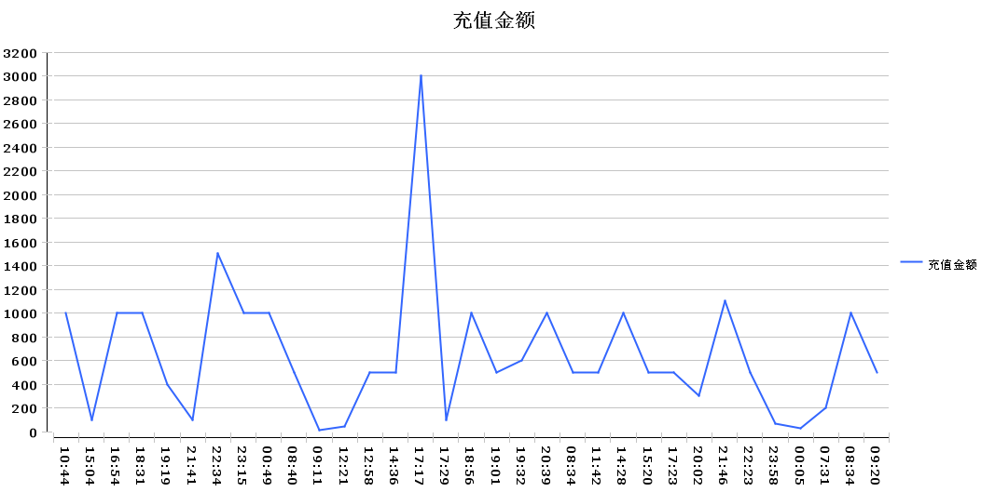

1. 每日充值

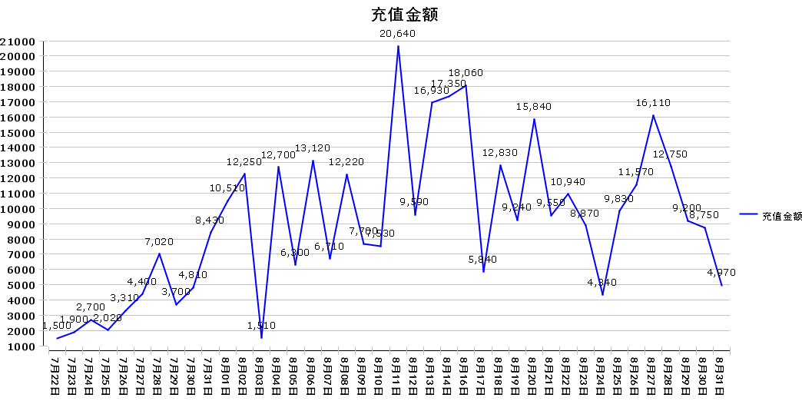

1. 每日充值人数

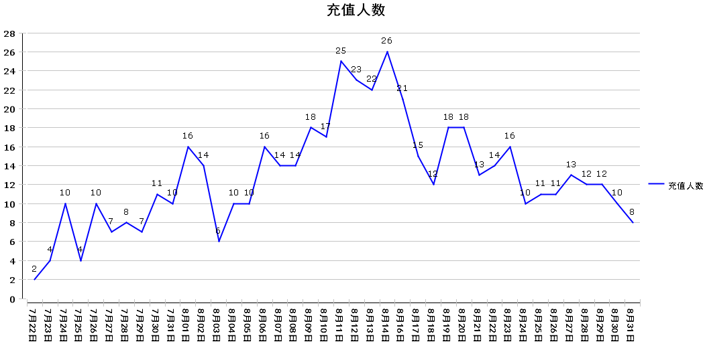

5.玩家充值统计

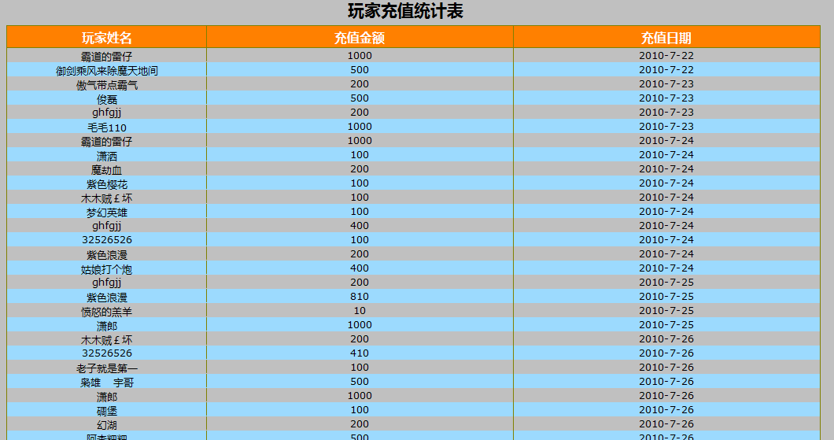

* + [24小时在线玩家实时统计](http://backstage1.astd.cn:8080/GameGateway/frameset?__report=manager/report/Player24Online.rptdesign)
  + [24小时在线创建统计](http://backstage1.astd.cn:8080/GameGateway/frameset?__report=manager/report/Player24create.rptdesign)
  + [每日平均在线人数统计](http://backstage1.astd.cn:8080/GameGateway/frameset?__report=manager/report/PlayerAvgDayOnline.rptdesign)
  + [新手流失统计(10级以内)](http://backstage1.astd.cn:8080/GameGateway/frameset?__report=manager/report/NewPlayerRunoff.rptdesign)
  + [新手流失等级分布(10级以内)](http://backstage1.astd.cn:8080/GameGateway/frameset?__report=manager/report/newPlayerRunoffLevelRange.rptdesign)
  + [一般流失统计(10级以上)](http://backstage1.astd.cn:8080/GameGateway/frameset?__report=manager/report/commPlayerRunoff.rptdesign)
  + [老玩家流失统计(50级以上)](http://backstage1.astd.cn:8080/GameGateway/frameset?__report=manager/report/oldPlayerRunoff.rptdesign)
  + [活跃玩家统计](http://backstage1.astd.cn:8080/GameGateway/frameset?__report=manager/report/activeLevelRange.rptdesign)
  + [每日登录数统计](http://backstage1.astd.cn:8080/GameGateway/frameset?__report=manager/report/loginNumberOnline.rptdesign)
  + [后台接口调用统计](http://backstage1.astd.cn:8080/GameGateway/frameset?__report=manager/report/interfac_op_record.rptdesign)
  + [后台接口调用统计表](http://backstage1.astd.cn:8080/GameGateway/frameset?__report=manager/report/interfac_op_record_table.rptdesign)
  + [接口调用明细表格](http://backstage1.astd.cn:8080/GameGateway/frameset?__report=manager/report/interfac_op_detail_record.rptdesign)
  + [PVP次数统计](http://backstage1.astd.cn:8080/GameGateway/frameset?__report=manager/report/pvpNumber_record.rptdesign)
  + [武将出战&招募统计](http://backstage1.astd.cn:8080/GameGateway/frameset?__report=manager/report/general_WarRecruit_table.rptdesign)
  + [征战统计](http://backstage1.astd.cn:8080/GameGateway/frameset?__report=manager/report/battle_table.rptdesign&propFile=propFile.properties)
  + [物品获得和出售统计](http://backstage1.astd.cn:8080/GameGateway/frameset?__report=manager/report/goods_table.rptdesign)
  + [即时充值情况统计](http://backstage1.astd.cn:8080/GameGateway/frameset?__report=manager/report/PayRealTime.rptdesign)
  + [每日充值金额统计](http://backstage1.astd.cn:8080/GameGateway/frameset?__report=manager/report/PayDaysRecord.rptdesign)
  + [每日充值人数统计](http://backstage1.astd.cn:8080/GameGateway/frameset?__report=manager/report/PayDaysUserRecord.rptdesign)
  + [每日玩家充值统计](http://backstage1.astd.cn:8080/GameGateway/frameset?__report=manager/report/PlayerPayRecord.rptdesign)
  + [每日金币产生和消费统计](http://backstage1.astd.cn:8080/GameGateway/frameset?__report=manager/report/GoldOverRallRecord.rptdesign)
  + [消耗项目明细统计](http://backstage1.astd.cn:8080/GameGateway/frameset?__report=manager/report/GoldConsumeItemRecord.rptdesign)
  + [属性的获得和消耗统计](http://backstage1.astd.cn:8080/GameGateway/frameset?__report=manager/report/attribute_copper.rptdesign)