Machine learning homework03

Name: 張天佑

ID:M10715812

In this assignment, I used the MLP classifier in sklearn. I got good result in the training of these two data sets. So for more complex processing such as text, speech, we may need a neural network, or a deep neural network to train.

In the training, i tried to change the solver in MLPClassifier, and found that lbfgs is suitable for small data sets, and other solutions such as Adam are more suitable for large data sets. Of course, comparing two data sets, there are only two outputs in the bank task, so logistic(SIGMOD) is suitable and the latter has more than two outputs, so the SOFTMAX method is used.

In my implementation, I only set up a two layers network structure. Figure 1 shows the results of the bank task. Here I set up a two-layer 20-node network model. Figure 2 shows the results of the ghost task. Here I also set up a network model with two layers of 40 nodes.

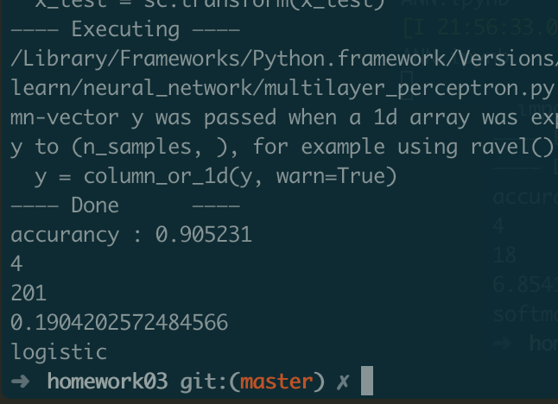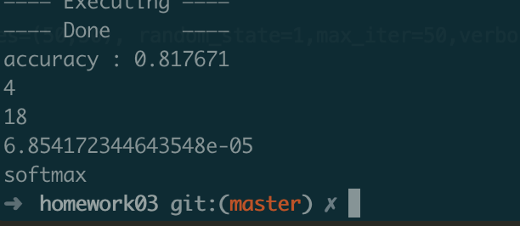

In the implementation process, I also tried to add hidden layer, but there was no obvious better score in the bank task. However, in the implementation of the next task, what happened to me was unexpected: the result after adding the number of layers did not exceed the original score. The problem that I considering is overfitting. Later soon, I tried to change the solver, adding early_stopping but still has no significant improvement. Of course, I will continue to explore such problems.

Finally, what I want to say is that for more complex data processing, we may rely more on ANN. For the simple two-class problem, we can give priority to the decision tree because the explanatory is strong and the model is simpler. But I think in practical problems, we may need ANN more. Because the decision tree can solve the problem and the ANN is also not inferior.