Shared Hub Genes and Immune Signatures of Sepsis and ARDS: A Multi-Omics Integration
Running head: Shared Hub Genes in Sepsis and ARDS
Article type: Original Research
AI usage disclosure: AI-assisted language editing was used; no AI tool generated scientific content or data. All authors accept responsibility for the manuscript.
Acknowledgments: No non-author contributors to acknowledge.
Funding: This study was supported in part by National Clinical Key Specialty Construction Project (Grant No. 0060112505) to Xiuling Shang, Fuzhou University Affiliated Provincial Hospital Huo Shi Fund Project (Grant No. 2019HSJJ09) to Dansen Wu, and Fujian Provincial Department of Finance Project (Grant No. {2025}876) to Dansen Wu.
Conflicts of interest: H.Y., Y.S., W.C., J.W., Z.W., Q.W., and D.W. reported no relevant financial relationships with ineligible companies.
Author contributions: D.W. conceived and designed the study. Y.S., W.C., and J.W. contributed to data curation, formal analysis, and development of methodology. H.Y. and D.W. contributed to the writing, reviewing, and revision of the paper. Y.S., W.C., J.W., Z.W., and Q.W. provided acquisition, analysis, and interpretation of data and statistical analysis. H.Y. and D.W. provided technical and material support. D.W. acquired funding and supervised the study. All authors read and approved the final version of the manuscript.
Under re-curation and independent validation, this work defines six genes that mark the shared molecular intersection of sepsis and ARDS in a blood compartment characterized by myeloid expansion and cytotoxic lymphocyte depletion. It provides an openly reproducible marker panel validated in independent external cohorts, with a map of causal and prognostic boundaries that indicates where these genes can and cannot be used clinically.
Word counts: Abstract 247; main text 3,495 (Introduction 434, Methods 430, Results 1,633, Discussion 947, Conclusion 51; excluding abstract, references, tables, and figure legends).
Corresponding author: Dansen Wu, Department of Critical Care Medicine, Fuzhou University Affiliated Provincial Hospital, Fujian Provincial Hospital, Fuzhou, Fujian 350001, China. Email: wds_9201851126@fjmu.edu.cn. ORCID: 0000-0002-8429-168X.
Authors: Huobao Yang, Yanghui Shen, Wenjun Chen, Jiali Wu, Zhimin Wu, Qihua Wu, Dansen Wu. 1 Shengli Clinical Medical College of Fujian Medical University, Fujian Medical University, Fuzhou 350001, China; 2 Department of Critical Care Medicine, Fuzhou University Affiliated Provincial Hospital, Fujian Provincial Hospital, Fuzhou, Fujian 350001, China; 3 Fujian Provincial Center for Critical Care Medicine, Fuzhou University Affiliated Provincial Hospital, Fujian Provincial Hospital, Fuzhou, Fujian 350001, China; 4 Fujian Provincial Key Laboratory of Critical Care Medicine, Fuzhou University Affiliated Provincial Hospital, Fujian Provincial Hospital, Fuzhou, Fujian 350001, China. H.Y., Y.S., W.C., J.W., Z.W., and D.W.: affiliations 1-4; Q.W.: affiliation 1.

ABSTRACT
Rationale: Sepsis is the most common precipitant of the acute respiratory distress syndrome (ARDS), but the mechanisms the two share remain poorly defined.
Objectives: To identify molecular nodes and immune features that sepsis and ARDS share in blood.
Methods: We reanalyzed two discovery cohorts from source matrices after removing off-target samples. Machine learning prioritized genes supported by both differential expression and coexpression modules, and two external cohorts tested them. Immune deconvolution, single-cell mapping, bidirectional Mendelian randomization (MR), drug repurposing, and prognostic modeling followed.
Measurements and Main Results: Six hub genes (CDK5RAP2, CD177, GRB10, UPP1, EXOSC4, and VNN1) separated sepsis or ARDS from control subjects in external validation (AUC, 0.753–0.998) but did not separate the two syndromes. Both diseases showed monocyte expansion with CD8+ T-cell and natural killer cell depletion, and complement activation was the only pathway shared by the top-20 lists. MR did not detect a causal effect in either direction; the reverse had adequate power (minimum detectable odds ratio, 1.04) and the forward did not (2.26). In 479 patients with septic shock, a six-gene score stratified 28-day all-cause mortality (log-rank P = 0.002) but added nothing to age, sex, and molecular phenotype (likelihood ratio P = 0.16), whereas a nonoverlapping 171-gene LASSO signature remained independently predictive after optimism correction (C index, 0.622). Docking prioritized VNN1.
Conclusions: The signature describes a convergent phenotype of myeloid hyperactivation and cytotoxic lymphocyte dysfunction in both diseases. These genes report disease-associated states rather than independent prognostic biomarkers and require functional validation.
Keywords: Transcriptome; Machine Learning; Mendelian Randomization Analysis; Single-Cell Analysis; Drug Repositioning

INTRODUCTION
Sepsis is life-threatening organ dysfunction caused by a dysregulated host response to infection (1) and a leading cause of death in the critically ill. It is also the most common predisposing condition for the acute respiratory distress syndrome (ARDS) (2, 3), an acute hypoxemic respiratory failure dominated by neutrophilic inflammation. Mortality in sepsis-associated ARDS remains high, and no therapy targets the underlying mechanism (4). The two syndromes share much of their inflammatory machinery, including complement activation, cytokine release, and neutrophil and monocyte recruitment (5), yet they have been studied largely in isolation.
Shared-gene screens spanning the two diseases have been reported (6). Sepsis is biphasic: an early cytokine storm gives way to protracted immunosuppression with lymphocyte apoptosis, myeloid-derived suppressor cell expansion, and monocyte HLA-DR downregulation (7–11). ARDS is marked by neutrophilic, complement-activating inflammation in the lung (2, 5). Single-cell profiling resolves the septic state into immunosuppressive HLA-DR-low S100A-high monocytes (12). The neutrophil CD177/CD10 ratio distinguishes infection from noninfectious inflammation and stratifies mortality (13). CD177+ neutrophils are linked to necroptosis-driven inflammation (14) and to a stable subtype identity (15). Macrophage UPP1 drives a mitochondrial ROS–cGAS–NLRP3 axis (16). Molecularly defined sepsis subphenotypes also respond differently to fluid resuscitation (17).
Three gaps remain. The input series were never re-curated: GSE76293 mixes disease samples with neutrophils cultured in vitro, and GSE69528 includes uninfected patients with type 2 diabetes, both distort differential expression and machine-learning inference. Validation was internal, with candidates nominated and tested in the same data. Causal and cell-level questions were left open, and signature-matching repurposing inherits the reproducibility limits (18) and context-agnostic matching (19) of cancer cell line compendia.
We asked which genes and immune processes are coordinately dysregulated in both conditions and survive re-curation, external validation, and orthogonal testing. Intersecting differentially expressed genes with disease-associated weighted gene co-expression network analysis modules yielded 179 shared candidates. Machine learning, with cross-disease testing confined to discovery, reduced them to six hub genes (CDK5RAP2, CD177, GRB10, UPP1, EXOSC4, VNN1), confirmed in two independent cohorts. A compact, interpretable signature was prioritized over broad scores because it is more readily validated and nominates tractable targets. We then asked whether the shared genes behave consistently across cohorts, cell types, and analytic approaches, using immune deconvolution and single-cell mapping with dual virtual knockout, pathway enrichment, Mendelian randomization with summary-based Mendelian randomization (SMR)-HEIDI, linkage disequilibrium score regression and colocalization, and drug repurposing quantified against nulls.
Here we report a curated intersection: six hub genes that survive independent validation, together with their myeloid localization, genetic tests of causal status, and candidate compounds. CD177 and UPP1 extend from established sepsis markers into the shared sepsis–ARDS context.

METHODS

Study Cohorts
Two discovery cohorts were reanalyzed from raw probe-level matrices after removing off-target samples (Table 1). GSE76293 comprised ARDS and control neutrophils (12 cases and 12 control subjects; 70 in vitro samples excluded). GSE69528 comprised sepsis and control whole blood (83 cases and 28 control subjects; 27 uninfected patients with type 2 diabetes excluded). Validation used GSE100159 (sepsis; 33 cases and 12 control subjects) and GSE243066 (ARDS RNA sequencing; 34 cases and 15 control subjects). Single-cell analysis used GSE151263 (peripheral blood mononuclear cells; 13,996 cells from three ARDS and four sepsis donors) and GSE167363 (CD14+ monocytes; 12,359 cells). Prognostic evaluation used GSE65682 (479 patients with septic shock; admission blood; 28-day mortality, 114 deaths; Mars1 to Mars4 endotypes) (20).

Differential Expression and Enrichment
Differential expression used limma (21) at |log2 fold change| > 1 and adjusted P < 0.05. Intersecting these genes with disease-associated WGCNA (22) modules defined 179 shared candidates, which underwent Gene Ontology, Kyoto Encyclopedia of Genes and Genomes, and Reactome enrichment (23).

Machine Learning
Twelve machine-learning classifiers (24), eleven estimable, interpreted with SHapley Additive exPlanations (SHAP) (25) prioritized hub genes; ridge-regularized logistic models (26) predicted disease. Single-gene and transferred-model performance was confirmed in the validation cohorts with meta-analysis.

Prognostic Modeling
Prognostic models in GSE65682 were per-gene and joint six-gene Cox models (27), a least absolute shrinkage and selection operator (LASSO)-penalized Cox model (28) over the 171 platform-represented candidates, and a random survival forest (29), all with bootstrap optimism correction and likelihood ratio testing against a clinical model.

Mendelian Randomization
Bidirectional two-sample Mendelian randomization followed STROBE-MR (30), with power analysis, linkage disequilibrium score regression (31), SMR-HEIDI (32), and colocalization (33).

Immune and Single-Cell Analysis
Immune composition was estimated by CIBERSORT (34) and by deconvolution-independent single-sample gene set enrichment analysis (ssGSEA) (35), cell–cell communication by CellChat (36), and single-cell analyses with donor-level verification; extracellular-trap program activity was scored with AUCell and monocyte co-expression tested with metacell-based WGCNA.

Protein and Drug Analyses
Protein data came from the Human Protein Atlas (accessed November 6, 2025). Connectivity Map results were quantified against random gene-set nulls, and docking was validated by redocking and MM/GBSA rescoring. Druggability came from Open Targets (September 2026) and ChEMBL (release 37, accessed September 17, 2026).

Statistical Analysis
Analyses used R 4.6.1 from the raw data, with discovery confined to the discovery cohorts, and two-sided tests with Benjamini–Hochberg adjustment throughout (37). Because the validation cohorts also screened seven ARDS-nominated candidates down to six, their estimates carry a mild optimistic bias that a seven-gene sensitivity analysis bounds. Complete methods and validity restrictions appear in the Online Supplement (Supplementary Methods 1–14).

RESULTS

Re-Curation Yields 179 Shared Candidate Genes
Compared with control subjects, 557 genes were differentially expressed in ARDS and 1,458 in sepsis (Supplementary Table S6). WGCNA yielded 13 disease-associated modules in ARDS and 11 in sepsis, with strong preservation across cohorts (Zsummary, 19.5 and 21.4). Their intersection gave 179 shared candidates (Figure 1B–E; Supplementary Figure S1; Tables S7 and S10).

Enrichment Centers on Antigen Presentation and Th1/Th2/Th17 Differentiation
GO terms centered on immune activation and antigen presentation (positive regulation of cytokine production, MHC class II assembly). KEGG pathways converged on Th1/Th2/Th17 differentiation, antigen processing and presentation, and NOD-like receptor signaling (Supplementary Figure S23). Reactome ranked nucleotide catabolism first (P = 5.3 × 10⁻¹², UPP1) and centrosome maturation sixth (CDK5RAP2).

Machine Learning Narrows the Set to Six Hub Genes
Twelve machine-learning classifiers were trained on the 179 shared candidates in each discovery cohort, eleven of them estimable (Figure 2A and 2B; Supplementary Figure S22). Area under the receiver operating characteristic curve (AUC) values of 1.00 in the small ARDS cohort (n = 24) reflected overfitting and were not used for ranking; label permutation excluded label noise (Supplementary Figure S5). Shortlisting required concordance across LASSO, random forest, and SHAP, stable but not unanimous (Supplementary Table S9). The consensus rule nominated nine ARDS and six sepsis candidates. Cross-disease testing retained seven that discriminated in the same direction in the opposite cohort (AUC, 0.844–0.979), whereas DYRK2 and TCTN1 reversed direction (Figure 3A). External validation confirmed six of the seven ARDS-nominated candidates in both cohorts and refuted MUC1 in the ARDS cohort (AUC, 0.575; Supplementary Table S11), leaving CDK5RAP2, CD177, GRB10, UPP1, EXOSC4, and VNN1 (Figure 2C). These six span pyrimidine metabolism (UPP1), the RNA exosome (EXOSC4), pantetheinase signaling (VNN1), and the neutrophil-restricted marker CD177 (Figure 3B); metacell co-expression analysis placed UPP1, EXOSC4, and VNN1 in one module, with the remaining genes unassigned or undetectable (Supplementary Figure S27), so the panel is partly co-expressed rather than a single co-regulated module.

The Six Hub Genes Are Differentially Expressed Across Cohorts
UPP1 and CD177 were higher in disease in all four cohorts (UPP1 significant in three), and VNN1 and EXOSC4 showed cohort-dependent effects (Figure 4A–4D). Single-gene gene set enrichment analysis showed shared but context-dependent enrichment. Sepsis discovery enriched hub-gene networks for tumor necrosis factor and interleukin-6/JAK/STAT3 signaling, most strongly for VNN1. The ARDS neutrophil cohort showed negative enrichment for MYC targets and DNA repair (Supplementary Figure S6). Both validation cohorts were dominated by interferon responses, with an interferon-alpha response for CD177 (Figure 4E).

Six-Gene Models Discriminate Disease from Control
The six genes served as predictors in ridge-regularized logistic models displayed as nomograms (Figure 5). The ARDS model, trained on GSE76293 (n = 24) and validated on GSE243066 (n = 49), gave a training AUC of 1.000, an artifact of complete separation, and a validation AUC of 0.984. The sepsis model (GSE69528, n = 111; validated on GSE100159, n = 45) gave 0.993 in training and 0.980 in validation (95% CI, 0.949 to 1.000). Refitting with all seven nominated genes left both unchanged (ARDS, 0.984; sepsis transfer, 0.980–0.987), so screening did not affect performance (Supplementary Table S11). Neither model exceeded the best single gene. Disease status was not confounded with a technical axis in any cohort (Supplementary Figure S7).

Single-Gene Discrimination Is Confirmed Externally
Single-gene AUCs, which involve no model fitting, ranged from 0.753 to 0.998 in both validation cohorts (Figure 6; Table 2). EXOSC4, VNN1, CD177, and GRB10 discriminated consistently and strongly. UPP1 discriminated more modestly in sepsis (0.753) than in ARDS (0.935), and CDK5RAP2 least well in ARDS (0.782). Meta-analysis confirmed pooled discrimination for all six (Hedges g, 1.14–2.32; all P < 10⁻⁵), with heterogeneity in CD177, UPP1, and VNN1 (I² = 0.60–0.91; GRB10, 0.43) (Figure 6B; Supplementary Table S11). Dropping CD177 left transferred ARDS discrimination intact (AUC, 0.961 vs. 0.984; Supplementary Table S11). In a disease-versus-disease contrast (three ARDS and four sepsis donors), none of the six discriminated ARDS from sepsis (combined signature AUC, 0.50; all exact P ≥ 0.4).

Blood Shows Myeloid Expansion with Complement Activation
The six-gene score was higher in disease in both discovery cohorts (P = 3.2 × 10⁻⁵ and 2.3 × 10⁻¹⁴; Figure 7A), as was M2 macrophage infiltration (Figure 2D). CIBERSORT deconvolution showed monocyte expansion with depletion of CD8+ T cells, CD4 memory resting T cells, and resting natural killer cells across all three cohorts, significantly in both sepsis cohorts; M0 and neutrophil fractions were expanded in the two sepsis whole-blood cohorts, with M0 read as myeloid enrichment rather than macrophage abundance (Figure 7B; Supplementary Figures S9 and S24; Supplementary Table S2). Deconvolution-independent ssGSEA with 18 lineage marker sets reproduced the pattern (monocyte P as low as 1.7 × 10⁻¹²; Supplementary Figure S10). Regulatory T-cell direction differed by method. GSVA identified complement activation as the only shared pathway among the top-20 dysregulated immune processes of both diseases, yet this was threshold dependent: cutoffs of 30 and 50 yielded five and seven shared pathways, all concordant in direction (Figure 7C and 7D; Supplementary Table S15).

Hub Genes Localize to Monocytes in Single-Cell Data
The two single-cell cohorts sampled complementary stages (Figure 8). In PBMCs (GSE151263), signature scores were higher in sepsis in monocytes and platelets (Figure 8D; Supplementary Table S16). CellChat ranked MHC class I and macrophage migration inhibitory factor (MIF) as the strongest in both states, with MIF strength higher in sepsis than ARDS (1.24 × 10⁻³ vs. 6.43 × 10⁻⁴; Supplementary Figure S12D and Table S25). In CD14+ monocytes (GSE167363), MIF was again strongest in sepsis (3.16 × 10⁻³ vs. 2.85 × 10⁻³ in control subjects) and MHC class II led the healthy network (Figure 8E; Supplementary Figures S11 and S12A). UPP1 declined along the monocyte trajectory in four of five samples (Supplementary Figures S2B and S14C). Sepsis monocytes occupied later pseudotime positions (Figure 8C), and metabolic programs peaked in sepsis and receded partially in ARDS, an inverted-U pattern (Supplementary Figure S15A). CellOracle (38) in silico knockout made CEBPB the dominant upstream regulator of UPP1 in every stratum, with dependence rising from health to sepsis and receding in ARDS, reproduced in all five samples (Figure 8F; Supplementary Table S17). Group-stratified scTenifoldKnk (39) gave perturbation spectra more concordant between the two disease states (rho, 0.63–0.66) than between either and health (0.44–0.50) (Supplementary Figures S17 and S18; Supplementary Table S18). Donor-level pseudobulk DESeq2 (40) confirmed induction of CD177 by sepsis in classical monocytes (log2 fold change, 6.68; P = 0.002), the only hub-gene contrast significant at that level (Supplementary Figure S16B). Sepsis monocytes showed higher extracellular-trap (ETosis) program activity than healthy monocytes, whereas ARDS and sepsis monocytes did not differ (Supplementary Figure S26). Virtual knockout of the four testable hubs enriched perturbation spectra in a ribosomal-biogenesis module (odds ratios, 4.8–13.3; BH-adjusted P ≤ 9.7 × 10⁻⁶) but not their own sepsis-associated module, supporting marker-over-driver status (Supplementary Table S27).

Mendelian Randomization Is Null and Underpowered
Inverse-variance-weighted MR did not detect a causal effect of sepsis on ARDS (β = −0.336; 95% CI, −0.908 to 0.236; P = 0.249), with consistent nulls across sensitivity analyses; reverse MR was likewise null (P = 0.329) (Figure 9A and 9B; Supplementary Figure S8). The forward analysis had 28% power at a causal odds ratio of 1.5 (minimum detectable, 2.26), whereas the reverse was well powered (1.04) (Figure 9C; Supplementary Tables S13 and S14). Only the reverse null therefore constrains causal effects. LD score regression estimated a near-zero genetic correlation (rg = −0.05; P = 0.83) and single-nucleotide polymorphism (SNP) heritability h² ≤ 0.0022 for both traits. For the five hub genes with cis-expression quantitative trait loci, SMR-HEIDI gave no evidence of pleiotropy, no significant causal estimate, and no colocalization (Figure 9D).

The Six-Gene Score Stratifies Mortality but Adds Nothing Clinically
Prognostic association was tested in GSE65682 (479 patients with septic shock; 20). No hub gene was individually associated with 28-day mortality (hazard ratio per SD, 0.92–1.16; all 95% CIs spanning 1; adjusted P = 0.45–0.64; Supplementary Figure S20B). In the joint model, UPP1 was the only significant term (hazard ratio per SD, 0.64; 95% CI, 0.44–0.95; P = 0.026); the model as a whole was not (likelihood ratio P = 0.067). The score nevertheless separated outcomes (log-rank P = 0.002; Supplementary Figure S20A) but added no increment beyond age, sex, and Mars endotype (likelihood ratio P = 0.16; optimism-corrected C index, 0.603 vs. 0.606) (Supplementary Figures S20C–S20E). A LASSO Cox model over the 171 platform-represented candidates differed: the minimum-deviance penalty retained 15 genes, none a hub gene, and the one-standard-error rule retained none (Supplementary Figures S21A and S21B). This signature outperformed the six-gene score (optimism-corrected C index, 0.622 alone and 0.638 with covariates; 28-day AUC, 0.698; likelihood ratio P = 9.7 × 10⁻¹²; Supplementary Figures S21C–S21E).

Protein Data and Druggability Nominate VNN1 and UPP1
In the Human Protein Atlas, CD177 was up-regulated in 9 of 10 infectious diseases and VNN2 in all 10 (Figure 10A; Supplementary Figure S19). The prespecified, hypothesis-generating up-regulated CMap query returned eight compounds tied at the top (P = 3.7 × 10⁻⁴), including dexamethasone; this enrichment was matched or exceeded by size-matched non-hub signatures in 13 of 100 nulls, by transcriptome-wide sets in none, and by stringency-matched up-regulated backgrounds in 2 of 100 (Supplementary Figure S3). The down-regulated query yielded no glucocorticoid, and an independent compendium reproduced the up-regulated direction. Docking of 10 natural-product ligands, validated by redocking and MM/GBSA rescoring, nominated VNN1 as the preferred partner, with luteolin strongest by Vina (−10.01 kcal/mol) (Figure 10C; Table 3; Supplementary Figures S4 and S25; Supplementary Table S19). The two affinity measures agreed on VNN1 at target level but not ligand ranking, so no ligand-level prioritization is supported (Supplementary Table S20). Open Targets and ChEMBL identified VNN1 and UPP1 as the only tractable targets, and no approved or clinical-stage small-molecule drug exists for any of the six.

DISCUSSION
We identified six hub genes shared by sepsis and ARDS (CDK5RAP2, CD177, GRB10, UPP1, EXOSC4, VNN1) against a background of complement activation and a blood phenotype of myeloid expansion with cytotoxic depletion. The six were nominated within discovery, confirmed as single-gene markers in two independent cohorts, and corroborated at the protein level for CD177 across nine infections. In blood, the phenotype corresponds to the immunosuppressive phase long described in sepsis and first shown in human spleen and lung (7–11). Our analysis extends it to ARDS blood, where leukocyte expression separates reactive from uninflamed phenotypes (41). Signaling through MICB and NKG2D likewise implicates natural killer cells in lung injury (42).
Earlier screens differed in thresholds and cohorts. A screen with more permissive criteria nominated CX3CR1, PID1, and PTGDS (6); in the curated data all three are down-regulated in sepsis blood but none enters from the ARDS side (PID1: log2 fold change, −0.79, adjusted P = 0.006; CX3CR1 and PTGDS not differentially expressed). MUC1 failed ARDS validation; DYRK2 and TCTN1 reversed direction.
The six genes share annotation-level links. UPP1, VNN1, and CD177 map onto the observed myeloid and neutrophil phenotype: macrophage UPP1 drives a mitochondrial ROS–cGAS–NLRP3 axis in a lung adenocarcinoma model (16), and CD177 is neutrophil-restricted and induced during infection (13–15). EXOSC4, CDK5RAP2, and GRB10 connect the set to RNA processing, centrosome function, and growth factor signaling.
Both diseases shifted monocytes to later pseudotime positions; perturbation spectra were more concordant between ARDS and sepsis than either and health. ARDS blood carries a partial version of the sepsis program, in which UPP1 expression, CEBPB dependence, and metabolic activity peak in sepsis and recede in ARDS. This pattern is qualitative, fitting the transition from hyperinflammation to immune paralysis (9). ARDS itself comprises molecular phenotypes with divergent transcriptional trajectories (43), most of the sepsis transcriptome is shared across sources of infection (44), and CEBPB independently falls in a severity-correlated necroptosis signature enriched in CD177+ neutrophils (14). The validation estimates concern discrimination from health, and the combined signature did not separate the syndromes. Whether ARDS adds organ-specific regulation requires lung or bronchoalveolar sampling.
The Mendelian randomization result was null, with a clear asymmetry: the reverse null constrains causal effects of ARDS on sepsis risk, whereas the forward null lacks power for small or moderate effects. SMR-HEIDI tests were likewise null for the five genes with cis-eQTL support. The shared genes are therefore compatible with reactive markers of the host response rather than causal drivers, the pattern expected of a neutrophil activation marker such as CD177 (13). LD score regression showed near-zero genetic correlation and SNP heritability, and the nulls cannot separate absence of causality from phenotypic misclassification. Protein-level MR was precluded for five of six genes (intracellular or membrane-bound products), and a genetically supported intermediate exists for this axis (45). All MR sources and the eQTLGen reference were of European ancestry.
In univariable models none of the six genes was associated with 28-day mortality. The joint risk score separated survivors from non-survivors but added nothing beyond age, sex, and transcriptomic endotype (20), largely from overlapping information. The prognostic information in the candidate set lay in 15 other genes, none a hub gene; a random survival forest added no gain, so the advantage reflects variable selection rather than nonlinearity. Diagnostic and prognostic information are largely separable; prognostic work should start from the broader candidate set.
Only VNN1 and UPP1 have pharmacological precedent: uridine analogs inhibit UPP1, including the co-crystallized benzylacyclouridine; the orally active pantetheinase inhibitor RR6 inhibits VNN1 and abolishes plasma vanin activity in rats (46); and VNN1 inhibition limits ROS-dependent neutrophil extracellular trap formation and lung injury in septic mice (47). CD177 is tractable at the antibody or biomarker level, GRB10 would require targeting a protein–protein interface, and CDK5RAP2 and EXOSC4 are near-ubiquitous. Selectivity against the co-upregulated VNN2 paralog was not tested. The CMap glucocorticoid signal was weak against stringency-matched disease signatures and absent from the down-regulated query; its direction reflects the anti-inflammatory pharmacology and questioned reproducibility (18, 48) of cancer cell line compendia and their context-agnostic matching (19). That signal and the docking energies are both hypothesis generating, consistent with endotype-dependent corticosteroid responses (49).
These findings nominate testable experiments. If VNN1 links the shared state to extracellular-trap biology, inhibiting or silencing VNN1 in stimulated monocytes should reduce citrullinated-histone and myeloperoxidase–DNA readouts and blunt the sepsis-phase metabolic peak; luteolin, nominated only computationally, could be tested on the same readouts.

Limitations
The prognostic analysis rests on a single cohort with internal validation. The discovery ARDS cohort is small (n = 24), and every external contrast compares disease with healthy control subjects, so discrimination from noninfectious inflammation (systemic inflammatory response syndrome, cardiogenic pulmonary edema) is untested. The ARDS cohorts were not stratified by precipitating insult, so sepsis and ARDS are addressed as diseases, not sepsis-associated ARDS. Both single-cell cohorts are blood derived with two to four donors per group; donor-level analyses reproduced nearly every direction, but only CD177 induction reached significance. The sepsis model retained high external discrimination (AUC 0.980), but its absolute probabilities were not transportable across platforms; the score stratifies risk within a cohort rather than providing calibrated probabilities. The six-gene Cox model violated the proportional hazards assumption globally (P = 0.031) although no single gene did; its joint estimate is time averaged. The Kaplan-Meier split was insensitive to the cut point (log-rank P = 0.00026–0.0019), and ssGSEA immune comparisons retained Benjamini–Hochberg correction (Supplementary Table S24). Severity covariates were unavailable, and corticosteroid exposure, which could shape the immune signatures and CMap result, is unknown.
The six genes define a shared host response state and could stratify trials enrolling both syndromes. The null causal estimates support their use as markers rather than targets.

CONCLUSION
Sepsis and ARDS converge on a definable molecular intersection: six shared hub genes, complement activation, blood that is myeloid-expanded and depleted of cytotoxic lymphocytes, and monocyte metabolic reprogramming. Nominated in discovery and confirmed externally and at the protein level, it is measurable and testable. Tractability profiling puts VNN1 and UPP1 first.

ETHICS APPROVAL AND CONSENT TO PARTICIPATE
Not applicable. This study is a secondary analysis of publicly available, de-identified transcriptomic data sets, public genome-wide association summary statistics, and public protein resources. No participants were newly enrolled, no identifiable personal data were accessed, and no human or animal experiments were performed by the authors; institutional review board approval and informed consent were therefore not required.

DATA AVAILABILITY
All transcriptomic datasets analyzed in this study are publicly available from the Gene Expression Omnibus under the accession numbers GSE76293, GSE69528, GSE100159, GSE243066, GSE151263, GSE167363, and GSE65682. The sepsis genome-wide association study summary statistics used for Mendelian randomization are available from IEU OpenGWAS (ID ieu-b-4980; GWAS Catalog GCST90281174), and ARDS outcome data from FinnGen (R11). Protein-level data were obtained from the Human Protein Atlas Blood Atlas (version 24, accessed November 6, 2025), and protein structures from the Protein Data Bank (UPP1: 3EUF; VNN1: 7SLV) and AlphaFold. All analysis scripts are available at https://github.com/wuds2006/sepsis-ards-shared-hub-genes and archived at Zenodo (https://doi.org/10.5281/zenodo.23668532). The deposit contains the analysis code, the derived result files, all 27 supplementary tables as submitted, a machine-readable inventory of every public input with accession numbers, platform versions, and access dates, and a runbook for retrieving the raw data.

REFERENCES
1. Singer M, Deutschman CS, Seymour CW, Shankar-Hari M, Annane D, Bauer M, et al. The Third International Consensus Definitions for Sepsis and Septic Shock (Sepsis-3). JAMA. 2016;315(8):801–810. doi:10.1001/jama.2016.0287.
2. Bellani G, Laffey JG, Pham T, Fan E, Brochard L, Esteban A, et al. Epidemiology, patterns of care, and mortality for patients with acute respiratory distress syndrome in intensive care units in 50 countries. JAMA. 2016;315(8):788–800. doi:10.1001/jama.2016.0291.
3. ARDS Definition Task Force, Ranieri VM, Rubenfeld GD, Thompson BT, Ferguson ND, Caldwell E, et al. Acute respiratory distress syndrome: the Berlin Definition. JAMA. 2012;307(23):2526–2533. doi:10.1001/jama.2012.5669.
4. Fan E, Brodie D, Slutsky AS. Acute respiratory distress syndrome: advances in diagnosis and treatment. JAMA. 2018;319(7):698–710. doi:10.1001/jama.2017.21907.
5. Matthay MA, Zemans RL, Zimmerman GA, Arabi YM, Beitler JR, Mercat A, et al. Acute respiratory distress syndrome. Nat Rev Dis Primers. 2019;5(1):18. doi:10.1038/s41572-019-0069-0.
6. Jiang J, Chen Y, Su Y, Zhang L, Qian H, Song X, et al. Identification and experimental validation of diagnostic and prognostic genes CX3CR1, PID1 and PTGDS in sepsis and ARDS using bulk and single-cell transcriptomic analysis and machine learning. Front Immunol. 2024;15:1480542. doi:10.3389/fimmu.2024.1480542.
7. Boomer JS, To K, Chang KC, Takasu O, Osborne DF, Walton AH, et al. Immunosuppression in patients who die of sepsis and multiple organ failure. JAMA. 2011;306(23):2594–2605. doi:10.1001/jama.2011.1829.
8. Giamarellos-Bourboulis EJ, Aschenbrenner AC, Bauer M, Bock C, Calandra T, Gat-Viks I, et al. The pathophysiology of sepsis and precision-medicine-based immunotherapy. Nat Immunol. 2024;25(1):19–28. doi:10.1038/s41590-023-01660-5.
9. van der Poll T, Shankar-Hari M, Wiersinga WJ. The immunology of sepsis. Immunity. 2021;54(11):2450–2464. doi:10.1016/j.immuni.2021.10.012.
10. Monneret G, Lafon T, Gossez M, Evrard B, Bodinier M, Rimmelé T, et al. Monocyte HLA-DR expression in septic shock patients: insights from a 20-year real-world cohort of 1023 cases. Intensive Care Med. 2025;51(10):1820–1832. doi:10.1007/s00134-025-08110-w.
11. Uhel F, Azzaoui I, Grégoire M, Pangault C, Dulong J, Tadié JM, et al. Early expansion of circulating granulocytic myeloid-derived suppressor cells predicts development of nosocomial infections in patients with sepsis. Am J Respir Crit Care Med. 2017;196(3):315–327. doi:10.1164/rccm.201606-1143OC.
12. Yao RQ, Zhao PY, Li ZX, Liu YY, Zheng LY, Duan Y, et al. Single-cell transcriptome profiling of sepsis identifies HLA-DRlowS100Ahigh monocytes with immunosuppressive function. Mil Med Res. 2023;10(1):27. doi:10.1186/s40779-023-00462-y.
13. Huang J, Xie K, Li H, Wen X, Mei Y, Chen J, et al. Dynamic CD177/CD10 ratio for infection diagnosis and mortality risk stratification in critically ill patients: a prospective cohort study. EBioMedicine. 2026;123:106100. doi:10.1016/j.ebiom.2025.106100.
14. Liu H, Cheng X, Li J, Wei W, Yuan Y, Wang W, et al. Upregulated CD177 on neutrophils is implicated in sepsis pathogenesis and necroptosis-driven inflammation. Front Immunol. 2026;17:1785356. doi:10.3389/fimmu.2026.1785356.
15. Jung M, Beer A, Ghosh S, et al. CD177 deficiency defines a stable subtype of human neutrophil granulocytes with tumor promoting activity. Adv Sci (Weinh). 2026;13(52):e76236. doi:10.1002/advs.76236.
16. Feng M, Gao C, Yang Y, Li D, Zhou C, Chen L, et al. Upregulation of macrophage UPP1 promotes lung adenocarcinoma metastasis through an mtROS-cGAS-NLRP3 inflammasome axis. Cell Death Discov. 2026;12(1):385. doi:10.1038/s41420-026-03226-4.
17. Kiernan E, Zelnick LR, Khader A, Coston TD, Bailey ZA, Speckmaier S, et al. Molecular phenotyping of sepsis and differential response to fluid resuscitation. Am J Respir Crit Care Med. 2025;211(9):1681–1688. doi:10.1164/rccm.202412-2377OC.
18. Huang K, Lalagkas PN, Sultan B, Melamed R. Exploiting similarity in drug molecular effects for drug repurposing. Hum Genomics. 2025;19(1):110. doi:10.1186/s40246-025-00808-8.
19. Halu A, Chelvanambi S, Decano JL, Matamalas JT, Whelan M, Asano T, et al. Integrating pharmacogenomics and cheminformatics with diverse disease phenotypes for cell type-guided drug discovery. Genome Med. 2025;17(1):7. doi:10.1186/s13073-025-01431-x.
20. Davenport EE, Burnham KL, Radhakrishnan J, Humburg P, Hutton P, Mills TC, et al. Genomic landscape of the individual host response and outcomes in sepsis: a prospective cohort study. Lancet Respir Med. 2016;4(4):259–271. doi:10.1016/S2213-2600(16)00046-1.
21. Ritchie ME, Phipson B, Wu D, Hu Y, Law CW, Shi W, et al. limma powers differential expression analyses for RNA-sequencing and microarray studies. Nucleic Acids Res. 2015;43(7):e47. doi:10.1093/nar/gkv007.
22. Langfelder P, Horvath S. WGCNA: an R package for weighted correlation network analysis. BMC Bioinformatics. 2008;9:559. doi:10.1186/1471-2105-9-559.
23. Wu T, Hu E, Xu S, Chen M, Guo P, Dai Z, et al. clusterProfiler 4.0: A universal enrichment tool for interpreting omics data. Innovation (Camb). 2021;2(3):100141. doi:10.1016/j.xinn.2021.100141.
24. Breiman L. Random forests. Mach Learn. 2001;45(1):5–32. doi:10.1023/A:1010933404324.
25. Lundberg SM, Lee SI. A unified approach to interpreting model predictions. Adv Neural Inf Process Syst. 2017;30:4765–4774.
26. Friedman J, Hastie T, Tibshirani R. Regularization paths for generalized linear models via coordinate descent. J Stat Softw. 2010;33(1):1–22. doi:10.18637/jss.v033.i01.
27. Cox DR. Regression models and life-tables. J R Stat Soc Series B Stat Methodol. 1972;34(2):187–220. doi:10.1111/j.2517-6161.1972.tb00900.x.
28. Simon N, Friedman J, Hastie T, Tibshirani R. Regularization paths for Cox's proportional hazards model via coordinate descent. J Stat Softw. 2011;39(5):1–13. doi:10.18637/jss.v039.i05.
29. Ishwaran H, Kogalur UB, Blackstone EH, Lauer MS. Random survival forests. Ann Appl Stat. 2008;2(3):841–860. doi:10.1214/08-AOAS169.
30. Skrivankova VW, Richmond RC, Woolf BAR, Yarmolinsky J, Davies NM, Swanson SA, et al. Strengthening the reporting of observational studies in epidemiology using Mendelian randomization: the STROBE-MR statement. JAMA. 2021;326(16):1614–1621. doi:10.1001/jama.2021.18236.
31. Bulik-Sullivan BK, Loh PR, Finucane HK, Ripke S, Yang J, Schizophrenia Working Group of the Psychiatric Genomics Consortium, et al. LD Score regression distinguishes confounding from polygenicity in genome-wide association studies. Nat Genet. 2015;47(3):291–295. doi:10.1038/ng.3211.
32. Zhu Z, Zheng Z, Zhang F, Wu Y, Trzaskowski M, Maier R, et al. Causal associations between risk factors and common diseases inferred from GWAS summary data. Nat Commun. 2016;7:11204. doi:10.1038/ncomms11204.
33. Giambartolomei C, Vukcevic D, Schadt EE, Franke L, Hingorani AD, Wallace C, et al. Bayesian test for colocalisation between pairs of genetic association studies using summary statistics. PLoS Genet. 2014;10(5):e1004383. doi:10.1371/journal.pgen.1004383.
34. Newman AM, Liu CL, Green MR, Gentles AJ, Feng W, Xu Y, et al. Robust enumeration of cell subsets from tissue expression profiles. Nat Methods. 2015;12(5):453–457. doi:10.1038/nmeth.3337.
35. Hänzelmann S, Castelo R, Guinney J. GSVA: gene set variation analysis for microarray and RNA-seq data. BMC Bioinformatics. 2013;14:7. doi:10.1186/1471-2105-14-7.
36. Jin S, Guerrero-Juarez CF, Zhang L, Chang I, Ramos R, Kuan CH, et al. Inference and analysis of cell-cell communication using CellChat. Nat Commun. 2021;12:1088. doi:10.1038/s41467-021-21246-9.
37. Benjamini Y, Hochberg Y. Controlling the false discovery rate: a practical and powerful approach to multiple testing. J R Stat Soc Series B Stat Methodol. 1995;57(1):289–300. doi:10.1111/j.2517-6161.1995.tb02031.x.
38. Kamimoto K, Stringa B, Hoffmann CM, Jindal K, Solnica-Krezel L, Morris SA. Dissecting cell identity via network inference and in silico gene perturbation. Nature. 2023;614(7949):742–751. doi:10.1038/s41586-022-05688-9.
39. Osorio D, Zhong Y, Li G, Xu Q, Yang Y, Tian Y, et al. scTenifoldKnk: an efficient virtual knockout tool for gene function predictions via single-cell gene regulatory network perturbation. Patterns (N Y). 2022;3(3):100434. doi:10.1016/j.patter.2022.100434.
40. Love MI, Huber W, Anders S. Moderated estimation of fold change and dispersion for RNA-seq data with DESeq2. Genome Biol. 2014;15(12):550. doi:10.1186/s13059-014-0550-8.
41. Bos LDJ, Scicluna BP, Ong DSY, Cremer O, van der Poll T, Schultz MJ. Understanding heterogeneity in biologic phenotypes of acute respiratory distress syndrome by leukocyte expression profiles. Am J Respir Crit Care Med. 2019;200(1):42–50. doi:10.1164/rccm.201809-1808OC.
42. Aguilar OA, Qualls AE, Gonzalez-Hinojosa MDR, Obeidalla S, Kerchberger VE, Tsao T, et al. MICB genomic variant is associated with NKG2D-mediated acute lung injury and death. Am J Respir Crit Care Med. 2024;209(1):70–82. doi:10.1164/rccm.202303-0472OC.
43. Sinha P, Neyton L, Sarma A, Wu N, Jones C, Zhuo H, et al. Molecular phenotypes of acute respiratory distress syndrome in the ROSE trial have differential outcomes and gene expression patterns that differ at baseline and longitudinally over time. Am J Respir Crit Care Med. 2024;209(7):816–828. doi:10.1164/rccm.202308-1490OC.
44. Burnham KL, Davenport EE, Radhakrishnan J, Humburg P, Gordon AC, Hutton P, et al. Shared and distinct aspects of the sepsis transcriptomic response to fecal peritonitis and pneumonia. Am J Respir Crit Care Med. 2017;196(3):328–339. doi:10.1164/rccm.201608-1685OC.
45. Jones TK, Feng R, Kerchberger VE, Reilly JP, Anderson BJ, Shashaty MGS, et al. Plasma sRAGE acts as a genetically regulated causal intermediate in sepsis-associated acute respiratory distress syndrome. Am J Respir Crit Care Med. 2020;201(1):47–56. doi:10.1164/rccm.201810-2033OC.
46. Schalkwijk J, Jansen P. Chemical biology tools to study pantetheinases of the vanin family. Biochem Soc Trans. 2014;42(4):1052–1055. doi:10.1042/BST20140074.
47. Meng S, Ma X, Yang W, Zhao M. Inhibition of VNN1-induced ROS-dependent NETs formation alleviates lung injury and systemic inflammation in sepsis mice. J Inflamm Res. 2026;19:591174. doi:10.2147/JIR.S591174.
48. Lim N, Pavlidis P. Evaluation of connectivity map shows limited reproducibility in drug repositioning. Sci Rep. 2021;11(1):17624. doi:10.1038/s41598-021-97005-z.
49. Antcliffe DB, Burnham KL, Al-Beidh F, Santhakumaran S, Brett SJ, Hinds CJ, et al. Transcriptomic signatures in sepsis and a differential response to steroids: from the VANISH randomized trial. Am J Respir Crit Care Med. 2019;199(8):980–986. doi:10.1164/rccm.201807-1419OC.

AUTHOR CONTRIBUTIONS
D.W. conceived and designed the study. Y.S., W.C., and J.W. contributed to data curation, formal analysis, and development of methodology. H.Y. and D.W. contributed to the writing, reviewing, and revision of the paper. Y.S., W.C., J.W., Z.W., and Q.W. provided acquisition, analysis, and interpretation of data and statistical analysis. H.Y. and D.W. provided technical and material support. D.W. acquired funding and supervised the study. All authors read and approved the final version of the manuscript.

FUNDING
This study was supported in part by National Clinical Key Specialty Construction Project (Grant No. 0060112505) to Xiuling Shang, Fuzhou University Affiliated Provincial Hospital Huo Shi Fund Project (Grant No. 2019HSJJ09) to Dansen Wu, and Fujian Provincial Department of Finance Project (Grant No. {2025}876) to Dansen Wu.

CONFLICT OF INTEREST
The authors reported no relevant financial relationships with ineligible companies.

AI USAGE DISCLOSURE
AI-assisted language editing was used; no AI tool generated scientific content or data. All authors accept responsibility for the manuscript.

TABLES
Table 1. Characteristics of the transcriptomic datasets used in this study
Characteristic | GSE76293 | GSE69528 | GSE100159 | GSE243066 | GSE151263 | GSE167363
Platform | Affymetrix HG-U133 Plus 2.0 (GPL570) | Illumina HumanHT-12 v4 (GPL10558) | Illumina HumanWG-6 v3.0 (GPL6884) | Illumina NovaSeq 6000 RNA sequencing (GPL30209) | 10x Genomics | 10x Genomics
Disease | ARDS | Sepsis | Sepsis | ARDS | ARDS + Sepsis | Sepsis
Tissue / sample | Peripheral-blood polymorphonuclear neutrophils | Whole blood | Whole blood | Peripheral-blood mononuclear cells | Peripheral-blood mononuclear cells | Peripheral-blood CD14+ monocytes
Cases, n | 12 | 83 | 33 | 34 | 3 ARDS, 4 sepsis | 2 sepsis (3 samples; one patient sampled at two time points)
Controls, n | 12 (healthy) | 28 (uninfected) | 12 (healthy) | 15 (healthy) | N/A | 2 (healthy)
Excluded samples, n | 70 (in vitro-cultured PMNs) | 27 (uninfected type 2 diabetes) | 2 (recovery) | N/A | N/A | N/A
Total samples, n | 94 | 138 | 47 | 49 | 7 | 5 (12,359 cells)
Role in study | Discovery | Discovery | External validation | External validation | Single-cell analysis | Single-cell analysis
Abbreviations: ARDS = acute respiratory distress syndrome; PMN = polymorphonuclear neutrophil; T2DM = type 2 diabetes mellitus.

Table 2. External confirmation of the six hub genes and combined signature
Gene | GSE100159 (Sepsis) AUC | GSE100159 95% CI | GSE243066 (ARDS) AUC | GSE243066 95% CI
CD177 | 0.990 | 0.971–1.000 | 0.998 | 0.993–1.000
UPP1 | 0.753 | 0.540–0.965 | 0.935 | 0.863–1.000
GRB10 | 0.982 | 0.947–1.000 | 0.971 | 0.929–1.000
VNN1 | 0.995 | 0.983–1.000 | 0.982 | 0.954–1.000
EXOSC4 | 0.995 | 0.983–1.000 | 0.831 | 0.716–0.947
CDK5RAP2 | 0.934 | 0.864–1.000 | 0.782 | 0.655–0.909
Combined signature (in-cohort refit, descriptive) | 1.000 | ≥0.993 (exact) | 1.000 | ≥0.994 (exact)
Abbreviations: AUC = area under the receiver-operating-characteristic curve; CI = confidence interval.
Note: Confidence intervals for single genes were estimated by the DeLong method; single-gene AUCs involve no model fitting. The combined-signature row is an in-cohort refit of a logistic-regression signature within each validation cohort, reported for completeness and not used in gene selection; for perfect separation, an exact one-sided 95% lower confidence bound was computed from the rank statistic (alpha^(1/[n_case x n_control])) because the DeLong interval degenerates at AUC = 1.000. The primary multi-gene validation is the coefficient-transfer analysis (validation AUC 0.984 for ARDS and 0.980 for sepsis; see Disease Prediction Model). UPP1 showed lower discrimination in the sepsis cohort (AUC = 0.753) than in the ARDS cohort (AUC = 0.935). External validation played no role in gene selection: candidates were nominated by machine learning within discovery cohorts and screened cross-disease within discovery data (Supplementary Table S1); validation confirmed six of seven ARDS-nominated candidates and refuted MUC1 (AUC = 0.575 in GSE243066).

Table 3. Molecular-docking binding energies (AutoDock Vina, kcal/mol) of ten natural-product ligands against the six hub-gene protein targets
Target | EGCG | Quercetin | Luteolin | Kaempferol | Baicalein | Resveratrol | Curcumin | Berberine | Emodin | Tetrahydroalstonine
CDK5RAP2* | −6.09 | −6.37 | −6.42 | −6.18 | −6.63 | −6.21 | −6.34 | −6.68 | −6.91 | −6.62
CD177* | −7.64 | −7.54 | −7.24 | −6.95 | −6.98 | −5.82 | −5.76 | −6.68 | −7.54 | −7.62
GRB10* | −9.61 | −8.41 | −8.30 | −8.18 | −8.03 | −7.13 | −8.29 | −8.41 | −8.41 | −9.52
UPP1† | −8.29 | −8.00 | −8.12 | −7.41 | −7.88 | −6.61 | −8.85 | −7.10 | −7.57 | −8.28
EXOSC4* | −7.59 | −7.04 | −7.37 | −6.87 | −6.62 | −6.59 | −6.27 | −7.11 | −6.68 | −7.39
VNN1† | −7.53 | −9.84 | −10.01 | −9.57 | −9.83 | −9.40 | −9.18 | −6.62 | −7.70 | −8.67
Values are AutoDock Vina binding energies (kcal/mol); more negative values indicate stronger predicted binding. The strongest predicted binding across all 60 protein–ligand combinations was VNN1–luteolin (−10.01 kcal/mol, shown in bold).
* Docked at the AlphaFold centroid box (no co-crystallized ligand available).
† Docked at the co-crystallized ligand site (UPP1, PDB 3EUF; VNN1, PDB 7SLV).
Abbreviations: EGCG = epigallocatechin gallate.
Note: The best ligand per target was EGCG for GRB10 (−9.61 kcal/mol), emodin for CDK5RAP2 (−6.91 kcal/mol), EGCG for CD177 (−7.64 kcal/mol), curcumin for UPP1 (−8.85 kcal/mol), EGCG for EXOSC4 (−7.59 kcal/mol), and luteolin for VNN1 (−10.01 kcal/mol). VNN1 showed the strongest predicted binding of all targets for the flavonoid ligands tested; these are computational predictions requiring experimental confirmation. The docking protocol was validated by redocking the co-crystallized ligands (BAU at 3EUF and 9TC at 7SLV, chain A): top-ranked poses reproduced the crystallographic poses with heavy-atom root-mean-square deviation of 1.54 and 0.69 Å, respectively, below the 2.0 Å criterion. As an orthogonal affinity estimate, single-point MM/GBSA free energies were computed for the five targets with high-confidence structures (Supplementary Table S21); CDK5RAP2 was excluded from rescoring owing to moderate box-region model confidence (mean pLDDT 73.5; Supplementary Table S19), and its docking energies should be read as exploratory.

FIGURE LEGENDS
Figure 1. Study design and identification of 179 shared candidate genes.
(A) Analysis flow. Two discovery cohorts were reanalysed from probe-level matrices; differential expression and disease-associated coexpression modules were intersected, and the shared candidates were carried through machine-learning prioritisation, external validation, immune deconvolution, single-cell mapping, Mendelian randomisation, drug repurposing and prognostic modelling. (B) Volcano plot of differentially expressed genes in the ARDS discovery cohort (GSE76293, neutrophils, 12 ARDS vs 12 control). (C) Volcano plot of differentially expressed genes in the sepsis discovery cohort (GSE69528, whole blood, 83 sepsis vs 28 control). In B and C, red points mark up-regulated genes and blue points down-regulated genes (|log2 fold change| > 1, Benjamini–Hochberg adjusted P < 0.05); grey points are not significant. (D) Module–trait correlation from weighted gene coexpression network analysis in the two discovery cohorts; bars give the correlation of each module eigengene with disease status and the trait-associated modules are labelled. (E) Four-set intersection of ARDS differentially expressed genes, ARDS disease-module genes, sepsis differentially expressed genes and sepsis disease-module genes; the central intersection contains the 179 shared candidates.
Alt text: Five panels on study design and gene identification: an analysis flow chart; volcano plots of differential expression in the ARDS and sepsis discovery cohorts; module-trait correlation bars for both cohorts; and a four-set intersection yielding 179 shared candidate genes.
Figure 2. Machine-learning prioritisation and the shared immune signal.
(A) Cross-validated area under the receiver operating characteristic curve of eleven classifiers trained on the 179 shared candidates in the ARDS discovery cohort (GSE76293). Classifiers that reached complete separation are marked with a dagger and carry no interval. (B) Mean absolute SHAP value of the twelve most important genes in the ARDS discovery cohort; the six hub genes are shown in red. (C) Single-gene discrimination of the six hub genes in the two validation cohorts (GSE243066, ARDS; GSE100159, sepsis), with the combined six-gene signature shown for comparison; bars are the area under the curve with DeLong 95% confidence intervals. (D) M2 macrophage infiltration score in the two discovery cohorts, disease versus control. (E) Shift in immune-cell scores between disease and control samples in the two discovery cohorts; points give the log2 fold change, colour identifies the cohort and point size is proportional to −log10 adjusted P. P values in D and E are two-sided Wilcoxon rank-sum tests.
Alt text: Five panels on machine-learning prioritisation and immune signal: cross-validated AUC of eleven classifiers in the ARDS discovery cohort; SHAP importance of the twelve top genes; single-gene and six-gene-signature AUC with confidence intervals in the two validation cohorts; M2 macrophage scores by group; and a bubble plot of immune-cell score shifts in the two discovery cohorts.
Figure 3. Screening within the discovery data and the interaction network.
(A) Cross-disease testing. Candidates nominated in one disease were scored in the other discovery cohort; points give the area under the curve, with the null value of 0.5 marked, and candidates retaining same-direction discrimination are distinguished from those that reversed direction and from those not retained. (B) Protein–protein interaction network of the shared candidates (STRING), with nodes sized by degree and edges drawn for high-confidence interactions; the six hub genes are highlighted.
Alt text: Two panels: a lollipop chart of cross-disease AUC for candidates nominated in one disease and scored in the other, marking candidates that reversed direction; and a STRING protein-protein interaction network with hub genes highlighted and nodes sized by degree.
Figure 4. Expression and single-gene enrichment of the six hub genes.
(A–D) Transcript levels of CDK5RAP2, CD177, GRB10, UPP1, EXOSC4 and VNN1 in disease and control samples of the ARDS discovery (A, GSE76293), sepsis discovery (B, GSE69528), sepsis validation (C, GSE100159) and ARDS validation (D, GSE243066) cohorts. Boxes show the median and interquartile range, whiskers extend to 1.5 times the interquartile range and points are individual samples; P values are two-sided Wilcoxon rank-sum tests. (E) Single-gene gene set enrichment analysis. Rows are the six genes, columns the leading Hallmark pathways, and each facet a cohort; colour encodes the normalised enrichment score, and asterisks mark Benjamini–Hochberg adjusted P < 0.05.
Alt text: Five panels: four box-plot panels of hub-gene expression in the ARDS and sepsis discovery and validation cohorts, and a tile grid of single-gene Hallmark enrichment across the four cohorts.
Figure 5. Disease prediction models built on the six hub genes.
(A) Nomogram of the ridge-penalised logistic model for ARDS, fitted in GSE76293; per-gene points sum to a total score that maps to the predicted probability of ARDS. (B) Nomogram of the corresponding sepsis model, fitted in GSE69528. (C) Receiver operating characteristic curves of both models in their training and validation cohorts. (D) Distribution of model-predicted probabilities in control and disease samples of the validation cohorts (ARDS, GSE243066; sepsis, GSE100159); boxes show the median and interquartile range and points are individual samples. (E) Decision-curve analysis in the validation cohorts, showing net benefit across threshold probabilities for each model, with the treat-all strategy as a dashed line. Numbers in parentheses in C are areas under the curve.
Alt text: Five panels of disease prediction models: nomograms for ARDS and sepsis; receiver operating characteristic curves in training and validation; predicted-probability distributions by group in the validation cohorts; and decision curves in the validation cohorts.
Figure 6. External confirmation of the six-gene signature.
(A) Single-gene area under the receiver operating characteristic curve with DeLong 95% confidence intervals in the ARDS validation cohort (GSE243066) and the sepsis validation cohort (GSE100159); the dashed line marks the null value of 0.5. (B) Standardised mean difference (Hedges g) of each hub gene between disease and control samples in the two validation cohorts. Points are per-cohort estimates with 95% confidence intervals, diamonds are fixed-effect pooled estimates, and the right-hand column gives the between-cohort heterogeneity (I²). Pooled g ranged from 1.14 to 2.32 (all P < 10⁻⁵), and heterogeneity was concentrated in CD177, UPP1 and VNN1 (I² = 0.60 to 0.91). (C) Receiver operating characteristic curves of the six individual genes in the ARDS validation cohort; numbers in parentheses are areas under the curve. (D) The same curves in the sepsis validation cohort.
Alt text: Four panels: single-gene AUC with DeLong confidence intervals in the two validation cohorts; a forest plot of Hedges g with pooled estimates and between-cohort heterogeneity; and receiver operating characteristic curves of the six genes in each validation cohort.
Figure 7. Shared immune microenvironment of sepsis and ARDS.
(A) Six-gene signature score in disease and control samples of the two discovery cohorts (P = 3.2 × 10⁻⁵ and 2.3 × 10⁻¹⁴). (B) CIBERSORT cell-fraction shift between disease and control samples in the three interpretable cohorts. Each row is a cell type and each point the log2 fold change in estimated fraction (disease versus control); colour identifies the cohort and shape marks the significance of the two-sided Wilcoxon test, with point size proportional to −log10 adjusted P. Monocytes expanded and CD8 T cells, CD4 memory-resting T cells and resting natural killer cells contracted in all three cohorts. The full 22-subtype composition of the four cohorts is shown as stacked bars in Supplementary Figure S24. (C, D) Gene set variation analysis of immune pathways in the ARDS (C) and sepsis (D) discovery cohorts. Bars show the top 20 pathways by significance, ordered by the disease-versus-control difference; complement activation is the only pathway shared by the top-20 lists of both diseases.
Alt text: Four panels: six-gene signature scores by group in the two discovery cohorts; a bubble plot of CIBERSORT cell-fraction shifts in three cohorts; and gene set variation analysis pathway bars for the ARDS and sepsis discovery cohorts.
Figure 8. Single-cell localisation of the hub genes.
(A) Uniform manifold approximation and projection of CD14+ monocytes (GSE167363, 12,359 cells), coloured by annotated subpopulation. (B) Subpopulation composition in healthy control and sepsis samples of the same cohort. (C) Monocle3 pseudotime of each subpopulation, healthy versus sepsis. (D) AUCell score of the six-gene signature by cell type in the peripheral blood mononuclear cell cohort (GSE151263, 13,996 cells from three ARDS and four sepsis donors); asterisks mark adjusted P < 0.05 between groups. (E) CellChat pathway strength in CD14+ monocytes, expressed as the log2 ratio of sepsis to healthy control for the fifteen pathways with the largest change; positive values indicate stronger signalling in sepsis. MHC-I and MIF were the strongest pathways in both states. (F) CellOracle in silico knockout of candidate upstream regulators, showing the simulated change in UPP1 (red) and EXOSC4 (blue) expression after knockout of each regulator.
Alt text: Six panels: a monocyte UMAP; subpopulation fractions in health and sepsis; pseudotime by subpopulation; AUCell scores by cell type in the peripheral blood mononuclear cell cohort; CellChat pathway strength in monocytes; and CellOracle knockout effects on UPP1 and EXOSC4.
Figure 9. Mendelian randomisation under limited statistical power.
(A) Forward analysis (sepsis liability as exposure, ARDS as outcome, 18 instruments). Each row is one estimator; points are odds ratios with 95% confidence intervals, and the inverse-variance-weighted estimate was 0.71 (95% CI, 0.40 to 1.27; P = 0.249). (B) Reverse analysis (ARDS liability as exposure, sepsis as outcome, seven instruments); the estimate was likewise null (P = 0.329). (C) Post hoc power as a function of the causal odds ratio for the forward and reverse analyses; the dashed line marks 80% power. The forward analysis had 28% power at an odds ratio of 1.5 (minimum detectable odds ratio 2.26), whereas the reverse analysis was fully powered across the plotted range. (D) Summary-data-based Mendelian randomisation for the five hub genes with a cis-expression quantitative trait locus; points are the estimates at the top single-nucleotide polymorphism with 95% confidence intervals, and no gene reached significance or survived the HEIDI test and colocalisation.
Alt text: Four panels: forward and reverse Mendelian randomisation forest plots with four estimators; a power curve against the causal odds ratio; and summary-data-based Mendelian randomisation estimates for five hub genes, none of them significant.
Figure 10. Protein-level evidence and therapeutic relevance.
(A) Human Protein Atlas Blood Atlas protein change of CD177 and VNN2 across ten infectious diseases relative to healthy controls; point size is proportional to −log10 adjusted P. CD177 was up-regulated in nine of ten diseases and VNN2 in all ten. (B) Connectivity Map results for the up-regulated six-gene query, with the top compounds from the CMap library and from an independent gene-expression compendium; bars are −log10 P and facets identify the source library. Dexamethasone ranked first (P = 3.7 × 10⁻⁴). (C) Site-specific docking of six hub-gene proteins against ten natural-product ligands (AutoDock Vina). Colour encodes predicted affinity, and the strongest cell is outlined. VNN1 was the preferred target and luteolin the strongest ligand (−10.01 kcal/mol). (D) AlphaFold confidence for the four targets without an experimental structure (CDK5RAP2, CD177, GRB10, EXOSC4; VNN1 and UPP1 were docked into the crystal structures 7SLV and 3EUF). Open circles give the mean pLDDT over the whole model and filled circles the mean over the residues lining the docking box; the dashed line marks pLDDT 70, the conventional boundary between confident and low-confidence regions. (E) Protein–ligand interaction profiler contacts of the VNN1–luteolin complex. Each row is a contact residue and the position along the axis is the contact distance; symbol and colour distinguish hydrogen bonds, hydrophobic contacts and π-stacking.
Alt text: Five panels: protein fold change of CD177 and VNN2 across ten infectious diseases; Connectivity Map and compendium compound rankings; a docking heatmap of six targets against ten ligands; AlphaFold pLDDT for four targets; and the contact map of the VNN1-luteolin complex.

FIGURES
Figure 1
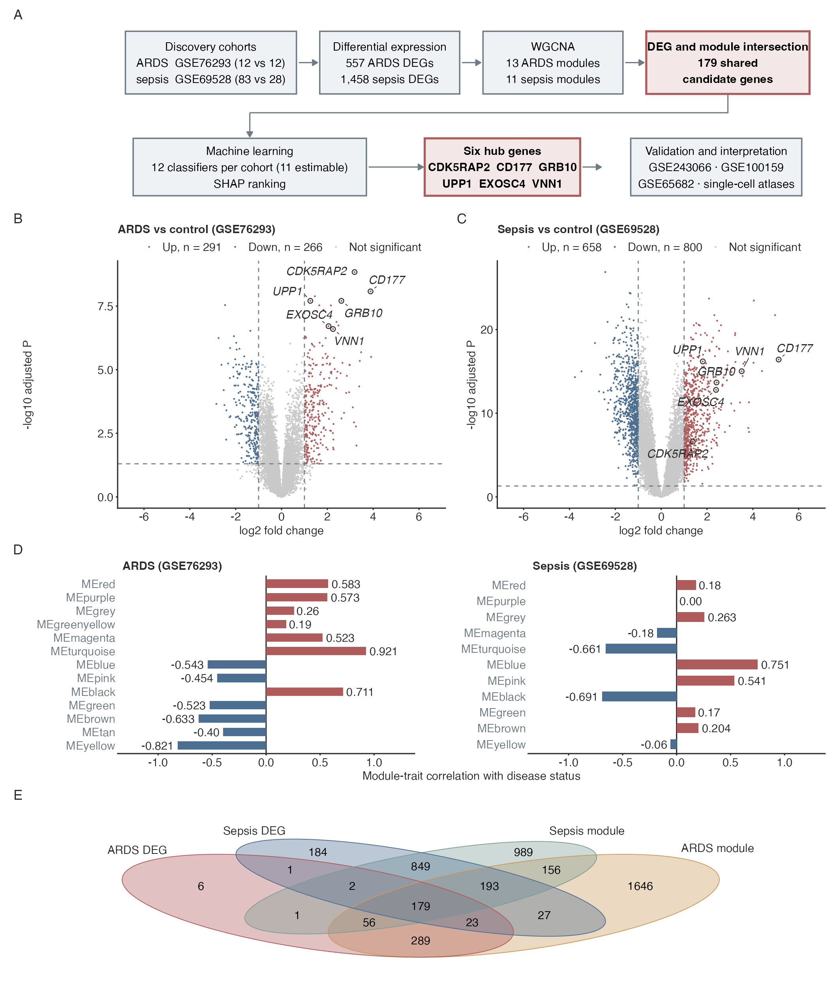
Figure 2
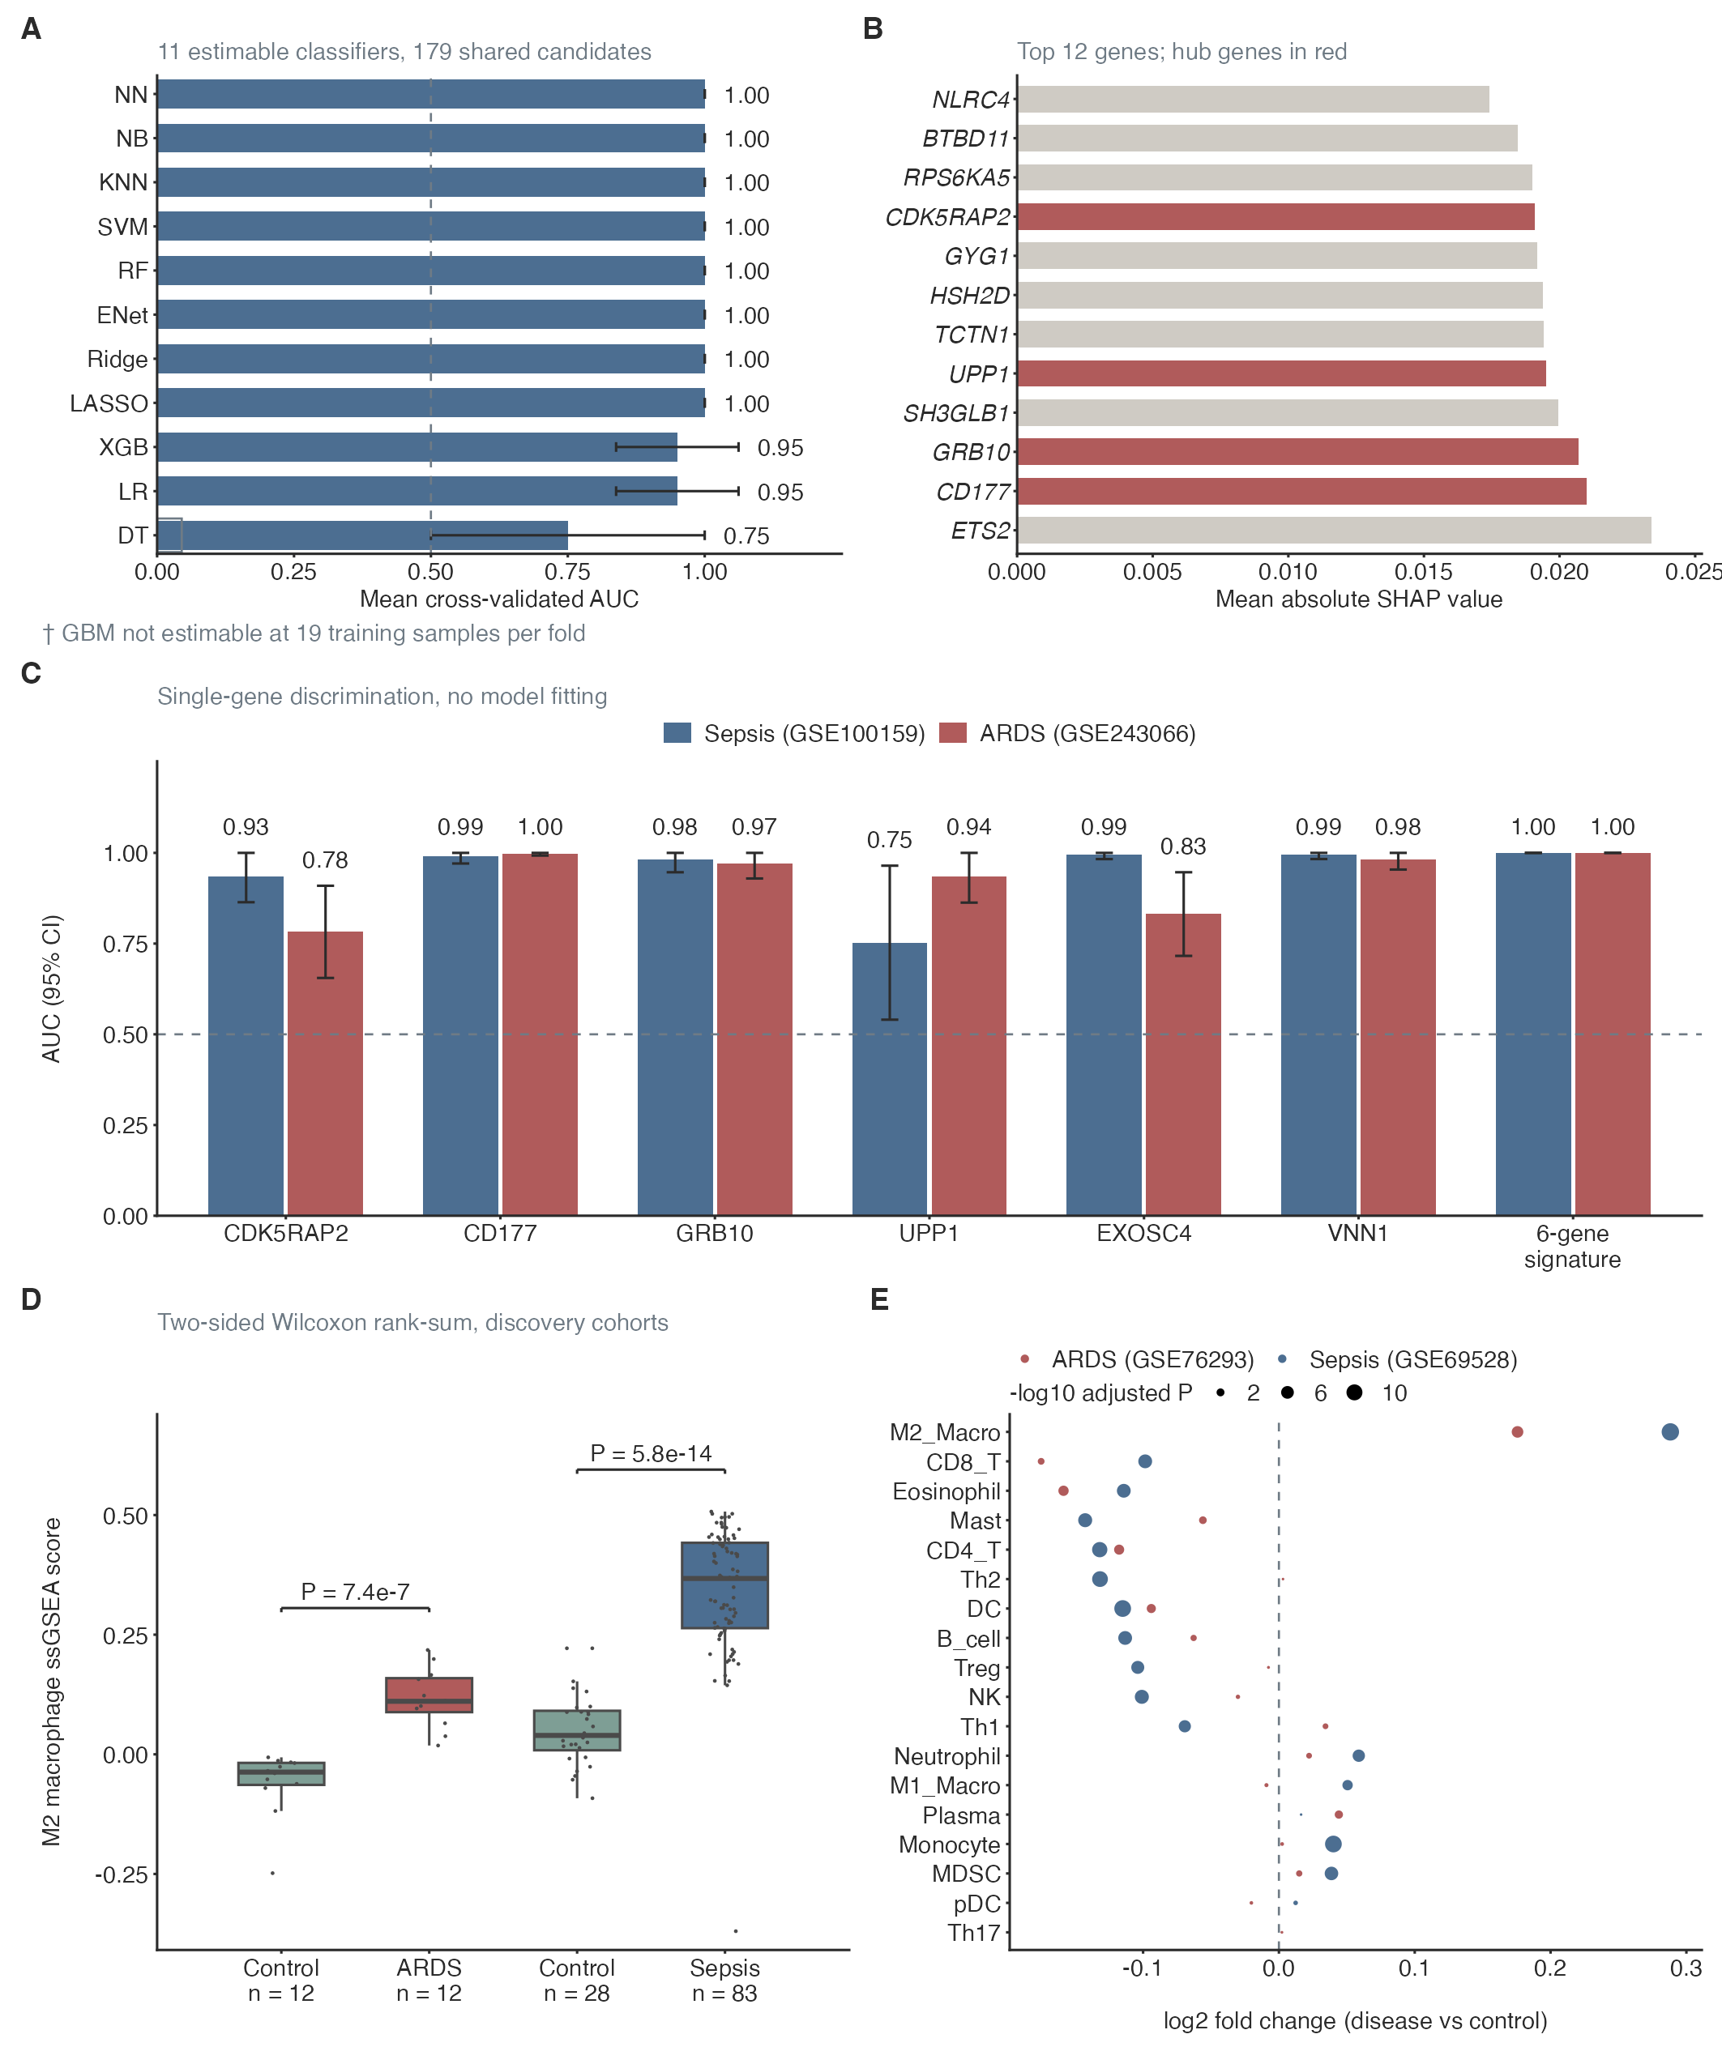
Figure 3
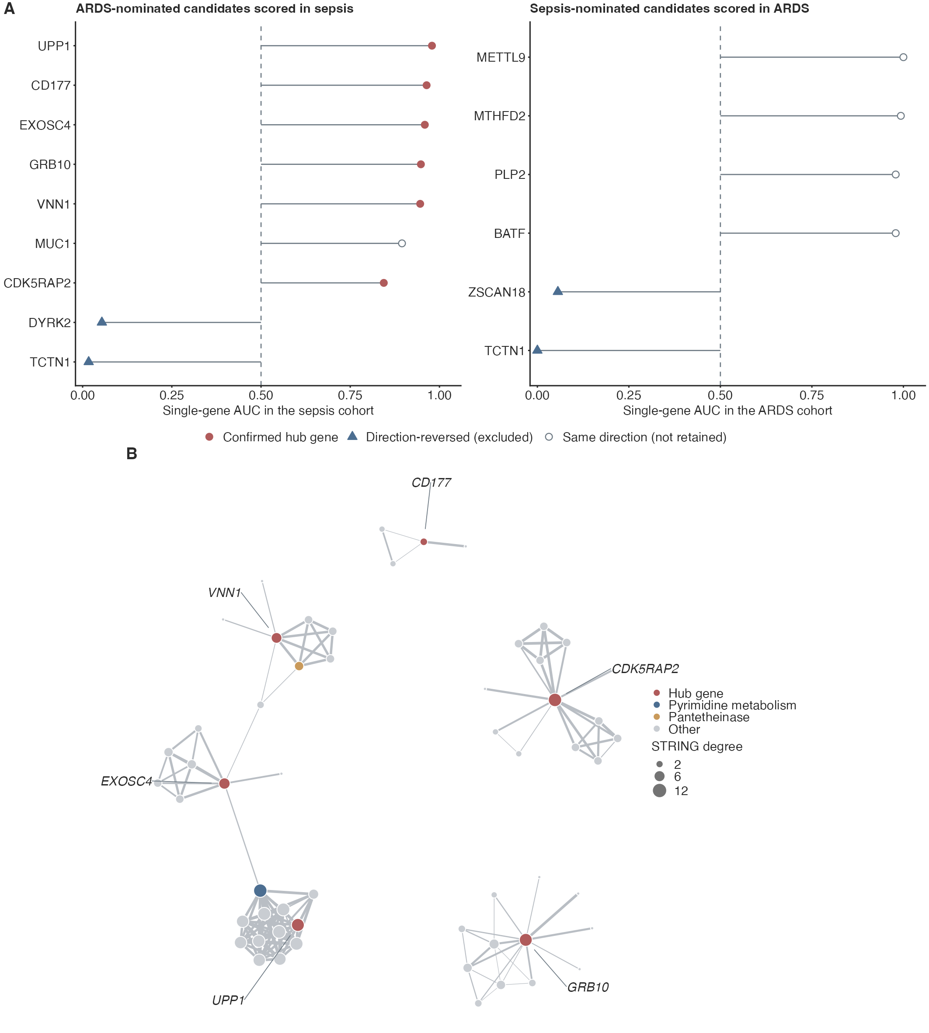

Figure 4
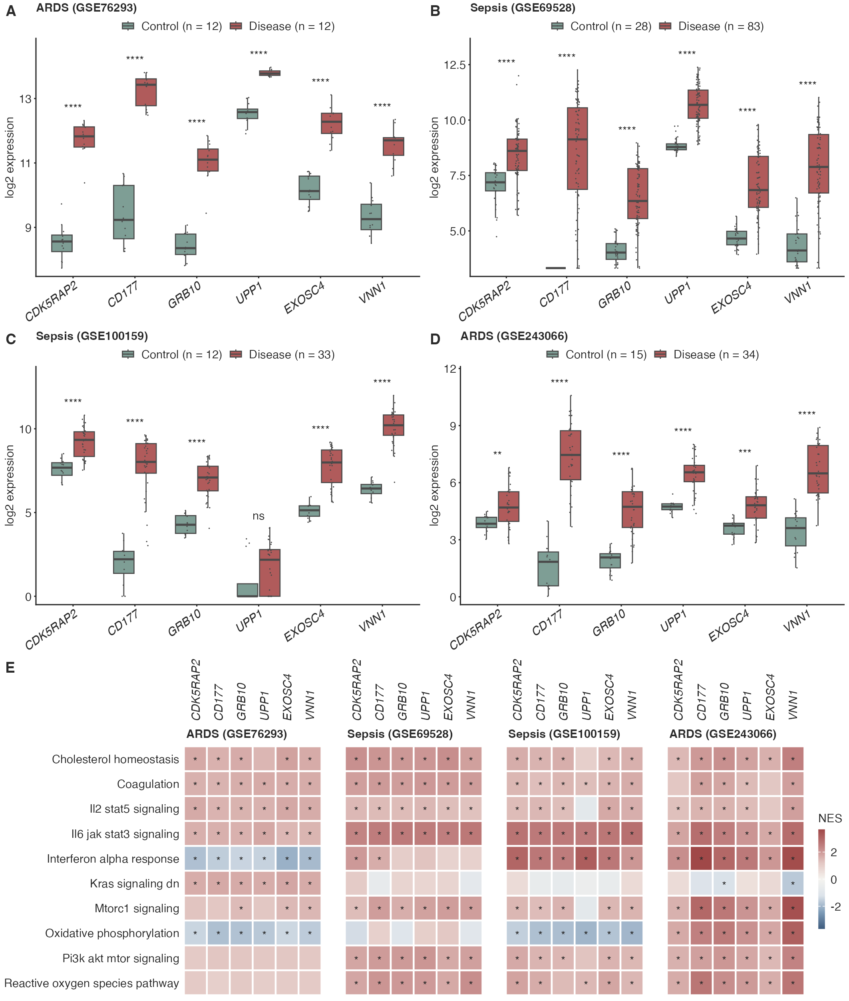

Figure 5
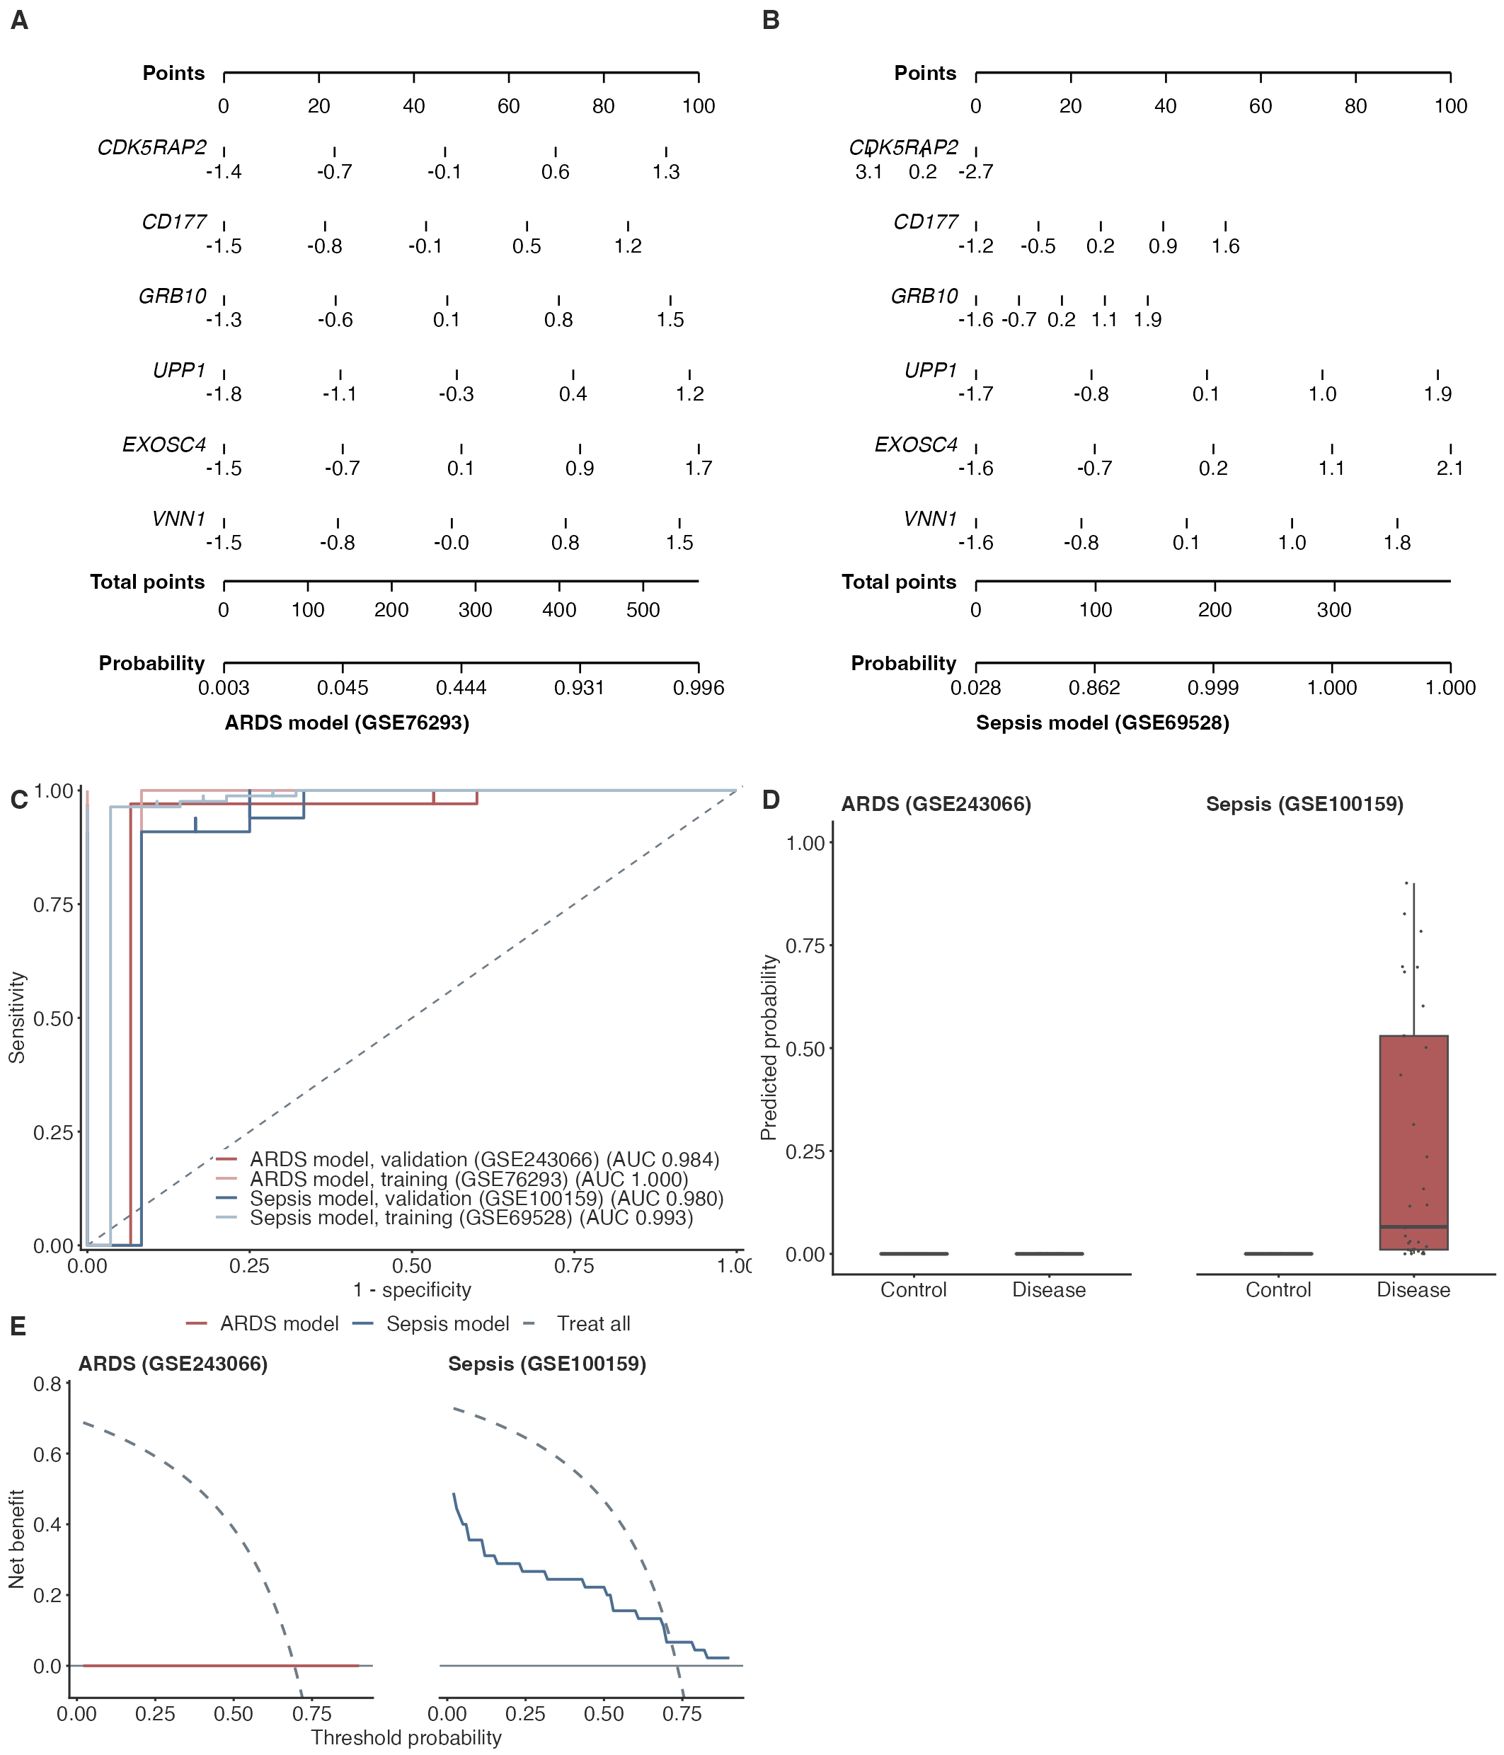

Figure 6
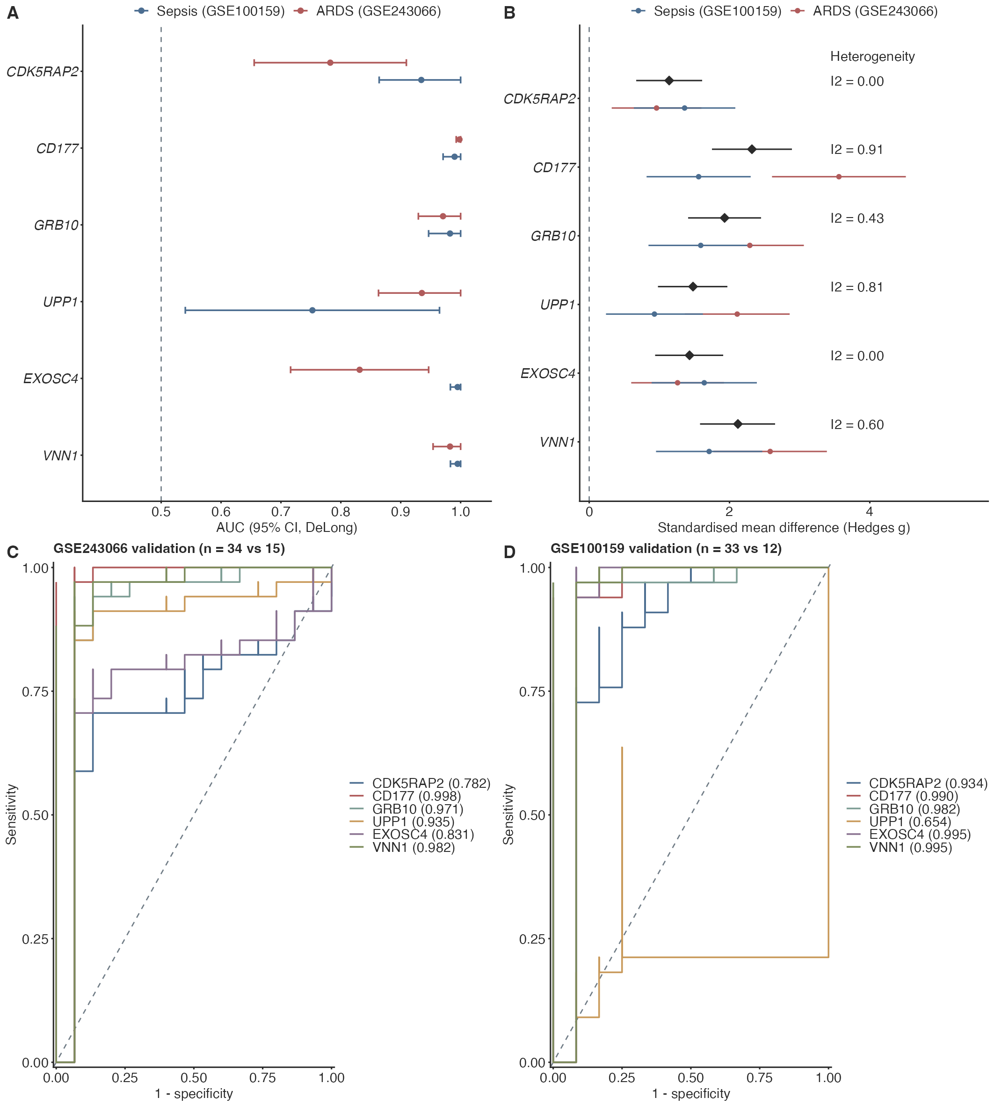

Figure 7
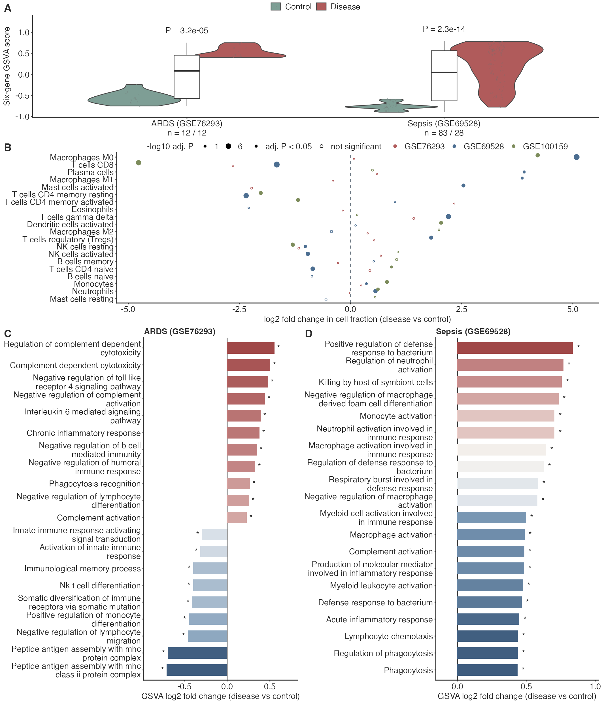
Figure 8
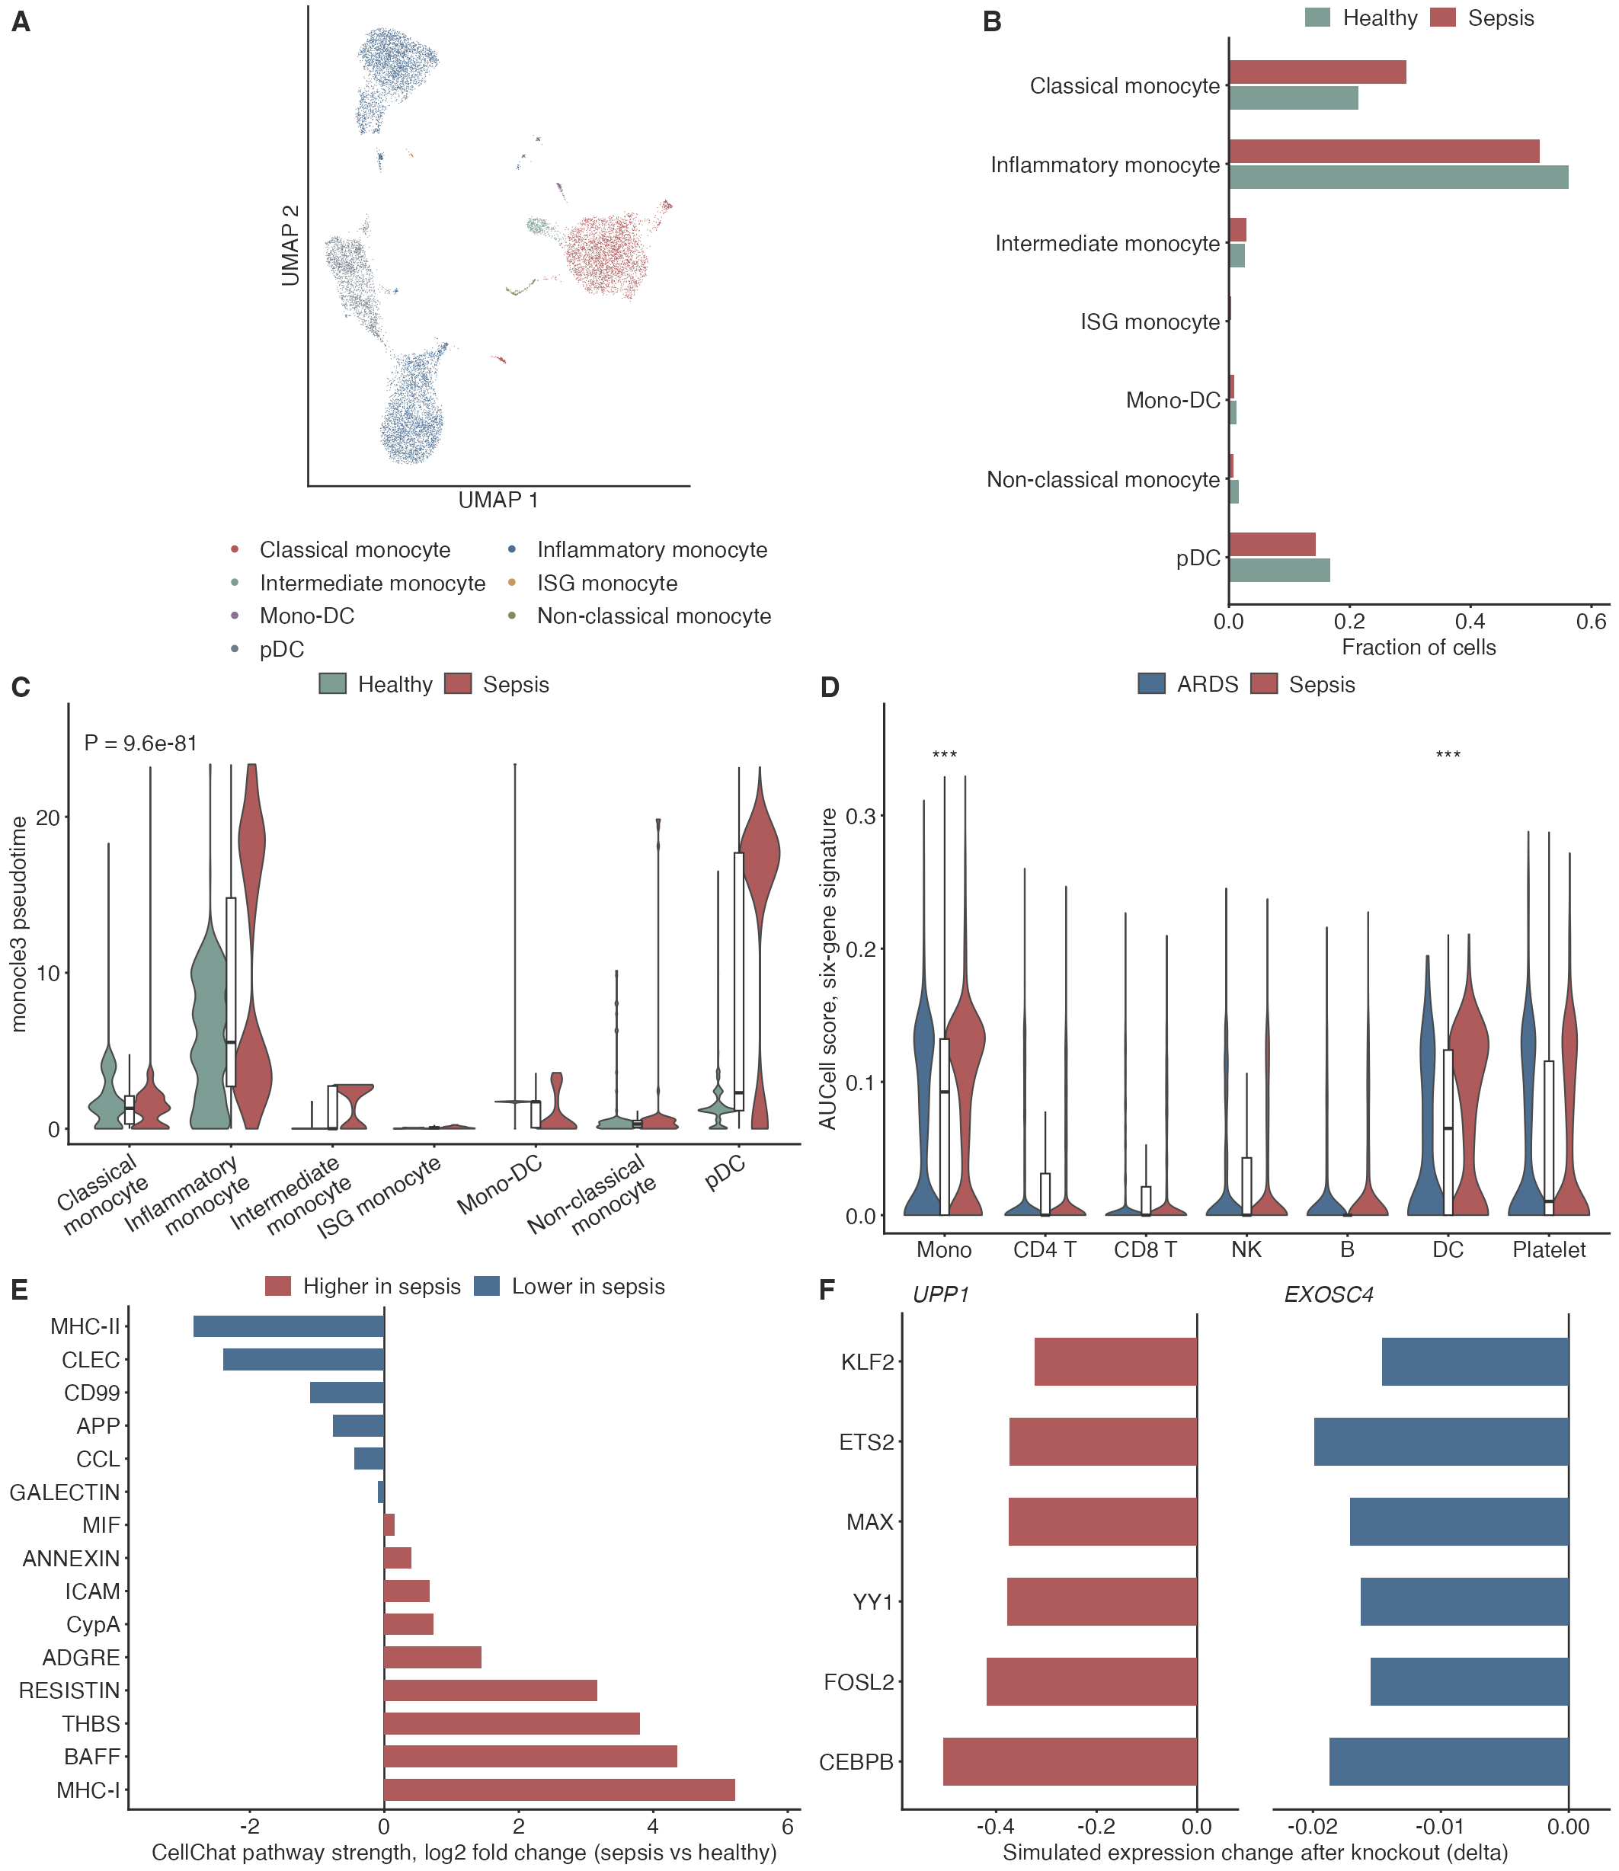
Figure 9
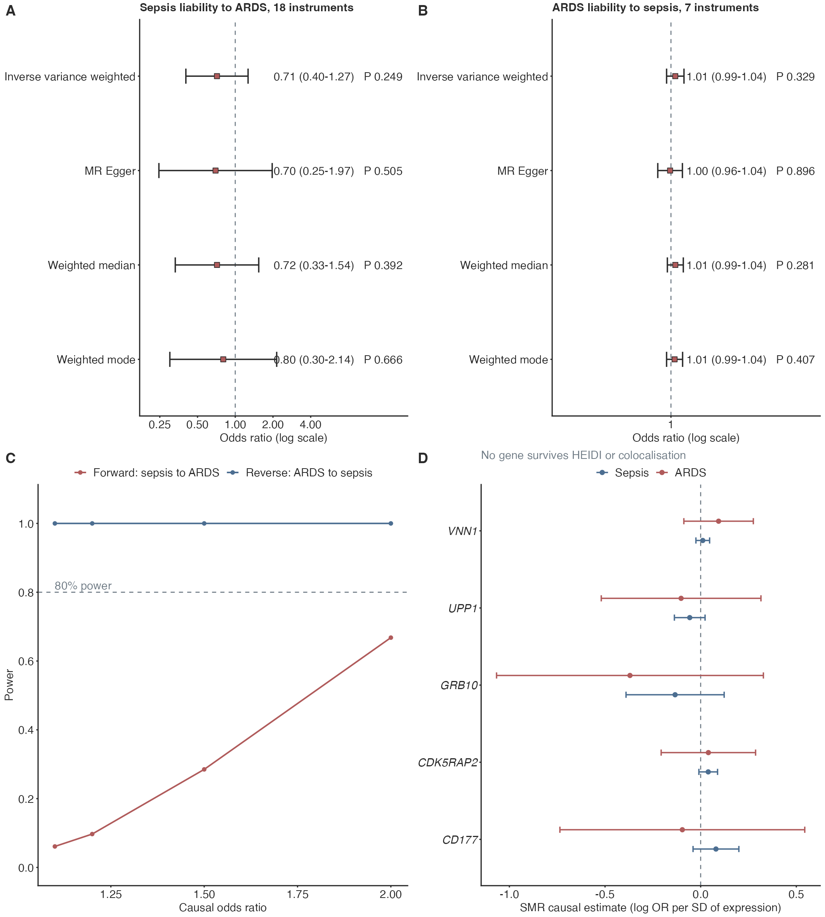

Figure 10


