# DonkeyCar代码整理

本文档主要整理GitHub项目【1】中donkeycar V2.2.1版本的代码。采用自顶向下的分析方法，模拟程序的跳转流程依次分析。

## 测试脚本：

|  |
| --- |
| from donkeycar import Vehicle  from donkeycar.parts.camera import PiCamera  from donkeycar.parts.datastore import Tub  V = Vehicle()  #add a camera part  cam = PiCamera()  V.add(cam, outputs=['image'], threaded=True)  #add tub part to record images  tub = Tub(path='~/d2/gettings_started',  inputs=['image'],  types=['image_array'])  V.add(tub, inputs=['image'])  #start the drive loop at 10 Hz  V.start(rate_hz=10) |



# 程序入口manage.py

安装好小车之后，进入系统，用命令donkey createcar –path ~/d2在本地文件夹下创建d2文件夹，这就是小车的根目录，建好之后会有一个manage.py文件，就是小车的启动入口。

通过命令 python manage.py drive可以启动小车。所以这一部分文档就来分析manage.py drive这个接口,manage.py的另一个接口是python manage.py train用来训练小车。

可先看一下驾驶小车时的入口程序：

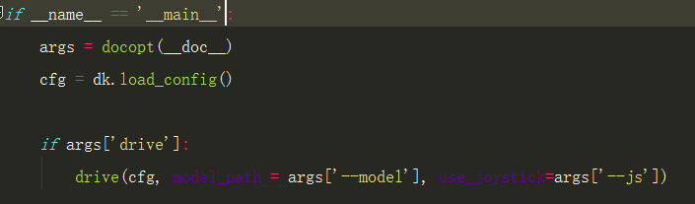

其中dk.load_config()是donkeycar目录下的config.py中的load_config（）函数。主要作用是从main目录下（即d2下的）config.py获取配置信息，并把配置信息以key-value对的形式设置为cfg的属性。

然后看一下drive函数

## Drive (cfg, model_path=None, use_joystick=False)

首先实例化小车：



加载摄像头：



其中PiCamera（）函数来自于引入的包文件donkeycar.parts.camera 具体见【附录1】

确定控制器，并加入小车的循环控制系统：

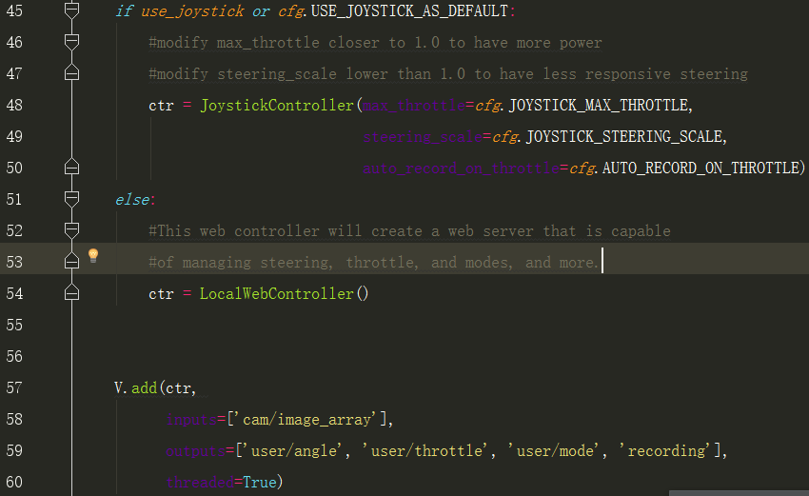

本案例中使用的LocalWebController()，详细见附录【2】

判断驾驶模式，并将驾驶模式的判断函数封装成小车的一个模块（Lambda()函数实现）：

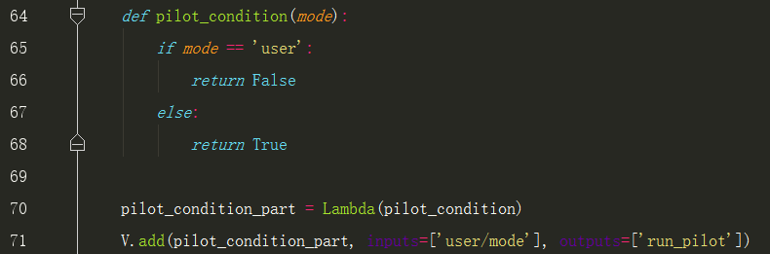

判断是否需要自动驾驶，如果需要，加入自动驾驶模式，可以对比启动自动驾驶的命令

python manage.py drive --model ~/d2/models/mypilot：

注意上述代码中的mode==’user’的mode是其input中的‘user/model’中的mode，也即ctr模块的outputs中的‘user/mode’。

以下是加载自动驾驶模块，如果需要修改模型，就是修改这部分的内容，即kl = KerasCategorical(),关于KerasCategorical()下文会有叙述。见附录【7】

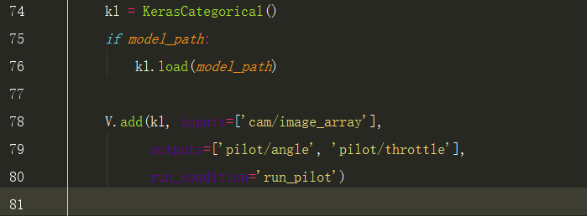

确定驾驶模式，并封装成小车模块（Lambda()函数实现，Lambda函数见附录【3】）：

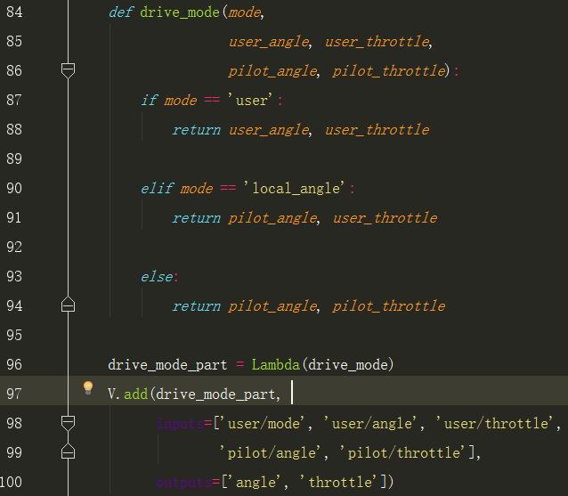

小车马达控制，这部分之后的都不用改，也不用关心怎么实现的，就是pca的驱动接口。

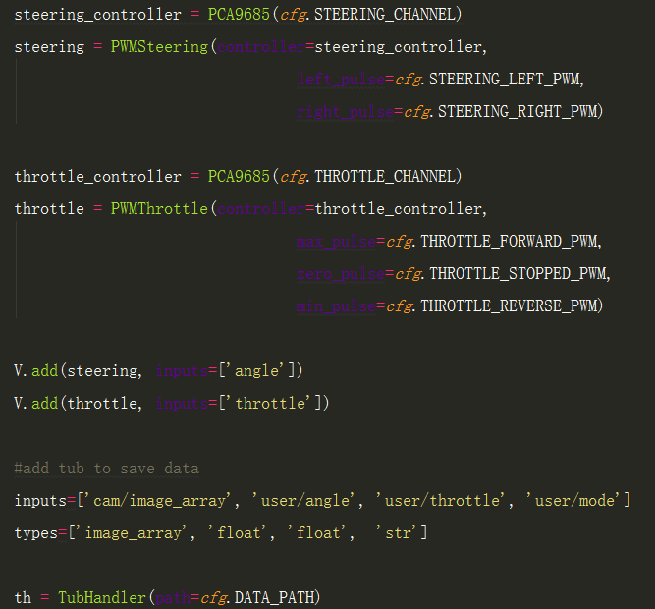

## train(cfg, tub_names, model_name):

利用tub_name中的数据训练模型并存储在model_name中，

*def* train(*cfg*, *tub_names*, *model_name*):  
 '''  
 use the specified data in tub_names to train an artifical neural network  
 saves the output trained model as model_name  
 '''  
 X_keys = ['cam/image_array']  
 y_keys = ['user/angle', 'user/throttle']  
  
 *def* rt(*record*):  
 *record*['user/angle'] = dk.utils.linear_bin(*record*['user/angle'])  
 *return record* kl = KerasCategorical()  
 *print*('tub_names', *tub_names*)  
 *if not tub_names*:  
 tub_names = os.path.join(*cfg*.DATA_PATH, '*')  
 tubgroup = TubGroup(*tub_names*)  
 train_gen, val_gen = tubgroup.get_train_val_gen(X_keys, y_keys, record_transform=rt,  
 batch_size=*cfg*.BATCH_SIZE,  
 train_frac=*cfg*.TRAIN_TEST_SPLIT)  
  
 model_path = os.path.expanduser(*model_name*)  
  
 total_records = len(tubgroup.df)  
 total_train = int(total_records * *cfg*.TRAIN_TEST_SPLIT)  
 total_val = total_records - total_train  
 *print*('train: %d, validation: %d' % (total_train, total_val))  
 steps_per_epoch = total_train // *cfg*.BATCH_SIZE  
 *print*('steps_per_epoch', steps_per_epoch)  
  
 kl.train(train_gen,  
 val_gen,  
 saved_model_path=model_path,  
 steps=steps_per_epoch,  
 train_split=*cfg*.TRAIN_TEST_SPLIT)

# 引用

1. <https://github.com/wroscoe/donkey/>

# 附录【1】donkeycar.parts.camera

附录1主要介绍donkeycar.parts.camera



# 附录【2】LocalWebController

附录2主要介绍LocalWebController()

LocalWebController的位置在donkeycar.parts.web_controller.web中，是一个用Tornado框架写的网络服务器，







# 附录【3】Lambda

附录【3】主要介绍将函数封装成小车模块的Lambda类:

|  |
| --- |
| class Lambda:  """  Wraps a function into a donkey part.  """  def __init__(self, f):  """  Accepts the function to use.  """  self.f = f    def run(self, *args, **kwargs):  return self.f(*args, **kwargs)    def shutdown(self):  return |

关于*args, **kwargs，用于当参数类型和参数个数不确定的时候使用，*args, 是一个元组类型的，**kwargs是字典类型的。

# 附录【4】PCA9685

附录【4】主要介绍类PCA9685，主要用于控制马达

# 附录【5】TubGroup()

附录【5】主要用于介绍TubGroup()，数据存储格式

TubGroup的父类时Tub(),

*def* get_train_val_gen(self, *X_keys*, *Y_keys*, *batch_size*=128, *record_transform*=None, *train_frac*=.8):  
 train_df = train=self.df.sample(frac=*train_frac*,random_state=200)  
 val_df = self.df.drop(train_df.index)  
  
 train_gen = self.get_train_gen(X_keys=*X_keys*, Y_keys=*Y_keys*, batch_size=*batch_size*,  
 record_transform=*record_transform*, df=train_df)  
  
 val_gen = self.get_train_gen(X_keys=*X_keys*, Y_keys=*Y_keys*, batch_size=*batch_size*,  
 record_transform=*record_transform*, df=val_df)  
  
 *return* train_gen, val_gen

|  |
| --- |
| def get_train_gen(self, X_keys, Y_keys, batch_size=128, record_transform=None, df=None):  batch_gen = self.get_batch_gen(X_keys + Y_keys,  batch_size=batch_size, record_transform=record_transform, df=df)  while True:  batch = next(batch_gen)  X = [batch[k] for k in X_keys]  Y = [batch[k] for k in Y_keys]  yield X, Y |

|  |
| --- |
| *def* get_batch_gen(self, *keys*, *record_transform*=None, *batch_size*=128, *shuffle*=True, *df*=None):   record_gen = self.get_record_gen(*record_transform*, shuffle=*shuffle*, df=*df*)   *if keys* == None:  keys = list(self.df.columns)   *while* True:  record_list = []  *for* _ *in* range(*batch_size*):  record_list.append(next(record_gen))   batch_arrays = {}  *for* i, k *in* enumerate(*keys*):  arr = np.array([r[k] *for* r *in* record_list])  # if len(arr.shape) == 1:  # arr = arr.reshape(arr.shape + (1,))  batch_arrays[k] = arr   *yield* batch_arrays |

|  |
| --- |
| def get_record_gen(self, record_transform=None, shuffle=True, df=None):  if df is None:  df = self.get_df()  while True:  for row in self.df.iterrows():  if shuffle:  record_dict = df.sample(n=1).to_dict(orient='record')[0]  if record_transform:  record_dict = record_transform(record_dict)  record_dict = self.read_record(record_dict)  yield record_dict |

meta.json格式如下：

{  
    **"types"**:[  
        **"image_array"**,  
        **"float"**,  
        **"float"**,  
        **"str"**  
    ],  
    **"inputs"**:[  
        **"cam/image_array"**,  
        **"user/angle"**,  
        **"user/throttle"**,  
        **"user/mode"**  
    ]  
}

Record.json格式如下：

{  
    **"cam/image_array"**:**"1_cam-image_array_.jpg"**,  
    **"user/angle"**:**-8.326672684688674e-17**,  
    **"user/throttle"**:**-3.191891195797325e-16**,  
    **"user/mode"**:**"user"**  
}

# 附录【6】KerasPilot()

附录【6】主要介绍KerasPilot()，机器学习的算法类

*class* KerasCategorical(KerasPilot):  
 *def __init__*(self, *model*=None, *\**args, *\*\**kwargs):  
 super(KerasCategorical, self).__init__(\**args*, \*\**kwargs*)  
 *if model*:  
 self.model = *model  
 else*:  
 self.model = default_categorical()  
   
 *def* run(self, *img_arr*):  
 img_arr = *img_arr*.reshape((1,) + *img_arr*.shape)  
 angle_binned, throttle = self.model.predict(*img_arr*)  
 #print('throttle', throttle)  
 #angle_certainty = max(angle_binned[0])  
 angle_unbinned = dk.utils.linear_unbin(angle_binned)  
 *return* angle_unbinned, throttle[0][0]

|  |
| --- |
| class KerasPilot():    def load(self, model_path):  self.model = keras.models.load_model(model_path)    def shutdown(self):  pass    def train(self, train_gen, val_gen,  saved_model_path, epochs=100, steps=100, train_split=0.8,  verbose=1, min_delta=.0005, patience=5, use_early_stop=True):    """  train_gen: generator that yields an array of images an array of    """  #checkpoint to save model after each epoch  save_best = keras.callbacks.ModelCheckpoint(saved_model_path,  monitor='val_loss',  verbose=verbose,  save_best_only=True,  mode='min')    #stop training if the validation error stops improving.  early_stop = keras.callbacks.EarlyStopping(monitor='val_loss',  min_delta=min_delta,  patience=patience,  verbose=verbose,  mode='auto')    callbacks_list = [save_best]  if use_early_stop:  callbacks_list.append(early_stop)    hist = self.model.fit_generator(  train_gen,  steps_per_epoch=steps,  epochs=epochs,  verbose=1,  validation_data=val_gen,  callbacks=callbacks_list,  validation_steps=steps*(1.0 - train_split))  return hist |

*def* default_categorical():  
 *from* keras.layers *import* Input, Dense, merge  
 *from* keras.models *import* Model  
 *from* keras.layers *import* Convolution2D, MaxPooling2D, Reshape, BatchNormalization  
 *from* keras.layers *import* Activation, Dropout, Flatten, Dense  
   
 img_in = Input(shape=(120, 160, 3), name='img_in') # First layer, input layer, Shape comes from camera.py resolution, RGB  
 x = img_in  
 x = Convolution2D(24, (5,5), strides=(2,2), activation='relu')(x) # 24 features, 5 pixel x 5 pixel kernel (convolution, feauture) window, 2wx2h stride, relu activation  
 x = Convolution2D(32, (5,5), strides=(2,2), activation='relu')(x) # 32 features, 5px5p kernel window, 2wx2h stride, relu activatiion  
 x = Convolution2D(64, (5,5), strides=(2,2), activation='relu')(x) # 64 features, 5px5p kernal window, 2wx2h stride, relu  
 x = Convolution2D(64, (3,3), strides=(2,2), activation='relu')(x) # 64 features, 3px3p kernal window, 2wx2h stride, relu  
 x = Convolution2D(64, (3,3), strides=(1,1), activation='relu')(x) # 64 features, 3px3p kernal window, 1wx1h stride, relu  
  
 # Possibly add MaxPooling (will make it less sensitive to position in image). Camera angle fixed, so may not to be needed  
  
 x = Flatten(name='flattened')(x) # Flatten to 1D (Fully connected)  
 x = Dense(100, activation='relu')(x) # Classify the data into 100 features, make all negatives 0  
 x = Dropout(.1)(x) # Randomly drop out (turn off) 10% of the neurons (Prevent overfitting)  
 x = Dense(50, activation='relu')(x) # Classify the data into 50 features, make all negatives 0  
 x = Dropout(.1)(x) # Randomly drop out 10% of the neurons (Prevent overfitting)  
 #categorical output of the angle  
 angle_out = Dense(15, activation='softmax', name='angle_out')(x) # Connect every input with every output and output 15 hidden units. Use Softmax to give percentage. 15 categories and find best one based off percentage 0.0-1.0  
   
 #continous output of throttle  
 throttle_out = Dense(1, activation='relu', name='throttle_out')(x) # Reduce to 1 number, Positive number only  
   
 model = Model(inputs=[img_in], outputs=[angle_out, throttle_out])  
 model.compile(optimizer='adam',  
 loss={'angle_out': 'categorical_crossentropy',   
 'throttle_out': 'mean_absolute_error'},  
 loss_weights={'angle_out': 0.9, 'throttle_out': .001})  
  
 *return* model

|  |
| --- |
| def save_model(model, filepath, overwrite=True, include_optimizer=True):  """Save a model to a HDF5 file.  Note: Please also see  [How can I install HDF5 or h5py to save my models in Keras?](  /getting-started/faq/  #how-can-i-install-HDF5-or-h5py-to-save-my-models-in-Keras)  in the FAQ for instructions on how to install `h5py`.  The saved model contains:  - the model's configuration (topology)  - the model's weights  - the model's optimizer's state (if any)  Thus the saved model can be reinstantiated in  the exact same state, without any of the code  used for model definition or training.  # Arguments  model: Keras model instance to be saved.  filepath: one of the following:  - string, path where to save the model, or  - h5py.File object where to save the model  overwrite: Whether we should overwrite any existing  model at the target location, or instead  ask the user with a manual prompt.  include_optimizer: If True, save optimizer's state together.  # Raises  ImportError: if h5py is not available.  """  if h5py is None:  raise ImportError('`save_model` requires h5py.')  def get_json_type(obj):  """Serialize any object to a JSON-serializable structure.  # Arguments  obj: the object to serialize  # Returns  JSON-serializable structure representing `obj`.  # Raises  TypeError: if `obj` cannot be serialized.  """  # if obj is a serializable Keras class instance  # e.g. optimizer, layer  if hasattr(obj, 'get_config'):  return {'class_name': obj.__class__.__name__,  'config': obj.get_config()}  # if obj is any numpy type  if type(obj).__module__ == np.__name__:  if isinstance(obj, np.ndarray):  return {'type': type(obj),  'value': obj.tolist()}  else:  return obj.item()  # misc functions (e.g. loss function)  if callable(obj):  return obj.__name__  # if obj is a python 'type'  if type(obj).__name__ == type.__name__:  return obj.__name__  raise TypeError('Not JSON Serializable:', obj)  from .. import __version__ as keras_version  if not isinstance(filepath, h5py.File):  # If file exists and should not be overwritten.  if not overwrite and os.path.isfile(filepath):  proceed = ask_to_proceed_with_overwrite(filepath)  if not proceed:  return  f = h5py.File(filepath, mode='w')  opened_new_file = True  else:  f = filepath  opened_new_file = False  try:  f.attrs['keras_version'] = str(keras_version).encode('utf8')  f.attrs['backend'] = K.backend().encode('utf8')  f.attrs['model_config'] = json.dumps({  'class_name': model.__class__.__name__,  'config': model.get_config()  }, default=get_json_type).encode('utf8')  model_weights_group = f.create_group('model_weights')  model_layers = model.layers  save_weights_to_hdf5_group(model_weights_group, model_layers)  if include_optimizer and model.optimizer:  if isinstance(model.optimizer, optimizers.TFOptimizer):  warnings.warn(  'TensorFlow optimizers do not '  'make it possible to access '  'optimizer attributes or optimizer state '  'after instantiation. '  'As a result, we cannot save the optimizer '  'as part of the model save file.'  'You will have to compile your model again '  'after loading it. '  'Prefer using a Keras optimizer instead '  '(see keras.io/optimizers).')  else:  f.attrs['training_config'] = json.dumps({  'optimizer_config': {  'class_name': model.optimizer.__class__.__name__,  'config': model.optimizer.get_config()  },  'loss': model.loss,  'metrics': model.metrics,  'sample_weight_mode': model.sample_weight_mode,  'loss_weights': model.loss_weights,  }, default=get_json_type).encode('utf8')  # Save optimizer weights.  symbolic_weights = getattr(model.optimizer, 'weights')  if symbolic_weights:  optimizer_weights_group = f.create_group(  'optimizer_weights')  weight_values = K.batch_get_value(symbolic_weights)  weight_names = []  for i, (w, val) in enumerate(zip(symbolic_weights,  weight_values)):  # Default values of symbolic_weights is /variable  # for Theano and CNTK  if K.backend() == 'theano' or K.backend() == 'cntk':  if hasattr(w, 'name'):  if w.name.split('/')[-1] == 'variable':  name = str(w.name) + '_' + str(i)  else:  name = str(w.name)  else:  name = 'param_' + str(i)  else:  if hasattr(w, 'name') and w.name:  name = str(w.name)  else:  name = 'param_' + str(i)  weight_names.append(name.encode('utf8'))  optimizer_weights_group.attrs[  'weight_names'] = weight_names  for name, val in zip(weight_names, weight_values):  param_dset = optimizer_weights_group.create_dataset(  name,  val.shape,  dtype=val.dtype)  if not val.shape:  # scalar  param_dset[()] = val  else:  param_dset[:] = val  f.flush()  finally:  if opened_new_file:  f.close() |

# 附录【7】KerasCategorica

附录【7】主要介绍KerasCategorical在小车运行时的输出的信号:

小车运行时，Keras模块的作用主要是根据训练的模型生成控制信号，从manage.py文件的一下代码：

|  |
| --- |
| kl = KerasCategorical() *if model_path*:  kl.load(*model_path*)  V.add(kl, inputs=['cam/image_array'],   outputs=['pilot/angle', 'pilot/throttle'],  run_condition='run_pilot') |

|  |
| --- |
| def load(self, model_path):  self.model = keras.models.load_model(model_path) |

可以看出，当有训练好的模型时，小车首先根据位置载入模型，在小车调用start函数的时候将输出信号输出到'pilot/angle', 'pilot/throttle'中，而实现的过程就是该模块的run方法。

|  |
| --- |
| *def* run(self, *img_arr*):  img_arr = *img_arr*.reshape((1,) + *img_arr*.shape)  angle_binned, throttle = self.model.predict(*img_arr*)  #print('throttle', throttle)  #angle_certainty = max(angle_binned[0])  angle_unbinned = dk.utils.linear_unbin(angle_binned)  *return* angle_unbinned, throttle[0][0] |

如上所示，run方法中输出结果的来源主要是model.predict函数，查看Keras Model.predict的源码可以知道，该函数主要的作用就是根据模型和输入信息给出一个预测结果。

# 附录【8】Vehicle()

附录【8】主要介绍一下小车的架构，整体来说，小车提供了一个平台，任何符合接口规

范的模块都可以加载上去，类似于一个支持组件插拔的架构。组织形式类似下图：

黑色部分是小车目前已有的模块，红色部分是如果想要对小车进行扩展可以采取的方案：

编写插件代码，将对应需要交互的数据写进memory，在需要调用的地方直接访问这些数据就行。类似于共享内存区的生产者消费者模型。



以下是UML图



### Vehicle.__init__():

初始化函数，主要声明并初始化了成员变量self.mem, self.parts, self.on, self.threads，

self.parts包含了目前小车所有需要运行的部件

|  |
| --- |
| def __init__(self, mem=None):  if not mem:  mem = Memory()  self.mem = mem  self.parts = []  self.on = True  self.threads = [] |

#### Memory()



### Vehicle.add():

主要是用于将摄像头、驱动单元等部件加载到小车的循环控制单元中，代码中表示主要是将部件信息加载到self.parts中。

参数part, inputs=[], outputs=[], threaded=False, run_condition=None

part 部件名称

inputs 从内存中获取数据的通道名列表

outputs 往内存中存储数据时的通道名列表

threaded 表示该部分代码是否需要单独的线程来运行

### Vehicle.start():

故名思议，开启小车的循环控制代码。是小车的主要线程，将开启在self.parts中的所有部件以及子线程，然后初始化运行的各个部件并定期刷新内存。

主要参数：rate_hz=10, max_loop_count=None

rate_hz：整型数,表示控制循环应该运行的最大频率，当有很多障碍是实际的运行速率会比这个低。

max_loop_count：整型数，表示控制循环要运行的最大次数，用于测试小车的各个部件是否工作。



### Vehicle. update_parts ()：

刷新self.parts中的部件信息

主要代码：在for循环中运行

|  |
| --- |
| p = entry['part']  #从内存中获取输入  inputs = self.mem.get(entry['inputs'])  #运行输入的信息  if entry.get('thread'):  outputs = p.run_threaded(*inputs)  else:  outputs = p.run(*inputs)  #将输出结果保存到outputs里  if outputs is not None:  self.mem.put(entry['outputs'], outputs) |

附录【9】