**关于测试多周期CPU的简单方法**

编写一个简单的排序程序。将4个未排序的个位数预先放入数据存储器连续的4个固定地址中。当编码开关为1：1时，将这4个固定地址的值在LED数码管上显示，检查时需要能观察到动态的排序过程。

编写程序时需要将排序过程封装为过程，并用 jal 和jr 指令调用和返回主程序。

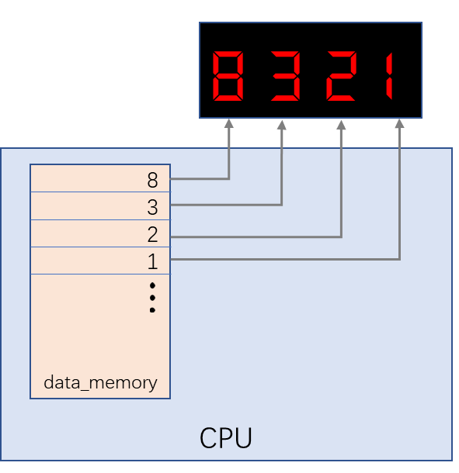

**（特别说明：本表每个同学都必须建立，检查实验时，必须提供！）**

1、测试程序段

|  |  |  |  |  |  |  |  |
| --- | --- | --- | --- | --- | --- | --- | --- |
| **地址** | **汇编程序** | **指令代码** | | | | | |
| **op（6）** | **rs(5)** | **rt(5)** | **rd(5)/immediate (16)** | **16进制数代码** | |
| **0x00000000** | addiu $1,$0,2 | **001001** | **00000** | **00001** | **0000000000000010** | **=** | 24010002 |
| **0x00000004** | addiu $2,$0,8 | 001001 | 00000 | 00010 | 0000000000001000 |  | 24020008 |
| **0x00000008** | addiu $3,$0,4 | 001001 | 00000 | 00011 | 0000000000000100 |  | 24030004 |
| **0x0000000C** | addiu $4,$0,1 | 001001 | 00000 | 00100 | 0000000000000001 |  | 24040001 |
| **0x00000010** | sw $1,0($0) |  |  |  |  |  |  |
| **0x00000014** | sw $2,4($0) |  |  |  |  |  |  |
| **0x00000018** | sw $3,8($0) |  |  |  |  |  |  |
| **0x0000001C** | sw $4,12($0) |  |  |  |  |  |  |
| **0x00000020** | jal 0x28 |  |  |  |  |  |  |
| **0x00000024** | halt |  |  |  |  |  |  |
| **0x00000028** | addiu $1,$0,0 |  |  |  |  |  |  |
| **0x0000002C** | addiu $2,$0,5 |  |  |  |  |  |  |
| **0x00000030** | addiu $1,$1,1 |  |  |  |  |  |  |
| **0x00000034** | bne $1,$2,1 |  |  |  |  |  |  |
| **0x00000038** | jr $31 |  |  |  |  |  |  |
| **0x0000003C** | addiu $3,$0,-4 |  |  |  |  |  |  |
| **0x00000040** | addiu $4,$0,8 |  |  |  |  |  |  |
| **0x00000044** | addiu $3,$3,4 |  |  |  |  |  |  |
| **0x00000048** | bne $3,$4,1 |  |  |  |  |  |  |
| **0x0000004C** | j 0x30 |  |  |  |  |  |  |
| **0x00000050** | lw $5,0($3) |  |  |  |  |  |  |
| **0x00000054** | lw $6,4($3) |  |  |  |  |  |  |
| **0x00000058** | slt $7,$5,$6 |  |  |  |  |  |  |
| **0x0000005C** | bne $7,$0,1 |  |  |  |  |  |  |
| **0x00000060** | j 0x44 |  |  |  |  |  |  |
| **0x00000064** | sw $6,0($3) |  |  |  |  |  |  |
| **0x00000068** | sw $5,4($3) |  |  |  |  |  |  |
| **0x0000006C** | j 0x44 |  |  |  |  |  |  |
| **0x00000070** |  |  |  |  |  |  |  |
| **0x00000074** |  |  |  |  |  |  |  |
| **0x00000078** |  |  |  |  |  |  |  |
| **0x0000007C** |  |  |  |  |  |  |  |
| **0x00000080** |  |  |  |  |  |  |  |
| **0x00000084** |  |  |  |  |  |  |  |
| **0x00000088** |  |  |  |  |  |  |  |
| **0x0000008C** |  |  |  |  |  |  |  |
| **0x00000090** |  |  |  |  |  |  |  |
| **0x00000094** |  |  |  |  |  |  |  |
| **0x00000098** |  |  |  |  |  |  |  |
| **0x0000009C** |  |  |  |  |  |  |  |
| **0x000000A0** |  |  |  |  |  |  |  |
| **0x000000A4** |  |  |  |  |  |  |  |
| **0x000000A8** |  |  |  |  |  |  |  |
| **0x000000AC** |  |  |  |  |  |  |  |
| **0x000000B0** |  |  |  |  |  |  |  |
| **0x000000B4** |  |  |  |  |  |  |  |
| **0x000000B8** |  |  |  |  |  |  |  |
| **0x000000BC** |  |  |  |  |  |  |  |
| **0x000000C0** |  |  |  |  |  |  |  |
| **0x000000C4** |  |  |  |  |  |  |  |

**00001100000000000000000000001010**

**00000011111000000000000000001000**

j 0x30

**00001000000000000000000000001100**

j 0x44

**00001000000000000000000000010001**

**00000000000000000000000**

**000000000000000000000000**