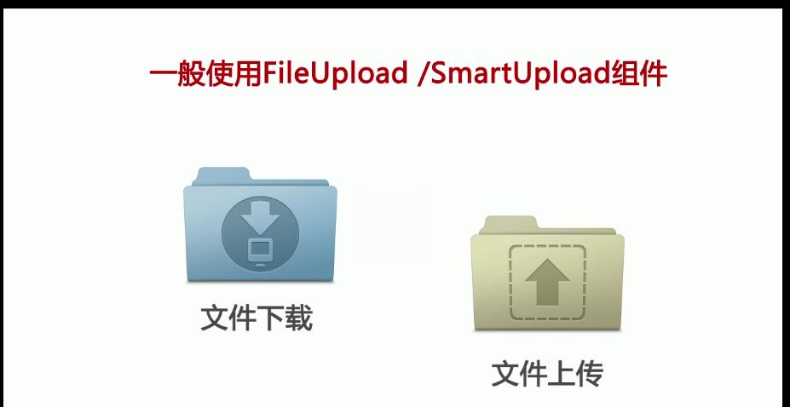


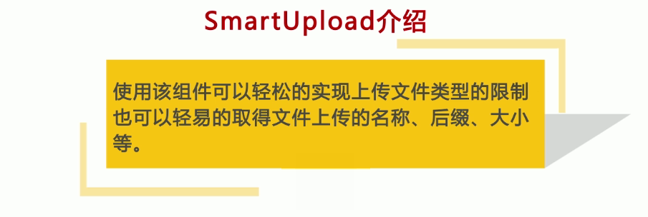


设置上传文件异常
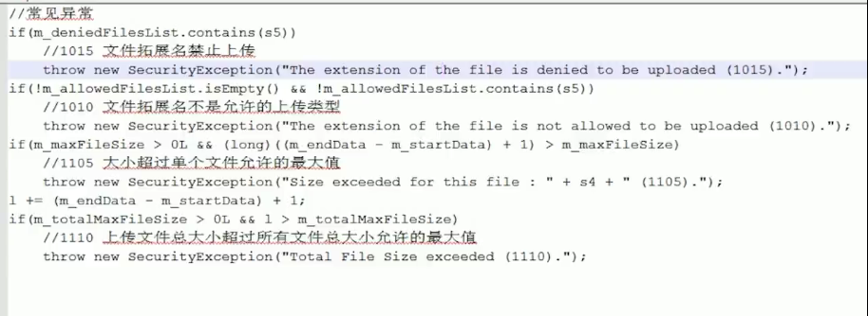

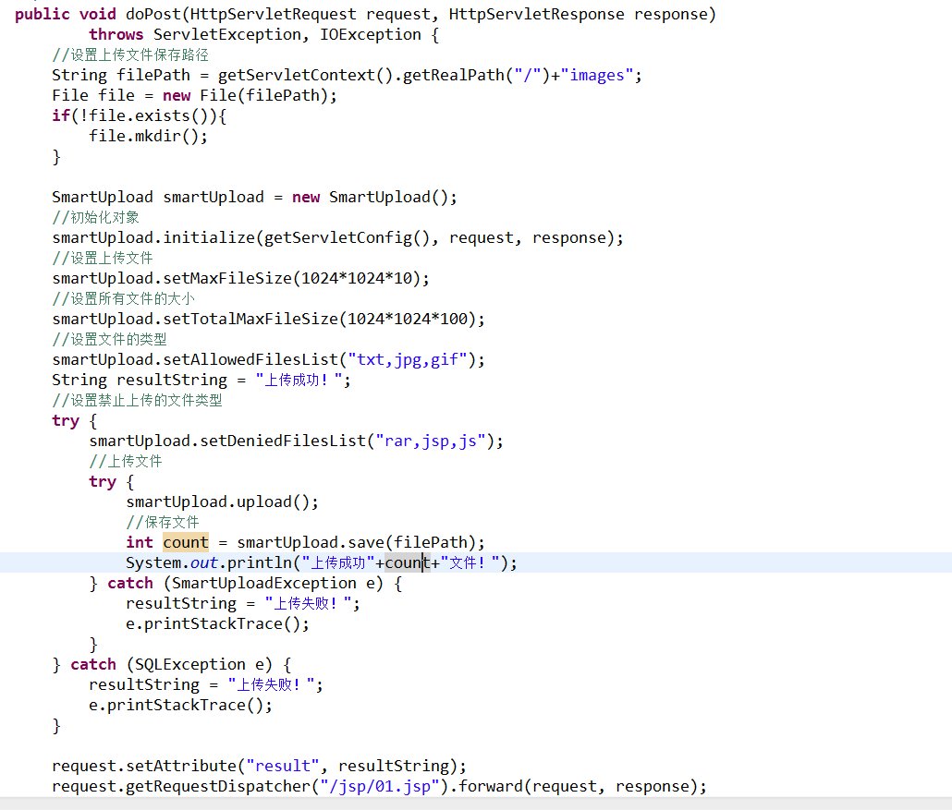

获取文件的其他属性

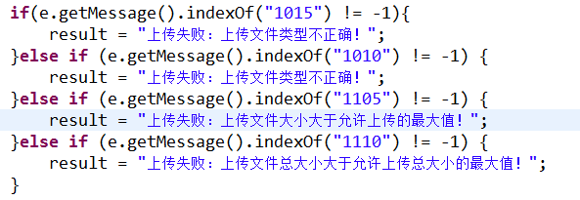

if(e.getMessage().indexOf("1015") != -1){
result = "上传失败：上传文件类型不正确！";
}else if (e.getMessage().indexOf("1010") != -1) {
result = "上传失败：上传文件类型不正确！";
}else if (e.getMessage().indexOf("1105") != -1) {
result = "上传失败：上传文件大小大于允许上传的最大值！";
}else if (e.getMessage().indexOf("1110") != -1) {
result = "上传失败：上传文件总大小大于允许上传总大小的最大值！";
}

下载
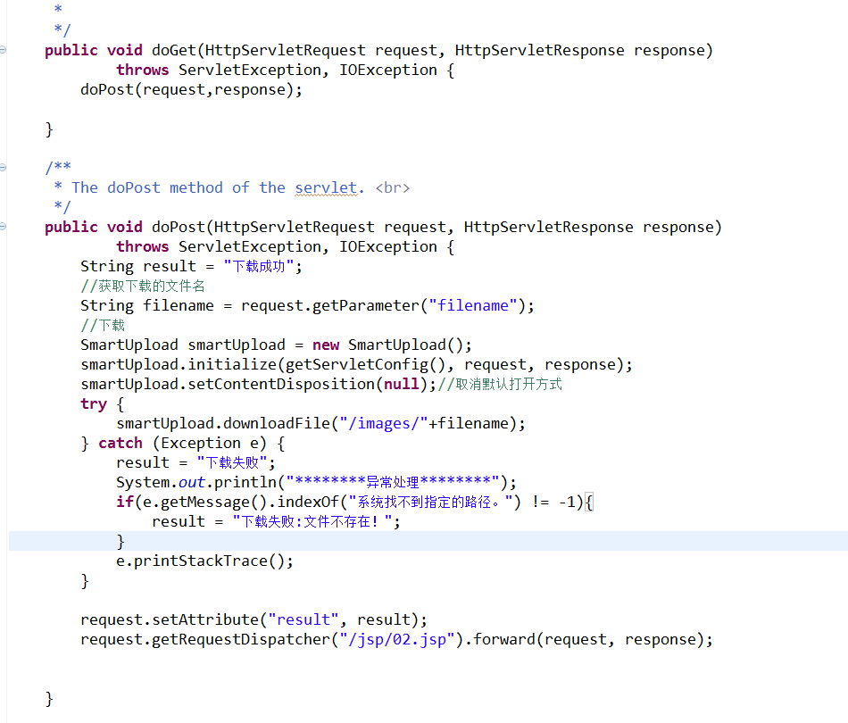
异常
********异常处理********
java.io.FileNotFoundException: \images\jplin-css.jpg (系统找不到指定的路径。)
at java.io.FileInputStream.open(Native Method)
at java.io.FileInputStream.<init>(FileInputStream.java:146)
at com.jspsmart.upload.SmartUpload.downloadFile(SmartUpload.java:276)
at com.jspsmart.upload.SmartUpload.downloadFile(SmartUpload.java:261)
at com.jspsmart.upload.SmartUpload.downloadFile(SmartUpload.java:249)
at com.wuhn.smartupload.servlet.SmartDownloadServlet.doPost(SmartDownloadServlet.java:39)
at com.wuhn.smartupload.servlet.SmartDownloadServlet.doGet(SmartDownloadServlet.java:22)
at javax.servlet.http.HttpServlet.service(HttpServlet.java:620)

at javax.servlet.http.HttpServlet.service(HttpServlet.java:727)
at org.apache.catalina.core.ApplicationFilterChain.internalDoFilter(ApplicationFilterChain.java:303)
at org.apache.catalina.core.ApplicationFilterChain.doFilter(ApplicationFilterChain.java:208)
at org.apache.tomcat.websocket.server.WsFilter.doFilter(WsFilter.java:52)
at org.apache.catalina.core.ApplicationFilterChain.internalDoFilter(ApplicationFilterChain.java:241)
at org.apache.catalina.core.ApplicationFilterChain.doFilter(ApplicationFilterChain.java:208)

at org.apache.catalina.core.StandardWrapperValve.invoke(StandardWrapperValve.java:220)
at org.apache.catalina.core.StandardContextValve.invoke(StandardContextValve.java:122)
at org.apache.catalina.authenticator.AuthenticatorBase.invoke(AuthenticatorBase.java:504)
at org.apache.catalina.core.StandardHostValve.invoke(StandardHostValve.java:170)
at org.apache.catalina.valves.ErrorReportValve.invoke(ErrorReportValve.java:103)
at org.apache.catalina.valves.AccessLogValve.invoke(AccessLogValve.java:950)

at org.apache.catalina.core.StandardEngineValve.invoke(StandardEngineValve.java:116)
at org.apache.catalina.connector.CoyoteAdapter.service(CoyoteAdapter.java:421)
at org.apache.coyote.http11.AbstractHttp11Processor.process(AbstractHttp11Processor.java:1074)
at org.apache.coyote.AbstractProtocol$AbstractConnectionHandler.process(AbstractProtocol.java:611)
at org.apache.tomcat.util.net.AprEndpoint$SocketProcessor.doRun(AprEndpoint.java:2466)
at org.apache.tomcat.util.net.AprEndpoint$SocketProcessor.run(AprEndpoint.java:2455)

at java.util.concurrent.ThreadPoolExecutor.runWorker(ThreadPoolExecutor.java:1145)
at java.util.concurrent.ThreadPoolExecutor$Worker.run(ThreadPoolExecutor.java:615)
at org.apache.tomcat.util.threads.TaskThread$WrappingRunnable.run(TaskThread.java:61)
at java.lang.Thread.run(Thread.java:745)

