- 准备
需要三个类，放进一个文件夹中：
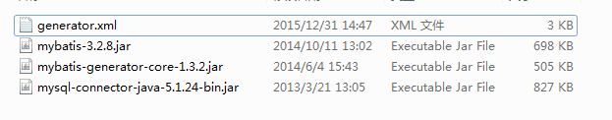

- 配置xml

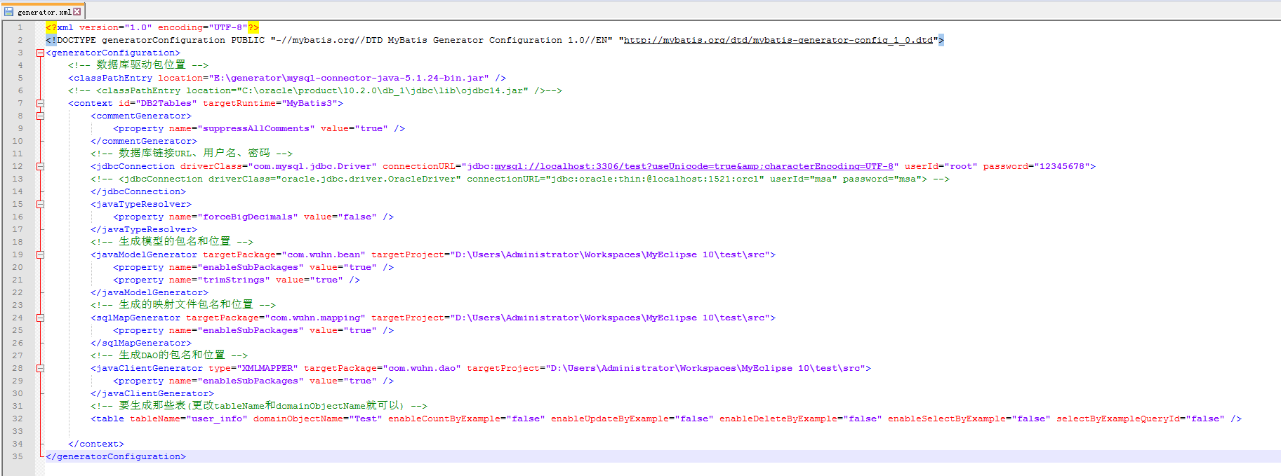

注意：因为mybatis是半自动的，所以数据库必须要有表，所以还是需要手动建表。
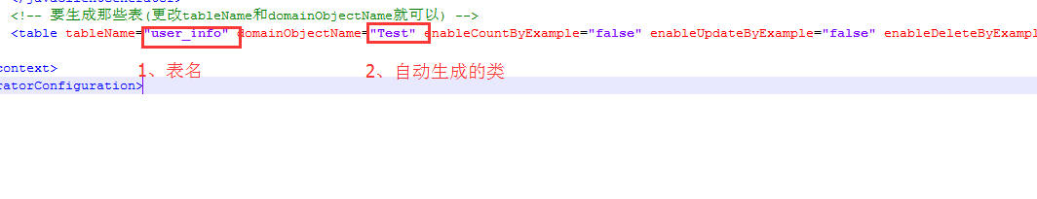

<?xml version="1.0" encoding="UTF-8"?>
<!DOCTYPE generatorConfiguration PUBLIC "-//mybatis.org//DTD MyBatis Generator Configuration 1.0//EN" "http://mybatis.org/dtd/mybatis-generator-config_1_0.dtd">
<generatorConfiguration>
<!-- 数据库驱动包位置 -->
<classPathEntry location="E:\generator\mysql-connector-java-5.1.24-bin.jar" />
<!-- <classPathEntry location="C:\oracle\product\10.2.0\db_1\jdbc\lib\ojdbc14.jar" />-->
<context id="DB2Tables" targetRuntime="MyBatis3">
<commentGenerator>
<property name="suppressAllComments" value="true" />
</commentGenerator>
<!-- 数据库链接URL、用户名、密码 -->
<jdbcConnection driverClass="com.mysql.jdbc.Driver" connectionURL="jdbc:mysql://localhost:3306/test?useUnicode=true&amp;characterEncoding=UTF-8" userId="root" password="12345678">
<!-- <jdbcConnection driverClass="oracle.jdbc.driver.OracleDriver" connectionURL="jdbc:oracle:thin:@localhost:1521:orcl" userId="msa" password="msa"> -->
</jdbcConnection>
<javaTypeResolver>
<property name="forceBigDecimals" value="false" />
</javaTypeResolver>
<!-- 生成模型的包名和位置 -->
<javaModelGenerator targetPackage="com.wuhn.bean" targetProject="D:\Users\Administrator\Workspaces\MyEclipse 10\test\src">
<property name="enableSubPackages" value="true" />
<property name="trimStrings" value="true" />
</javaModelGenerator>
<!-- 生成的映射文件包名和位置 -->
<sqlMapGenerator targetPackage="com.wuhn.mapping" targetProject="D:\Users\Administrator\Workspaces\MyEclipse 10\test\src">
<property name="enableSubPackages" value="true" />
</sqlMapGenerator>
<!-- 生成DAO的包名和位置 -->
<javaClientGenerator type="XMLMAPPER" targetPackage="com.wuhn.dao" targetProject="D:\Users\Administrator\Workspaces\MyEclipse 10\test\src">
<property name="enableSubPackages" value="true" />
</javaClientGenerator>
<!-- 要生成那些表(更改tableName和domainObjectName就可以) -->
<table tableName="user_info" domainObjectName="Test" enableCountByExample="false" enableUpdateByExample="false" enableDeleteByExample="false" enableSelectByExample="false" selectByExampleQueryId="false" />

</context>
</generatorConfiguration>

- 使用命令

在window下操作
打开cmd，进入文件夹
使用命令
java -jar mybatis-generator-core-1.3.2.jar -configfile generator.xml -overwrite

