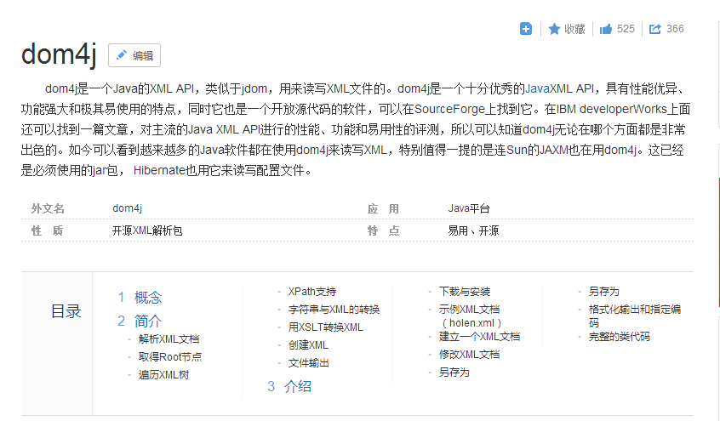
百度百科
http://baike.baidu.com/link?url=EiVtmARn6lZI40-2L-WMRbupyiUgXqhfMbIxDoPVU8kGVa5tnS9T2Fv7zMkCBxW5DDBBc8KbG2fkqXH-0ua7h_

