1. Physics and math equation

The intensity of magnetization *B* of the magnet ball is related with the distance from its center. Suppose that there is a sphere surface whose radius is a variable *r* and center coincides with the magnet ball center, the magnetic flux through this surface is:

$$Φ_{r}=4πr^{2}B_{r}$$

where $B_{r}$ is the intensity of *B* at a distance *r* from the center. Its direction is the vector from the center to the surface, which also means orthogonal to the surface, as Fig1 shows.

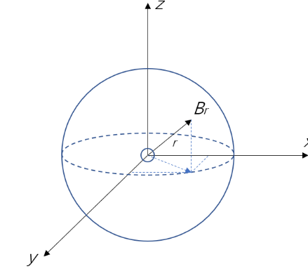

*Fig1. The intensity of magnetization of a magnet ball*

For single magnet source, it is obvious that the value of $Φ_{r}$ remains constant as radius *r* changes. Thus, the relationship between different *B* and *r* is:

$$\frac{B_{r1}}{B_{r2}}=\frac{{r_{r2}}^{2}}{{r_{r1}}^{2}}$$

The position of two magnetometers are shown in Fig2. Three representative positions are demonstrated. The main purposes of these two magnetometers is background field rejection. The intensity of earth magnetization is different in different directions, this difference can reach to about 50 μT, but the intensity of ball magnetization is so small, about 10-15 μT when the distance is 5 cm, therefore, earth magnet field can greatly affect the performance of measurement. With two magnetometers, this effect can be eliminated by doing vector subtraction, because the earth field can be considered uniform in such a small range.

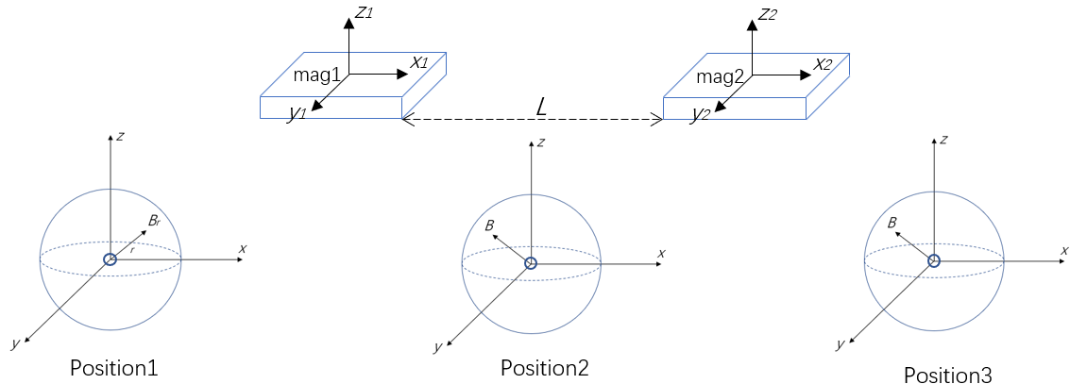

*Fig2. Position of two magnetometers and the small ball*

Then a math equation of how to use the measurements of two magnetometers is needed, thus, the subtraction the measurement in x-axis direction is given, which is:

$$B_{cal}=B_{2x}-B_{1x}$$

Where $B_{cal}$ is the variable that is needed to determine the existence of the small magnet ball, $B_{1x}$ and $B_{2x}$ represent the precise x-axis component of B measured by magnetometer 1 and 2. This equation is very simple, but it can satisfy demands. The value of $B_{cal}$ can be calculated through the equation above and basic geometry.

Fig3 shows the measurement value from only one magnetometer with the change of relative position between magnetometer and magnet ball. This trend is easy to explain with Fig2. When the ball is on the left of the magnetometer, $B_{x}$ is positive. At far distance, the value will approach zero since *B* will decrease to zero. When the ball aligns with the magnetometer in y-axis direction, $B_{x}$ will be zero since there will be no x-axis component of B. When the ball is on the right, the *B* that pass through the magnetometer will have a negative x-axis component.

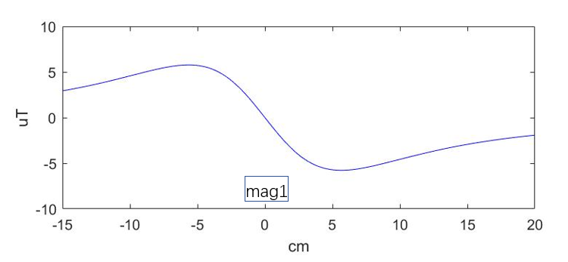

*Fig3. $B_{1x}$ versus relative position between ball and magnetometer*

The other magnetometer will have the same behavior, then $B_{cal}$ can be calculated. Fig4. Shows the result, where mag2 is 5 centimeters from mag1. It is apparent to predict that $B_{cal}$ will reach to the peak when the ball is in middle of both two magnetometers, that is, *position 2* in Fig2, at this time mag1 gives a negative value, mag2 gives a positive value. If a threshold value of 4uT is set, this device can detect the existence as well as approximate position of the magnet ball in ideal situation (no system error).

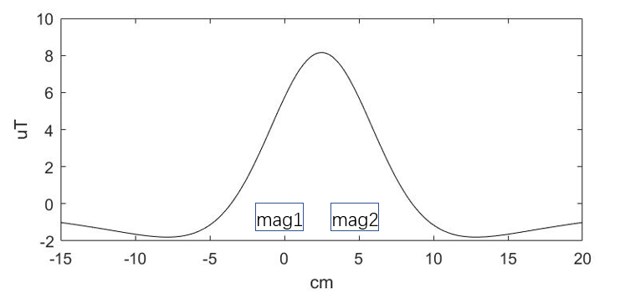

*Fig4. $B_{cal}$ versus relative position between ball and two magnetometers*

In physical diagnose the doctor will hold the device and move it left and right, up and down. Therefore, the change of value of $B_{cal}$ with respect to change of relative position in both x-axis direction and z-axis direction should also be calculated, as shown in Fig5. It can be seen that $B_{cal}$ will reach to the peak when z = 0 cm and x = 2.5 cm (middle of two magnetometers).

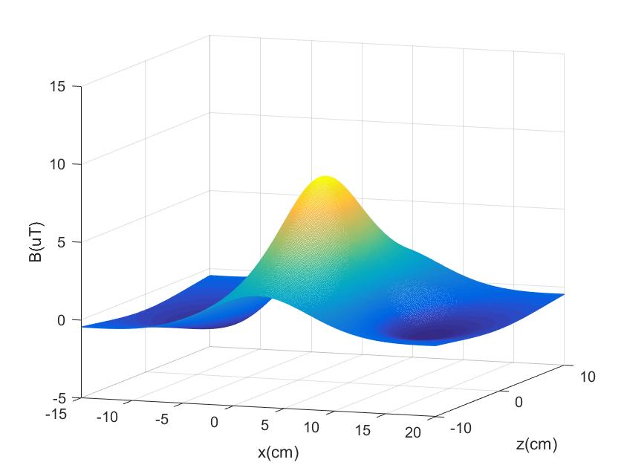

*Fig5. $B_{cal}$ versus relative position between ball and two magnetometers*

2. Circuit diagram

