City Assessment

When calculating carbon footprints in the context of cities, *The Global Protocol for Community-Scale Greenhouse Gas Emissions Inventories* (GPC) provides a well-defined framework that uses existing techniques to calculate and report the greenhouse gas (GHG) emissions for a city. It creates clear standards to calculate the GHG emissions of a city and thus, it would be able to help provide a direction and method for creating a reusable program to calculate the carbon footprint of a city. It would with giving a clearer understanding of the steps behind measuring the carbon footprint of a city. The steps provided by the GCP that are involved in calculating the carbon footprint of a city include setting an inventory boundary, conforming to reporting requirements and an overview to calculate GHG emissions.

A city must first create an inventory boundary which “identifies the gases, emission sources, geographic area, and time span” (29). Cities must first define a consistent geographical boundary that “identifies the spatial dimension or physical perimeter of the inventory’s boundary” (29), which would allow for comparisons over time. In addition, the GPC requires that the inventory should cover a timeframe of 12 months. The GHGs accounted for are the seven Kyoto gases which include carbon dioxide (CO2), methane (CH4), nitrous oxide (N2O), hydrofluorocarbons (HFCs), perfluorocarbons (PFCs), Sulphur hexafluoride (SF­6), and nitrogen trifluoride (NF3) (30). Furthermore, sources of GHG emissions in cities are categorized into six different sectors, which include stationary energy, transportation, waste, industrial processes and product use (IPPU), agriculture, forestry, and other land use (AFOLU) and any other scope 3 emissions (30). Sectors are defined as, “the topmost categorization of city-wide GHG sources, distinct from one another, that together make up the city’s GHG emission sources activities (30)”. The emissions from these sectors are further categorized into sub-sectors, which are divisions that constitute a main sector. Emissions are also classified by scope, where emissions that occur within the city are in scope 1, and emissions that derive from the use of electrical-grids are in scope 2 and emissions that occur outside the city’s boundaries are in scope 3. These factors help lay the foundation for process of GHG accounting.

In the reporting requirements used, there are two unique but complementary approaches that can be used to calculate the GHG emissions of cities: scopes framework and city-induced framework (35). The scopes framework allows for cities to organize their GHG emissions into the three scopes previously defined and the city-induced framework measures the GHG emissions for the six main sectors previously defined, all of which encapsulate scopes 1, 2 and 3. For the city-induced framework, two different levels of completeness are defined: “The BASIC level covers emission sources that occur in almost all cities and the calculation methodologies and data are more readily available” (35) while “The BASIC+ level has a more comprehensive coverage of emissions sources (BASIC sources plus IPPU, AFOLU, transboundary transportation, and energy transmission and distribution losses) and reflects more challenging data collection and calculation procedures” (35). In the GCP reporting requirements, cities must provide a description for the inventory boundary, which must include a brief on the geographical boundary, activities included in inventory, exclusion of emission sources, timeframe, reporting level (BASIC/BASIC+), and an overview of the city. In addition, the emissions of scope and sector, along with the type of gases and emissions from biogenic origin must be reported. Information on methodologies used to calculate GHG emissions and assessments of data quality must also be reported.

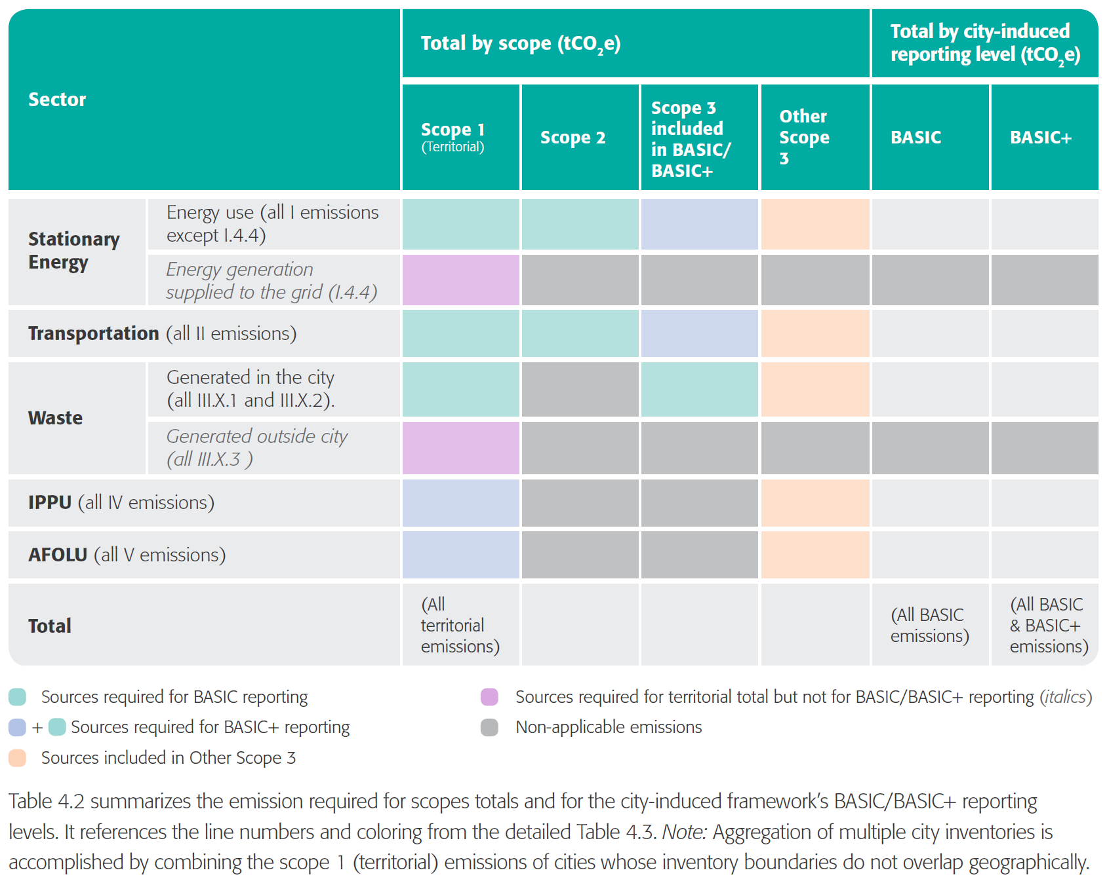

The GCP does not require cities to conform to specific methodologies to collect and calculate GHG emission data. It is stated that, “cities should select the most appropriate methodologies based on the purpose of their inventory, availability of data, and consistency with their country’s national inventory and/or other measurement and reporting program in which they participate” (47). When direct data from real-time observations are not available, cities will have to estimate GHG emissions with the following equation: $(GHG Emission=\left(Activity Data\right)*(Emission Factor)$, where activity data refers to the amount of activity that causes GHG emissions at a certain point of time, such as “volume of gas used, kilometers driven, tons of solid waste sent to landfill, etc.” (48). The emission factor refers to the ration needed to convert the activity data into terms of the specific GHG. Regarding the collection of activity data, data should be from reliable sources such as “government departments and statistics agencies, a country’s national GHG inventory report, universities and research institutes, scientific and technical articles in environmental books, journals and reports, and sector experts/stakeholder organizations” (49). Moreover, data should include information about, “Definition and description of the data set: time series, sector breakdown, units, assumptions, uncertainties, known gaps and frequency and timescales for data collection and publication” (49). These factors would ensure the reliability and thoroughness of the activity data, allowing for higher quality GHG emission measurements. After the collection of GHG emission data, different GHGs should be converted into units of carbon dioxide equivalent (CO2e) using the global warming potential ratios.

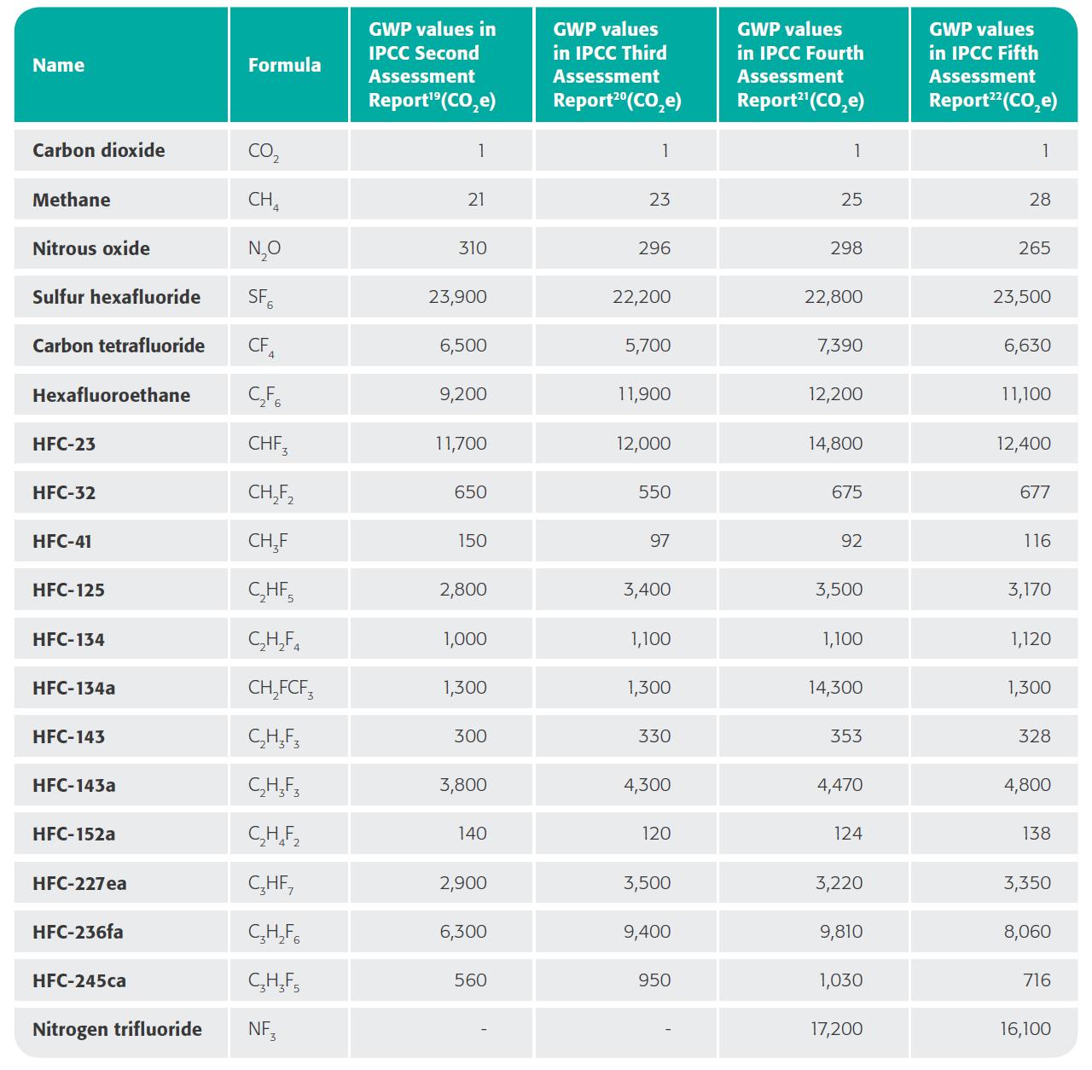

In summary, the initial process of calculating the carbon footprint of a city involves first setting up an inventory boundary, where factors such as the geographical boundary and time span are defined. Next the reporting requirements must be identified and fulfilled, which include identifying the city-induced framework level and providing a description of the inventory boundary. Finally, the calculation methodology should be identified along with sources of activity data and emission factors, in order to derive the GHG emission of various sectors in the city. Thus, the programming script that aims to calculate the carbon footprint of a city should also conform to several of the requirements of GCP, including stating basic inventory data information, displaying GHG emissions in the form of city-induced and scope frameworks and cite the methodology, activity data and emission factors. Altogether, in its early stages, the programming script would employ mainly a process analysis based to finding the carbon footprint of a city, and ideally, it would later be improved to make use of the economic input-output technique to increase flexibility and robustness of the program.

References

"GHG Protocol for Cities." GHG Protocol for Cities | Greenhouse Gas Protocol. Accessed April 24, 2017. <http://www.ghgprotocol.org/greenhouse-gas-protocol-accounting-reporting> standard-cities.