**Facility Management Documentation**

Iram Jehan, Jessica Mattick, Jerry Wu

**Overview**

This project uses a layered architecture that separates the client, models, and data access. This project includes unit tests for classes in src.com.test and integration tests in the client. The data access layer reads and writes objects in XML.

**Layered Architecture:**

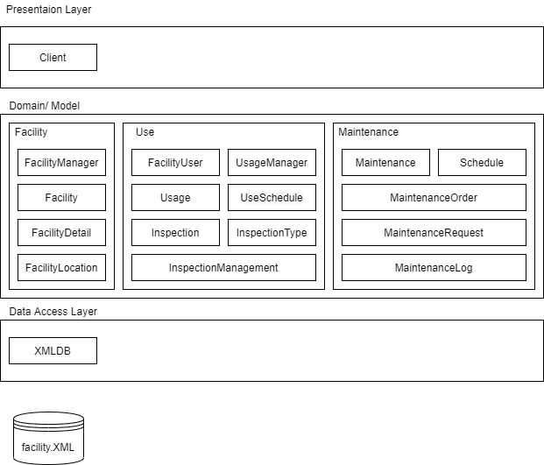

**UML diagram:**

