Lab7

Building web application using PHP and Mysql

Jiahui Wu

ID: 2670210

1. Populate data in database COMPANY, the following shows the content of table EMPLOYEE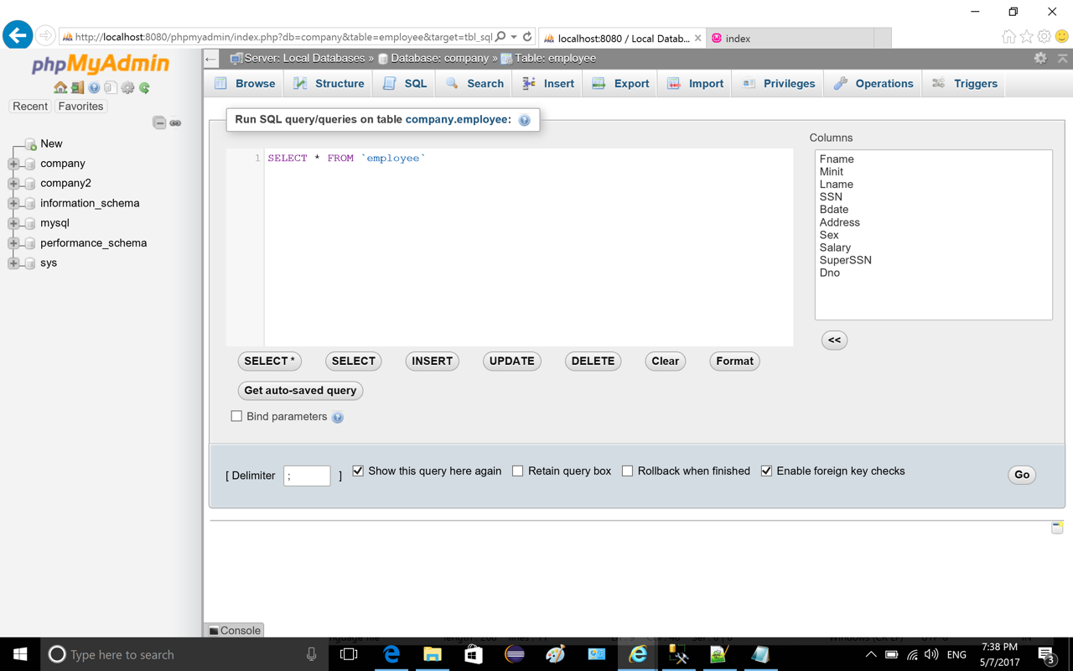

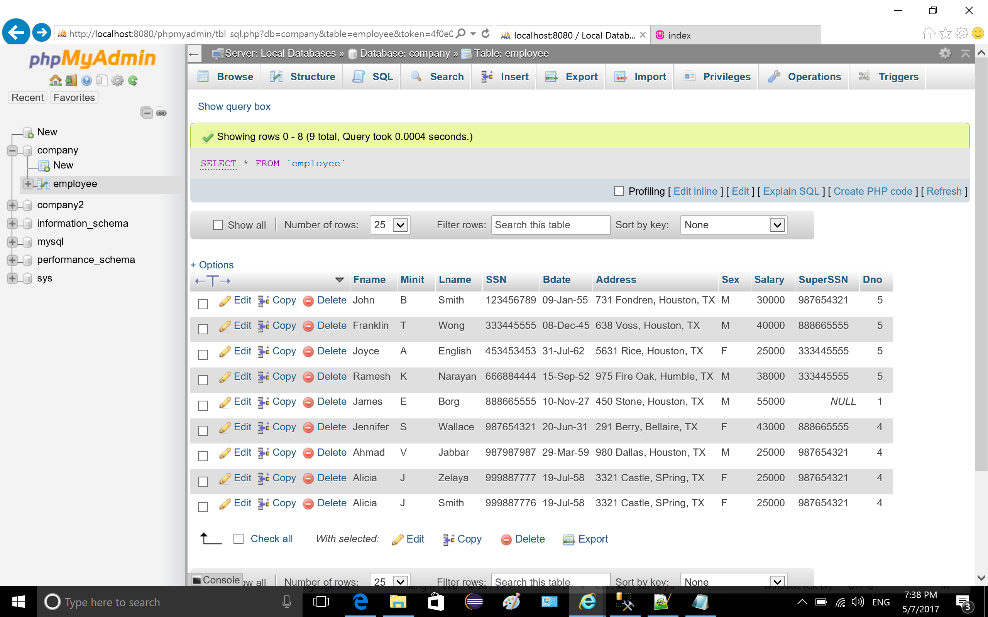

2. create root page “index.html”

source code

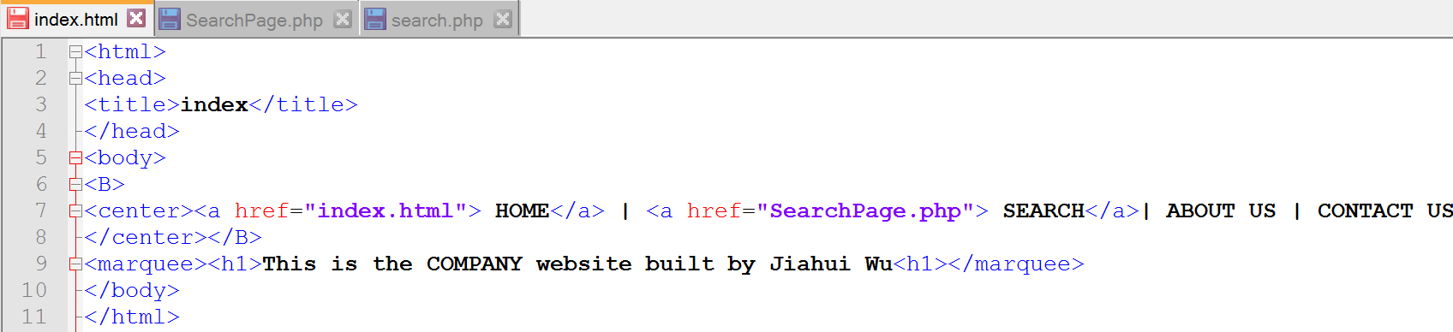

home page looks like this, there are two links, one is HOME which directs to the page itself, the other is SEARCH, click on it will direct to another page “searchPage.php”.

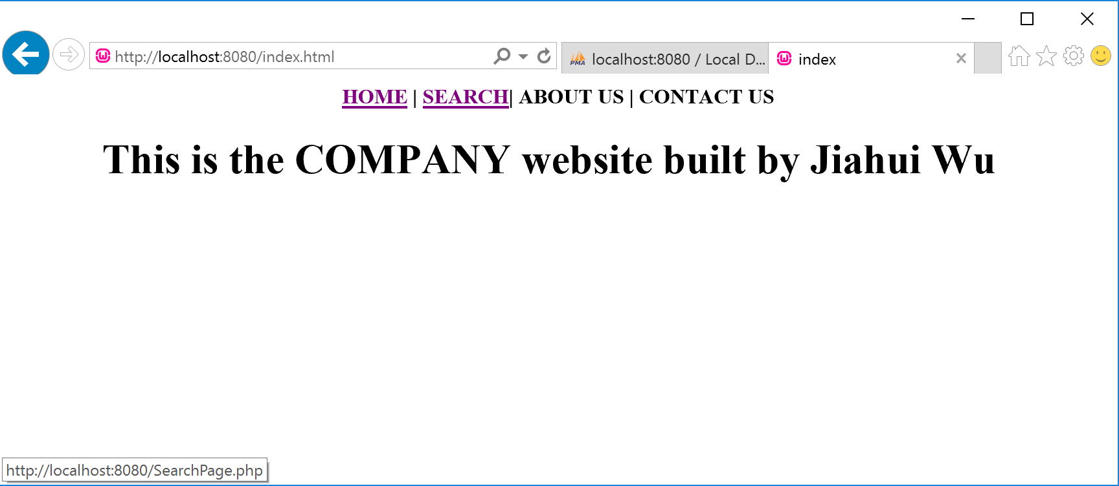

3. create a search page, in this page, there is a form and two buttons, user type input in the form, the name of the input is ‘searchname’, it will be used in the next page “search.php”. One button is “search” for submitting, the other is “reset” for resetting.

Source code of searchPage.php

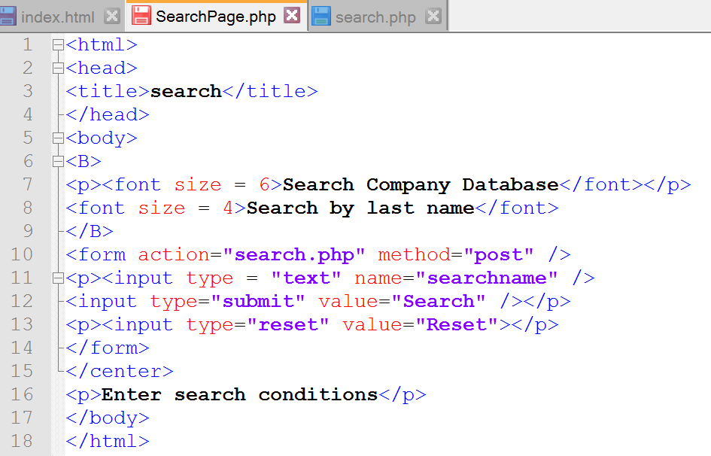

The page of SearchPage.php

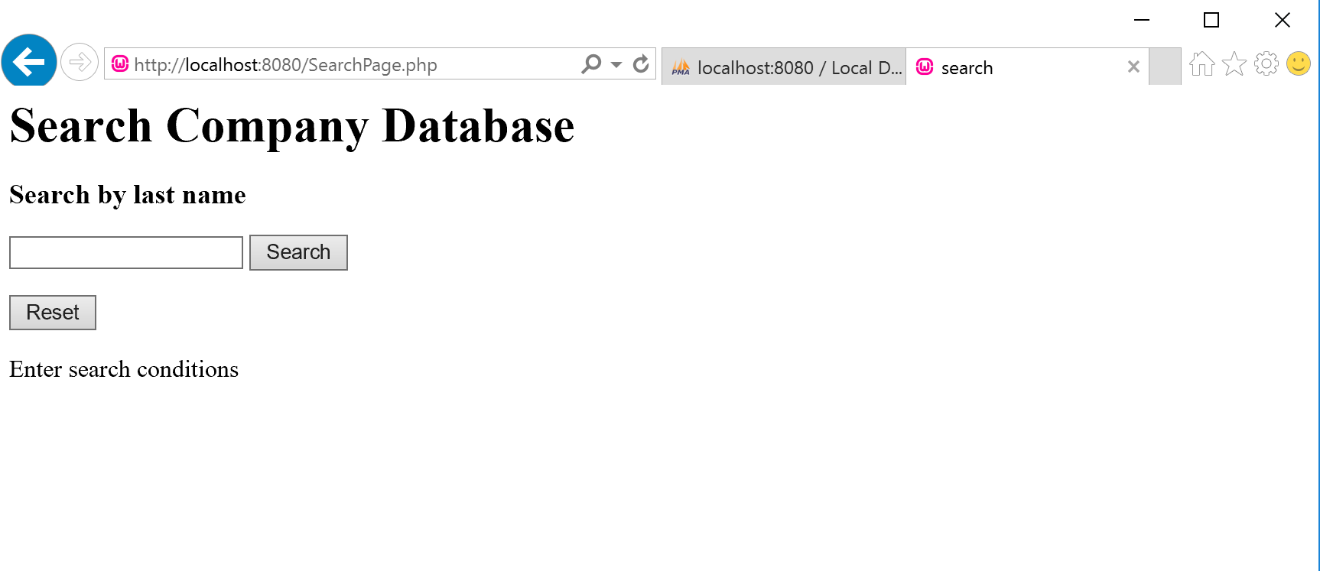

hit reset to clear the input

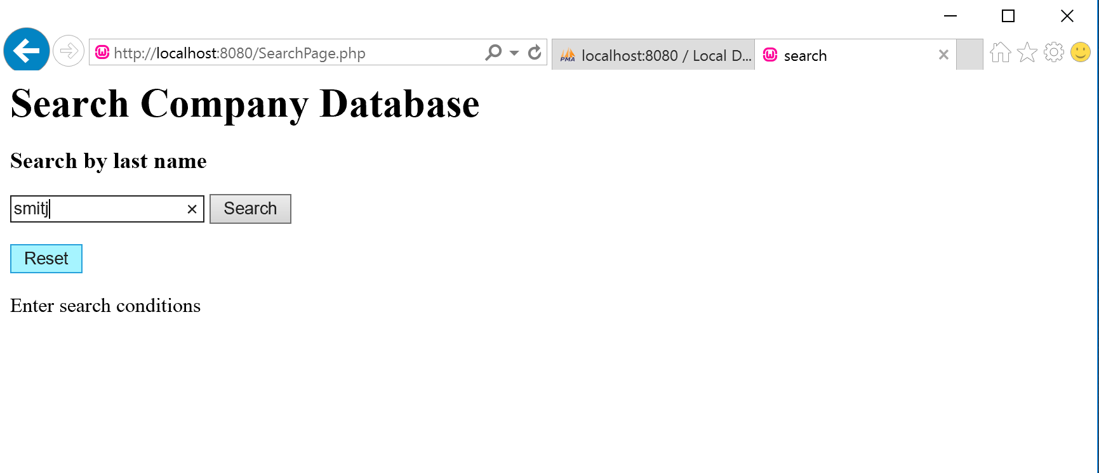

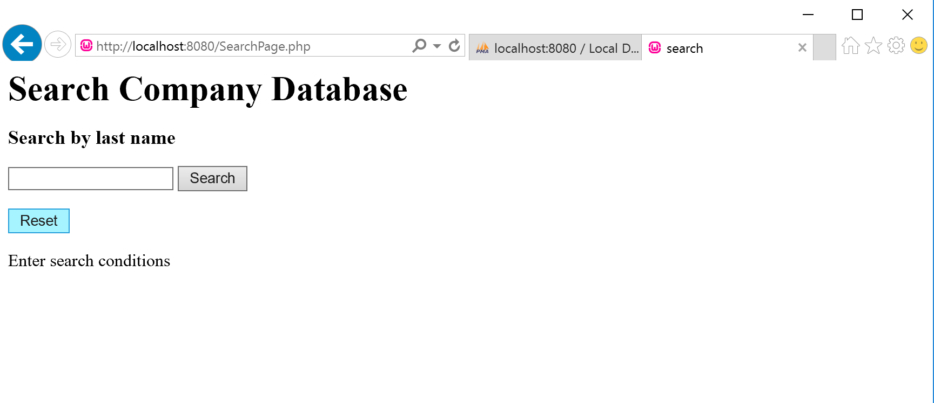

4. create “search.php” page. This php connect php to COMPANY database of mysql, it takes the ‘searchname’ using $_POST[searchname] as input and query mysql database. The query command is ‘select * from employee where lname = $_POST[searchname]’. If record is found, the while loop will print the information of employee with the input last name. There is a ‘back’ link to go back to page SearchPage.php.

Source code of search.php

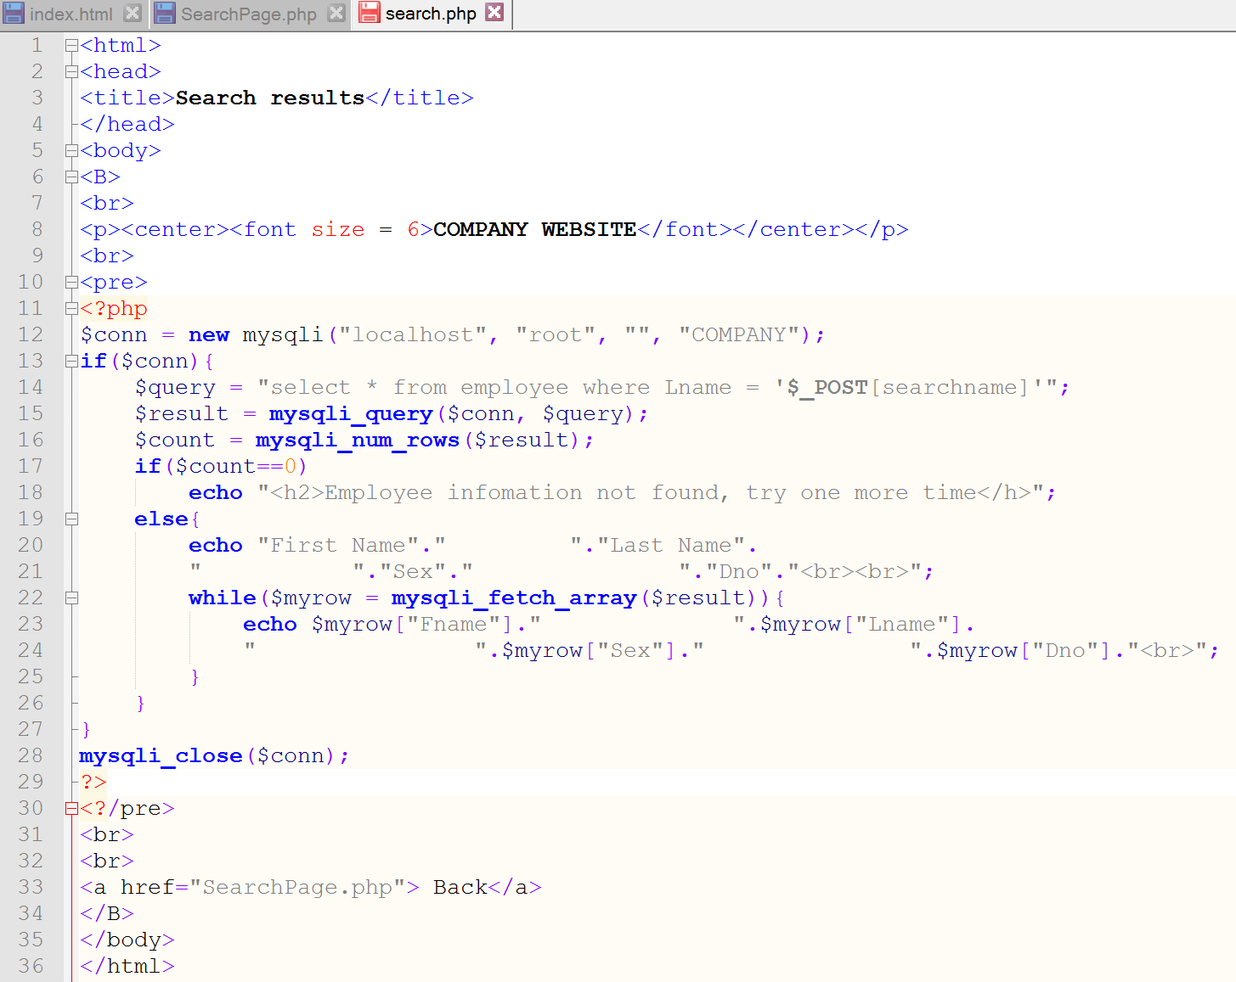

webpage of search.php, there are two person with last name ‘Smith’.

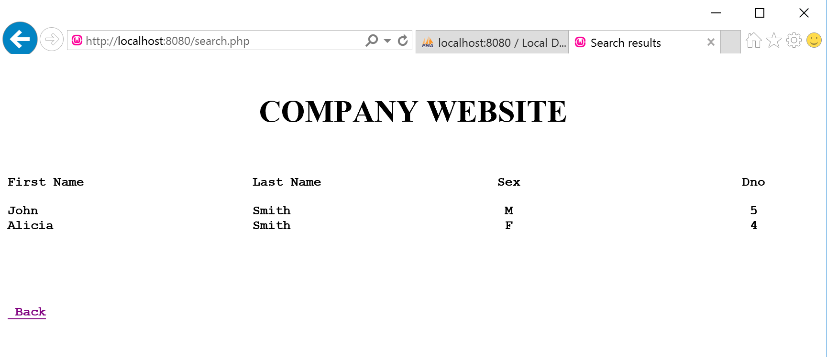

If no matching record, the search page will show the following. For example, there is no person named Green in the database:

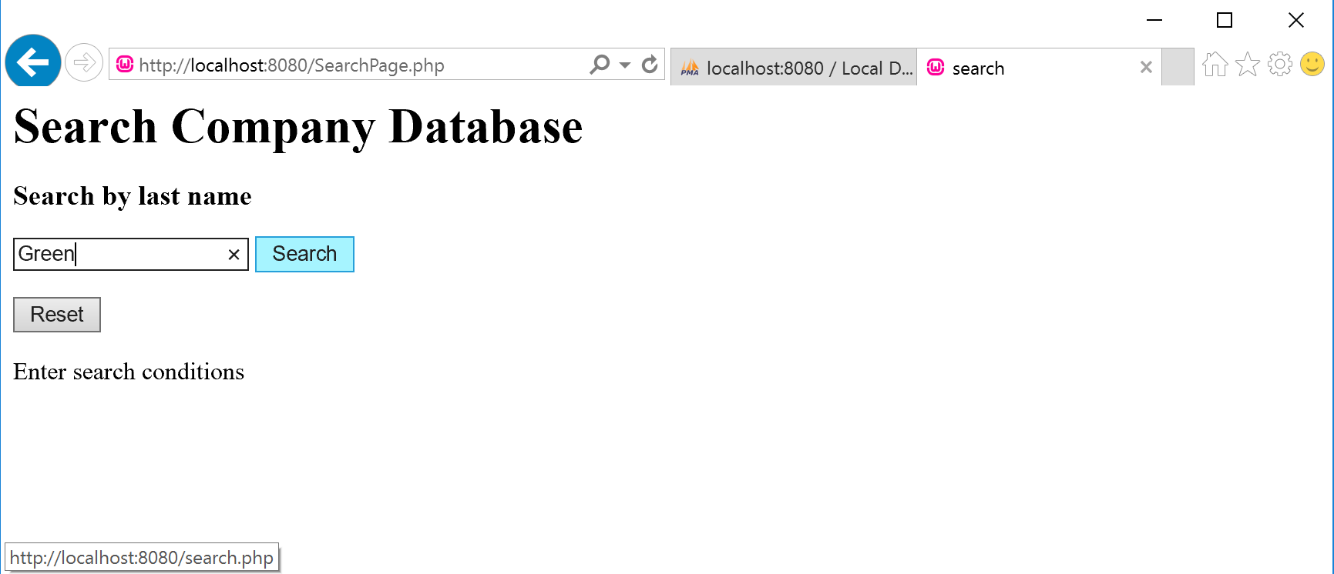

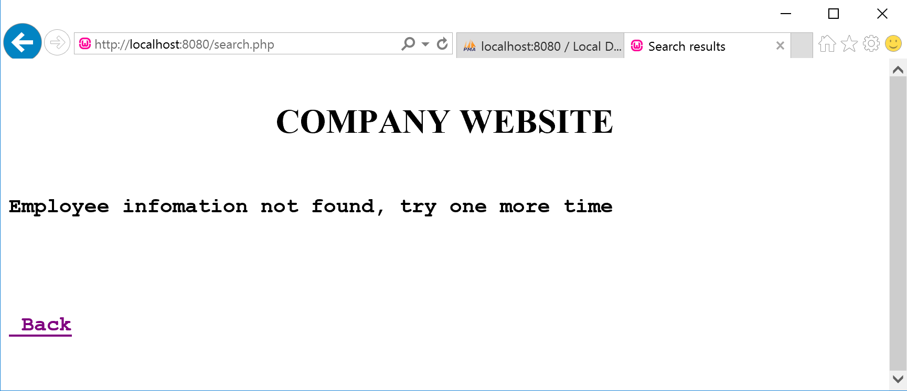

There is a person named “English”

