CIS430-Lab Assignment 1

Name: Jiahui Wu

ID: 2670210

Object: Creating a Relational Database Schema Using SQL and SQL server

1. create a database named COMPANY

Command:



output:

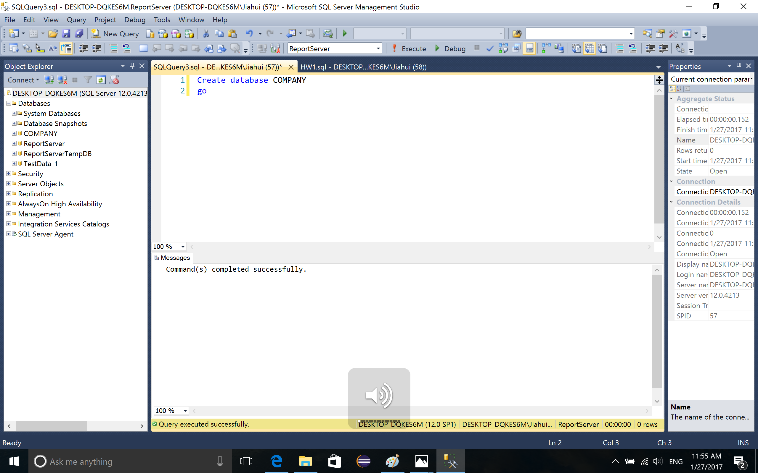

2. Then I use COMPANY, create a table named EMPLOYEE, and define the attributes such as fNAME and SSN in the EMPLOYEE, selelct \* to show the table

Command:

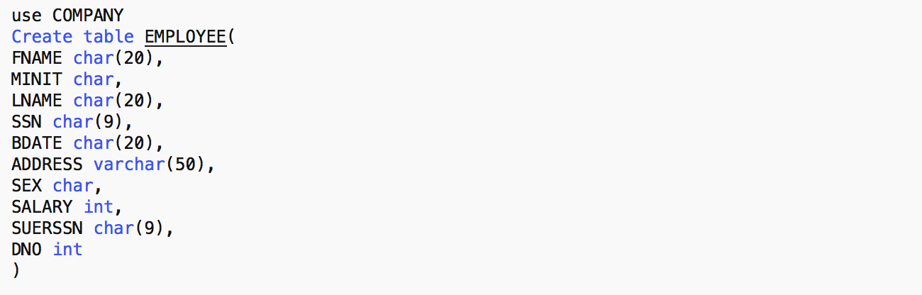

output:

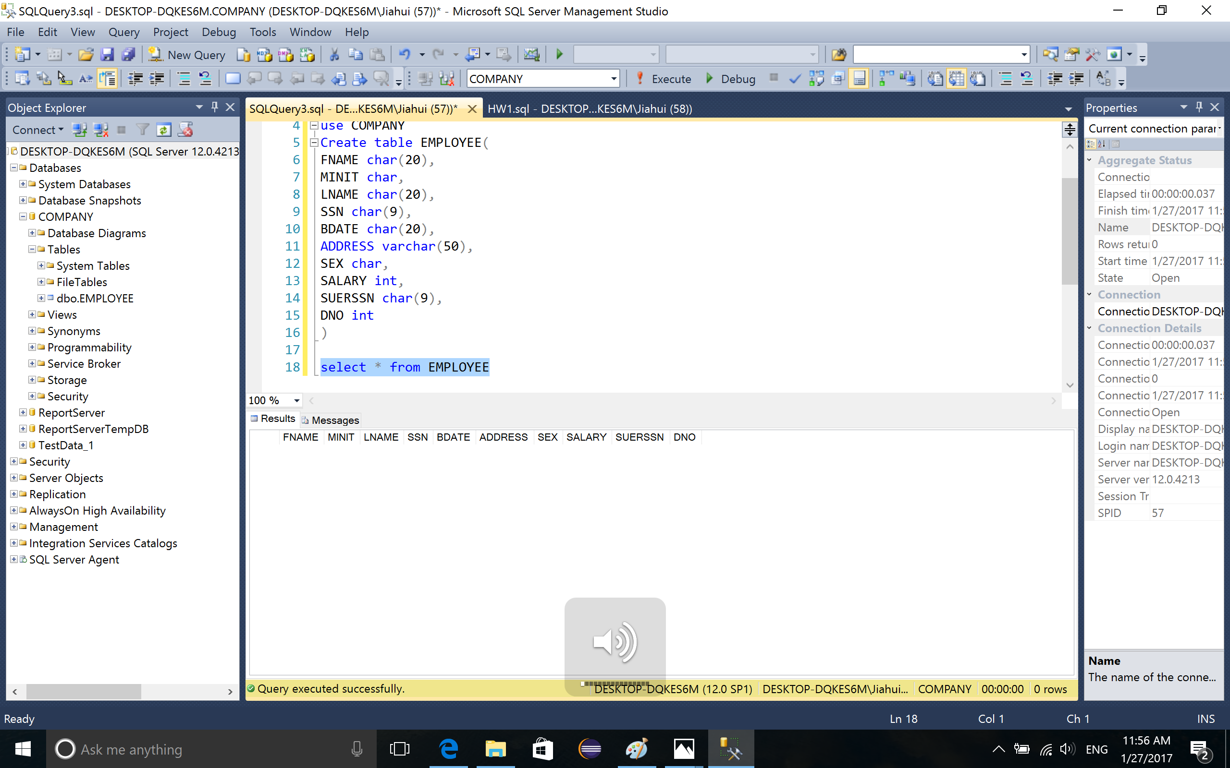

3. Insert information into the table and select \* from EMPLOYEE to show the table

command:

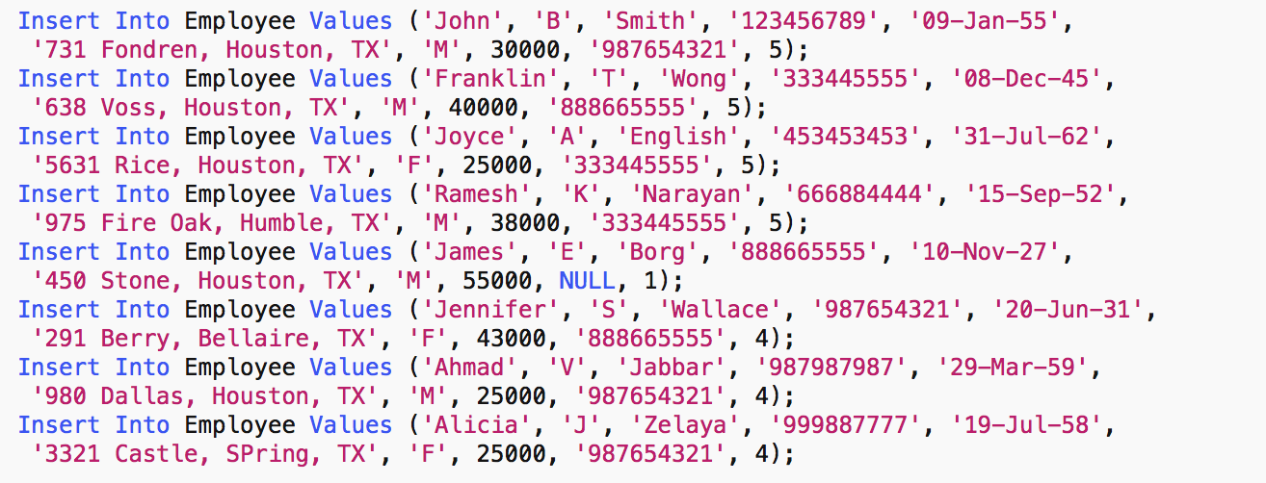

output:

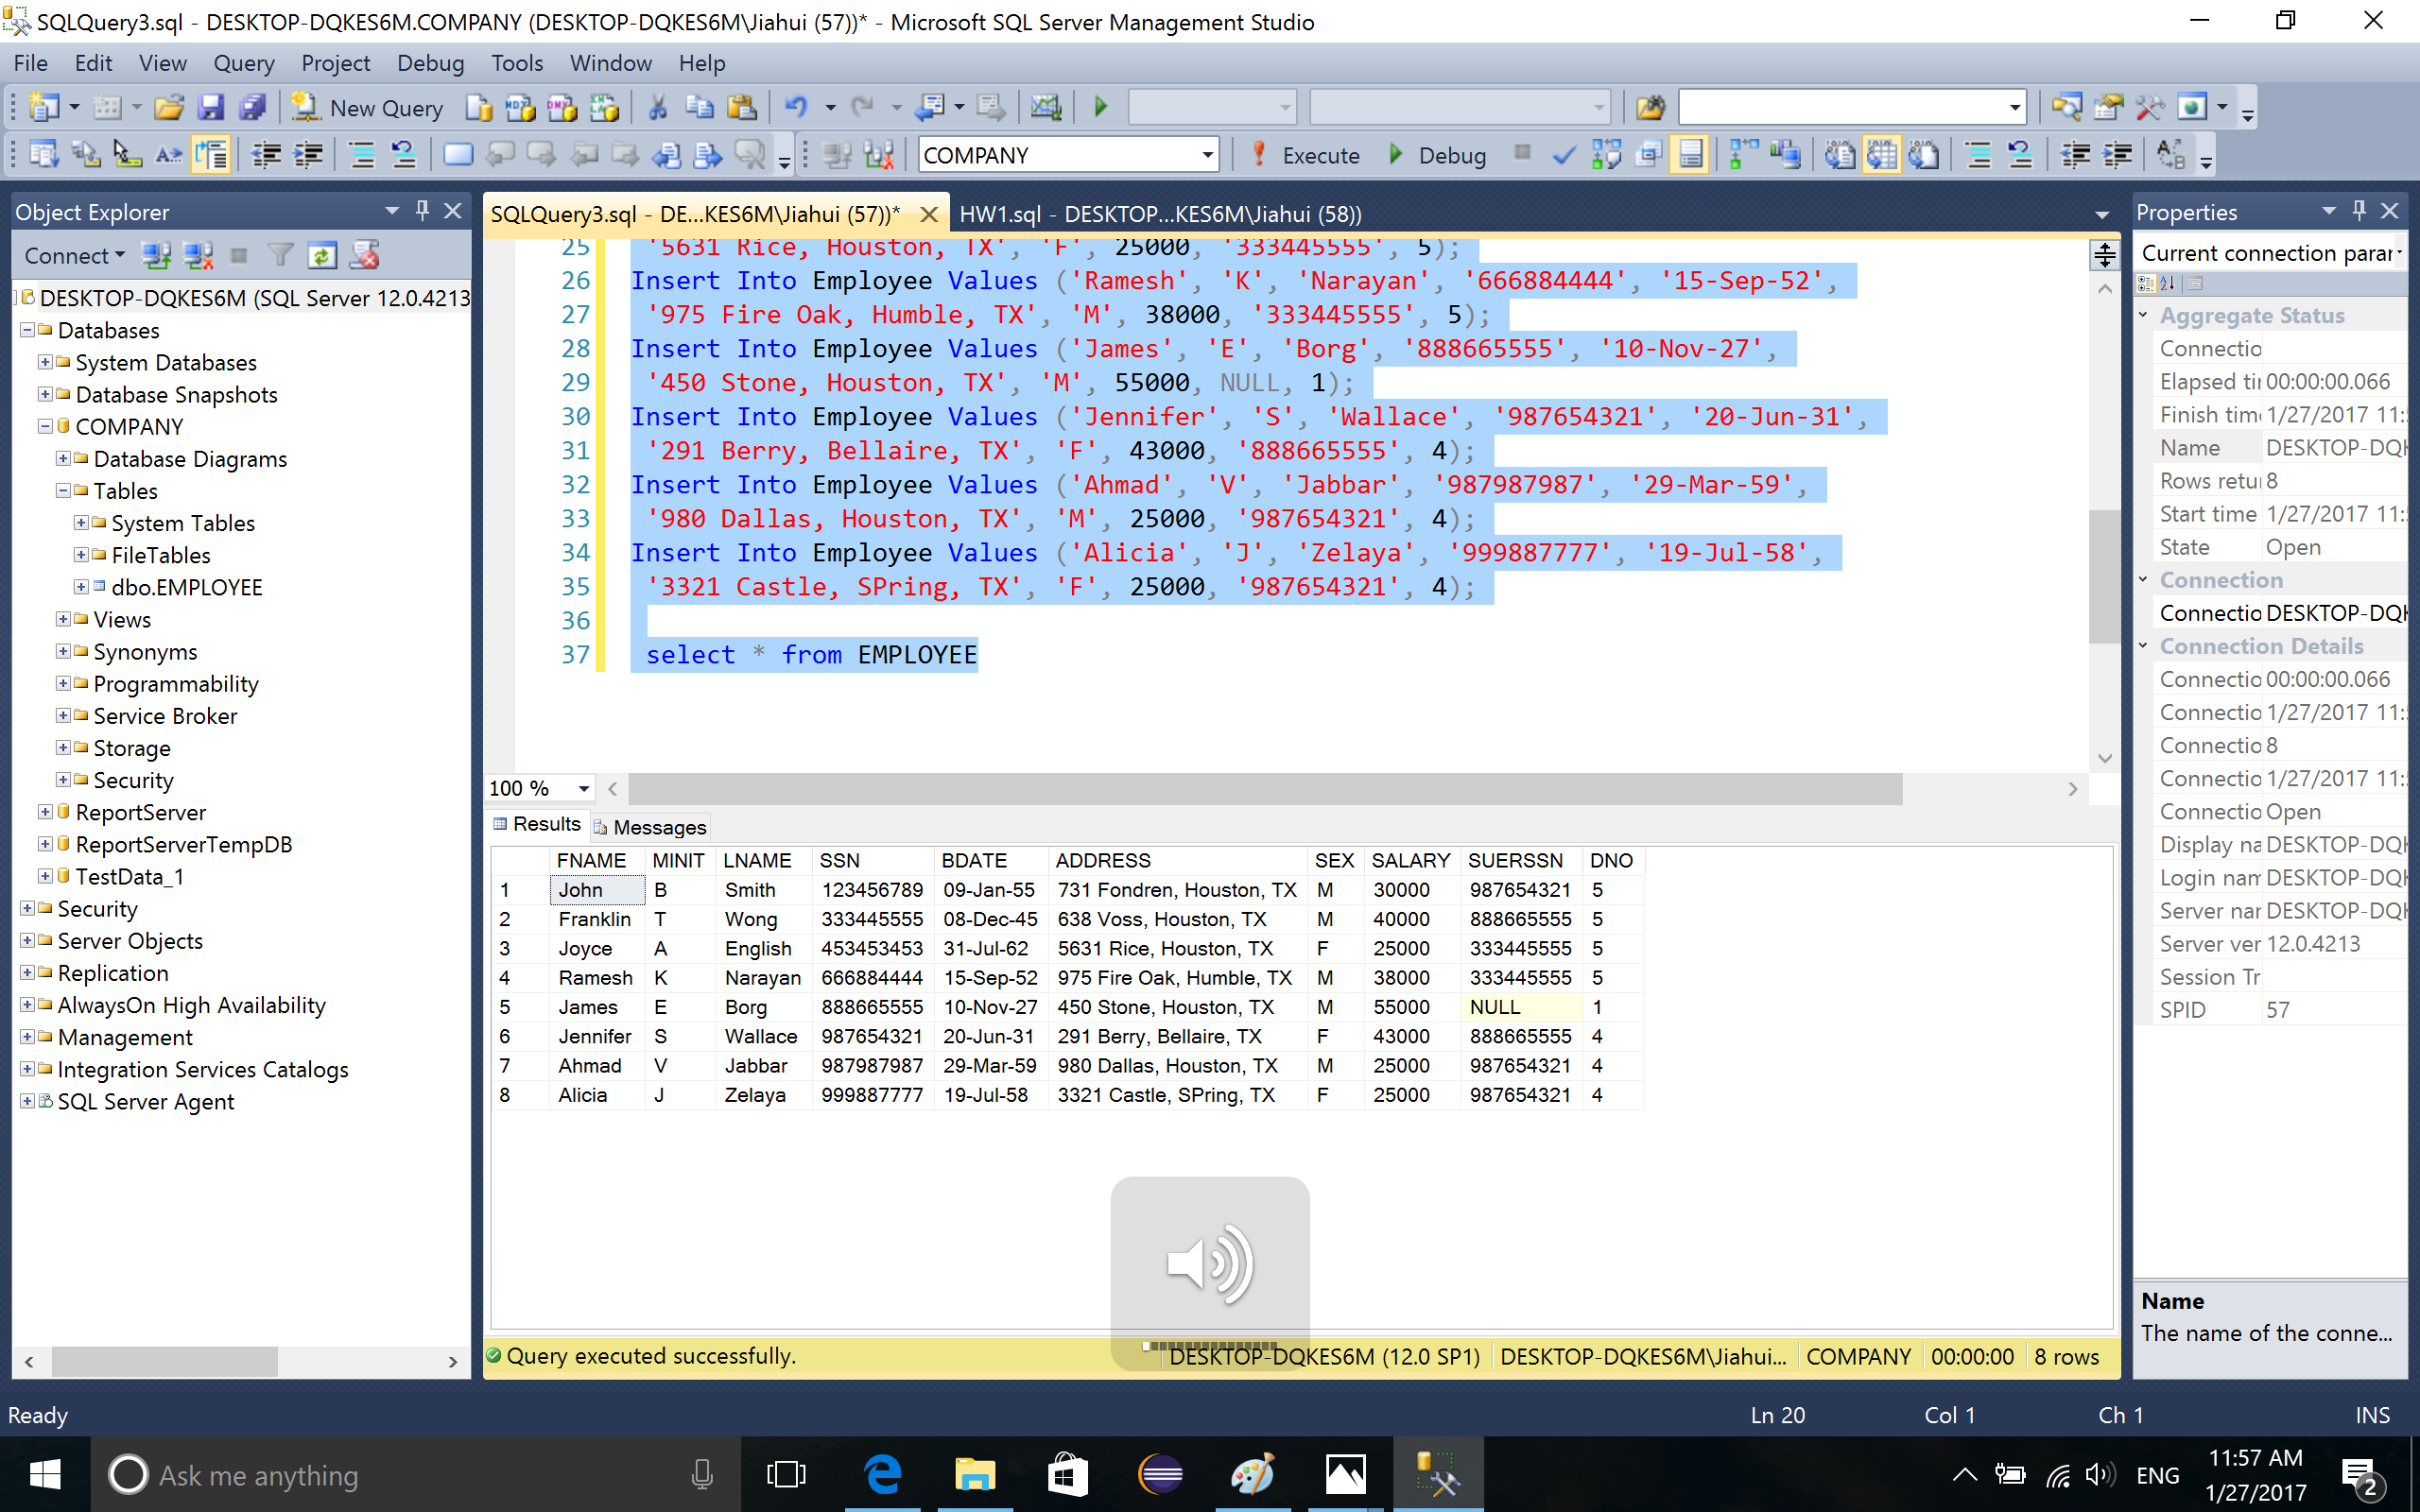

4. Then I created another table named DEPARTMENT and defined the attributes

command:

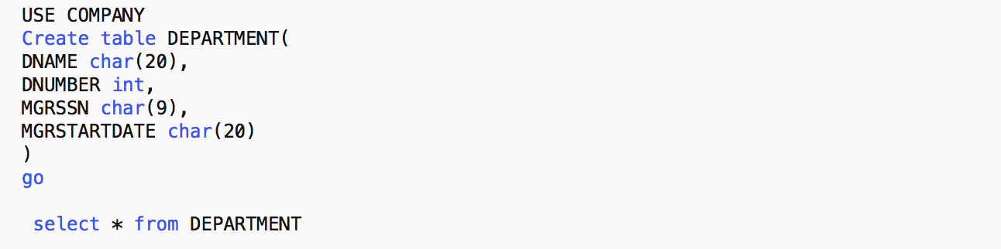

output:

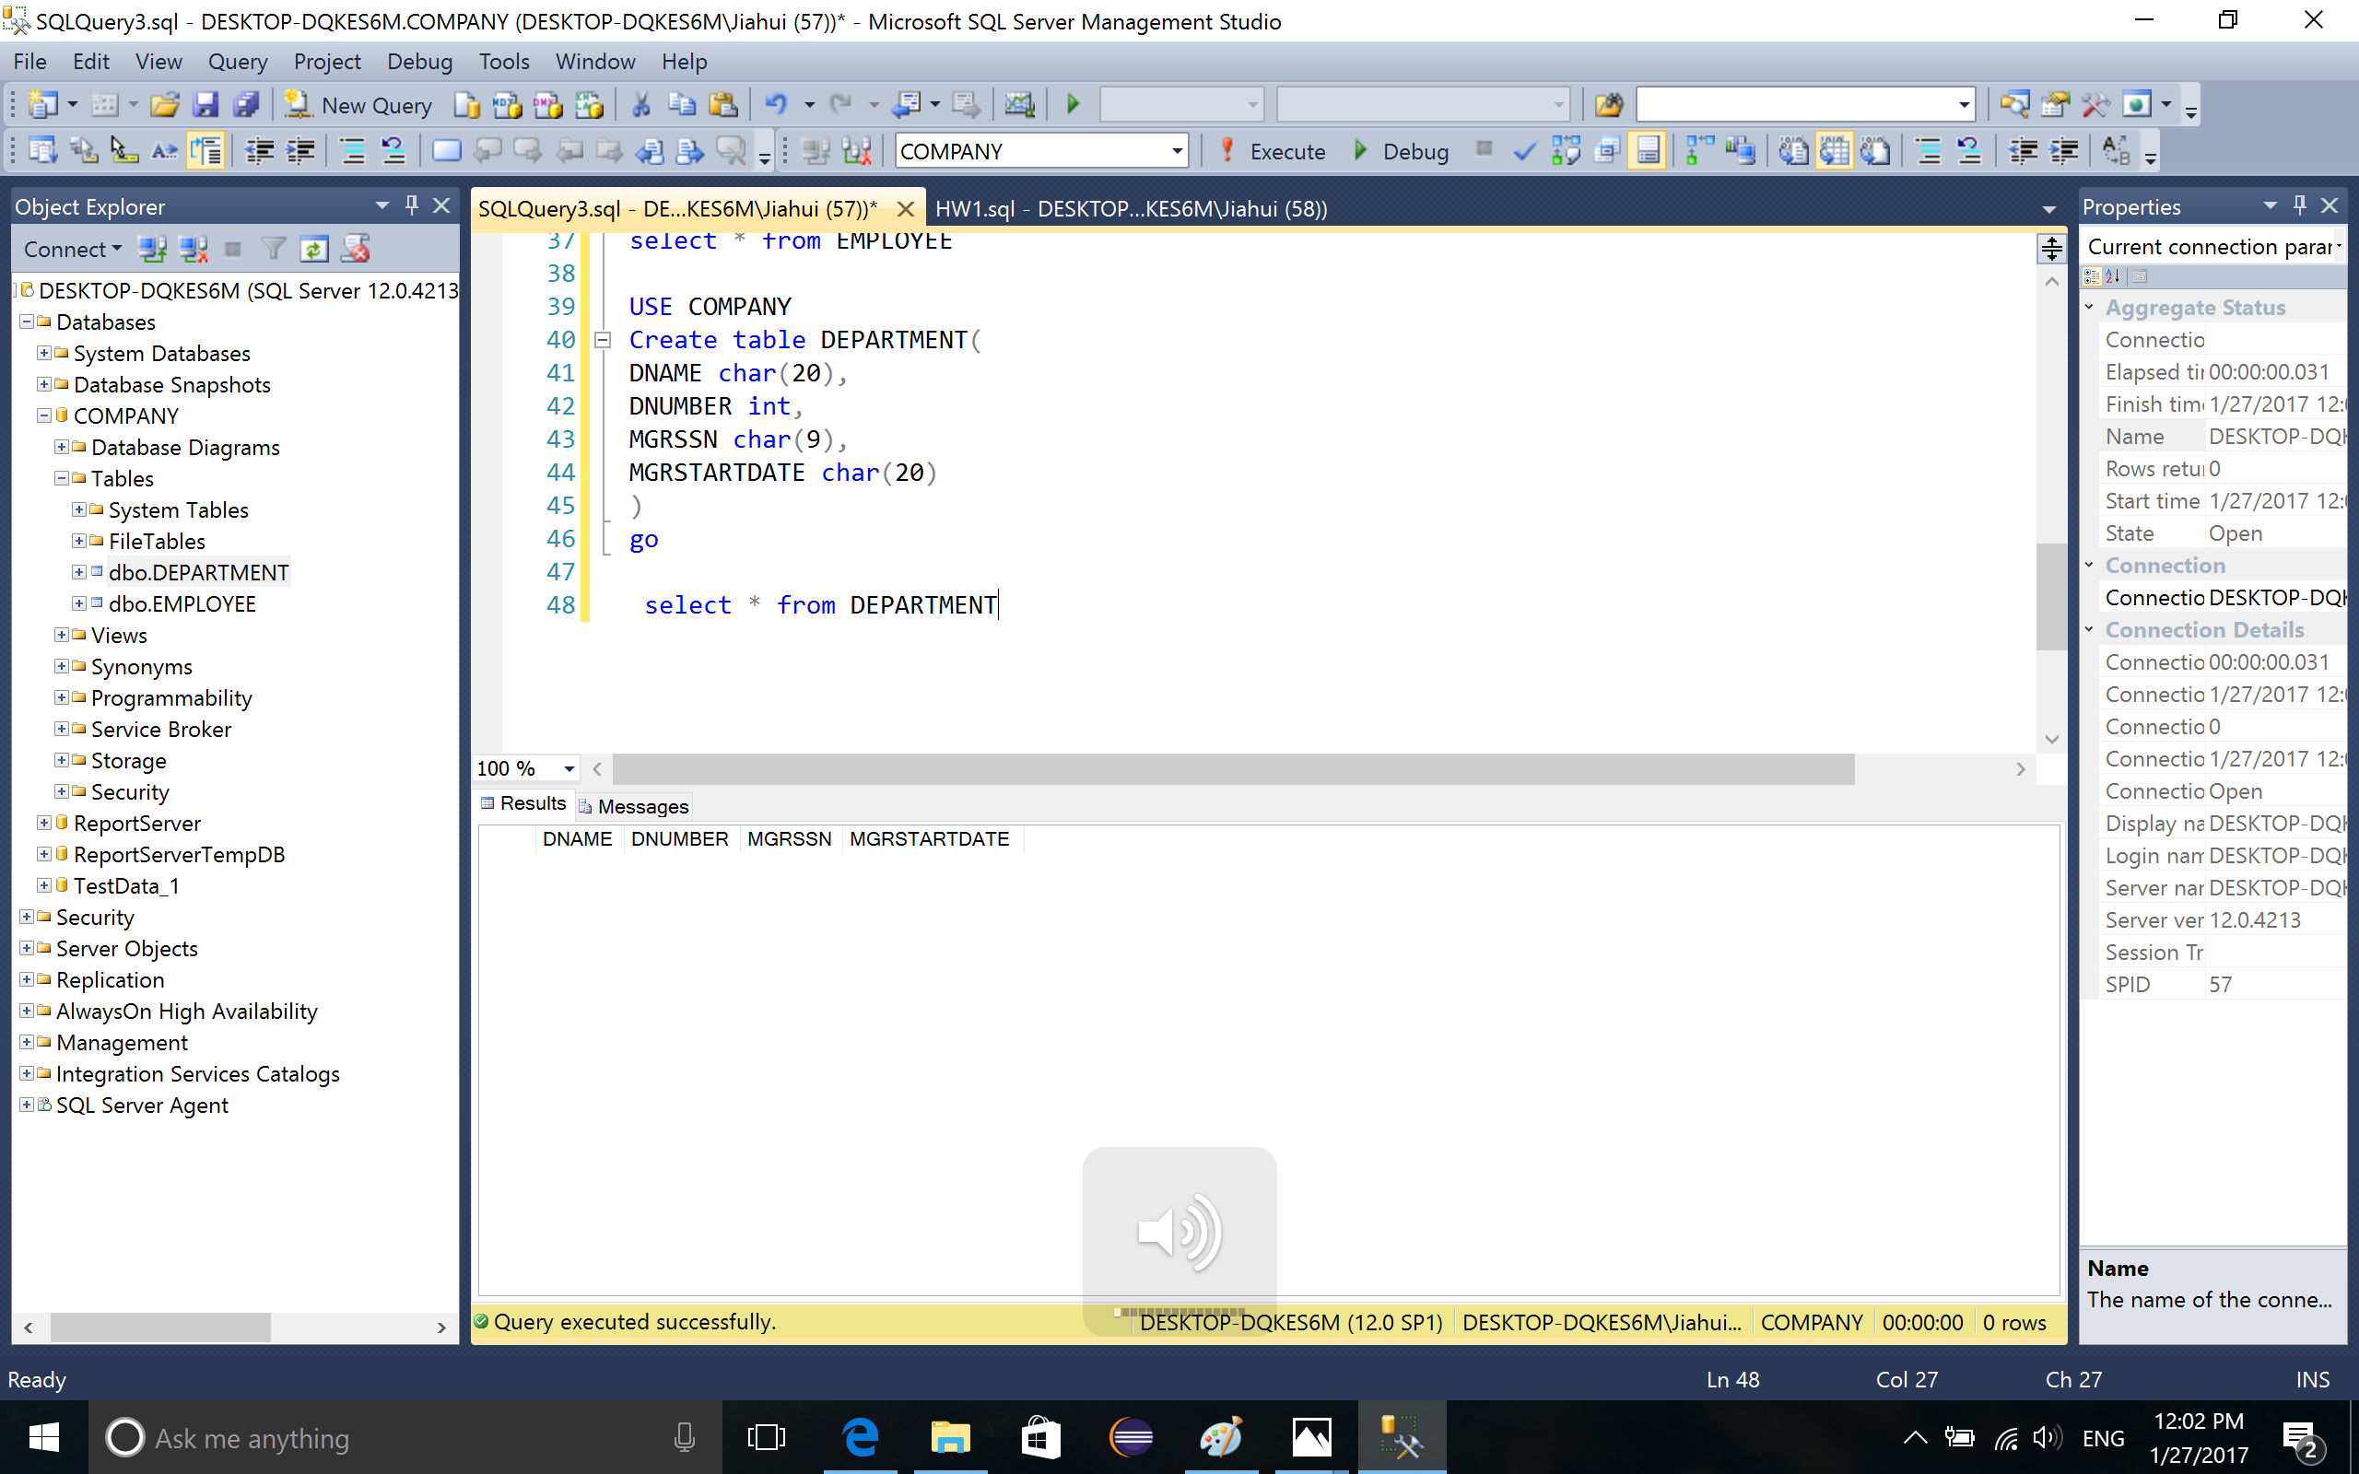

5. Insert information into the DEPARTMENT table

command:

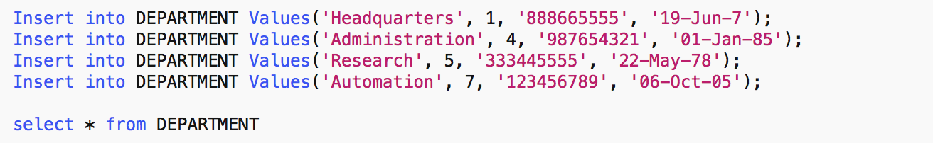

output:

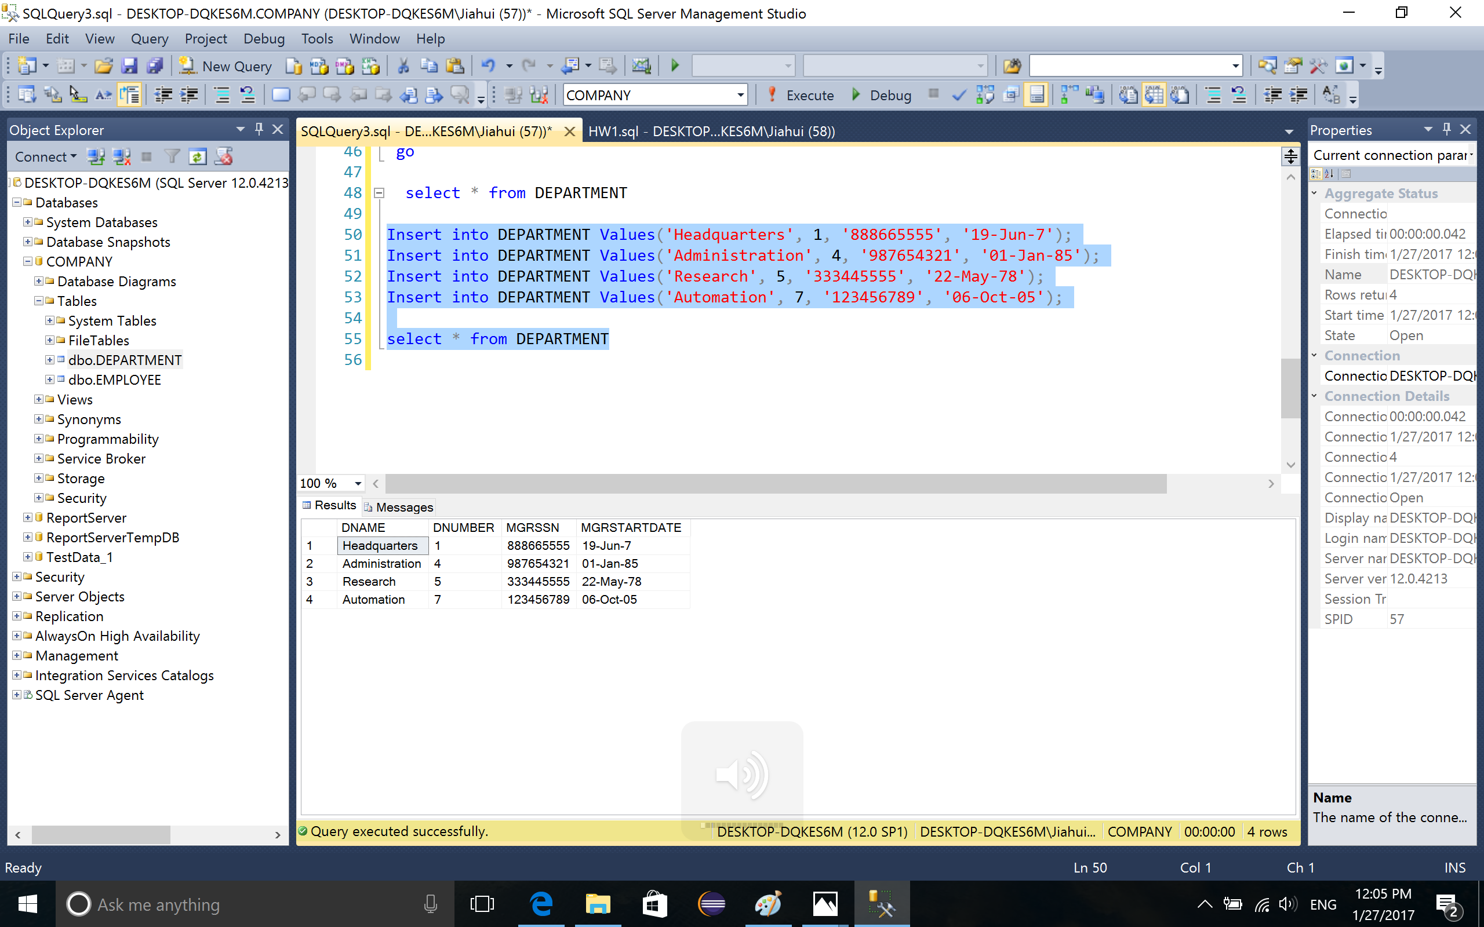

6. Delete the contents in table DEPARTMENT

command:



output:

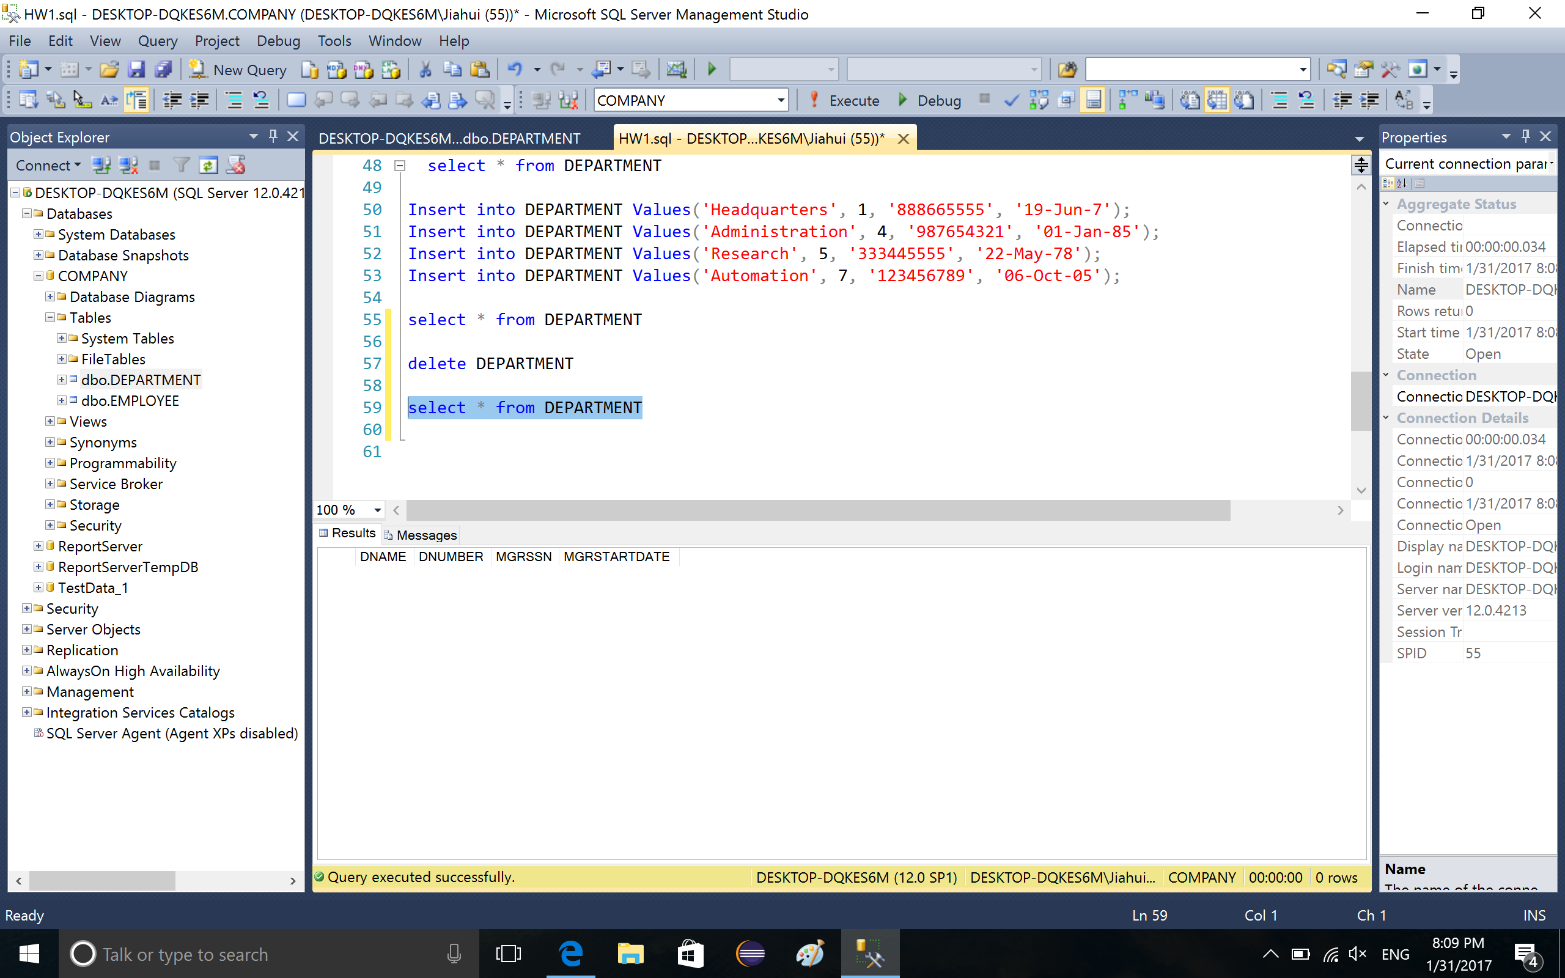

7. Drop table DEPARTMENT, which delete the table completely

command:



output:

