CIS430-Lab Assignment 2

Name: **Jiahui Wu**

ID: 2670210

Object: Creating a Relational Database Schema from ER diagram and populating the database

1. test different insertion conditions to see how it works

2. create schema with PK and FK constraints

3. populating data

4. test the insertions again to see how it works

5 relationship visualization

6 ER diagram

7 SQL code

1.1 create database COMPANY and table EMPLOYEE_TEST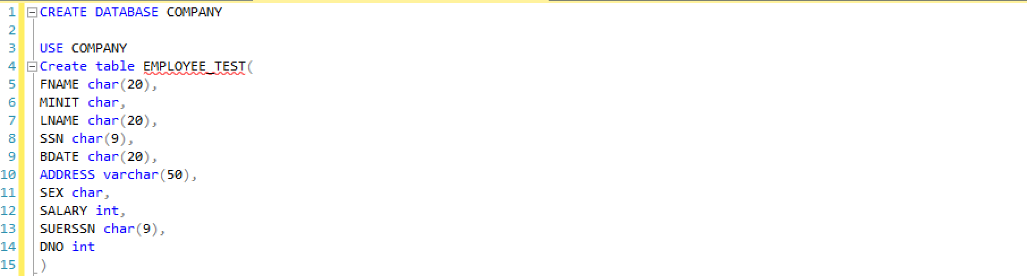

1.2 insert tuples into the table before setting any constraints, the system allowed null SSN/FNAME/LNAME, duplicate tuples and all null values to be inserted.

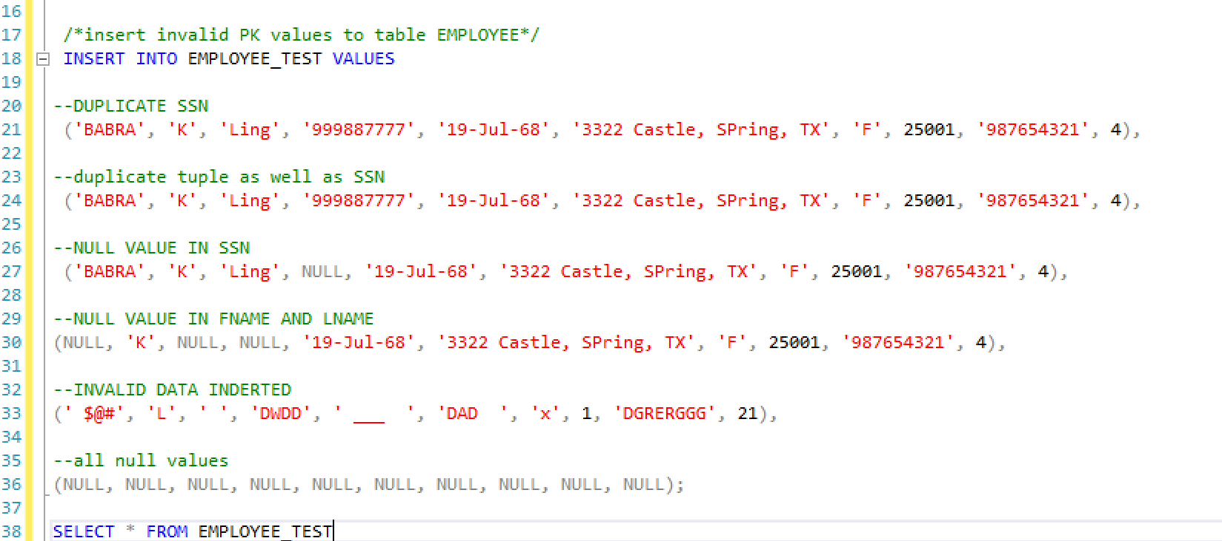

1.3 view table EMPLOYEE_TEST

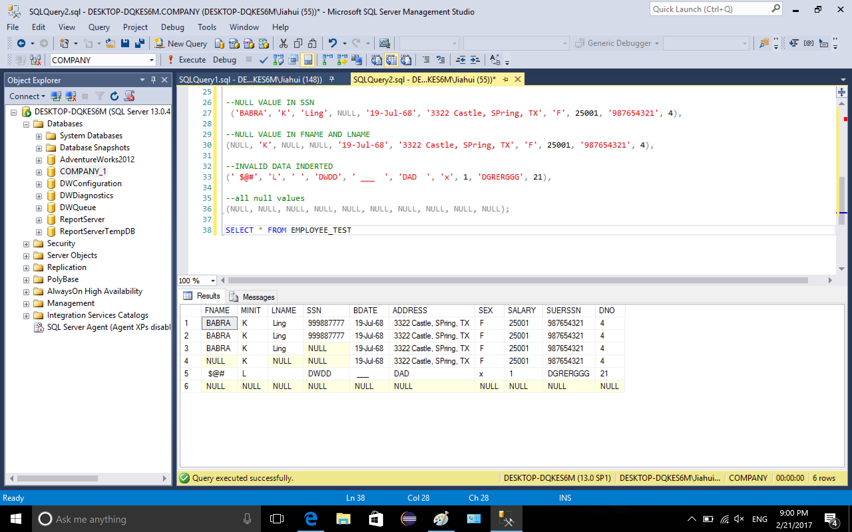

2.1 drop table EMPLOYEE_TEST, create table EMPLOYEE, define PK SSN

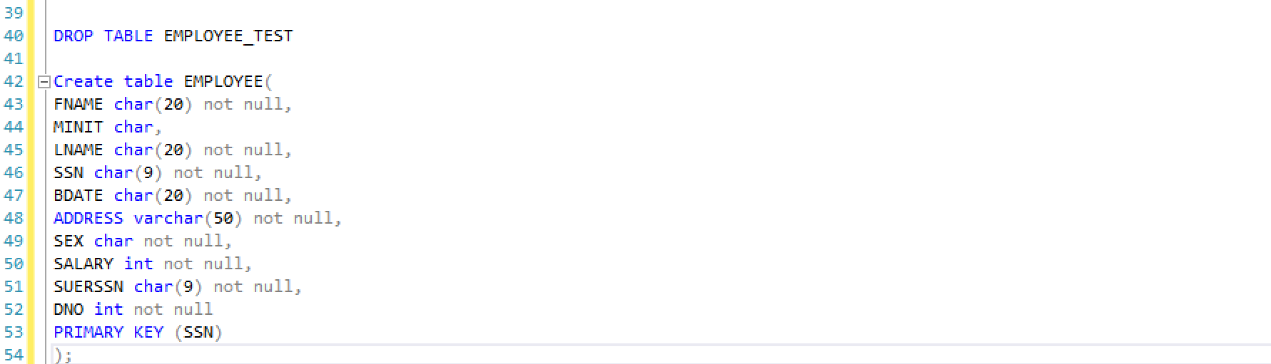

2.2 create table department, define PK DNUMBER

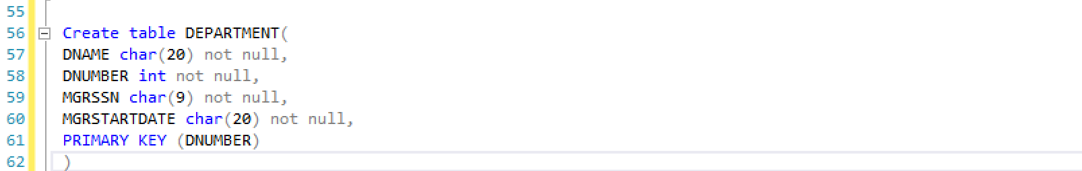

2.3 create table DEPT_LOCATIONS, define PK DUMBER, DLOCATION, FK DUMBER references DEPARTMENT DNUMBER

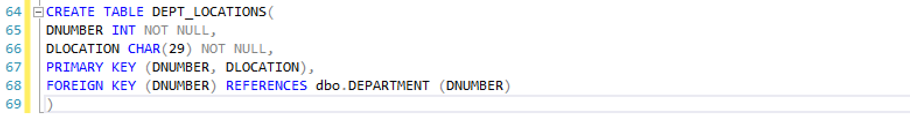

2.4 create table project, define PK PNUMBER, FK DNUM references DEPARTMENT DNUMBER

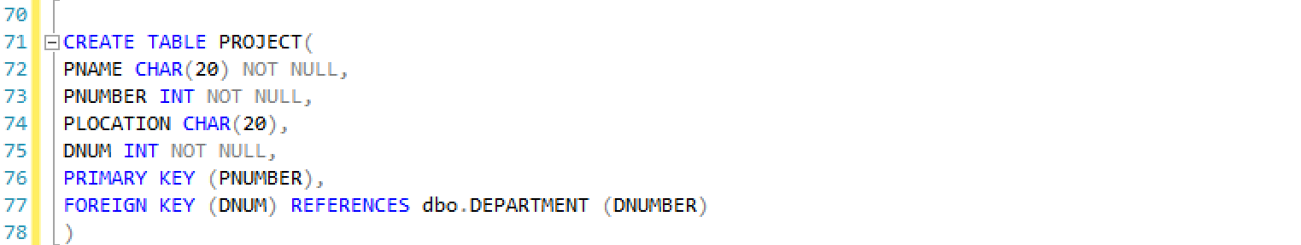

2.5 create table works_on, define PK ESSN&PNO, FK ESSN references EMPLOYEE SSN, PNO references DEPARTMENT DNUMBER

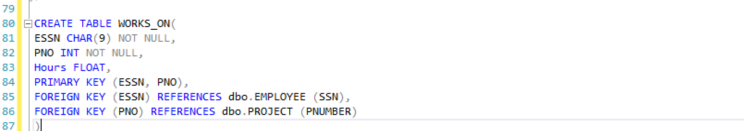

2.6 create table dependent, define PK ESSN&dependent_name, FK ESSN references EMPLOYEE SSN

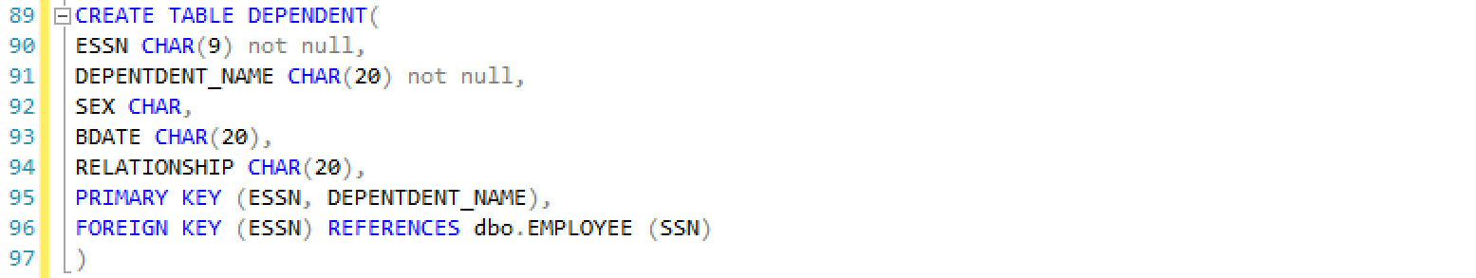

2.7 view those tables.

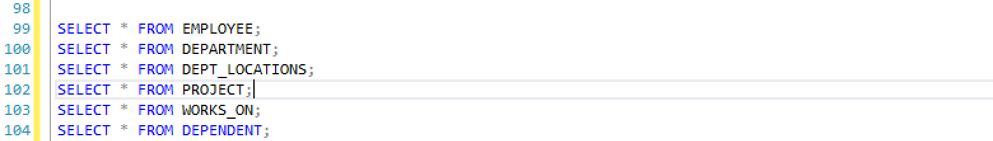

2.8 no tuples were inserted yet

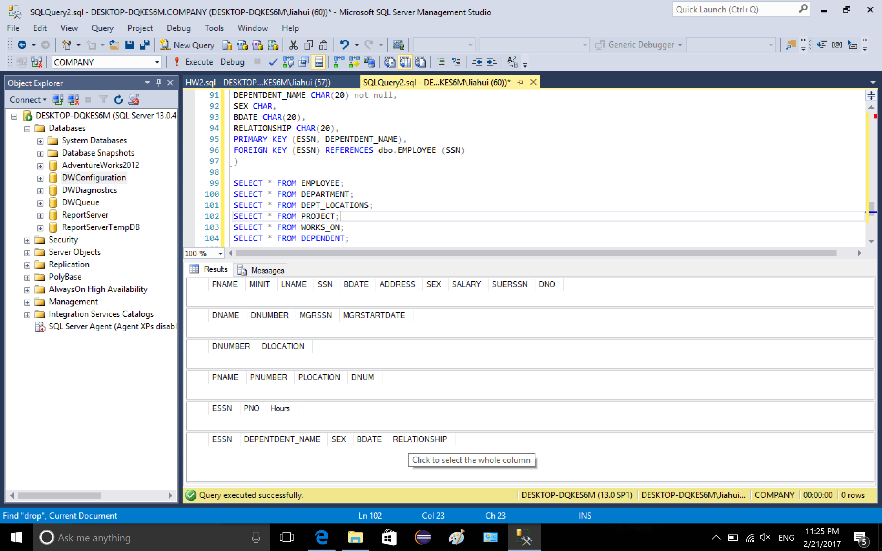

3.1 Populating the data, start inserting value into table employee

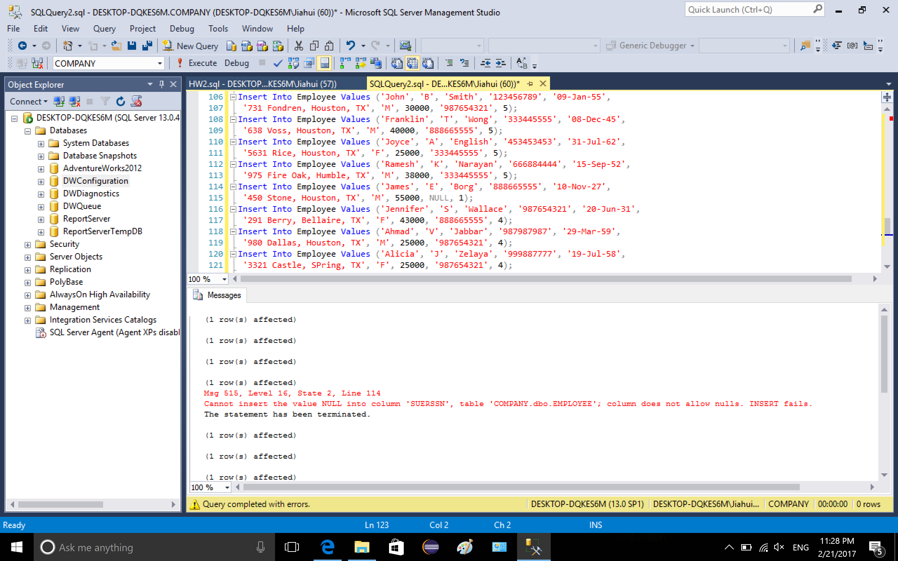

An insertion was denied because I tried to insert a null value into column SUERSSN, which was defined not null

../../../Volumes/WININSTALL/CIS530/HW



3.2 add foreign key SUERSSN to employee references employee table itself, a confliction was reported because a value in column SUERSSN does not exist in SSN.

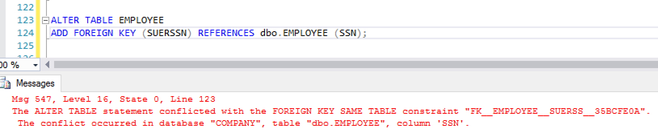

After checking, it was because of no matching SUERSSN (‘888665555’) in column SSN.

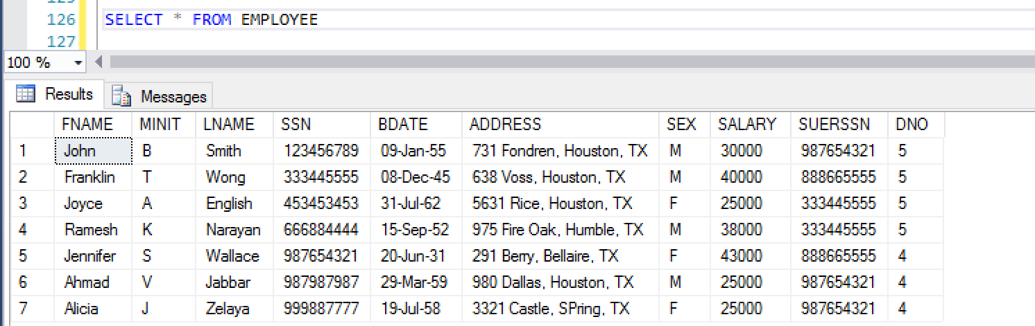

Insert the tuple which was not inserted in 3.1, its SSN value is ‘888665555’, its null value of SUERSSN was corrected to valid value

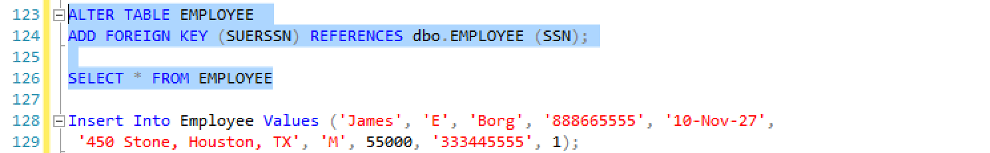

No confliction was reported.

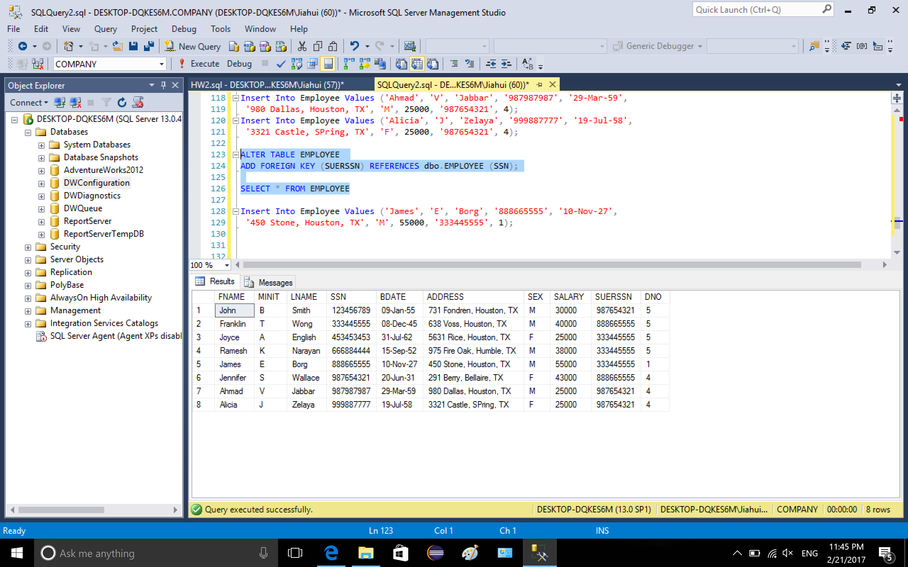

3.3 populating data to table department

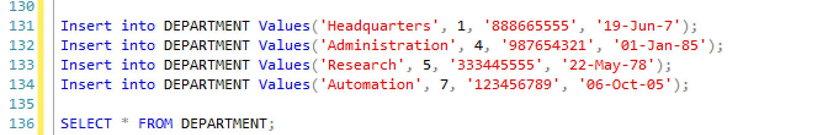

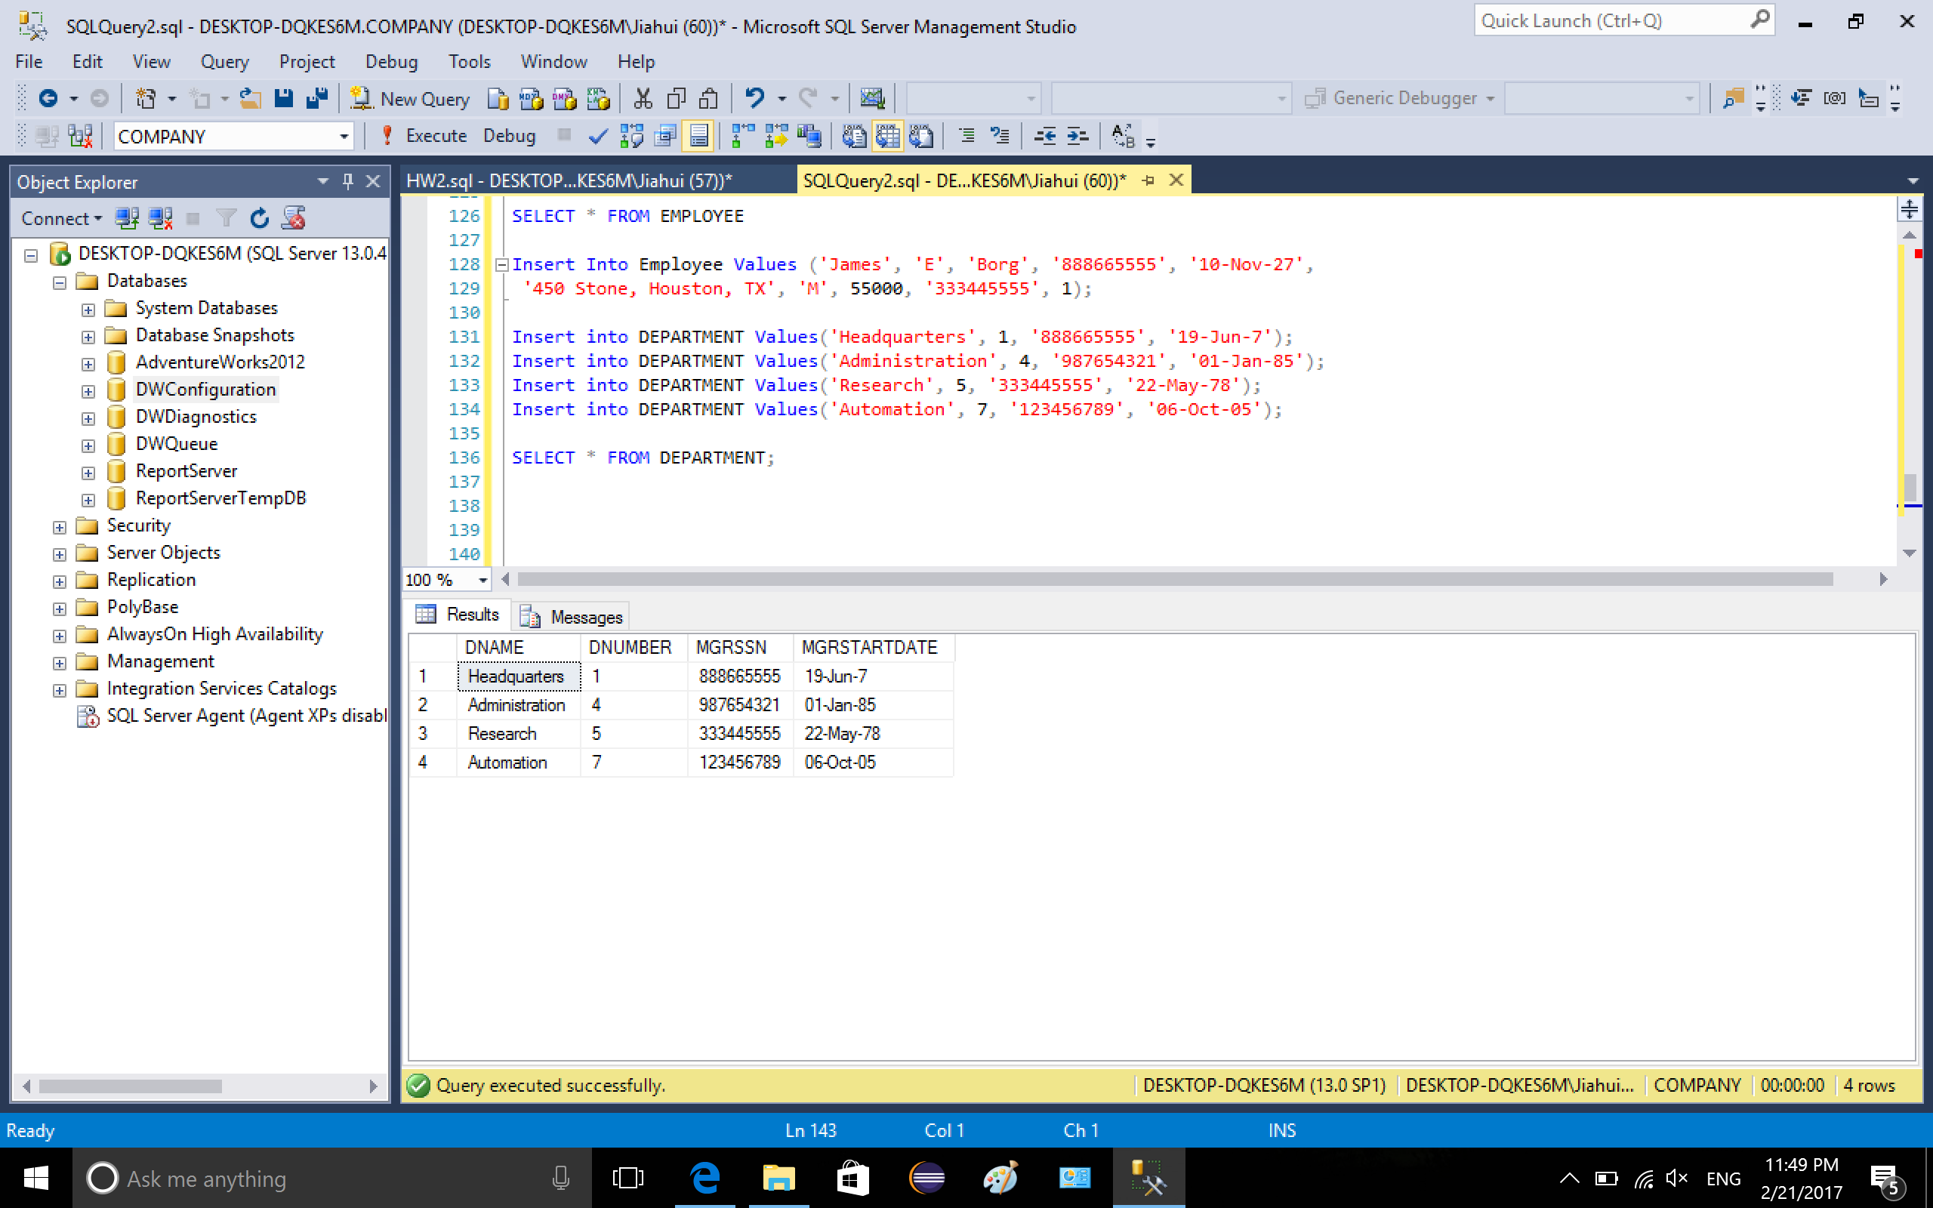

3.4 Add foreign key (DNO) to table employee which references department dnumber, no errors or conflictions were reported

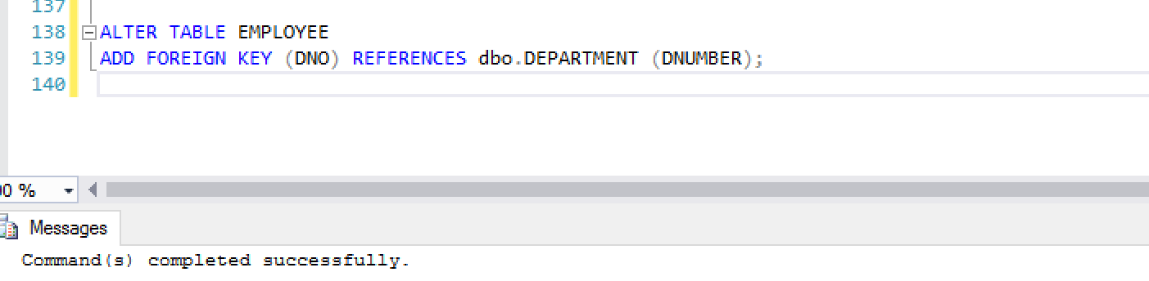

3.5 populating data to table DEPT_LOCATIONS

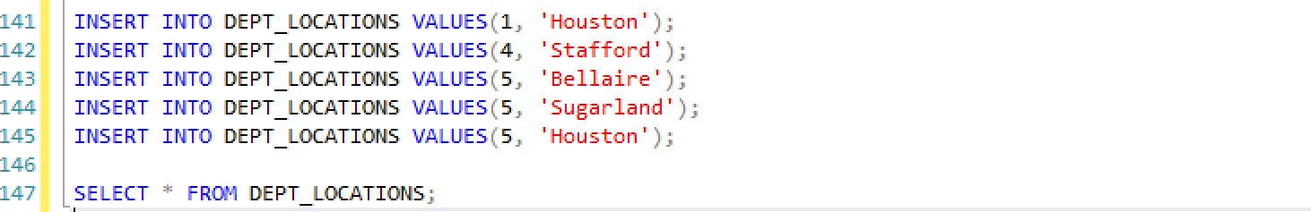

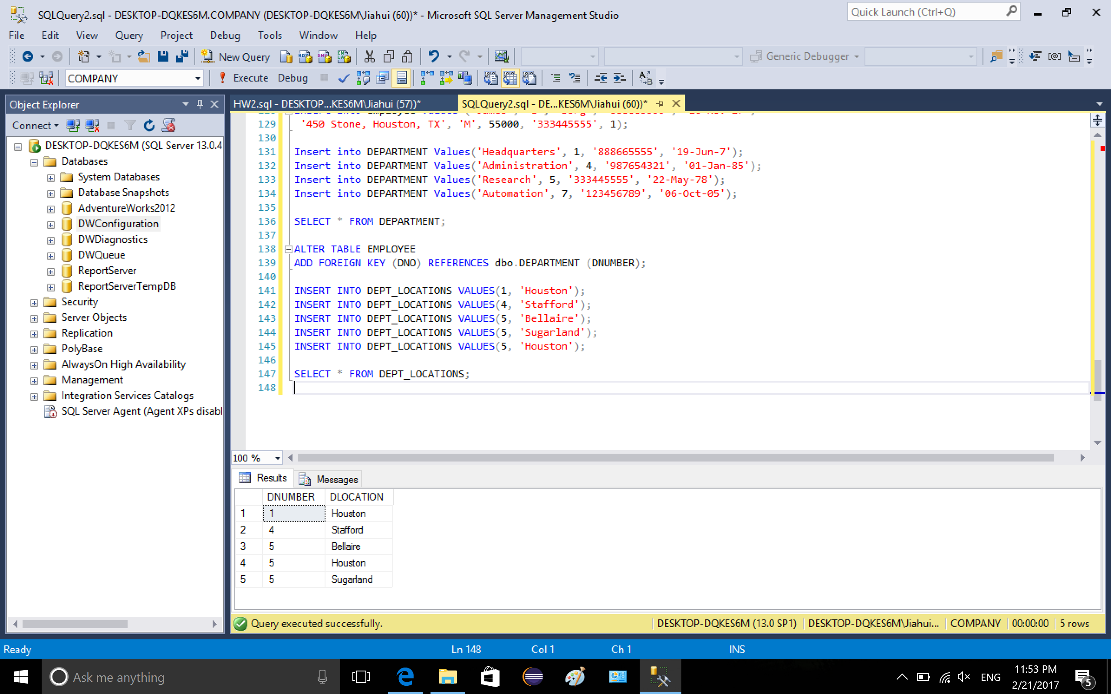

3.6 populating data to table project

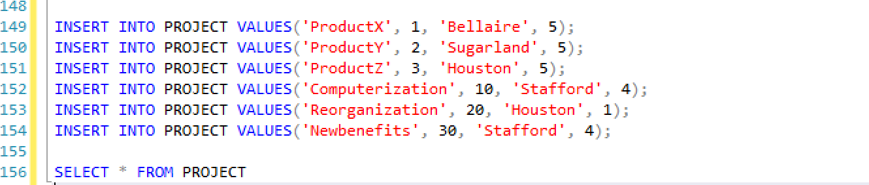

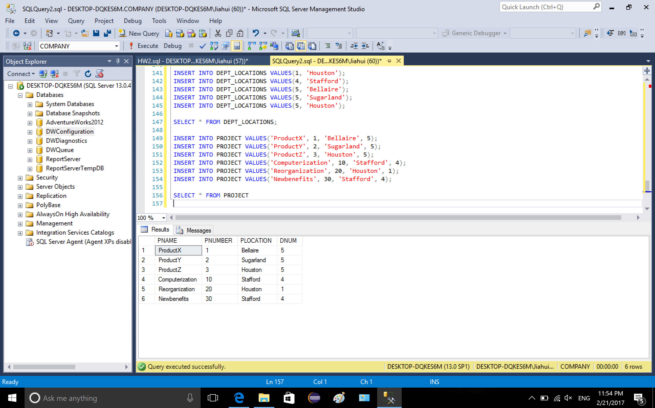

3.7 populating data to table works_on

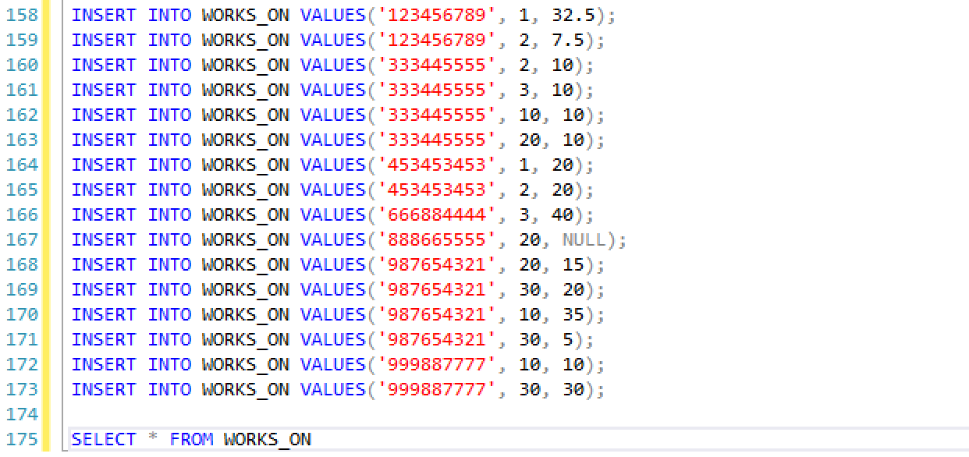

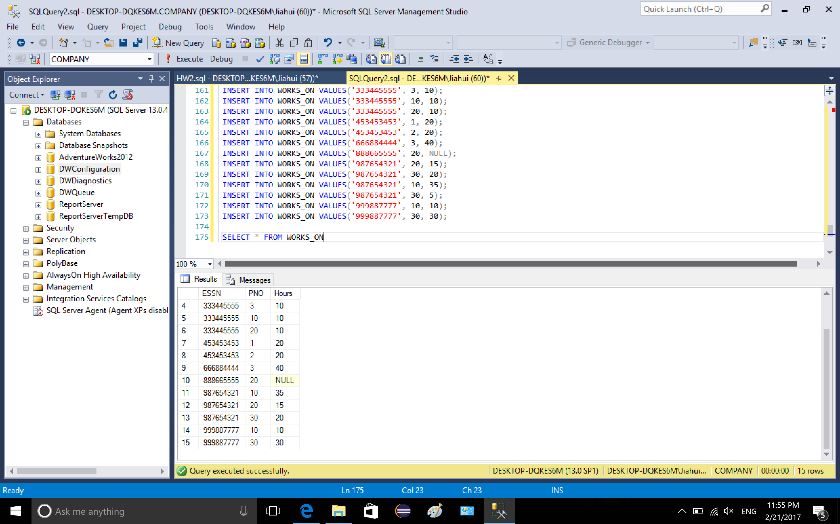

3.8 populating data to table dependent

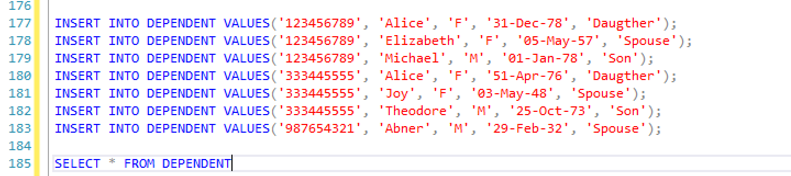

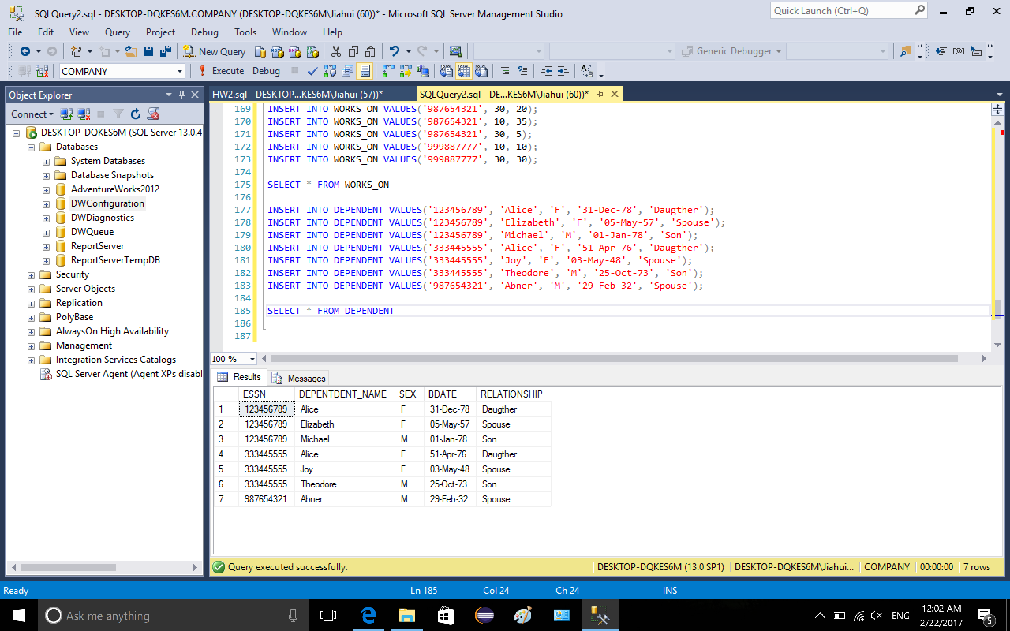

4.1 test the various conditions that was tested in the first part

insert a tuple with duplicate SSN, the statement was terminated because cannot insert duplicate key in employee

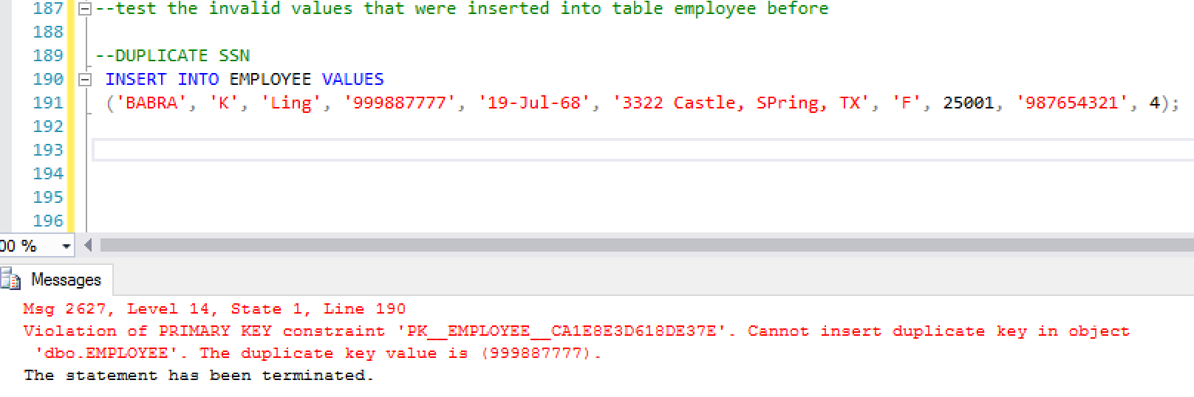

4.2 insert duplicate tuples, since the SSN is also duplicate, same violation

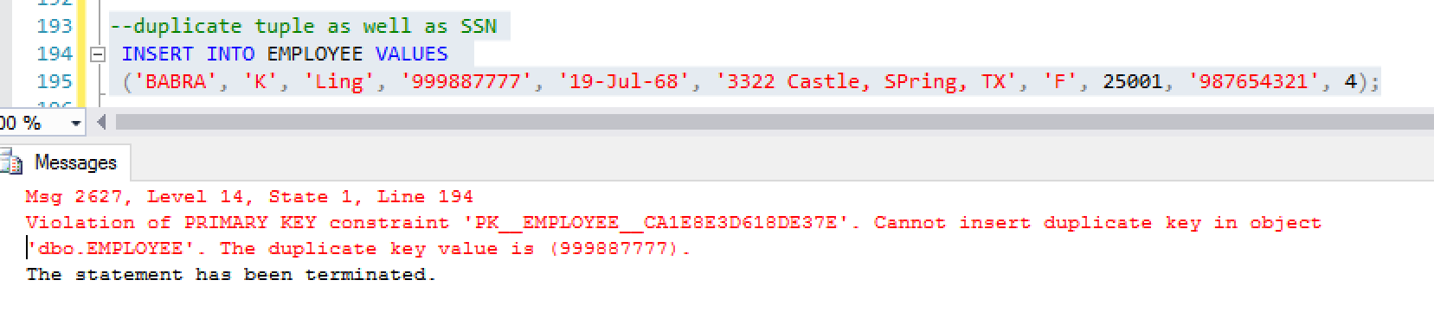

4.3 insert null value in SSN. Insertion failed because SSN was defined not null

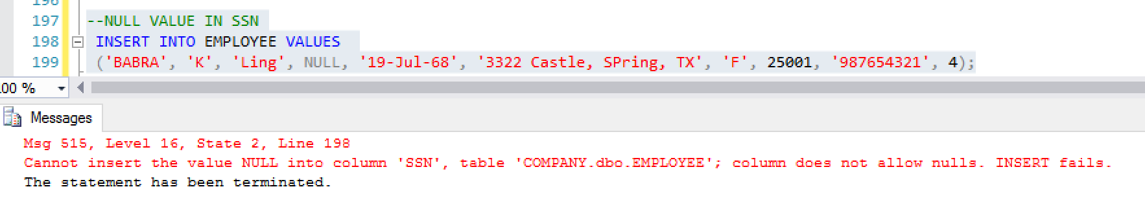

4.4 insert null Fname and Lname, insertion failed because the two columns were defined not null

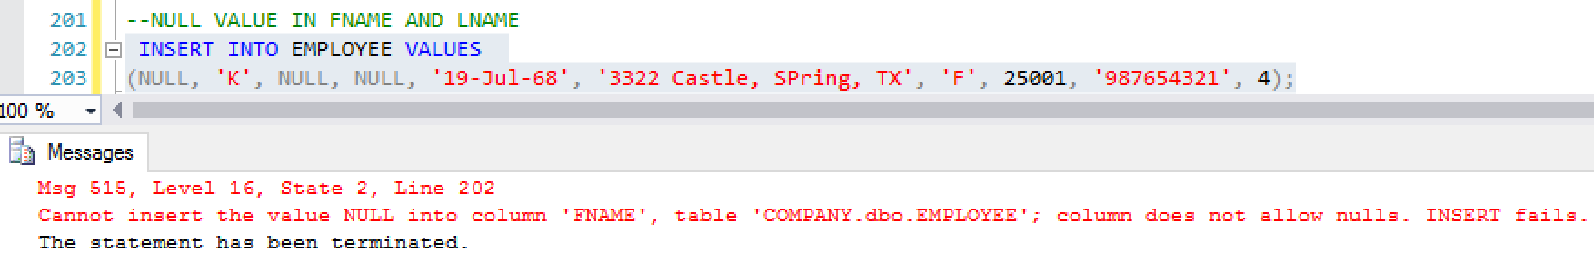

4.5 insert symbols, statement was terminated because of the conflict with the foreign key constraint, value in column DNO was not found in table department, column DNUMBER

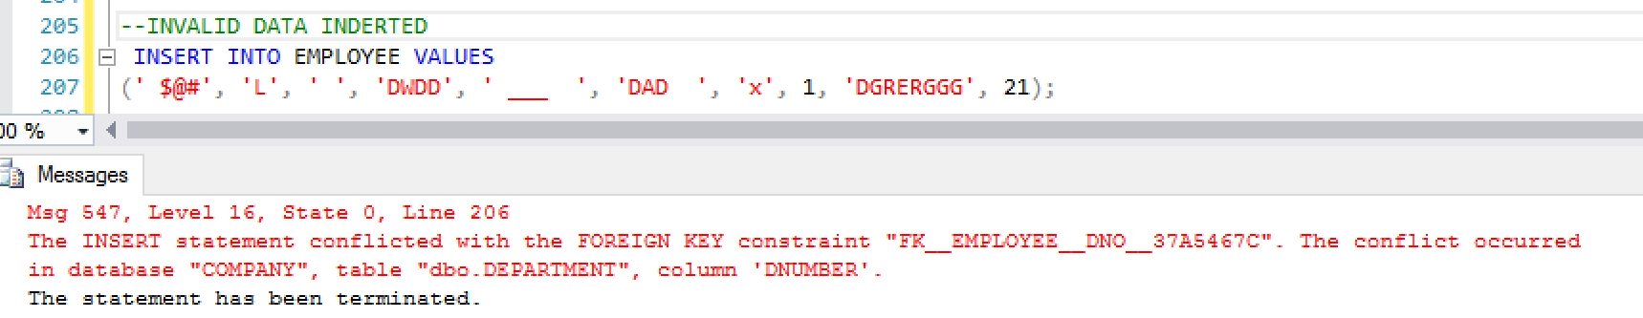

4.6 insert a tuple with null values, insertion failed because some columns such as PK(SSN), fname and lname don’t allow null values

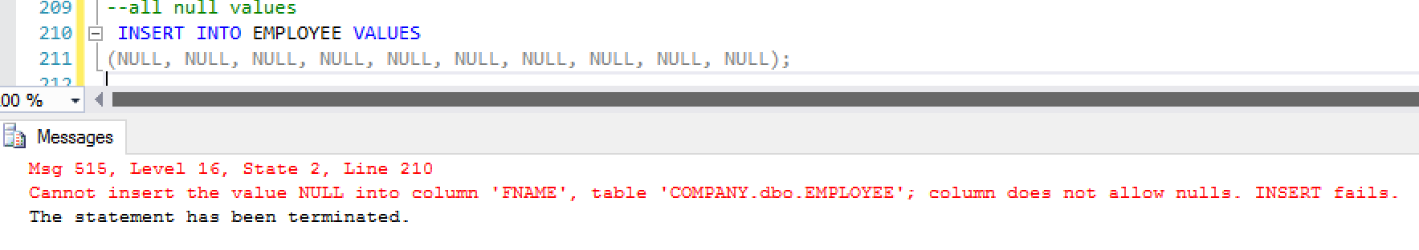

5 visualize the relationship

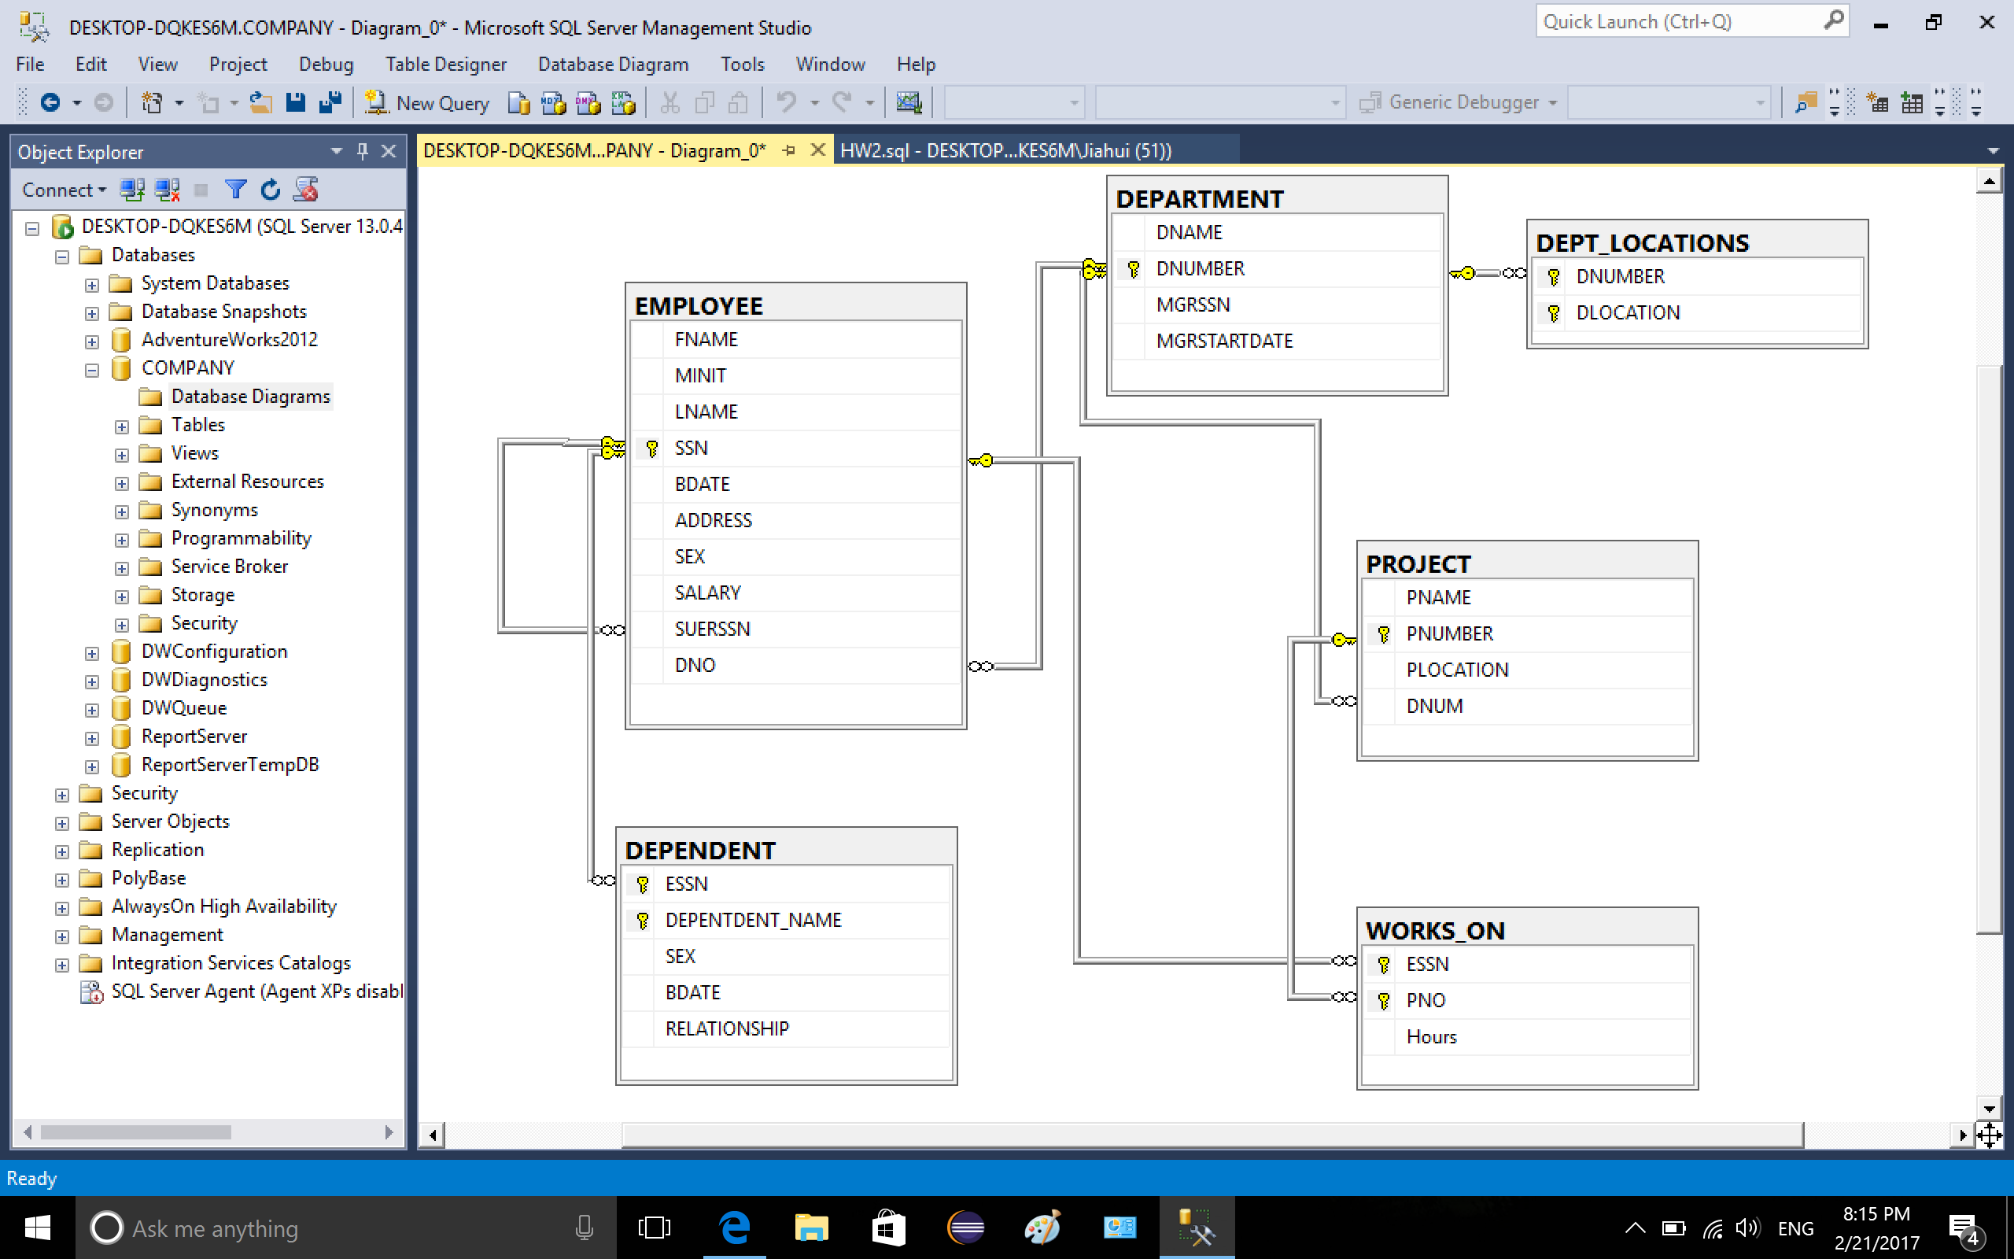

6 ER diagram of the relationship

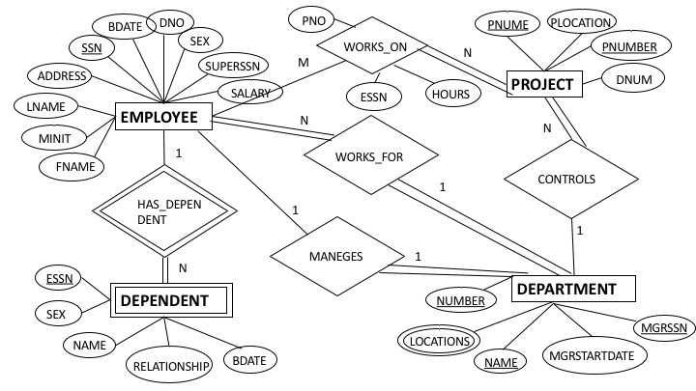

7 SQL code

CREATE DATABASE COMPANY

USE COMPANY

Create table EMPLOYEE_TEST(

FNAME char(20),

MINIT char,

LNAME char(20),

SSN char(9),

BDATE char(20),

ADDRESS varchar(50),

SEX char,

SALARY int,

SUERSSN char(9),

DNO int

)

/*insert invalid PK values to table EMPLOYEE*/

INSERT INTO EMPLOYEE_TEST VALUES

--DUPLICATE SSN

('BABRA', 'K', 'Ling', '999887777', '19-Jul-68', '3322 Castle, SPring, TX', 'F', 25001, '987654321', 4),

--duplicate tuple as well as SSN

('BABRA', 'K', 'Ling', '999887777', '19-Jul-68', '3322 Castle, SPring, TX', 'F', 25001, '987654321', 4),

--NULL VALUE IN SSN

('BABRA', 'K', 'Ling', NULL, '19-Jul-68', '3322 Castle, SPring, TX', 'F', 25001, '987654321', 4),

--NULL VALUE IN FNAME AND LNAME

(NULL, 'K', NULL, NULL, '19-Jul-68', '3322 Castle, SPring, TX', 'F', 25001, '987654321', 4),

--INVALID DATA INDERTED

(' $@#', 'L', ' ', 'DWDD', ' ___ ', 'DAD ', 'x', 1, 'DGRERGGG', 21),

--all null values

(NULL, NULL, NULL, NULL, NULL, NULL, NULL, NULL, NULL, NULL);

SELECT * FROM EMPLOYEE_TEST

DROP TABLE EMPLOYEE_TEST

Create table EMPLOYEE(

FNAME char(20) not null,

MINIT char,

LNAME char(20) not null,

SSN char(9) not null,

BDATE char(20) not null,

ADDRESS varchar(50) not null,

SEX char not null,

SALARY int not null,

SUERSSN char(9) not null,

DNO int not null

PRIMARY KEY (SSN)

);

Create table DEPARTMENT(

DNAME char(20) not null,

DNUMBER int not null,

MGRSSN char(9) not null,

MGRSTARTDATE char(20) not null,

PRIMARY KEY (DNUMBER)

)

CREATE TABLE DEPT_LOCATIONS(

DNUMBER INT NOT NULL,

DLOCATION CHAR(29) NOT NULL,

PRIMARY KEY (DNUMBER, DLOCATION),

FOREIGN KEY (DNUMBER) REFERENCES dbo.DEPARTMENT (DNUMBER)

)

CREATE TABLE PROJECT(

PNAME CHAR(20) NOT NULL,

PNUMBER INT NOT NULL,

PLOCATION CHAR(20),

DNUM INT NOT NULL,

PRIMARY KEY (PNUMBER),

FOREIGN KEY (DNUM) REFERENCES dbo.DEPARTMENT (DNUMBER)

)

CREATE TABLE WORKS_ON(

ESSN CHAR(9) NOT NULL,

PNO INT NOT NULL,

Hours FLOAT,

PRIMARY KEY (ESSN, PNO),

FOREIGN KEY (ESSN) REFERENCES dbo.EMPLOYEE (SSN),

FOREIGN KEY (PNO) REFERENCES dbo.PROJECT (PNUMBER)

)

CREATE TABLE DEPENDENT(

ESSN CHAR(9) not null,

DEPENTDENT_NAME CHAR(20) not null,

SEX CHAR,

BDATE CHAR(20),

RELATIONSHIP CHAR(20),

PRIMARY KEY (ESSN, DEPENTDENT_NAME),

FOREIGN KEY (ESSN) REFERENCES dbo.EMPLOYEE (SSN)

)

SELECT * FROM EMPLOYEE;

SELECT * FROM DEPARTMENT;

SELECT * FROM DEPT_LOCATIONS;

SELECT * FROM PROJECT;

SELECT * FROM WORKS_ON;

SELECT * FROM DEPENDENT;

Insert Into Employee Values ('John', 'B', 'Smith', '123456789', '09-Jan-55',

'731 Fondren, Houston, TX', 'M', 30000, '987654321', 5);

Insert Into Employee Values ('Franklin', 'T', 'Wong', '333445555', '08-Dec-45',

'638 Voss, Houston, TX', 'M', 40000, '888665555', 5);

Insert Into Employee Values ('Joyce', 'A', 'English', '453453453', '31-Jul-62',

'5631 Rice, Houston, TX', 'F', 25000, '333445555', 5);

Insert Into Employee Values ('Ramesh', 'K', 'Narayan', '666884444', '15-Sep-52',

'975 Fire Oak, Humble, TX', 'M', 38000, '333445555', 5);

Insert Into Employee Values ('James', 'E', 'Borg', '888665555', '10-Nov-27',

'450 Stone, Houston, TX', 'M', 55000, NULL, 1);

Insert Into Employee Values ('Jennifer', 'S', 'Wallace', '987654321', '20-Jun-31',

'291 Berry, Bellaire, TX', 'F', 43000, '888665555', 4);

Insert Into Employee Values ('Ahmad', 'V', 'Jabbar', '987987987', '29-Mar-59',

'980 Dallas, Houston, TX', 'M', 25000, '987654321', 4);

Insert Into Employee Values ('Alicia', 'J', 'Zelaya', '999887777', '19-Jul-58',

'3321 Castle, SPring, TX', 'F', 25000, '987654321', 4);

ALTER TABLE EMPLOYEE

ADD FOREIGN KEY (SUERSSN) REFERENCES dbo.EMPLOYEE (SSN);

SELECT * FROM EMPLOYEE

Insert Into Employee Values ('James', 'E', 'Borg', '888665555', '10-Nov-27',

'450 Stone, Houston, TX', 'M', 55000, '333445555', 1);

Insert into DEPARTMENT Values('Headquarters', 1, '888665555', '19-Jun-7');

Insert into DEPARTMENT Values('Administration', 4, '987654321', '01-Jan-85');

Insert into DEPARTMENT Values('Research', 5, '333445555', '22-May-78');

Insert into DEPARTMENT Values('Automation', 7, '123456789', '06-Oct-05');

SELECT * FROM DEPARTMENT;

ALTER TABLE EMPLOYEE

ADD FOREIGN KEY (DNO) REFERENCES dbo.DEPARTMENT (DNUMBER);

INSERT INTO DEPT_LOCATIONS VALUES(1, 'Houston');

INSERT INTO DEPT_LOCATIONS VALUES(4, 'Stafford');

INSERT INTO DEPT_LOCATIONS VALUES(5, 'Bellaire');

INSERT INTO DEPT_LOCATIONS VALUES(5, 'Sugarland');

INSERT INTO DEPT_LOCATIONS VALUES(5, 'Houston');

SELECT * FROM DEPT_LOCATIONS;

INSERT INTO PROJECT VALUES('ProductX', 1, 'Bellaire', 5);

INSERT INTO PROJECT VALUES('ProductY', 2, 'Sugarland', 5);

INSERT INTO PROJECT VALUES('ProductZ', 3, 'Houston', 5);

INSERT INTO PROJECT VALUES('Computerization', 10, 'Stafford', 4);

INSERT INTO PROJECT VALUES('Reorganization', 20, 'Houston', 1);

INSERT INTO PROJECT VALUES('Newbenefits', 30, 'Stafford', 4);

SELECT * FROM PROJECT

INSERT INTO WORKS_ON VALUES('123456789', 1, 32.5);

INSERT INTO WORKS_ON VALUES('123456789', 2, 7.5);

INSERT INTO WORKS_ON VALUES('333445555', 2, 10);

INSERT INTO WORKS_ON VALUES('333445555', 3, 10);

INSERT INTO WORKS_ON VALUES('333445555', 10, 10);

INSERT INTO WORKS_ON VALUES('333445555', 20, 10);

INSERT INTO WORKS_ON VALUES('453453453', 1, 20);

INSERT INTO WORKS_ON VALUES('453453453', 2, 20);

INSERT INTO WORKS_ON VALUES('666884444', 3, 40);

INSERT INTO WORKS_ON VALUES('888665555', 20, NULL);

INSERT INTO WORKS_ON VALUES('987654321', 20, 15);

INSERT INTO WORKS_ON VALUES('987654321', 30, 20);

INSERT INTO WORKS_ON VALUES('987654321', 10, 35);

INSERT INTO WORKS_ON VALUES('987654321', 30, 5);

INSERT INTO WORKS_ON VALUES('999887777', 10, 10);

INSERT INTO WORKS_ON VALUES('999887777', 30, 30);

SELECT * FROM WORKS_ON

INSERT INTO DEPENDENT VALUES('123456789', 'Alice', 'F', '31-Dec-78', 'Daugther');

INSERT INTO DEPENDENT VALUES('123456789', 'Elizabeth', 'F', '05-May-57', 'Spouse');

INSERT INTO DEPENDENT VALUES('123456789', 'Michael', 'M', '01-Jan-78', 'Son');

INSERT INTO DEPENDENT VALUES('333445555', 'Alice', 'F', '51-Apr-76', 'Daugther');

INSERT INTO DEPENDENT VALUES('333445555', 'Joy', 'F', '03-May-48', 'Spouse');

INSERT INTO DEPENDENT VALUES('333445555', 'Theodore', 'M', '25-Oct-73', 'Son');

INSERT INTO DEPENDENT VALUES('987654321', 'Abner', 'M', '29-Feb-32', 'Spouse');

SELECT * FROM DEPENDENT;

--test the invalid values that were inserted into table employee before

--DUPLICATE SSN

INSERT INTO EMPLOYEE VALUES

('BABRA', 'K', 'Ling', '999887777', '19-Jul-68', '3322 Castle, SPring, TX', 'F', 25001, '987654321', 4);

--duplicate tuple as well as SSN

INSERT INTO EMPLOYEE VALUES

('BABRA', 'K', 'Ling', '999887777', '19-Jul-68', '3322 Castle, SPring, TX', 'F', 25001, '987654321', 4);

--NULL VALUE IN SSN

INSERT INTO EMPLOYEE VALUES

('BABRA', 'K', 'Ling', NULL, '19-Jul-68', '3322 Castle, SPring, TX', 'F', 25001, '987654321', 4);

--NULL VALUE IN FNAME AND LNAME

INSERT INTO EMPLOYEE VALUES

(NULL, 'K', NULL, NULL, '19-Jul-68', '3322 Castle, SPring, TX', 'F', 25001, '987654321', 4);

--INVALID DATA INDERTED

INSERT INTO EMPLOYEE VALUES

(' $@#', 'L', ' ', 'DWDD', ' ___ ', 'DAD ', 'x', 1, 'DGRERGGG', 21);

--all null values

INSERT INTO EMPLOYEE VALUES

(NULL, NULL, NULL, NULL, NULL, NULL, NULL, NULL, NULL, NULL);