CIS430-Lab Assignment 3

Jiahui Wu

ID: 2670210

Object: Querying a relational database COMPANY database

1.Add yourself into the database and retrieve the information.

First, I insert my information into table EMPLOYEE

Command:

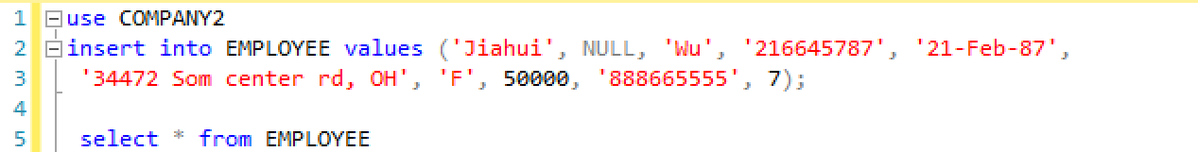

output:

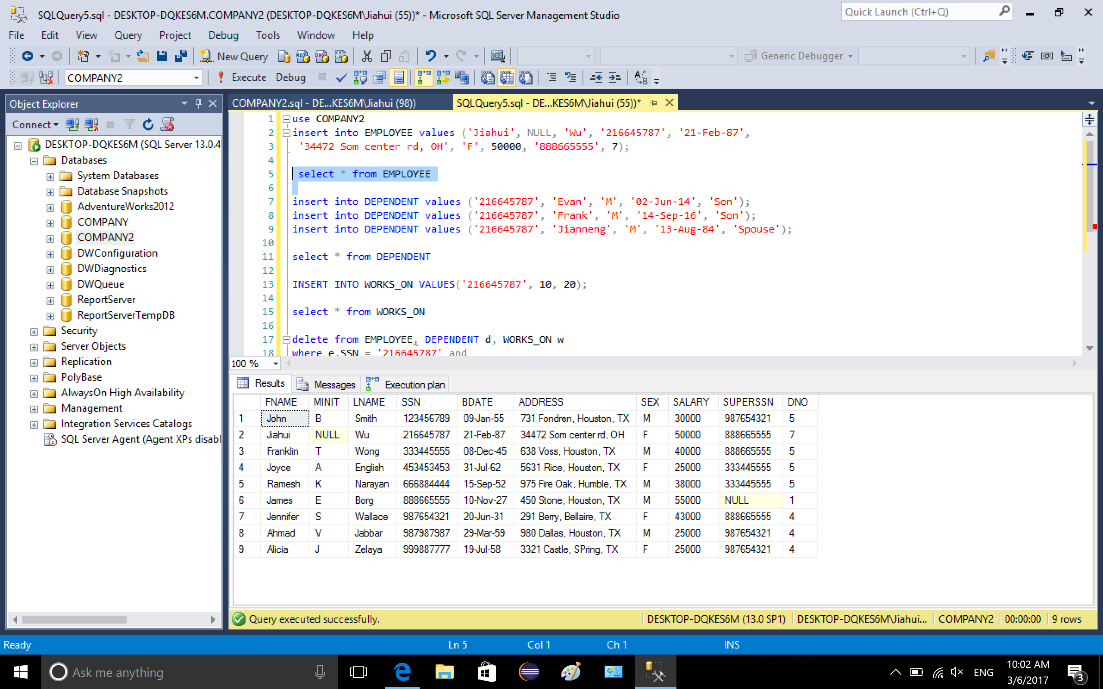

Then insert my dependents information into table DEPENDENT

Command:

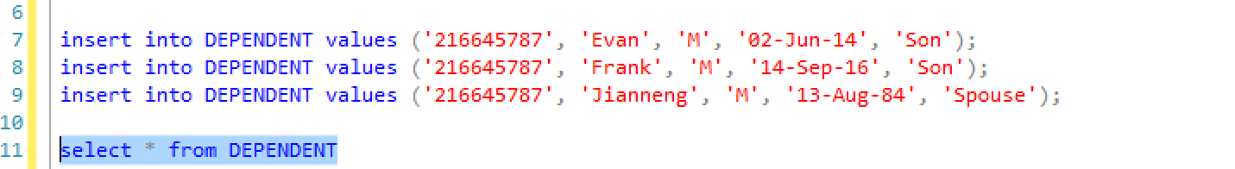

output:

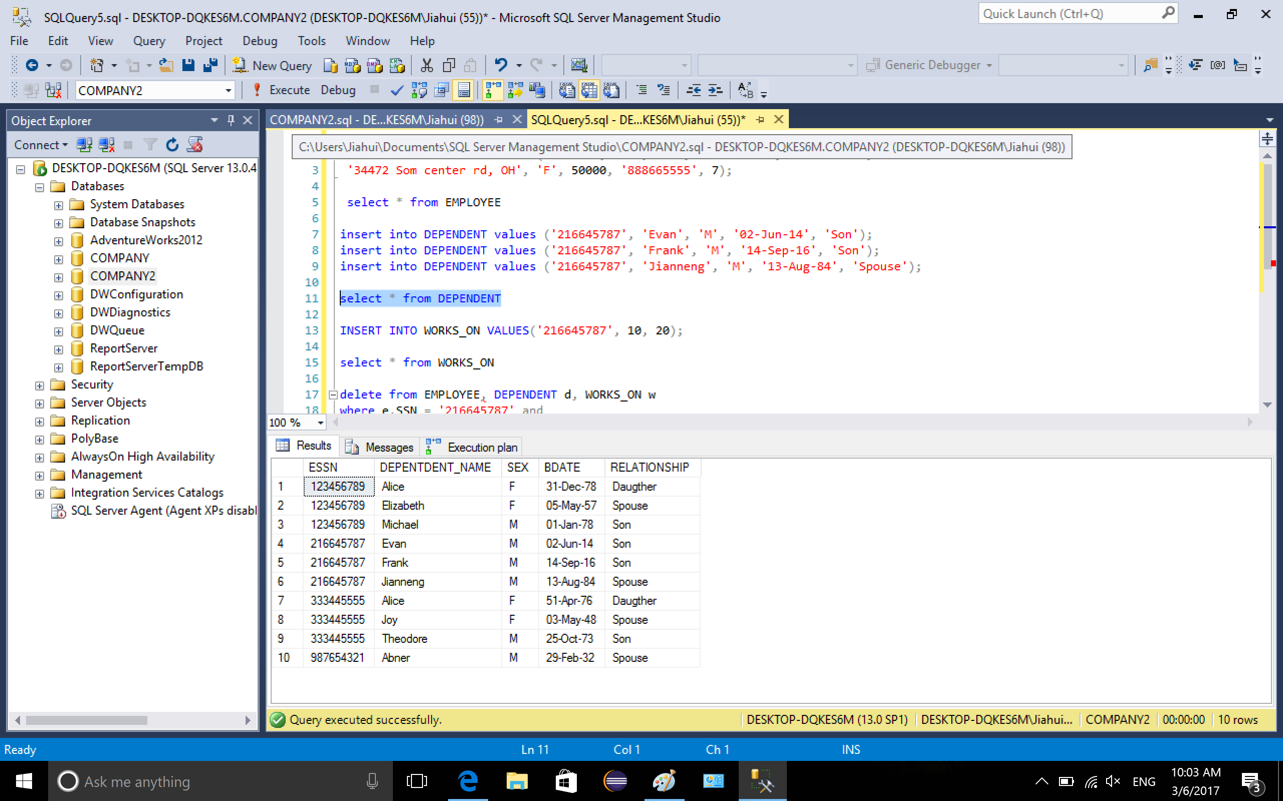

Then insert my info into table WORDS_ON

command

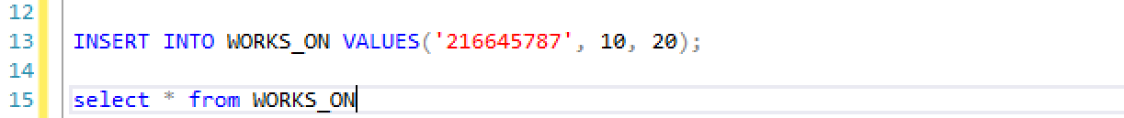

output

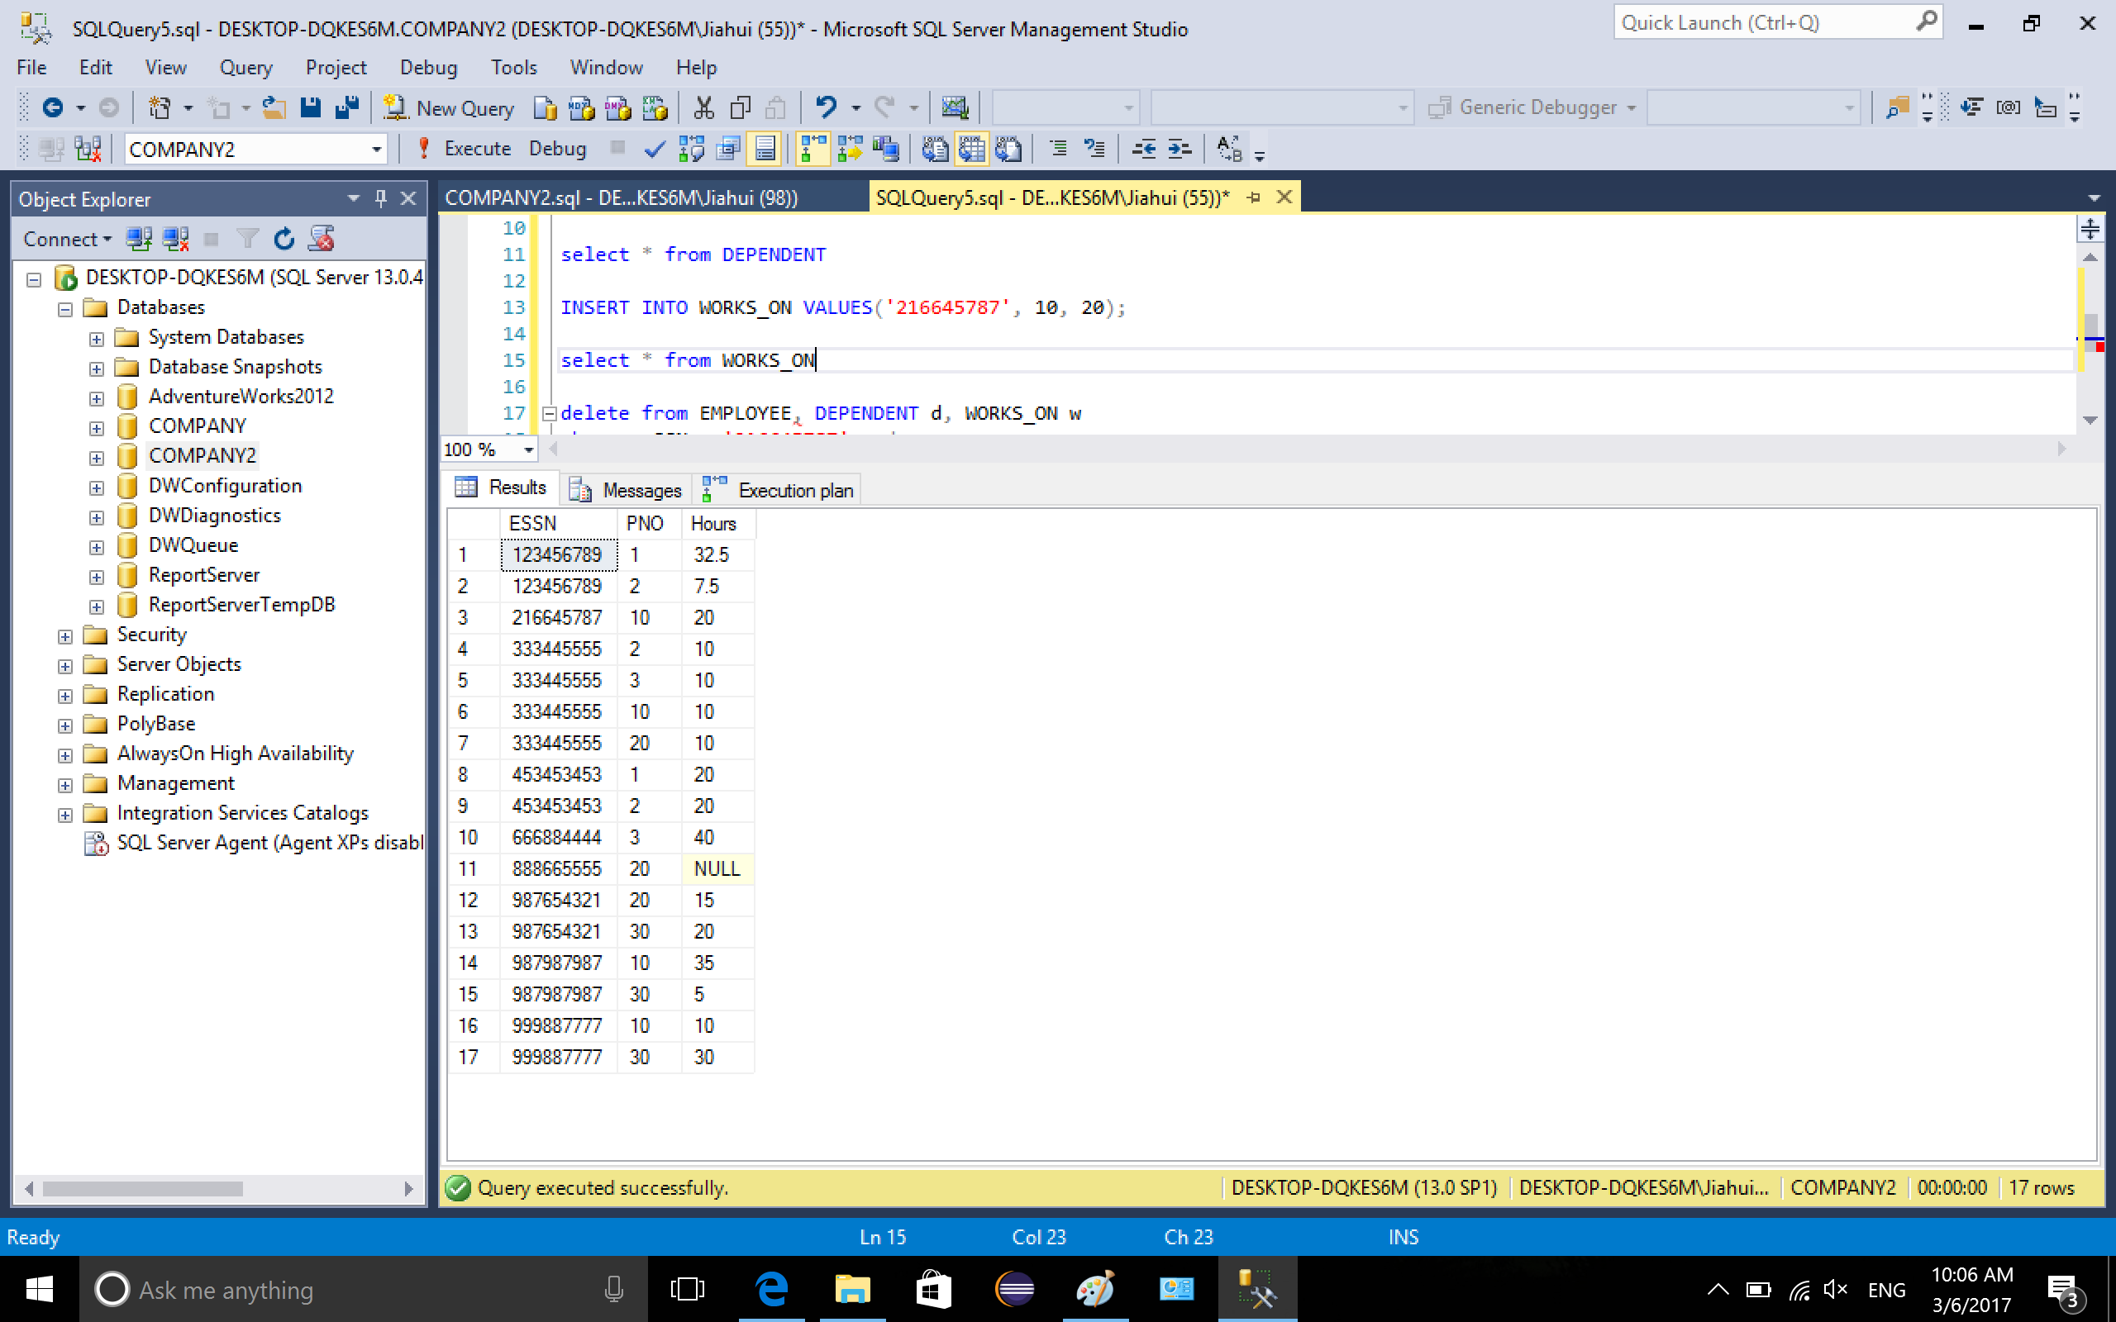

After completing insertion, I retrieve the my info from the database using primary key of EMPLOYEE (my SSN) and foreign key in table DEPENDENT and WORKS_ON referencing the PK

Command

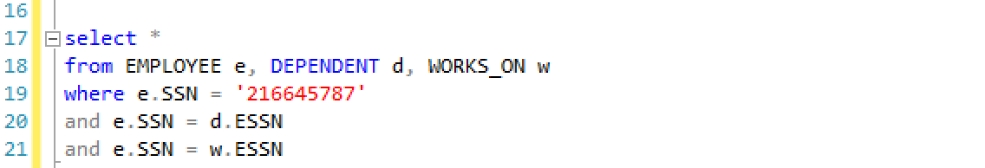

output

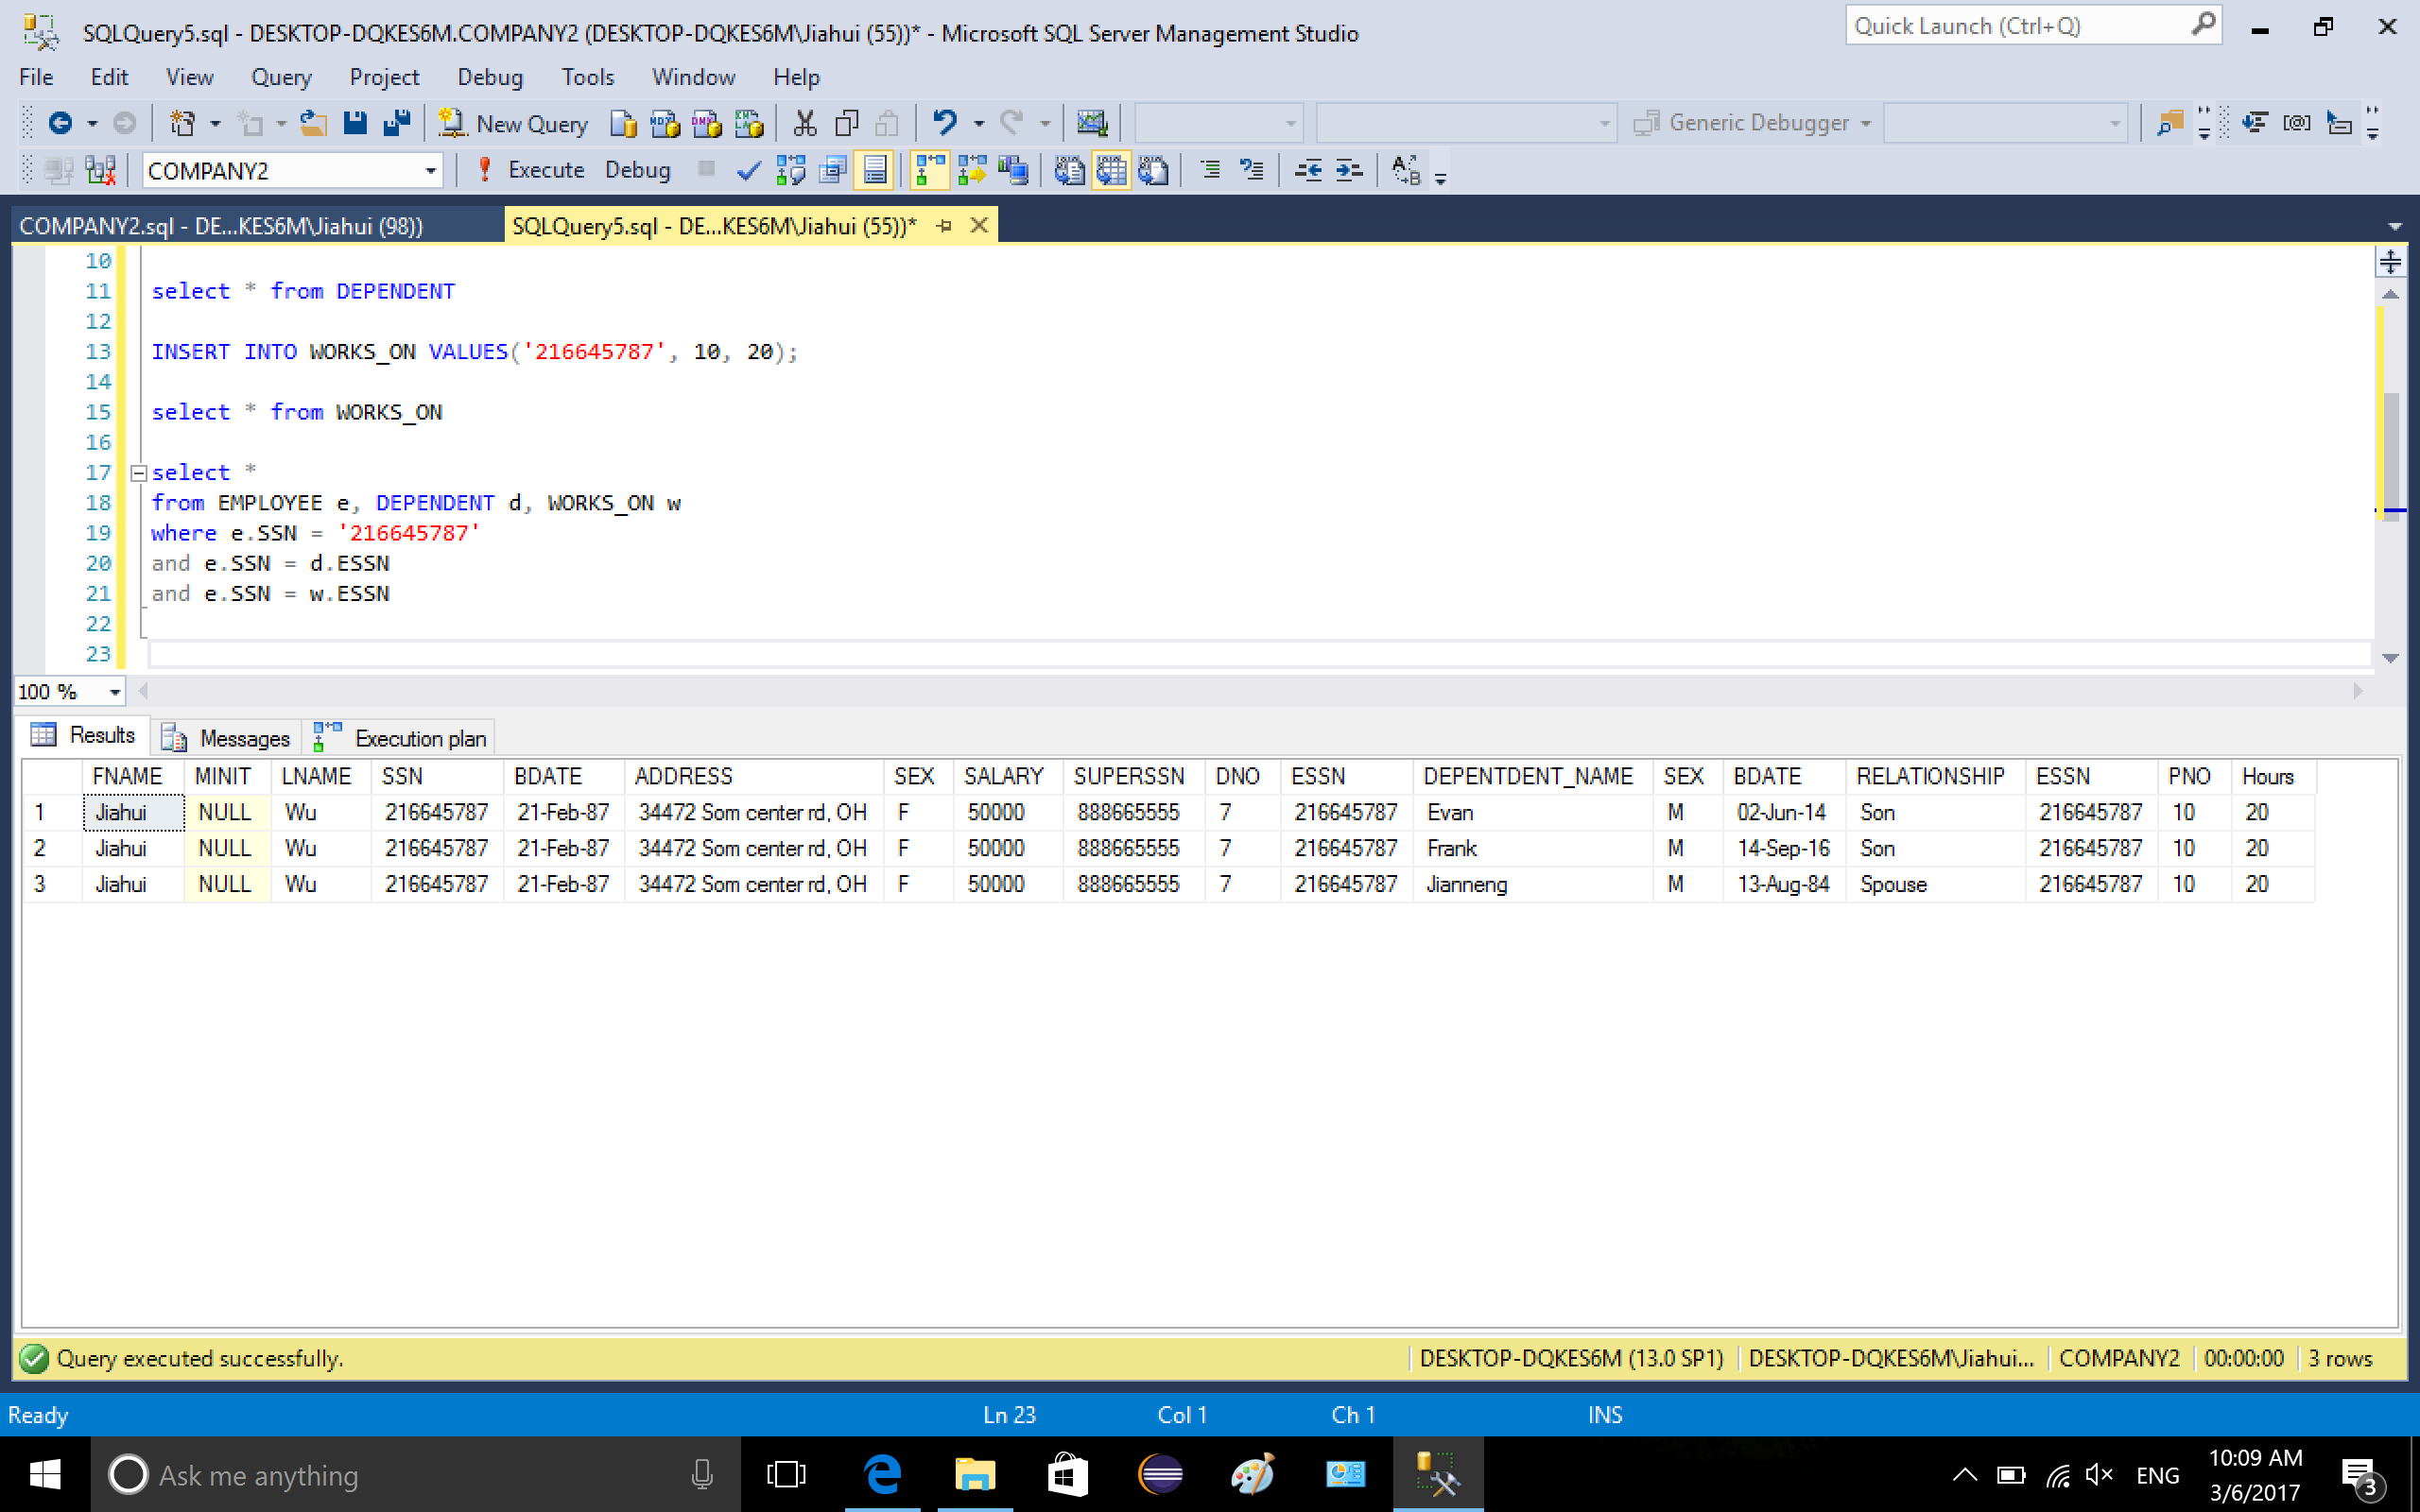

2. Q1: Retrieve the name and address of all the female managers.

I select ATTRIBUTES fname, minit, lname and address from table EMPLOYEE and DEPARTMENT, the conditions are when attribute SEX is F in table EMPLOYEE and attribute MGRSSN (department manager) matches to the PK SSN in table EMPLOYEE.

Command:

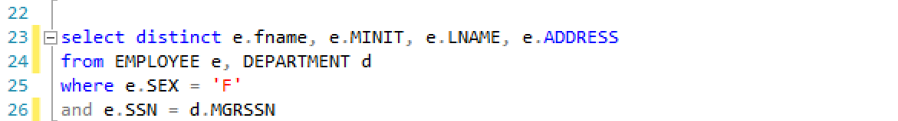

output:

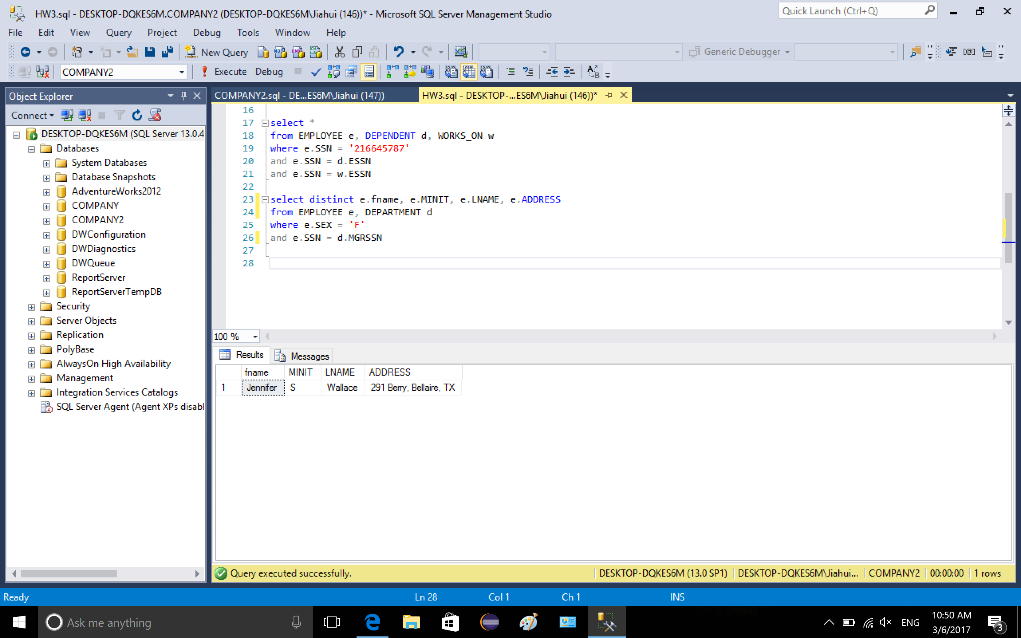

Q2: Make a list of all project numbers for projects that involve an employee whose lase name is ‘Smith’, either as a worker or as a manager of the department that controls the project.

In this case, I will use UNION command to select both worker and manager whose lase name is ‘Smith’. The first selection in the command is to select worker, I selected the project number from table WORKS_ON, ssn, fname and lname from table EMPLOYEE. The condition is the last name of employee is ‘Smith’ and SSN matched the ESSN in table WORKS_ON.

The second selection is to select manager whose last name is ‘Smith’ and the project number he/they are in charge of. Four tables are involved: WORKS_ON, EMPLOYEE, DEPARTMENT and PROJECT. The conditions are the last name of employee should be ‘Smith’, whose SSN matches MGRSSN in table DEPARMENT, then we find the department number and the project that manager Smith are in charge of.

Command:

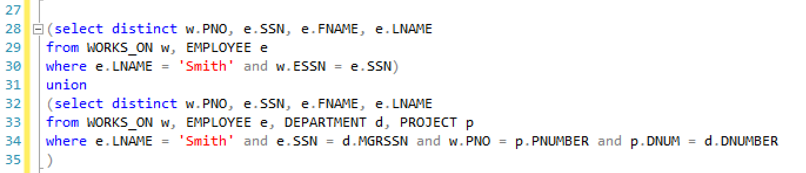

output:

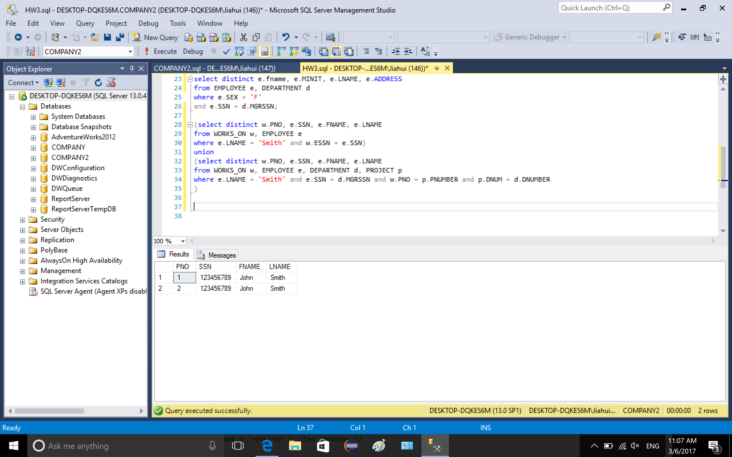

Q3: Retrieve the name and address and his/her department name of the highest ranked employee who does not report to anybody in the company.

Since we are looking for a person who does not have a supervisor, then this person’s SUPERSSN attribute should be NULL, and we also use condition DNO in EMPLOYEE equals DNUMBER in DEPARTMENT to target the tuple to get the department name of the tuple.

Command:



output:

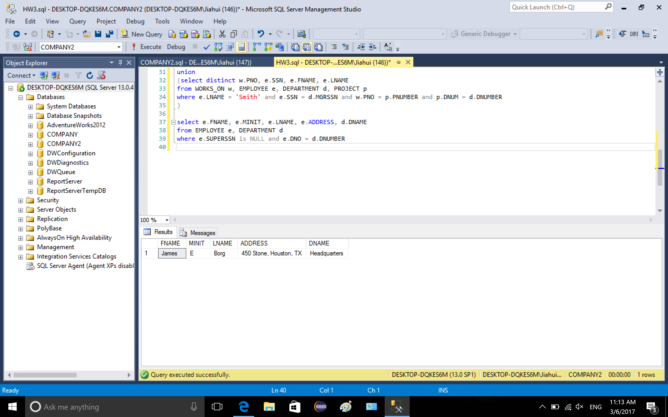

Q4: List all the employees who are working in the department with their name and their supervisor’s name, in the order of each department number and department name. Extra points: include all the employee who do not have supervisor.

To get the extra points, I use UNION command to join two selections. First selection is to select info of employee who have supervisor, I select attribute DNO in DEPARTMENT, DNAME in department, lname and fname in table EMPLOYEE e, lname and fname in table EMPLOYEE f. The conditions are the employee’s department number matches DNUMBER in table DEPARTMENT, so we can retrieve the value of attribute DNAME. Employee’s SUPERSSN matches supervisor’s SSN, so we can get supervisor’s name as well.

The second selection is to select the employee who does not have a supervisor. To match the selected attribute, the f.FNAME and f.LNAME of supervisor were set NULL. The condition is when the SUPERSSN of a tuple in table EMPLOYEE is NULL and the DNO references DNUMBER in DEPARTMENT. The selection is ordered by department number and department name.

Commands:

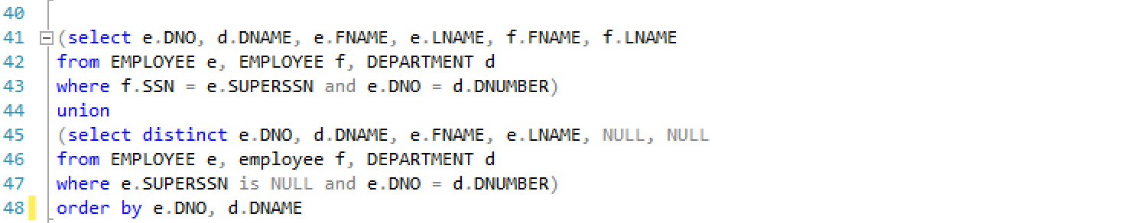

output:

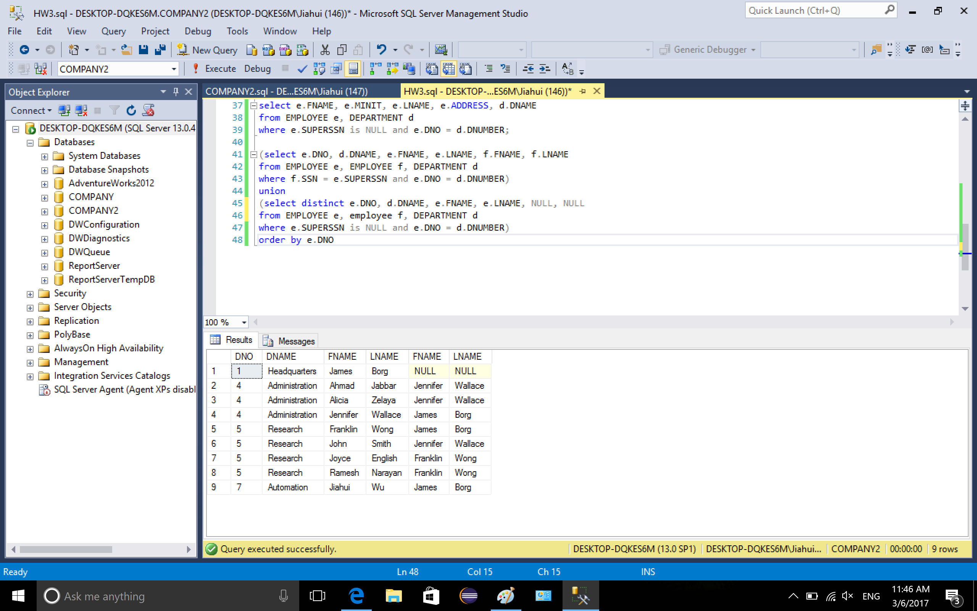

note: without union and the second selection, the output is only the employees with supervisor, the output is as following (without order):

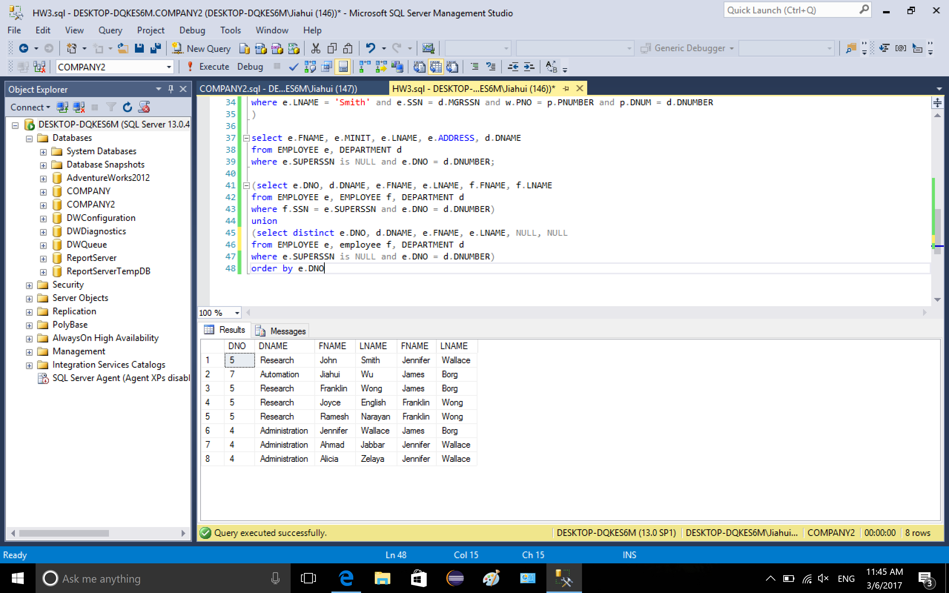

Q5: List the names of managers who have no dependents

Select name attributes from table EMPLOYEE and department, the conditions are: EMPLOYEE.SSN = DEPARTMENT.MGRSSN to get the managers’ SSN, and the SSN should NOT exist in condition DEPENDENT.ESSN = EMPLOYEE.SSN.

Command:

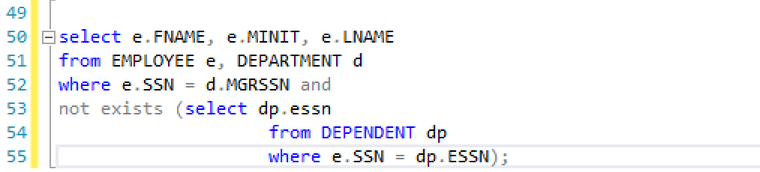

output:

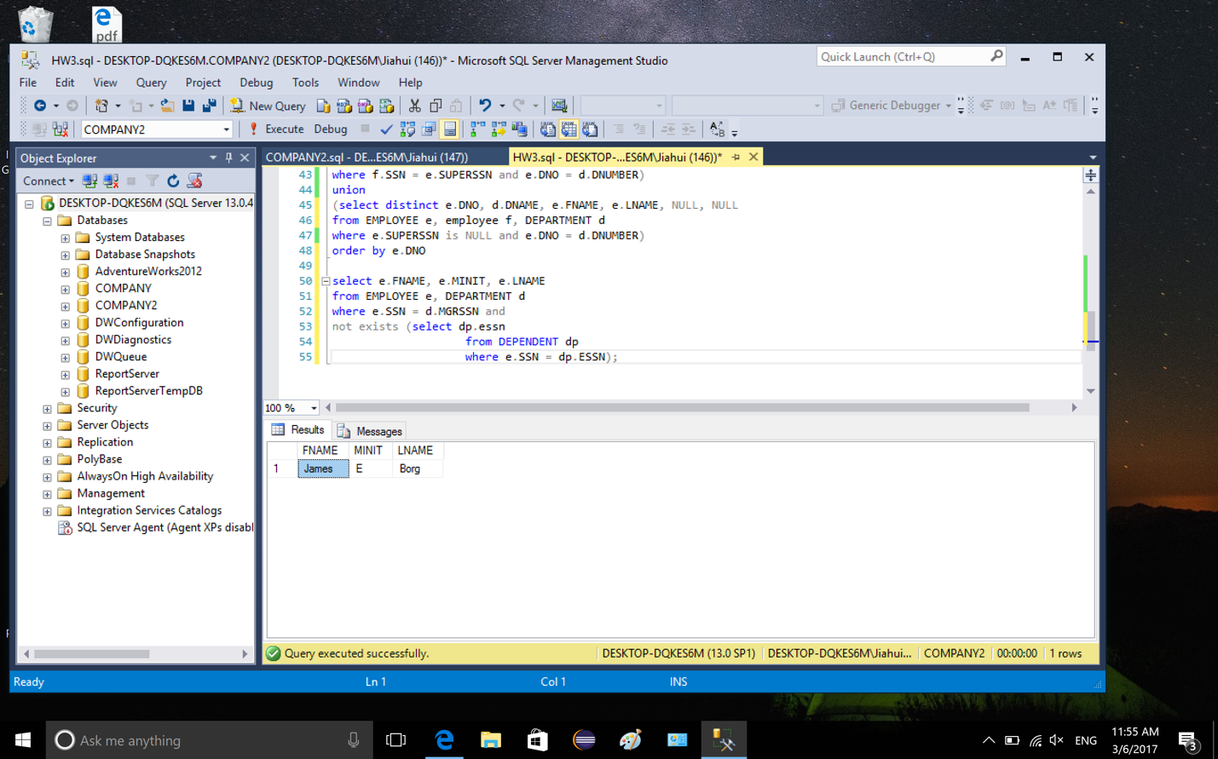

SQL code:

use COMPANY2

insert into EMPLOYEE values ('Jiahui', NULL, 'Wu', '216645787', '21-Feb-87',

'34472 Som center rd, OH', 'F', 50000, '888665555', 7);

select * from EMPLOYEE

insert into DEPENDENT values ('216645787', 'Evan', 'M', '02-Jun-14', 'Son');

insert into DEPENDENT values ('216645787', 'Frank', 'M', '14-Sep-16', 'Son');

insert into DEPENDENT values ('216645787', 'Jianneng', 'M', '13-Aug-84', 'Spouse');

select * from DEPENDENT

INSERT INTO WORKS_ON VALUES('216645787', 10, 20);

select * from WORKS_ON

select *

from EMPLOYEE e, DEPENDENT d, WORKS_ON w

where e.SSN = '216645787'

and e.SSN = d.ESSN

and e.SSN = w.ESSN

select distinct e.fname, e.MINIT, e.LNAME, e.ADDRESS

from EMPLOYEE e, DEPARTMENT d

where e.SEX = 'F'

and e.SSN = d.MGRSSN;

(select distinct w.PNO, e.SSN, e.FNAME, e.LNAME

from WORKS_ON w, EMPLOYEE e

where e.LNAME = 'Smith' and w.ESSN = e.SSN)

union

(select distinct w.PNO, e.SSN, e.FNAME, e.LNAME

from WORKS_ON w, EMPLOYEE e, DEPARTMENT d, PROJECT p

where e.LNAME = 'Smith' and e.SSN = d.MGRSSN and w.PNO = p.PNUMBER and p.DNUM = d.DNUMBER

)

select e.FNAME, e.MINIT, e.LNAME, e.ADDRESS, d.DNAME

from EMPLOYEE e, DEPARTMENT d

where e.SUPERSSN is NULL and e.DNO = d.DNUMBER;

(select e.DNO, d.DNAME, e.FNAME, e.LNAME, f.FNAME, f.LNAME

from EMPLOYEE e, EMPLOYEE f, DEPARTMENT d

where f.SSN = e.SUPERSSN and e.DNO = d.DNUMBER)

union

(select distinct e.DNO, d.DNAME, e.FNAME, e.LNAME, NULL, NULL

from EMPLOYEE e, employee f, DEPARTMENT d

where e.SUPERSSN is NULL and e.DNO = d.DNUMBER)

order by e.DNO, d.DNAME

select e.FNAME, e.MINIT, e.LNAME

from EMPLOYEE e, DEPARTMENT d

where e.SSN = d.MGRSSN and

not exists (select dp.essn

from DEPENDENT dp

where e.SSN = dp.ESSN);