CIS430-Lab Assignment 4

Jiahui Wu

ID: 2670210

Object: Querying a relational database COMPANY database

1. Updating the following new changes into the database

First, I use the database built in lab2, insert values into table DEPENDENT

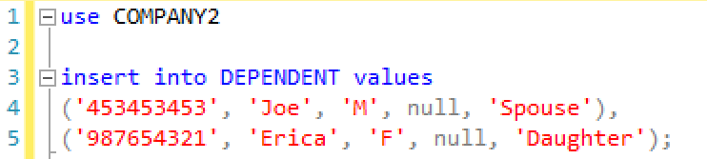

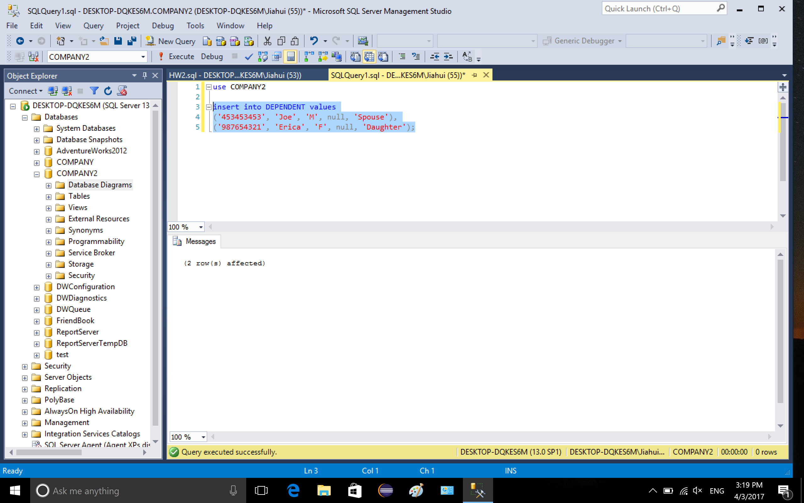

Then I insert values into table WORKS_ON

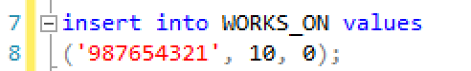

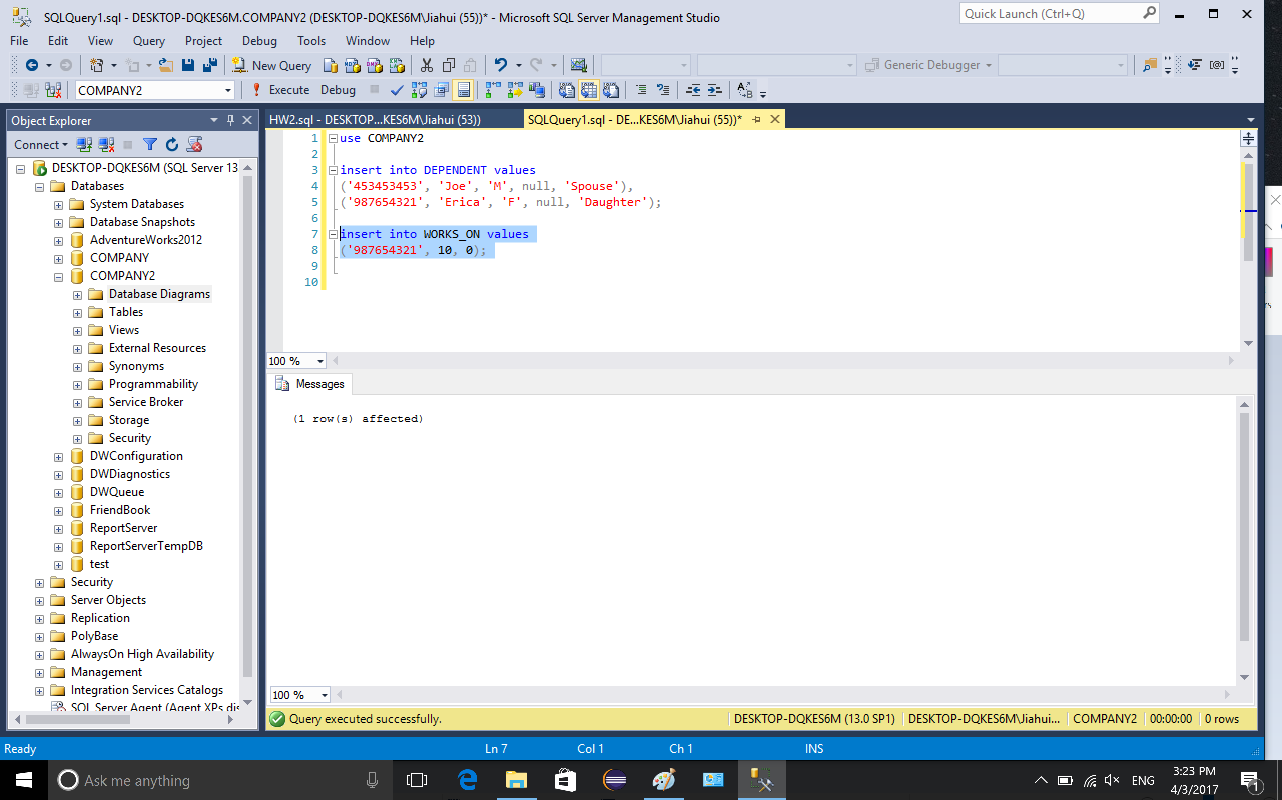

show the content of DEPENDENT

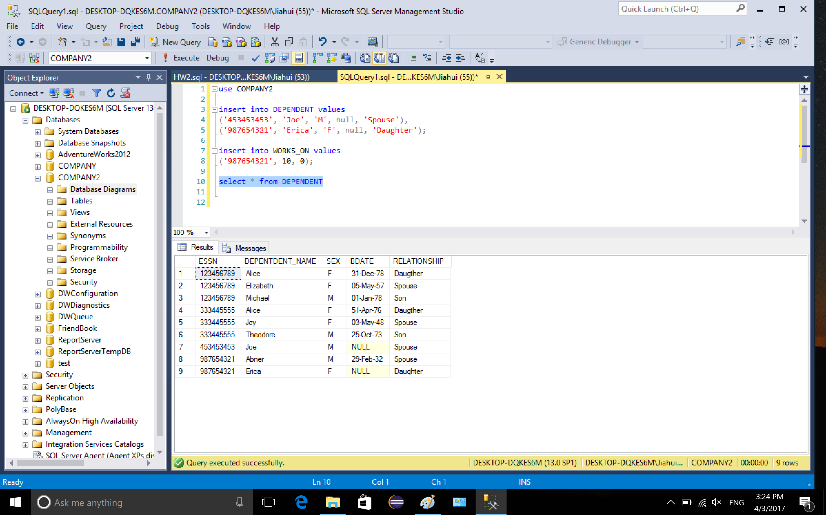

show the content of WORKS_ON

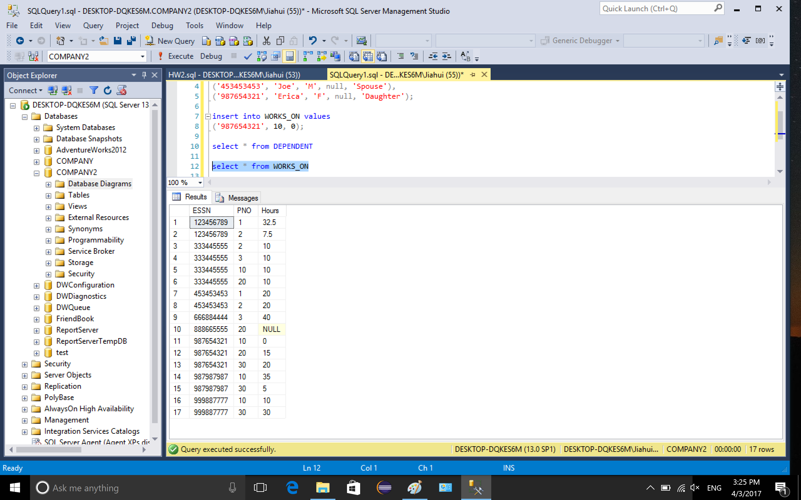

2. retrieve data

Q1: list the employee and supervisor names for each department

Since we need to list all the department, we should use DEPARTMENT to left outer join the employee selection. For employee selection, we should use EMPLOYEE e left outer join EMPLOYEE s on e.SUPERSSN = s.SSN.

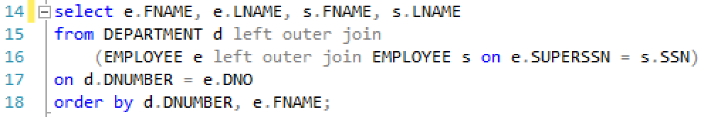

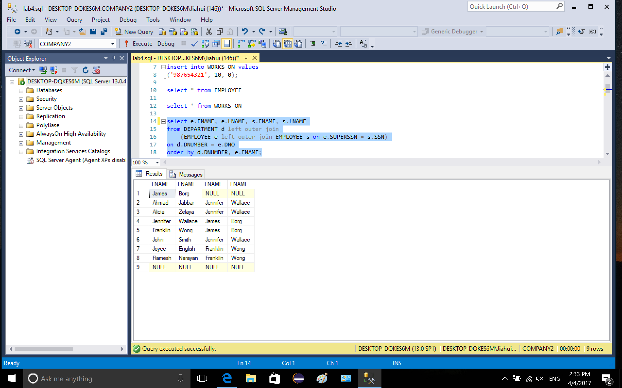

Q1_1: list all the employee who don’t have supervisor but do not list the department which does not have employee

Since the department that have no employee will not be listed, DEPARTMENT should inner join with the selection from EMPLOYEE table on department number.

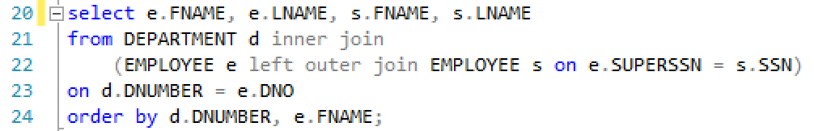

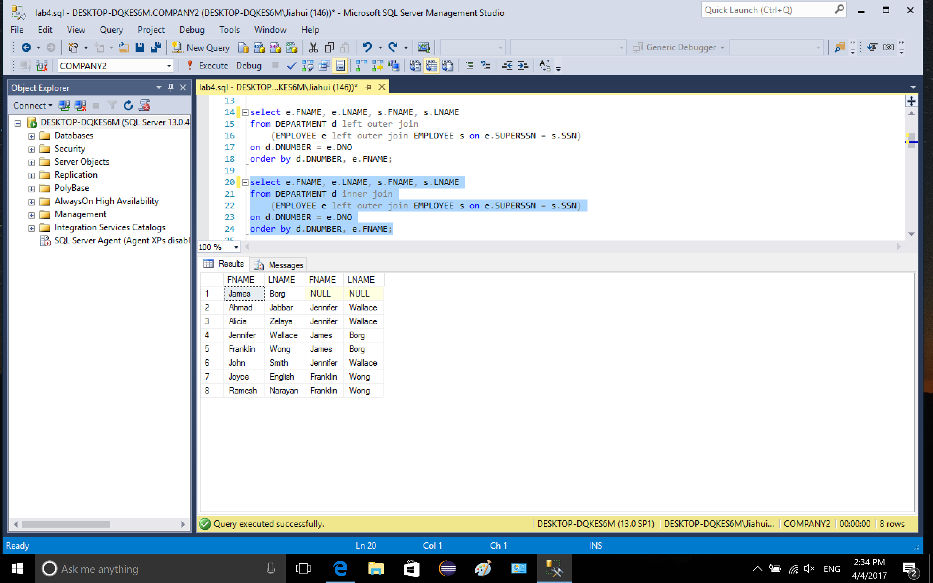

Q2: SSN and last name of married female employee who works on three or more projects.

I filtered the employee info with e.sex = ‘F’ (female employee), connect employee info with work_on info by e.SSN = w.ESSN and select e.SSN in married employee. After grouping, I use having count(*) >= 3 to show the selected employee

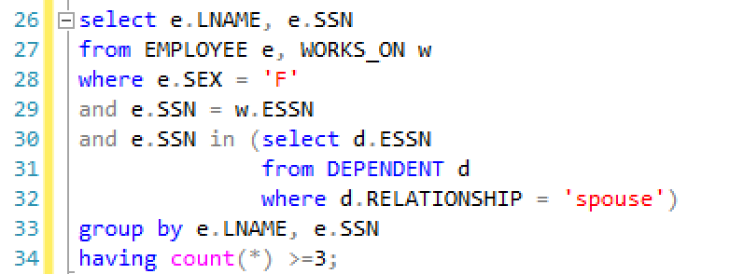

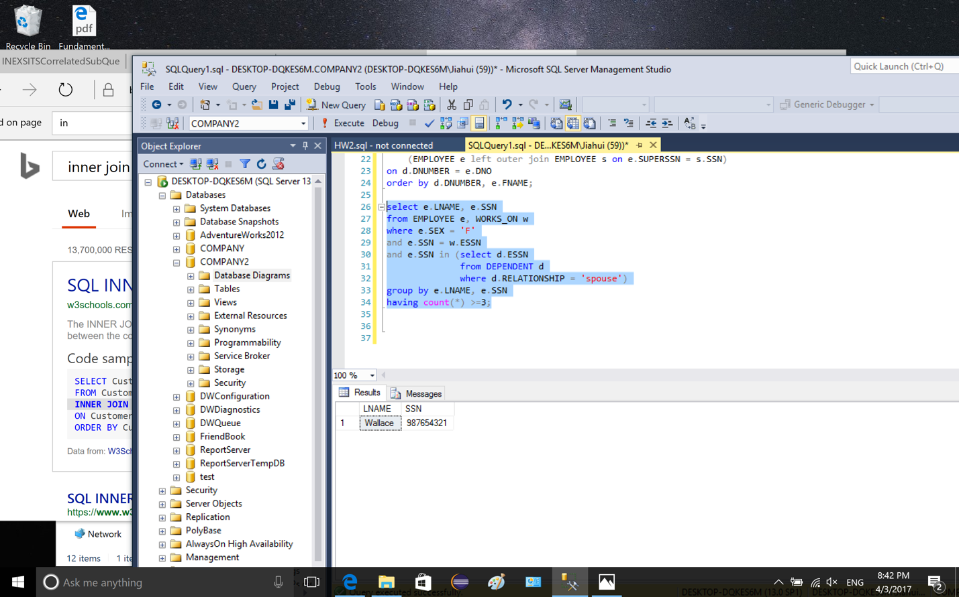

Q3: list married employee who are working for Research department but have no children.

I used several in and not in condition to retrieve the selected data.

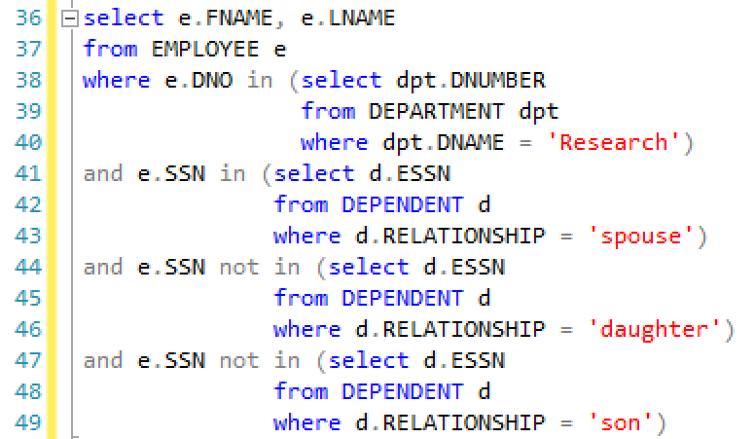

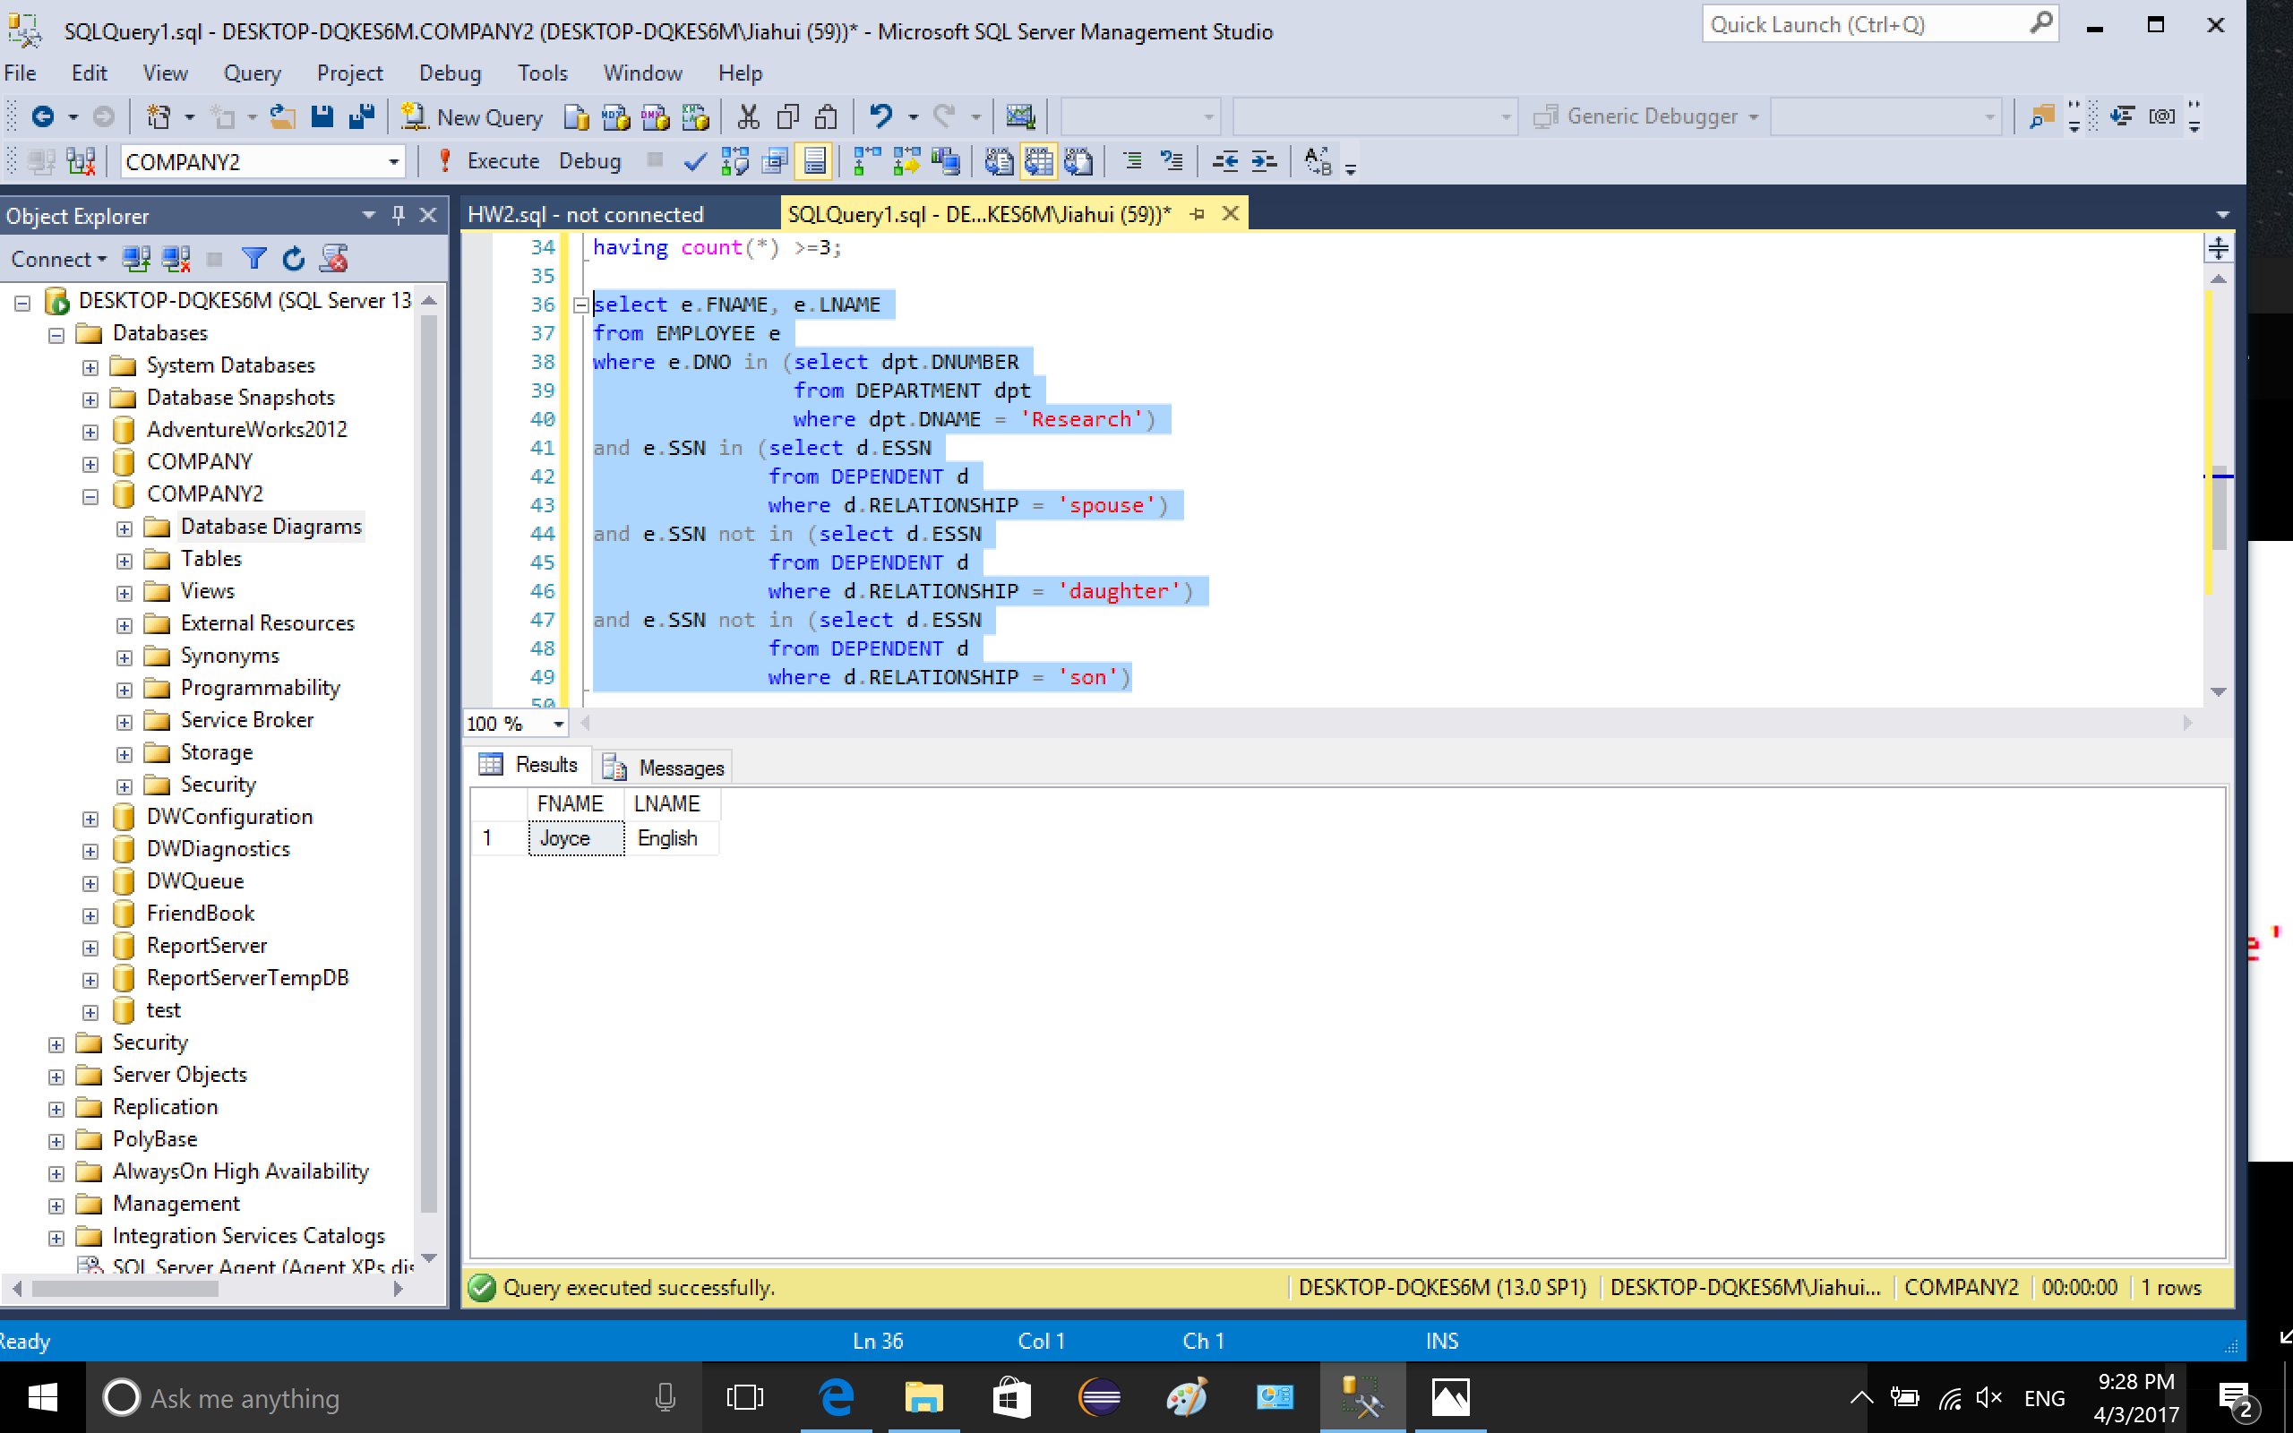

Q4: Get the last name of married employee who only have daughters

Similar as Q3

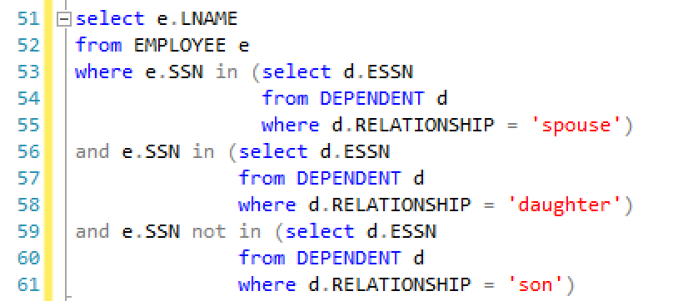

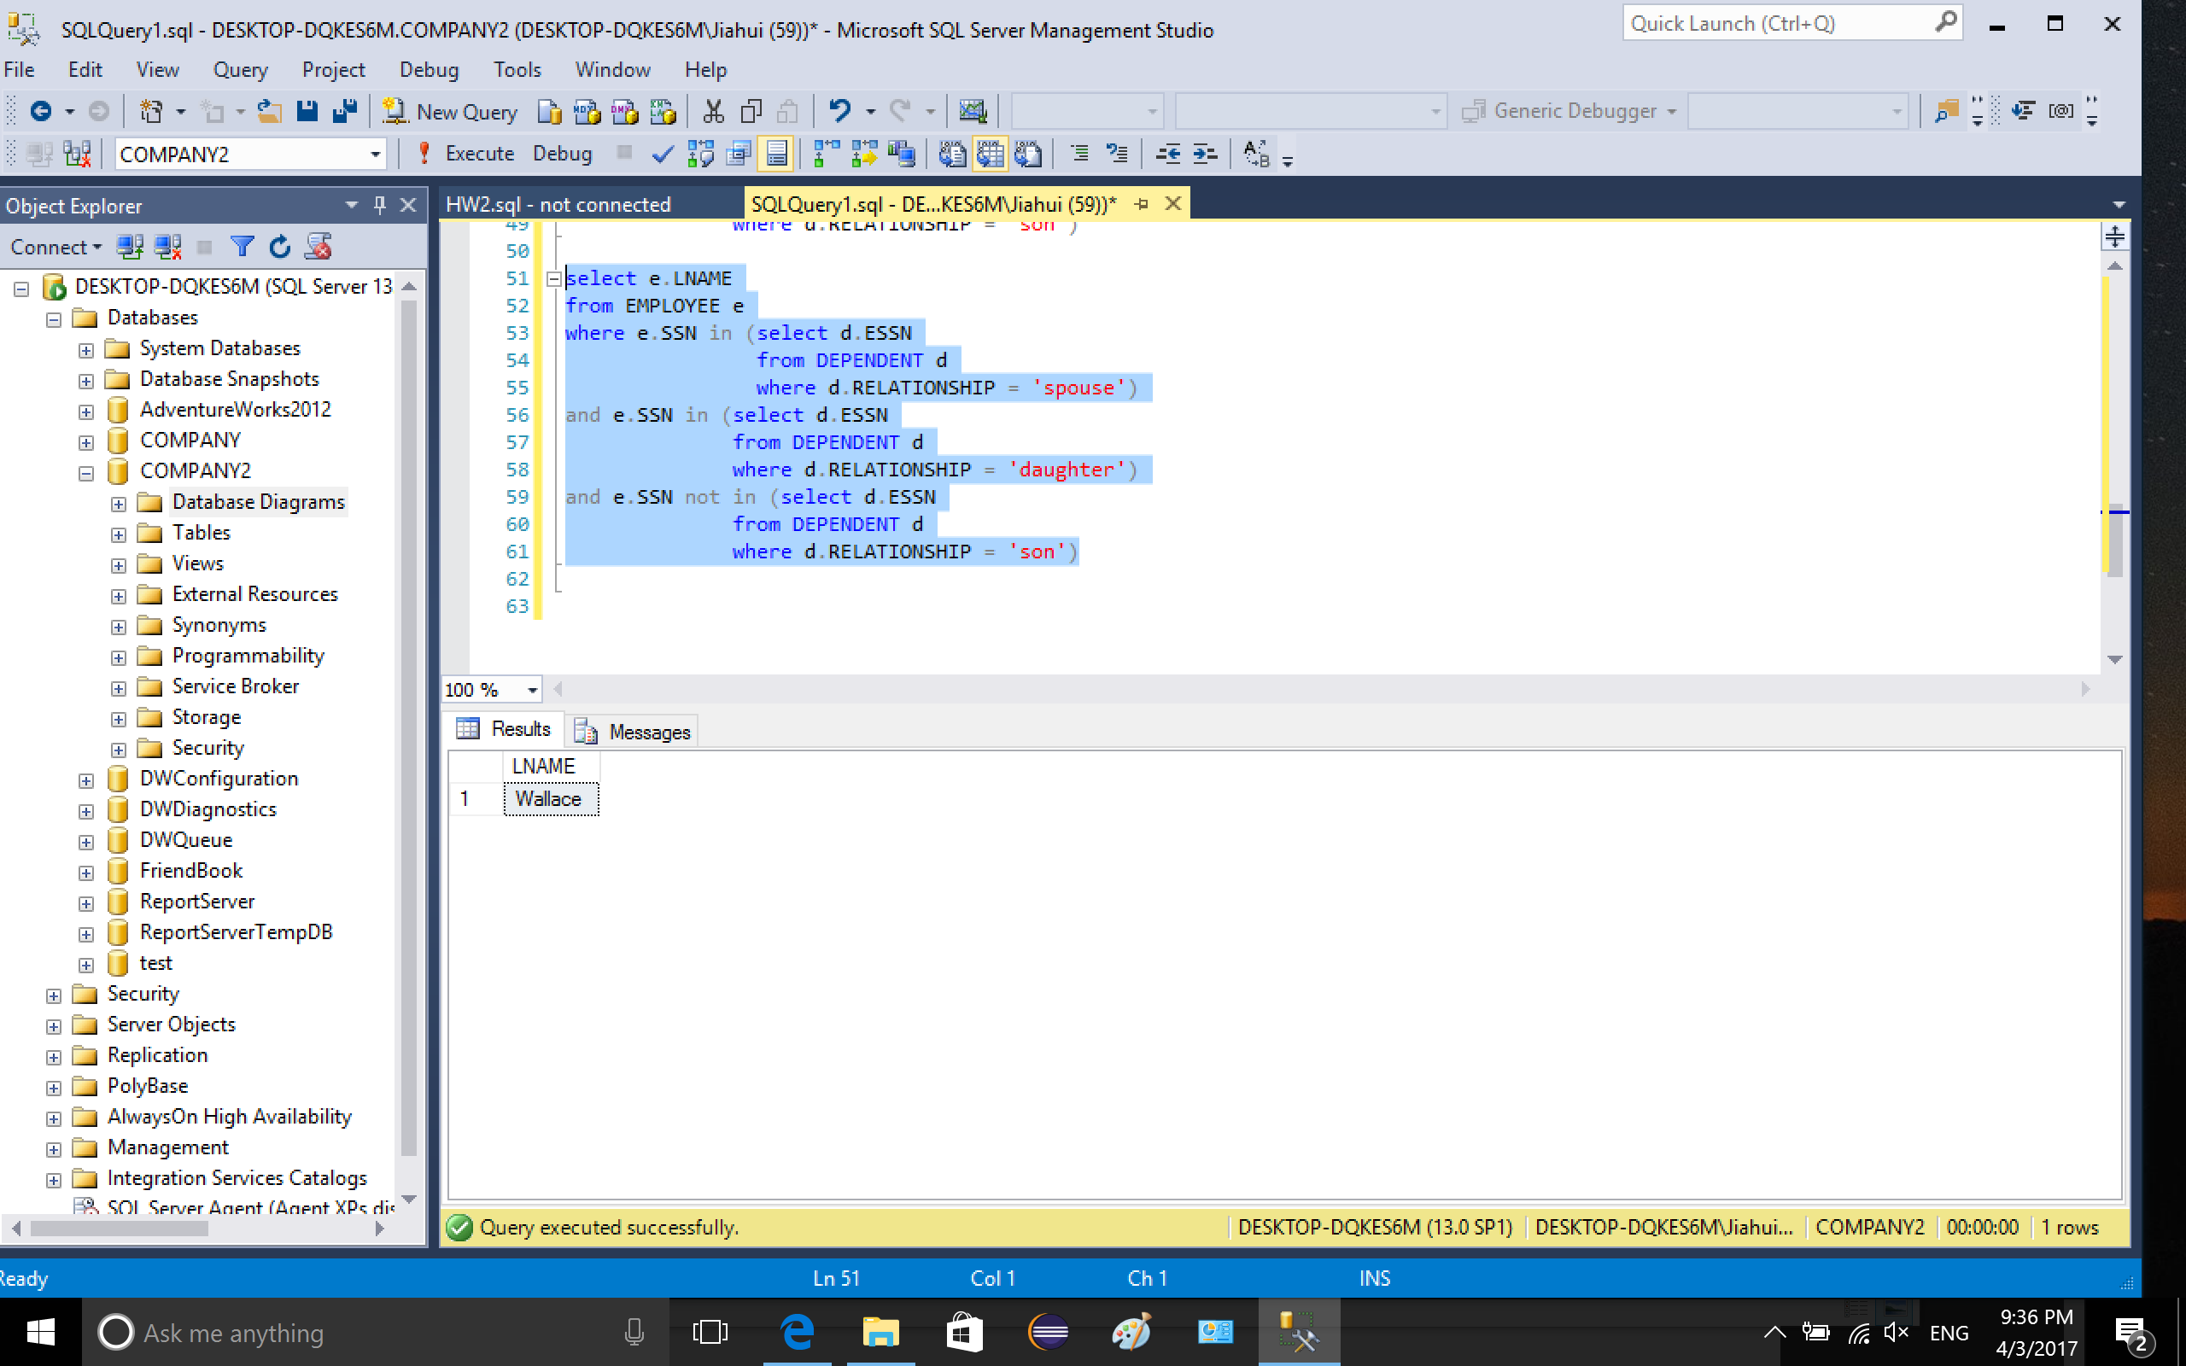

Q5: Get the name and SSN of employee who works on the project that have more female than male

I used nested selections to retrieve the data. In the inner most selection, I grouped the selection by WORKS_ON.PNO to count the male number and female number in each project. In the outer selection, I named two selected tables (female and male) and assigned two attributes to the tables (count and PNO). By inner join the two tables, I can compare female.count and male.count. After comparison, I can get the project number that has more female than male. Then I select the employee info by selecting EMPLOYEE.SSN in WORKS_ON.ESSN which has the project number.

