CIS430-Lab Assignment 5

Jiahui Wu

ID: 2670210

Object: View, stored procedure and cursor

Part 1

1-1) create a view

I created a view named VDept\_Budget includes three columns, since we need to include all departments, I used left outer join to include the department with no employee. I use count(e.DNO) to count the employee number in each department.

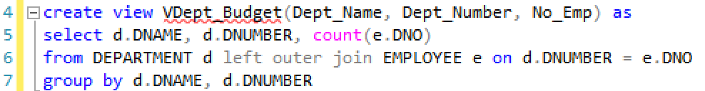

execute

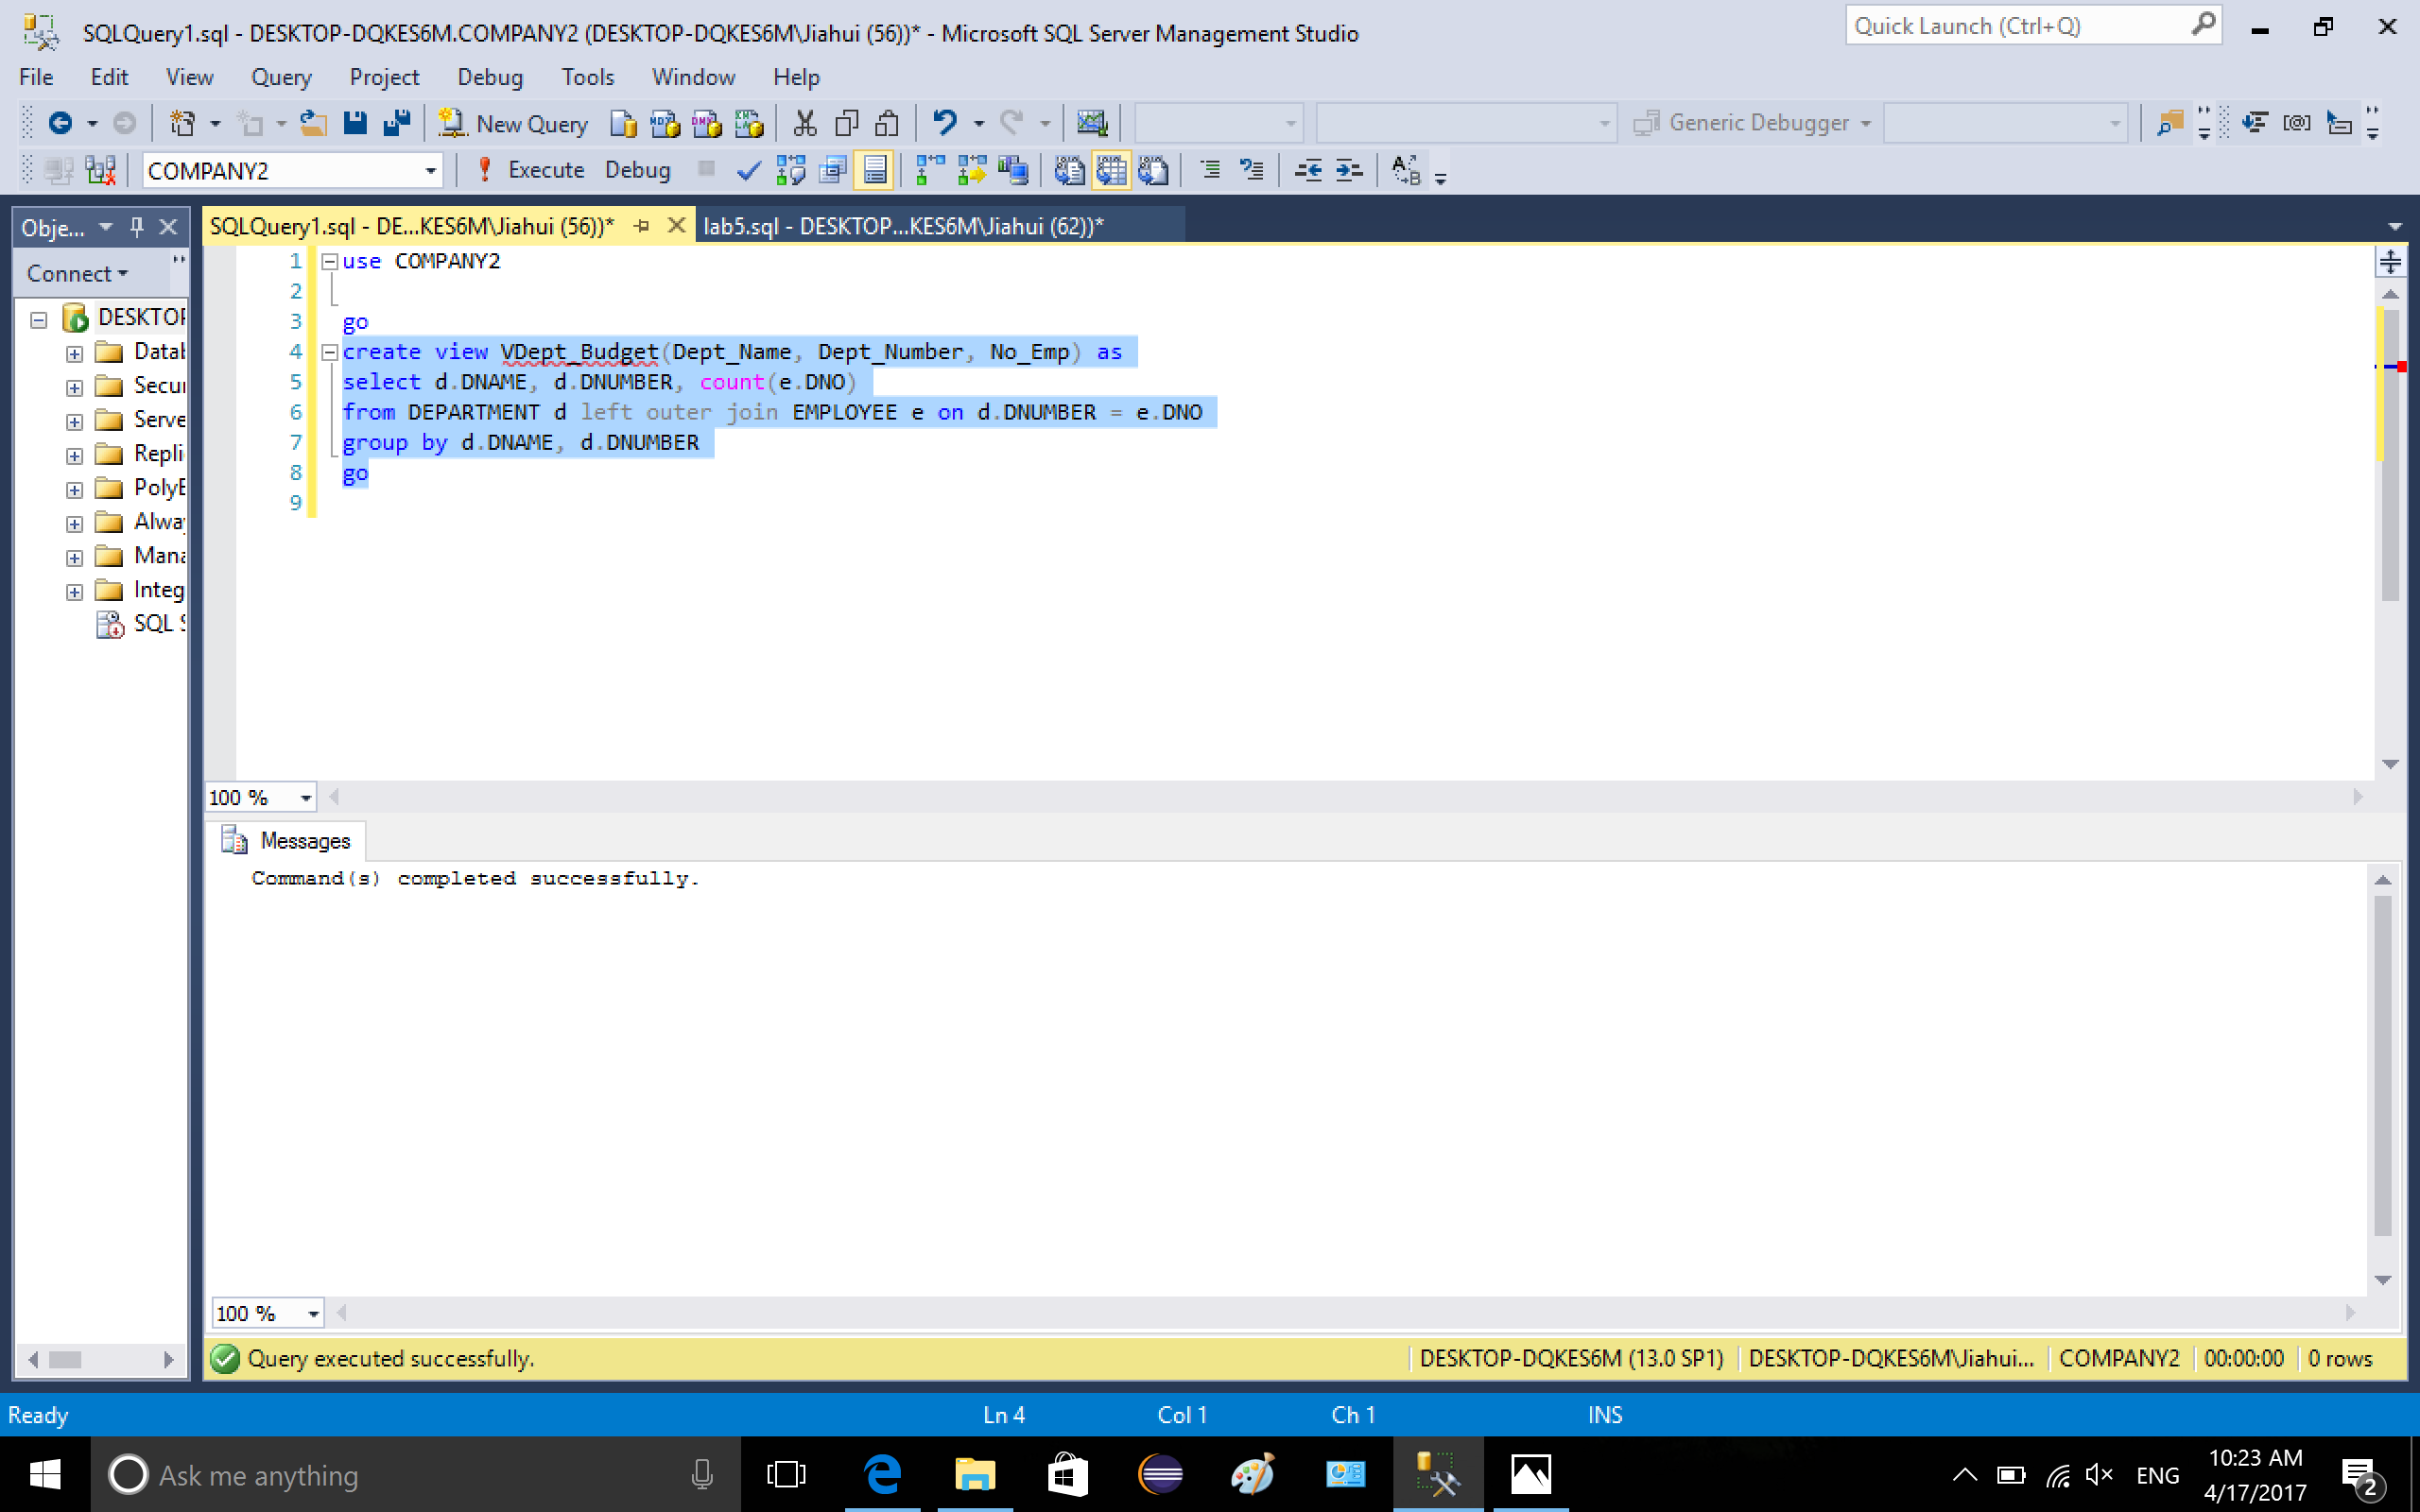

use select \* from VDept\_Budget to show the view

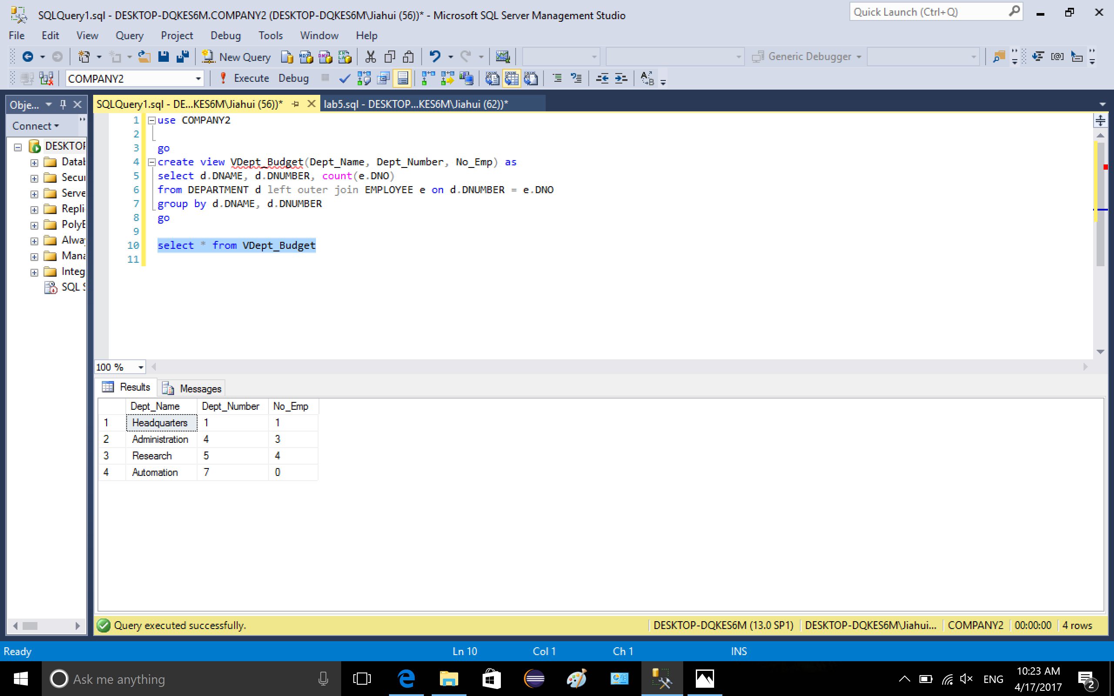

1-2) add yourself to the database, show the view



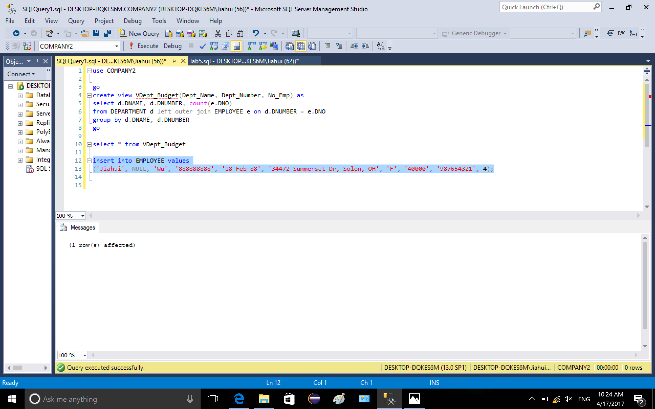

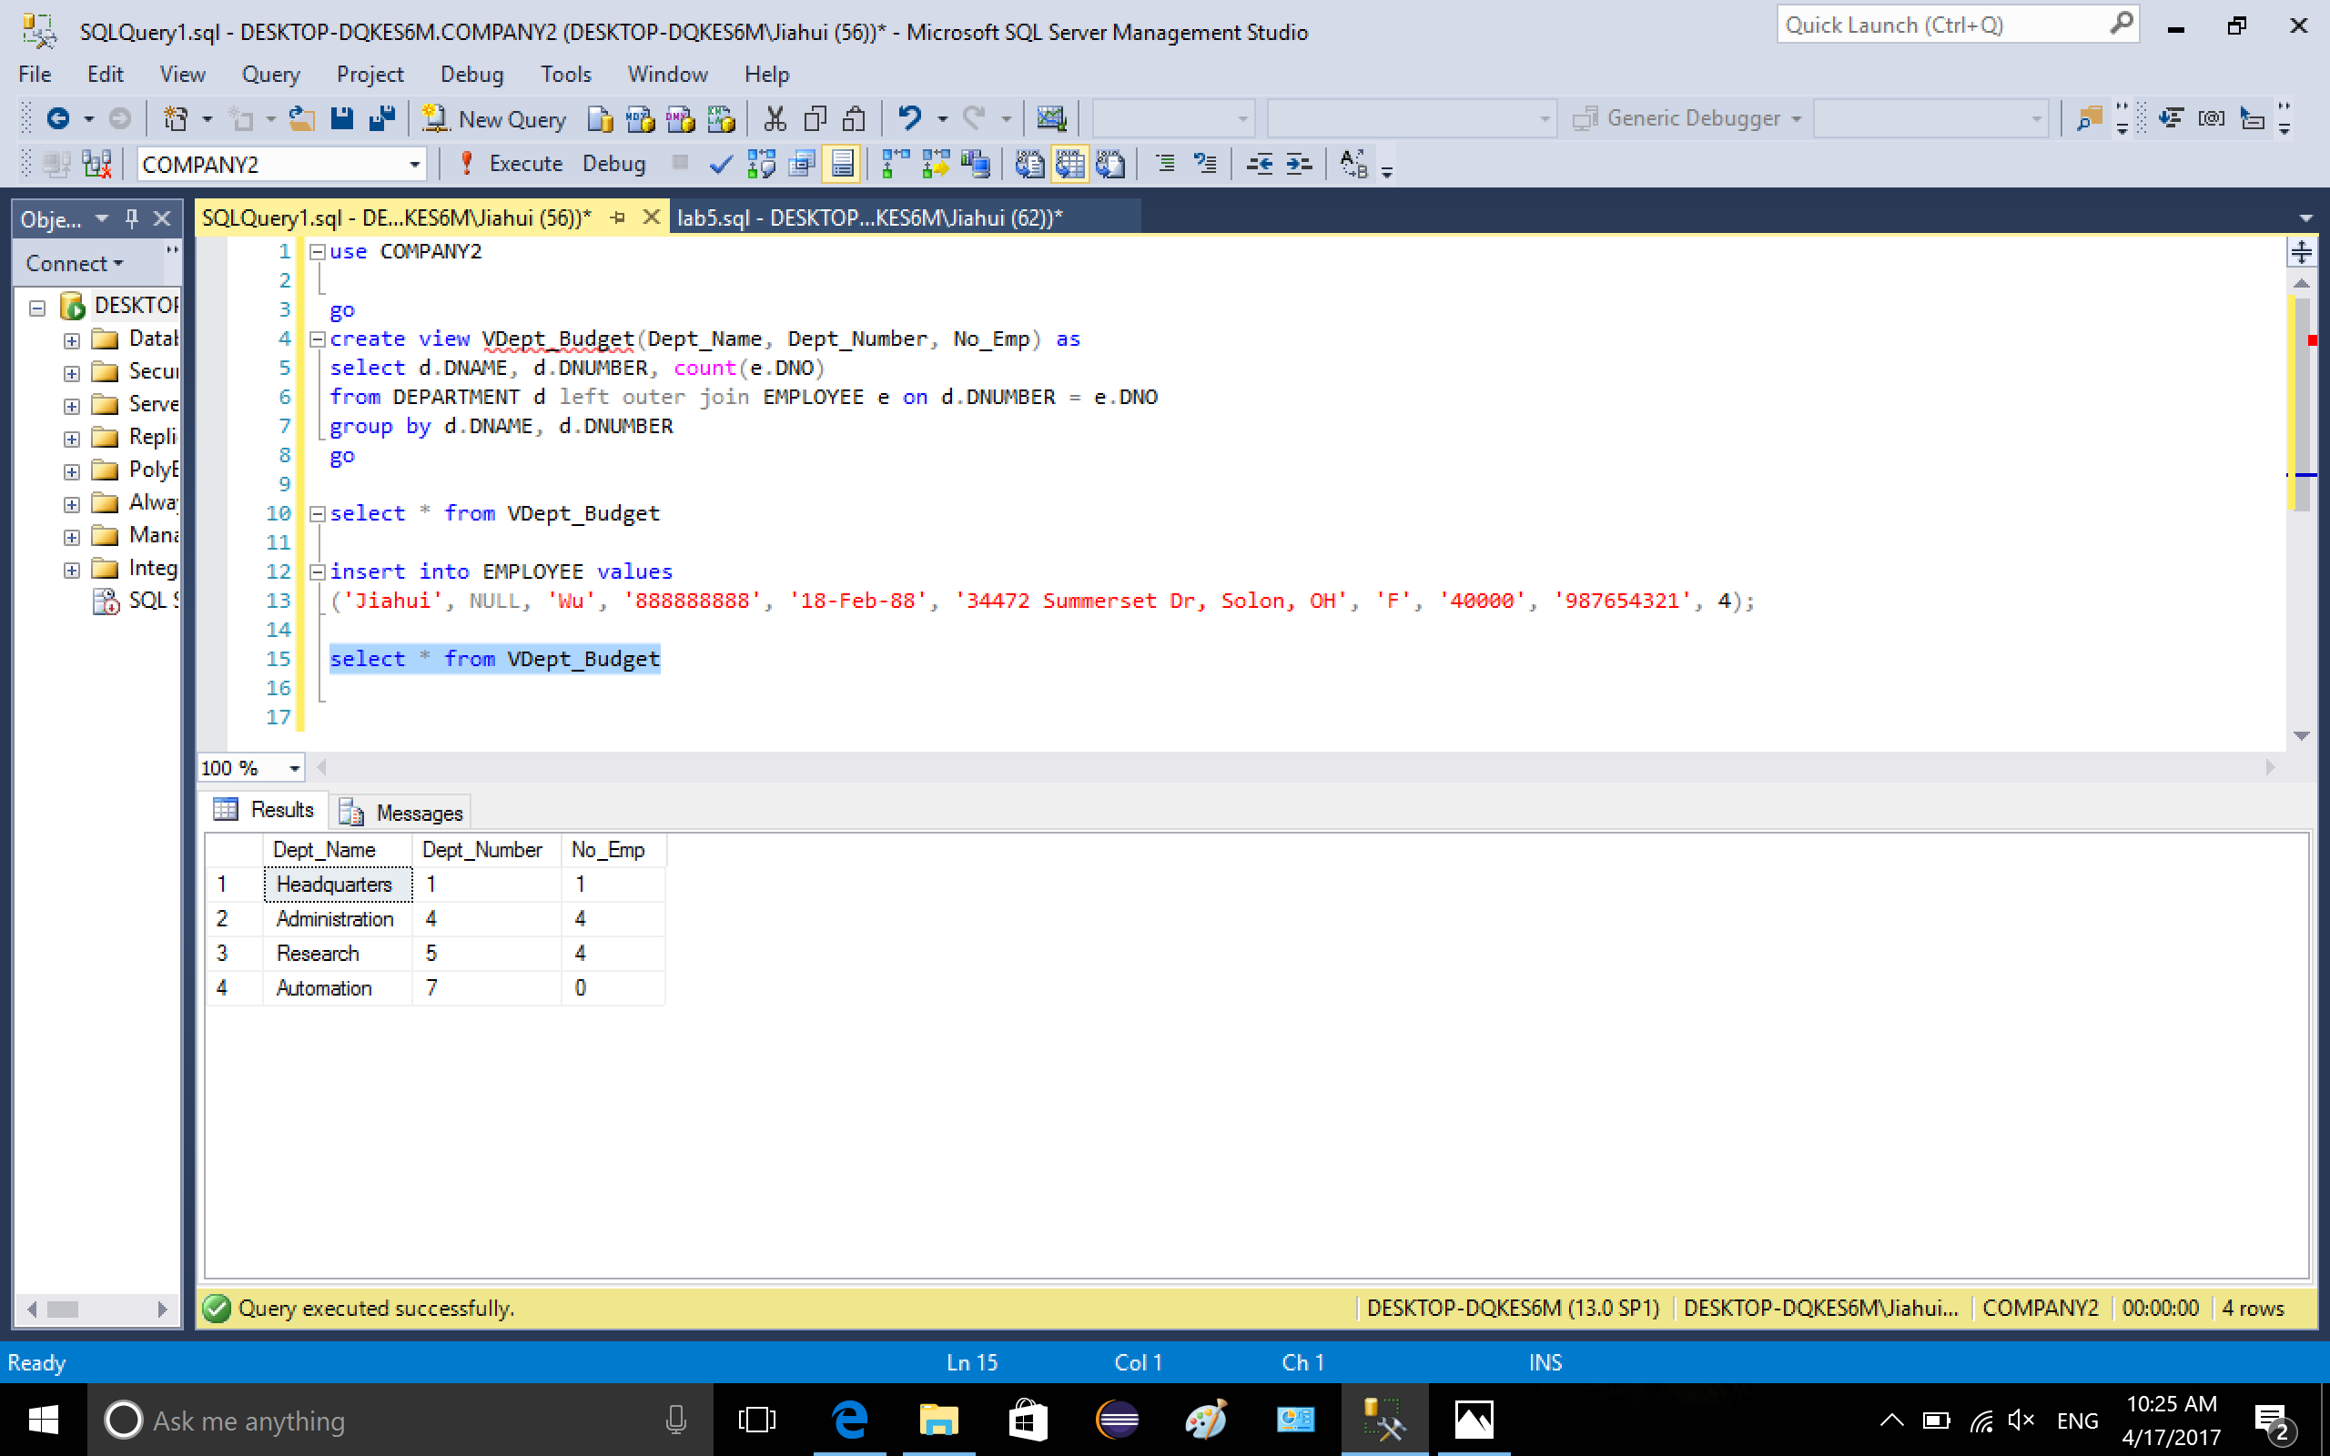

1-3) add two more columns to the view and show the changes

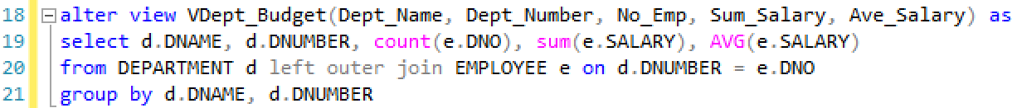

execute

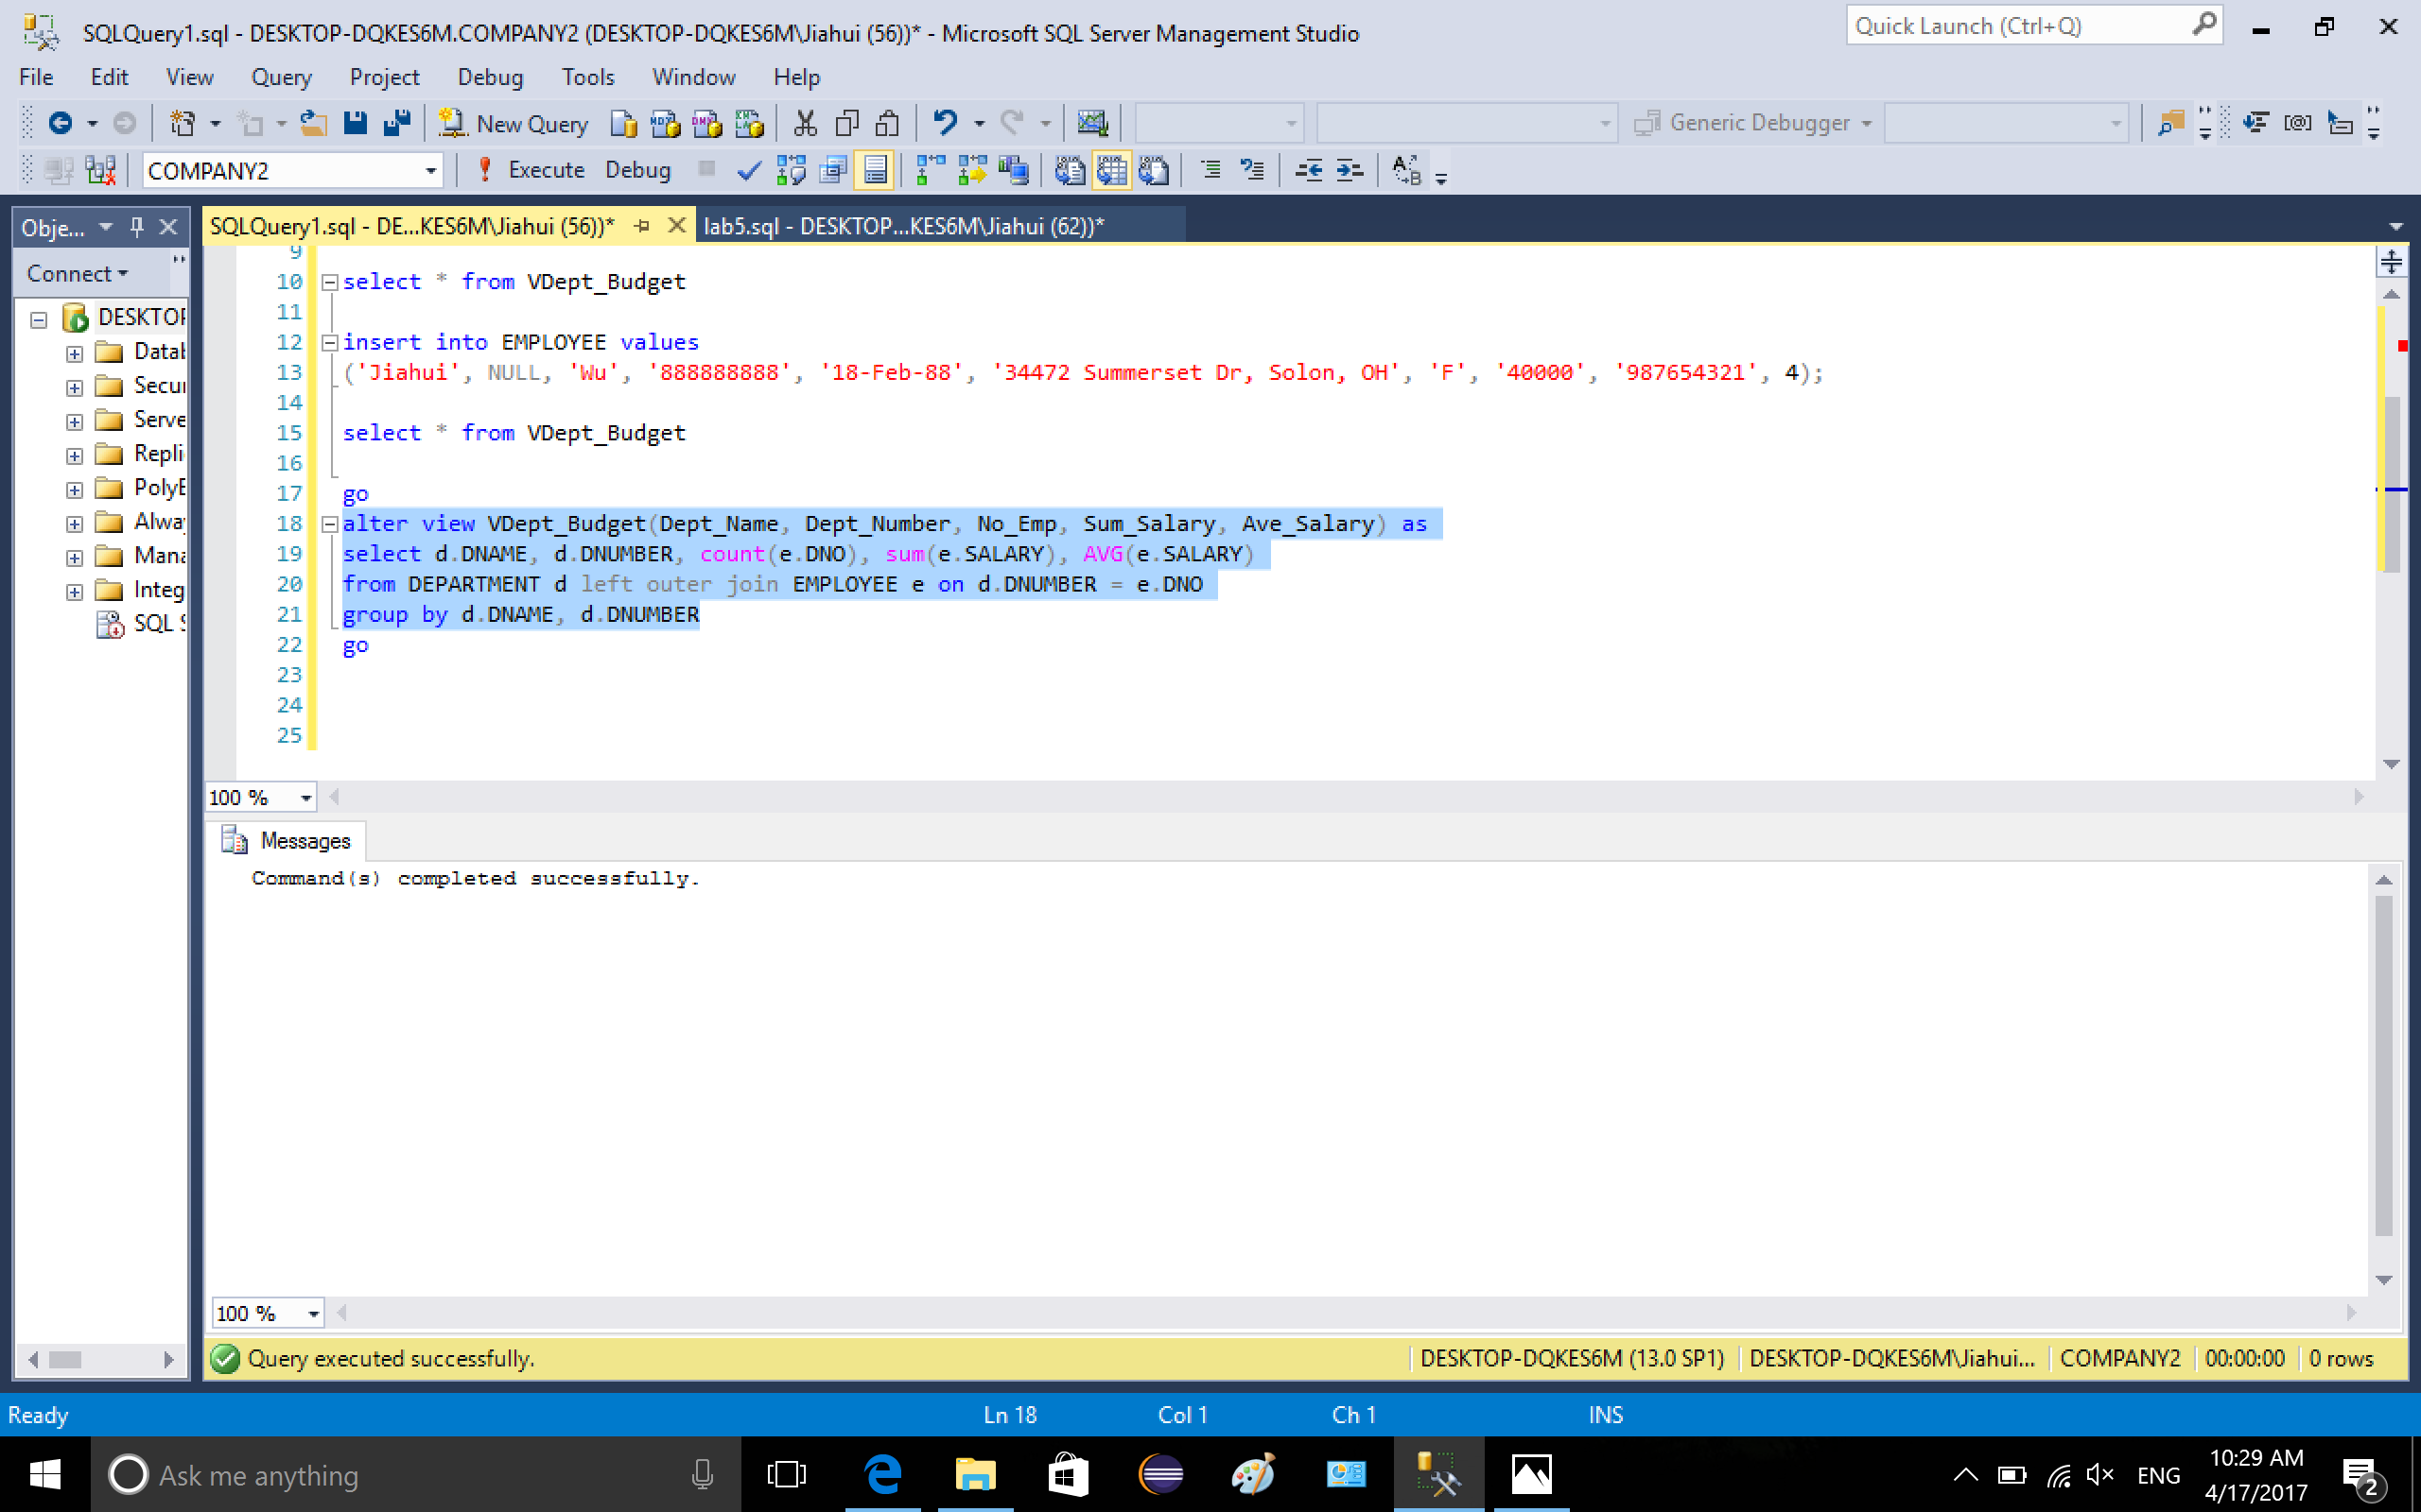

use select \* from VDept\_Budget to show the view

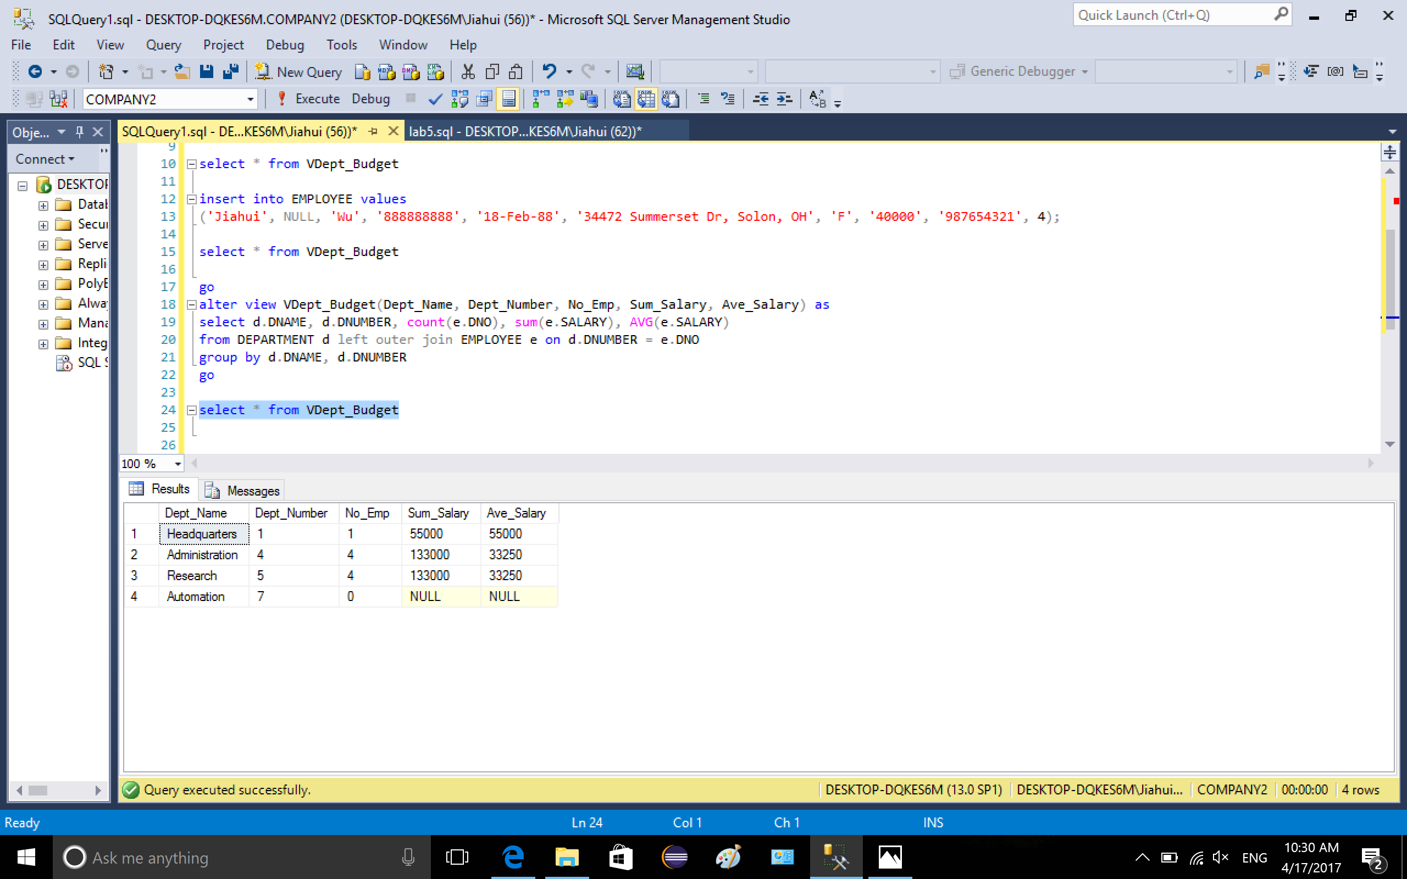

Part 2 on stored procedure using cursor

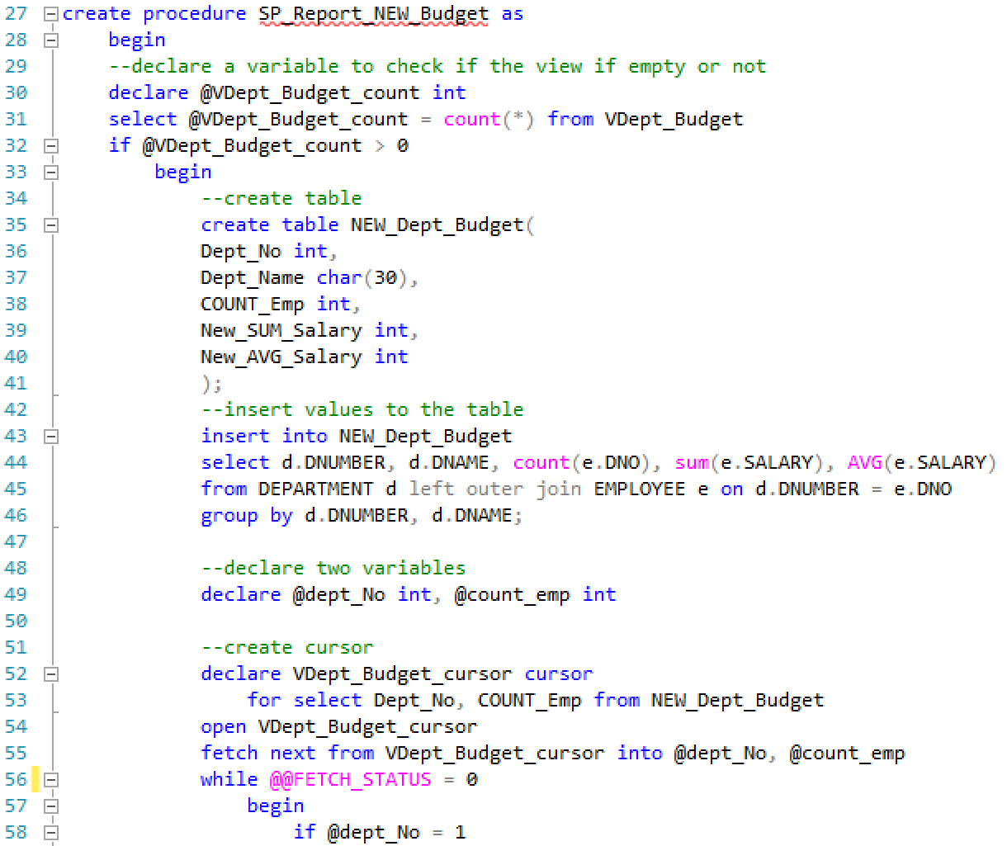

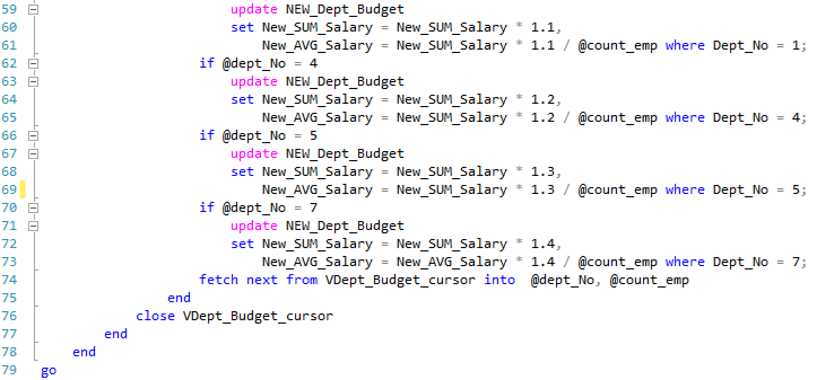

execute the procedure creation

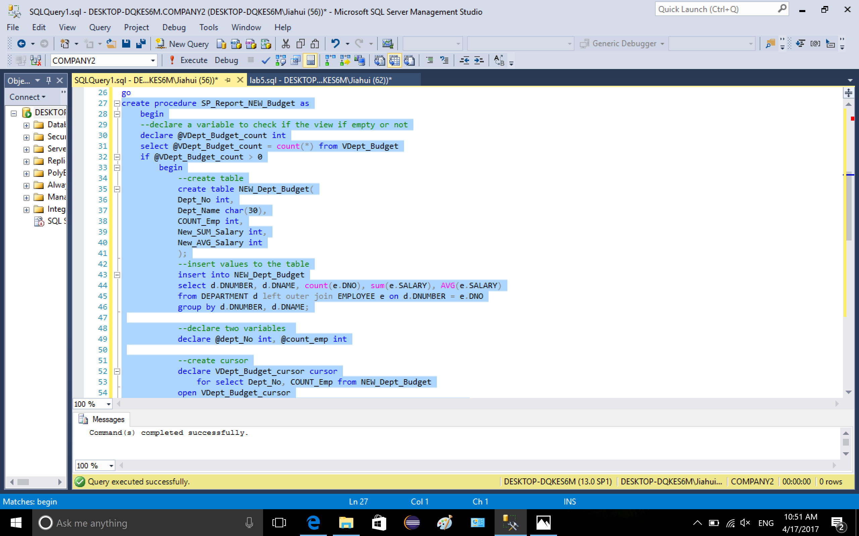

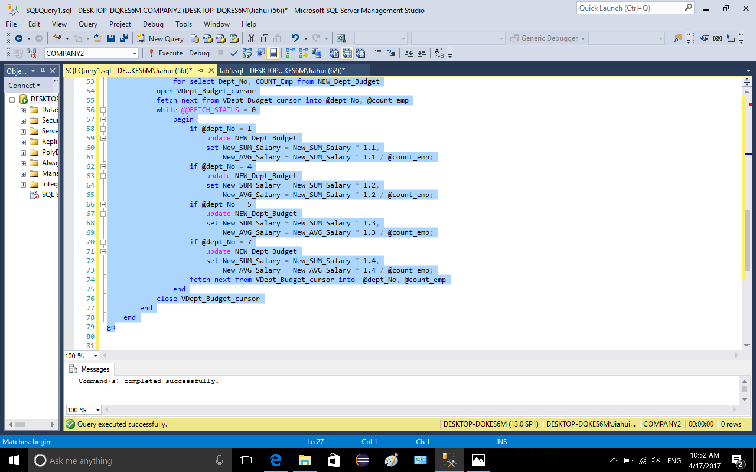

execute procedure

../lab5_2/9-1.png

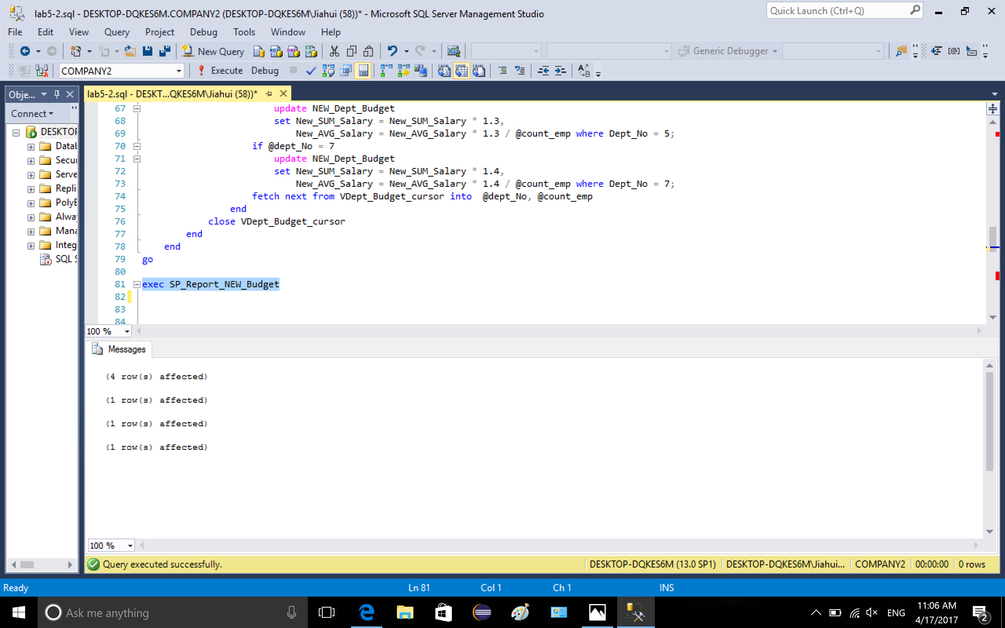

show the new table

