How to autoload DLLs with AutoCAD

<https://knowledge.autodesk.com/support/autocad/troubleshooting/caas/sfdcarticles/sfdcarticles/How-to-autoload-DLLs-with-AutoCAD.html>

Issue:

You created or use an application stored in a DLL file, but the APPLOAD function is not allowing to add it in the autoload case. How this files can be loaded automatically?

Solution:

**A:**To automatically load DLL files you can follow next procedure:

* Browse with the file explorer to the *c:\program files\autodesk\autocad 20****xx****\support* folder
* Check if there is any file named *acad20****xx****doc.lsp.* If it's there, open with an ASCII editor such as notepad.exe. If it's not there, create it with an ASCII editor.
* Add the list of DLL's that you want to load following the next structure:

*(command "_netload" "C:/folder1/folder2/my_DLL_1.DLL")*  
*(command "_netload" "C:/folder1/folder2/my_DLL_2.DLL")  
(command "_netload" "C:/folder1/folder2/my_DLL_3.DLL")  
(command "_netload" "C:/folder1/folder2/my_DLL_4.DLL")*

Update the path and file names to match your needs.

* Save the acad20**xx**doc.lsp
* Every time that you start a new file or open an existing one it will load the list of DLL.

**Note 1:** The ***xx*** means the AutoCAD version, for example, the file *acad20****xx****doc.lsp, means that if you are working with AutoCAD 2015, the file name should be acad20****15****doc.lsp*.

**Note 2:** You should add the folder where the DLLs are stored in the variable AUTOLOADPATH to automatically load the files without user interactions.

**B:**

* Edit the Windows Registry and add a folder to the following path (for example, for the DGNLSPurge Hotfix DLL for AutoCAD Civil 3D 2014):
  + *HKEY_LOCAL_MACHINE\SOFTWARE\Autodesk\AutoCAD\R19.1\ACAD-D000:407\Applications*
* Add the following keys:
  + "LOADER"="C:\\Program Files\\Autodesk\\Autodesk AutoCAD Civil 3D 2014\\DgnLsPurge.dll"
  + "DESCRIPTION"="DGN Linestyle Purge"
  + "LOADCTRLS"=dword:0000000e
  + "MANAGED"=dword:00000001

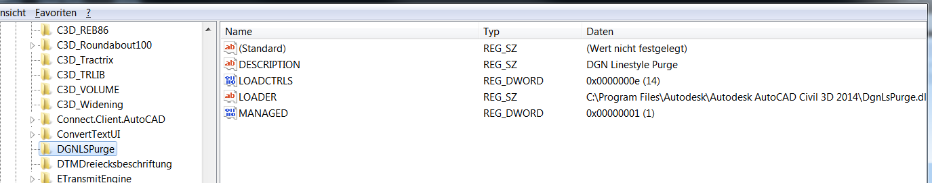

**C.** Use the Startup Suite in AutoCAD's Application Loader to always call the plug-in or DLL at startup.

1. Create a LSP file which calls the file in question.
2. Place the LSP file into a folder on your computer.
3. Add that folder location to the Trusted Locations section of the Files tab, within AutoCAD's Options.
4. Launch AutoCAD.
5. Use NETLOAD to load the DLL file in question.
6. Run APPLOAD.
7. Click the Contents button in the Startup Suite.
8. Click Add and browse to the folder where you saved the LSP file.

Now, when AutoCAD is launched, the LSP in the Startup Suite will call the DLL file specified within the LSP file.