任务15：
问题：1、 人脸检测：请从下图中圈出尽可能多的人脸。
2、 人脸识别：识别并分辨至少2张不同人脸（比如你和你的同桌），打开摄像头实时识别。
3、 人脸跟踪：获取摄像头的的实时图像，识别自己的脸，选择一顶帽子或者眼镜实时戴在自己头上或脸上。（帽子和眼镜的素材可以自己找）
代码实现1：
import cv2
import numpy as np

# 加载 Haar Cascade 预训练人脸检测模型
face_cascade = cv2.CascadeClassifier(cv2.data.haarcascades + 'haarcascade_frontalface_default.xml')

# 读取图像
image = cv2.imread(r"D:\qwe\666.jpg")

# 转换为灰度图像
gray = cv2.cvtColor(image, cv2.COLOR_BGR2GRAY)

# 使用 Haar Cascade 检测人脸
faces = face_cascade.detectMultiScale(gray, 1.3, 5)

# 如果检测到人脸
for (x, y, w, h) in faces:
# 在图像上画出人脸的矩形框
cv2.rectangle(image, (x, y), (x + w, y + h), (255, 0, 0), 2)

# 显示检测到的人脸
cv2.imshow('Faces Detected', image)

# 进行 MeanShift 跟踪 (假设我们选择第一个检测到的脸)
if len(faces) > 0:
# 提取第一个人脸的坐标
x, y, w, h = faces[0]
track_window = (x, y, w, h)

# 为 MeanShift 跟踪准备初始化
roi = image[y:y + h, x:x + w]
hsv_roi = cv2.cvtColor(roi, cv2.COLOR_BGR2HSV)
mask = cv2.inRange(hsv_roi, (0, 60, 32), (180, 255, 255))
roi_hist = cv2.calcHist([hsv_roi], [0], mask, [180], [0, 180])
cv2.normalize(roi_hist, roi_hist, 0, 255, cv2.NORM_MINMAX)

# 使用 MeanShift 跟踪
term_criteria = (cv2.TERM_CRITERIA_EPS | cv2.TERM_CRITERIA_COUNT, 10, 1)
hsv = cv2.cvtColor(image, cv2.COLOR_BGR2HSV)
dst = cv2.calcBackProject([hsv], [0], roi_hist, [0, 180], 1)
ret, track_window = cv2.meanShift(dst, track_window, term_criteria)

# 画出 MeanShift 跟踪结果
x, y, w, h = track_window
cv2.rectangle(image, (x, y), (x + w, y + h), (0, 255, 0), 2)

# 显示 MeanShift 跟踪结果
cv2.imshow('MeanShift Tracking', image)

# 等待按键后关闭所有窗口
cv2.waitKey(0)
cv2.destroyAllWindows()
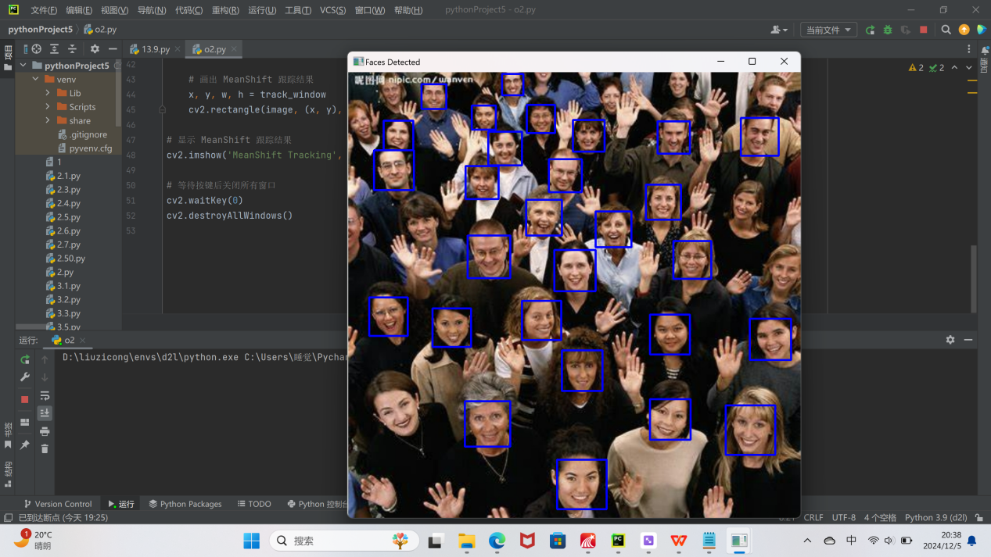
代码实现2：
import cv2
import numpy as np

# 加载Haar级联人脸检测分类器
face_cascade = cv2.CascadeClassifier(cv2.data.haarcascades + 'haarcascade_frontalface_default.xml')

# 打开摄像头
cap = cv2.VideoCapture(0)

# 用于存储每个人脸的跟踪窗口
tracking_windows = []

while True:
ret, frame = cap.read()
if not ret:
break

# 转换为灰度图像
gray = cv2.cvtColor(frame, cv2.COLOR_BGR2GRAY)

# 检测人脸
faces = face_cascade.detectMultiScale(gray, scaleFactor=1.1, minNeighbors=5, minSize=(30, 30))

# 对每个检测到的人脸，应用MeanShift跟踪
for (x, y, w, h) in faces:
# 在第一次检测到人脸时初始化跟踪窗口
roi = frame[y:y + h, x:x + w]
hsv_roi = cv2.cvtColor(roi, cv2.COLOR_BGR2HSV)
mask = cv2.inRange(hsv_roi, np.array((0., 60., 32.)), np.array((180., 255., 255.)))
roi_hist = cv2.calcHist([hsv_roi], [0], mask, [180], [0, 180])
cv2.normalize(roi_hist, roi_hist, 0, 255, cv2.NORM_MINMAX)

# 设置跟踪的ROI窗口
track_window = (x, y, w, h)
tracking_windows.append((track_window, roi_hist))

# 在每一帧中，跟踪已初始化的窗口
for (track_window, roi_hist) in tracking_windows:
# 获取当前跟踪窗口区域
x, y, w, h = track_window
roi = frame[y:y + h, x:x + w]
hsv_roi = cv2.cvtColor(roi, cv2.COLOR_BGR2HSV)
mask = cv2.inRange(hsv_roi, np.array((0., 60., 32.)), np.array((180., 255., 255.)))
# 计算反向投影
dst = cv2.calcBackProject([hsv_roi], [0], roi_hist, [0, 180], 1)
# 应用meanShift跟踪
ret, track_window = cv2.meanShift(dst, (x, y, w, h), (cv2.TERM_CRITERIA_EPS | cv2.TERM_CRITERIA_COUNT, 10, 1))
x, y, w, h = track_window
cv2.rectangle(frame, (x, y), (x + w, y + h), (0, 255, 0), 2)

# 显示视频流
cv2.imshow('MeanShift Face Tracking', frame)

# 按'q'退出
if cv2.waitKey(1) & 0xFF == ord('q'):
break

cap.release()
cv2.destroyAllWindows()
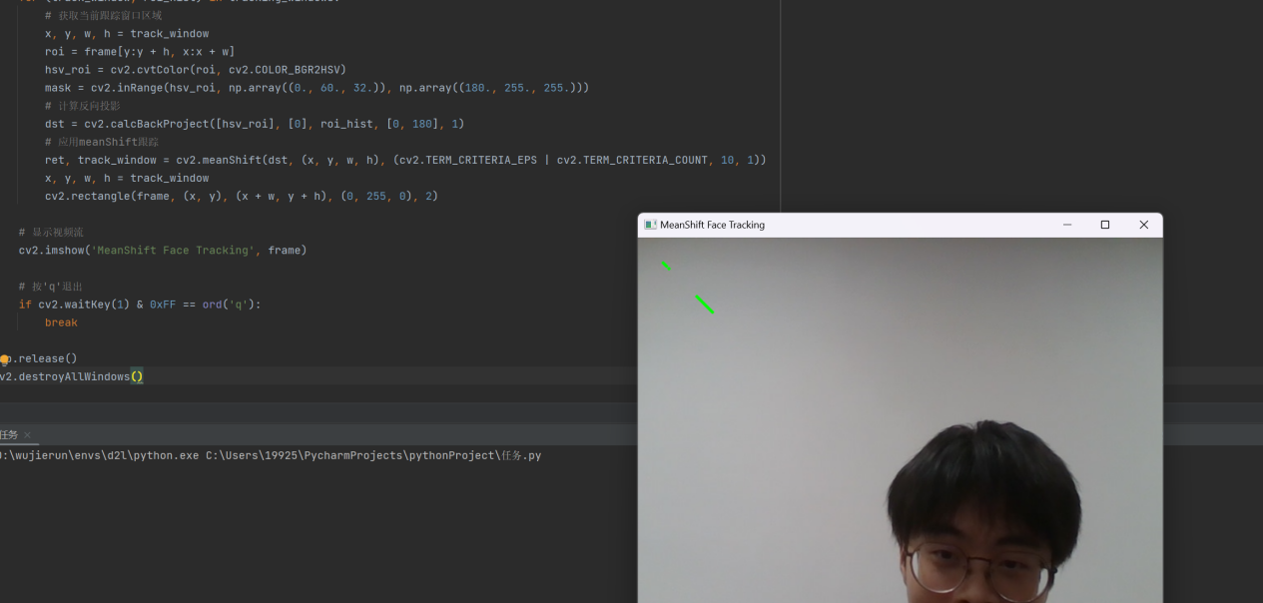
代码实现3：
import cv2
import numpy as np

# 加载Haar级联人脸检测分类器
face_cascade = cv2.CascadeClassifier(cv2.data.haarcascades + 'haarcascade_frontalface_default.xml')

# 加载帽子和眼镜的图片（确保素材是透明背景PNG）
hat_img = cv2.imread(r"D:\qwe\123.png", -1) # 读取带透明背景的帽子图像
glasses_img = cv2.imread(r"D:\qwe\1234.png", -1) # 读取带透明背景的眼镜图像

# 打开摄像头
cap = cv2.VideoCapture(0)

# 用于存储每个人脸的跟踪窗口
tracking_window = None
roi_hist = None

while True:
ret, frame = cap.read()
if not ret:
break

# 转换为灰度图像
gray = cv2.cvtColor(frame, cv2.COLOR_BGR2GRAY)

# 检测人脸
faces = face_cascade.detectMultiScale(gray, scaleFactor=1.1, minNeighbors=5, minSize=(30, 30))

for (x, y, w, h) in faces:
# 初始化跟踪窗口
if tracking_window is None:
tracking_window = (x, y, w, h)
roi = frame[y:y + h, x:x + w]
hsv_roi = cv2.cvtColor(roi, cv2.COLOR_BGR2HSV)
mask = cv2.inRange(hsv_roi, np.array((0., 60., 32.)), np.array((180., 255., 255.)))
roi_hist = cv2.calcHist([hsv_roi], [0], mask, [180], [0, 180])
cv2.normalize(roi_hist, roi_hist, 0, 255, cv2.NORM_MINMAX)
else:
# 使用meanShift进行跟踪
hsv = cv2.cvtColor(frame, cv2.COLOR_BGR2HSV)
dst = cv2.calcBackProject([hsv], [0], roi_hist, [0, 180], 1)
ret, tracking_window = cv2.meanShift(dst, tracking_window,
(cv2.TERM_CRITERIA_EPS | cv2.TERM_CRITERIA_COUNT, 10, 1))
x, y, w, h = tracking_window

# 绘制人脸跟踪框
cv2.rectangle(frame, (x, y), (x + w, y + h), (0, 255, 0), 2)

# 叠加帽子或眼镜（根据跟踪框计算位置）
if hat_img is not None:
# 调整帽子图片的大小，使其适应人脸的宽度
hat_resized = cv2.resize(hat_img, (w, int(h / 3)))
hat_h, hat_w = hat_resized.shape[:2]

# 计算帽子位置
hat_y = y - hat_h
hat_x = x
if hat_y < 0:
hat_y = y + h // 10 # 避免帽子超出图像上边界

# 使用透明通道（alpha通道）叠加帽子
for c in range(0, 3):
frame[hat_y:hat_y + hat_h, hat_x:hat_x + hat_w, c] = \
frame[hat_y:hat_y + hat_h, hat_x:hat_x + hat_w, c] * (1 - hat_resized[:, :, 3] / 255.0) + \
hat_resized[:, :, c] * (hat_resized[:, :, 3] / 255.0)

# 叠加眼镜（可以根据需要调整大小和位置）
if glasses_img is not None:
glasses_resized = cv2.resize(glasses_img, (w, int(h / 4))) # 眼镜宽度与人脸一致
glasses_h, glasses_w = glasses_resized.shape[:2]

# 计算眼镜位置
glasses_y = y + int(h / 4) # 眼镜位于人脸的中间偏下位置
glasses_x = x
if glasses_y + glasses_h > frame.shape[0]:
glasses_y = frame.shape[0] - glasses_h - 1

# 使用透明通道（alpha通道）叠加眼镜
for c in range(0, 3):
frame[glasses_y:glasses_y + glasses_h, glasses_x:glasses_x + glasses_w, c] = \
frame[glasses_y:glasses_y + glasses_h, glasses_x:glasses_x + glasses_w, c] * (
1 - glasses_resized[:, :, 3] / 255.0) + \
glasses_resized[:, :, c] * (glasses_resized[:, :, 3] / 255.0)

# 显示结果
cv2.imshow("Face with Hat/Glasses", frame)

# 按'q'退出
if cv2.waitKey(1) & 0xFF == ord('q'):
break

cap.release()
cv2.destroyAllWindows()

