任务五：
使用cv2.add()增加和降低一张任意图像的亮度。
import cv2
import numpy as np
# 读取图片
image = cv2.imread(r"C:\tupian\paiqiuq.jpg")
# 检查图片是否读取成功
if image is None:
print("图片读取失败，请检查图片路径。")
else:
# 增加亮度
brightness_increase = 50 # 增加的亮度值
brightened_image = cv2.add(image, np.array([brightness_increase, brightness_increase, brightness_increase]))
# 降低亮度
brightness_decrease = 50 # 降低的亮度值
darkened_image = cv2.add(image, np.array([-brightness_decrease, -brightness_decrease, -brightness_decrease]))
# 显示和保存结果
cv2.imshow('Brightened Image', brightened_image)
cv2.imshow('Darkened Image', darkened_image)
cv2.imwrite('brightened_image.jpg', brightened_image)
cv2.imwrite('darkened_image.jpg', darkened_image)
# 等待按键后关闭所有窗口
cv2.waitKey(0)
cv2.destroyAllWindows()

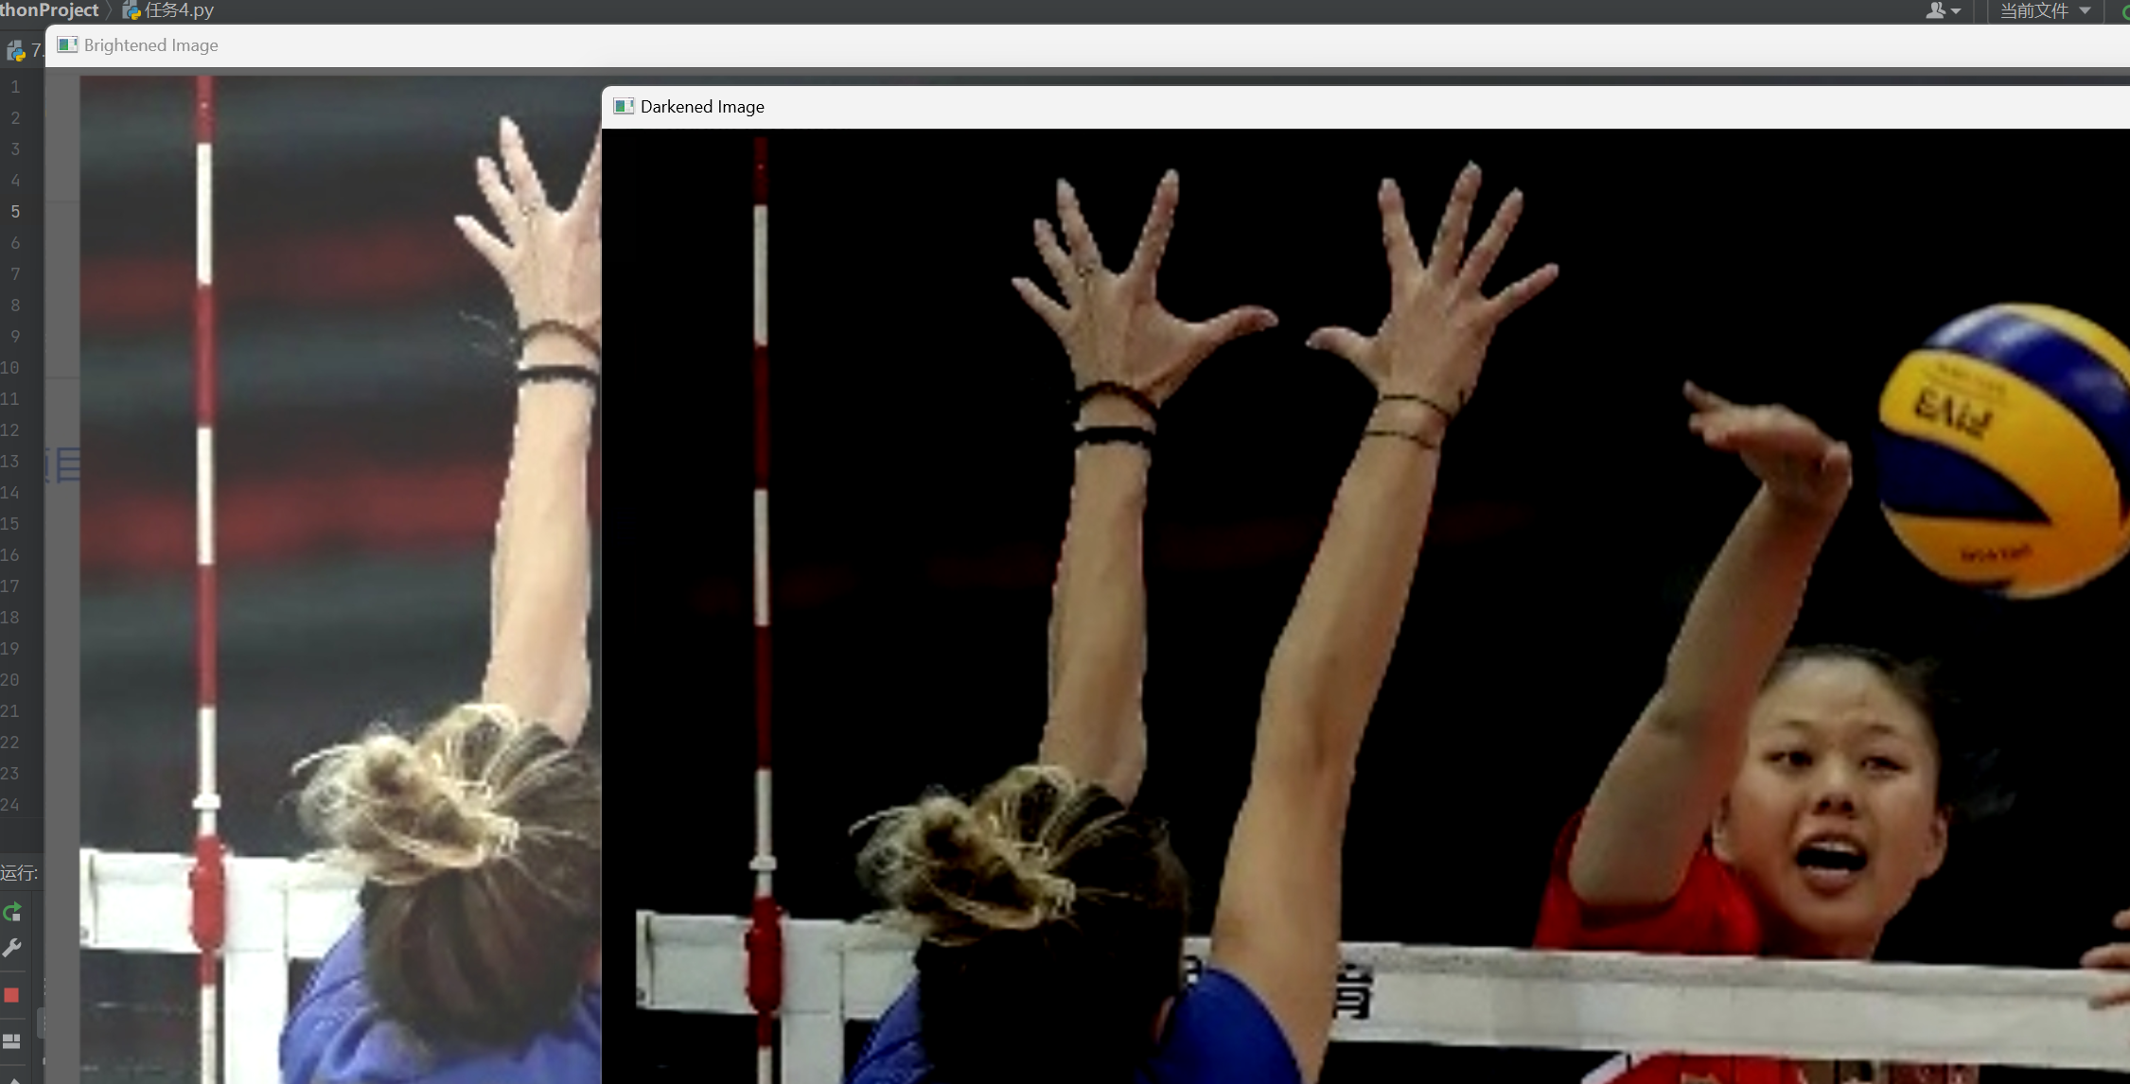

使用cv2.add()、cv2.addWeighted()、cv2.subtract()、cv2.absdiff()对两张任意图像进行操作。（注意调整图像大小）

import cv2
# 读取两张图片
image1 = cv2.imread(r"C:\tupian\paiqiuq.jpg")
image2 = cv2.imread(r"C:\tupian\wew.jpg")
# 检查图片是否读取成功
if image1 is None or image2 is None:
print("图片读取失败，请检查图片路径。")
else:
# 调整图像大小以匹配
resized_image2 = cv2.resize(image2, (image1.shape[1], image1.shape[0]))
# 使用cv2.add()将两张图像相加
added = cv2.add(image1, resized_image2)
# 使用cv2.addWeighted()混合两张图像
alpha = 0.5 # 混合比例
weighted = cv2.addWeighted(image1, alpha, resized_image2, 1 - alpha, 0)
# 使用cv2.subtract()相减
subtracted = cv2.subtract(image1, resized_image2)
# 使用cv2.absdiff()求绝对差值
abs_diff = cv2.absdiff(image1, resized_image2)
# 显示和保存结果
cv2.imshow('Added Image', added)
cv2.imshow('Weighted Image', weighted)
cv2.imshow('Subtracted Image', subtracted)
cv2.imshow('Absolute Difference', abs_diff)
cv2.imwrite('added_image.jpg', added)
cv2.imwrite('weighted_image.jpg', weighted)
cv2.imwrite('subtracted_image.jpg', subtracted)
cv2.imwrite('abs_diff_image.jpg', abs_diff)
# 等待按键后关闭所有窗口
cv2.waitKey(0)
cv2.destroyAllWindows()

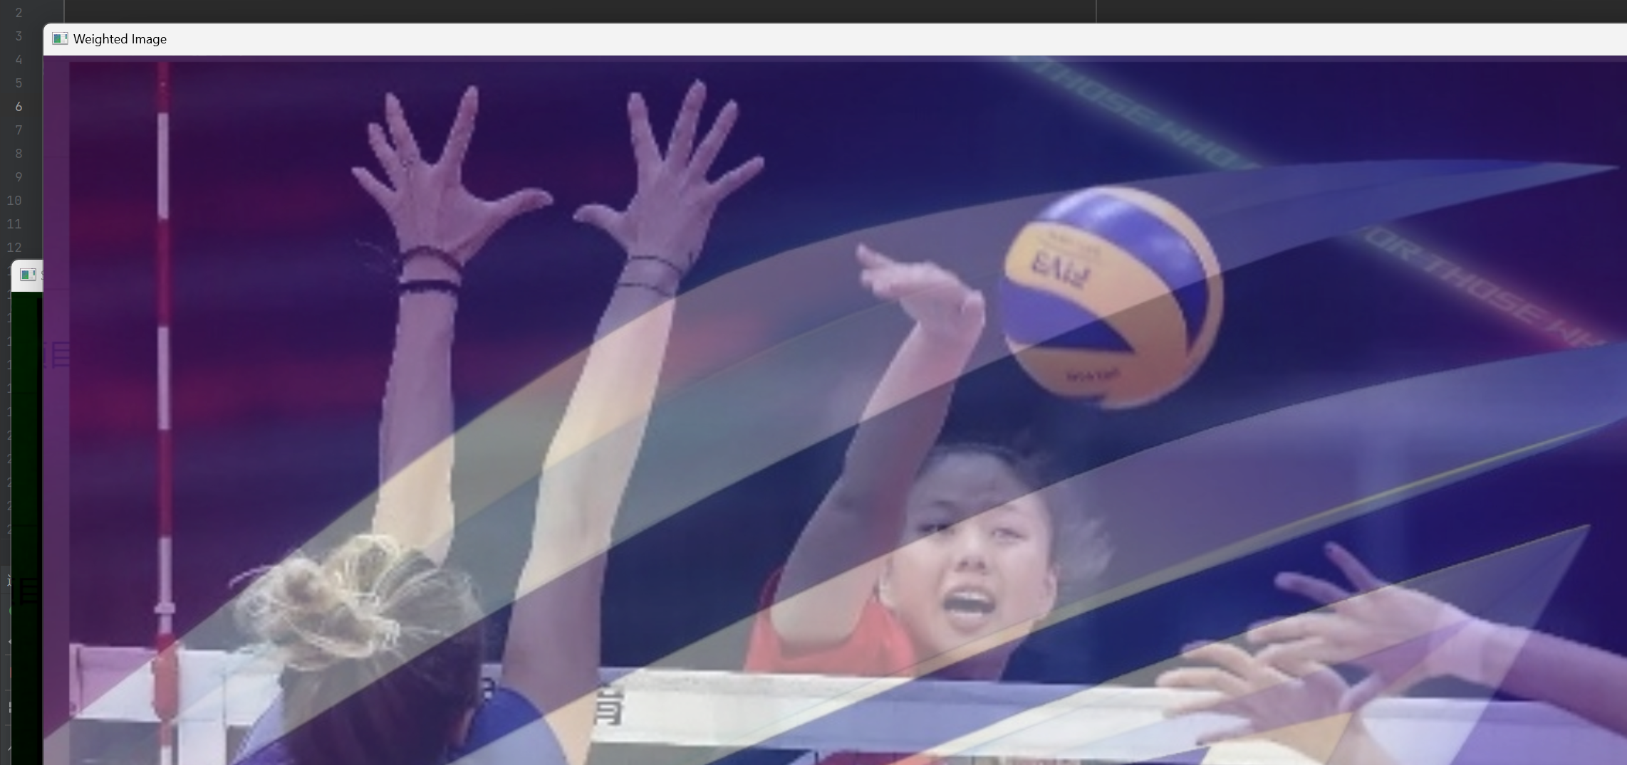

把opencv的logo放在任意一张图片的左上角。（如果使用加法，颜色会改变。如果使用混合，会得到透明效果。如果它是矩形，可以像上一个任务那样进行切片和赋值。我们可以通过阈值处理和掩膜操作实现灵活的图像合成效果。涉及函数：cv2.cvtColor、cv2.threshold、cv2.bitwise_not、cv2.bitwise_and()、cv2.add。)
import cv2
import numpy as np
# 读取图片和OpenCV的logo
image = cv2.imread(r"C:\tupian\paiqiuq.jpg")
logo = cv2.imread(r"C:\tupian\oopencv.jpg", cv2.IMREAD_UNCHANGED) # 确保logo是RGBA
# 检查图片是否读取成功
if image is None or logo is None:
print("图片或logo读取失败，请检查路径。")
else:
# 调整logo大小以适应图片左上角
logo_height = 100 # 根据需要调整logo大小
logo_width = int(logo.shape[1] * (logo_height / logo.shape[0]))
logo = cv2.resize(logo, (logo_width, logo_height))
# 创建掩膜和掩膜的反色
mask = cv2.cvtColor(logo, cv2.COLOR_BGR2GRAY)
mask = mask // 255
mask_inv = cv2.bitwise_not(mask)
# 将logo的背景变为透明
image_bg = cv2.bitwise_and(image, image, mask=mask_inv)
# 将logo和背景合并
image_fg = cv2.bitwise_and(logo, logo, mask=mask)
result = cv2.add(image_bg, image_fg)
# 显示和保存结果
cv2.imshow('Image with OpenCV Logo', result)
cv2.imwrite('image_with_logo.jpg', result)
# 等待按键后关闭所有窗口
cv2.waitKey(0)
cv2.destroyAllWindows()

