任务八：
- 绘制硬币图和硬币图的灰度直方图，采用5个等级的灰度阈值分割硬币和数字图，并对比它们的效果。固定阈值：cv2.threshold()；
- 绘制硬币图和硬币图的灰度直方图，采用自适应阈值分割硬币和数字图，搜集并阅读资料，说明自适应阈值和固定阈值的异同；
- 采用其他阈值分割算法分割硬币和数字图（最大类间方差、迭代式阈值分割、熵算法）

import cv2
import numpy as np
import matplotlib.pyplot as plt

# 读取图像
img = cv2.imread(r"D:\qwe\p.jpg", 0)

# 绘制灰度直方图
plt.hist(img.ravel(), 256, [0, 256])
plt.title('Gray-Scale Histogram')
plt.show()

# 固定阈值分割
ret, thresh1 = cv2.threshold(img, 127, 255, cv2.THRESH_BINARY)
ret, thresh2 = cv2.threshold(img, 127, 255, cv2.THRESH_BINARY_INV)
ret, thresh3 = cv2.threshold(img, 128, 255, cv2.THRESH_BINARY)
ret, thresh4 = cv2.threshold(img, 128, 255, cv2.THRESH_BINARY_INV)
ret, thresh5 = cv2.threshold(img, 129, 255, cv2.THRESH_BINARY)

# 显示结果
titles = ['Original Image', 'B&W Binary', 'B&W Binary Inv', 'B&W Binary 128', 'B&W Binary Inv 128', 'B&W Binary 129']
images = [img, thresh1, thresh2, thresh3, thresh4, thresh5]

for i in range(6):
plt.subplot(2, 3, i+1), plt.imshow(images[i], 'gray')
plt.title(titles[i])
plt.show()
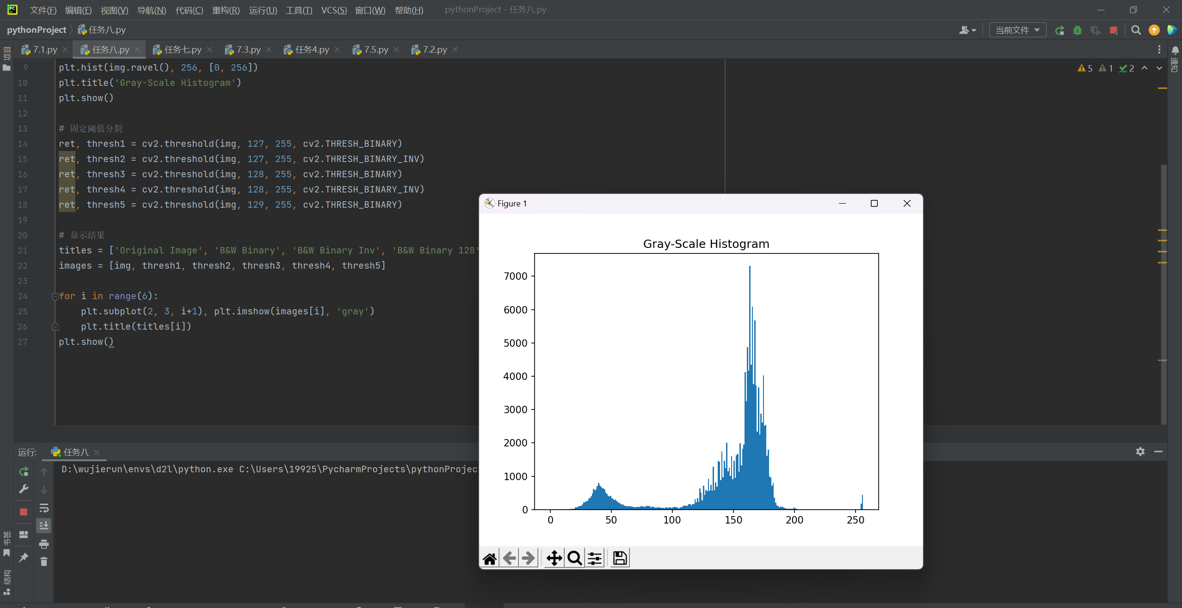

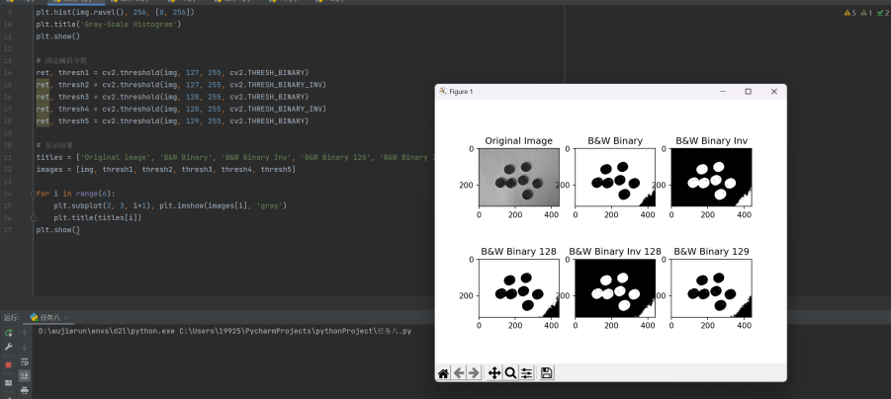

import cv2
import numpy as np
from matplotlib import pyplot as plt

# 读取图像
img = cv2.imread(r"D:\qwe\p.jpg", 0) # 确保路径正确

# 绘制灰度直方图
plt.hist(img.ravel(), 256, [0, 256])
plt.title('Gray-Scale Histogram')
plt.show()

# 自适应阈值分割
# 均值自适应阈值
adaptive_thresh_mean = cv2.adaptiveThreshold(img, 255, cv2.ADAPTIVE_THRESH_MEAN_C, cv2.THRESH_BINARY, 11, 2)
# 高斯自适应阈值
adaptive_thresh_gaussian = cv2.adaptiveThreshold(img, 255, cv2.ADAPTIVE_THRESH_GAUSSIAN_C, cv2.THRESH_BINARY, 11, 2)

# 显示结果
titles = ['Original Image', 'Adaptive Mean Threshold', 'Adaptive Gaussian Threshold']
images = [img, adaptive_thresh_mean, adaptive_thresh_gaussian]

for i in range(3):
plt.subplot(1, 3, i+1), plt.imshow(images[i], 'gray')
plt.title(titles[i])
plt.xticks([]), plt.yticks([])
plt.show()

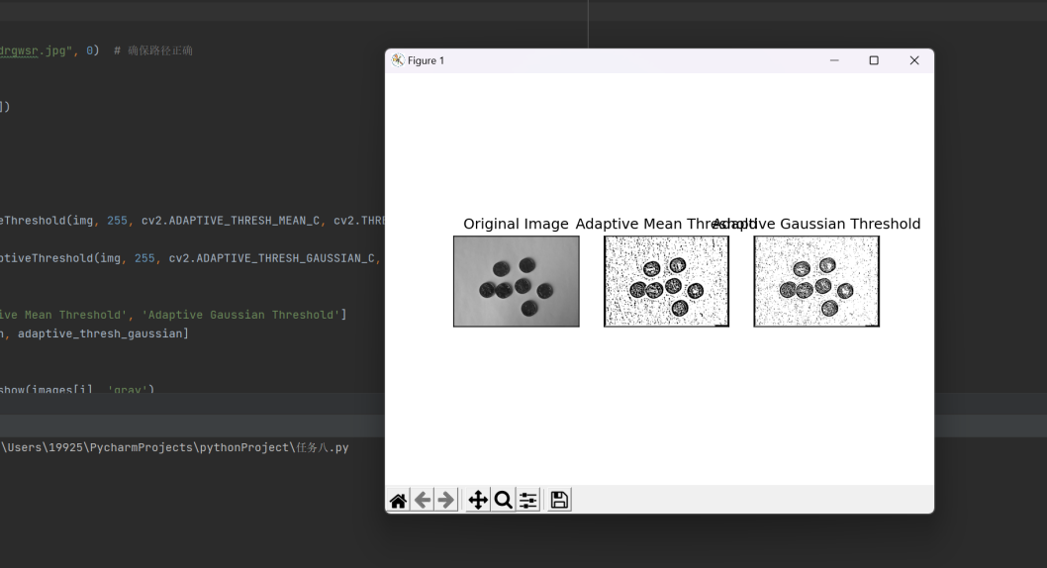

最大类间方差：
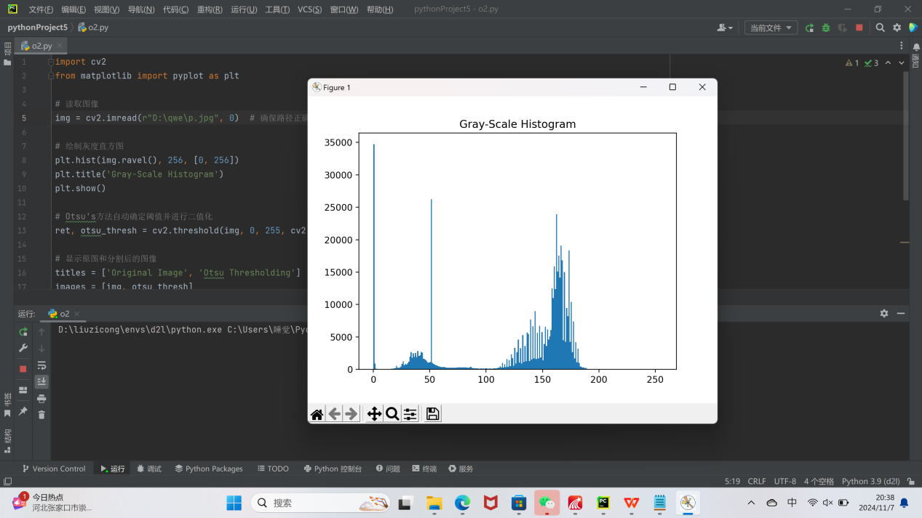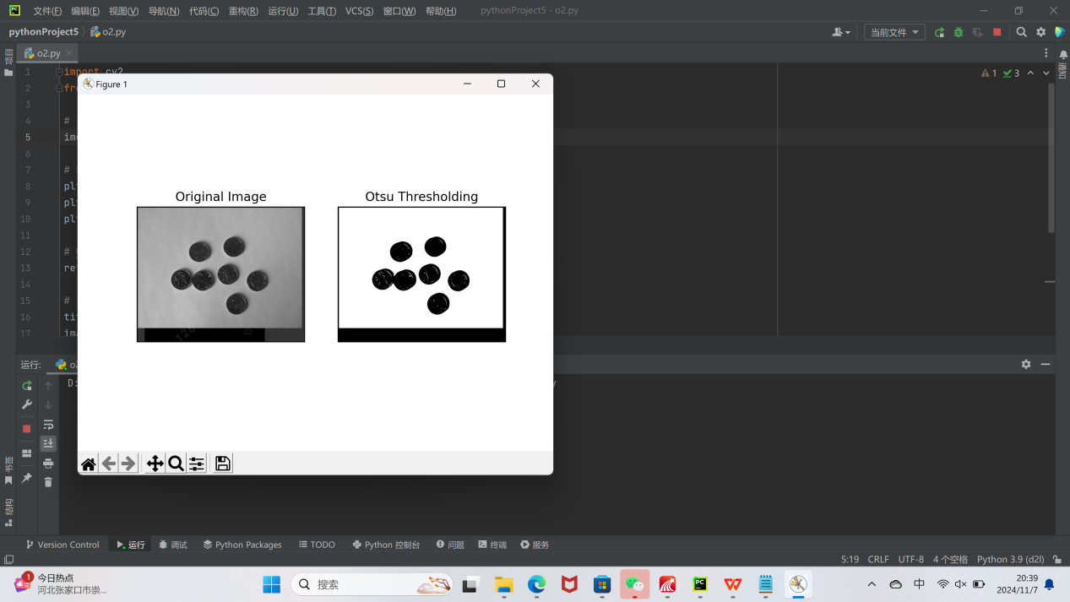

迭代式阈值分割：
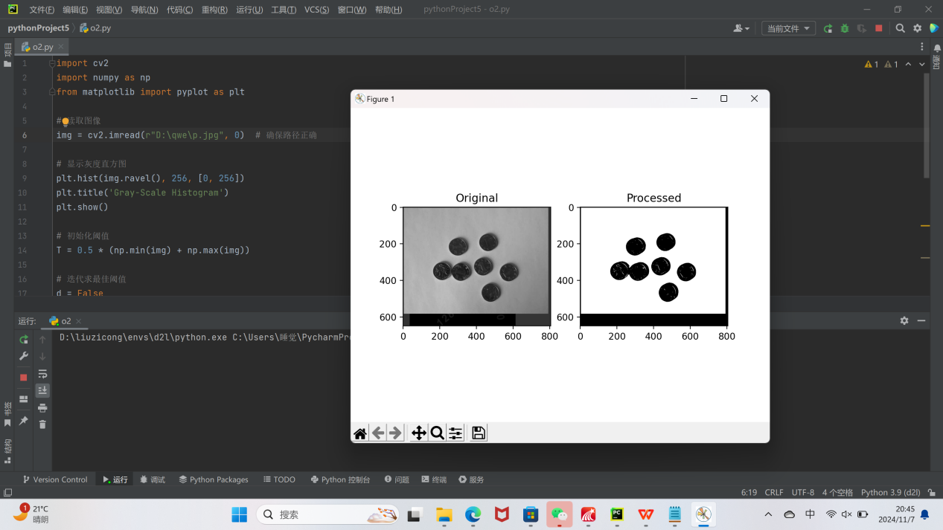

熵算法：
