任务十四

- 以下是实验图像，用以上各种特征检测方法，检测相似特征点并用线连接在一起。并对比不同算法的效果。

import cv2
import numpy as np

# 读取图像
image1 = cv2.imread('image1.jpg', cv2.IMREAD_GRAYSCALE)
image2 = cv2.imread('image2.jpg', cv2.IMREAD_GRAYSCALE)

# 初始化ORB检测器
orb = cv2.ORB_create()

# 检测关键点和计算描述子
kp1, des1 = orb.detectAndCompute(image1, None)
kp2, des2 = orb.detectAndCompute(image2, None)

# 创建BFMatcher对象
bf = cv2.BFMatcher(cv2.NORM_HAMMING, crossCheck=True)

# 进行匹配
matches = bf.match(des1, des2)

# 根据距离排序
matches = sorted(matches, key=lambda x: x.distance)

# 绘制前N个匹配点
N = 10
image_matches = cv2.drawMatches(image1, kp1, image2, kp2, matches[:N], None, flags=2)

# 显示匹配结果
cv2.imshow('Matches', image_matches)
cv2.waitKey(0)
cv2.destroyAllWindows()
A组：
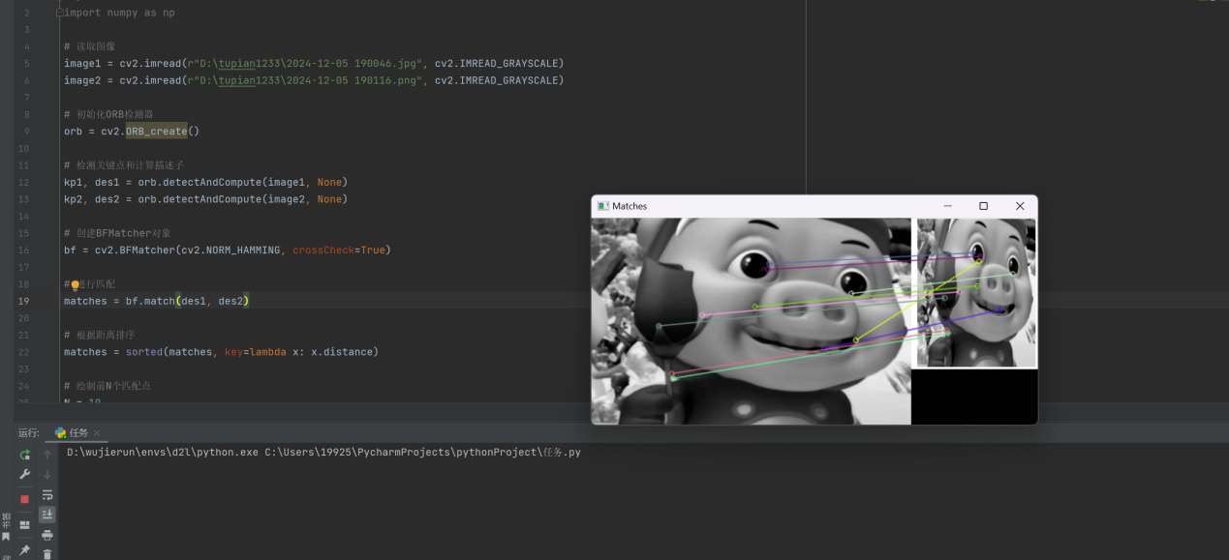
B组：
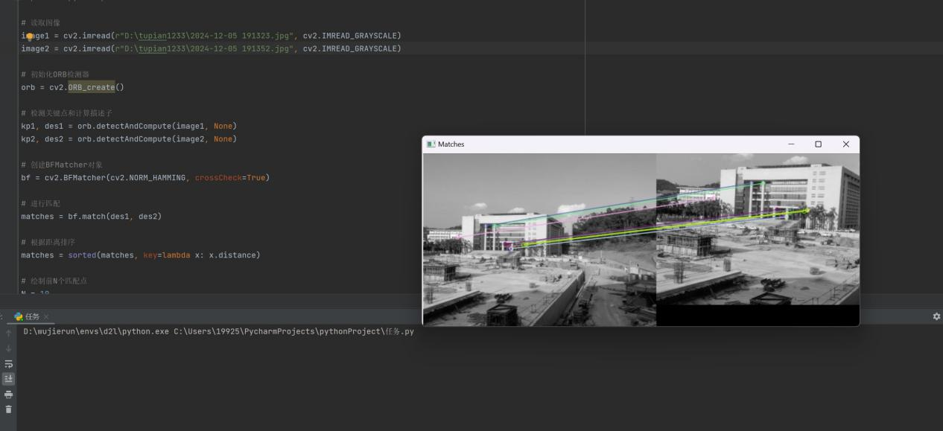
C组：
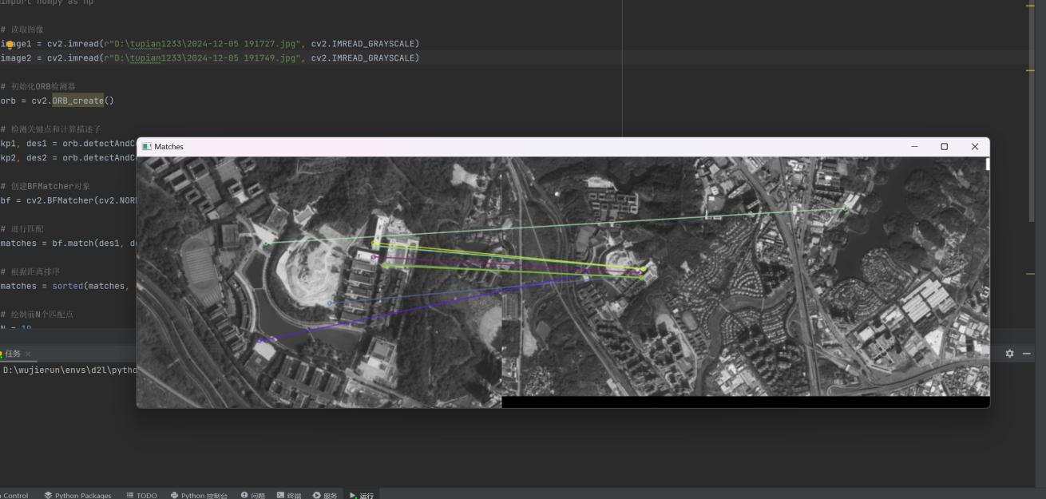

- 调用摄像头，识别自己人脸的特征，并实现实时追踪。

import cv2
cap = cv2.VideoCapture(0)
if not cap.isOpened():
print("无法打开摄像头")
exit()
face_cascade = cv2.CascadeClassifier('haarcascade_frontalface_default.xml')
tracker = cv2.TrackerCSRT_create()
while True:
ret, frame = cap.read()
if not ret:
break
gray = cv2.cvtColor(frame, cv2.COLOR_BGR2GRAY)
faces = face_cascade.detectMultiScale(gray, scaleFactor=1.1, minNeighbors=5, minSize=(30, 30))
if len(faces) > 0:
(x, y, w, h) = faces[0]
tracker.init(frame, (x, y, w, h))
if tracker is not None:
success, box = tracker.update(frame)
if success:
(x, y, w, h) = [int(v) for v in box]
cv2.rectangle(frame, (x, y), (x + w, y + h), (0, 255, 0), 2)
cv2.imshow('Tracking', frame)
if cv2.waitKey(1) & 0xFF == 27:
break
cap.release()
cv2.destroyAllWindows()

