Shifting oncogenic HPV ecology after COVID-19: emergence of HPV-51 and decoupling of HPV-16 in a cervical-cancer screening cohort in Xi’an, China (2021–2025)
Running title: Post-pandemic HR-HPV dynamics in Xi'an, 2021–2025

Jingrui Wu^{1,7,*}, Haihui Yang¹, Jinhua Zhi¹, Jinjin Yan², Wen Wang³, Ki-Hyun Kim⁴, Wenping Yang⁵, Le Fang^{6,*}
¹ College of Medical Technology, Xi'an Medical College, Xi'an, Shaanxi, China
² Department of Basic Sciences, Xi'an Medical College, Xi'an, Shaanxi, China
³ Clinical Medical College, Xi'an Medical College, Xi'an, Shaanxi, China
⁴ Department of Physical Therapy, Kyungwoon University, Gumi, Gyeongsangbuk-do, Republic of Korea
⁵ Department of Nursing, Kyungwoon University, Gumi, Gyeongsangbuk-do, Republic of Korea
⁶ Department of Clinical Laboratory, Norinco General Hospital, Xi'an, Shaanxi, China
⁷ Department of Public Health, Kyungwoon University, Gumi, Gyeongsangbuk-do, Republic of Korea
Submitting author
Jingrui Wu (first author and submitting author), College of Medical Technology, Xi’an Medical College, No. 1 Weiwu Road, Huyi District, Xi’an, Shaanxi 710309, China; and Department of Public Health, Kyungwoon University, Gumi 39160, Republic of Korea. E-mail: 253207006@ikw.ac.kr. ORCID: 0009-0006-0123-808X. Wu submitted this manuscript on behalf of all listed authors and will handle pre-acceptance editorial correspondence with the journal.
Corresponding authors:
Le Fang, MSc (corresponding author), Department of Clinical Laboratory, Norinco General Hospital, Xi’an, Shaanxi 710043, China. E-mail: 289278162@qq.com. ORCID: 0009-0009-3486-6076.
Jingrui Wu (co-corresponding author; also first author and submitting author), College of Medical Technology, Xi’an Medical College, Xi’an, Shaanxi 710309, China; and Department of Public Health, Kyungwoon University, Gumi 39160, Republic of Korea. E-mail: 253207006@ikw.ac.kr. ORCID: 0009-0006-0123-808X.

ORCID iDs

Jingrui Wu: ORCID 0009-0006-0123-808X; Haihui Yang: ORCID 0009-0005-6474-2278; Jinhua Zhi: ORCID 0009-0008-3118-6000; Jinjin Yan: ORCID 0009-0007-4539-9667; Wen Wang: ORCID 0009-0006-8844-0976; Ki-Hyun Kim: ORCID 0009-0005-4961-9685; Wenping Yang: ORCID 0009-0000-3952-984X; Le Fang: ORCID 0009-0009-3486-6076.

Abstract
Background: High-risk human papillomavirus (HR-HPV) is the prototype oncogenic DNA virus and the necessary cause of essentially all cervical cancer, yet genotype-resolved post-pandemic dynamics in Chinese populations remain poorly characterised. Methods: We did a single-centre retrospective cohort analysis of consecutive cervical HPV genotyping records from women aged ≥21 years at Norinco General Hospital (Xi’an, China) between 2021 and 2025. The primary trend metric was the annual percentage change (AAPC) in the prevalence of 15 platform-comparable HR-HPV genotypes (STABLE15), with 95% bootstrap CIs. Results: Among 18 185 eligible women (mean age 42.1 years), any HR-HPV prevalence rose from 9.68% (95% CI 8.80–10.64) in 2021 to 15.79% (14.63–17.01) in 2025; crude AAPC was +11.6% (+8.6 to +14.6; p<0.001) and age-standardised AAPC +10.5% (+7.5 to +13.6; p<0.001), excluding demographic ageing. HPV-51, not covered by the 9-valent vaccine, was the fastest-growing genotype (+30.2%; +16.8 to +48.1), whereas HPV-16 alone showed no detectable change (+1.7%; −5.1 to +8.8). The non-9-valent HR-HPV burden doubled from 4.28% to 8.75%. Conclusions: Rising HPV-51 against flat HPV-16 marks a shift in the carcinogenic HR-HPV landscape, warranting genotype-specific surveillance and broader-spectrum vaccines. Multicentre confirmation is needed.

Keywords
human papillomavirus; cervical carcinogenesis; HPV-51; HPV-16; HPV genotype attribution; 9-valent HPV vaccine.

1. Introduction
Persistent infection with high-risk human papillomavirus (HR-HPV) causes nearly all cervical cancers and accounts for about 95% of cases worldwide.¹ The viral oncoproteins E6 and E7 drive carcinogenesis by inactivating the p53 and retinoblastoma (pRb) tumour-suppressor pathways, which makes HR-HPV the prototype human DNA tumour virus.^{2,3} Cervical cancer is still the fourth most common cancer and the fourth leading cause of cancer death in women worldwide, with 660 000 new cases and 350 000 deaths in 2022.⁴ The burden weighs heavily on China. National HPV vaccination coverage in eligible women stayed below 5% through 2024,⁵ cervical cancer incidence climbed from 9.1 to 18.1 per 100 000 women between 2005 and 2018 (AAPC +5.4%),⁶ and the country now accounts for an estimated 18% of cases globally.⁷ The World Health Organization's goal of eliminating cervical cancer within a generation^{8,9} depends on HPV-based screening—which conferred 60–70% greater protection against invasive cervical cancer than cytology in four European randomised trials¹⁰—together with sustained, genotype-level surveillance able to detect shifting transmission and gaps in vaccine coverage.
The COVID-19 pandemic severely disrupted cervical cancer screening worldwide. In mainland China, lockdowns from early 2020 to late 2022 cut gynaecological clinic attendance by an estimated 30–60%, and the rebound after the December 2022 reopening varied sharply by region.^{11,12} Two recent regional Chinese cohorts show how inconsistent that direction has been. A western China cohort of 129 585 women (2017–2024) found HR-HPV prevalence falling steadily from 31.6% before the pandemic to 21.5% afterwards, which the authors attributed to behavioural change and healthcare disruption.¹¹ A Chengdu cohort of 51 556 women (2020–2024) reported the opposite—a rise from 18.7% to 25.3%.¹³ A national pooled analysis of 2 728 321 cases over 2017–2023 found overall HPV prevalence stable, with a slight dip in 2023,^{5,14} extending an earlier pooled analysis of 1.7 million Chinese women. None of these studies reached 2025, and none used genotype-resolved annual percentage change (AAPC) with distribution-free bootstrap CIs to separate uniform from genotype-specific dynamics.
Three gaps motivated this study. First, no published Chinese cohort has reported genotype-resolved AAPC with binomial-bootstrap CIs spanning the full 2021–2025 pandemic transition. Second, the role of demographic ageing—a known confounder of HPV epidemiology, given the bimodal prevalence curve¹⁵—in apparent temporal trends has never been formally tested in Chinese surveillance data. Third, the share of HR-HPV burden carried by genotypes outside the current 9-valent vaccine, a key parameter for next-generation vaccine evaluation, has not been quantified in Chinese populations. We therefore analysed a 5-year retrospective cohort of 18 185 women attending Norinco General Hospital in Xi’an between 5 January 2021 and 31 December 2025. Our pre-specified aims were to (i) estimate annual genotype-resolved HR-HPV prevalence with 95% Wilson CIs; (ii) compute AAPC and pandemic-versus-post-pandemic prevalence ratios with pre-specified age standardisation; and (iii) quantify genotype-specific signals relevant to vaccine policy and screening triage.

2. Materials and methods

2.1. Study design and population
We did a single-centre retrospective cohort analysis of all consecutive cervical HPV genotyping records from women attending Norinco General Hospital, a tertiary hospital serving an urban catchment area of approximately 9.6 million in Xi’an, Shaanxi province, northern China, between 5 January 2021 and 31 December 2025. Records were eligible if (i) the documented sex was female; (ii) age was non-missing; (iii) the recorded age was greater than zero (one record carrying an implausible 0-year data-entry error was removed); and (iv) age was ≥21 years, the lower bound of cervical cancer screening recommended by the Chinese national programme¹⁶ and the US Preventive Services Task Force.¹⁷ Of 18 670 initial records, we excluded 374 male records, 1 record with an invalid sex code, 52 records with missing age, 1 record with implausible age of 0 years, and 57 records of women aged <21 years, yielding a final analytic cohort of 18 185 women (97.4%; Supplementary Figure S1). All cervical exfoliated cell specimens were collected as part of routine outpatient clinical care, independent of and prior to the present analysis: a gynaecologist used a standardised cytobrush protocol during routine examination and the specimen was processed for HPV genotyping in the hospital’s College-of-American-Pathologists– certified clinical laboratory using real-time PCR-based reverse line blot hybridisation. The sole research activity was retrospective extraction of pre-existing de-identified records (sex, age, detection date, and HPV genotyping result) from the hospital laboratory information system; no study-specific recruitment, sampling, consent, follow-up, or intervention was performed, and no clinical history or personal identifiers were available to the authors. A subset of the urban 2023–2025 records (n=11 413, 62.8% of the present analytic cohort) overlaps with our previously accepted cross-sectional study of urban-versus-rural HPV disparity (Wu et al, BMC Infect Dis 2026; 26: 13647; doi:10.1186/s12879-026-13647-2 ¹⁸); the two studies differ in research question, design, statistical core, and eligibility, and share no result, figure, or table (detailed in §4.1 and Supplementary Table S8). The study was approved by the Medical Ethics Review Committee of Norinco General Hospital (Approval No. 202601271338000343089, project code 26z03, issued 27 January 2026); the ethics committee confirmed that the approved retrospective, de-identified analysis under this project covers the record stream from 5 January 2021 to 31 December 2025. The board waived the requirement for individual informed consent given the retrospective design and use of fully de-identified records. The study followed the STROBE reporting guideline and its RECORD extension for routinely-collected health data.¹⁹ A dimension-by-dimension comparison confirming zero overlap in research question, primary analysis, figures, and tables is provided in Supplementary Table S8.

2.2. HPV genotyping panel
Because the institutional panel composition evolved across the study period (28 genotypes assayed cumulatively via either a 25-type Sansure real-time PCR reverse-line-blot kit [Sansure Biotech, Changsha, China; CFDA-approved] or a comparable 15-type HR-HPV panel, pooled as in our prior study¹⁸), three nested HPV groupings were defined a priori. To ensure platform comparability across the mixed-panel record stream, all analyses were restricted to the 15 HR-HPV genotypes detected by both panels — termed STABLE15 (HPV-16, 18, 31, 33, 35, 39, 45, 51, 52, 53, 56, 58, 59, 66, and 68) — the same framework used in the prior cross-sectional study,¹⁸ making the two directly comparable. Sansure-only types (HPV-6, 11, 26, 42, 43, 70, 73, 81, 82, 83) were excluded to avoid selection bias from partial coverage. Within STABLE15, the HR-IARC13 sub-panel comprised the 13 IARC Group 1/2A carcinogens (HPV-16/18/31/33/35/39/45/51/52/56/58/59/68) and HR-2B the two Group 2B types (HPV-53, HPV-66).^{2,3,20} Eight low-risk genotypes with partial (2023–2025) coverage were analysed in an available-case sensitivity analysis (Supplementary Tables S3–S4). Three records carrying a Chinese-language “weakly positive” qualifier were treated as positive per the manufacturer’s convention (Supplementary Methods Note 1); excluding them changed no AAPC by more than 0.01 percentage points. Panel composition and yearly coverage are summarised in Supplementary Table S0.

2.3. Statistical analyses
The primary descriptive estimator was the yearly prevalence of each STABLE15 genotype and of the three aggregate metrics (any STABLE15, HR-IARC13, HR-2B), reported as proportions with 95% Wilson confidence intervals.²¹ The primary inference for temporal trend was the AAPC²² derived from log-linear regression of yearly prevalences with 1 500-replicate binomial bootstrap 95% CIs and two-sided percentile-based p values; for each year the positive count was resampled from a binomial distribution defined by that year's woman-level denominator and prevalence (one row per woman, not per record), using NumPy's default_rng pseudo-random number generator (MT19937 Mersenne Twister) seeded at 20260520 (Supplementary Methods Note 2). This approach is distribution-free and avoids the parametric Wald approximations that perform poorly for short series.²³ Non-parametric Mann–Kendall τ²⁴ and Cochran–Armitage trend tests served as corroborative trend estimators. Pandemic (2021–2022) and post-pandemic (2023–2025) periods were compared by prevalence ratio (PR) with log-PR Wald 95% CIs; Pearson chi-square (Fisher exact when expected cell count <5) provided a secondary check. Age-stratified analyses used 11 prespecified 5-year bins from 21–25 to >70 years. All p values are two-sided; α was 0.05 without multiplicity adjustment because each genotype carries an independent policy-relevant interpretation and we present full 95% CIs throughout to support reader-level inference.

2.4. Monthly time-series and interrupted time-series (ITS) regression
To complement the year-level AAPC with finer temporal resolution, records were aggregated by calendar month, yielding 60 monthly observations (January 2021 to December 2025). The monthly logit prevalence was modelled by segmented (interrupted time-series, ITS) regression following Bernal and colleagues²⁵ to assess whether China’s December 2022 reopening of COVID-19 restrictions (intervention month t = 24 of 60) produced a level change, a slope change, or both. Standard errors used the Newey–West HAC estimator (maximum lag 4 months), with Haldane shrinkage for thinly-populated months.

2.5. Twelve-month SARIMA forecast for 2026
Seasonal ARIMA (SARIMA) models were fitted to the logit-transformed monthly series via state-space maximum likelihood, selecting the order minimising the Akaike Information Criterion by grid search (p, q ∈ {0, 1, 2}; d, P, Q, D ∈ {0, 1}; seasonal period 12). The selected models forecast the 12 months of 2026, with point forecasts and 95% prediction intervals back-transformed via the inverse-logit function.

2.6. Sensitivity analyses
Three pre-specified sensitivity analyses were undertaken. First, the cohort’s mean age rose from 40.8 (2021) to 43.6 years (2025) and the proportion aged ≥60 years approximately doubled (3.6% to 7.7%); to test whether this demographic shift confounded the temporal trend, AAPC was recomputed after direct standardisation to the 2021 age structure, with bootstrap CIs from binomial resampling within strata (Supplementary Table S5). In addition, prevalence was directly age-standardised to the WHO World Standard Population²⁶ to enable external comparison, with 95% confidence intervals from the directly-standardised-rate variance and the AAPC from a 2000-replicate stratified binomial bootstrap; reporting of standardised estimates followed the GATHER recommendations²⁷ (Supplementary Table S9). Second, the expanded 23-genotype panel (STABLE15 plus 8 low-risk types) was analysed under available-case denominators (Supplementary Table S3, S4). Third, joinpoint regression with BIC-selected 0-versus-1-break log-linear segments²⁸ is reported as exploratory only (Supplementary Figure S2, Supplementary Table S2) because n=5 timepoints cannot reliably support break detection; the n≤2 caveat is annotated visually on the joinpoint figure. Fourth, as an independent check on the genotype-specific trends using a different model family, monthly genotype counts were modelled by Poisson regression with calendar time and first- and second-order harmonic (sine–cosine) seasonal terms and a log(monthly tests) offset, refitted as negative binomial when the Pearson dispersion exceeded 1.5²⁹; the annualised trend was (exp(12·β_time) − 1) × 100 (Supplementary Table S10).

2.7. Software and reproducibility
Analyses were done in Python 3.12 with pandas 2.2, scipy 1.14, statsmodels 0.14, matplotlib 3.9, and seaborn 0.13. The full analysis pipeline (Jupyter notebook), de-identified cohort summaries, and all output tables and figures are publicly archived at Zenodo (concept DOI 10.5281/zenodo.20256624, permanently resolving to the latest version). The notebook re-creates every numerical result in this manuscript from the de-identified intermediate files; a stand-alone Python QC verification script (qc_verification_18185.py) independently reproduces all yearly counts, Wilson 95% CIs, AAPC point estimates, set identities, and the STROBE-flow exclusions directly from the raw genotyping export, providing a second independent path to every reported number. The methodology-upgrade analyses (external age-standardisation to the WHO World Standard Population, the harmonic seasonal generalised linear model, and the monthly joinpoint analysis) together with Supplementary Figure S6 and Supplementary Tables S9 and S10 are reproduced by an accompanying self-contained script (methodology_upgrade.py) deposited alongside the notebook. Individual-level genotyping records are available from the corresponding author on reasonable request, conditional on Norinco General Hospital data-sharing approval.

2.8. Role of the funding source
The funder had no role in study design, data collection, analysis, interpretation, or writing of the report. The corresponding authors had full access to all data and shared final responsibility for the decision to submit for publication.

3. Results

3.1. Cohort and yearly HPV prevalence
Of 18 670 initial records, 18 185 women met inclusion criteria (Supplementary Figure S1). Mean age was 42.1 years (SD 10.1; median 41, IQR 35–49). Yearly sample sizes were 3 946, 2 826, 4 460, 3 355, and 3 598 records for 2021 through 2025 (Table 1). The age structure shifted older over time: mean age rose from 40.8 years in 2021 to 43.6 years in 2025, and the proportion aged ≥60 years approximately doubled from 3.6% to 7.7% (Table 1). Among the 2 318 women positive for any STABLE15 type, 1 879 (81.1% of positives; 10.33% of the cohort) carried a single HR-HPV type, 345 (14.9% of positives; 1.90% of the cohort) carried two types, and 94 (4.1% of positives; 0.52% of the cohort) carried three or more HR types concurrently – a multiplicity distribution relevant to broader-spectrum vaccine policy evaluation (Supplementary Methods Note 3).
Table 1. Cohort characteristics, 2021–2025.
Characteristic | 2021 | 2022 | 2023 | 2024 | 2025 | Total
Demographics
N | 3 946 | 2 826 | 4 460 | 3 355 | 3 598 | 18 185
Age, mean (SD) | 40.8 (9.4) | 40.6 (10.0) | 42.3 (10.0) | 42.8 (10.7) | 43.6 (10.4) | 42.1 (10.1)
Age, median (IQR) | 39 (34–47) | 39 (33–48) | 41 (35–49) | 41 (35–50) | 42 (36–51) | 41 (35–49)
Age group, n (%)
21–39 years | 2 050 (52.0) | 1 471 (52.1) | 1 992 (44.7) | 1 464 (43.6) | 1 396 (38.8) | 8 373 (46.0)
40–59 years | 1 755 (44.5) | 1 256 (44.4) | 2 201 (49.3) | 1 642 (48.9) | 1 926 (53.5) | 8 780 (48.3)
≥60 years | 141 (3.6) | 99 (3.5) | 267 (6.0) | 249 (7.4) | 276 (7.7) | 1 032 (5.7)
HPV positivity, % (95% CI)
Any STABLE15 | 9.68 (8.80–10.64) | 13.34 (12.14–14.64) | 10.87 (9.99–11.82) | 15.08 (13.91–16.33) | 15.79 (14.63–17.01) | 12.75 (12.27–13.24)
HR-IARC13 | 8.87 (8.02–9.80) | 11.32 (10.21–12.54) | 9.57 (8.74–10.47) | 13.23 (12.13–14.42) | 14.12 (13.02–15.30) | 11.27 (10.82–11.74)
HR-2B (HPV-53/66) | 1.47 (1.14–1.90) | 2.76 (2.22–3.43) | 2.06 (1.69–2.52) | 2.89 (2.38–3.51) | 3.34 (2.80–3.97) | 2.45 (2.23–2.68)
Values are n, mean (SD), median (IQR), or n (%). HR-IARC13=IARC Group 1+2A high-risk types (HPV-16/18/31/33/35/39/45/51/52/56/58/59/68). HR-2B=IARC Group 2B types (HPV-53/66). 95% CI computed by the Wilson method. The Any STABLE15 row equals the set union of HR-IARC13 and HR-2B positives: 2 049 + 445 − 176 women concurrently positive in both subsets = 2 318 women (12.75% of the 18 185-woman cohort); identity verified by independent recomputation from the raw genotyping export. Three records carrying a Chinese-language "weakly positive" free-text qualifier (one each for HPV-52, HPV-66, and HPV-81) were treated as positive throughout (Methods; Supplementary Methods Note 1).
Any HR-HPV (STABLE15) prevalence rose from 9.68% (95% CI 8.80–10.64) in 2021 to 15.79% (14.63–17.01) in 2025, with an intermediate peak in 2022 (13.34%) and a transient dip in 2023 (10.87%) likely reflecting the lockdown-rebound discontinuity (Fig 1a; Table 2). HR-IARC13 followed a parallel trajectory (8.87%→14.12%), whereas the smaller HR-2B aggregate (HPV-53/66) more than doubled (1.47%→3.34%; Table 2; full yearly long-format counts and 95% CIs are reported in Supplementary Table S1).
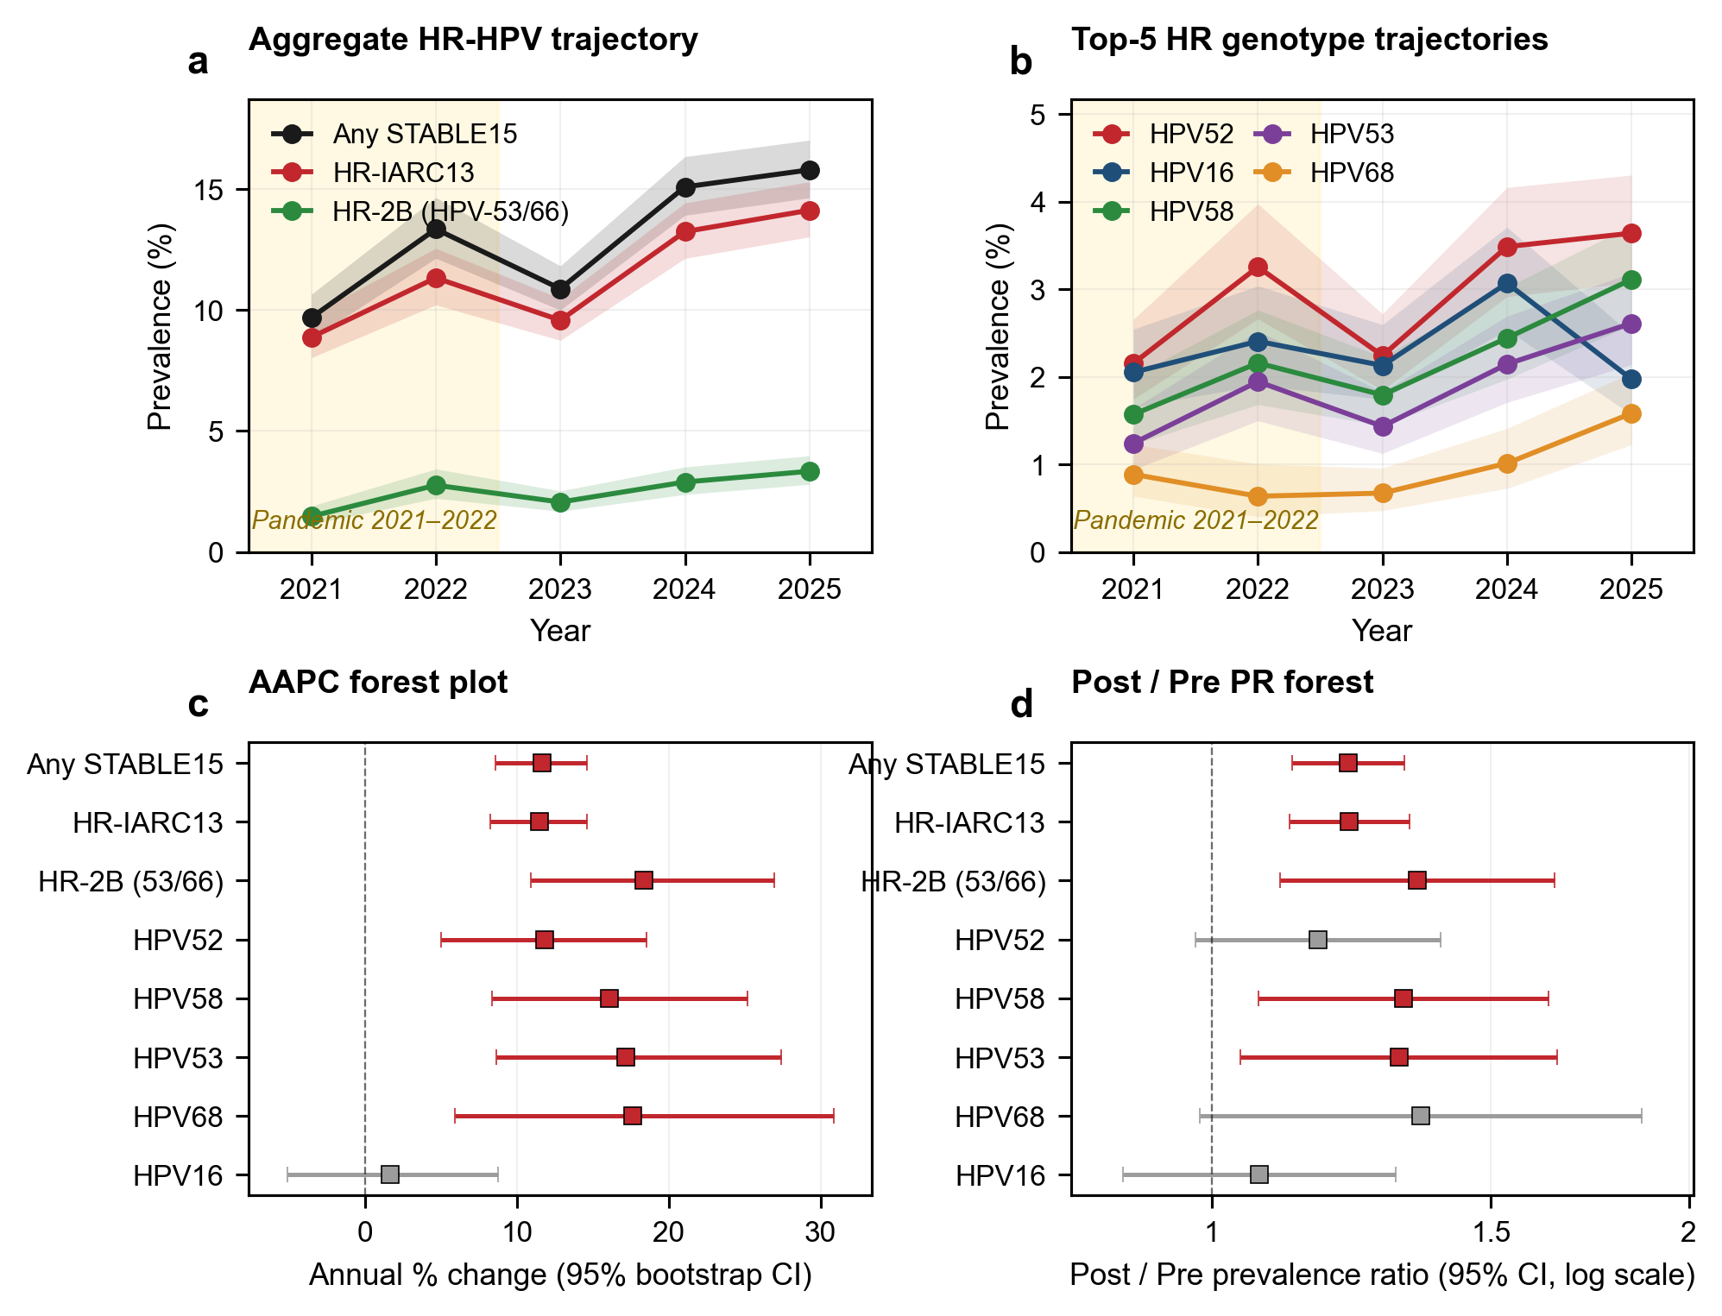
Figure 1. Temporal dynamics of cervical HPV in Xi’an, China, 2021–2025.
(a) Aggregate HR-HPV prevalence (any STABLE15 in black; HR-IARC13 [IARC Group 1+2A, 13 types] in red; HR-2B [HPV-53/66] in green) with 95% Wilson CI bands. (b) Top-5 HR-HPV genotype trajectories (HPV-52, -58, -16, -53, -68) with 95% Wilson CI bands. (c) Annual percentage change (AAPC) forest plot with 95% bootstrap CIs from 1 500 binomial resamples; red markers denote 95% CI excluding zero (significant increase). (d) Pandemic-to-post-pandemic prevalence ratio (PR; post-pandemic 2023–2025 / pandemic 2021–2022) forest plot with 95% log-PR CIs; red markers denote PR 95% CI excluding 1.0.
Table 2. Annual HPV prevalence with annual percentage change, 2021–2025.
Metric | 2021 | 2022 | 2023 | 2024 | 2025 | AAPC % (95% CI) | p | M–K τ
Any STABLE15 | 9.68 (8.80–10.64) | 13.34 (12.14–14.64) | 10.87 (9.99–11.82) | 15.08 (13.91–16.33) | 15.79 (14.63–17.01) | +11.6 (+8.6 to +14.6) | <0.001 | +0.80
HR-IARC13 | 8.87 (8.02–9.80) | 11.32 (10.21–12.54) | 9.57 (8.74–10.47) | 13.23 (12.13–14.42) | 14.12 (13.02–15.30) | +11.5 (+8.3 to +14.6) | <0.001 | +0.80
HR-2B (HPV-53/66) | 1.47 (1.14–1.90) | 2.76 (2.22–3.43) | 2.06 (1.69–2.52) | 2.89 (2.38–3.51) | 3.34 (2.80–3.97) | +18.4 (+10.9 to +27.0) | <0.001 | +0.80
HPV-52 | 2.15 (1.75–2.66) | 3.26 (2.66–3.98) | 2.24 (1.85–2.72) | 3.49 (2.92–4.16) | 3.64 (3.08–4.30) | +11.8 (+5.0 to +18.5) | <0.001 | +0.80
HPV-58 | 1.57 (1.23–2.01) | 2.16 (1.68–2.76) | 1.79 (1.44–2.23) | 2.44 (1.97–3.02) | 3.11 (2.59–3.73) | +16.1 (+8.3 to +25.2) | <0.001 | +0.80
HPV-16 | 2.05 (1.65–2.54) | 2.41 (1.90–3.04) | 2.13 (1.75–2.60) | 3.07 (2.54–3.71) | 1.97 (1.57–2.48) | +1.7 (-5.1 to +8.8) | 0.632 | 0.00
HPV-53 | 1.24 (0.94–1.64) | 1.95 (1.50–2.52) | 1.43 (1.13–1.83) | 2.15 (1.71–2.69) | 2.61 (2.14–3.19) | +17.2 (+8.6 to +27.4) | <0.001 | +0.80
HPV-68 | 0.89 (0.64–1.23) | 0.64 (0.40–1.00) | 0.67 (0.47–0.96) | 1.01 (0.73–1.41) | 1.58 (1.22–2.05) | +17.6 (+5.9 to +30.9) | 0.001 | +0.60
HPV-51 | 0.63 (0.43–0.93) | 0.46 (0.27–0.79) | 0.58 (0.40–0.85) | 1.10 (0.80–1.52) | 1.53 (1.18–1.98) | +30.2 (+16.8 to +48.1) | <0.001 | +0.60
Prevalence values are % (95% Wilson CI). AAPC from log-linear regression with 1 500-replicate binomial bootstrap. p value is two-sided percentile-based from the bootstrap distribution. M–K τ=Mann–Kendall trend statistic.

3.2. Aggregate temporal trend and pandemic-versus-post-pandemic comparison
The crude AAPC for any HR-HPV was +11.6% (95% CI +8.6 to +14.6; bootstrap p<0.001), corresponding to an approximately 63% relative increase over 5 years (Fig 1c; Table 2; full 18-metric synthesis in Supplementary Figure S3). Direct standardisation to the 2021 age structure yielded an age-standardised AAPC of +10.5% (95% CI +7.5 to +13.6; p<0.001), confirming that the trend was not an artefact of demographic ageing (Supplementary Table S5). External age-standardisation to the WHO World Standard Population yielded a concordant trend (age-standardised AAPC +11.8%, 95% CI +7.5 to +16.7; Supplementary Table S9; Supplementary Figure S6a), confirming that the post-pandemic rise is robust to the choice of standard population. Across nine pre-specified metrics, age standardisation changed the AAPC point estimate by a mean of 2.3 percentage points (maximum 4.9), and every metric with a significant crude trend remained significant after standardisation. The Mann–Kendall τ was +0.80 for any HR-HPV (p=0.086 with n=5), and the Cochran–Armitage trend test across the 5 ordered years was strongly significant (z=11.8, p<0.001).
The pandemic-versus-post-pandemic comparison reinforced the temporal signal. Any HR-HPV prevalence rose from 11.21% (95% CI 10.48–11.98) in the pandemic period (2021–2022; 759 of 6 772) to 13.66% (13.04–14.30) in the post-pandemic period (2023–2025; 1 559 of 11 413), yielding a PR of 1.22 (95% CI 1.12–1.32; p<0.001; Table 3, Fig 1d). All three aggregate metrics moved in the same direction with non-overlapping confidence intervals: HR-IARC13 PR 1.22 (1.12–1.33) and HR-2B PR 1.35 (1.10–1.65) (Table 3).
Table 3. Pandemic (2021–2022) versus post-pandemic (2023–2025) HPV prevalence.
Metric | Pandemic n/N | Pandemic % (95% CI) | Post-pandemic n/N | Post-pandemic % (95% CI) | PR (95% CI) | p (log-PR)
Any STABLE15 | 759/6 772 | 11.21 (10.48–11.98) | 1 559/11 413 | 13.66 (13.04–14.30) | 1.22 (1.12–1.32) | <0.001
HR-IARC13 | 670/6 772 | 9.89 (9.21–10.63) | 1 379/11 413 | 12.08 (11.50–12.69) | 1.22 (1.12–1.33) | <0.001
HR-2B (HPV-53/66) | 136/6 772 | 2.01 (1.70–2.37) | 309/11 413 | 2.71 (2.43–3.02) | 1.35 (1.10–1.65) | 0.003
HPV-52 | 177/6 772 | 2.61 (2.26–3.02) | 348/11 413 | 3.05 (2.75–3.38) | 1.17 (0.98–1.39) | 0.091
HPV-58 | 123/6 772 | 1.82 (1.52–2.16) | 274/11 413 | 2.40 (2.14–2.70) | 1.32 (1.07–1.63) | 0.009
HPV-16 | 149/6 772 | 2.20 (1.88–2.58) | 269/11 413 | 2.36 (2.09–2.65) | 1.07 (0.88–1.31) | 0.496
HPV-53 | 104/6 772 | 1.54 (1.27–1.86) | 230/11 413 | 2.02 (1.77–2.29) | 1.31 (1.04–1.65) | 0.020
HPV-68 | 53/6 772 | 0.78 (0.60–1.02) | 121/11 413 | 1.06 (0.89–1.27) | 1.35 (0.98–1.87) | 0.064
HPV-51 | 38/6 772 | 0.56 (0.41–0.77) | 118/11 413 | 1.03 (0.86–1.24) | 1.84 (1.28–2.65) | 0.001
Values are % (95% Wilson CI). PR=prevalence ratio (post-pandemic/pandemic). 95% CI for PR by the log-PR Wald method. p value from the log-PR Wald z-test.

3.3. Emergence of HPV-51 and the rising non-9-valent HR-HPV share
Genotype-resolved analysis revealed marked heterogeneity (Fig 1b, c; Fig 2; Supplementary Figure S3). HPV-51 was the fastest-growing HR genotype, with AAPC +30.2% (95% CI +16.8 to +48.1; p<0.001) and a pandemic-to-post-pandemic PR of 1.84 (95% CI 1.28–2.65; p=0.001); its prevalence rose from 0.63% (95% CI 0.43–0.93) in 2021 to 1.53% (1.18–1.98) in 2025 – a 2.4-fold increase over 5 years. HPV-51 is not covered by the currently licensed 9-valent HPV vaccine (Gardasil 9), which targets HPV-6/11/16/18/31/33/45/52/58. Three additional HR genotypes also showed AAPC values exceeding +15% with 95% CIs excluding zero: HPV-68 (+17.6%; +5.9 to +30.9), HPV-53 (+17.2%; +8.6 to +27.4), and HPV-58 (+16.1%; +8.3 to +25.2); of these, only HPV-58 is 9-valent-covered. Among the 15 STABLE15 genotypes, 12 showed AAPC point estimates above zero and three (HPV-16, HPV-35, HPV-45) had 95% CIs that crossed zero (Fig 2; Supplementary Figure S3).
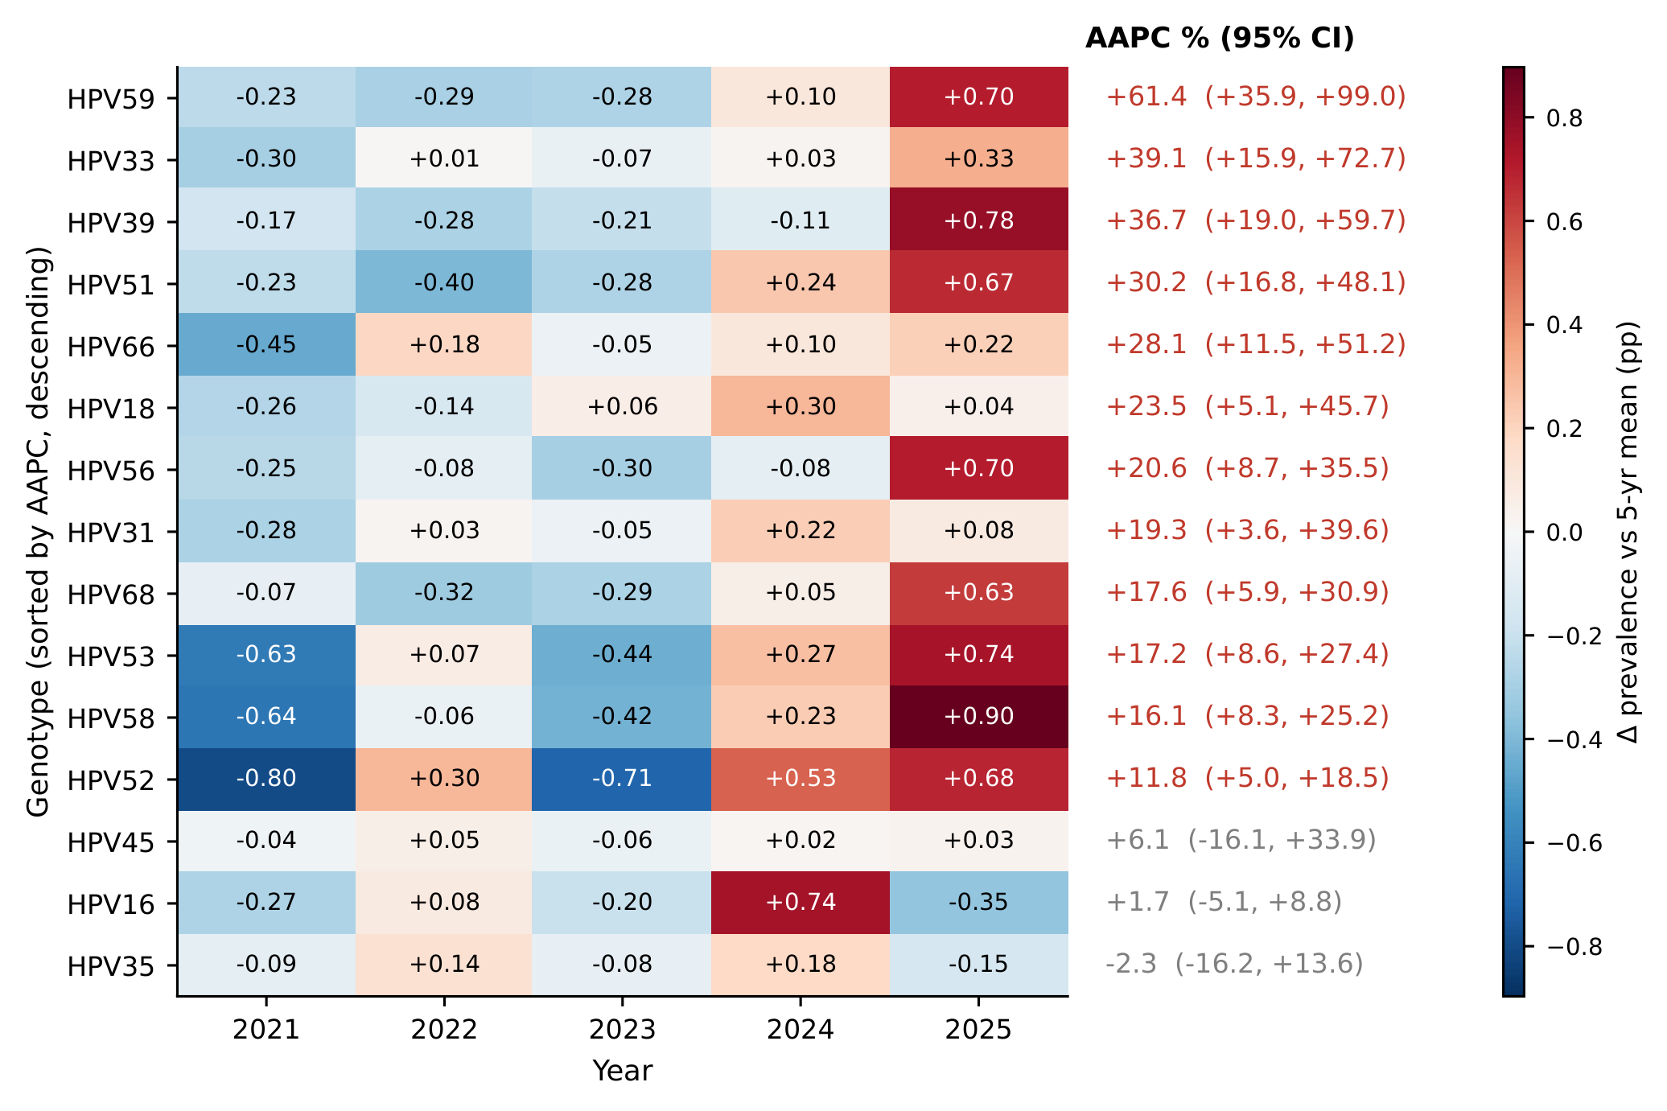
Figure 2. Genotype landscape: deviation from 5-year mean.
Rows are the 15 STABLE15 genotypes sorted top-to-bottom by AAPC (most increasing at top, most decreasing at bottom). Cell value = deviation from the genotype-specific 5-year mean (percentage points). Diverging RdBu_r colourmap centred at zero. Right column annotates each genotype’s AAPC % (95% bootstrap CI), colour-coded by significance.
At the cohort level, the burden of HR-HPV genotypes not covered by the 9-valent HPV vaccine (HPV-35/39/51/53/56/59/66/68) rose from 4.28% in 2021 to 8.75% in 2025, more than doubling, while the share of HR-HPV-positive women carrying at least one non-9-valent HR type rose from 44.2% in 2021 to 55.5% in 2025 (Table 2). In the post-pandemic period (2023–2025), 744 (47.7%) of 1 559 HR-HPV-positive women carried at least one non-9-valent HR genotype, and 548 (35.2%) carried only non-9-valent HR genotypes – a group that current vaccination would not have prevented.

3.4. Stagnation and decoupling of HPV-16
In sharp contrast to the other 14 stable genotypes, HPV-16 showed no detectable temporal change. The AAPC for HPV-16 was +1.7% (95% CI −5.1 to +8.8; p=0.632), and the Mann–Kendall τ was 0.00 (p=1.00; Fig 1b, c; Fig 2; Supplementary Figure S2d). The 2025 HPV-16 prevalence (1.97%; 95% CI 1.57–2.48) was virtually identical to the 2021 value (2.05%; 1.65–2.54). The pandemic-to-post-pandemic PR for HPV-16 was 1.07 (95% CI 0.88–1.31; p=0.496), the only HR genotype whose PR 95% CI firmly straddled the null. Across the genotype landscape sorted by AAPC (Fig 2), HPV-16 occupied a singular position: its row lay in the centre of the diverging RdBu colourmap with year-to-year deviations of ≤0.5 percentage points, whereas all other HR types showed monotonically increasing or otherwise directional patterns. A harmonic seasonal negative-binomial model with a testing-volume offset independently reproduced this divergence — HPV-51 +29.1% per year (95% CI +3.1 to +61.7; p=0.026) versus HPV-16 +1.4% per year (95% CI −5.4 to +8.6; p=0.70; Supplementary Table S10; Supplementary Figure S6b).

3.5. Monthly trajectory and interrupted time-series analysis
Monthly interrupted time-series analysis (60 timepoints; Supplementary Figure S4) localised the resurgence to the post-reopening period. For any STABLE15, the post-intervention slope was significantly positive (+0.014 logit/month, 95% CI +0.005 to +0.022) against a statistically null pre-intervention slope and a non-significant level change at the December 2022 reopening, indicating gradual catch-up rather than an abrupt structural shift. HPV-51 showed the most pronounced post-reopening acceleration of any genotype (slope change +0.063 logit/month, 95% CI +0.033 to +0.092; p<0.001). Full interrupted time-series estimates for both metrics are reported in Supplementary Figure S4.

3.6. Twelve-month SARIMA forecast for 2026
Seasonal ARIMA models forecast that, absent policy or behavioural change, any-STABLE15 prevalence will remain near the 2025 plateau through 2026 (12-month mean 15.85%; December 2026 16.62%, 95% prediction interval 9.41–27.65), whereas HPV-51 is projected to continue rising (December 2026 2.63%, 95% PI 0.95–7.04) rather than revert to its 2021 baseline of 0.63% (Supplementary Figure S5).

3.7. Age structure and the bimodal curve
Age-stratified HR-HPV prevalence (11 bins from 21–25 to >70 years) followed a pronounced bimodal pattern (Cochran–Armitage trend z=6.49; p<0.001; Fig 3a; Supplementary Table S7). The first peak occurred at 21–25 years (25.8%, 95% CI 22.3–29.7; n=534), declining to a nadir at 36–40 years (≈10%), before rising to a second peak at 66–70 years (27.7%, 95% CI 21.3–35.1; n=159) and declining again among women >70 years (20.6%, n=107). The bimodal pattern was present in both the pandemic and post-pandemic periods, but the post-pandemic curve was shifted upward at every age stratum (Fig 3b), indicating a population-level rise rather than an age-cohort-specific effect. The genotype-by-age heatmap (Fig 3c) showed that HPV-52 and HPV-58 dominated the elderly peak, whereas HPV-52 and HPV-16 contributed comparably to the early-adult peak.
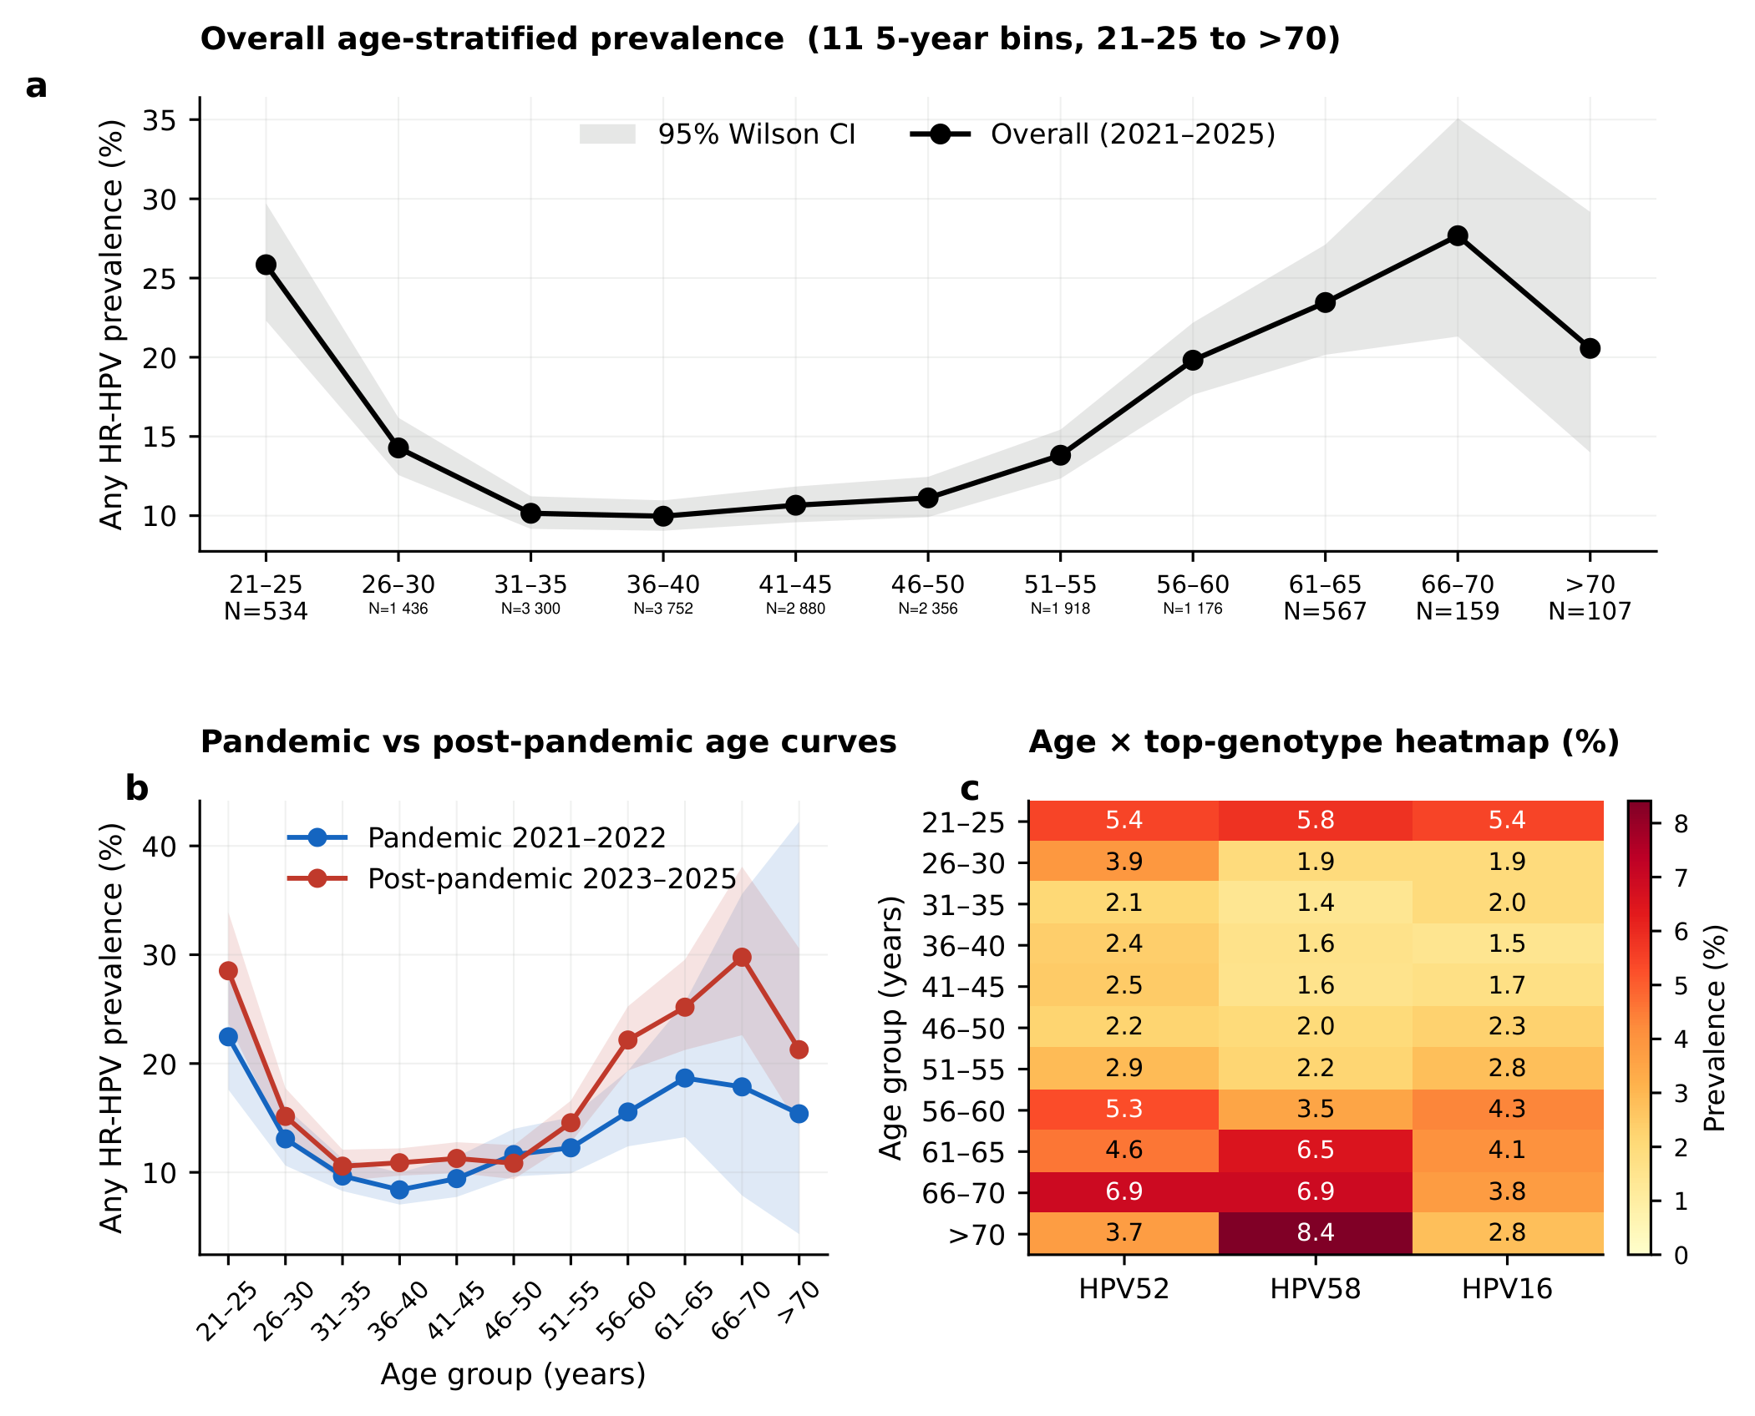
Figure 3. Age structure of HR-HPV prevalence.
(a) Overall age-stratified STABLE15 prevalence (11 5-year bins from 21–25 to >70) with 95% Wilson CI bands; per-stratum sample sizes annotated below the x-axis. (b) Pandemic (2021–2022; blue) versus post-pandemic (2023–2025; red) age curves with 95% CI bands. (c) Age × top-genotype heatmap (HPV-52, HPV-58, HPV-16; %).

4. Discussion
In this 5-year retrospective single-centre cohort of 18 185 women in Xi’an spanning the complete COVID-19 transition, three findings stand out. HR-HPV prevalence rose sharply after the pandemic—crude AAPC +11.6% (95% CI +8.6 to +14.6; p<0.001), age-standardised AAPC +10.5% (+7.5 to +13.6; p<0.001)—and this resurgence is not an artefact of demographic ageing. HPV-51 was the fastest-growing genotype (AAPC +30.2%), it is not covered by the 9-valent HPV vaccine, and by the post-pandemic period 47.7% of HR-HPV-positive women carried at least one non-9-valent type. Among the 15 stable genotypes, HPV-16 alone showed no detectable change.
HR-HPV is the prototype DNA tumour virus and the necessary cause of essentially all cervical cancer.^{2,3} The IARC Group 1 types, however, differ sharply in attributable fraction: HPV-16 alone causes the largest single share (about 50–60%), HPV-18 a further 10–13%, and HPV-51 only about 1%.^{3,30} The pattern we observe—HPV-51 rising fast while HPV-16 stays flat—therefore shifts HR-HPV community structure in a way whose cancer-risk implications are not proportional to prevalence, because the genotypes gaining ground carry less per-infection oncogenic weight than the dominant driver. This mirrors the well-characterised differences in E6 and E7 immortalising and transforming activity across high-risk genotypes, which is greatest for HPV-16.³¹ Reading such signals calls for genotype-resolved, biology-informed surveillance that links circulating oncogenic-HPV ecology to cervical carcinogenesis and broader-spectrum vaccine design.

4.1. Consistency with a prior cross-sectional study from the same urban cohort
A subset of these records (2023–2025; n=11 413, 62.8% of the present cohort) was reported in our cross-sectional urban–rural study (Wu et al, BMC Infect Dis 2026; 26: 13647¹⁸). That study addressed a different question (urban–rural disparity in a single 3-year window) with a different statistical core (age-standardised prevalence ratios, broader 25-type panel) and a different eligibility window (15–100 vs ≥21 years here); no result, figure, or table is reproduced, and the 6 772 women added from 2021–2022 are unique to this time-series analysis (Supplementary Table S8).

4.2. Comparison with regional Chinese cohorts
Our crude AAPC of +11.6% exceeds the Chengdu cohort’s rise from 18.7% to 25.3% (2020–2024),¹³ likely because we include 2025—which earlier Chinese series lack—and capture post-reopening catch-up screening. It contrasts with the western China cohort’s 2017–2024 decline (31.6% to 21.5%)¹¹ and the national meta-analysis (a slight 2017–2023 decline),⁵ both of which predate the post-2022 surge seen here. The Xiamen cohort’s³² U-shaped recovery after 2022 fits the December-2022 inflection in our ITS analysis (Supplementary Figure S4). Heterogeneity across Chinese cohorts thus reflects both observation-window differences and genuine regional variation (a structured comparison across these cohorts is given in Supplementary Table S6).
To our knowledge, no Chinese surveillance cohort has previously quantified the decoupling of HPV-16 from other HR genotypes using genotype-resolved bootstrap CIs. The Xiamen cohort³² described a declining HPV-16 trend in southern China qualitatively but gave no AAPC with formal CIs, and the Beijing,¹² Chongqing,³³ and Hangzhou³⁴ analyses folded HPV-16 into an aggregate. Whether HPV-16 stagnation reflects immunological saturation, cross-protection from earlier bivalent/quadrivalent programmes (Gardasil 9 reached mainland China in 2018¹⁶), or stochastic noise in our 5-year window cannot be settled with the present data.

4.3. Vaccine policy implications
The 9-valent vaccine (Gardasil 9; HPV-6/11/16/18/31/33/45/52/58) covers our two highest-incidence HR types (HPV-52, HPV-16) but not HPV-35, -39, -51, -53, -56, -59, -66, or -68. Of the four genotypes with AAPC >+15% (HPV-51 +30.2%, HPV-68 +17.6%, HPV-53 +17.2%, HPV-58 +16.1%), only HPV-58 is covered; the three uncovered, rapidly rising types—HPV-51, -53, and -68, each with a 95% CI excluding zero—are priority candidates for next-generation broader-spectrum formulations. Bivalent-vaccine cross-protection against HPV-31/45 is established,³⁵ and population vaccination has cut HR-HPV infection and cervical disease at scale,^{36,37} yet no current vaccine directly targets HPV-51, the fastest-growing genotype here. If the HPV-16 plateau holds up in multicentre data, HPV-16-centric triage that prioritises immediate colposcopy may also deserve re-examination, since the rising burden increasingly comes from other oncogenic HR types and many CIN-2 lesions regress on their own.³⁸

4.4. Bimodal age structure and the elderly peak
The bimodal age distribution in our cohort—peaks at 21–25 years (25.8%) and 66–70 years (27.7%)—parallels the global meta-analysis of women aged ≥50 years¹⁵ and the bimodal pattern reported in recent Chinese cohorts,^{5,13,34} in which the elderly peak falls at ≥61 versus 66–70 in our cohort. HPV-52 and HPV-58 dominated the elderly peak, while HPV-16 and HPV-52 contributed comparably to the early-adult peak (Fig 3c). The elderly peak could arise from reactivation of latent infection after immunosenescence-related impaired clearance or from new acquisition as partnerships change in middle and older age; cross-sectional data cannot separate the two. Either way, current age-cap screening recommendations appear to under-protect women aged ≥60 years in this population.

4.5. Strengths and limitations
The principal strengths of this study are: (i) the longest single-centre time window (5 years) published to date from China, fully bracketing the COVID-19 pandemic transition; (ii) genotype-resolved AAPC with binomial-bootstrap 95% CIs rather than parametric standard errors, which is the appropriate inferential approach for short time series with between-year denominator differences; (iii) pre-specified direct age standardisation that formally excludes demographic ageing as the primary driver of the trend; (iv) explicit demotion of joinpoint regression to exploratory status given the n=5 constraint, with visual annotation of underpowered segments in Supplementary Figure S2; and (v) full archival of the analysis pipeline and de-identified intermediate data at Zenodo, permitting independent reproduction of every numerical result.
Limitations include: (i) the single-centre design, which limits generalisability beyond Xi’an and the immediate catchment population; (ii) hospital-based sampling, which may over-represent symptomatic women and women in age groups likelier to attend gynaecological clinics; (iii) absence of paired cytology, histology, vaccination history, or sexual-behaviour data, which precludes individual-level mechanistic inference and constrains policy claims to ecological rather than causal levels; (iv) the relatively small sample size of the >70-year stratum (n=107), reflected in a wide 95% CI for that age band; (v) yearly panel composition was not perfectly uniform, although our STABLE15 definition specifically restricts inference to the 15 HR-HPV genotypes with 100% yearly assay coverage; and (vi) the binomial bootstrap assumes between-year independence, which may be partially violated by the underlying calendar-time trend, although sensitivity analyses using Mann–Kendall and Cochran–Armitage tests yielded directionally identical conclusions.

5. Conclusions
In this 5-year single-centre cohort of 18 185 women in Xi’an spanning the COVID-19 transition, high-risk HPV prevalence rose substantially after the pandemic (crude AAPC +11.6%, age-standardised +10.5%; both p<0.001), driven by HPV-52, HPV-58, and an emergent HPV-51 (+30.2%), while the non-9-valent share more than doubled to 8.75% and HPV-16 alone showed no detectable change. These findings support genotype-resolved post-pandemic surveillance, broader-spectrum vaccine evaluation, and re-examination of HPV-16-centric triage in Chinese populations; multicentre confirmation is now warranted.

Declarations

CRediT authorship contribution statement
JW conceived and designed the study, secured funding, performed all statistical analyses, drafted the manuscript, and is the guarantor of the work; she assumes overall responsibility for the integrity of the analysis and for the decision to submit. LF curated the cervical-HPV genotyping database, supervised laboratory operations and quality assurance at Norinco General Hospital, contributed to data interpretation, and critically revised the manuscript. JW and LF directly accessed and verified the underlying data. HY contributed to the literature review and synthesis of prior evidence. JZ assisted in preparing the ethics-review materials. JY supported dataset cleaning and quality control of the cohort records. WW contributed methodological review of the statistical and trend-analysis approaches. KK contributed Korean comparative perspective to the discussion. WY contributed nursing-perspective interpretation of the clinical findings. All authors critically revised the manuscript for important intellectual content, approved the final version, had full access to the de-identified study data, met the ICMJE criteria for authorship, agree to be accountable for all aspects of the work, and approved the decision to submit for publication.

Conflict of Interest Statement
All authors declare no competing interests.

Data availability statement
The full analysis pipeline (Jupyter notebook), de-identified intermediate data tables, and all output figures and tables are publicly archived at Zenodo (concept DOI 10.5281/zenodo.20256624, permanently resolving to the latest version). The archive contains everything needed to regenerate every numerical result, figure, and table in this manuscript from the de-identified intermediate CSVs. Individual participant-level genotyping records cannot be made publicly available because they are derived from clinical specimens collected under a waiver of informed consent; de-identified individual-level data are available from the corresponding author on reasonable request, conditional on completion of a data-sharing agreement and approval from the Medical Ethics Review Committee of Norinco General Hospital.

Generative AI and AI-assisted technologies in the writing process
Generative artificial intelligence (Claude, Anthropic, USA) was used solely for language editing of author-drafted prose, in accordance with COPE and ICMJE guidance. No AI tool contributed to study design, data acquisition, analysis, interpretation, or the generation of scientific content. The authors reviewed and verified all material and take full responsibility for the manuscript.

Ethics approval
The study protocol was approved by the Medical Ethics Review Committee of Norinco General Hospital under project 26z03 (Approval No. 202601271338000343089, issued 27 January 2026); the Committee confirmed that the approved retrospective, de-identified analysis covers the record stream from 5 January 2021 to 31 December 2025. The Committee waived the requirement for individual written informed consent under all three conditions of 45 CFR 46.116(f) and Article 32 of the Chinese Measures for Ethical Review of Life-Science and Medical Research Involving Humans: (i) the research presents no more than minimal risk because it analyses pre-existing routine clinical records with no new contact, sample collection, questionnaire, follow-up, or intervention; (ii) the waiver does not adversely affect participants’ rights or welfare and the study could not practicably be carried out without it, as the 5-year cohort comprises 18 185 women most of whom can no longer be contacted; and (iii) all records were de-identified before analysis (direct identifiers replaced by unique study codes; the analytic file encrypted at rest with AES-256; access restricted to named investigators with full audit logging; and only aggregate results – yearly, age-stratified, and genotype-specific prevalences – reported). The IRB-approved analytic envelope covered 18 243 records meeting the original eligibility criteria (female sex, non-missing age). The present analysis applied two further restrictions that are uniformly more conservative than the approved protocol – exclusion of 1 record with an implausible age of 0 years (data-quality measure) and 57 records of women aged <21 years (below the cervical-cancer-screening lower bound recommended by the Chinese national programme and the US Preventive Services Task Force). Tightening (but not loosening) of eligibility criteria does not require an IRB amendment under 45 CFR 46.110 or the Chinese Measures (Article 28); the final 18 185-woman analytic cohort therefore falls strictly within the 18 243-record approval envelope.

Funding
This work was supported by the Xi’an Medical College Scientific Research Project (Grant No. 26z03). Kyungwoon University and Norinco General Hospital provided in-kind support in the form of computing resources and laboratory infrastructure. The funders had no role in study design, data collection, analysis, interpretation, writing of the report, or the decision to submit for publication.

Acknowledgments
We thank the laboratory staff of Norinco General Hospital for their meticulous specimen handling and quality assurance, and the women whose clinical records contributed to this analysis. We thank the Norinco General Hospital biostatistics and information-systems teams for technical advice on cohort extraction and quality control.

References
1 Walboomers JM, Jacobs MV, Manos MM, et al. Human papillomavirus is a necessary cause of invasive cervical cancer worldwide. J Pathol 1999; 189: 12–19. doi:10.1002/(SICI)1096-9896(199909)189:1<12::AID-PATH431>3.0.CO;2-F.
2 Bouvard V, Baan R, Straif K, et al; WHO IARC Monograph Working Group. A review of human carcinogens—Part B: biological agents. Lancet Oncol 2009; 10: 321–22. doi:10.1016/S1470-2045(09)70096-8.
3 IARC Working Group on the Evaluation of Carcinogenic Risks to Humans. Biological agents. IARC Monogr Eval Carcinog Risks Hum 2012; 100B: 1–441.
4 Zhang J, Ke Y, Chen C, et al. HPV cancer burden by anatomical site, country, and region in 2022. Sci Rep 2025; 15: 21048. doi:10.1038/s41598-025-06700-8.
5 Han S, Lin M, Liu M, et al. Prevalence, trends, and geographic distribution of human papillomavirus infection in Chinese women: a summative analysis of 2,728,321 cases. BMC Med 2025; 23: 158. doi:10.1186/s12916-025-03975-6.
6 Liu P, Zhu Y, Zhou H, Li R. Trends and urban–rural disparities in cervical cancer epidemiology in China, 2005–2018. Sci Rep 2025; 15: 25021. doi:10.1038/s41598-025-09004-z.
7 Sung H, Ferlay J, Siegel RL, et al. Global cancer statistics 2020: GLOBOCAN estimates of incidence and mortality worldwide for 36 cancers in 185 countries. CA Cancer J Clin 2021; 71: 209–49. doi:10.3322/caac.21660.
8 World Health Organization. Global strategy to accelerate the elimination of cervical cancer as a public health problem. Geneva: WHO; 2020. https://www.who.int/publications/i/item/9789240014107 (accessed 1 May 2026).
9 Chidebe RCW, Osayi A, Torode JS. The Global Fund, cervical cancer, and HPV infections: what can low- and middle-income countries do to accelerate progress by 2030? eClinicalMedicine 2025; 81: 103127. doi:10.1016/j.eclinm.2025.103127.
10 Ronco G, Dillner J, Elfström KM, et al. Efficacy of HPV-based screening for prevention of invasive cervical cancer: follow-up of four European randomised controlled trials. Lancet 2014; 383: 524–32. doi:10.1016/S0140-6736(13)62218-7.
11 Liu Y, Xiang Y, Liu Y, et al. COVID-19 pandemic disruptions drive decreases in HPV prevalence and shift genotype distribution in Western China. BMC Infect Dis 2025; 25: 1254. doi:10.1186/s12879-025-11706-8.
12 Xu MY, Feng MJ, Geng WY, Liu XK, Ma R. Prevalence and type distribution of human papillomavirus in a Chinese urban population between 2019 and 2023: a retrospective study. Front Microbiol 2026; 16: 1735393. doi:10.3389/fmicb.2025.1735393.
13 Wang W, Zhang J, Mei C, et al. Prevalence and genotype distribution of human papillomavirus infection among women in Chengdu, China between 2020 and 2024. Front Public Health 2026; 13: 1740177. doi:10.3389/fpubh.2025.1740177.
14 Zhu B, Liu Y, Zuo T, et al. The prevalence, trends, and geographical distribution of human papillomavirus infection in China: the pooled analysis of 1.7 million women. Cancer Med 2019; 8: 5373–85. doi:10.1002/cam4.2017.
15 Osmani V, Hörner L, Nkurunziza T, Rank S, Tanaka LF, Klug SJ. Global prevalence of cervical human papillomavirus in women aged 50 years and older with normal cytology: a systematic review and meta-analysis. Lancet Microbe 2025; 6: 100955. doi:10.1016/j.lanmic.2024.100955.
16 General Office of the National Health Commission of the People’s Republic of China. Work plan for cervical cancer screening (Guoweiban Fuyou Han [2021] No. 635). Beijing: National Health Commission of the PRC, 2022.
17 US Preventive Services Task Force; Curry SJ, Krist AH, Owens DK, et al. Screening for cervical cancer: US Preventive Services Task Force recommendation statement. JAMA 2018; 320: 674–86. doi:10.1001/jama.2018.10897.
18 Wu J, Yi J, Fang L, et al. Urban–rural disparities in HPV prevalence and genotype distribution: a large-scale cervical cancer screening study in Xi’an, China. BMC Infect Dis 2026; 26: 13647. doi:10.1186/s12879-026-13647-2.
19 Benchimol EI, Smeeth L, Guttmann A, et al; RECORD Working Committee. The REporting of studies Conducted using Observational Routinely-collected health Data (RECORD) Statement. PLoS Med 2015; 12: e1001885. doi:10.1371/journal.pmed.1001885.
20 de Martel C, Georges D, Bray F, Ferlay J, Clifford GM. Global burden of cancer attributable to infections in 2018: a worldwide incidence analysis. Lancet Glob Health 2020; 8: e180–90. doi:10.1016/S2214-109X(19)30488-7.
21 Wilson EB. Probable inference, the law of succession, and statistical inference. J Am Stat Assoc 1927; 22: 209–12.
22 Clegg LX, Hankey BF, Tiwari R, Feuer EJ, Edwards BK. Estimating average annual per cent change in trend analysis. Stat Med 2009; 28: 3670–82. doi:10.1002/sim.3733.
23 Efron B, Tibshirani RJ. An introduction to the bootstrap. New York: Chapman and Hall, 1993.
24 Mann HB. Nonparametric tests against trend. Econometrica 1945; 13: 245–59.
25 Lopez Bernal J, Cummins S, Gasparrini A. Interrupted time series regression for the evaluation of public health interventions: a tutorial. Int J Epidemiol 2017; 46: 348–55. doi:10.1093/ije/dyw098.
26 Ahmad OB, Boschi-Pinto C, Lopez AD, Murray CJL, Lozano R, Inoue M. Age standardization of rates: a new WHO standard (GPE Discussion Paper No. 31). Geneva: World Health Organization, 2001.
27 Stevens GA, Alkema L, Black RE, et al; GATHER Working Group. Guidelines for Accurate and Transparent Health Estimates Reporting: the GATHER statement. Lancet 2016; 388: e19–23. doi:10.1016/S0140-6736(16)30388-9.
28 Kim HJ, Fay MP, Feuer EJ, Midthune DN. Permutation tests for joinpoint regression with applications to cancer rates. Stat Med 2000; 19: 335–51. doi:10.1002/(SICI)1097-0258(20000215)19:3<335::AID-SIM336>3.0.CO;2-Z.
29 Stolwijk AM, Straatman H, Zielhuis GA. Studying seasonality by using sine and cosine functions in regression analysis. J Epidemiol Community Health 1999; 53: 235–38. doi:10.1136/jech.53.4.235.
30 de Sanjosé S, Quint WGV, Alemany L, et al. Human papillomavirus genotype attribution in invasive cervical cancer: a retrospective cross-sectional worldwide study. Lancet Oncol 2010; 11: 1048–56. doi:10.1016/S1470-2045(10)70230-8.
31 Moody CA, Laimins LA. Human papillomavirus oncoproteins: pathways to transformation. Nat Rev Cancer 2010; 10: 550–60. doi:10.1038/nrc2886.
32 Chen Z, Lin E, Chen M, et al. Temporal trends in cervical human papillomavirus prevalence among females in Xiamen, China (2016–2023): cross-sectional study. JMIR Public Health Surveill 2025; 11: e70507. doi:10.2196/70507.
33 Li S, He X, Li S, Su Y, Wang X, Li C. The prevalence of HPV in Chongqing, China from 2017 to 2022: a retrospective cohort study. Sci Rep 2024; 14: 23973. doi:10.1038/s41598-024-74588-x.
34 Ke Q, Zhao K, Jin Y, et al. Multicenter study on the distribution and prevalence of human papillomavirus types in Hangzhou, Zhejiang from 2017 to 2023. Sci Rep 2025; 15: 9374. doi:10.1038/s41598-025-92102-9.
35 Wheeler CM, Castellsagué X, Garland SM, et al; HPV PATRICIA Study Group. Cross-protective efficacy of HPV-16/18 AS04-adjuvanted vaccine against cervical infection and precancer caused by non-vaccine oncogenic HPV types: 4-year end-of-study analysis of the randomised, double-blind PATRICIA trial. Lancet Oncol 2012; 13: 100–10. doi:10.1016/S1470-2045(11)70287-X.
36 Drolet M, Bénard É, Pérez N, et al. Population-level impact and herd effects following the introduction of human papillomavirus vaccination programmes: updated systematic review and meta-analysis. Lancet 2019; 394: 497–509. doi:10.1016/S0140-6736(19)30298-3.
37 Falcaro M, Castañon A, Ndlela B, et al. The effects of the national HPV vaccination programme in England, UK, on cervical cancer and grade 3 cervical intraepithelial neoplasia incidence: a register-based observational study. Lancet 2021; 398: 2084–92. doi:10.1016/S0140-6736(21)02178-4.
38 Castle PE, Schiffman M, Wheeler CM, Solomon D. Evidence for frequent regression of cervical intraepithelial neoplasia-grade 2. Obstet Gynecol 2009; 113: 18–25. doi:10.1097/AOG.0b013e31818f5008.

