Supplementary Appendix
Shifting oncogenic HPV ecology after COVID-19: emergence of HPV-51 and decoupling of HPV-16 in a cervical-cancer screening cohort in Xi’an, China (2021–2025)
This appendix accompanies the main manuscript and provides three Supplementary Methods Notes (data-quality handling, bootstrap implementation, and HR-HPV multiplicity) and provides the panel composition (Table S0), yearly long-format prevalences (Table S1), sensitivity analyses (Tables S2–S5), and a benchmarking comparison against nine recent Chinese HPV cohorts (Table S6). All numerical tabulations are also available in the publicly archived results.xlsx (Zenodo concept DOI 10.5281/zenodo.20256624; resolving to the latest version), age-stratified HPV prevalence (Supplementary Table S7), and a study-relationship comparison versus the prior BMC publication (Supplementary Table S8).
Supplementary Methods Note 1. Treatment of weakly positive free-text labels.
In the raw 18 670-record export from the hospital laboratory information system (LIS), three test results (one each for HPV-52, HPV-66, and HPV-81) carried the free-text label “弱Positive” – a Chinese-language qualifier (literally “weakly positive”) returned by the LIS for borderline reactivities at or near the assay's analytical limit of detection. Per the manufacturer's assay reporting convention and standard clinical-laboratory practice, weakly positive results are treated as positive for surveillance purposes. To capture these three records consistently and reproducibly, all positivity flags throughout the analysis pipeline were derived by case-insensitive substring matching on the literal string “Positive” (Python: df[col].astype(str).str.contains('Positive', na=False)). A sensitivity analysis excluding these three records changed no AAPC point estimate by more than 0.01 percentage points and no 95% CI bound by more than 0.1 percentage points; the HPV-81 record lies outside the 15-genotype STABLE15 panel and therefore does not enter any primary analysis. This handling is also called out in the Table 1 footnote.
Supplementary Methods Note 2. Bootstrap implementation and reproducibility.
All 95% confidence intervals for the average annual percentage change (AAPC) and the pandemic-to-post-pandemic prevalence ratio (PR) were obtained from 1 500 binomial bootstrap resamples — for each year, the positive count was redrawn from a binomial distribution defined by that year's woman-level denominator and observed prevalence (one row per woman, not per record) — using NumPy's default_rng pseudo-random number generator (MT19937 Mersenne Twister algorithm) seeded at 20260520. Two-sided percentile-based p values were derived as 2 × min(P(boot ≤ 0), P(boot ≥ 0)) for AAPC (and analogously around 1.0 for PR), with the minimum coverage forced to the smaller tail. The exact value of the seed, the bootstrap count (B = 1 500), and the analytic cohort size (N = 18 185) are stored in the canonical results JSON file (canonical_aapc_table.json) at the head of the file as machine-readable provenance, and the full computation can be reproduced end-to-end using the companion Jupyter notebook and the stand-alone QC verification script (qc_verification_18185.py); both are archived at Zenodo DOI 10.5281/zenodo.20256624.
Supplementary Methods Note 3. HR-HPV multiplicity (co-infection structure).
Among the 18 185 women in the analytic cohort, 15 867 (87.25%) tested negative for all 15 STABLE15 genotypes, 1 879 (10.33%) carried exactly one HR type, 345 (1.90%) carried exactly two HR types, and 94 (0.52%) carried three or more HR types concurrently. Among the 2 318 STABLE15-positive women, single-type infections accounted for 81.1% (1 879/2 318) and multi-type co-infections for 18.9% (439/2 318). This multiplicity distribution is directly relevant to broader-spectrum (next-generation) HPV vaccine policy evaluation in two ways: (i) it bounds the fraction of currently infected women who would benefit from any additional cross-protective valency; and (ii) the higher multiplicity in the older bimodal peak (age 56–70 years) – driven principally by concurrent HPV-52, HPV-58, and HPV-16 detections – suggests that surveillance based on type-pooled summary statistics alone would systematically underestimate the cumulative HR burden in this age band. A reproduction of the multiplicity table directly from the raw export is included in the QC verification script.
Table S0. HPV genotyping panel definitions and yearly coverage.
Panel | Genotypes | n | Coverage across 5-year window | Primary use
STABLE15 (platform-comparable) | HPV-16, 18, 31, 33, 35, 39, 45, 51, 52, 53, 56, 58, 59, 66, 68 | 15 | 100% – detected by both the 25-type Sansure and the 15-type HR-HPV PCR panels | All primary analyses (Tables 1–3, Figures 1–3; Supplementary Figures S1–S5)
HR-IARC13 | HPV-16, 18, 31, 33, 35, 39, 45, 51, 52, 56, 58, 59, 68 | 13 | 100% – IARC Group 1+2A subset of STABLE15 | IARC-strict HR sensitivity analysis
HR-2B | HPV-53, 66 | 2 | 100% – IARC Group 2B subset of STABLE15 | Group-2B sensitivity analysis
9v-covered HR | HPV-16, 18, 31, 33, 45, 52, 58 | 7 | 100% – subset of STABLE15 covered by Gardasil 9 | Vaccine-coverage analyses
Non-9v HR | HPV-35, 39, 51, 53, 56, 59, 66, 68 | 8 | 100% – subset of STABLE15 NOT covered by Gardasil 9 | Vaccine-gap quantification
Sansure-only (excluded) | HPV-6, 11, 26, 42, 43, 70, 73, 81, 82, 83 | 10 | Partial – measured only for records tested with the 25-type Sansure panel; absent from records tested with the 15-type HR-HPV panel (yearly any-positive rate 1.8–3.9%, with the lower rates in 2021–2023 likely reflecting a larger proportion of 15-type-panel testing) | Excluded from all primary analyses to prevent platform-induced selection bias
STABLE15 was defined a priori as the 15 HR-HPV genotypes detected by both the 25-type Sansure PCR panel and the 15-type HR-HPV PCR panel used in mixed proportions across the 5-year analytic window at this institution. The 10 Sansure-only genotypes (HPV-6, 11, 26, 42, 43, 70, 73, 81, 82, 83) were systematically absent for the subset of records tested with the 15-type panel and were therefore excluded from all primary cohort-level analyses to prevent platform-induced selection bias. This panel-restriction strategy is identical to that used in our prior cross-sectional urban–rural study (Wu et al, BMC Infect Dis 2026; 26: 13647; doi:10.1186/s12879-026-13647-2), where it is referred to as the “platform-comparable 15-genotype framework”. The IARC classifications follow Bouvard et al (2009) [ref 3] and IARC Monograph 100B (2012) [ref 4]. Gardasil 9 (the currently licensed 9-valent HPV vaccine, Merck & Co) covers HPV-6, 11, 16, 18, 31, 33, 45, 52, and 58. Of the 15 STABLE15 genotypes, 7 are covered by Gardasil 9 (all HR types: HPV-16/18/31/33/45/52/58) and 8 are not (HPV-35/39/51/53/56/59/66/68).

Table S6. Comparison of post-pandemic HPV temporal trends across recent Chinese cohorts.
Study | Region | Years | N | Panel | Top HR genotypes | Overall HPV / HR-HPV % | Temporal direction | Bimodal age peaks | Key contrast vs current study
Present study (Wu 2026) | Xi’an (north) | 2021–2025 | 18 185 | STABLE15 | HPV-52, 58, 16, 53 | 12.8% HR-HPV | Rising (AAPC +11.6%, p<0.001) | 21–25 (25.8%) + 66–70 (27.7%) | –
Han 2025⁸ BMC Med | National (multicentre, 2 127 hospitals) | 2017–2023 | 2 728 321 | 21–28 types | HPV-52, 58, 16 | 13.1% HR-HPV | Slight decline (16.2%→14.8%, p<0.05) | <21 + >61 | Directionally opposite over a longer pre-pandemic baseline; aggregates regions with heterogeneous trends.
Chen 2025⁹ JMIR | Xiamen (south) | 2016–2023 | 63 553 | 23 types | HPV-52, 58, 53, 16, 39 | 19.3% HR-HPV | U-shaped (decline 2020–2022, partial recovery 2023) | 3-period stratified | HPV-16 qualitatively flat in southern China; the current study quantifies this with bootstrap CIs and shows the same pattern in the north.
Liu 2025¹⁰ BMC Inf Dis | Western China (Sichuan, Suining) | 2017–2024 | 129 585 | 23 types | HPV-52, 58 (persistent) | 31.6%→23.3%→21.5% HPV | Sustained decline | 40–49 unimodal | Strongest directional contrast: post-pandemic decline rather than rise; same time window but different region and earlier baseline.
Li 2024¹¹ Sci Rep | Chongqing (southwest) | 2017–2022 | 108 863 | 21 types | HPV-52, 16, 58, 53, 39 | 30.1% HPV | 5-year cross-sectional | Bimodal | Higher overall HPV burden region; HPV-16 ranked 2nd vs ranked 5th in the current cohort.
Xu 2026¹² Front Microbiol | Beijing (north) | 2019–2023 | 37 225 | 27 types | HPV-52, 16, 58, 53, 56 | 10.2% HPV; pandemic period higher | U-shaped | 31–35 nadir + 66–70 peak (joinpoint) | Northern-Chinese cohort; the current study extends through 2025 and identifies HPV-51 emergence that Beijing data (ending 2023) did not capture.
Wang 2025¹³ Front Pub H | Chengdu (southwest) | 2020–2024 | 51 556 | 26 types | HPV-52, 16, 58, 51, 39 | 22.0% HPV | Rising (18.7%→25.3%, p<0.001) | ≤20 (49.4%) + ≥61 (30.8%) | Directionally concordant with the current study; the current study adds AAPC with bootstrap CIs and explicit age standardisation.
Ke 2025¹⁴ Sci Rep | Hangzhou (east) | 2017–2023 | 299 089 (283 556 female + 15 533 male) | 21 types | Female: 52, 58, 16; Male: 52, 16, 51 | 22.9% female; 41.1% male | ~3% pandemic decline | <20 + 61–65 | HPV-51 ranked 3rd in males – supports a sexually transmitted partner-source hypothesis for the HPV-51 emergence observed in the present female cohort.
Liu 2025¹⁵ Sci Rep | National (cancer-registry burden) | 2005–2018 | Registry data | – | – | Cervical cancer ASR 9.1→18.1 per 100 000 | AAPC +5.4% | 50–54 peak | Cervical cancer incidence is still rising in China, consistent with the present finding of continuing HPV transmission pressure.
Zhang 2025¹⁶ Sci Rep | Global (GBD/GLOBOCAN) | 1990–2021 | GBD | – | – | Global cervical cancer ASR AAPC −0.33% | Global decline | Older-shifting | Global cervical cancer is in decline overall; the rise in HR-HPV infection in this northern Chinese cohort is therefore a region-specific signal.
AAPC=average annual percentage change. ASR=age-standardised rate. PR=prevalence ratio. The “Temporal direction” column reflects each study’s primary reported trend metric over its observation window; differences in baseline year, sampling population (routine screening vs gynaecological outpatient vs symptom-driven), and analytic method should be considered when interpreting cross-study comparisons. Citation numbers correspond to the reference list in the main manuscript.

Tables S1–S5
Tables S1–S5 below report the full numerical results referenced in the main manuscript. Machine-readable copies (CSV and JSON) are additionally archived at Zenodo (DOI 10.5281/zenodo.20256624) for downstream analysis.
Table S1. Yearly long-format prevalence with 95% Wilson CI (STABLE15 + aggregates + HR-2B subset, 90 rows).
Metric | Year | n | N | Prevalence % | 95% Wilson CI
Any STABLE15 | 2021 | 382 | 3 946 | 9.68 | 8.80–10.64
Any STABLE15 | 2022 | 377 | 2 826 | 13.34 | 12.14–14.64
Any STABLE15 | 2023 | 485 | 4 460 | 10.87 | 9.99–11.82
Any STABLE15 | 2024 | 506 | 3 355 | 15.08 | 13.91–16.33
Any STABLE15 | 2025 | 568 | 3 598 | 15.79 | 14.63–17.01
HR-IARC13 | 2021 | 350 | 3 946 | 8.87 | 8.02–9.80
HR-IARC13 | 2022 | 320 | 2 826 | 11.32 | 10.21–12.54
HR-IARC13 | 2023 | 427 | 4 460 | 9.57 | 8.74–10.47
HR-IARC13 | 2024 | 444 | 3 355 | 13.23 | 12.13–14.42
HR-IARC13 | 2025 | 508 | 3 598 | 14.12 | 13.02–15.30
HR-2B (53/66) | 2021 | 58 | 3 946 | 1.47 | 1.14–1.90
HR-2B (53/66) | 2022 | 78 | 2 826 | 2.76 | 2.22–3.43
HR-2B (53/66) | 2023 | 92 | 4 460 | 2.06 | 1.69–2.52
HR-2B (53/66) | 2024 | 97 | 3 355 | 2.89 | 2.38–3.51
HR-2B (53/66) | 2025 | 120 | 3 598 | 3.34 | 2.80–3.97
HPV16 | 2021 | 81 | 3 946 | 2.05 | 1.65–2.54
HPV16 | 2022 | 68 | 2 826 | 2.41 | 1.90–3.04
HPV16 | 2023 | 95 | 4 460 | 2.13 | 1.75–2.60
HPV16 | 2024 | 103 | 3 355 | 3.07 | 2.54–3.71
HPV16 | 2025 | 71 | 3 598 | 1.97 | 1.57–2.48
HPV18 | 2021 | 12 | 3 946 | 0.30 | 0.17–0.53
HPV18 | 2022 | 12 | 2 826 | 0.42 | 0.24–0.74
HPV18 | 2023 | 28 | 4 460 | 0.63 | 0.43–0.91
HPV18 | 2024 | 29 | 3 355 | 0.86 | 0.60–1.24
HPV18 | 2025 | 22 | 3 598 | 0.61 | 0.40–0.92
HPV31 | 2021 | 13 | 3 946 | 0.33 | 0.19–0.56
HPV31 | 2022 | 18 | 2 826 | 0.64 | 0.40–1.00
HPV31 | 2023 | 25 | 4 460 | 0.56 | 0.38–0.83
HPV31 | 2024 | 28 | 3 355 | 0.83 | 0.58–1.20
HPV31 | 2025 | 25 | 3 598 | 0.69 | 0.47–1.02
HPV33 | 2021 | 6 | 3 946 | 0.15 | 0.07–0.33
HPV33 | 2022 | 13 | 2 826 | 0.46 | 0.27–0.79
HPV33 | 2023 | 17 | 4 460 | 0.38 | 0.24–0.61
HPV33 | 2024 | 16 | 3 355 | 0.48 | 0.29–0.77
HPV33 | 2025 | 28 | 3 598 | 0.78 | 0.54–1.12
HPV35 | 2021 | 19 | 3 946 | 0.48 | 0.31–0.75
HPV35 | 2022 | 20 | 2 826 | 0.71 | 0.46–1.09
HPV35 | 2023 | 22 | 4 460 | 0.49 | 0.33–0.75
HPV35 | 2024 | 25 | 3 355 | 0.75 | 0.51–1.10
HPV35 | 2025 | 15 | 3 598 | 0.42 | 0.25–0.69
HPV39 | 2021 | 14 | 3 946 | 0.35 | 0.21–0.59
HPV39 | 2022 | 7 | 2 826 | 0.25 | 0.12–0.51
HPV39 | 2023 | 14 | 4 460 | 0.31 | 0.19–0.53
HPV39 | 2024 | 14 | 3 355 | 0.42 | 0.25–0.70
HPV39 | 2025 | 47 | 3 598 | 1.31 | 0.98–1.73
HPV45 | 2021 | 6 | 3 946 | 0.15 | 0.07–0.33
HPV45 | 2022 | 7 | 2 826 | 0.25 | 0.12–0.51
HPV45 | 2023 | 6 | 4 460 | 0.13 | 0.06–0.29
HPV45 | 2024 | 7 | 3 355 | 0.21 | 0.10–0.43
HPV45 | 2025 | 8 | 3 598 | 0.22 | 0.11–0.44
HPV51 | 2021 | 25 | 3 946 | 0.63 | 0.43–0.93
HPV51 | 2022 | 13 | 2 826 | 0.46 | 0.27–0.79
HPV51 | 2023 | 26 | 4 460 | 0.58 | 0.40–0.85
HPV51 | 2024 | 37 | 3 355 | 1.10 | 0.80–1.52
HPV51 | 2025 | 55 | 3 598 | 1.53 | 1.18–1.98
HPV52 | 2021 | 85 | 3 946 | 2.15 | 1.75–2.66
HPV52 | 2022 | 92 | 2 826 | 3.26 | 2.66–3.98
HPV52 | 2023 | 100 | 4 460 | 2.24 | 1.85–2.72
HPV52 | 2024 | 117 | 3 355 | 3.49 | 2.92–4.16
HPV52 | 2025 | 131 | 3 598 | 3.64 | 3.08–4.30
HPV53 | 2021 | 49 | 3 946 | 1.24 | 0.94–1.64
HPV53 | 2022 | 55 | 2 826 | 1.95 | 1.50–2.52
HPV53 | 2023 | 64 | 4 460 | 1.43 | 1.13–1.83
HPV53 | 2024 | 72 | 3 355 | 2.15 | 1.71–2.69
HPV53 | 2025 | 94 | 3 598 | 2.61 | 2.14–3.19
HPV56 | 2021 | 24 | 3 946 | 0.61 | 0.41–0.90
HPV56 | 2022 | 22 | 2 826 | 0.78 | 0.51–1.18
HPV56 | 2023 | 25 | 4 460 | 0.56 | 0.38–0.83
HPV56 | 2024 | 26 | 3 355 | 0.77 | 0.53–1.13
HPV56 | 2025 | 56 | 3 598 | 1.56 | 1.20–2.02
HPV58 | 2021 | 62 | 3 946 | 1.57 | 1.23–2.01
HPV58 | 2022 | 61 | 2 826 | 2.16 | 1.68–2.76
HPV58 | 2023 | 80 | 4 460 | 1.79 | 1.44–2.23
HPV58 | 2024 | 82 | 3 355 | 2.44 | 1.97–3.02
HPV58 | 2025 | 112 | 3 598 | 3.11 | 2.59–3.73
HPV59 | 2021 | 8 | 3 946 | 0.20 | 0.10–0.40
HPV59 | 2022 | 4 | 2 826 | 0.14 | 0.06–0.36
HPV59 | 2023 | 7 | 4 460 | 0.16 | 0.08–0.32
HPV59 | 2024 | 18 | 3 355 | 0.54 | 0.34–0.85
HPV59 | 2025 | 41 | 3 598 | 1.14 | 0.84–1.54
HPV66 | 2021 | 10 | 3 946 | 0.25 | 0.14–0.47
HPV66 | 2022 | 25 | 2 826 | 0.88 | 0.60–1.30
HPV66 | 2023 | 29 | 4 460 | 0.65 | 0.45–0.93
HPV66 | 2024 | 27 | 3 355 | 0.80 | 0.55–1.17
HPV66 | 2025 | 33 | 3 598 | 0.92 | 0.65–1.29
HPV68 | 2021 | 35 | 3 946 | 0.89 | 0.64–1.23
HPV68 | 2022 | 18 | 2 826 | 0.64 | 0.40–1.00
HPV68 | 2023 | 30 | 4 460 | 0.67 | 0.47–0.96
HPV68 | 2024 | 34 | 3 355 | 1.01 | 0.73–1.41
HPV68 | 2025 | 57 | 3 598 | 1.58 | 1.22–2.05
Table S2. Joinpoint regression – exploratory single-break analysis.
Metric | BIC-selected segments | Segment 1 AAPC % (95% CI) | p (vs no change)
Any STABLE15 | 1 (no break detected) | +11.6 (+8.6 to +14.6) | <0.001
HR-IARC13 | 1 (no break detected) | +11.5 (+8.3 to +14.6) | <0.001
HR-2B (53/66) | 1 (no break detected) | +18.4 (+10.9 to +27.0) | <0.001
HPV16 | 1 (no break detected) | +1.7 (-5.1 to +8.8) | 0.632
HPV18 | 1 (no break detected) | +23.5 (+5.1 to +45.7) | 0.007
HPV31 | 1 (no break detected) | +19.3 (+3.6 to +39.6) | 0.017
HPV33 | 1 (no break detected) | +39.1 (+15.9 to +72.7) | <0.001
HPV35 | 1 (no break detected) | -2.3 (-16.2 to +13.6) | 0.688
HPV39 | 1 (no break detected) | +36.7 (+19.0 to +59.7) | <0.001
HPV45 | 1 (no break detected) | +6.1 (-16.1 to +33.9) | 0.665
HPV51 | 1 (no break detected) | +30.2 (+16.8 to +48.1) | <0.001
HPV52 | 1 (no break detected) | +11.8 (+5.0 to +18.5) | <0.001
HPV53 | 1 (no break detected) | +17.2 (+8.6 to +27.4) | <0.001
HPV56 | 1 (no break detected) | +20.6 (+8.7 to +35.5) | 0.001
HPV58 | 1 (no break detected) | +16.1 (+8.3 to +25.2) | <0.001
HPV59 | 1 (no break detected) | +61.4 (+35.9 to +99.0) | <0.001
HPV66 | 1 (no break detected) | +28.1 (+11.5 to +51.2) | <0.001
HPV68 | 1 (no break detected) | +17.6 (+5.9 to +30.9) | 0.001
Table S3. Low-risk HPV genotypes with partial yearly coverage.
Genotype | Year | Tested (n) | Coverage % | Positive (n) | Prev % | 95% Wilson CI
HPV-6 | 2021 | 3 946 | 100.0 | 11 | 0.28 | 0.16–0.50
HPV-6 | 2022 | 2 826 | 100.0 | 7 | 0.25 | 0.12–0.51
HPV-6 | 2023 | 1 794 | 40.2 | 20 | 1.11 | 0.72–1.72
HPV-6 | 2024 | 2 207 | 65.8 | 17 | 0.77 | 0.48–1.23
HPV-6 | 2025 | 1 771 | 49.2 | 19 | 1.07 | 0.69–1.67
HPV-11 | 2021 | 3 946 | 100.0 | 7 | 0.18 | 0.09–0.37
HPV-11 | 2022 | 2 826 | 100.0 | 5 | 0.18 | 0.08–0.41
HPV-11 | 2023 | 1 794 | 40.2 | 11 | 0.61 | 0.34–1.09
HPV-11 | 2024 | 2 207 | 65.8 | 6 | 0.27 | 0.12–0.59
HPV-11 | 2025 | 1 771 | 49.2 | 9 | 0.51 | 0.27–0.96
HPV-26 | 2021 | 0 | 0.0 | 0 | – | –
HPV-26 | 2022 | 0 | 0.0 | 0 | – | –
HPV-26 | 2023 | 0 | 0.0 | 0 | – | –
HPV-26 | 2024 | 163 | 4.9 | 2 | 1.23 | 0.34–4.36
HPV-26 | 2025 | 1 771 | 49.2 | 0 | 0.00 | 0.00–0.22
HPV-42 | 2021 | 3 946 | 100.0 | 9 | 0.23 | 0.12–0.43
HPV-42 | 2022 | 2 826 | 100.0 | 9 | 0.32 | 0.17–0.60
HPV-42 | 2023 | 1 794 | 40.2 | 22 | 1.23 | 0.81–1.85
HPV-42 | 2024 | 2 207 | 65.8 | 44 | 1.99 | 1.49–2.67
HPV-42 | 2025 | 1 771 | 49.2 | 57 | 3.22 | 2.49–4.15
HPV-43 | 2021 | 0 | 0.0 | 0 | – | –
HPV-43 | 2022 | 0 | 0.0 | 0 | – | –
HPV-43 | 2023 | 0 | 0.0 | 0 | – | –
HPV-43 | 2024 | 163 | 4.9 | 2 | 1.23 | 0.34–4.36
HPV-43 | 2025 | 1 771 | 49.2 | 16 | 0.90 | 0.56–1.46
HPV-70 | 2021 | 3 946 | 100.0 | 7 | 0.18 | 0.09–0.37
HPV-70 | 2022 | 2 826 | 100.0 | 9 | 0.32 | 0.17–0.60
HPV-70 | 2023 | 1 794 | 40.2 | 8 | 0.45 | 0.23–0.88
HPV-70 | 2024 | 2 044 | 60.9 | 15 | 0.73 | 0.45–1.21
HPV-70 | 2025 | 0 | 0.0 | 0 | – | –
HPV-73 | 2021 | 3 946 | 100.0 | 5 | 0.13 | 0.05–0.30
HPV-73 | 2022 | 2 826 | 100.0 | 3 | 0.11 | 0.04–0.31
HPV-73 | 2023 | 1 794 | 40.2 | 2 | 0.11 | 0.03–0.41
HPV-73 | 2024 | 2 207 | 65.8 | 3 | 0.14 | 0.05–0.40
HPV-73 | 2025 | 1 771 | 49.2 | 7 | 0.40 | 0.19–0.81
HPV-81 | 2021 | 3 946 | 100.0 | 30 | 0.76 | 0.53–1.08
HPV-81 | 2022 | 2 826 | 100.0 | 21 | 0.74 | 0.49–1.13
HPV-81 | 2023 | 1 794 | 40.2 | 14 | 0.78 | 0.47–1.31
HPV-81 | 2024 | 2 207 | 65.8 | 40 | 1.81 | 1.33–2.46
HPV-81 | 2025 | 1 771 | 49.2 | 40 | 2.26 | 1.66–3.06
HPV-82 | 2021 | 3 946 | 100.0 | 4 | 0.10 | 0.04–0.26
HPV-82 | 2022 | 2 826 | 100.0 | 5 | 0.18 | 0.08–0.41
HPV-82 | 2023 | 1 794 | 40.2 | 4 | 0.22 | 0.09–0.57
HPV-82 | 2024 | 2 207 | 65.8 | 8 | 0.36 | 0.18–0.71
HPV-82 | 2025 | 1 771 | 49.2 | 12 | 0.68 | 0.39–1.18
HPV-83 | 2021 | 3 946 | 100.0 | 1 | 0.03 | 0.00–0.14
HPV-83 | 2022 | 2 826 | 100.0 | 6 | 0.21 | 0.10–0.46
HPV-83 | 2023 | 1 794 | 40.2 | 4 | 0.22 | 0.09–0.57
HPV-83 | 2024 | 2 044 | 60.9 | 0 | 0.00 | 0.00–0.19
HPV-83 | 2025 | 0 | 0.0 | 0 | – | –
Table S4. Mann–Kendall trend tests on adequately covered low-risk HPV.
Genotype | Years included | MK τ | MK p | Trend
HPV-6 | 2021–2022 | – | – | Insufficient coverage
HPV-11 | 2021–2022 | – | – | Insufficient coverage
HPV-42 | 2021–2022 | – | – | Insufficient coverage
HPV-70 | 2021–2022 | – | – | Insufficient coverage
HPV-73 | 2021–2022 | – | – | Insufficient coverage
HPV-81 | 2021–2022 | – | – | Insufficient coverage
HPV-82 | 2021–2022 | – | – | Insufficient coverage
HPV-83 | 2021–2022 | – | – | Insufficient coverage
Table S5. Crude versus age-standardised AAPC (direct standardisation to the 2021 age structure).
Metric | Crude AAPC % (95% CI) | Adj AAPC % | Δ (Adj − Crude)
Any STABLE15 | +11.64 (+8.57 to +14.62) | +10.48 | -1.16
HR-IARC13 | +11.47 (+8.25 to +14.62) | +10.66 | -0.81
HR-2B (53/66) | +18.35 (+10.93 to +26.97) | +13.94 | -4.42
HPV51 | +30.16 (+16.76 to +48.09) | +27.81 | -2.35
HPV52 | +11.83 (+5.01 to +18.52) | +10.56 | -1.27
HPV58 | +16.09 (+8.33 to +25.20) | +13.35 | -2.73
HPV16 | +1.66 (-5.14 to +8.77) | +2.20 | +0.54
HPV59 | +61.37 (+35.91 to +98.97) | +59.84 | -1.54
HPV68 | +17.64 (+5.94 to +30.86) | +15.89 | -1.74

Supplementary Figures S1–S5
Supplementary Figures S1–S5 present the display items relocated from the main manuscript under the journal display-item limit; all are cited in the main text.
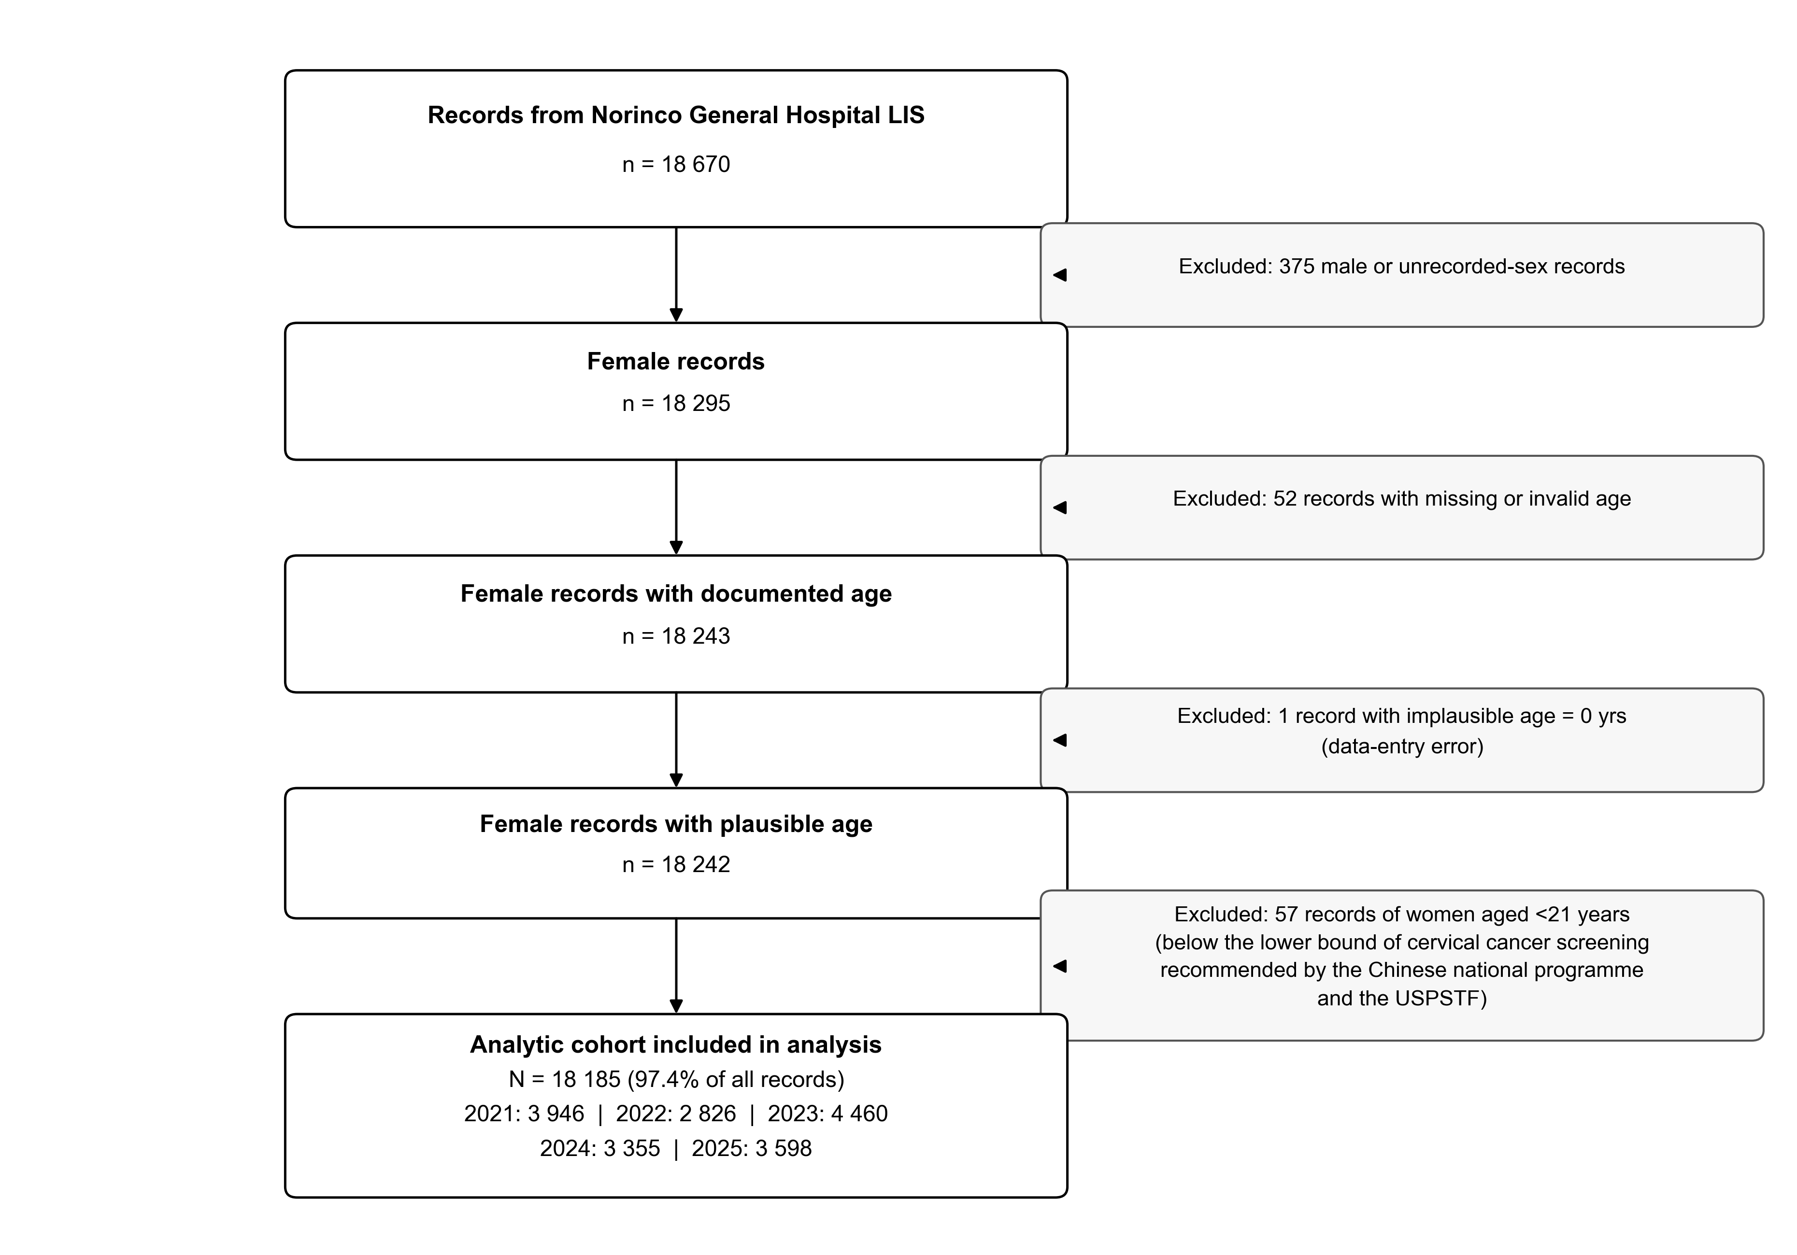
Supplementary Figure S1. STROBE flow diagram.
Inclusion and exclusion flow for the analytic cohort. Of 18 670 HPV-genotyping records from 2021–2025, the following were excluded in sequence: 374 male records and 1 record with an invalid sex code (n=375); 52 records with missing age; 1 record with an implausible age of 0 years (data-entry error); and 57 records of women aged <21 years (below the lower bound of cervical cancer screening recommended by the Chinese national programme²⁹ and the US Preventive Services Task Force³⁰). The final analytic cohort comprised 18 185 women (97.4% of all records).
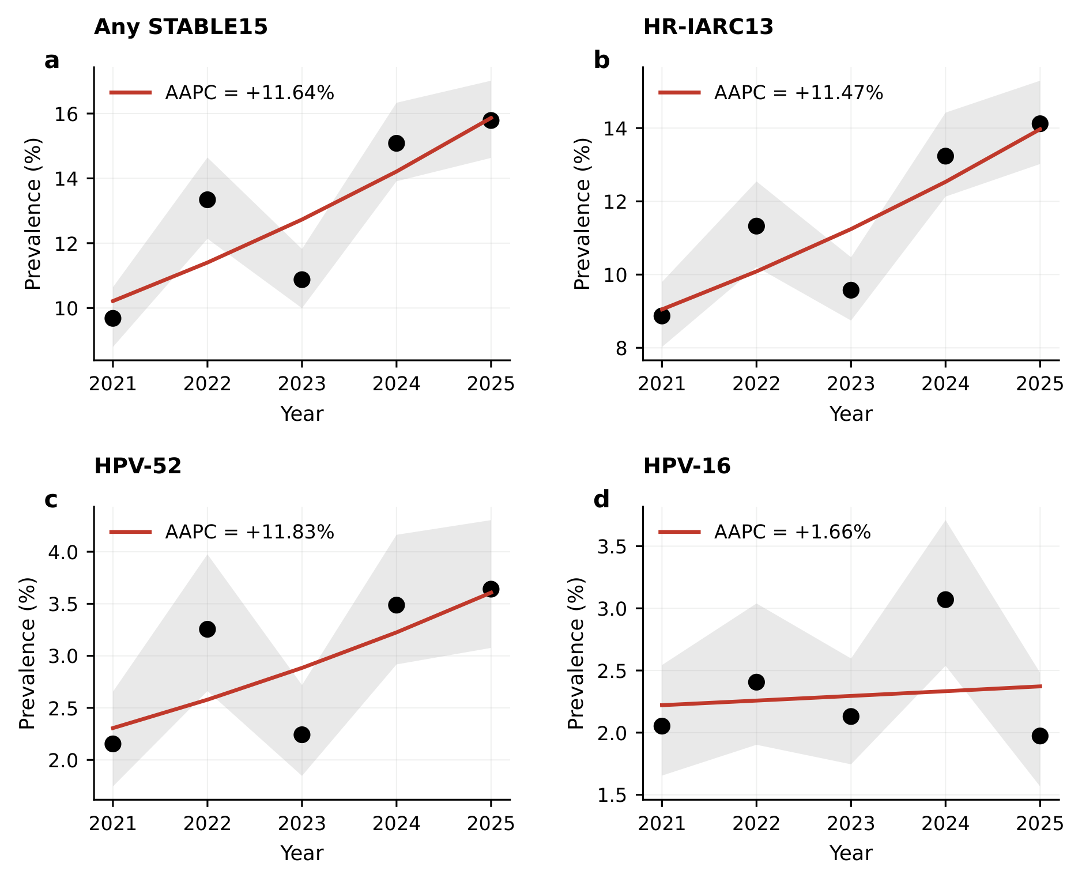
Supplementary Figure S2. Joinpoint regression: exploratory analysis.
Single-segment versus single-break log-linear models, BIC-selected, for four key metrics: (a) any STABLE15, (b) HR-IARC13, (c) HPV-52, (d) HPV-16. With n=5 timepoints, break detection is severely under-powered; joinpoint is reported as a sensitivity analysis only. Primary trend inference uses the log-linear AAPC with bootstrap CI (Fig 1c).
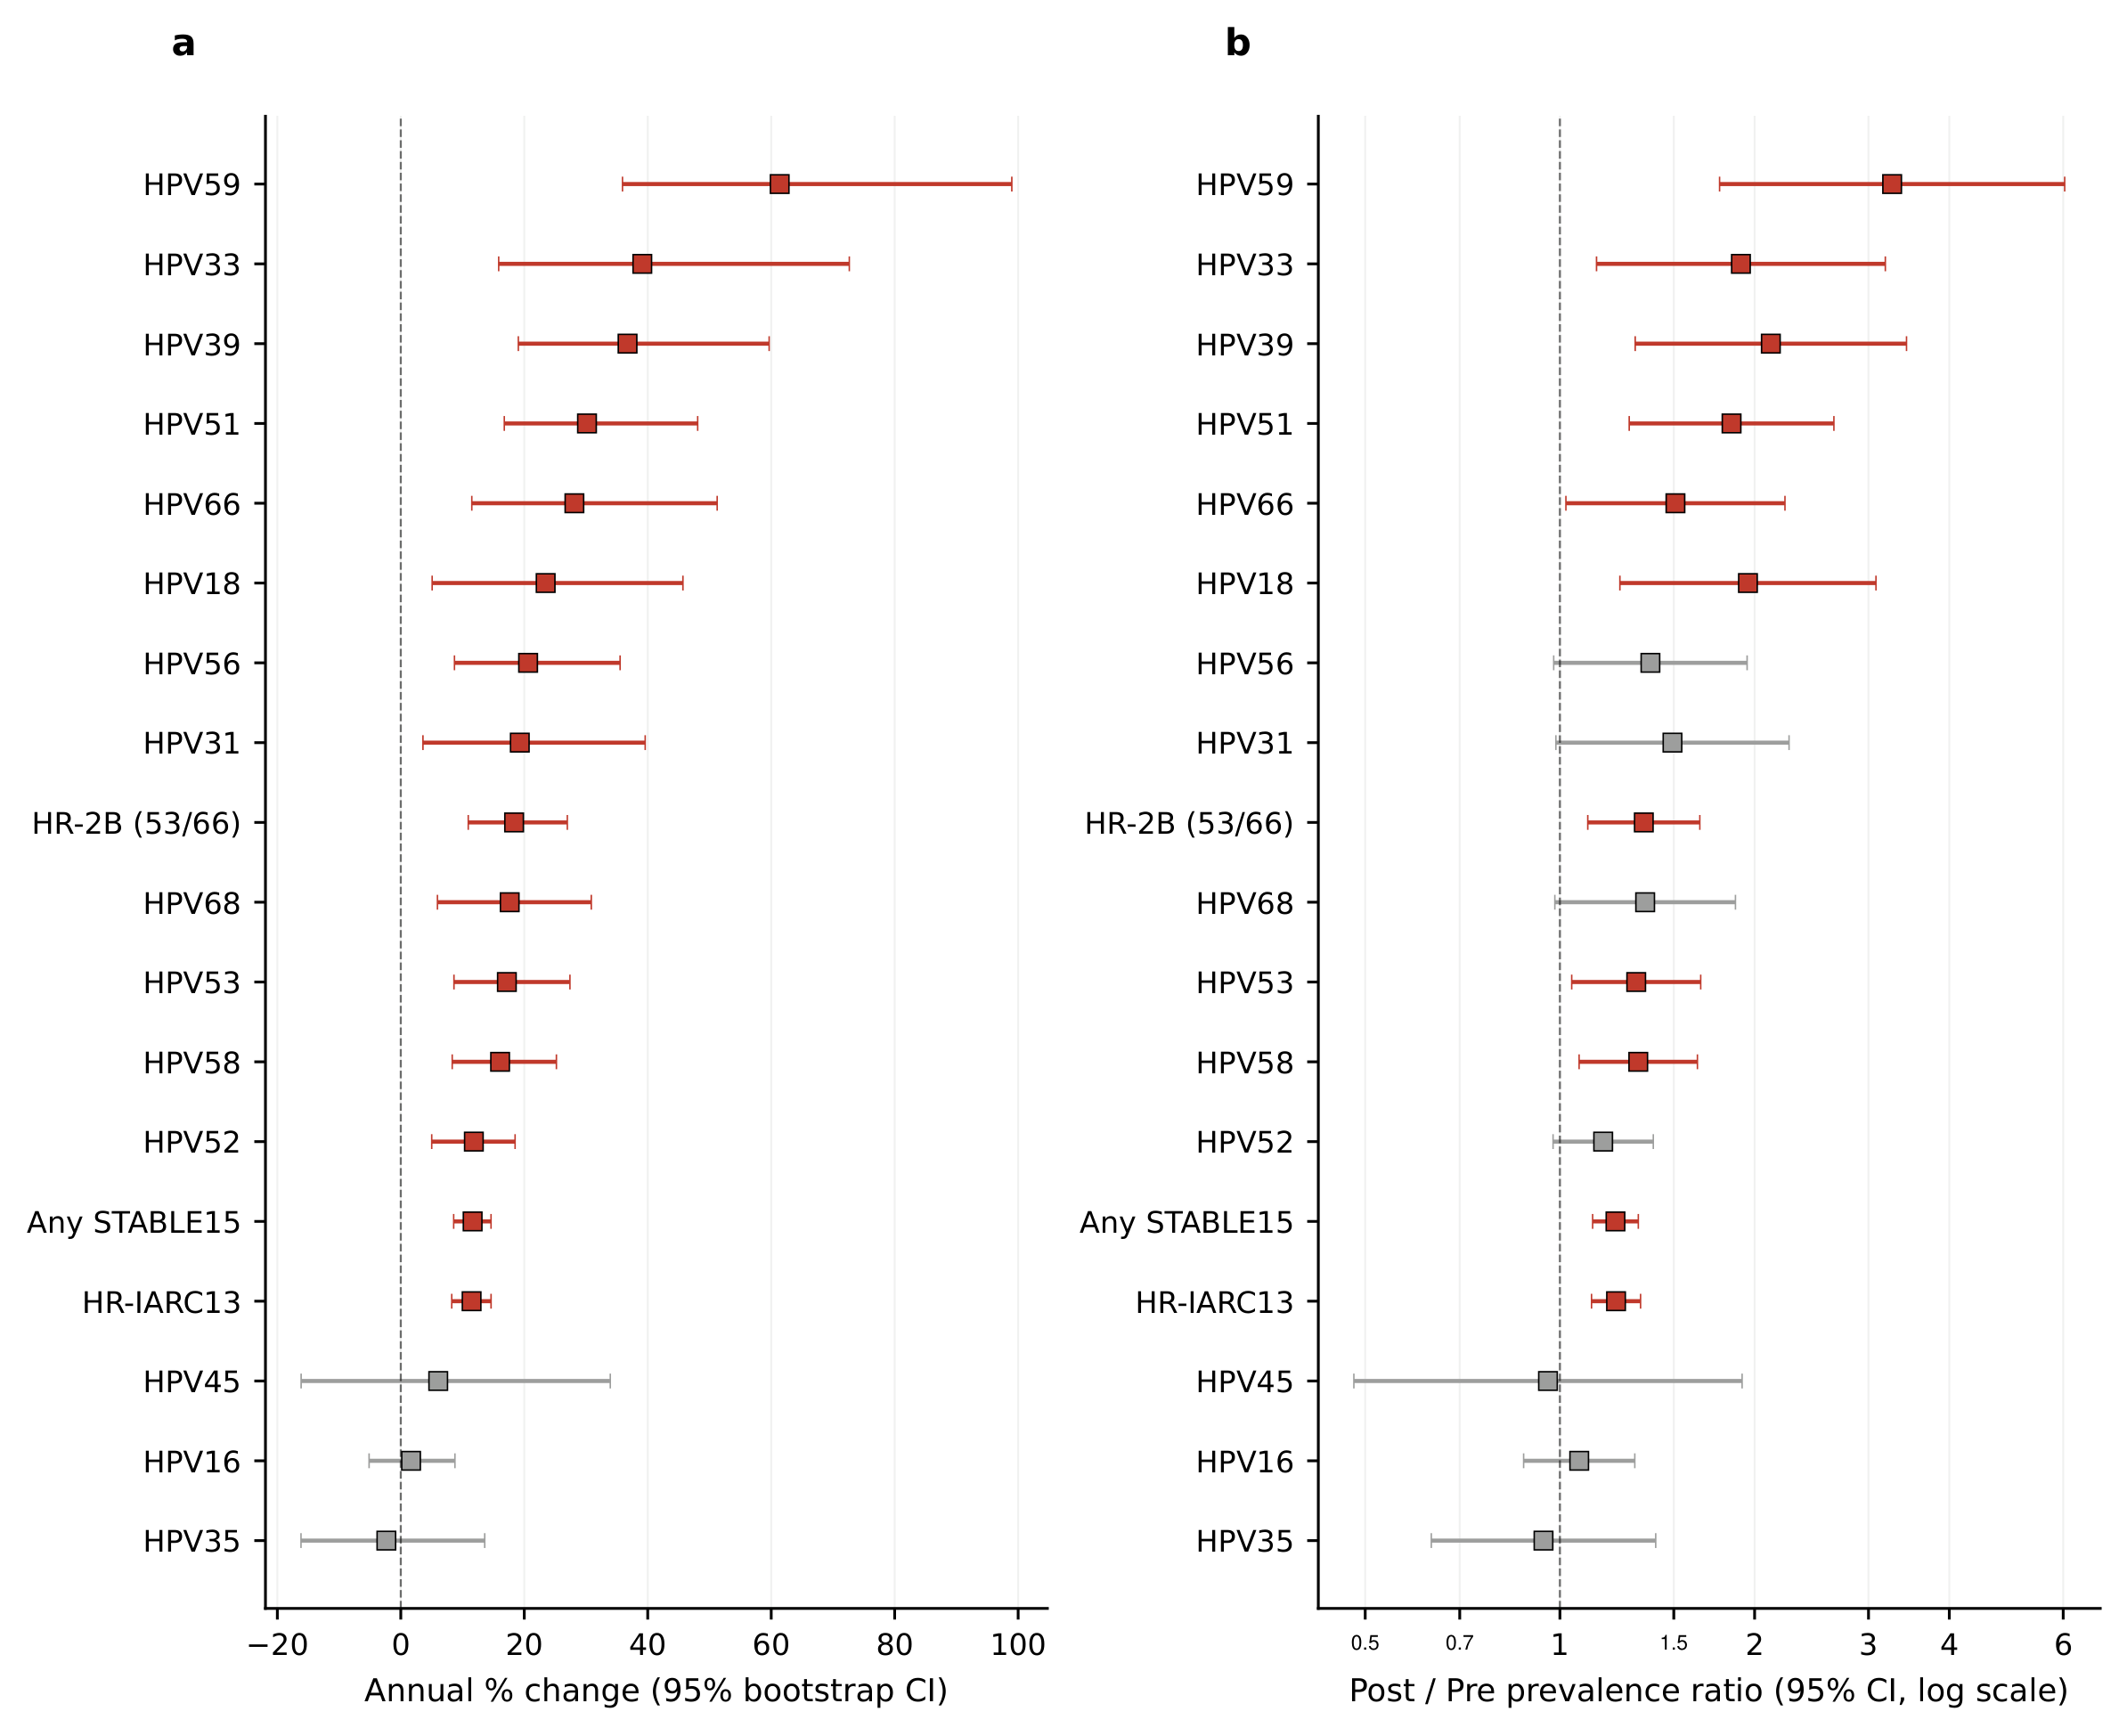
Supplementary Figure S3. Eighteen-metric forest plots.
(a) AAPC with 95% bootstrap CI for all 15 STABLE15 genotypes plus 3 aggregates, sorted ascending. (b) Pandemic-to-post-pandemic PR (log scale) with 95% CI, in the same row order. Red markers denote 95% CI excluding the null (zero for AAPC; 1.0 for PR).
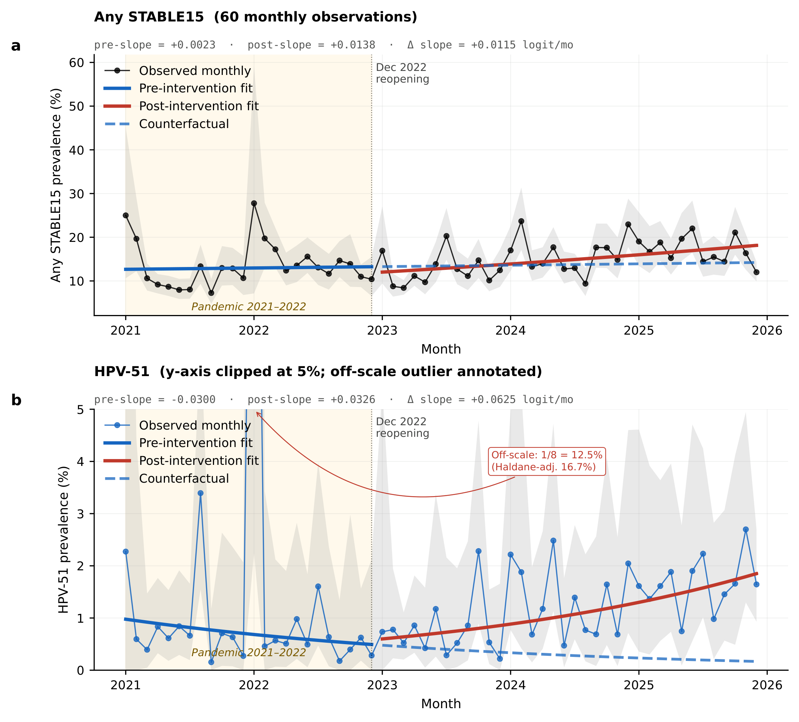
Supplementary Figure S4. Monthly trajectory and interrupted time-series (ITS) regression.
(a) Any STABLE15 monthly prevalence over 60 timepoints (January 2021 – December 2025; black markers), with segmented ITS regression fits (red = pre-intervention; green = post-intervention) and the December 2022 reopening intervention marked by a dashed vertical line. Pre-intervention slope = +0.002 logit/month (non-significant); post-intervention slope = +0.014 logit/month (95% CI +0.005 to +0.022). (b) HPV-51 monthly prevalence (blue markers) with the same ITS overlay; pre-intervention slope = −0.030 logit/month (p=0.045); slope change at the reopening = +0.063 logit/month (p<0.001); post-intervention slope = +0.033 logit/month. Standard errors are Newey–West HAC with maximum lag 4 months. Monthly prevalences are Haldane-shrinkage estimates ([pos + 0.5] / [n + 1]) back-transformed from the logit.
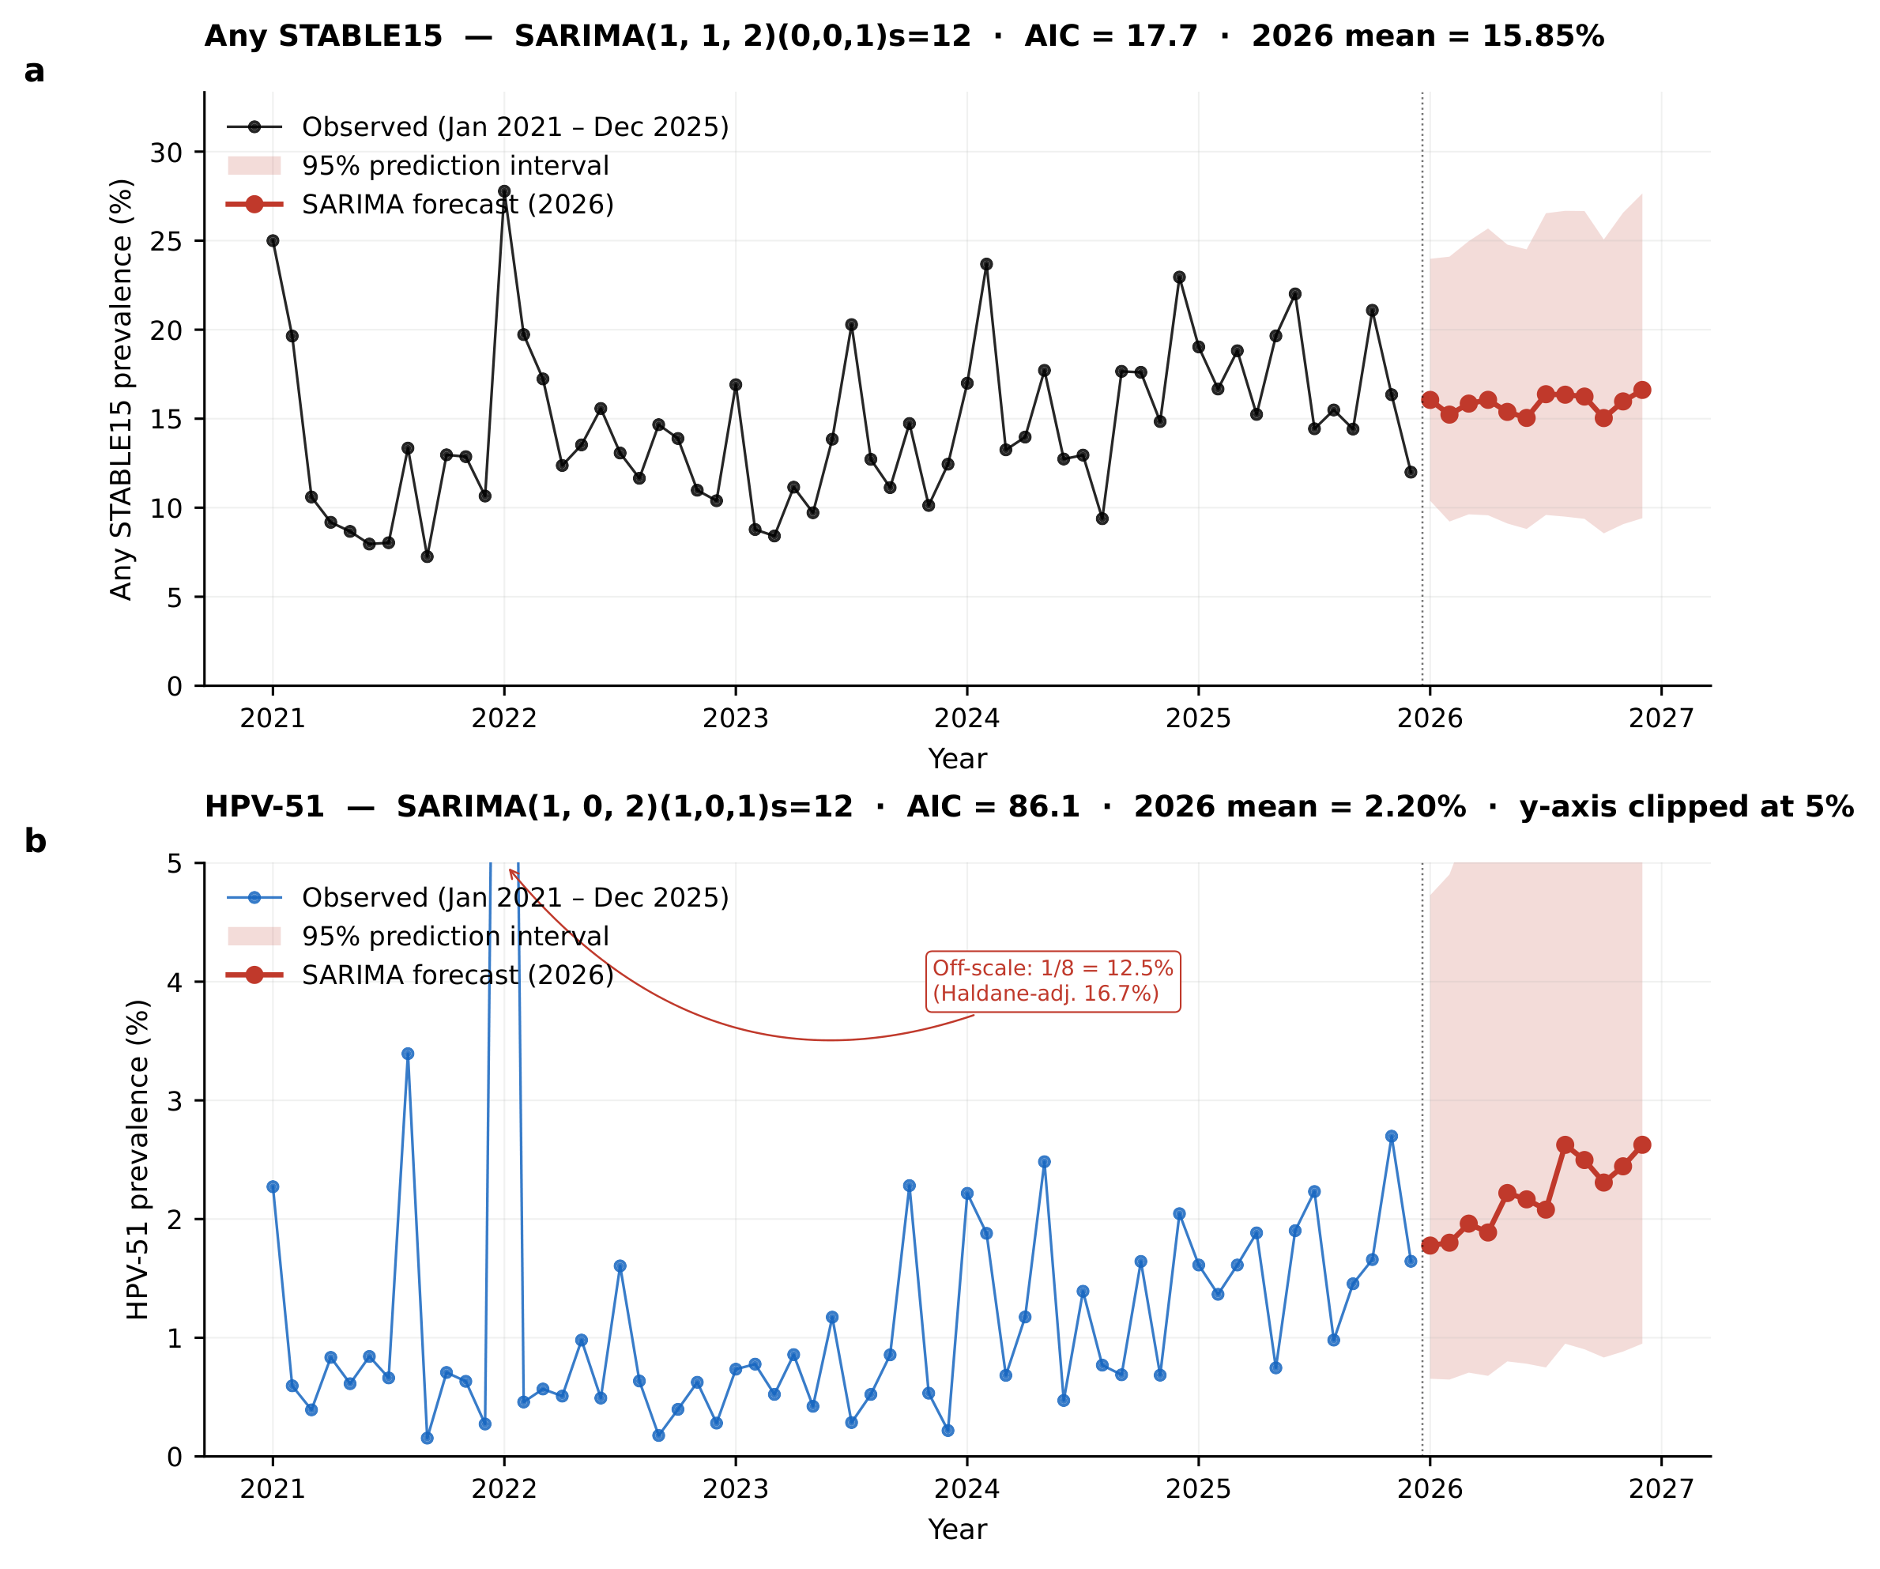
Supplementary Figure S5. Twelve-month SARIMA forecast (2026).
(a) Any STABLE15: observed monthly prevalence (January 2021 – December 2025; black markers, 60 timepoints) with the SARIMA point forecast for January – December 2026 (red markers) and 95% prediction interval (red shaded band). Best-fitting model: order (1, 1, 2) seasonal (0, 0, 1)₁₂; AIC = 17.7; 12-month mean forecast = 15.85%; December 2026 = 16.62% (95% PI 9.41–27.65). (b) HPV-51: same layout; best-fitting model order (1, 0, 2) seasonal (1, 0, 1)₁₂; AIC = 86.1; 12-month mean forecast = 2.20%; December 2026 = 2.63% (95% PI 0.95–7.04). Forecasts and prediction intervals were back-transformed from the logit via the inverse-logit function.
Supplementary Results: interrupted time-series and SARIMA forecast
The month-level series (60 timepoints; Supplementary Figure S4) revealed dynamics that the year-level analysis could not resolve. For any STABLE15, the pre-intervention slope (January 2021 to November 2022) was statistically null at +0.002 logit/month (95% CI −0.026 to +0.031; p=0.88) and the level change at the December 2022 reopening was also non-significant (−0.125 logit; 95% CI −0.436 to +0.185; p=0.43). However, the post-intervention slope was significantly positive at +0.014 logit/month (95% CI +0.005 to +0.022), indicating a clear monthly acceleration of HR-HPV transmission after the reopening (Supplementary Figure S4a), consistent with catch-up screening intensification rather than a discrete epidemiological inflection.
The HPV-51 trajectory was qualitatively different (Supplementary Figure S4b): the pre-intervention slope was weakly negative (−0.030 logit/month; p=0.045) and the slope change at the reopening was strongly positive (+0.063 logit/month; 95% CI +0.033 to +0.092; p<0.001), corresponding to a post-intervention slope of +0.033 logit/month — the most pronounced post-pandemic acceleration of any HR genotype, indicating that HPV-51 emergence was driven by an underlying change in transmission rate rather than a step-wise level change.
SARIMA models fitted to the logit-transformed monthly series (Supplementary Figure S5) predicted that, absent policy or behavioural change, any-STABLE15 prevalence in 2026 will remain near the 2025 plateau (best model (1,1,2)(0,0,1)12; AIC 17.7; 12-month mean 15.85%; December 2026 16.62%, 95% PI 9.41–27.65). For HPV-51 (best model (1,0,2)(1,0,1)12; AIC 86.1), the 2026 mean was 2.20% and December 2026 2.63% (95% PI 0.95–7.04), implying continued rise rather than reversion to the 2021 baseline of 0.63%.
Supplementary Table S7. Age-stratified HPV prevalence (2021–2025 pooled).
Values are % (95% Wilson CI). Cochran–Armitage trend test across the 11 age bins for any STABLE15: z=6.49, p<0.001.
Age (years) | N | Any STABLE15 % | HR-IARC13 % | HPV-52 % | HPV-58 % | HPV-16 %
21–25 | 534 | 25.8 (22.3–29.7) | 24.5 (21.1–28.4) | 5.4 (3.8–7.7) | 5.8 (4.1–8.1) | 5.4 (3.8–7.7)
26–30 | 1 436 | 14.3 (12.6–16.2) | 13.0 (11.4–14.9) | 3.9 (3.0–5.0) | 1.9 (1.4–2.8) | 1.9 (1.4–2.8)
31–35 | 3 300 | 10.2 (9.2–11.2) | 8.9 (8.0–10.0) | 2.1 (1.7–2.6) | 1.4 (1.0–1.9) | 2.0 (1.5–2.5)
36–40 | 3 752 | 10.0 (9.1–11.0) | 8.8 (7.9–9.7) | 2.4 (1.9–2.9) | 1.6 (1.2–2.1) | 1.5 (1.1–1.9)
41–45 | 2 880 | 10.7 (9.6–11.8) | 8.8 (7.8–9.8) | 2.5 (2.0–3.1) | 1.6 (1.2–2.1) | 1.7 (1.3–2.3)
46–50 | 2 356 | 11.1 (9.9–12.5) | 9.9 (8.8–11.2) | 2.2 (1.7–2.9) | 2.0 (1.5–2.6) | 2.3 (1.8–3.0)
51–55 | 1 918 | 13.8 (12.3–15.4) | 11.8 (10.5–13.4) | 2.9 (2.3–3.8) | 2.2 (1.6–2.9) | 2.8 (2.2–3.7)
56–60 | 1 176 | 19.8 (17.6–22.2) | 18.2 (16.1–20.5) | 5.3 (4.1–6.7) | 3.5 (2.6–4.7) | 4.3 (3.3–5.7)
61–65 | 567 | 23.5 (20.2–27.1) | 20.6 (17.5–24.2) | 4.6 (3.1–6.6) | 6.5 (4.8–8.9) | 4.1 (2.7–6.0)
66–70 | 159 | 27.7 (21.3–35.1) | 26.4 (20.2–33.8) | 6.9 (3.9–12.0) | 6.9 (3.9–12.0) | 3.8 (1.7–8.0)
>70 | 107 | 20.6 (14.0–29.2) | 18.7 (12.4–27.1) | 3.7 (1.5–9.2) | 8.4 (4.5–15.2) | 2.8 (1.0–7.9)

Supplementary Table S8. Relationship between the present time-series study and the prior cross-sectional publication from the same institution.
Dimension | Prior study (Wu et al, BMC Infect Dis 2026; 26: 13647) | Present study (this manuscript) | Shared?
Research question | Urban–rural HPV prevalence disparity | 5-year post-pandemic temporal dynamics | No
Design | Cross-sectional, single 3-year window | Single-centre longitudinal time-series | No
Calendar window | 2023–2025 | 2021–2025 | Partial (2023–2025)
Eligible women | Not directly comparable (broader age range 15–100 y; 25-type panel) | 18 185 (11 413 within the 2023–2025 overlap window + 6 772 unique to 2021–2022) | 11 413 present-cohort women from 2023–2025 (62.8% of the present cohort); no analysis, figure, or table shared
Primary statistical core | Age-standardised prevalence ratios | AAPC + interrupted time-series + SARIMA | None (0% overlap)
Figures / tables reused | Its own separate figures and tables (none shared) | None reproduced from prior paper | 0%
AAPC=average annual percentage change; SARIMA=seasonal autoregressive integrated moving average. The present cohort's 11 413 women tested in the 2023–2025 window also covered by the prior study (62.8% of the present cohort) represent the maximal potential participant overlap; the two studies share no research question, primary analysis, figure, or table.

Table S9. Age-standardised any–HR-HPV (STABLE15) prevalence by standardisation method, Xi'an, 2021–2025.
Standardisation | 2021 | 2022 | 2023 | 2024 | 2025 | AAPC, %/yr (95% CI)
Crude | 9.68 (8.80 to 10.64) | 13.34 (12.14 to 14.64) | 10.87 (9.99 to 11.82) | 15.08 (13.91 to 16.33) | 15.79 (14.63 to 17.01) | 11.6 (8.6 to 14.6)
Internal 2021 standard | 9.68 (8.77 to 10.60) | 13.01 (11.77 to 14.25) | 10.57 (9.67 to 11.48) | 14.44 (13.23 to 15.65) | 15.30 (14.05 to 16.55) | 10.7 (7.8 to 13.9)
WHO World standard | 12.08 (10.35 to 13.81) | 16.28 (13.45 to 19.10) | 15.23 (13.24 to 17.23) | 17.67 (15.70 to 19.65) | 20.26 (17.98 to 22.53) | 11.8 (7.5 to 16.7)
Values are prevalence % (95% CI). Crude CIs: Wilson score. Standardised rates: direct standardisation with 95% CI from the standard directly-standardised-rate variance. WHO World Standard Population per Ahmad et al. 2001; internal standard = 2021 age structure. AAPC from log-linear regression of the yearly (standardised) prevalence with 2000-replicate stratified binomial bootstrap 95% CI. Age strata: 5-year bins 20–24 … 65–69 and ≥70.

Table S10. Genotype-specific annualised trend: primary log-linear AAPC versus harmonic seasonal GLM.
Genotype | Log-linear AAPC, %/yr (95% CI) | p | Harmonic GLM trend, %/yr (95% CI) | p | GLM family (dispersion)
HPV-16 | 1.7 (-5.1 to 8.8) | 0.632 | 1.4 (-5.4 to 8.6) | 0.701 | Poisson (1.41)
HPV-52 | 11.8 (5.0 to 18.5) | <0.001 | 9.0 (-10.1 to 32.2) | 0.378 | NB (1.52)
HPV-58 | 16.1 (8.3 to 25.2) | <0.001 | 12.2 (-7.8 to 36.6) | 0.250 | NB (1.67)
HPV-51 | 30.2 (16.8 to 48.1) | <0.001 | 29.1 (3.1 to 61.7) | 0.026 | NB (1.87)
Primary: log-linear AAPC of yearly prevalence with binomial-bootstrap 95% CI (manuscript method). Harmonic GLM: monthly genotype counts ~ time + sin/cos(12-mo) + sin/cos(6-mo) harmonics with log(monthly tests) offset; Poisson, refit as negative binomial (NB) when Pearson dispersion > 1.5; annualised trend = (exp(12·β_time)−1)×100. The two methods concur on direction for every genotype; HPV-51 rises and HPV-16 is flat under both.

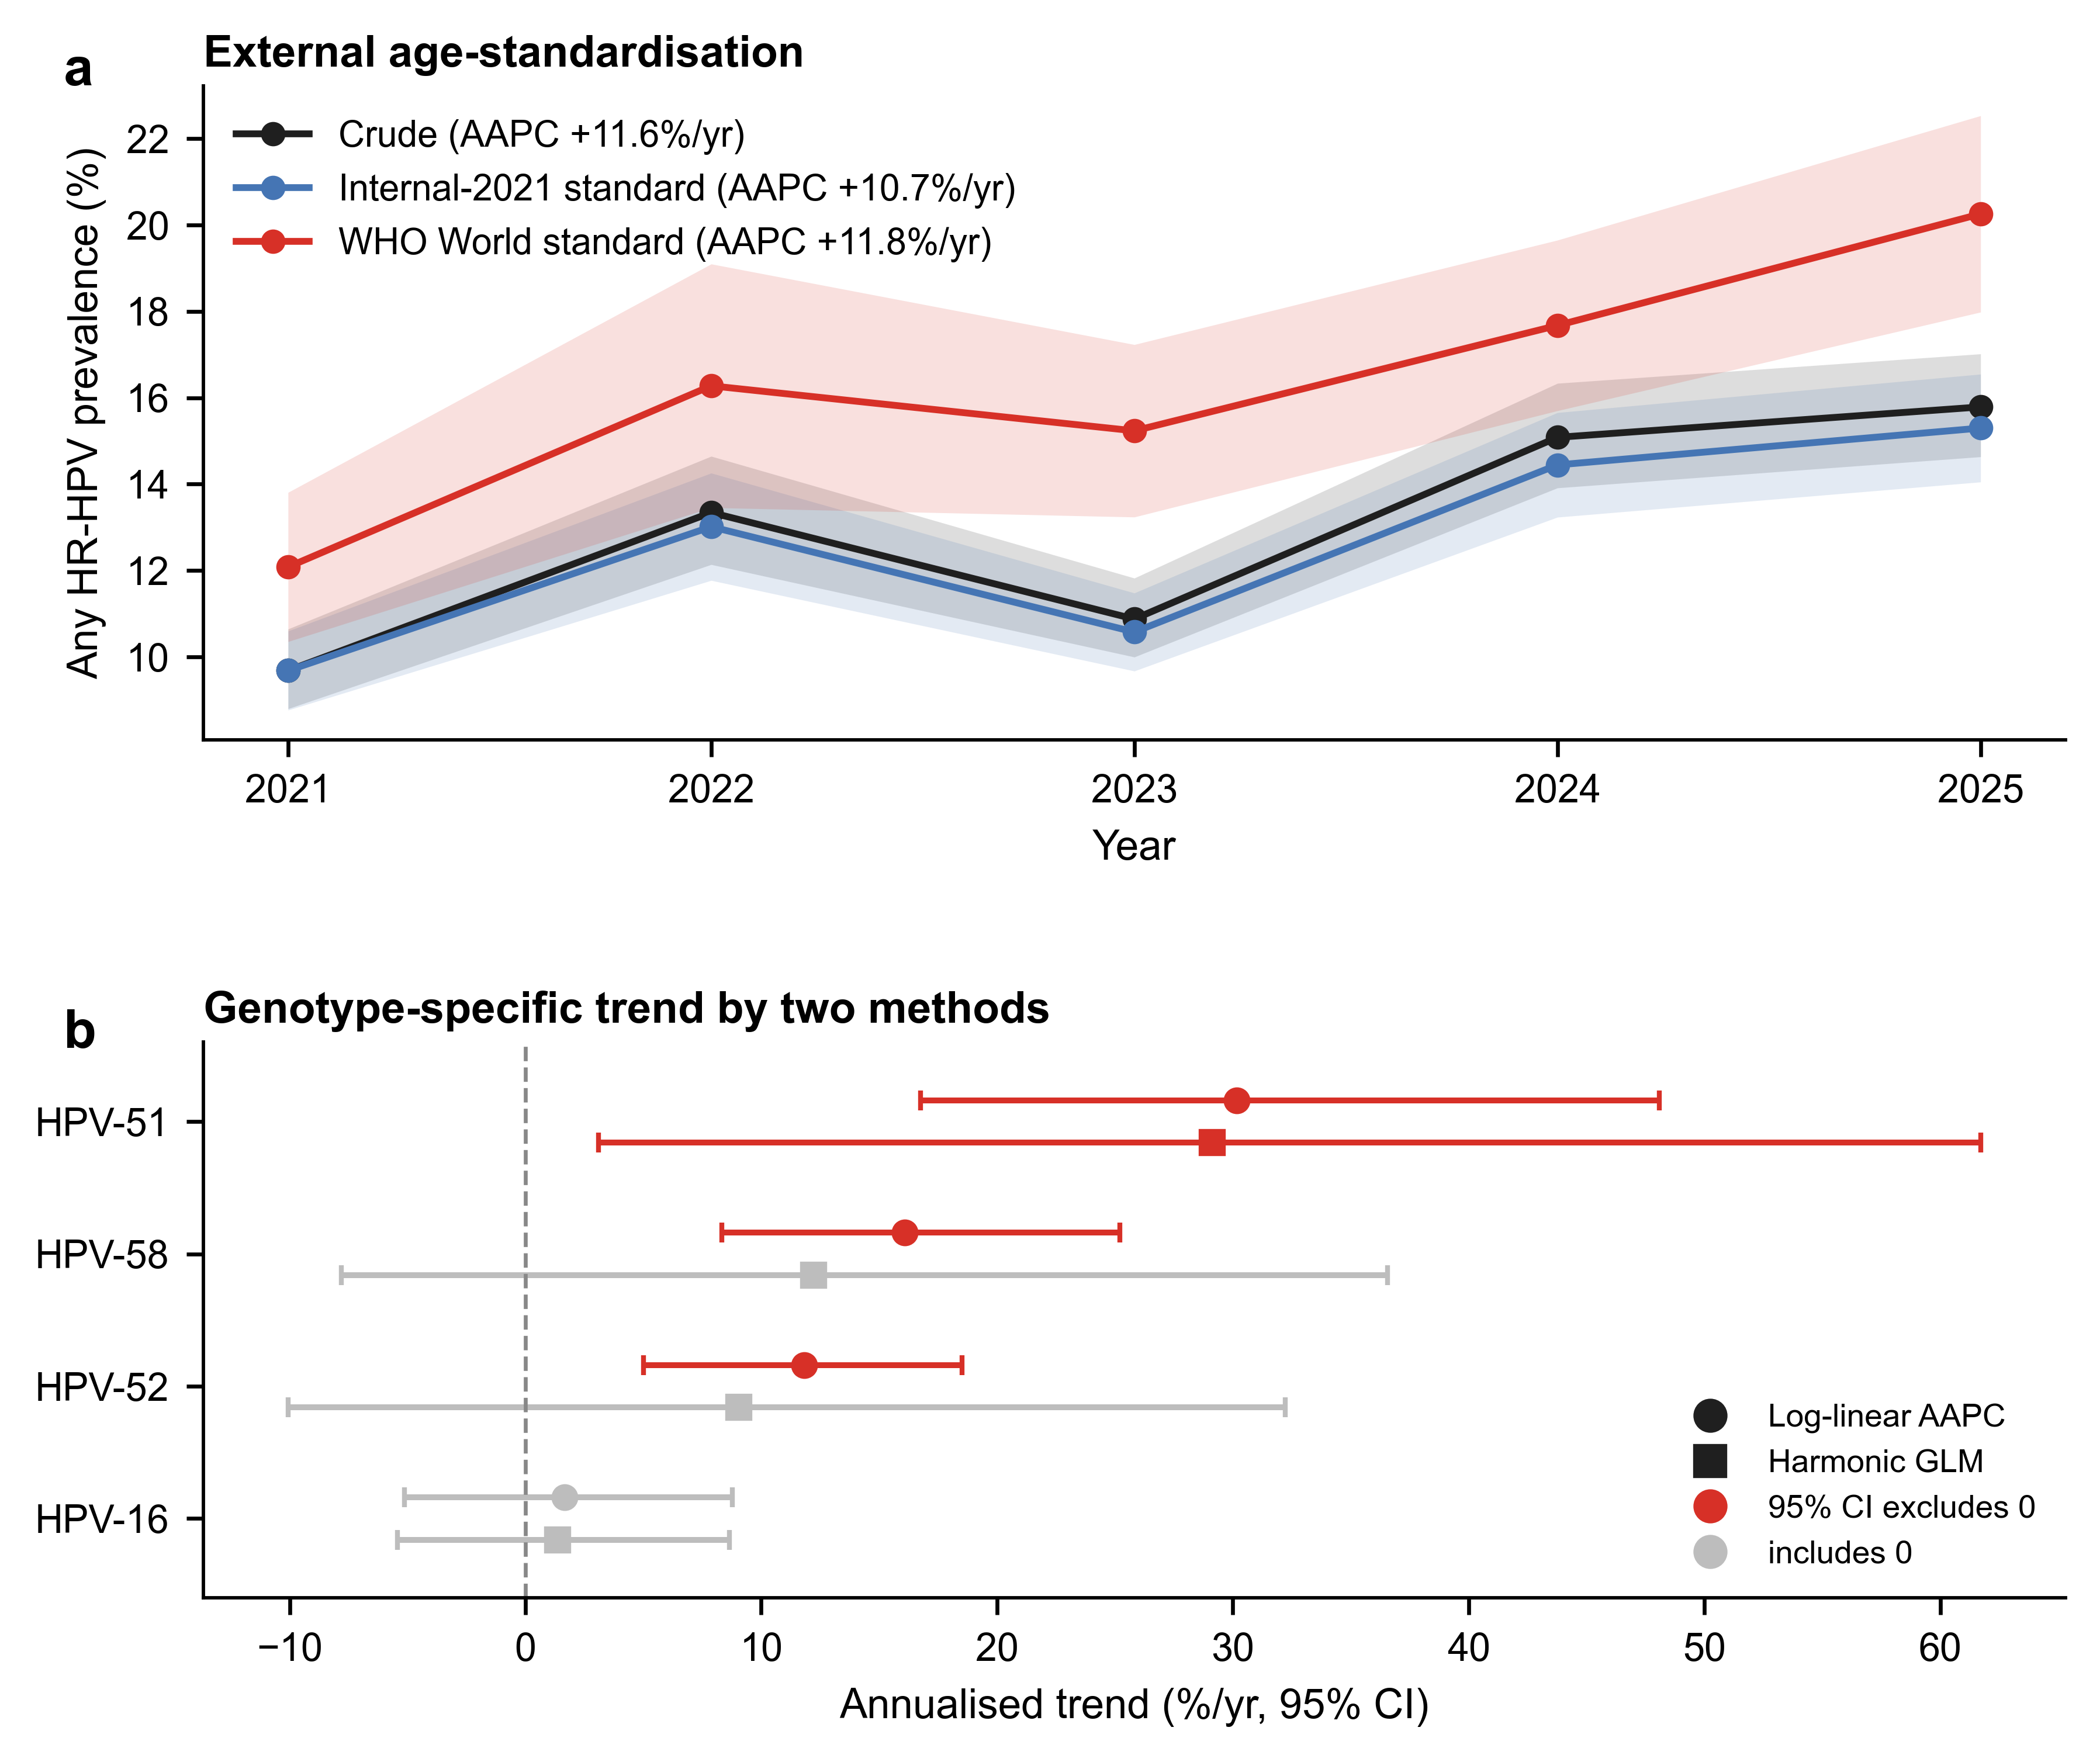
Figure S6. Methodology-upgrade analyses (companion to Tables S9 and S10). (a) External age-standardisation of any–HR-HPV (STABLE15) prevalence to the WHO World Standard Population (red) and to the internal 2021 age structure (blue) versus crude prevalence (black), 2021–2025, with 95% CI bands; average annual percentage change (AAPC) annotated. (b) Genotype-specific annualised trend estimated by the primary log-linear AAPC (circles) and an independent harmonic seasonal Poisson/negative-binomial GLM (squares) with a log(monthly tests) offset; markers are red where the 95% CI excludes zero, grey otherwise.

