stage.MouseX 相对于舞台注册点的鼠标位置
sp.MouseX 相对于此影片的鼠标位置。

2Π =6.2382弧度=360度
弧度(radians) = 角度(degrees) * Math.PI /180
角度(degrees) = 弧度(radians) * 180 / Math.PI

Flash中角度是颠倒的,顺时针旋转角度为正角,逆时针就意味着为负角.

指向鼠标的箭头:
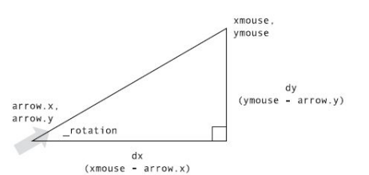
var dx:Number = MouseX-arrow.x;
Var dy:Number = MouseY - arrow.y;
var radis:Number = Math.atan(dy,dx);
Arrow.rotation = (radis*180/Math.PI)

//波形
private function sinaMove():void
{
ball.x += _xSpeed;
ball.y = Math.sin(angle) * range;
angle += speed;
}

//心跳运动
private function heartMove():void
{
ball.scaleX = ball.scaleY = 1+Math.sin(angle) * range;
angle += speed;
}

//圆周运动
private function circleMove():void
{
ball.x = Math.cos(angle) * range;
ball.y = Math.sin(angle) * range;
angle += speed;
}

//椭圆运动
private function ellipseMove():void
{
ball.x = Math.cos(angle) * (range + 10);
ball.y = Math.sin(angle) * range;
angle += speed;
}

计算两点间距离：
// points are x1, y1 and x2, y2
// can be sprite / movie clip positions, mouse coordinates, etc.
dx = x2 – x1;
dy = y2 – y1;
dist = Math.sqrt(dx*dx + dy*dy);

颜色合成：
color24 = red << 16 | green << 8 | blue;
color32 = alpha << 24 | red << 16 | green << 8 | blue;

颜色提取：
red = color24 >> 16;
green = color24 >> 8 & 0xFF;
blue = color24 & 0xFF;
alpha = color32 >> 24;
red = color32 >> 16 & 0xFF;
green = color32 >> 8 & 0xFF;
blue = color232 & 0xFF;

过控制点的曲线：
// xt, yt is the point you want to draw through
// x0, y0 and x2, y2 are the end points of the curve
x1 = xt * 2 – (x0 + x2) / 2;
y1 = yt * 2 – (y0 + y2) / 2;
moveTo(x0, y0);
curveTo(x1, y1, x2, y2);

