HourX 供应商后台界面优化需求
  - 中英文双语执行文件
HourX Supplier Portal Interface Optimization Requirements
本文件明确 HourX 供应商后台已确认的页面结构、导航、状态名称和报价流程，供产品、设计、开发及运营团队统一执行。核心目标是减少重复页面与含义不清的操作，让供应商可以顺利完成入驻、设置服务区域、管理订单并按服务提交报价。
This document defines the approved structure, navigation, status labels and quotation workflow for the HourX Supplier Portal. It is intended for product, design, development and operations teams. The objective is to remove duplicate pages and ambiguous actions so suppliers can complete onboarding, configure coverage, manage orders and submit service-specific quotations without confusion.

核心决策
Key Decisions
模块  Module | 确认修改  Approved Change | 优先级  Priority
全局导航  Global navigation | 公司名称、供应商编号和当前状态始终显示在左侧导航。  Keep company name, supplier ID and current status visible in the left navigation. | P0
公司资料  Business profile | 将公司、联系人、收款和验证资料合并为一个引导流程。  Combine company, contact, payout and verification information into one guided flow. | P0
服务区域  Coverage | 将服务区域与可用时间合并为一个操作页面。  Merge Service Area and Availability into one operational workspace. | P0
订单  Orders | 说明审核期间的空状态，并简化订单状态和筛选。  Explain the empty state during review and simplify order status and filters. | P1
服务与报价  Services and pricing | 按类别进入每项服务，分别管理报价和审核状态。  Enter each service by category and manage its quote and review state separately. | P0
报价流程  Quotation workflow | 支持按小时报价和一口价，最后进入检查并提交步骤。  Support Hourly Rate and Fixed Price, followed by a Review and Submit step. | P0

1 全局导航与供应商身份
1 Global Navigation and Supplier Identity
供应商身份信息需要在后台所有页面持续可见。左侧导航用于确认当前公司、审核状态和所在页面，因此不需要在页面顶部重复显示大块公司信息。
Supplier identity information must remain visible throughout the portal. The left navigation is the primary location for confirming the active company, review status and current page, so the same information should not be repeated in large page headers.
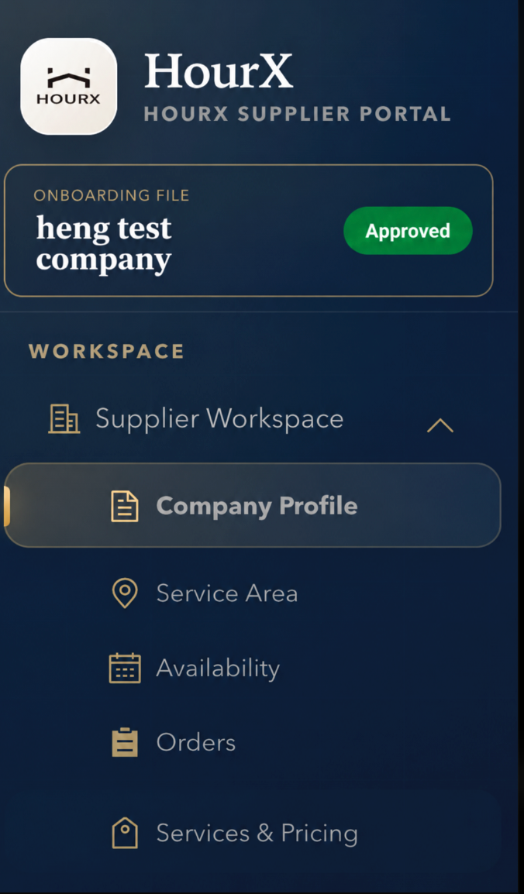
图 1 左侧导航中的公司身份与审核状态
Figure 1 Company identity and approval status in the left navigation

修改要求
Required Changes
- 在 HourX 标志下方直接显示公司名称、供应商编号和入驻审核状态。
Show the company name, supplier ID and onboarding status directly below the HourX logo.
- 统一使用以下菜单结构：供应商工作台、公司资料与验证、服务区域与可用时间、订单、服务与报价。
Use one menu structure: Supplier Workspace, Business Profile & Verification, Coverage & Availability, Orders, and Services & Pricing.
- 当前页面使用金色标记和深色选中状态，同一时间只能突出显示一个菜单项。
Use a gold marker and dark selected state for the current page. Never highlight two menu items at the same time.
- 入驻审核状态与接单状态分别显示，例如“审核中”和“可接单”。
Display onboarding status separately from booking availability, for example Under Review and Available.
验收标准
Acceptance Criteria
- 切换任何页面后，公司名称、供应商编号和状态仍然可见。
Company name, supplier ID and status remain visible after every page change.
- “服务区域”和“可用时间”不再作为两个独立导航项目。
Service Area and Availability no longer appear as separate navigation items.

2 公司资料与验证
2 Business Profile & Verification

2.1 公司与联系人信息
2.1 Company and Contact Details
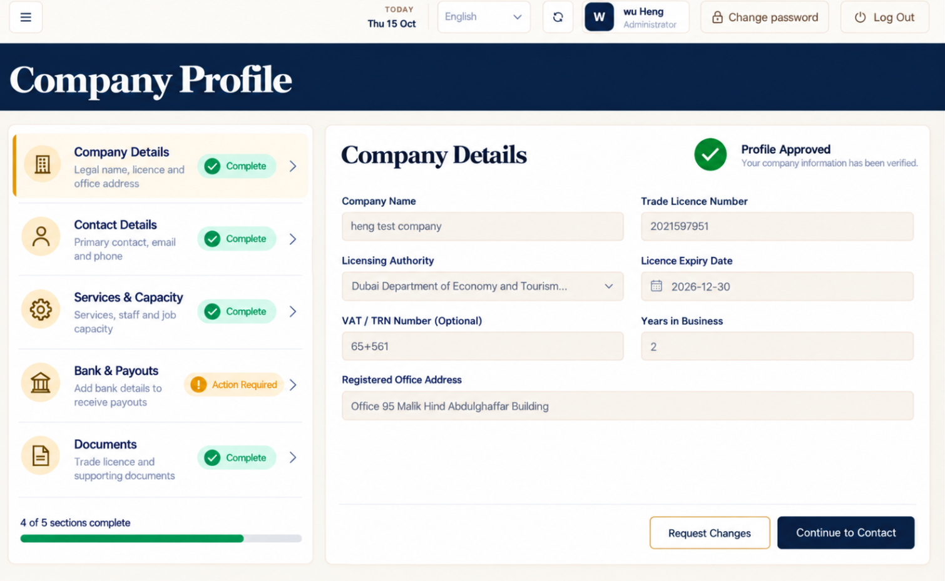
图 2 公司信息与联系人信息合并为同一引导流程
Figure 2 Company Details and Contact Details in one guided profile flow

修改要求
Required Changes
- 公司信息包括公司名称、营业执照、发证机构、到期日期、TRN、经营年限和注册地址。
Company Details includes company name, trade licence, licensing authority, expiry date, TRN, years in business and registered office address.
- 联系人信息保留在同一资料流程内，不单独设置为一级菜单。
Contact Details remains part of the same profile flow and is not a separate top-level menu item.
- 资料步骤列表持续显示每个部分的“已完成”或“需要处理”状态。
The section list continuously shows Complete or Action Required for every profile section.
- 按钮需要明确说明下一步去向，例如“继续填写联系人”或“继续填写服务与接单能力”。
Buttons identify the next destination, such as Continue to Contact or Continue to Services & Capacity.

2.2 服务与接单能力
2.2 Services & Capacity
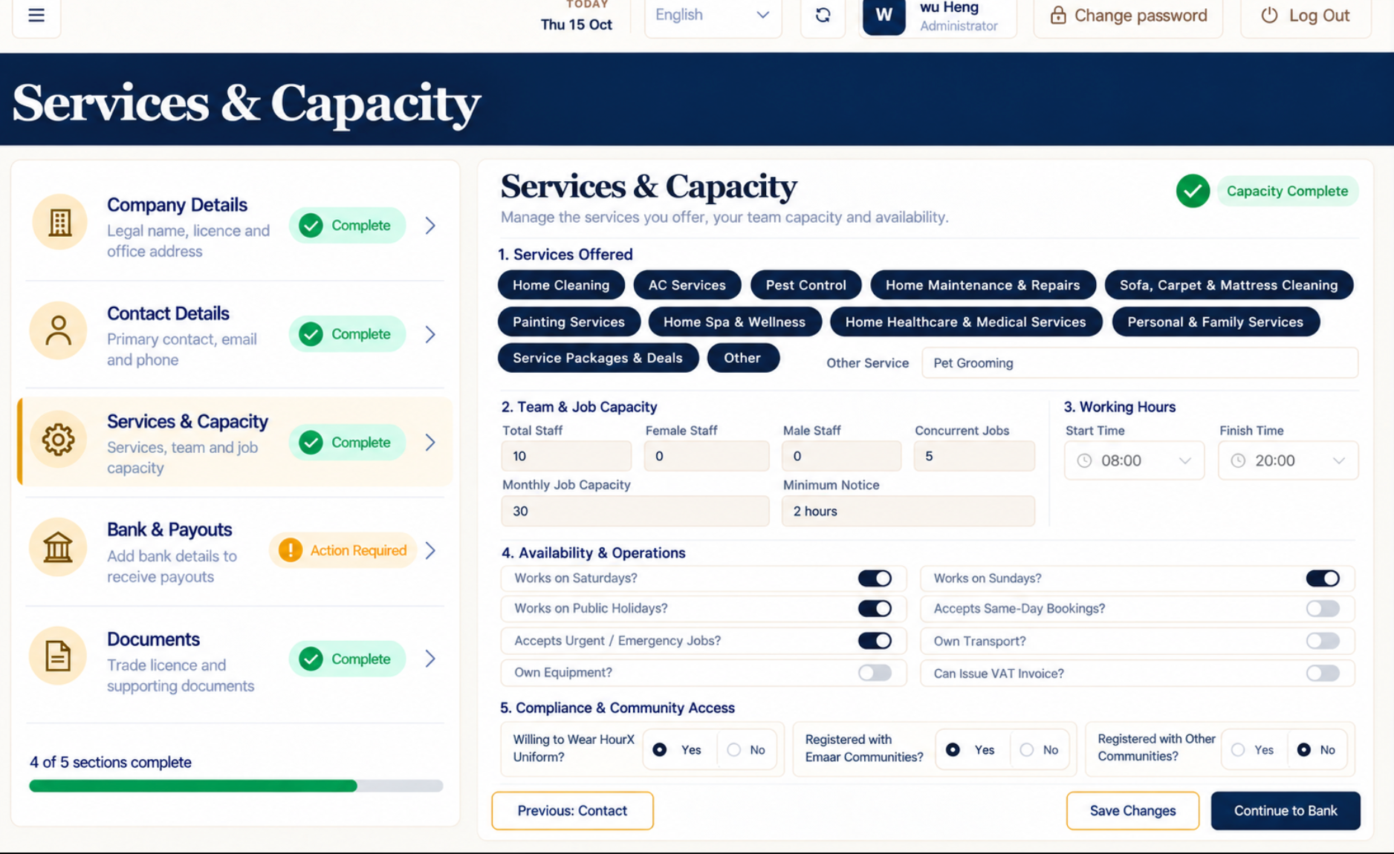
图 3 服务、人员配置与工作时间集中在同一部分
Figure 3 Services, staffing capacity and working hours in one section

修改要求
Required Changes
- 服务类别使用紧凑标签展示，供应商只选择自己能够提供的类别。
Display service categories as compact tags and allow suppliers to select only the categories they can provide.
- 将员工总数、女员工、男员工、同时接单数、每月接单量和最短提前预约时间集中显示。
Group Total Staff, Female Staff, Male Staff, Concurrent Jobs, Monthly Job Capacity and Minimum Notice together.
- 工作时间使用开始时间和结束时间字段，不使用占据大面积的开关卡片。
Use start and finish time fields for Working Hours instead of large toggle cards.
- 制服要求、Emaar 注册及其他社区准入信息统一放在“合规与社区准入”下。
Place uniform requirements, Emaar registration and other community access under Compliance & Community Access.
- 底部按钮统一为“上一步：联系人”“保存修改”和“继续填写收款与验证”。
Use Previous: Contact, Save Changes and Continue to Payouts & Verification as the footer actions.

2.3 收款与验证
2.3 Payouts & Verification
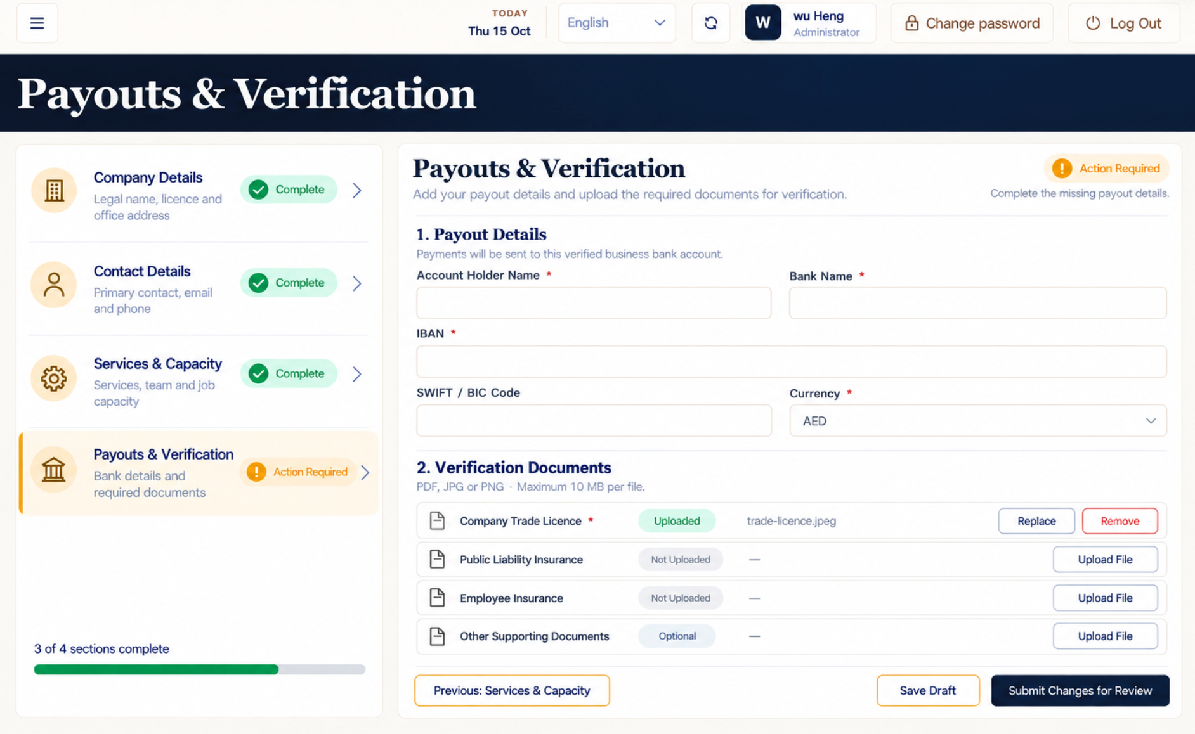
图 4 收款账户与验证文件合并在同一页面
Figure 4 Payout account and verification documents on one page

修改要求
Required Changes
- 收款资料和验证文件保留在同一页面。
Keep payout details and verification documents on the same page.
- 文件名应简短易读，不显示系统内部编号。
Use short, readable filenames and do not expose internal system identifiers.
- 文件状态统一使用“已上传”“未上传”和“选填”。
Use Uploaded, Not Uploaded and Optional as the document statuses.
- 底部按钮统一为“上一步：服务与接单能力”“保存草稿”和“提交并继续设置服务区域与可用时间”。
Use Previous: Services & Capacity, Save Draft and Submit & Continue to Coverage & Availability as footer actions.
验收标准
Acceptance Criteria
- 缺少必需文件时禁用主要提交按钮，并明确指出缺少的文件。
Disable the main submission action when a required document is missing and identify the missing item.
- 允许将收款资料和已上传文件保存为草稿。
Allow payout details and uploaded documents to be saved as a draft.

2.4 提交确认与下一步
2.4 Submission Confirmation and Next Step
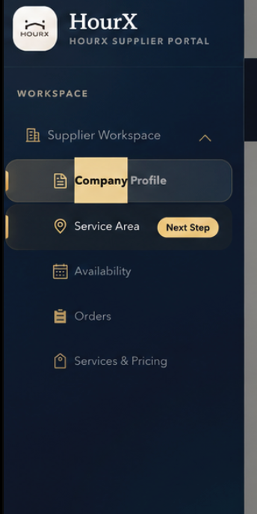
图 5 左侧导航中的“下一步”提示
Figure 5 Next Step indicator in the left navigation
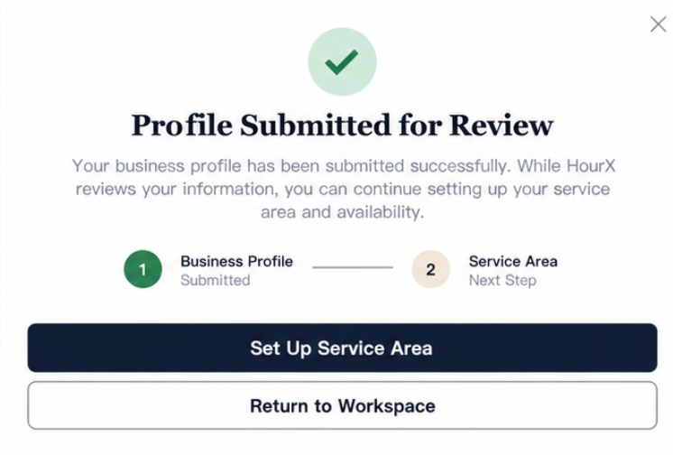
图 6 “资料已提交审核”确认界面
Figure 6 Profile Submitted for Review confirmation

修改要求
Required Changes
- 提交成功后立即显示“资料已提交审核”。
Show Profile Submitted for Review immediately after a successful submission.
- 主要按钮使用“设置服务区域与可用时间”，次要按钮使用“返回工作台”。
Use Set Up Coverage & Availability as the primary action and Return to Workspace as the secondary action.
- 在左侧导航的“服务区域与可用时间”旁显示“下一步”标签。
Show a Next Step label beside Coverage & Availability in the left navigation.
- 说明供应商在资料审核期间仍可设置服务区域、工作时间和报价。
Explain that suppliers can configure coverage, working hours and quotations while their profile is under review.

3 服务区域与可用时间
3 Coverage & Availability
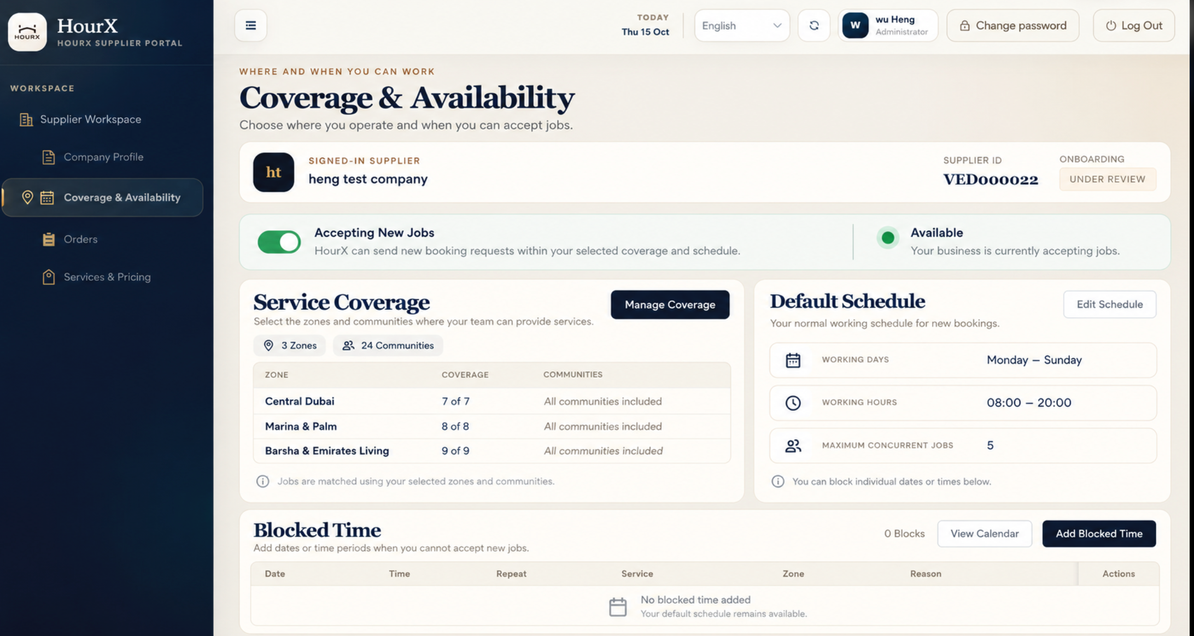
图 7 合并后的服务区域与预约可用时间页面
Figure 7 Combined service coverage and booking availability workspace

修改要求
Required Changes
- “服务覆盖范围”显示区域、社区数量和覆盖状态。
Service Coverage shows zones, community counts and coverage status.
- “默认排班”显示工作日、每日工作时间和最大同时接单数。
Default Schedule shows working days, daily hours and maximum concurrent jobs.
- “不可用时间”用于管理临时无法接单的日期、时间、服务和原因。
Blocked Time manages temporary unavailable dates, times, services and reasons.
- “接受新订单”作为全局接单开关。
Accepting New Jobs is the global booking availability control.
- 主要操作统一使用“管理服务区域”“编辑排班”“查看日历”和“添加不可用时间”。
Use Manage Coverage, Edit Schedule, View Calendar and Add Blocked Time as the primary actions.
验收标准
Acceptance Criteria
- 关闭“接受新订单”后，不再向该供应商分配新订单。
When Accepting New Jobs is off, do not assign new orders to the supplier.
- “不可用时间”只覆盖所选时段，不修改默认排班。
Blocked Time overrides only the selected period and does not change the default schedule.

4 订单
4 Orders
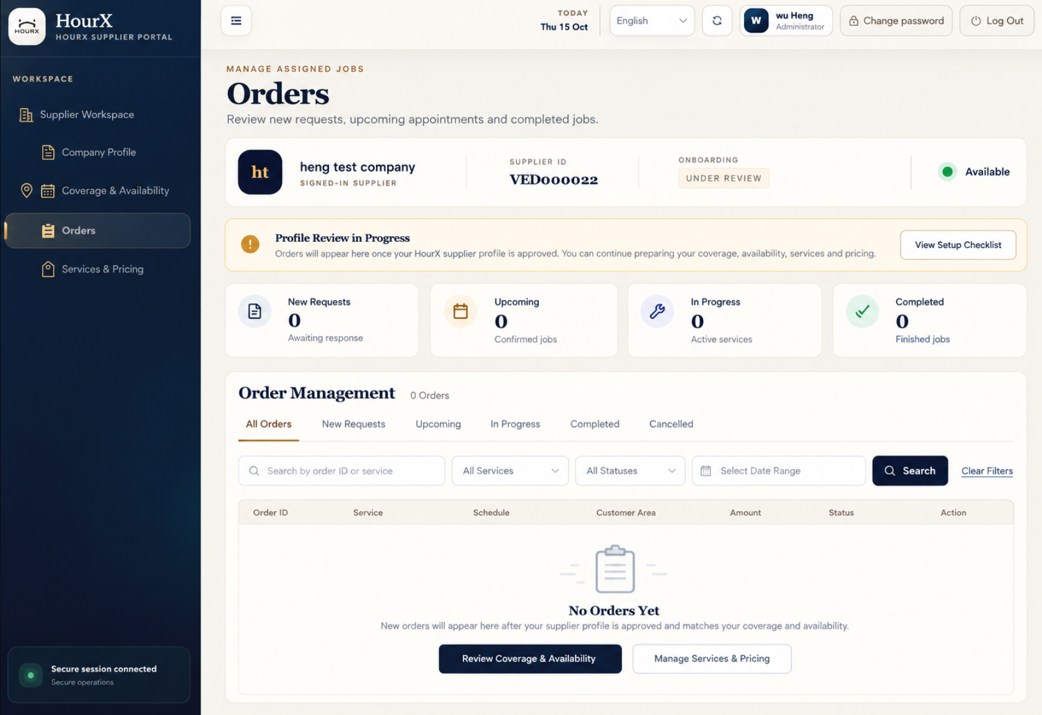
图 8 订单管理及资料审核期间的空状态
Figure 8 Order management and the empty state during profile review

修改要求
Required Changes
- 移除重复的“订单工作台”大横幅。
Remove the duplicate Order Workspace hero banner.
- 显示“资料审核中”，并说明当前尚未出现订单的原因。
Show Profile Review in Progress and explain why orders are not yet available.
- 汇总指标统一使用“新请求”“即将开始”“进行中”和“已完成”。
Use New Requests, Upcoming, In Progress and Completed for the summary metrics.
- 订单标签和搜索筛选保持在同一层级，并删除重复控件。
Keep order tabs and search filters at one level and remove duplicate controls.
- 订单表格列统一为订单编号、服务、预约时间、客户区域、金额、状态和操作。
Use Order ID, Service, Schedule, Customer Area, Amount, Status and Action as the table columns.
- 空状态提供“检查服务区域与可用时间”和“管理服务与报价”两个入口。
Provide Review Coverage & Availability and Manage Services & Pricing in the empty state.

5 服务与报价
5 Services & Pricing
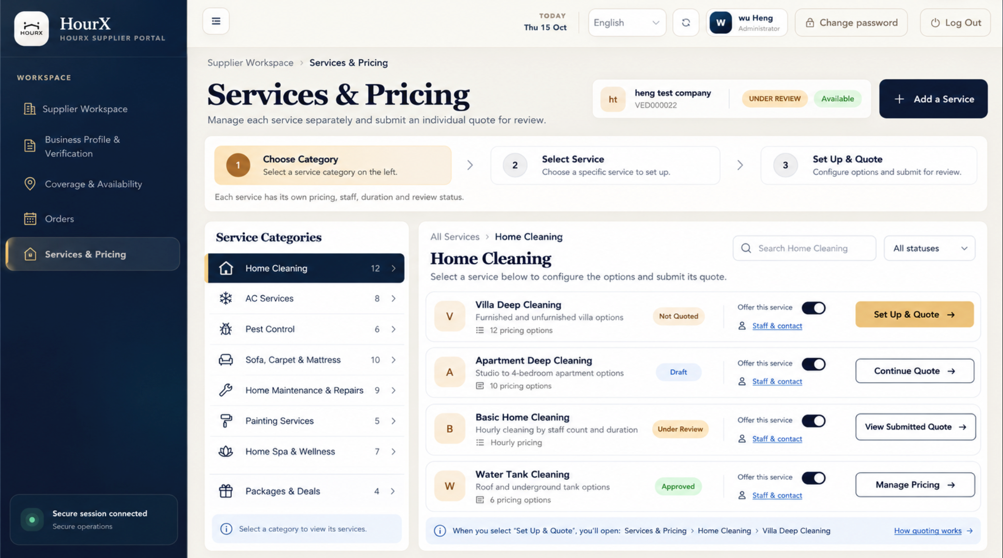
图 9 服务类别导航与单项服务报价操作
Figure 9 Category navigation and service-specific quotation actions

修改要求
Required Changes
- 服务类别保留在左侧栏，不一次性展示全部 57 项服务。
Keep service categories in the left panel instead of showing all 57 services at once.
- 仅显示当前所选类别下的服务，并提供搜索和状态筛选。
Show only the services in the selected category and provide search and status filters.
- 操作按钮根据状态变化：设置并报价、继续报价、查看已提交报价或管理价格。
Change the action by status: Set Up & Quote, Continue Quote, View Submitted Quote or Manage Pricing.
- 返回按钮需要写明去向，例如“返回家庭清洁”，不使用含义不清的“返回”。
Use a destination-specific return action such as Back to Home Cleaning instead of a generic Back.
- 不显示“删除”或“移除”，使用“提供此服务”开关控制服务是否可售。
Do not show Delete or Remove. Use Offer this service to control service availability.
验收标准
Acceptance Criteria
- 选择类别时只刷新服务列表。
Selecting a category refreshes only the service list.
- 点击某项服务的操作按钮时，只打开该服务的独立报价，不影响其他服务。
Selecting a service action opens its individual quote without affecting other services.

6 报价设置
6 Quote Setup

6.1 按小时报价
6.1 Hourly Rate
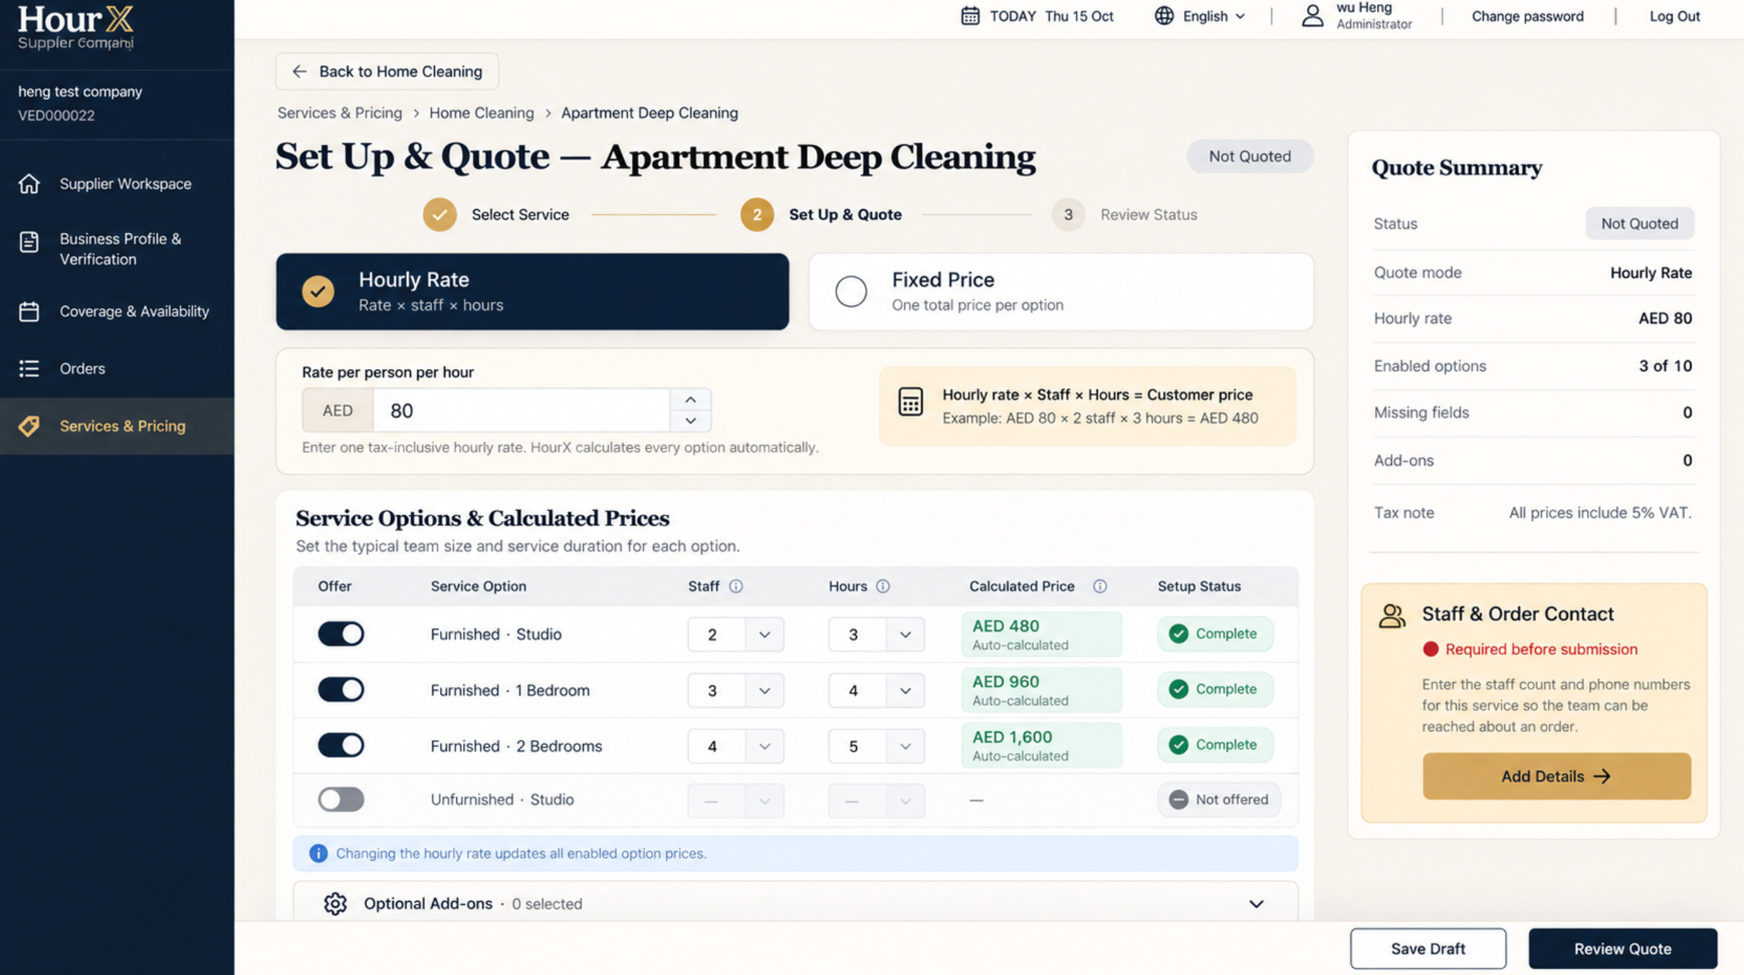
图 10 按小时报价页面
Figure 10 Hourly Rate quotation page

修改要求
Required Changes
- 供应商只需填写一个每人每小时单价。
The supplier enters one Rate per person per hour.
- 供应商为每个启用选项填写人数和时长，系统自动计算客户价格。
The supplier enters Staff and Hours for each enabled option; the system calculates the customer price.
- 计算公式为：每小时单价 × 人数 × 小时数 ＝ 客户价格。
Use the formula Hourly Rate × Staff × Hours = Customer Price.
- 自动计算的价格不可手动编辑，并在每小时单价变化时同步更新。
Calculated prices are read-only and update when the hourly rate changes.
- 所有显示价格均包含 5% 增值税。
All displayed prices include 5% VAT.

6.2 一口价
6.2 Fixed Price
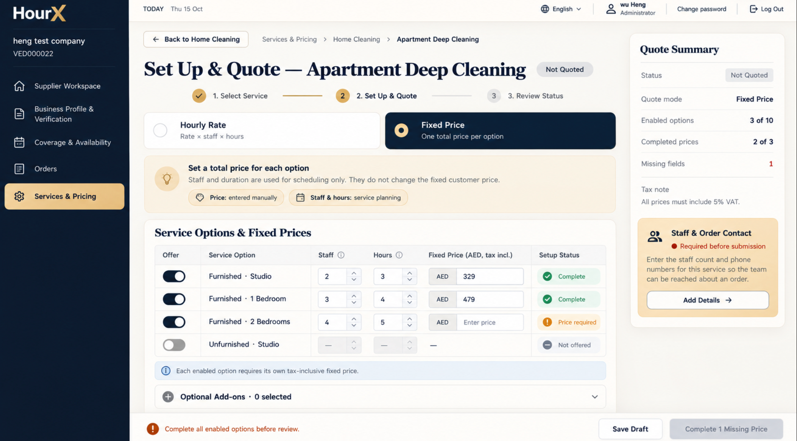
图 11 一口价报价页面
Figure 11 Fixed Price quotation page

修改要求
Required Changes
- 每个启用的服务选项分别填写一口总价。
Enter a separate fixed total price for every enabled service option.
- 人数和时长只用于人员安排和排班，不参与一口价计算。
Staff and Hours are used for planning and scheduling only and do not calculate the fixed price.
- 缺少价格时显示“需要填写价格”，并计入“缺失字段”。
Show Price Required for missing values and include them in Missing Fields.
- 未提供的选项不要求填写人数、时长或价格。
When an option is not offered, do not require staff, hours or price.
- 所有必需的一口价填写完整前，禁用“审核报价”按钮。
Disable Review Quote until all required fixed prices are complete.

7 检查并提交
7 Review & Submit
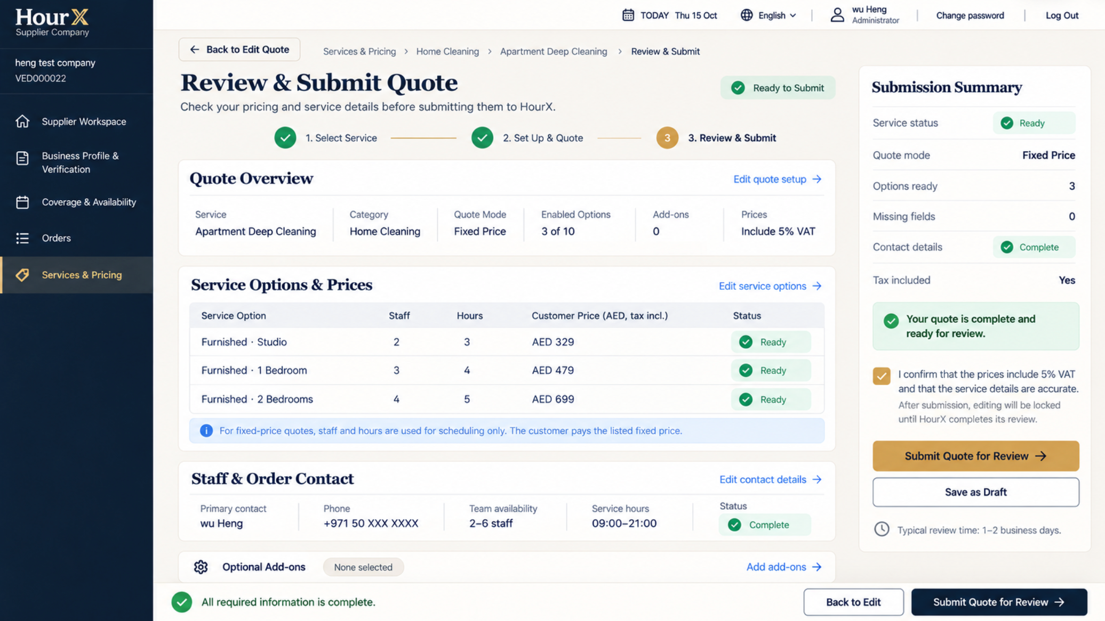
图 12 最终报价检查与提交页面
Figure 12 Final quotation review and submission page

修改要求
Required Changes
- 第三步命名为“检查并提交”，只有提交后才显示“审核中”。
Name the third step Review & Submit. Show Under Review only after submission.
- 汇总报价模式、已启用选项、人数、时长、客户价格、联系人信息和附加项。
Summarize quote mode, enabled options, staff, hours, customer prices, contact details and add-ons.
- 提交前要求确认价格包含 5% 增值税，且所有提交信息准确无误。
Require confirmation that prices include 5% VAT and the submitted details are accurate.
- “返回编辑”回到第 2 步；“提交报价审核”将报价发送给 HourX。
Back to Edit returns to Step 2; Submit Quote for Review sends the quotation to HourX.
- 提交后锁定编辑，并显示预计审核时间为 1 至 2 个工作日。
Lock editing after submission and show an expected review time of 1–2 business days.

报价状态规则
Quotation Status Rules
状态  Status | 页面表现  Page Behaviour | 供应商操作  Supplier Action
未报价  Not Quoted | 尚未提交报价，所有字段均可编辑。  No quotation has been submitted; all fields remain editable. | 设置并报价  Set Up & Quote
草稿  Draft | 保存未完成内容并提示缺失字段。  Save incomplete work and identify missing fields. | 继续报价  Continue Quote
审核中  Under Review | 锁定编辑，并显示提交日期和审核进度。  Lock editing and show the submission date and review progress. | 查看已提交报价  View Submitted Quote
已通过  Approved | 已通过价格继续生效；修改后生成新的审核草稿。  Keep approved prices live; changes create a new review draft. | 管理价格  Manage Pricing
需要处理  Action Required | 显示退回原因，并重新开放相关字段。  Show the rejection reason and reopen the relevant fields. | 修改并重新提交  Update & Resubmit

最终验收清单
Final Acceptance Checklist
- 所有页面的左侧导航名称、供应商身份和状态保持一致。
Left navigation labels, supplier identity and status remain consistent on every page.
- 所有返回按钮都要写明目的页面，不使用含义不清的“返回”或“编辑”。
Every return action names its destination; do not use ambiguous Back or Edit labels.
- 每种服务和报价状态只对应一个清晰可执行的操作。
Each service and quotation status maps to one clear available action.
- 页面内清楚说明按小时报价与一口价的计算规则。
Hourly Rate and Fixed Price calculation rules are explained on the page.
- 供应商提交前可以核对全部信息，提交后锁定编辑。
Suppliers can verify all details before submission; editing is locked after submission.
- 桌面端页面无需横向滚动，按钮、状态和表格字段不得被截断。
Desktop pages require no horizontal scrolling and do not truncate buttons, statuses or table fields.

