# 目标

物体检测或者行人检测，网络速度提升2倍

# 方法

Baseline：lightweight network + ssd lite

Optimise：cascade filter, inception block improve, ssd improve

Cascade filter:

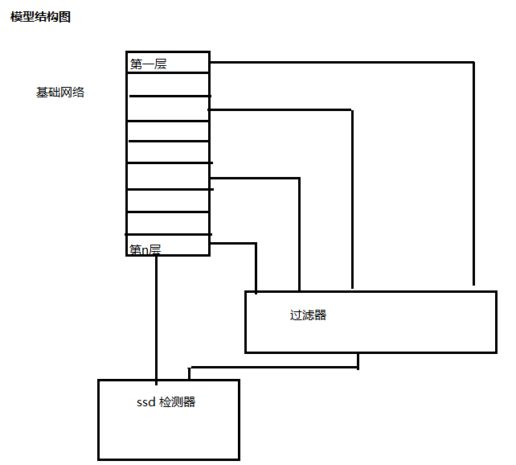

# 问题

1 Does cascade filter idea work？

2 how to merge with mobilenet + ssd

# 论文结构

1 Introduction

object detection promise, DNN advantage(accurate) and dis(slow )(why: too much redundant parameters), SSD advantage and dis.

We propose a new function to overcome these dis to make DNN faster without accurate dropped sharply.

2 Recent work:

pruning, compress, distilling, lightweight framework: shufflenet , mobilenet + ssd lite etc.

Pruning

Advantage: could prune much parameters.

Dis:prune metric is hard to set and implement is complex and real speed up depends on implement

Compress:

Advantage: could decrease model size sharply

Disadvantage: speed up is rare.

Distilling:

Advantage: good performance

Disadvantage: need a good model first, the process and result is black box

Lightweight framework:

Advantage: small cell has been optimized and makes state of the art performance. Architecture is clear and easy to organize and extend.

Dis: Architecture’s organize principle is summarized from rather much lab data.

3 Our method

Make a cascade filter:

Merge into mobilenet ssd lite.

4 Experiment data & **Comparison**

Performance describe:

Compare with original:

Compare with other state of the art:

5 Conclusion

We make a new function.

Advantage:

Improvement could make later:

6 Inference