**Part 1: Load data**

1. The code takes as input the yields of the bonds (**US Treasury Yield Curve T-Note Constant Maturity**) in Excel. It mentions “Index” because normally there are no bonds of exactly that maturity available, so they interpolated it from the available bonds.
2. Data from June, 1976. There’s no data for 2 years bond before that date.
3. Monthly data, as the paper suggests.
4. Forward rates only available for 1, 2, 3, 5 and 7 years.
   1. **Assumption!** 4 and 5 forward rates are equal, and 6 and 7 the same.

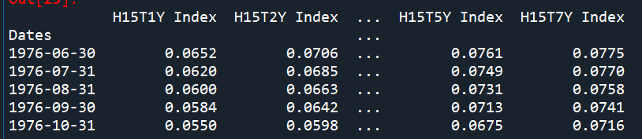

1. Returns the forward rates to a csv, that can be imported from the next code.

