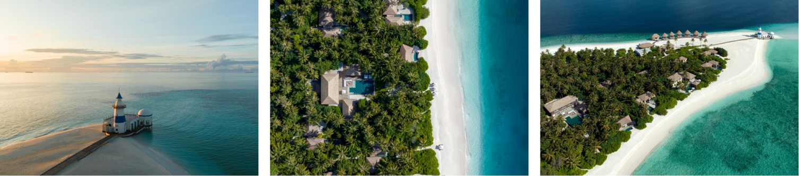

**Welcome to**

**InterContinental Maldives Maamunagau Resort***“Where time stops and beautiful stories unfold”’*

Mr. Mohamed Wishan

**Kastanj Collection**

It is our pleasure to welcome you to our island home in beautiful Raa Atoll. We are looking forward to creating memorable moments for you. Please have a look at the below itinerary we curated for you and do not hesitate to reach out to your Island Curator or our Sales & Marketing team for assistance anytime.

Please note that we are +1 hour ahead of Male time.

|  |  |
| --- | --- |
| Stay Dates: | 10 to 15 July 2025 |
| Meal Plan: | All Inclusive |
| Inclusions: | Club InterContinental Benefits:  Afternoon Tea from 03.00 pm – 05.00 pm,  Aperitif Hours from 05.00 pm – 07.00 pm  Poolside Refreshments from 11.00 am - 06.00 pm  20% Discount on spa treatments at AVI spa  *Not applicable for treatments with visiting practitioners* 20% Discount on activities at the Marine Centre  The below activities are complimentary. For any additional activities outside the itinerary charges may apply. |

|  |  |
| --- | --- |
| ${dates} | |
| ${time} | ${main}  *${sub}* |

${table_placeholder}