Lab Report: Unified Kill Chain

Author: Vineeth M
Date: May 1, 2026

Aim
The aim of this lab was to understand the Unified Kill Chain (UKC) framework and how it helps analyze cyber attacks from reconnaissance to objectives. The lab also showed why kill chain models are useful for improving cybersecurity posture and threat modelling.

Introduction
The term kill chain originates from the military and is used in cybersecurity to describe the stages an attacker follows to compromise a target. The Unified Kill Chain, introduced by Paul Pols in 2017, is a modern framework with 18 attack phases and is designed to complement frameworks such as Lockheed Martin’s Cyber Kill Chain and MITRE ATT&CK. It helps defenders understand attacker behaviour, methods, and goals.

Unified Kill Chain Phases
The UKC organizes attacks into phases such as reconnaissance, weaponization/resource development, delivery, exploitation, persistence, defense evasion, command and control, pivoting/lateral movement, collection, exfiltration, impact, and objectives. In the room, these phases were grouped into three broad goals: In (initial foothold), Through (network propagation), and Out (action on objectives). This structure makes it easier to understand what an attacker is trying to do at each stage.
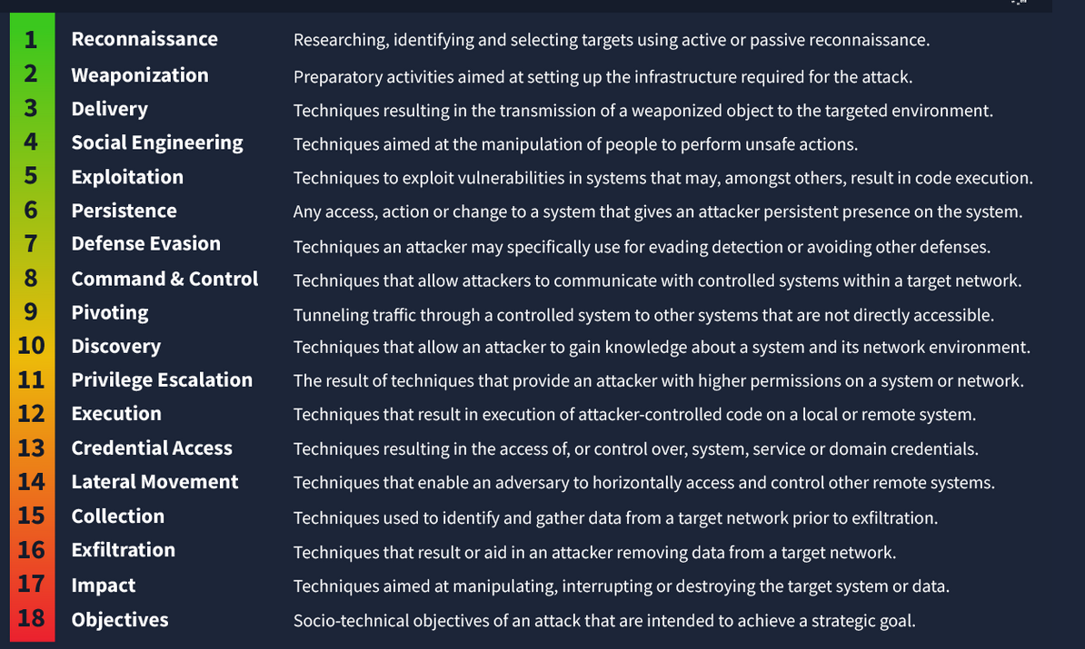
The UKC”s 18 phases to an attack.
These 18 phases were grouped into three broad goals: In (initial foothold), Through (network propagation), and Out (action on objectives). The UKC”s 18 phases to an attack.

In: Initial Foothold
This phase describes how an attacker first gains access to a target system or network. It includes activities such as reconnaissance, resource development, delivery, social engineering, exploitation, persistence, defense evasion, and command and control. In simple terms, this is the stage where the attacker breaks in and establishes a starting point inside the environment.

Through: Network Propagation
This phase begins after the attacker has gained access. The attacker tries to move deeper into the network by discovering internal systems, escalating privileges, accessing credentials, executing malicious actions, pivoting to other machines, and moving laterally. The goal here is to expand control and increase access across the network.

Out: Action on Objectives
This is the final phase, where the attacker carries out the main goal of the attack. It includes collecting data, exfiltrating information, disrupting services, causing damage, or achieving another objective such as ransomware deployment or public data release. This phase shows the impact of the attack on confidentiality, integrity, or availability.

Below are the answers from the learning tasks listed:

Question | Answer
Where does the term “Kill Chain” originate from? | Military
What is the technical term for a piece of software or hardware in IT? | Asset
In what year was the Unified Kill Chain framework released? | 2017
According to the Unified Kill Chain, how many phases are there to an attack? | 18
What phase involves techniques to evade detection? | Defense Evasion
What phase removes data from a network? | Exfiltration
What phase is where the attacker achieves objectives? | Objectives
Example of a tactic to gain a foothold using emails? | Phishing
Impersonating an employee to request a password reset is what? | Social Engineering
Setting up a Command & Control server is what phase? | Weaponization
Exploiting a vulnerability present on a system is what phase? | Exploitation
Moving from one system to another is an example of? | Pivoting
Leaving behind a malicious service for later access is what? | Persistence
Failed logins from an administrator account relate to what phase? | Privilege Escalation
Mimikatz dumping secrets relates to what phase? | Credential Access
Big traffic to an unknown IP address relates to what phase? | Exfiltration
PII released publicly affects which CIA element? | Confidentiality
Final flag from the practical | THM{UKC_SCENARIO}

