Lab Wazuh Report : TryHackMe

Author : Vineeth M
Date: May 4 , 2026

Lab Overview:

- Platform: TryHackMe
- Room Name: Wazuh
- Lab Type: Interactive Learning Lab

Purpose of the Lab :
The purpose of this lab is to provide a practical environment for mastering a comprehensive security platform Wazuh SIEM that integrates endpoint protection, log analysis, and vulnerability management. It allows for the hands-on configuration of agents to monitor system integrity, identify potential security flaws against global vulnerability databases, and visualize complex event logs to effectively detect and respond to suspicious activity.

Task 1 : Introduction

Wazuh is an open-source cybersecurity platform used for threat prevention, detection, and response. It helps organizations monitor endpoints, analyze logs, detect suspicious activity, assess vulnerabilities, and support compliance requirements. Wazuh uses an agent and manager model, where agents collect data from monitored devices and the manager receives, processes, and analyzes that data. Because of these features, Wazuh is useful for improving visibility, strengthening security monitoring, and identifying threats early.

Wazuh basics
Wazuh is a unified security platform used for endpoint monitoring, threat detection, and compliance reporting. It works using a manager-and-agent model, where agents send data to the manager for processing and analysis.
Answers in Introduction:
- Wazuh was released in 2015.
- A monitored device is called an agent.
- The device that manages them is called the manager.
Task 2: Deploy Wazuh Server

Task 2: Accessing the Wazuh dashboard
In this task, we connected to the Wazuh management server using the provided machine IP address through the browser at https://MACHINE_IP. After the server finished loading, we logged in using the supplied username and password. Once authenticated, we selected Global Tenant to access the dashboard and continue with the lab.

Task 3: Wazuh Agents

Agents are devices that collect logs and events such as authentication and user activity, then send them to the Wazuh server for processing. They must be installed on endpoints so Wazuh can monitor them

The deployment wizard helps you set up an agent more easily by guiding you through the basic details needed for installation. It lets you choose the operating system, enter the Wazuh server address, and assign the agent to a group.

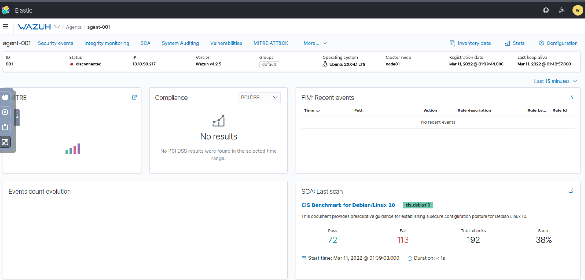
The two agent status is Disconnected here.

Task 4: Wazuh Vulnerability Assessment & Security Events

Vulnerability assessment module
Wazuh’s Vulnerability Assessment module scans each agent’s operating system to detect installed software and version numbers, then compares that inventory with CVE data to identify known weaknesses. In this task, that is how Wazuh can flag a package such as vim as vulnerable to CVE-2019-12735 when the installed version matches a known affected release.

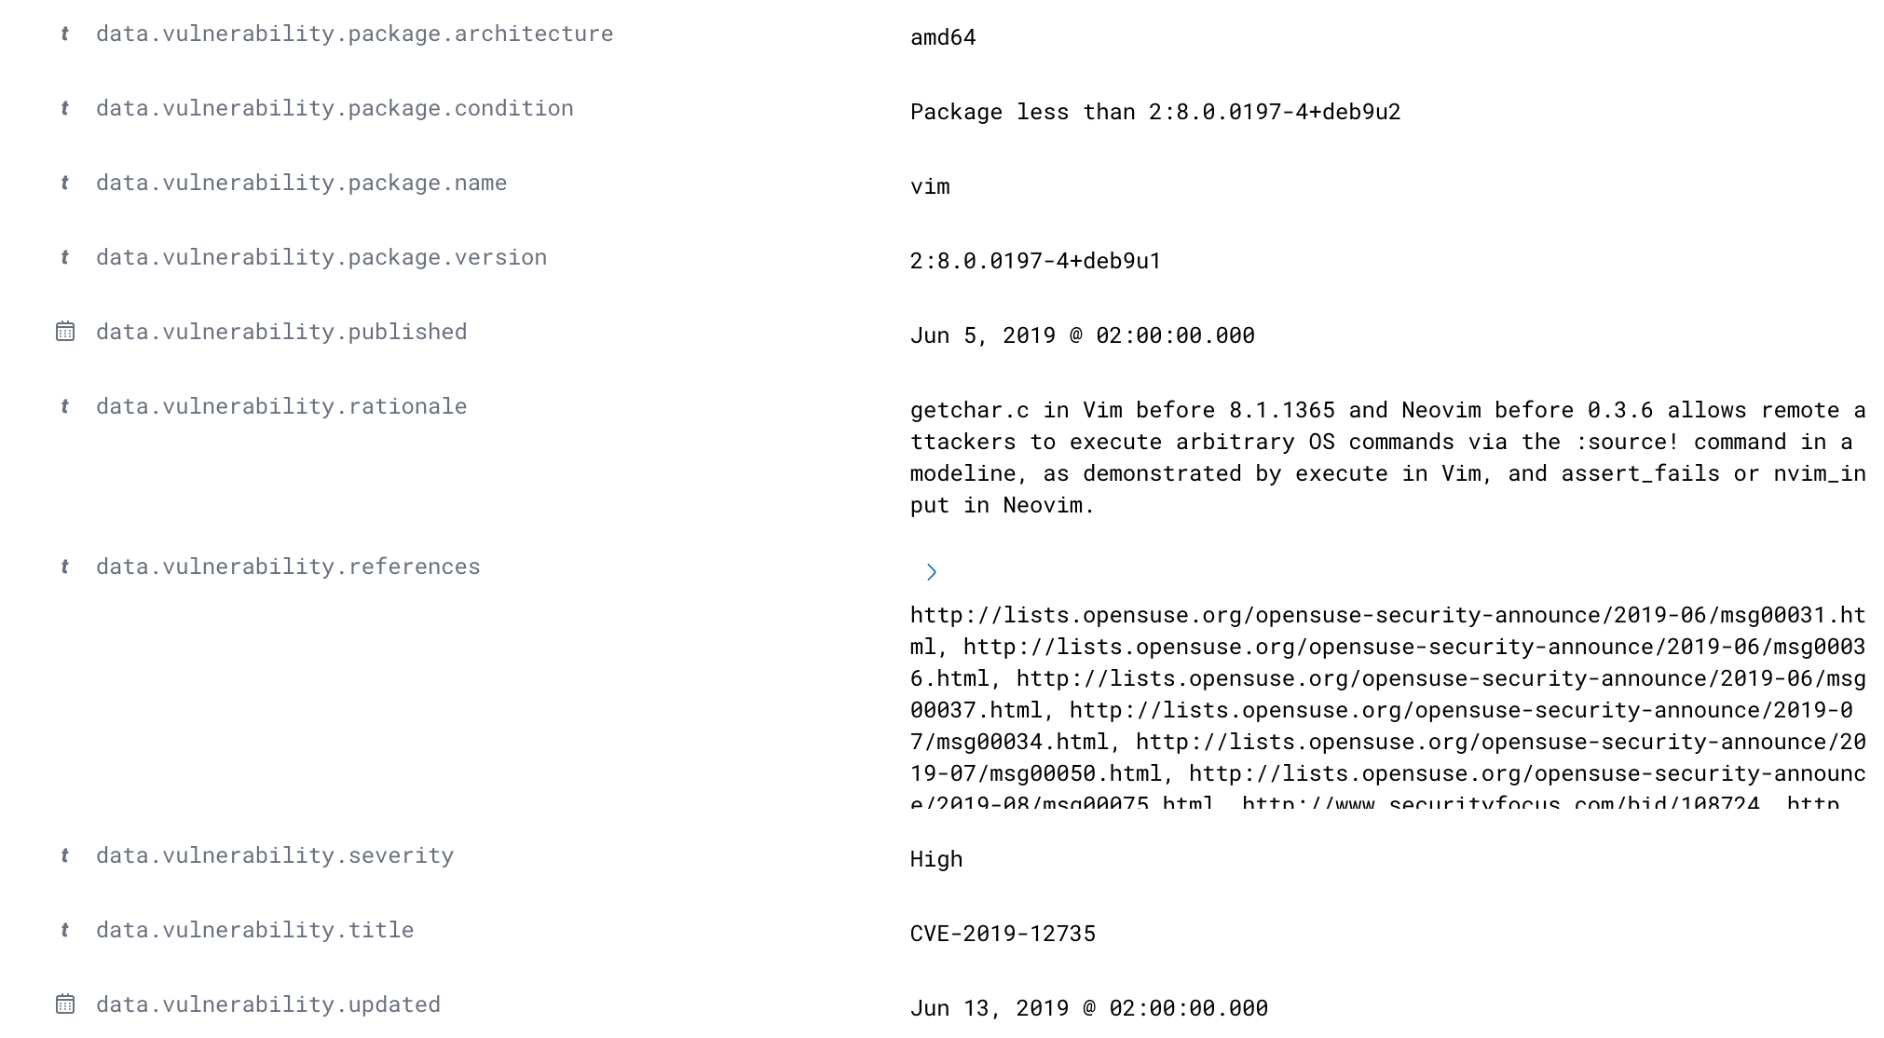

Version of Vim that is vulnerable to CVE-2019-12735

The module depends on the agent collecting software inventory, and the manager correlates that data with vulnerability intelligence. This makes it useful for continuously identifying exposed packages without manually checking each host.

Scan interval
When vulnerability detection is enabled, Wazuh can be configured to run scans at regular intervals instead of only once at installation. A common configuration uses an interval of 5 minutes, with settings such as

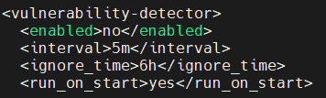

Configuring the management server to audit agents for vulnerabilities frequently in (/var/ossec/etc/ossec.conf)

so that the first scan happens at startup and later scans repeat on schedule.
In practice, this means Wazuh performs an initial full scan when the agent is installed, then continues checking for changes at the configured interval. The ignore_time setting helps prevent duplicate alerts for the same vulnerability from being generated too often.

Security events and compliance
Wazuh can also test an agent’s activity and configuration against built-in rulesets to support compliance monitoring. Out of the box, this can be sensitive, so normal maintenance actions may be flagged as security events even when they are not malicious.
For example, frequent system actions such as removing files, checking system integrity, or other routine maintenance operations can trigger alerts depending on the active ruleset. This is why Wazuh security events often need tuning so that expected behavior is not treated as suspicious activity.

Task 5 : Wazuh Policy Auditing

Wazuh’s Security Configuration Assessment (SCA) module audits an endpoint’s configuration against policy files and reports whether the host meets expected security and hardening standards. It also helps map results to compliance frameworks such as NIST 800-53 and GDPR, while Wazuh detections can be correlated with MITRE ATT&CK for broader security context.

When an agent is installed, Wazuh begins collecting and evaluating configuration and event data so you can track the system’s security posture over time. The platform presents this information through dashboards and visualizations, which makes it easier to break down large volumes of logs into understandable findings for auditing and reporting.

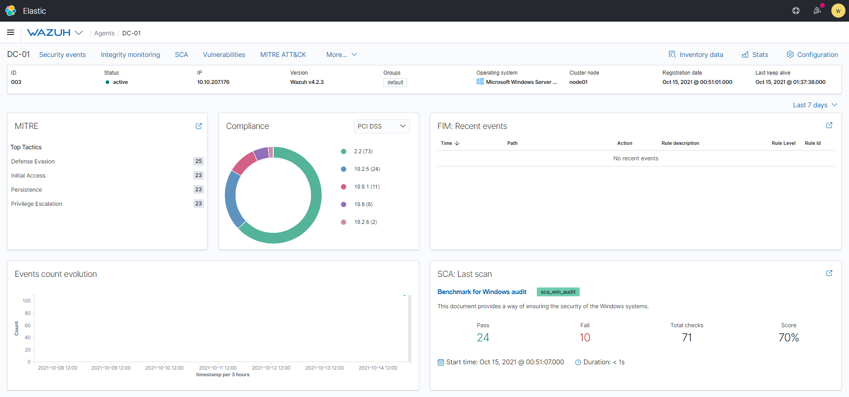
This pitcher shows how Agent DC-01 score against MITRE , NIST , SCA

Task 6: Monitoring Logons with Wazuh

Wazuh’s security event monitoring capabilities allow it to detect and analyze both successful and unsuccessful authentication attempts. This is a critical component for identifying suspicious activity, such as brute-force attacks, and maintaining visibility over user access patterns.

Authentication Monitoring
The system uses pre-defined rules to categorize authentication events. For example:
- Rule ID 5710: Detects failed authentication attempts, such as when an invalid user tries to log in.
- Rule ID 5501: Identifies successful login sessions (e.g., "PAM: Login session opened"), which are mapped to MITRE ATT&CK techniques like T1078 (Valid Accounts) to help security teams track authorized vs. unauthorized access.

Analysis and Reporting
Wazuh enables deep analysis of these events through its management dashboard. By navigating to Wazuh → Management → Rules, administrators can view, search, and modify the rulesets that trigger these alerts.

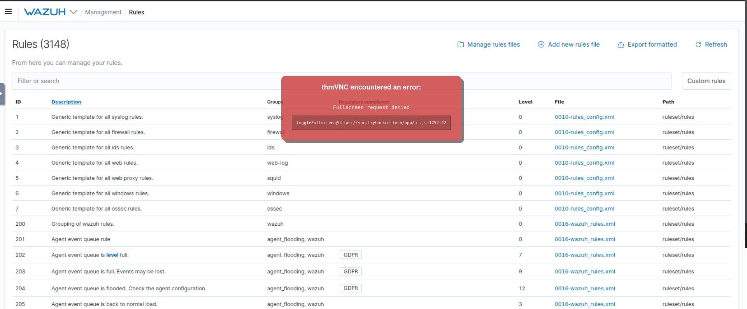
Administrators can view ,search, modify rules here.

Additionally, raw authentication event logs are stored directly on the Wazuh management server at the following path:
/var/ossec/logs/alerts/alerts.log

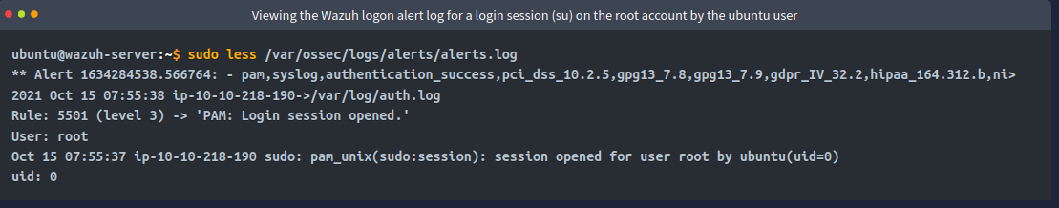

Task 7 Collecting Windows Logs with Wazuh

To monitor Windows endpoints effectively, Wazuh can be integrated with Sysmon (System Monitor), a tool that provides detailed logs on process creation, network connections, file access, and service behavior. This process involves configuring the endpoint, the Wazuh agent, and the Wazuh management server.

1. Configure and Install Sysmon
Sysmon uses an XML-based configuration file to determine which activities to monitor (e.g., PowerShell process monitoring).
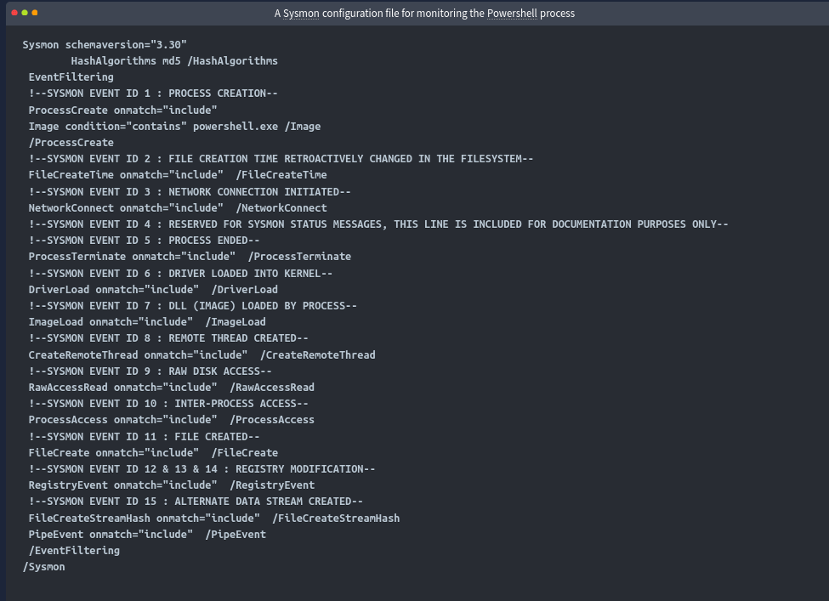
- Execution: Run the Sysmon application from a command prompt with administrator privileges to apply your configuration:
Sysmon64.exe -accepteula -i detect_powershell.xml
- Verification: After installation, verify that Sysmon is active by opening the Event Viewer on your Windows server and checking the Applications and Services Logs > Microsoft > Windows > Sysmon > Operational channel.

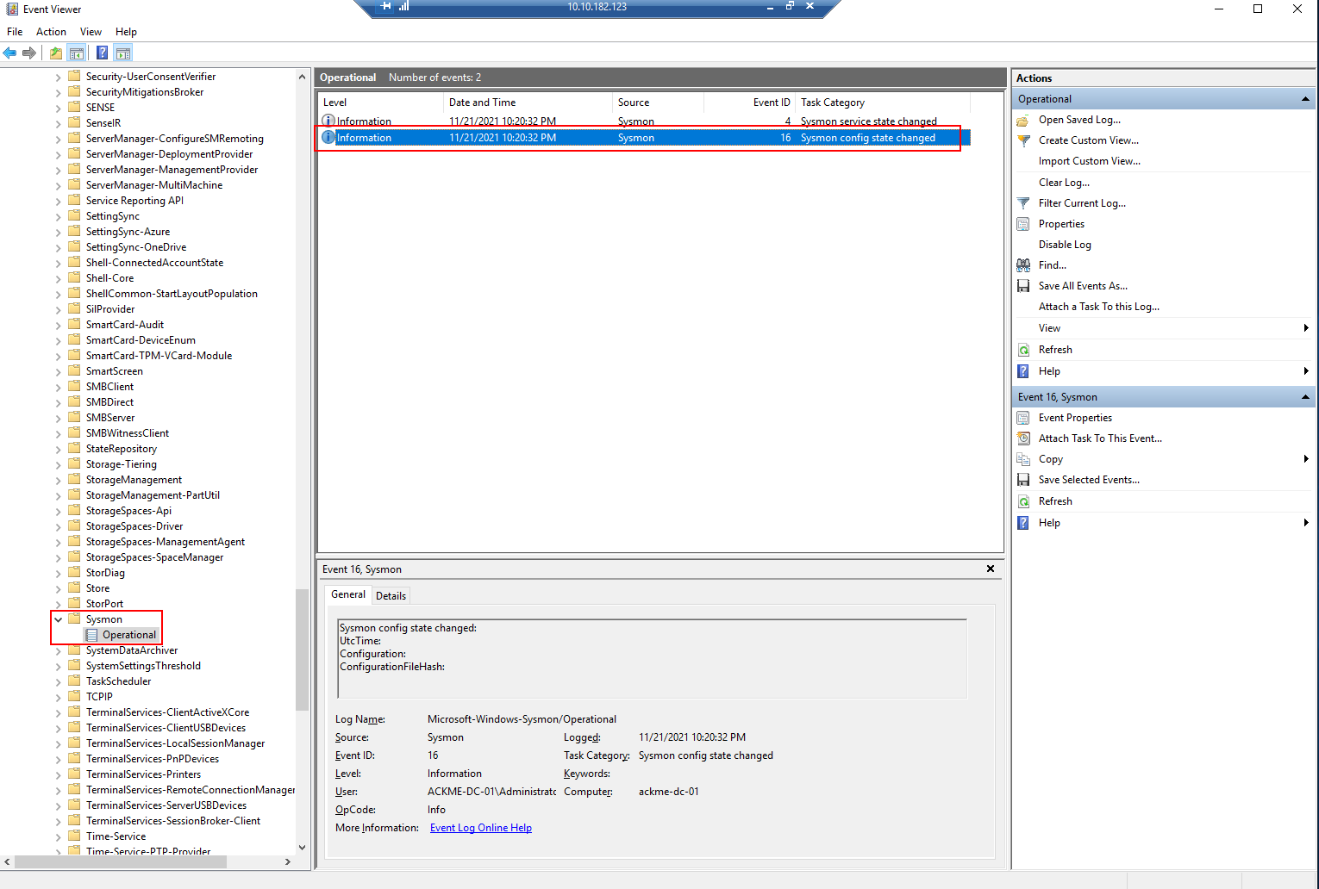

verifying that Sysmon is active by opening the Event Viewer

2. Configure the Wazuh Agent
Once Sysmon is generating events, we must instruct the Wazuh agent to collect them and send them to the management server.
- File Location: Open the Wazuh agent configuration file located at: C:\Program Files\ossec-agent\ossec.conf
- Configuration: Add the following <localfile> block within the <ossec_config> section to enable Sysmon log collection:
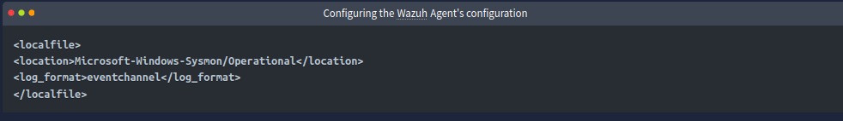

- Restart: Save the file and restart the Wazuh agent service to apply the new configuration.

3. Configure the Wazuh Server
Finally, we need to add rules to the Wazuh management server so it can interpret and visualize the incoming Sysmon events.
- File Location: Edit the local rules file on the Wazuh server: /var/ossec/etc/rules/local_rules.xml
- Configuration: Insert your custom XML rule set for Sysmon events into this file. After saving, restart the Wazuh manager service to finalize the setup.

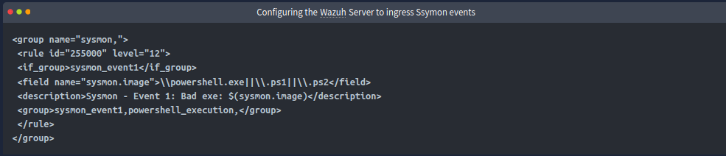

we will need to restart the Management server for this to apply

By completing these steps, we enable the Wazuh manager to ingest detailed telemetry from your Windows endpoints, allowing for robust monitoring and alerting of critical activities like PowerShell usage.

Task 8: Collecting Linux Logs with Wazuh

Collecting logs from Linux endpoints is a streamlined process similar to Windows log collection. By configuring the log collector service on the Wazuh agent, you can specify exactly which application logs (such as Apache2) should be forwarded to the Wazuh management server for analysis.

Monitoring Application Logs
Wazuh includes an extensive built-in ruleset containing approximately 900 pre-defined rules, located in /var/ossec/ruleset/rules/. These rules allow the platform to automatically parse and interpret logs from common applications like Docker, FTP, WordPress, SQL Server, and MongoDB.
For Apache2 web server monitoring, Wazuh uses the 0250-apache_rules.xml ruleset, which is capable of detecting various warnings, errors, and authentication events within your web server logs.

Agent Configuration
To start collecting these logs, you must modify the configuration file on the Linux server running the Wazuh agent:
- Access the Config File: Open the configuration file located at /var/ossec/etc/ossec.conf.
- Add Log Collector: Within the <ossec_config> section, insert a <localfile> block to point Wazuh to the Apache2 log files:
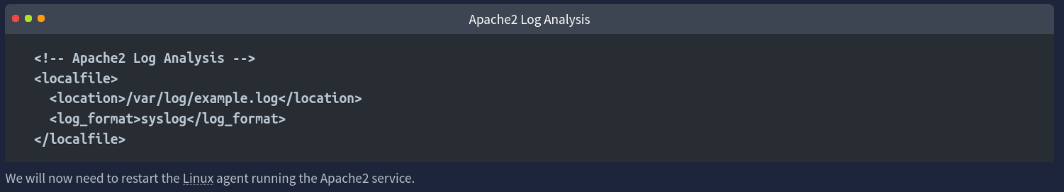
- Restart Services: Once the configuration is updated, restart the Wazuh agent service and the Apache2 service to ensure the changes take effect and log collection begins.

Task 9: Auditing Commands on Linux with Wazuh

To monitor sensitive activities on Linux systems—such as commands executed with root privileges or attempts to access critical files like /etc/passwd—Wazuh integrates with the auditd package. By capturing system-level events and forwarding them to the Wazuh management server, administrators can gain real-time visibility into potential security breaches.

Installing and Enabling Auditd
The first step is to ensure auditd and its plugins are installed and active. Run the following commands to install the package and enable it to start automatically on boot:
bash

sudo apt-get install auditd audispd-plugins

sudo systemctl enable auditd.service

sudo systemctl start auditd.service

Configuring Audit Rules
You must specify which events auditd should monitor by editing the rules configuration file.
- Edit the rules file: Open /etc/audit/rules.d/audit.rules.
- Add the monitoring rule: Append the following line to monitor all commands executed with root privileges (euid=0):
-a exit,always -F arch=64 -F euid=0 -S execve -k audit-wazuh-c
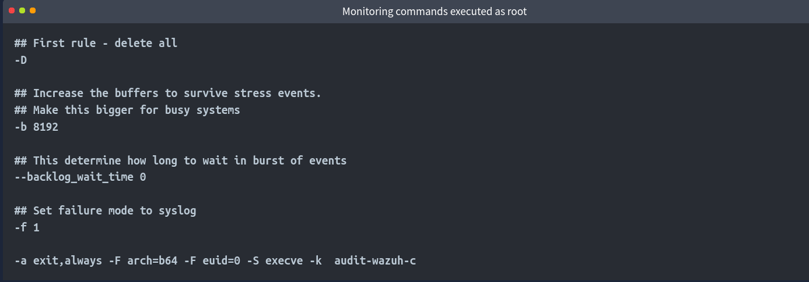

- Apply the changes: Inform auditd of the new rule by running:
sudo auditctl -R /etc/audit/rules.d/audit.rules

Configuring the Wazuh Agent
Once auditd is capturing these events, you must configure the Wazuh agent to read the generated logs and forward them to the Wazuh manager.
- Access the Config File: Open the Wazuh agent configuration file at /var/ossec/etc/ossec.conf.
- Add Log Collector: Include a <localfile> block to monitor the auditd log file:
xml

<localfile>
<location>/var/log/audit/audit.log</location>
<log_format>audit</log_format>
</localfile>

- Restart the Agent: Save the changes and restart the Wazuh agent service to begin sending the audit logs to the manager for processing and alerting.
By implementing these configurations, you can detect unauthorized or suspicious command execution in real-time, providing an essential layer of security for your Linux infrastructure.

Task 10: Using the Wazuh API

The Wazuh API is a powerful RESTful interface that allows administrators to interact with the Wazuh management server programmatically, enabling automation and integration with other security tools.

Authenticating and Interacting via CURL
To interact with the API, you must first authenticate and obtain a JSON Web Token (JWT), which must then be included in the header of all subsequent requests.

- Authentication: Obtain your token using your credentials:
TOKEN=$(curl -u : -k -X GET "https://WAZUH_MANAGEMENT_SERVER_IP:55000/security/user/authenticate?raw=true")
- Test the Token:
curl -k -X GET "https://MACHINE_IP:55000/" -H "Authorization: Bearer $TOKEN"
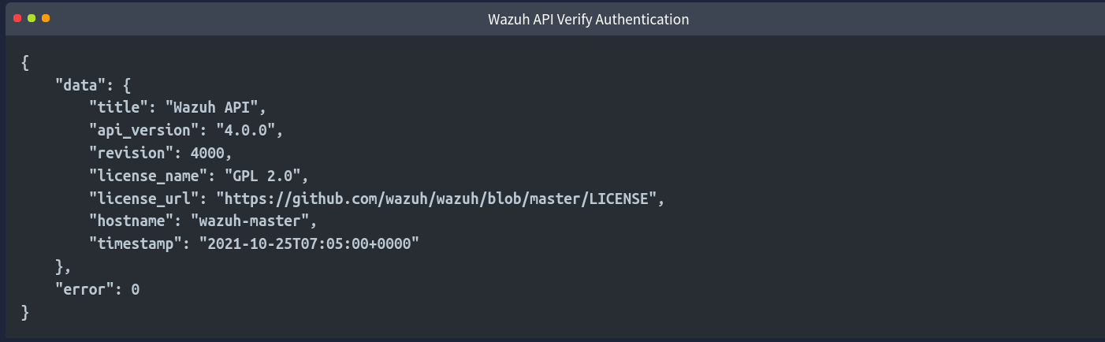

The picture is the successful response from the second command.

3. Standard Requests: You can use standard HTTP methods like GET, POST, PUT, or DELETE by providing the relevant option after the -X flag. For example, to check the manager status or retrieve configuration details:
For example, let’s use the Wazuh API to list some statistics and important information about the Wazuh management server:

curl -k -X GET "https://MACHINE_IP:55000/manager/configuration?pretty=true&section=global" -H "Authorization: Bearer $TOKEN"

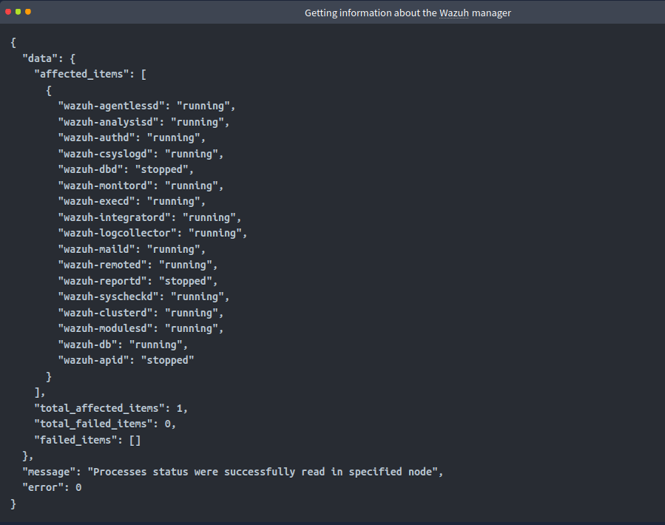
--

Or perhaps, we can use the management server’s API to interact with an agent info from the sever:
curl -k -X GET "https://MACHINE_IP:55000/agents?pretty=true&offset=1&limit=2&select=status%2Cid%2Cmanager%2Cname%2Cnode_name%2Cversion&status=active" -H "Authorization: Bearer $TOKEN"

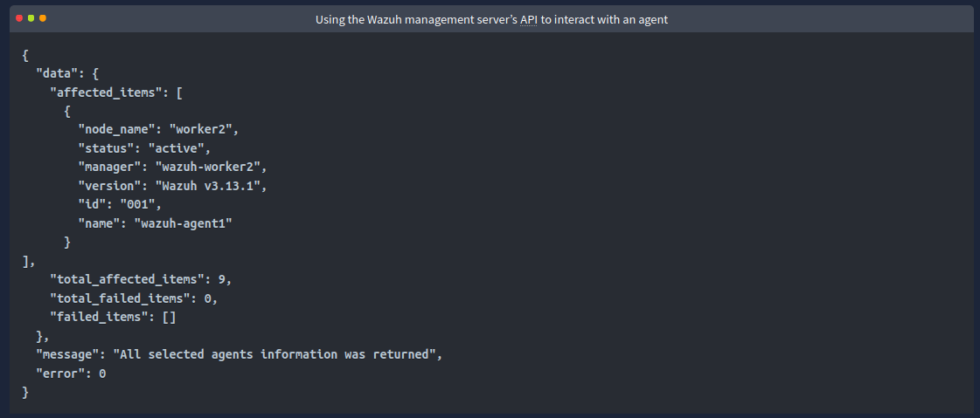

Using the Built-in API Console
For tasks that do not require complex scripting, Wazuh provides an integrated API Console directly within the Wazuh dashboard. This is a user-friendly interface for testing queries and managing the platform without needing a separate command-line environment.
- Access: Navigate to the Tools category within the top Wazuh heading in the web interface and select API Console.
- Operation: The console allows you to select the HTTP method (GET, POST, etc.), enter specific endpoints (e.g., /agents, /manager/configuration), and execute the requests, with results displayed immediately in the interface.
By utilizing the API, we can automate agent management, retrieve detailed statistics, and perform system configuration tasks directly through programmatic requests.

Task 11 : Generating Reports with Wazuh

Wazuh features a robust reporting module that enables users to generate summarized, formatted reports based on security events, system inventory, or compliance data. These reports are highly useful for auditing and sharing security insights across your team.

Generating a Report
You can generate a report for any view within the Wazuh dashboard, such as the Security Events module, by applying the desired time filters (e.g., the last 24 hours):
- Navigate to the Data: Access the relevant view (e.g., Modules > Security Events).
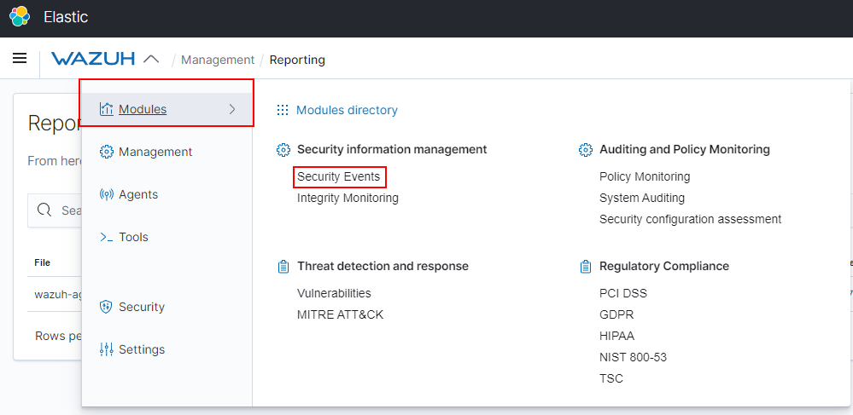

- Generate: Once the data is filtered and loaded, locate the Generate Report button (typically found in the upper-right corner of the dashboard).
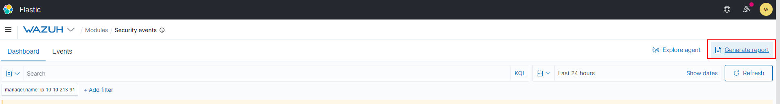
- Processing: Depending on the volume of data to be processed, report generation may take a few seconds to several minutes.

Accessing and Downloading Reports
Once a report is generated, it is stored in the reporting dashboard until you are ready to download it:
- Reporting Dashboard: Navigate to the main menu (the Wazuh heading at the top), select Management, and click on Reporting under the "Status and Reports" sub-heading.
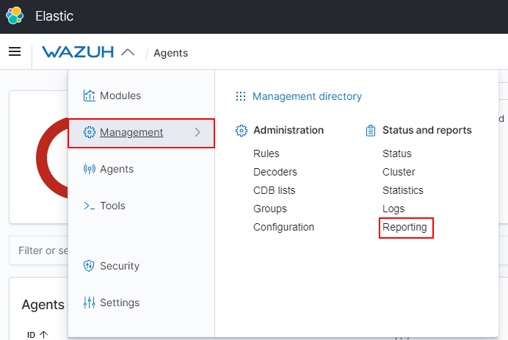
- Download: The reporting dashboard lists all available reports. To download a report as a PDF, click the save/download icon located on the right side of the desired report under the "Actions" heading.

Task 12: Loading Sample Data
To demonstrate the extensibility and reporting capabilities of Wazuh without relying on live environment data, you can import pre-bundled sample data. This is particularly useful for exploring dashboards and security event modules when the server is first set up.

Importing Sample Data
Follow these steps to load the sample datasets:
- Navigate to Settings: Open the Wazuh tab in the main header, highlight Settings, and select Sample Data.

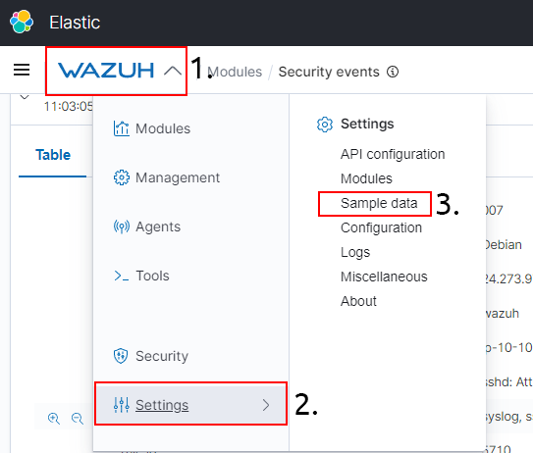

- Add Data: You will be presented with cards representing different datasets (e.g., sample security info, threat detection). Click the Add Data button on each card you wish to import.
- Completion: Importing may take up to a minute per dataset. The data is successfully imported once the card button changes to "Remove data".

