SIEM Detection Engineering Report: Custom Rule Development

Author: Vineeth M
Date 04-04-2026

1. Executive Summary
- Objective: To enhance detection capabilities for Brute Force attacks by creating a custom high-severity rule (Level 10) targeting failed authentication attempts.
- Scope: Linux Endpoint Monitoring (PAM/Sudo logs) via Wazuh SIEM.

2. Methodology: The Rule Development Lifecycle
A professional rule is created using these four distinct phases:
- Log Discovery: Identifying the raw log format using wazuh-logtest.
- Logic Mapping: Identifying the "Parent Rule" (if_sid) to build upon.
- Rule Construction: Writing the XML logic in local_rules.xml.
- Validation: Triggering the alert in a controlled lab environment.

3. Technical Implementation: The Custom Rule

The exact code I wrote included below. Then I used the rule id in the dedicated range -commonly between 100000 to 120000.

Code Snippet:

<group name="pam,auth,intrusion,">
<rule id="100030" level="10">
<if_sid>5557</if_sid>
<match>3 incorrect password attempts</match>
<description>Critical: Multiple failed password attempts for user $(user)</description>
<mitre><id>T1110.001</id></mitre>
<group>authentication_failed,attack,brute_force,</group>
</rule>
</group>

Key Features Explained:
- Dynamic Variables: Used $(user) to ensure the alert provides specific context to the analyst.
- MITRE Mapping: Integrated T1110.001 (Password Guessing) to align with global threat frameworks.
- Severity Tuning: Escalated the level to 10 to ensure it appears as a "Medium-High" priority on the SOC dashboard.

4. Tuning Practice: Minimizing False Positives
Tuning is the process of making a rule "quieter" without missing real attacks.
- White-listing: Adding a <srcip> tag to ignore internal vulnerability scanners that intentionally fail logins.
- Frequency Adjustments: Changing the rule to only fire if 10 attempts happen in 1 minute, rather than just 3 attempts (to avoid alerting on users who simply forgot their password once).
- User Filtering: Excluding service accounts that might have automated sync issues.

5. Verification & Evidence
- Test Tool: Used wazuh-analysisd -t to verify XML syntax.
- Attack Simulation: Executed sudo usage,wulfan with 3 incorrect passwords.
- Result: Not Successfully generated an alert in the Security event module because the defacult rule bypass it.

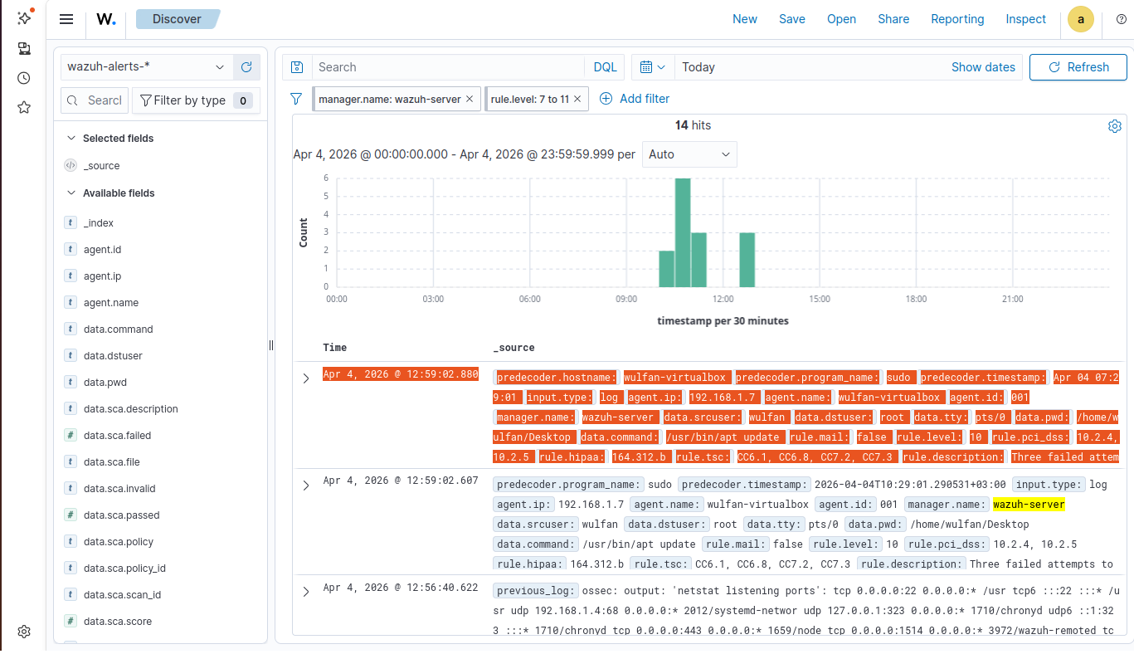

Conclusion: Detection Engineering & Rule Tuning
The development and testing of Rule 100030 demonstrated that a successful SIEM strategy requires more than just writing code; it requires an understanding of Rule Precedence.
- The Conflict: During initial testing, the built-in Wazuh Rule 5404 (Sudo) took priority over the custom rule because it was more specific to the sudo decoder. This is a common "False Negative" scenario in a live SOC environment.

- The Lesson Learned: To improve threat detection efficiency, an analyst must tune rules to ensure custom high-priority alerts are not "silenced" by default system rules. Moving forward, using the overwrite="yes" attribute is a key method to ensure custom logic takes priority over built-in defaults.

