ELK Stack Installation & Configuration Document

Author: Vineeth M
Date: May 12, 2026

1. Introduction
The ELK Stack consists of Elasticsearch, Logstash, and Kibana, with beats used on the client machine to collect and ship logs to the server. This document explains the installation process, basic configuration steps, and how the stack is prepared for log collection and visualization. Elasticsearch and Kibana package instructions also note that Elastic signs packages with its public PGP key, which should be imported before repository-based installation.

2. System Setup
The ELK server was installed on the main server machine, while Filebeat was installed on the Lubuntu client machine to forward logs. This separation allows the client to collect local logs and send them to the ELK server for indexing and analysis. Elasticsearch’s Debian package places configuration under /etc/elasticsearch, logs under /var/log/elasticsearch, and data under /var/lib/elasticsearch; Kibana uses /etc/kibana for configuration and /var/log/kibana for logs.

3. GPG Key Installation (optional)
Before installing Elastic packages, the Elastic GPG key should be imported to verify package authenticity. The recommended command is: wget -qO - https://artifacts.elastic.co/GPG-KEY-elasticsearch | sudo gpg --dearmor -o /usr/share/keyrings/elasticsearch-keyring.gpg. This key is used to validate packages from Elastic’s repositories and is part of the official Debian installation flow for Elasticsearch and Kibana.

4. Elasticsearch Installation (Manual)
Elasticsearch 9.4.0 was downloaded as a Debian package and verified using SHA-512 before installation. The commands used were:

wget https://artifacts.elastic.co/downloads/elasticsearch/elasticsearch-9.4.0-amd64.deb

wget https://artifacts.elastic.co/downloads/elasticsearch/elasticsearch-9.4.0-amd64.deb.sha512

shasum -a 512 -c elasticsearch-9.4.0-amd64.deb.sha512

sudo dpkg -i elasticsearch-9.4.0-amd64.deb

Elastic’s documentation confirms that the .deb package can be installed manually after checksum verification.

5. Kibana Installation (Manual)
Kibana 9.4.0 was installed on the server using the Debian package method. The commands used were:

wget https://artifacts.elastic.co/downloads/kibana/kibana-9.4.0-amd64.deb

shasum -a 512 kibana-9.4.0-amd64.deb

sudo dpkg -i kibana-9.4.0-amd64.deb

Kibana’s Debian package documentation states that checksum verification should be performed before installation, and the package should match the same Elastic Stack version family used on the server.

6. Logstash Installation (Manual)
Logstash 8.17.0 was installed on the server using the Debian package file. The commands used were:

wget https://artifacts.elastic.co/downloads/logstash/logstash-8.17.0-amd64.deb

sudo dpkg -i logstash-8.17.0-amd64.deb
```
After installation, Logstash is ready to receive events from Beats or other input sources and process them through pipelines.

7. Filebeat Installation (Client side)
Filebeat was installed on the Lubuntu client machine to collect log files and forward them to the ELK server. The commands used were:

curl -L -O https://artifacts.elastic.co/downloads/beats/filebeat/filebeat-9.4.0-amd64.deb

sudo dpkg -i filebeat-9.4.0-amd64.deb
```
Filebeat is typically used as the lightweight log shipper in the Elastic Stack and can be configured to send logs to Logstash or directly to Elasticsearch.

8. Basic Configuration

The main configuration files are:
- Elasticsearch: /etc/elasticsearch/elasticsearch.yml
- Kibana: /etc/kibana/kibana.yml
- Logstash: /etc/logstash/logstash.yml and pipeline files in /etc/logstash/conf.d/
- Filebeat: /etc/filebeat/filebeat.yml

After installation, Elasticsearch is typically configured in /etc/elasticsearch/elasticsearch.yml, Kibana in /etc/kibana/kibana.yml, Logstash in /etc/logstash/logstash.yml and pipeline configuration files in /etc/logstash/conf.d/, and Filebeat in /etc/filebeat/filebeat.yml. For a server accessible from other machines, Kibana can be set to listen on all interfaces using server.host: 0.0.0.0, and Elasticsearch can be configured for network access if needed. Logstash is used to receive logs from Filebeat, process them through filters, and forward them to Elasticsearch for indexing. Elasticsearch’s documentation also notes that on first start it automatically performs security setup, including TLS and enrollment support for Kibana.

Configuration Report

1. Elasticsearch Configuration
Elasticsearch is the storage and search engine layer of the ELK stack, so its configuration focuses on cluster behavior, network access, security, and data paths. The main configuration file is /etc/elasticsearch/elasticsearch.yml, which controls how Elasticsearch runs on the server. Common settings include the cluster name, node name, network host, discovery mode, and security options. These settings are used to make Elasticsearch reachable, stable, and secure in a production or lab environment.

Typical example:
cluster.name: my-application
node.name: node-1
network.host: 0.0.0.0
discovery.type: single-node
xpack.security.enabled: true

Purpose of each setting:
- cluster.name: Identifies the Elasticsearch cluster.
- node.name: Gives the node a readable name.
- network.host: Allows the node to listen on all interfaces if remote access is needed.
- discovery.type: single-node: Used in a lab or standalone setup.
- xpack.security.enabled: Enables authentication and security features.

2. Kibana Configuration
Kibana is the visualization and management layer, so its configuration is mainly about connecting to Elasticsearch and exposing the interface to users. The main file is /etc/kibana/kibana.yml, which defines the server address, Elasticsearch connection details, and security-related settings. In a basic setup, Kibana is usually configured to listen on all interfaces so it can be accessed from another machine. Kibana also needs Elasticsearch credentials or enrollment information depending on the version and security setup.

Typical example:

server.host: 0.0.0.0
server.port: 5601
elasticsearch.hosts: ["http://localhost:9200"]

Purpose of each setting:
- server.host: Controls which network interface Kibana listens on.
- server.port: Sets the port used to access Kibana.
- elasticsearch.hosts: Tells Kibana where Elasticsearch is located.
- Security settings: Allow Kibana to authenticate with Elasticsearch and display dashboards securely.

3. Logstash Configuration
Logstash is the processing layer of the ELK stack, so its configuration defines how logs are received, transformed, and forwarded. It uses /etc/logstash/logstash.yml for general service settings and /etc/logstash/conf.d/ for pipeline configuration files. The pipeline files define the input, filter, and output stages, which is the core of Logstash operation. This makes Logstash especially useful when logs need parsing, normalization, or enrichment before being stored in Elasticsearch.

Typical pipeline example:

input {
beats {
port => 5044
}
}

filter {
mutate {
add_field => { "env" => "prod" }
}
}

output {
elasticsearch {
hosts => ["http://localhost:9200"]
index => "filebeat-%{+YYYY.MM.dd}"
}
}

Purpose of each part:
- input: Receives data from Filebeat or other sources.
- filter: Parses, cleans, and enriches the log records.
- output: Sends processed data to Elasticsearch.
- logstash.yml: Controls Logstash service-level behavior.
- pipelines.yml: Used when running multiple pipelines.

4. Filebeat Configuration
Filebeat is the lightweight log shipper installed on the client machine, and its configuration controls which logs are collected and where they are sent. The main file is /etc/filebeat/filebeat.yml, which includes input settings, output settings, and optional processing rules. In your setup, Filebeat’s job is to read log files from the Lubuntu client and forward them to Logstash or Elasticsearch. This keeps log collection efficient and centralized.
Typical example:
filebeat.inputs:
- type: filestream
id: my-filestream-id
enabled: true
paths:
- /var/log/*.log

output.elasticsearch:
hosts: [“<elasticsearch_IP>:9200”]
preset: balanced
protocol: “http” (or https)
username: “elastic”
password: “changeme”

output.logstash:
hosts: ["<logstash-ip>:5044"]

Purpose of each setting:
- filebeat.inputs: Defines which log files Filebeat reads.
- paths: Points to the log file locations.
- output.logstash: Sends logs to Logstash for processing.
- output.elasticsearch: Can be used if sending directly to Elasticsearch instead.
- processors: Adds filtering or enrichment before shipping logs.

Summary
The purpose of the full configuration is to make each ELK component do its role clearly and efficiently. Elasticsearch stores and indexes the data, Kibana displays and analyzes it, Logstash processes and transforms it, and Filebeat collects and ships the logs from the client machine. Together, these configuration files create a working pipeline from log generation to visualization.

Test 1 — Elasticsearch service & basic health
- Objective: Verify Elasticsearch is installed, running, reachable, and cluster health is green.
- Steps performed:

  - Check service status: sudo systemctl status elasticsearch
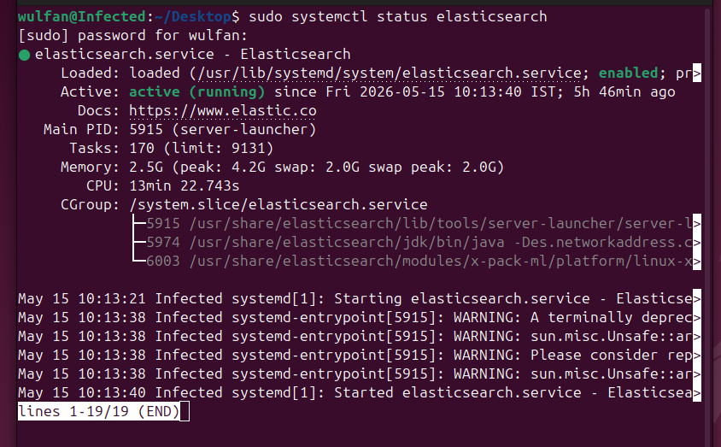
  - Verify process: ps aux | grep elasticsearch

  - Check HTTP API: http://<elasticsearch-ip>:9200/
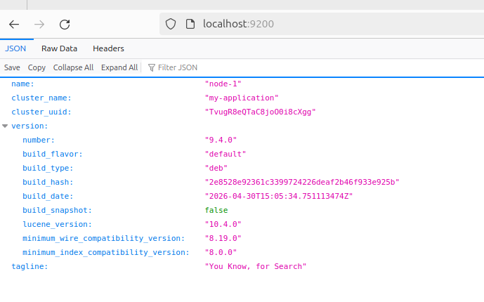

  - Check nodes: curl -s -u elastic:<password> http://<elasticsearch-ip>:9200/_cat/nodes?v
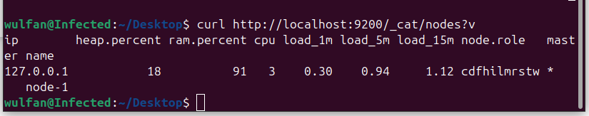
- Expected result:
  - Service active (running)
  - curl returns cluster status "green" or "yellow" (green preferred for single-node with ready indices)
  - Nodes list shows the node and roles

Test 2 — Kibana accessibility and login
- Objective: Confirm Kibana service is running, accessible remotely, and user can log in.
- Steps performed:
  - Check service: sudo systemctl status kibana
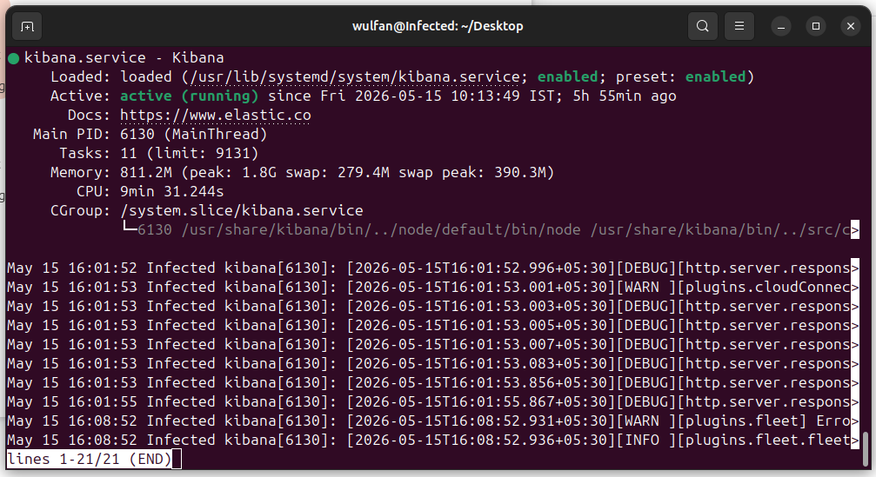

  - Verify Kibana listening port: ss -tlnp | grep 5601
  - Access in browser: http://<kibana-ip>:5601
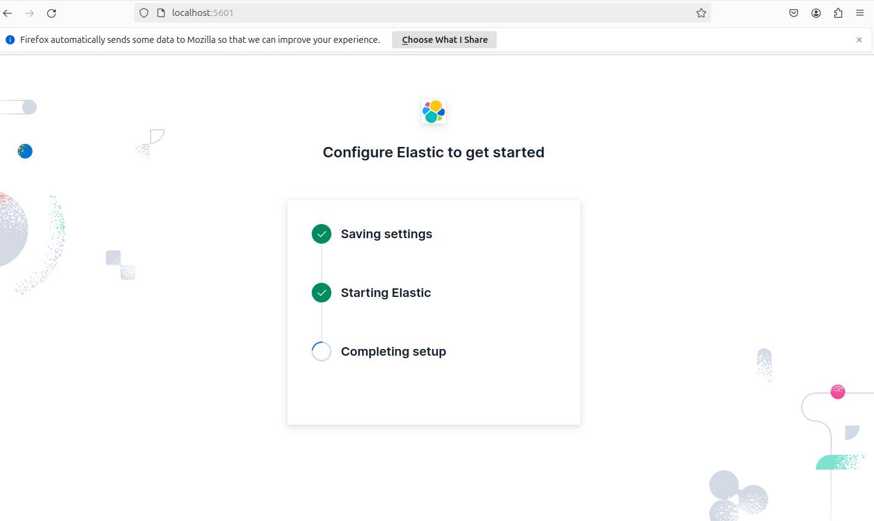

  - Login with elastic user or enrolled Kibana user
- Expected result:
  - Service active (running)
  - Port 5601 listening on server interface
  - Browser loads Kibana UI; login succeeds

Test 3 — Logstash pipeline and Beats input
- Objective: Validate Logstash receives events from Filebeat and forwards to Elasticsearch.
- Steps performed:
  - Check Logstash service: sudo systemctl status logstash
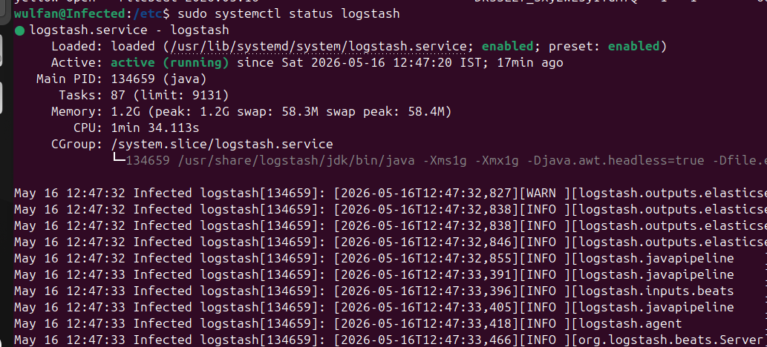
  - Confirm Logstash listening on Beats port: ss -tlnp | grep 5044
  - Tail Logstash logs: sudo tail -n 100 /var/log/logstash/logstash-plain.log
This log Contains Logstash service logs mainly used for troubleshooting and monitoring.
  - Tests whether Filebeat can successfully connect to its configured output destination.
sudo filebeat test output
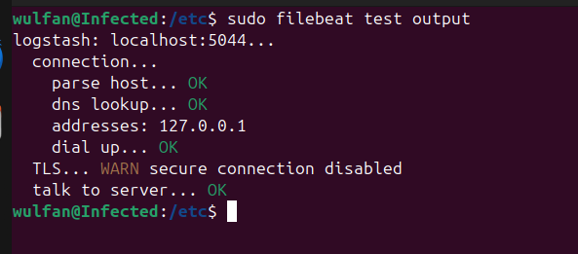
  - Verify Logstash pipelines: sudo cat /etc/logstash/conf.d/<pipeline>.conf
sudo nano /etc/logstash/conf.d/beats.conf
6. Check Elasticsearch Indices

sudo curl -X GET "localhost:9200/_cat/indices?v"
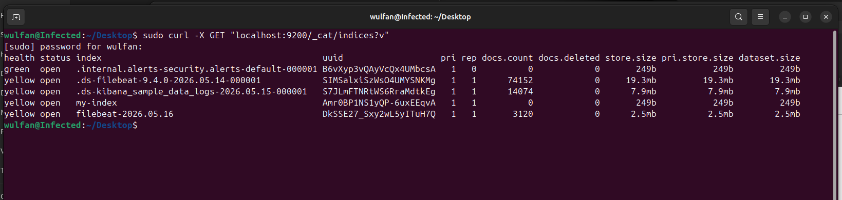

Test 4 — Filebeat log shipping (client)

- Objective: Confirm Filebeat collects specified logs on client and forwards them to Logstash/Elasticsearch.

- Steps performed:
  - Check Filebeat service on client: sudo systemctl status filebeat
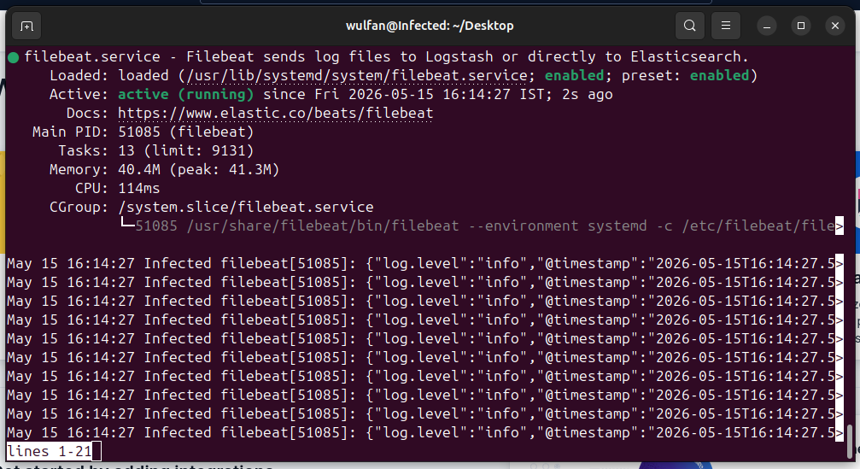

  - The Kibana Dev Tools Console, used to send API requests to Elasticsearch. The command shown (GET /_cat/indices?v) lists all indices in the cluster along with their health, document count, and storage usage.

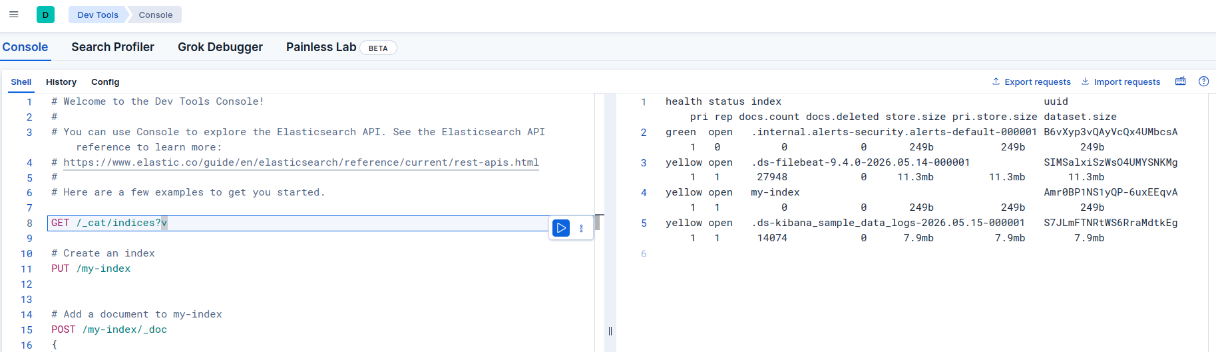

  - File beat output testing using sudo filebeat test output.
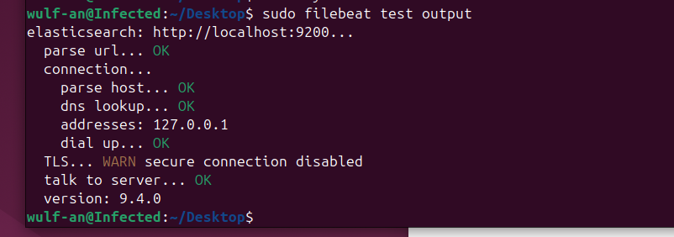
This talk to server … OK means ouput are properly reach kibana.

4. Data checking using Dev tools results.

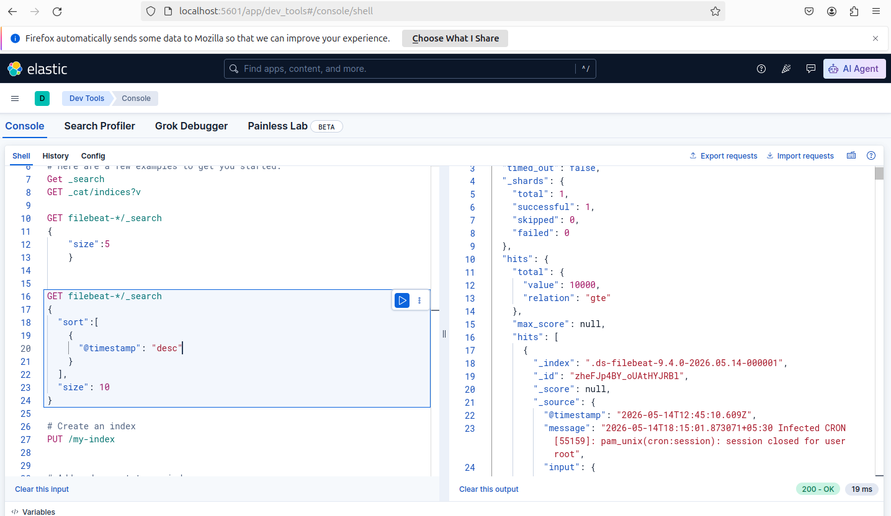

5. Verify receipt in Logstash or Elasticsearch: use Kibana Discover to search recently indexed document.

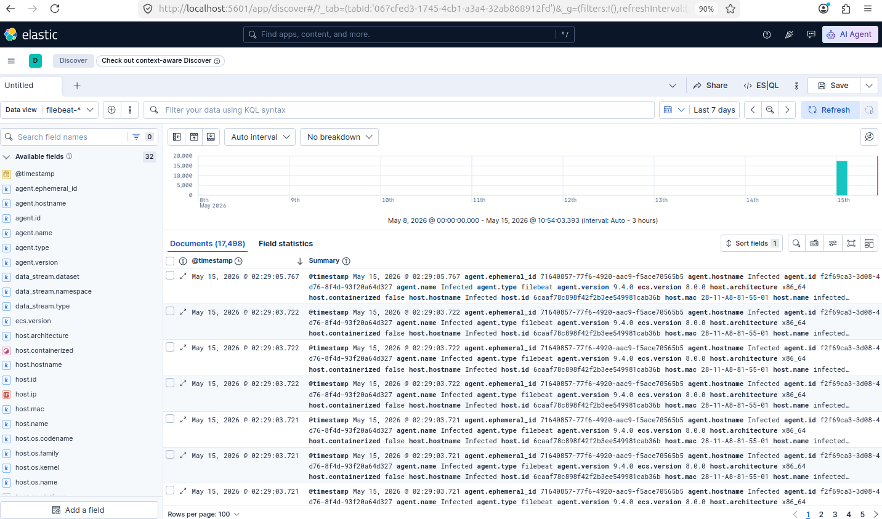
Logs are reached kibana discover properly.

- Expected result:
  - Filebeat active; logs show harvested file and events sent
  - Documents appear in Elasticsearch index (logs-YYYY.MM.dd or beats index)

Test 5 — End-to-end search & dashboard

- Objective: Verify a log produced on client appears in Kibana Discover and can be visualized on a dashboard.
- Steps performed:
  - Produce a uniquely identifiable log message on client.
  - Wait for Filebeat →→ Elasticsearch indexing (monitor logs).
  - Open Kibana Discover, search for the test message.
  - Create a small dashboard or visualize a chart showing message count over time.

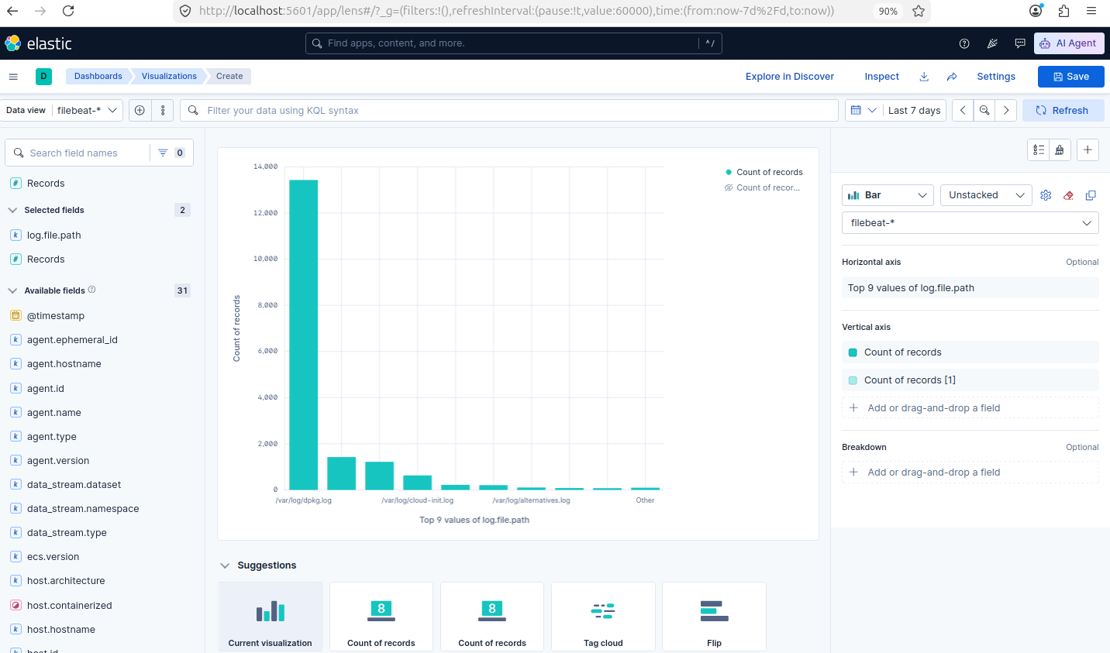
Data visualization Creation for log Volume Analysing.

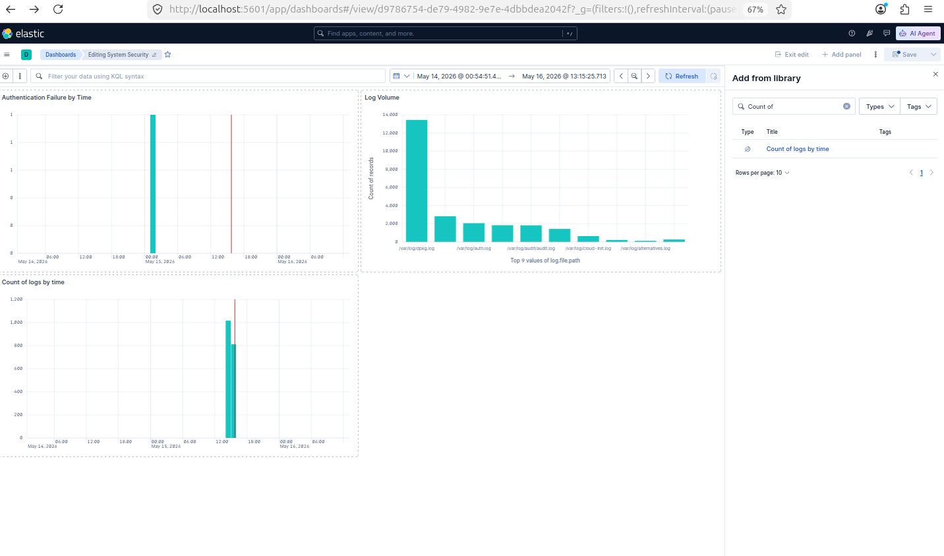
This screenshot clearly shows that our Kibana dashboard was created successfully. The dashboard is open in edit mode and contains multiple visualizations, including “Authentication Failure by Time,” “Log Volume,” and “Count of logs by time,” which indicates that data is being read and displayed properly in Kibana.

------------------------------------------------------------------------------------------------------------------------

