Investigation Resource Report: Splunk Interface Optimization

1. The Search & Reporting App (The Engine)
This isn’t just a tab; it’s the primary workspace where nearly all investigation happens.
- Why it’s helpful: This is where you write Search Processing Language (SPL). For Volt Typhoon, you aren't just looking for "malware files" (which they rarely use); you are searching for behavior. You'll use this app to filter through thousands of logs to find that one specific netsh or wmic command used to move laterally.

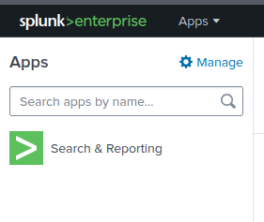

2. The Time Picker (The Context Filter)
Located at the top right of the search bar, it defaults to "Last 24 Hours."
- Why it’s helpful: Advanced Persistent Threats (APTs) like Volt Typhoon often remain quiet for weeks. If you search "Last 24 hours" in a lab containing data from three months ago, you will see zero results.
- Pro-Tip: Always set this to "All Time" or a specific date range provided in your challenge brief to ensure you aren't missing the attack window.
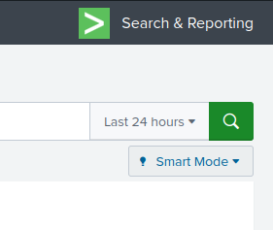

3. The Fields Sidebar (The Discovery Tool)
Once you run a search, this appears on the left side of your screen under "Selected Fields" and "Interesting Fields."
- Why it’s helpful: It automatically parses your logs into categories like User, CommandLine, Image, or EventID.
- Strategic Use: Instead of guessing what happened, look at the Interesting Fields. If you see CommandLine has a high count of powershell.exe entries, click it. Splunk will show you exactly what those scripts were doing without you needing to write a complex query.

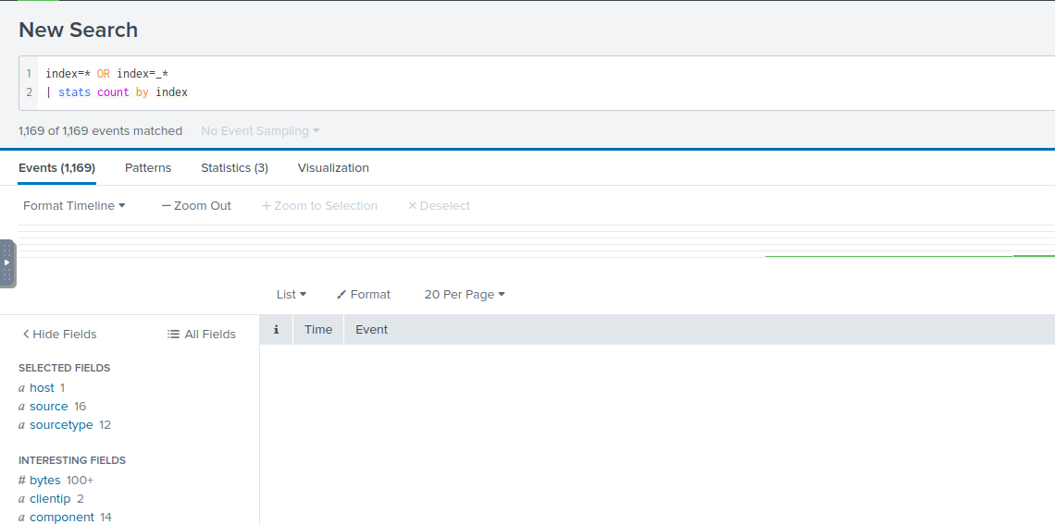

4. The "Data Summary" Button
Found on the main Search & Reporting page before you run a query.
- Why it’s helpful: It gives you a bird's-eye view of your environment across three tabs:
  - Hosts: Which computers are sending logs?
  - Sources: Which specific files (like C:\Windows\System32\winevt\Logs\Security.evtx) are being read?
  - Sourcetypes: What kind of data is it? (e.g., WinEventLog, sysmon, xmlwiretap).
- Investigation Value: If you don't know where to start, check the Sourcetypes. If you see XmlWinEventLog:Microsoft-Windows-Sysmon/Operational, that is your "gold mine" for finding suspicious process executions.

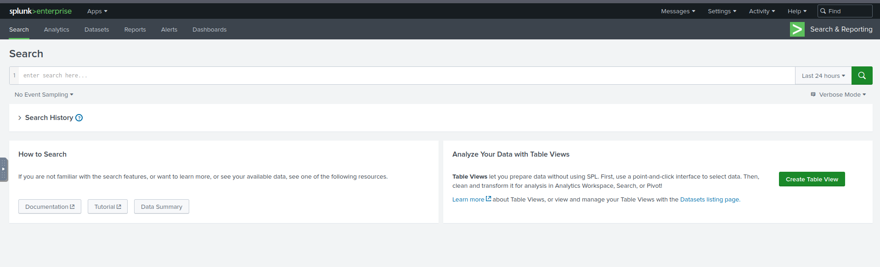

5. Search Result Tabs: Events vs. Statistics
After running a search, you can toggle between these views directly under the search bar.
- Events Tab: Shows raw logs. Essential for "Deep Dives" into exactly what a specific command looked like.
- Statistics Tab: Shows tables created by commands like | stats count by User.
- Why it’s helpful: Use Statistics to find outliers (e.g., "Which user logged into 50 machines in 10 minutes?"). Use Events to see what that user actually did once they logged in.
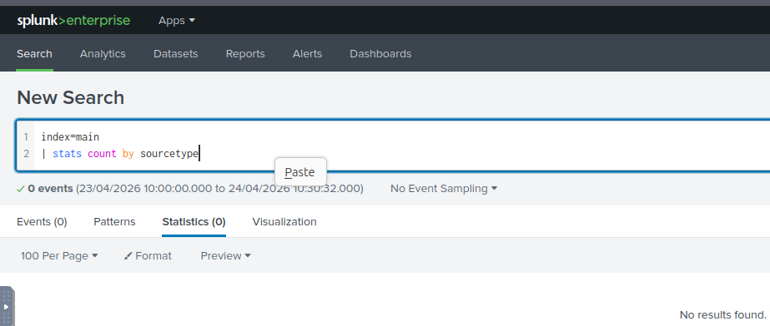

6. The "Save As" / "Export" Menu
Located at the top right of your search results.
- Why it’s helpful: During an investigation, you need to document your findings.
- Practical Use: When you find a "smoking gun" (like an encoded PowerShell command), you can Export that specific result to a CSV or PDF to include in your final report for the challenge.

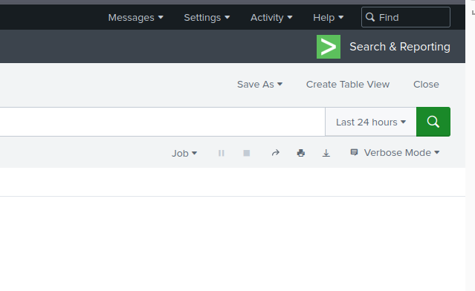

Summary of Workflow for Volt Typhoon
- Open Search & Reporting.
- Set Time Picker to "All Time."
- Run a broad search: index=* sourcetype="*WinEventLog*".
- Use the Fields Sidebar to find the CommandLine field.
- Filter for "Living off the Land" binaries (e.g., *vssadmin*, *ntdsutil*, or *certutil*).
